### List of Use Case

##### <User> Log in

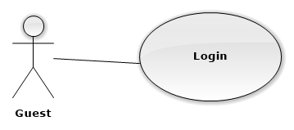

|  |  |  |  |
| --- | --- | --- | --- |
| **USE CASE - UCA01** | | | |
| **Use Case No.** | UCA01 | **Use Case Version** | 2.0 |
| **Use Case Name** | Log in | | |
| **Author** | QuanTD | | |
| **Date** | 1/10/2015 | **Priority** | Normal |
| **Actor:**   * Guest.   **Summary:**   * This use case allows authorized user logging in system.   **Goal:**   * Guest can log in the system.   **Triggers:**   * Guest send the login command.   **Preconditions:**   * N/A.   **Post Conditions:**   * **Success:** User login system. * **Fail:** Show error message.   **Main Success Scenario:**   |  |  |  | | --- | --- | --- | | Step | Actor Action | System Response | | 1 | Guest goes to login view. | System require information:   * Username: free text input, required, length is 3-50. * Password: free text input, required, length is 8-50. | | 2 | User input information | System validate input information.  [Exception 1, 2] | | 3 | User send login command. | Guest will login system with their specified role.  [Alternative 1] |   **Alternative Scenario:**   |  |  |  | | --- | --- | --- | | No | Cause | System Response | | 1 | User input wrong credential information | System show error message that wrong username or password. |   **Exceptions:**   |  |  |  | | --- | --- | --- | | No | Cause | System Response | | 1 | User does not input username, or input username including special characters | System notice that user need to input valid username. | | 2 | User does not input password, or input password including special characters | System notice that user need to input valid password. |   **Relationships:** N/A  **Business Rules:**   * After login to system, actor will see suitable view:   + Doctor will see Doctor view, including list of patient today.  + Nurse will see Nurse view, including list of patient and register patient view.  + Doctor Manager will see list of regimen.  + Administrator will see list of user account.  + Staff will see list of available device.   * Guest can’t use patient account to log in web view of system. | | | |

##### <User> Log out

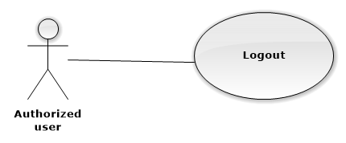

|  |  |  |  |
| --- | --- | --- | --- |
| **USE CASE – UCA02** | | | |
| **Use Case No.** | UCA02 | **Use Case Version** | 2.0 |
| **Use Case Name** | Log out | | |
| **Author** | QuanTD | | |
| **Date** | 1/10/2015 | **Priority** | High |
| **Actor:**   * Authorized user.   **Summary:**   * This use case allows authorized user logging out of system.   **Goal:**   * User can log out of system.   **Triggers:**   * User send logout command * User send other command after not available too long.   **Preconditions:**   * User must be logged in the system before.   **Post Conditions:**   * **Success:** Display login view. * **Fail:** N/A.   **Main Success Scenario:**   |  |  |  | | --- | --- | --- | | Step | Actor Action | System Response | | 1 | User send log out command  [Alternative 1] | Display login view. |   **Alternative Scenario:**   |  |  |  | | --- | --- | --- | | Step | Actor Action | System Response | | 1 | User send any command after not available too long. | Display login view. |   **Exceptions:** N/A  **Relationships:** N/A  **Business Rules:**   * If user not available longer than 30 minutes, they will see the login view when they be back. | | | |

##### <Nurse> Create patient’s profile

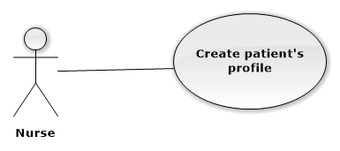

|  |  |  |  |
| --- | --- | --- | --- |
| **USE CASE – UCA03** | | | |
| **Use Case No.** | UCA03 | **Use Case Version** | 2.0 |
| **Use Case Name** | Create patient profile | | |
| **Author** | QuanTD | | |
| **Date** | 1/10/2015 | **Priority** | High |
| **Actor:**   * Nurse.   **Summary:**   * This use case allows nurse to register new patient profile.   **Goal:**   * Nurse can create new patient profile.   **Triggers:**   * Nurse send create patient profile command.   **Preconditions:**   * Actor must be logged in system before with role “Nurse”.   **Post Conditions:**   * **Success:**   + New patient profile is stored.  + Credential information is sent to patient.  + Doctor will see new appointment with patient in his/her scheduler.   * **Fail:** Display error message.   **Main Success Scenario:**   |  |  |  | | --- | --- | --- | | Step | Actor Action | System Response | | 1 | Nurse send create patient profile command. | System require inputting information:   * Patient name: free text input, required, length is 3- 50. * Birthdate: date time input, required, year old value is 20-60. * Male: option input, value is choose or not. * Weight: free text input, required, value is 2- 300, unit: kilogram. * Height: free text input, required, value = 100 - 250, unit: centimeter. * Doctor: text input with suggestion, required. * Medicine usage history: free text input. * Medical history: free text input. * Symptom: free text input, required, length = 10 – 1000. * Email: free text input, required, length = 10 – 100, unique. * Heart beat: free text input, required, value is 20-200, unit: times/minute. * Blood pressure: free text input, required, value is 20-200, unit: mmHg. * Waits: free text input, required, value is 50-300. * Body fat: free text input, required, value is 1-100, unit: %. * Visceral fat: free text input, required, value is 1-100, unit: level. * Muscle mass: free text input, required, value is 1-100, unit: %. * Body water: free text input, required, value is 1-100, unit: %. * Phase angle: free text input, required, value is 1-100, unit: o. * Impedance: free text input, required, value is 1-100, unit: Ohm. * Basal metabolic rate: free text input, value is 1-5000, unit: kilo calories. | | 2 | Nurse input all required information  [Alternative 1] | System validate information.  [Exception 1] | | 3 | Nurse send register patient profile command | Display message that profile has been created. Credential information is sent to patient’s email.  [Exception 2] |   **Alternative Scenario:**   |  |  |  | | --- | --- | --- | | No | Actor Action | System Response | | 1 | Nurse send cancel command. | Display main view. |   **Exceptions:**   |  |  |  | | --- | --- | --- | | No | Actor Action | System Response | | 1 | Nurse does not input all required fields, or input wrong some fields. | System notice that user need to input all required field.  + Patient name: System ask user to input patient name.  + Birthday: System ask user to input valid birthday.  + Weight: System ask user to input valid weight.  + Height: System ask user to input valid height.  + Doctor: System ask user to input valid doctor name.  + Symptom: System ask user input symptom, do not make it blank.  + Email: System ask user to input a valid email.  + Heart beat: System ask user input symptom, do not make it blank.  + Blood pressure: System ask user input blood pressure, do not make it blank.  + Waits: System ask user input waits, do not make it blank.  + Body fat: System ask user input body fat, do not make it blank.  + Visceral fat: System ask user input visceral fat, do not make it blank.  + Muscle mass: System ask user input muscle mass, do not make it blank.  + Body water: System ask user input body water, do not make it blank.  + Phase angle: System ask user input phase angle, do not make it blank.  + Impedance: System ask user input impedance, do not make it blank.  + Basal metabolic rate: System ask user input basal metabolic rate, do not make it blank. | | 2 | Nurse input email that existed in system. | System notify user that email is existed in system, required user inputting again. |   **Relationships:** N/A.  **Business Rules:**   * With old patient, nurse don’t need to create new patient profile. System will suggest if nurse input duplicate name. * An email contain username and password should be send to patient, patient can use this credential information to login system. * The initial status of patient account will be set to INACTIVE. * New medical record data will be created with status AWAITING TO CHECK. * Email pattern should be: **/^[a-zA-Z0-9.!#$%&'*+\/=?^_`{|}~-]+@[a-zA-Z0-9](?:[a-zA-Z0-9-]{0,61}[a-zA-Z0-9])?(?:\.[a-zA-Z0-9](?:[a-zA-Z0-9-]{0,61}[a-zA-Z0-9])?)*$/** (following *RFC 5322 standard).* | | | |

##### <Nurse> Update patient’s history

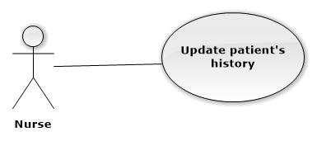

|  |  |  |  |
| --- | --- | --- | --- |
| **USE CASE – UCA04** | | | |
| **Use Case No.** | UCA04 | **Use Case Version** | 2.0 |
| **Use Case Name** | Update patient’s history. | | |
| **Author** | QuanTD | | |
| **Date** | 1/10/2015 | **Priority** | High |
| **Actor:**   * Nurse.   **Summary:**   * This use case allows nurse to update patient’s history.   **Goal:**   * Nurse can update patient’s history.   **Triggers:**   * Nurse send updating patient’s history command.   **Preconditions:**   * Actor must be logged in system before with role “Nurse”. * The patient profile must is available before.   **Post Conditions:**   * **Success:**   + New patient’s history is created in storage.  + Doctor will see new appointment with patient in his/her scheduler.   * **Fail:** Display error message.   **Main Success Scenario:**   |  |  |  | | --- | --- | --- | | Step | Actor Action | System Response | | 1 | Nurse send update patient’s history command. | System require inputting information:   * Weight: free text input, required, value is 2- 300, unit: kilogram. * Height: free text input, required, value = 100 - 250, unit: centimeter. * New medical record: option input, value is choose or not. * Doctor: text input with suggestion, required. * Medicine usage history: free text input. * Medical history: free text input. * Symptom: free text input, required, length = 10 – 1000. * Heart beat: free text input, required, value is 20-200, unit: times/minute. * Blood pressure: free text input, required, value is 20-200, unit: mmHg. * Waits: free text input, required, value is 50-300. * Body fat: free text input, required, value is 1-100, unit: %. * Visceral fat: free text input, required, value is 1-100, unit: level. * Muscle mass: free text input, required, value is 1-100, unit: %. * Body water: free text input, required, value is 1-100, unit: %. * Phase angle: free text input, required, value is 1-100, unit: o. * Impedance: free text input, required, value is 1-100, unit: Ohm. * Basal metabolic rate: free text input, value is 1-5000, unit: kilo calories. | | 2 | Nurse input all require field  [Alternative 1] | System validate information.  [Exception 1] | | 3 | Nurse send update history command | Display that new patient’s history is added into system.  [Exception 2] |   **Alternative Scenario:**   |  |  |  | | --- | --- | --- | | No | Actor Action | System Response | | 1 | Nurse send cancel command | Display main view. |   **Exceptions:**   |  |  |  | | --- | --- | --- | | No | Actor Action | System Response | | 1 | Nurse does not input all required fields, or input wrong some fields. | System notice that user need to input all required field.  + Patient name: System ask user to input patient name.  + Birthday: System ask user to input valid birthday.  + Weight: System ask user to input valid weight.  + Height: System ask user to input valid height.  + Doctor: System ask user to input valid doctor name.  + Symptom: System ask user input symptom, do not make it blank.  + Heart beat: System ask user input symptom, do not make it blank.  + Blood pressure: System ask user input blood pressure, do not make it blank.  + Waits: System ask user input waits, do not make it blank.  + Body fat: System ask user input body fat, do not make it blank.  + Visceral fat: System ask user input visceral fat, do not make it blank.  + Muscle mass: System ask user input muscle mass, do not make it blank.  + Body water: System ask user input body water, do not make it blank.  + Phase angle: System ask user input phase angle, do not make it blank.  + Impedance: System ask user input impedance, do not make it blank.  + Basal metabolic rate: System ask user input basal metabolic rate, do not make it blank. | | 2 | Nurse send update history command | System display error message that can’t update patient’s history. |   **Relationships:** N/A.  **Business Rules:**   * Patient’s profile must be available before. * New appointment record data will be created with status AWAITING TO CHECK. | | | |

##### <Scheduler> Notify to doctor.

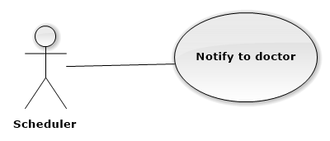

|  |  |  |  |
| --- | --- | --- | --- |
| **USE CASE – UCA07** | | | |
| **Use Case No.** | UCA07 | **Use Case Version** | 2.0 |
| **Use Case Name** | Notify to doctor. | | |
| **Author** | QuanTD | | |
| **Date** | 1/10/2015 | **Priority** | High |
| **Actor:**   * Scheduler.   **Summary:**   * This use case allows doctor receiving notification from nurse.   **Goal:**   * Doctor can receive notification.   **Triggers:**   * The scheduling time is configured.   **Preconditions:**   * Nurse assign a patient need to check for doctor before.   **Post Conditions:**   * **Success:** Doctor will receive notification. * **Fail:**   + Doctor won’t receive notification.  **+** Log file will record error and time.  **Main Success Scenario:**   |  |  |  | | --- | --- | --- | | Step | Actor Action | System Response | | 1 | *Server checks the current time.* *If it hits configured time, scheduler* *process starts.* | [Exception 1]  System reads all uncompleted notification data from storage.  With all uncompleted notifications:   * System tries to send to doctor, then mark notification as COMPLETED.   [Exception 2]   * Generate log file. |   **Alternative Scenario:** N/A  **Exceptions:**   |  |  |  | | --- | --- | --- | | No | Actor action | Cause | | 1 | *Server checks the current time.* *If it hits configured time, scheduler* *process starts.* | Scheduler can’t start:   * Generate log file with error and time. | | 2 | *Server checks the current time.* *If it hits configured time, scheduler* *process starts.* | System can’t send notification to doctor:   * Notification will be marked as UNCOMPLETED. * Generate log file with error and time. |   **Relationships:** N/A.  **Business Rules:**   * Scheduler will try to send notification to doctor in 3 times/scheduler running time. * If notification is sent to doctor successfully, the status of notification data in storage will be set COMPLETED. * If notification can’t be sent to doctor successfully, the status of notification data in storage will be set UNCOMPLETED. | | | |

##### <Doctor Manager> Create new regimen

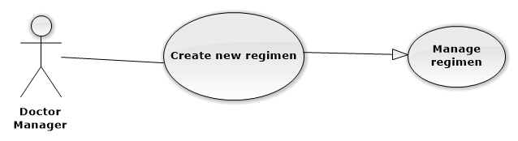

|  |  |  |  |
| --- | --- | --- | --- |
| **USE CASE – UCA09** | | | |
| **Use Case No.** | UCA09 | **Use Case Version** | 2.0 |
| **Use Case Name** | Create new regimen | | |
| **Author** | QuanTD | | |
| **Date** | 1/10/2015 | **Priority** | Normal |
| **Actor:**   * Doctor Manager.   **Summary:**   * This use case allows doctor manager create new regimen.   **Goal:**   * Doctor manager can create new regimen.   **Triggers:**   * Doctor send create regimen command.   **Preconditions:**   * Actor must login system before with role “Doctor Manager”.   **Post Conditions:**   * **Success:** New regimen data is inserted into storage. * **Fail:** System display error message.   **Main Success Scenario:**   |  |  |  | | --- | --- | --- | | Step | Actor Action | System Response | | 1 | Doctor manager send create new regimen command | System require input fields:   * Name of regimen: free text input, required, length is 1- 100. * Name of illness: free text input, required, length is 1-100. * Detail of treatment phases:   + Number of day per a phase: free text input, required, value is 1-100.  + Medicine:   * Medicine name: text input with suggestion, required. * Quantitative: free text input with suggestion, required, value is 1-10. * Number of time: free text input, required, value is 1-7. * Advice: free text input, not required.   + Food:   * Food name: text input with suggestion, required. * Food unit: text input with suggestion, required. * Quantitative: free text input with suggestion, required, value is 1-10. * Number of time: free text input, required, value is 1-7. * Advice: free text input, not required.   + Practice:   * Practice name: text input with suggestion, required. * Time duration: free text input, required. * Number of time: free text input, required, value is 1-7. * Advice: free text input, not required. | | 2 | Doctor manager input all required field.  [Alternative 1] | System validate information.  [Exception 1] | | 3 | Doctor manager send create regimen command | System required doctor manager confirming all inputted information. | | 4 | Doctor manager send submit command  [Alternative 1] | New regimen and detail of phases, medicines, foods and practices data are created in storage. System display main view.  [Exception 2] |   **Alternative Scenario:**   |  |  |  | | --- | --- | --- | | No | Actor Action | System Response | | 1 | Doctor manager send cancel command | Display main view. |   **Exceptions:**   |  |  |  | | --- | --- | --- | | No | Actor Action | System Response | | 1 | Doctor manager does not input required fields. | System notice that user need to input required field.   * Regimen name: System ask user to input valid regimen name. * Name of illness: System ask user to input valid illness name. * Detail of treatment phases:   + Number of treatment day per phase: System ask user to input valid number of treatment day.  + Medicine:   * Medicine name: System ask user to input valid medicine name. * Quantitative: System ask user to input valid quantitative value. * Number of time: System ask user to input valid number of time value.   + Food:   * Food name: System ask user to input valid food name. * Food unit: System ask user to input valid food unit. * Quantitative: System ask user to input valid quantitative value. * Number of time: System ask user to input valid number of time value.   + Practice:   * Practice name: System ask user to input valid practice name. * Time duration: System ask user to input valid time duration value. * Number of time: System ask user to input valid number of time value. | | 2 | Doctor manager send submit command | System display error message that can’t create new regimen data. Creating regimen request is aborted. |   **Relationships:** N/A.  **Business Rules:**   * Name of regimen must be unique. | | | |

##### <Doctor Manager> Update regimen

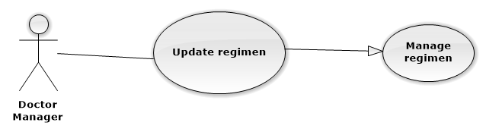

|  |  |  |  |
| --- | --- | --- | --- |
| **USE CASE – UCA09** | | | |
| **Use Case No.** | UCA10 | **Use Case Version** | 2.0 |
| **Use Case Name** | Update regimen | | |
| **Author** | QuanTD | | |
| **Date** | 1/10/2015 | **Priority** | Normal |
| **Actor:**   * Doctor Manager.   **Summary:**   * This use case allows doctor manager update regimen.   **Goal:**   * Doctor manager can update an available regimen.   **Triggers:**   * Doctor send update regimen command.   **Preconditions:**   * Actor must login system before with role “Doctor Manager”. * The regimen must be available before.   **Post Conditions:**   * **Success:** New regimen data is inserted into storage. * **Fail:** System display error message.   **Main Success Scenario:**   |  |  |  | | --- | --- | --- | | Step | Actor Action | System Response | | 1 | Doctor send update regimen command | System require input fields:   * Name of regimen: free text input, required, length is 1- 100. * Name of illness: free text input, required, length is 1-100. * Detail of treatment phases:   + Number of day per a phase: free text input, required, value is 1-100.  + Medicine:   * Medicine name: text input with suggestion, required. * Quantitative: free text input with suggestion, required, value is 1-10. * Number of time: free text input, required, value is 1-7. * Advice: free text input, not required.   + Food:   * Food name: text input with suggestion, required. * Food unit: text input with suggestion, required. * Quantitative: free text input with suggestion, required, value is 1-10. * Number of time: free text input, required, value is 1-7. * Advice: free text input, not required.   + Practice:   * Practice name: text input with suggestion, required. * Time duration: free text input, required. * Number of time: free text input, required, value is 1-7.   Advice: free text input, not required. | | 2 | Doctor manager input all required field.  [Alternative 1] | System validate information.  [Exception 1] | | 3 | Doctor send update regimen command | System required doctor confirming all inputted information  [Alternative 1]  [Exception 1] | | 4 | Doctor send submit command | System validate all information. If all information is valid, regimen information and detail of phases, medicines, foods and practices data are updated into storage. |   **Alternative Scenario:**   |  |  |  | | --- | --- | --- | | No | Actor Action | System Response | | 1 | Doctor manager send cancel command | Display main view. Regimen data is not updated into storage. |   **Exceptions:**   |  |  |  | | --- | --- | --- | | No | Actor Action | System Response | | 1 | Doctor manager send update regimen command without inputting all required fields. | System notice that user need to input required field.   * Regimen name: System ask user to input valid regimen name. * Name of illness: System ask user to input valid illness name. * Detail of treatment phases:   + Number of treatment day per phase: System ask user to input valid number of treatment day.  + Medicine:   * Medicine name: System ask user to input valid medicine name. * Quantitative: System ask user to input valid quantitative value. * Number of time: System ask user to input valid number of time value.   + Food:   * Food name: System ask user to input valid food name. * Food unit: System ask user to input valid food unit. * Quantitative: System ask user to input valid quantitative value. * Number of time: System ask user to input valid number of time value.   + Practice:   * Practice name: System ask user to input valid practice name. * Time duration: System ask user to input valid time duration value. * Number of time: System ask user to input valid number of time value. | | 2 | Doctor manager send submit command | System display error message that can’t update regimen data. Updating regimen request is aborted. |   **Relationships:** N/A.  **Business Rules:**   * After regimen is updated in storage, all information will be used for suggesting doctor make prescription to patient. | | | |

##### <Doctor Manager> Delete regimen

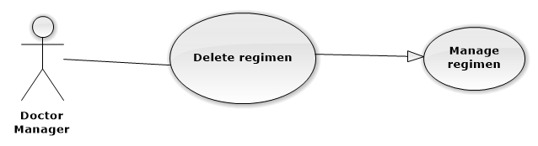

|  |  |  |  |
| --- | --- | --- | --- |
| **USE CASE – UCA11** | | | |
| **Use Case No.** | UCA11 | **Use Case Version** | 1.0 |
| **Use Case Name** | Delete regimen | | |
| **Author** | QuanTD | | |
| **Date** | 24/09/2015 | **Priority** | Normal |
| **Actor:**   * Doctor Manager.   **Summary:**   * This use case allows doctor manager delete a regimen.   **Goal:**   * Doctor manager can delete a regimen.   **Triggers:**   * Doctor send delete regimen command.   **Preconditions:**   * Actor must login system before with role “Doctor Manager”. * The regimen must be available before.   **Post Conditions:**   * **Success:** The regimen has been deleted. * **Fail:** Display error message.   **Main Success Scenario:**   |  |  |  | | --- | --- | --- | | Step | Actor Action | System Response | | 1 | Doctor send delete command | System require doctor manager to confirm deletion | | 2 | Doctor send submit command  [Alternative 1] | System display main view. The regimen request is deleted from storage.  [Exception 1] |   **Alternative Scenario:**   |  |  |  | | --- | --- | --- | | No | Actor Action | System Response | | 1 | Doctor send cancel command | Display main view. Regimen data is not deleted from storage. |   **Exceptions:**   |  |  |  | | --- | --- | --- | | No | Actor Action | System Response | | 2 | Doctor send submit command | System display error message that can’t delete regimen data. Deleting regimen request is aborted. |   **Relationships:** N/A.  **Business Rules:**   * The regimen is deleted from storage, or mark as unused. | | | |