1. **<Nurse> Register examming**

**Description: This diagram show how nurse register examming for a patient.**

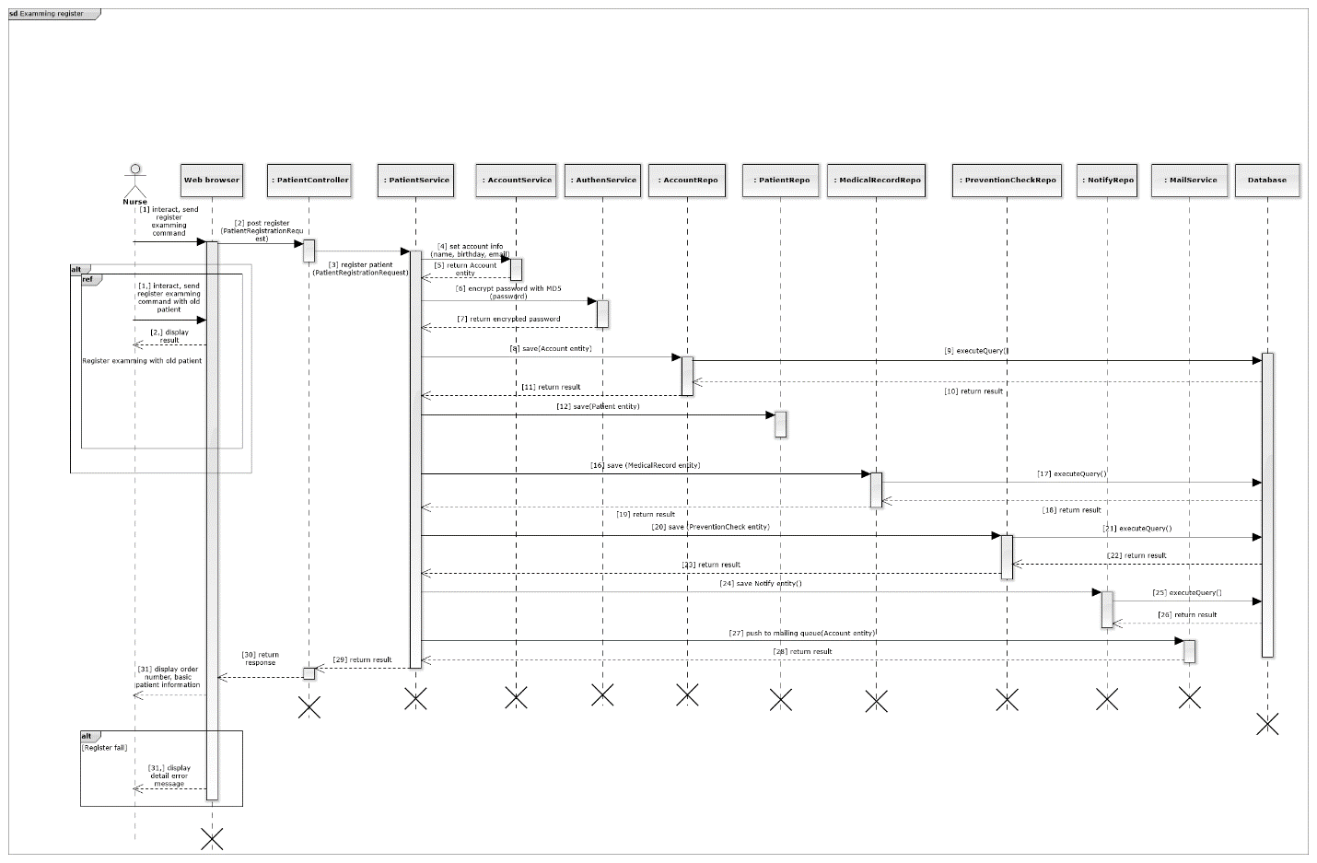

1. **<Nurse> Register examming with old patient – sub sequence diagram**

**Description: This diagram show how a nurse register examming for an old patient.**

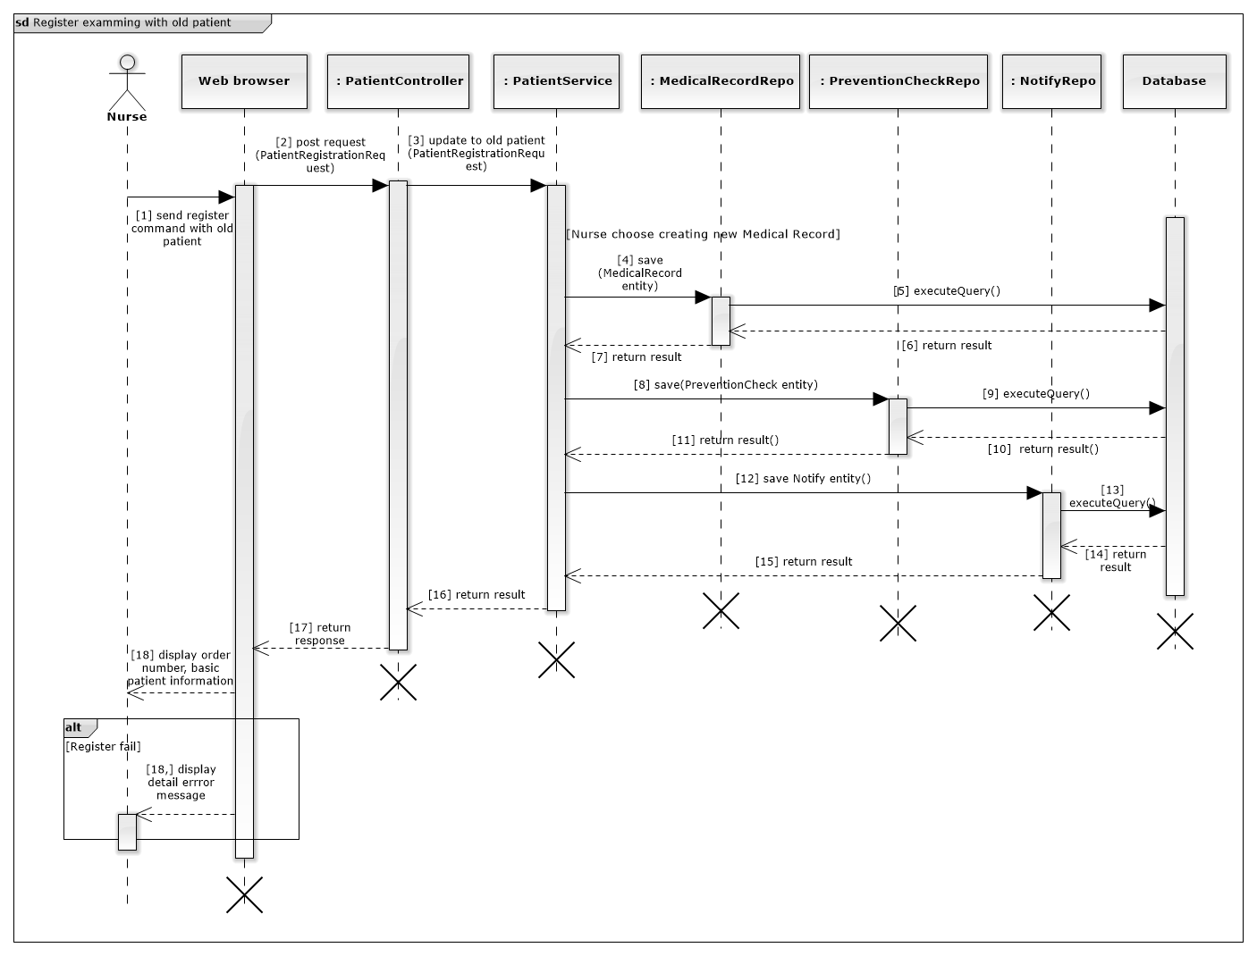

1. **<Nurse> Print prescription**

**This diagram show how to print a prescription for a patient.**

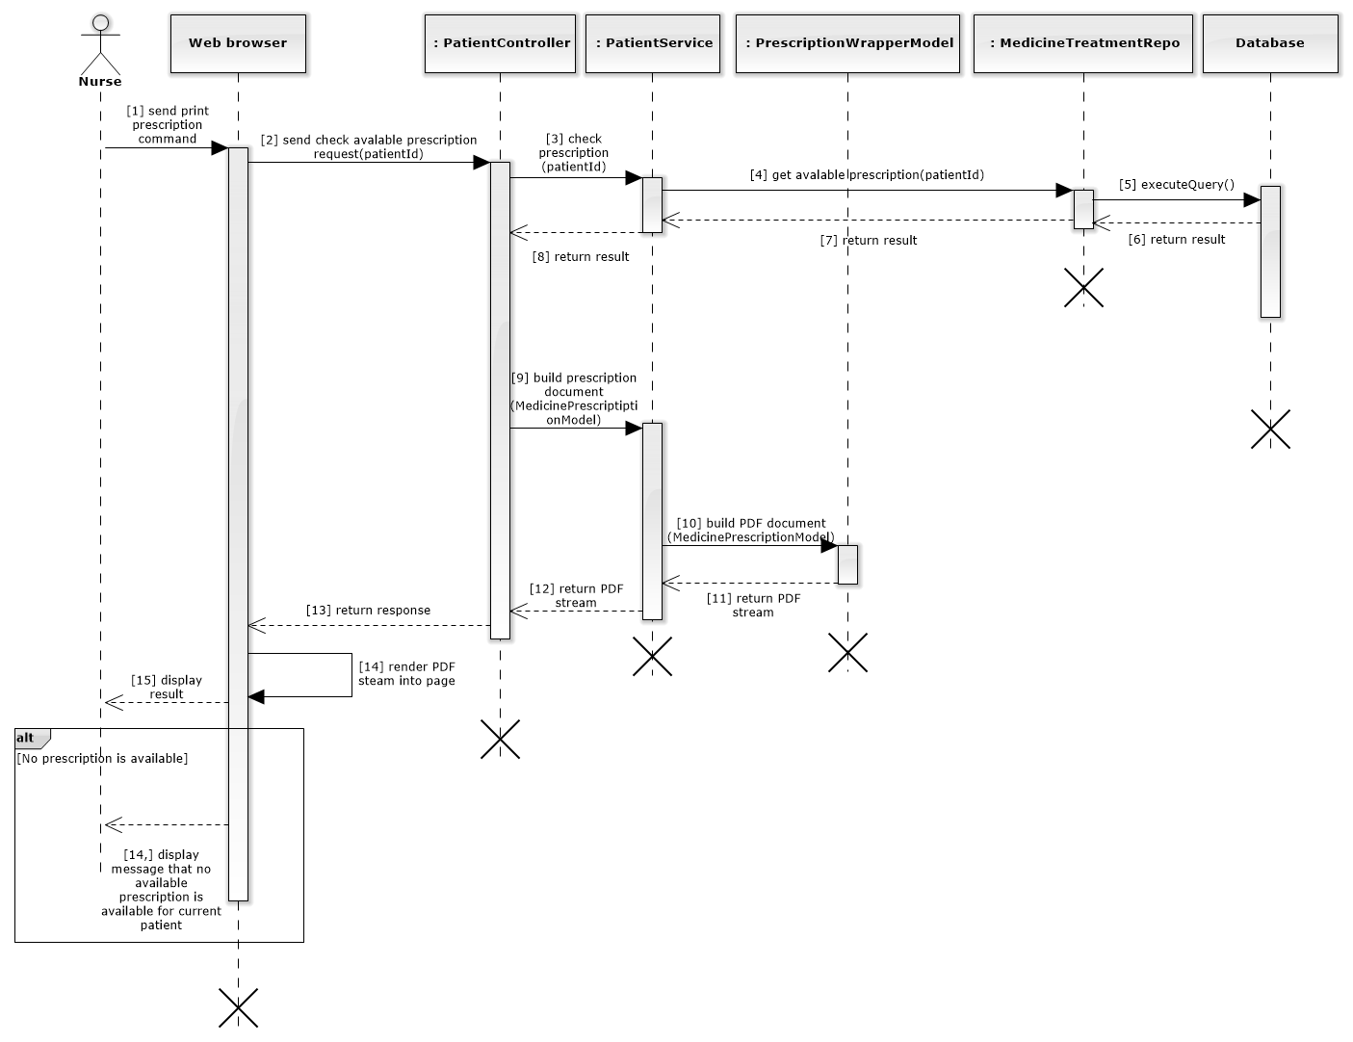

1. **<Doctor manager> Create regimen  
   This diagram show how doctor manager create regimen**

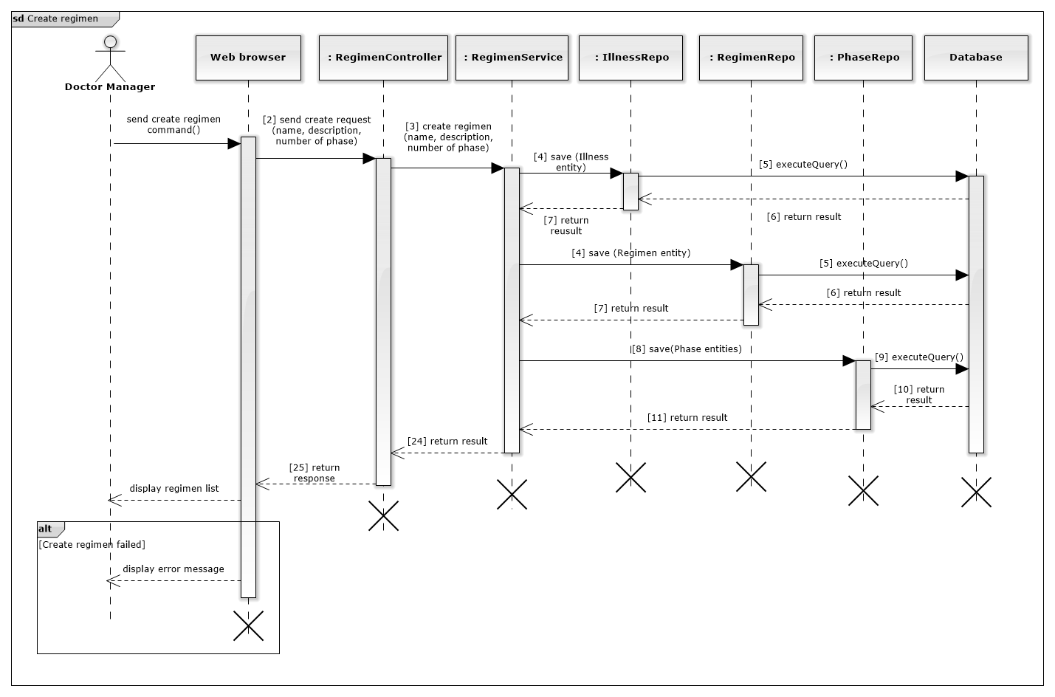

1. **<Doctor manager> Update regimen  
   This diagram show how doctor manager update regimen**

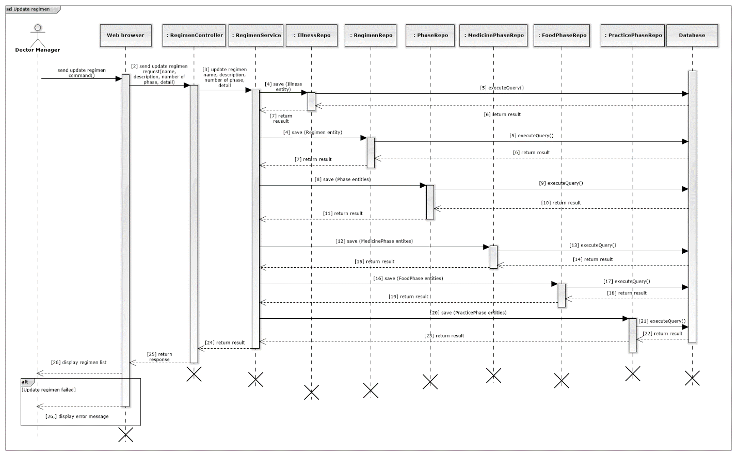

1. **<Doctor manager> Delete regimen  
   This diagram show how doctor manager delete regimen**

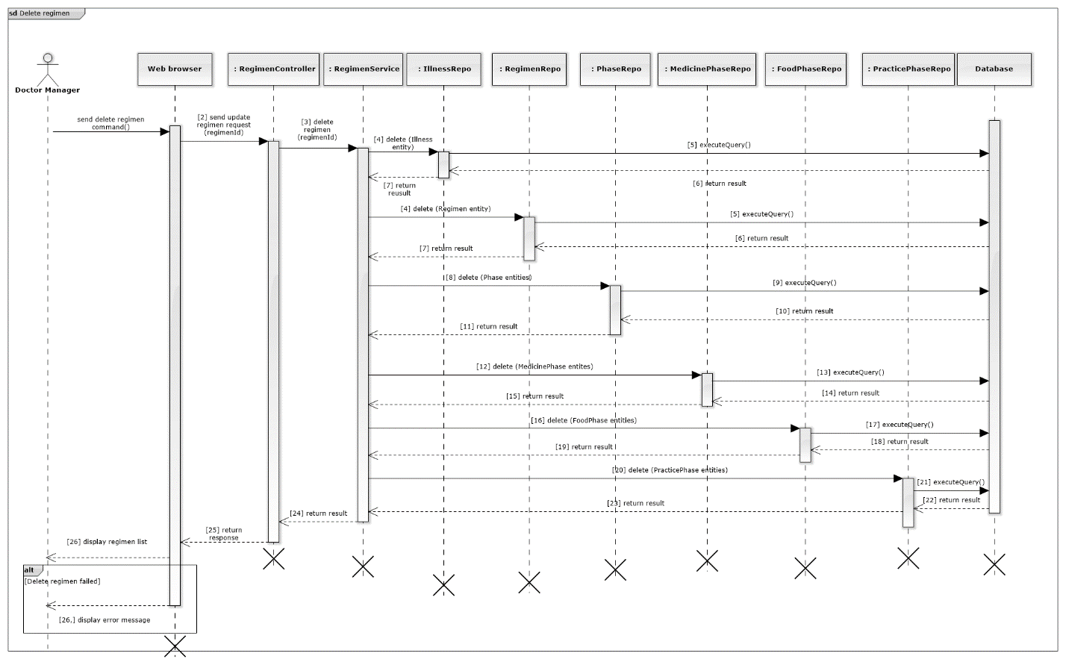

1. **Login**

**This diagram show how a guest log in system.**

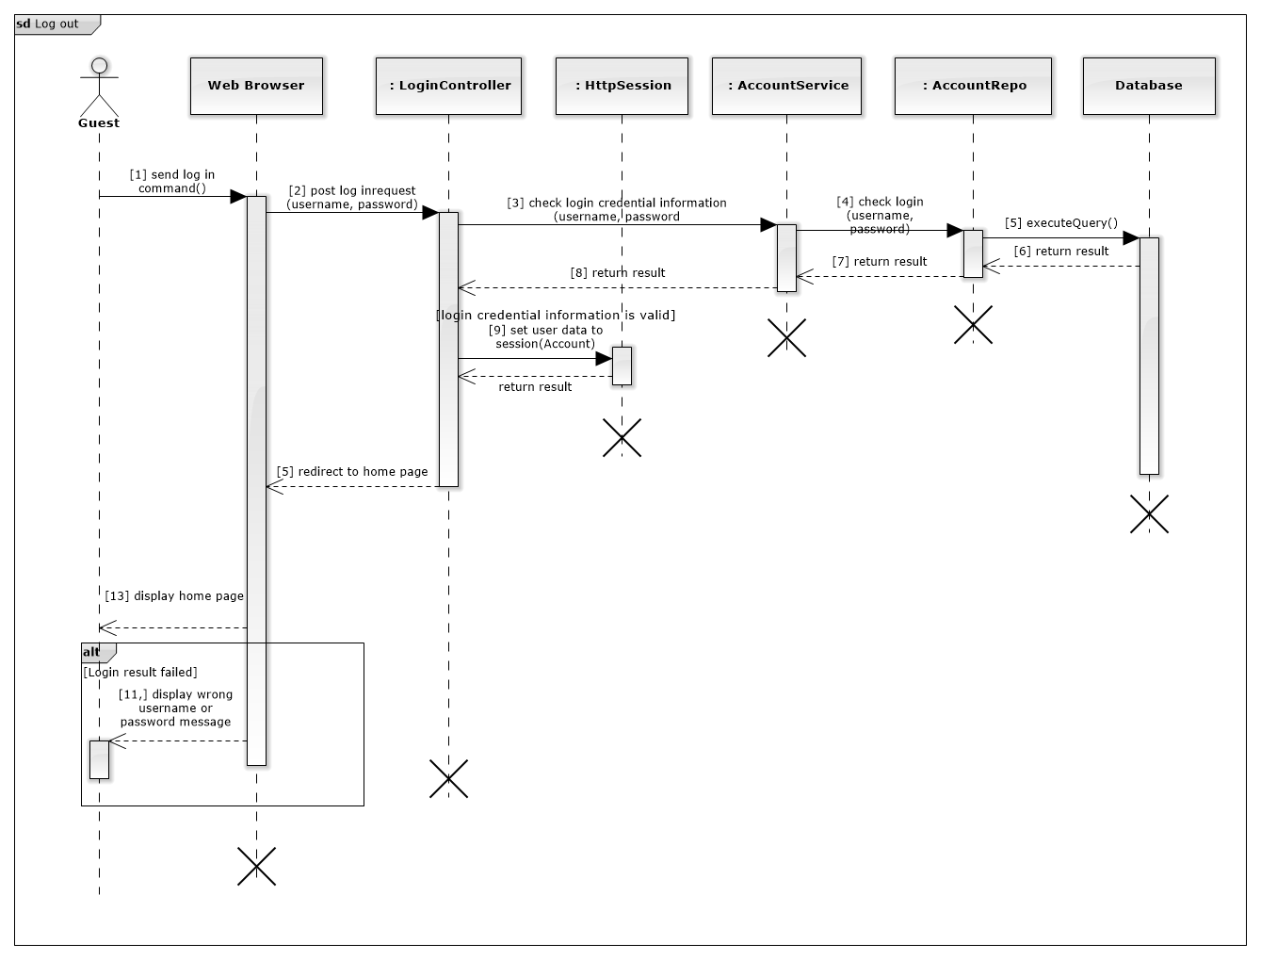

1. **Logout**

**This diagram show how an authorized user log out of system.**

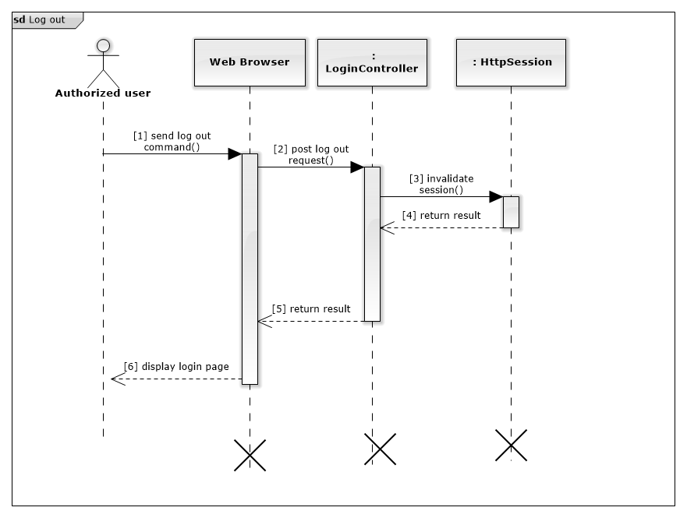

1. **Notify to doctor**

**This diagram show how doctor receive notification**

