## Algorithms

1. Medical record state

The medical record in HSTS system is complex and can be managed differently during the operation. The state chart below describes all the state of a medical record.

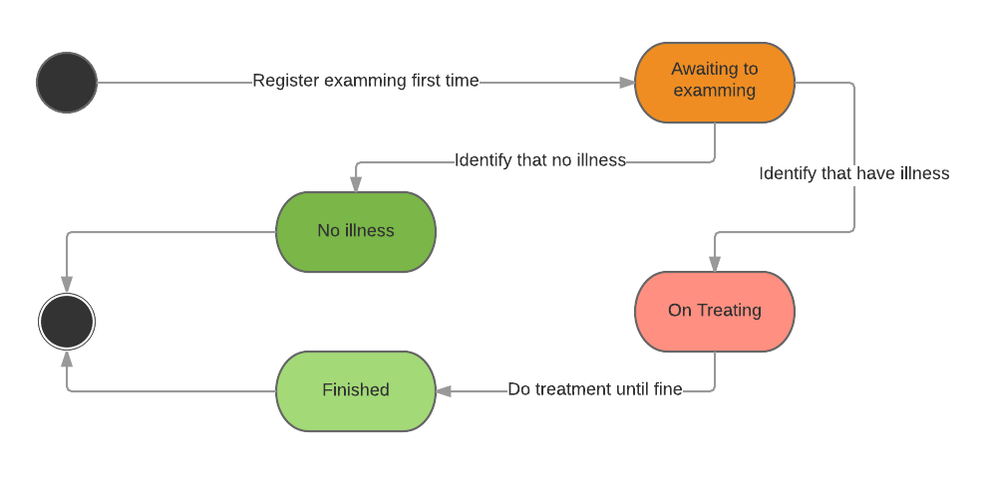

1. Appointment state

An appointment with doctor in HSTS system is complex and can be managed differently during the operation. The state chart below describes all the state of a an appointment.

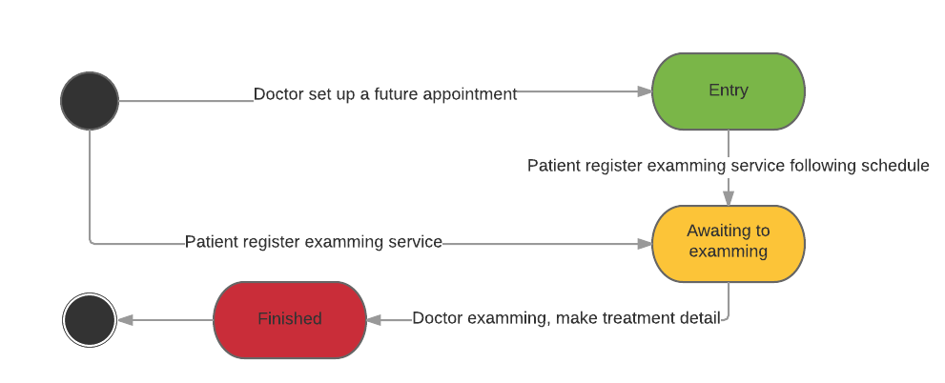

1. Mail scheduler process
   1. Definition

System scheduler is a component of the Web application, this component is responsible for checking the changes from web application and updates information day by day.

* 1. Definition problem

In Web application, we need a system scheduler that runs automatically every day to send email contains login credential information to user such as new patients, doctor, nurse, etc. For their usage, we see that it is necessary to send email to target users immediately after account had been created, or reset password request created.

* 1. Solution

We create an embed scheduler in our web application. The scheduler will automatically run following schedule setting that system administrator defines when deploy the system. The scheduler will automatically access to a queue contains accounts, then send an email with username and password to target email address.

* 1. Flow chart

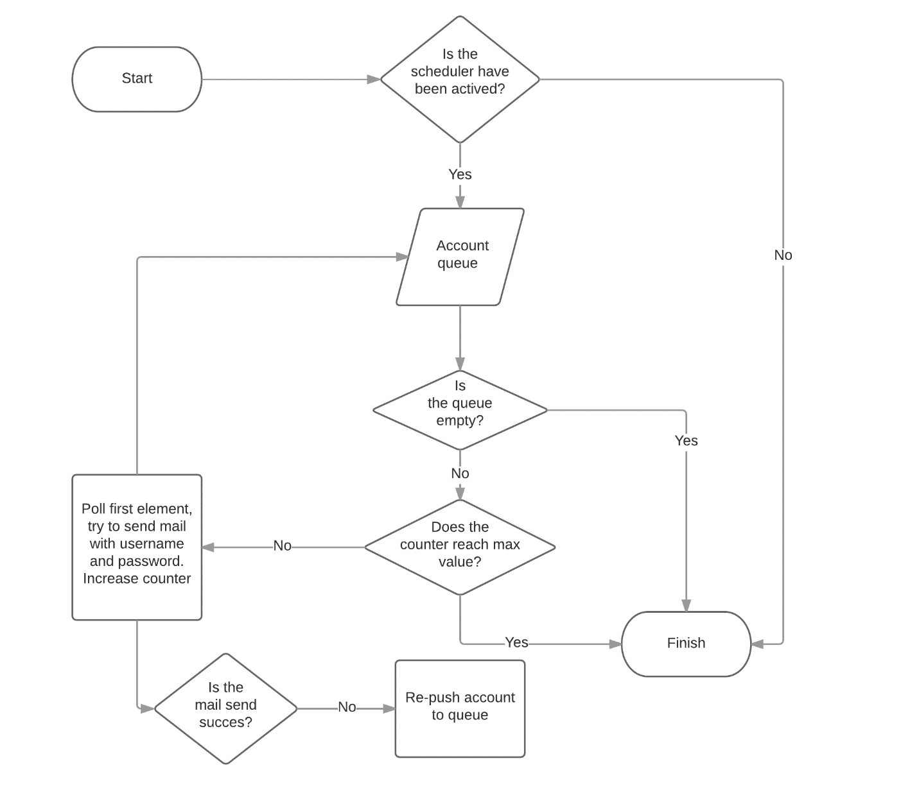

1. Analytic medical record data process
   1. Definition

System scheduler is a component of the Web application, this component is responsible for checking the changes from web application and updates information day by day.

* 1. Definition problem

In Web application, for the purpose that make a statistics report for doctor tracking patient’s treatment status, we need to calculate all values sending from patient’s device.

* 1. Solution

We create a scheduler in our web application, scheduler will automatically run at specific time that system administrator defines when deploy the system. The scheduler will access to database to check the status of all medical record data and update it.

The scheduler process is describe as below:

* Parse new formula from setting file if need.
* Get all unprocessed medical record data from database.
* Calculate practice result base on distance, calories value, etc.
* Save result to database.
  1. Flow chart

