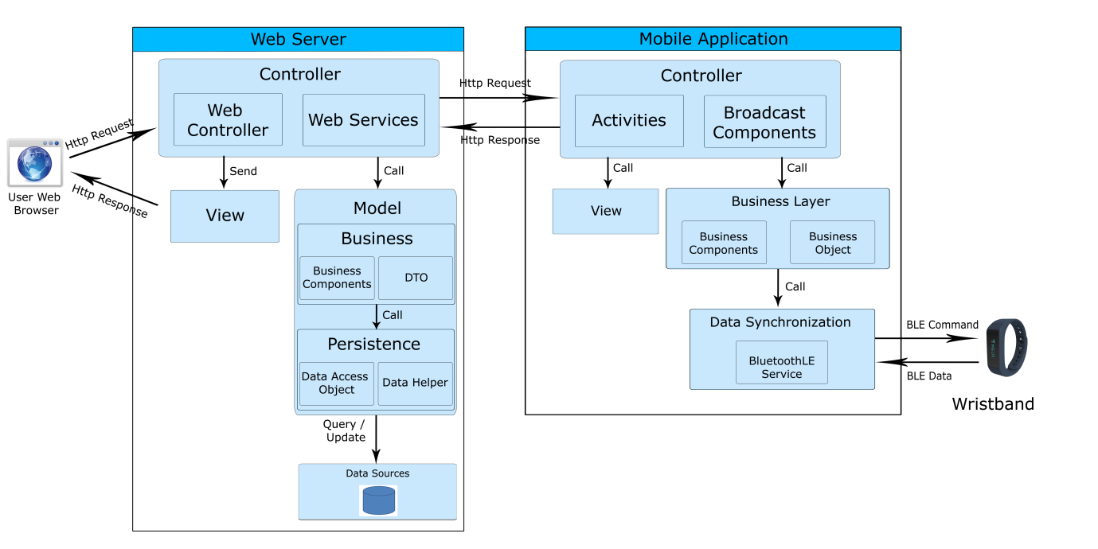

**WEB SERVER**

**Controller** is the parts of the web server that acts like event handler to handles user interaction.

**Web Controller** is the parts of the controller that acts like event handler for web and server communication via HTTP protocol.

**Web Services** is the parts of the controller that acts like event handler for android application and server communication via HTTP protocol.

**Model** is the parts of the web server that acts like a data transfer object between the system and database, handle business of system.

**Business** is the parts of the model that do business processing to solve domain problems.

**Business Component** is the parts of the business that do business of system.

**DTO** is the parts of the business that define some object to use in business component.

**Persistence** is the parts of the model that transfer object between the system and database.

**Data Access Object** is the parts of persistence that mapping table in database with each object in DAO.

**Data Helper** is the parts of persistence that provides some methods and classes to persistent store data into database.

**View** is the parts of the web server that acts like event handles the display of the data. The selection of View is under control of Controller.

**MOBILE APPLICATION**

**Controller** is the parts of mobile application that handles user input, create thread to run asynchronous tasks and syschronize data, get notify from server

**Activities** is the parts of the controller that handles user input, create thread to run asynchronous tasks, send request and receive data from server via web services,…4

**Broadcast Components** is the parts of the controller that tracking notify or new data from server

**View** is the parts of the web server that acts like event handles the display of the data. The selection of View is under control of Controller.

**Business Layer** is the parts of the mobile application that do business processing to solve domain problems in mobile application.

**Business Component** is the parts of business layer that do business of mobile application.

**Business Object** is the parts of business layer that define some objects like DTO in server and some objects to use in business component.

**Data Synchronization** is the parts of the mobile application that use to get data from wristband and manage connection with wristband.

**BluetoothLE Service** is the parts of the data synchronization that tracking data from wristband.