**TAnimal Programmer test log – HMS JSON vs. AQUATOX 3.2**

**Animal model “simple” (one animal only) 12/20/2019**

AQUATOX 3.2 file**: Farm Pond mayflyonly.aps**

HMS Input file: **Farm Pond mayflyonly.JSON**

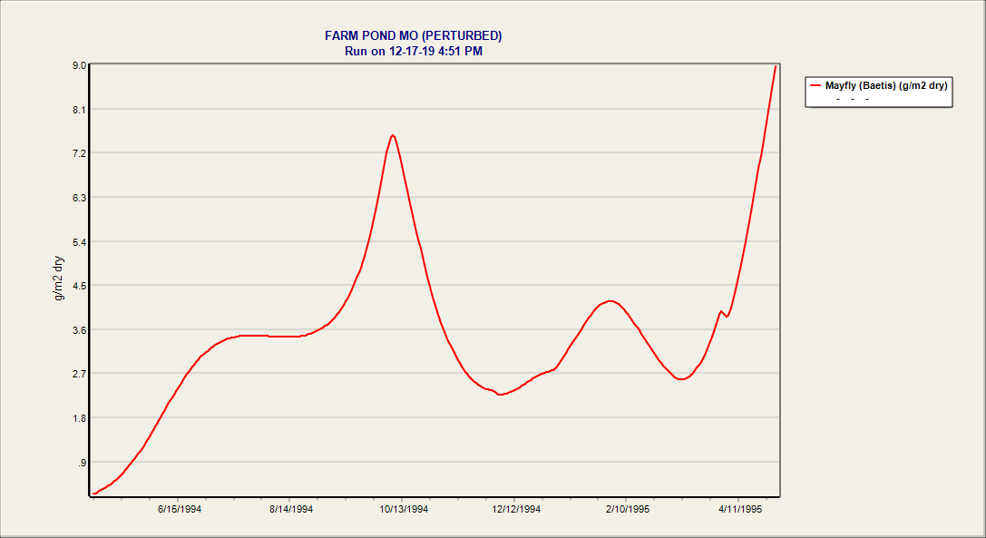

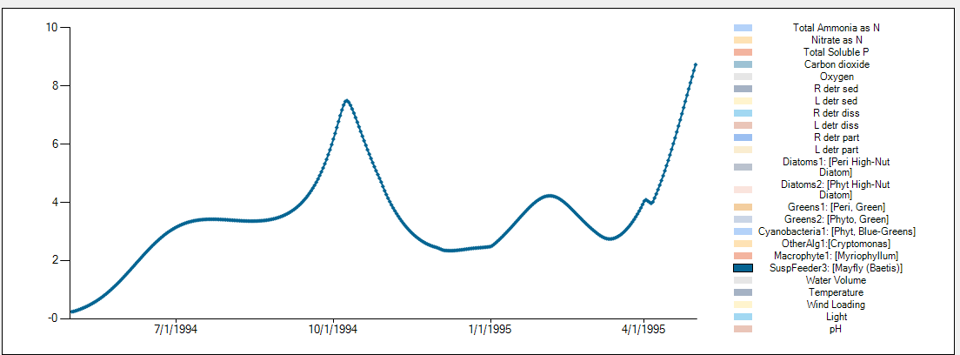

**Mayfly results identical**

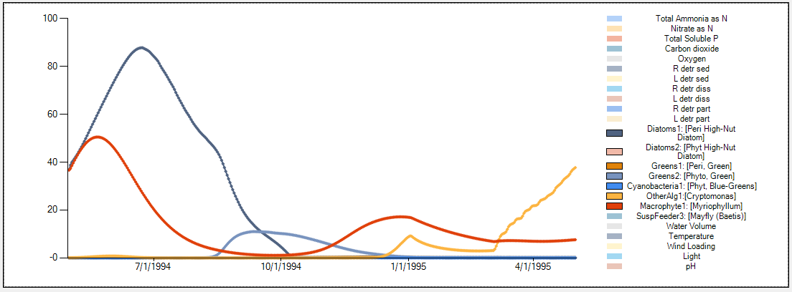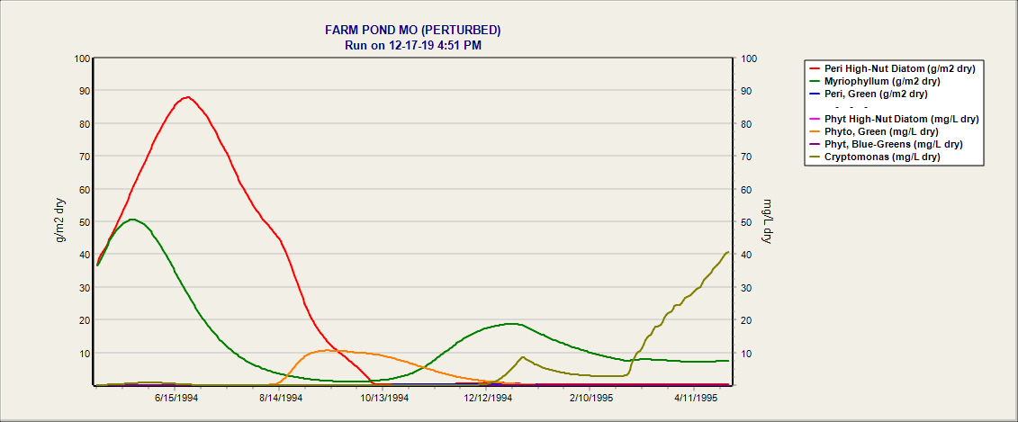

**Plant results identical – grazing is working properly (Also verified, nutrients, oxygen, organic matter.)**

**12/26/2019**

**Completed highly complex food web verification (blue earth river, short duration, including ammonia toxicity impacts)** System has **13 plants** and **20 animals**

AQUATOX 3.2 file**: Blue Earth R.MN_noTSS.aps**

HMS Input file: **Blue Earth R.MN_noTSS.JSON**

Verified all state variables to a tiny fraction of a percent error in **P_Blue Earth R.MN_noTSS_Table.xlsx**

**Long run verification and ammonia toxicity**

**Phytoplankton:**



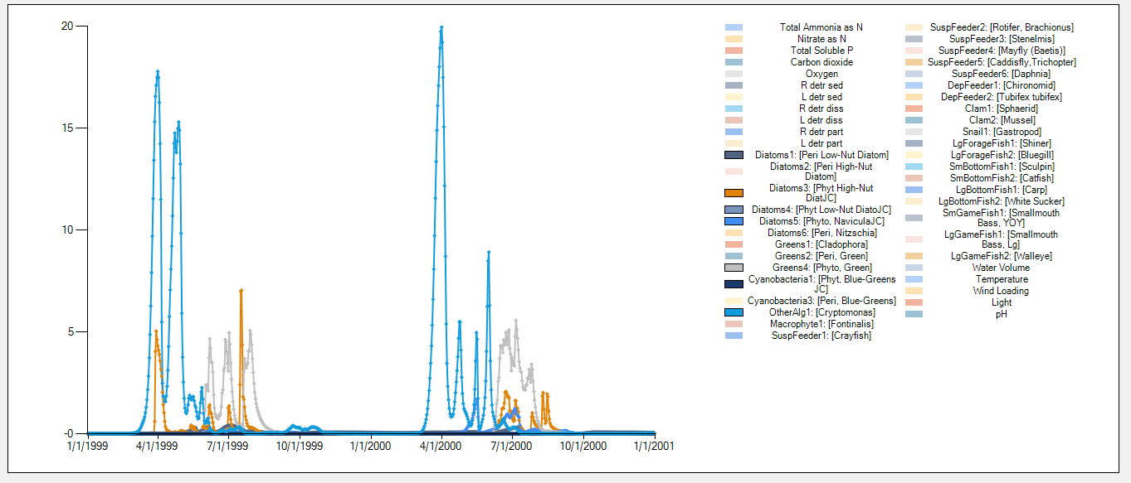

**Periphyton**



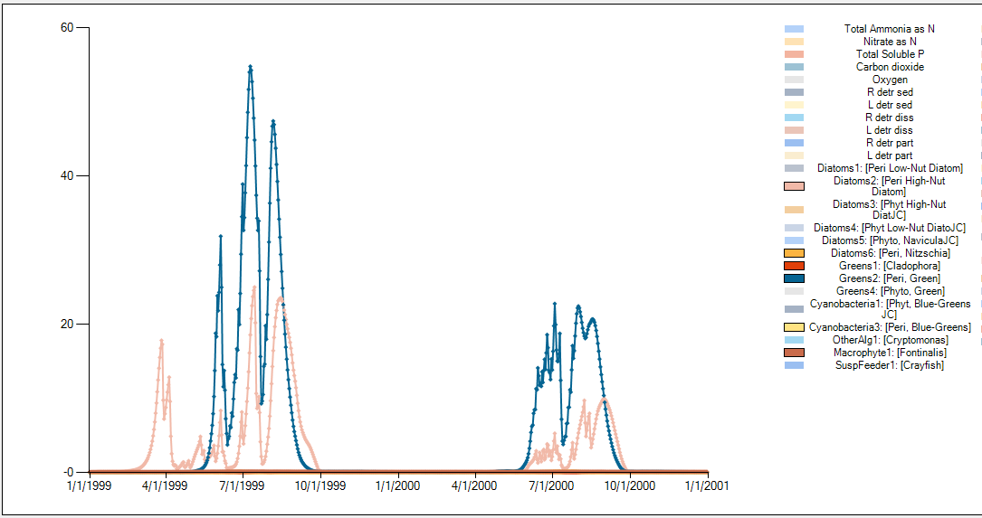

**Fish:**



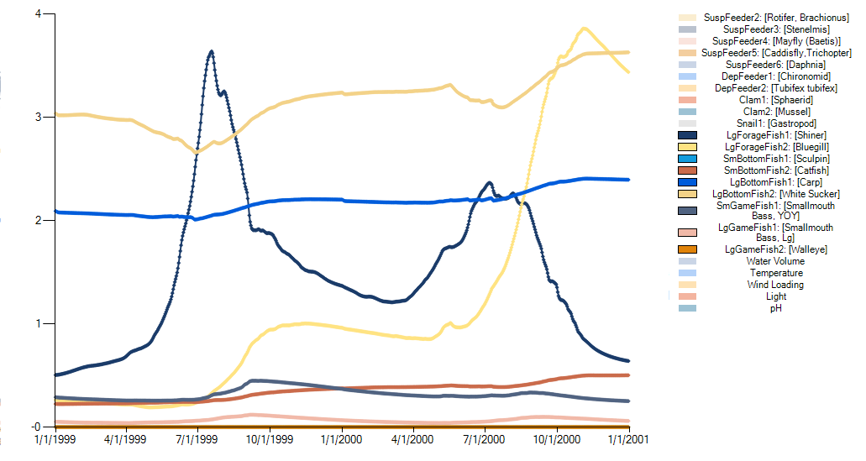

Pct error is extremely low when step size reduced as shown in Blue Earth R.MN_Long_Run.001.xlsx

**Tests to run:**

* Multi-animal test (done)
* Inorganic sediments effects test

Initial test TSS on light climate:

Cahaba R AL X2 TSS.JSON

Needed to fix initialization of optimal depth for algae adaptive light calculation

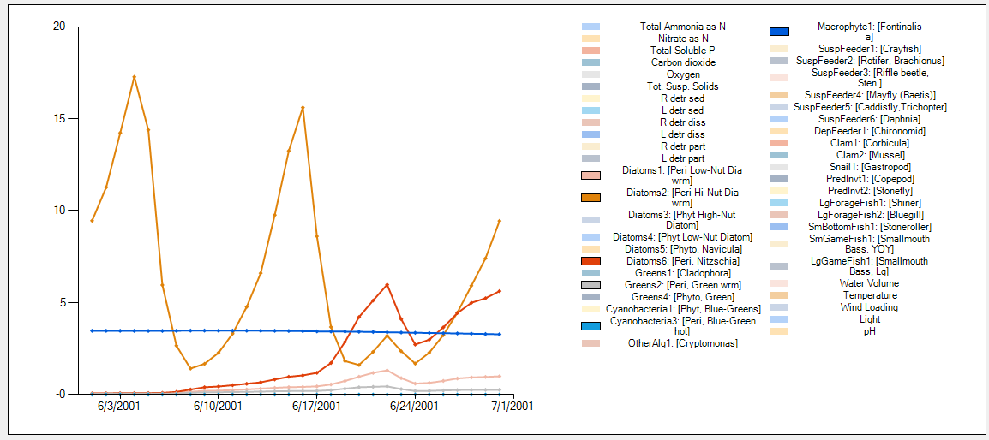



Direct effects of inorganic sediments

Feeding effects verified with daphnia and mussel. Verified results and looked at debug feeding impact calculations.

Toxicity effects verified with stoneroller



No inorganic sediment mortality calculated



Organism set to “highly sensitive”

Highly sensitive results precisely verified in HMS

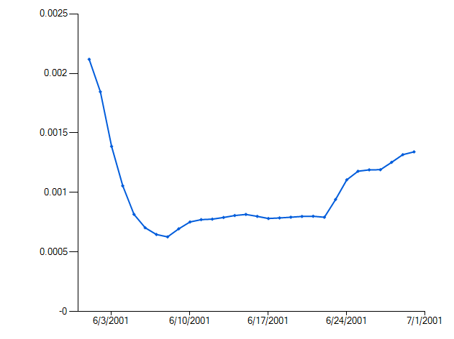

* Age-class fish test
* Marine animals test including size-class oysters
* Low-oxygen effects