**HMS AQUATOX Bioaccumulation Model Data Requirements**

To model bioaccumulation in HMS, the HMS AQUATOX chemical-fate model may be implemented so that chemical concentrations in the water column are available. Alternatively, chemical concentrations in the water column and/or sediment may be externally input to the model based on data, assumption, or alternative model calculation.

To model accumulation in organic matter, plants, and animals, those models may be implemented and the data requirements for those components met. Again, plant, animal, and organic-matter concentrations in the model may be externally input as an alternative.

Example JSON data files that include chemical models with and without external linkages may be found in the associated DOCS and TEST directories.

The following pages are excerpts from the relevant sections of the AQUATOX Release 3.2 Technical Documentation. The HMS bioaccumulation model was not changed from the AQUATOX Release 3.2 implementation and results were verified against AQUATOX Release 3.2 results.

**8. TOXIC ORGANIC CHEMICALS** **(FOCUS ON HMS BIOACCUMULATION)**

The chemical fate module of AQUATOX predicts the partitioning of a compound between water, sediment, and biota (Figure 133), and estimates the rate of degradation of the compound (Figure 134). Microbial degradation, biotransformation, photolysis, hydrolysis, and volatilization are modeled in AQUATOX. Each of these processes is described generally, and again in more detail below.

**Toxic Organic Chemicals: Simplifying Assumptions**

* Kinetic model of toxicant fate
* Photolysis in sediments is not included
* A generalized equation is used to calculate partitioning of polar compounds
* Direct sorption onto the body of an animal is ignored
* The exchange of toxicant through the gill membrane is assumed to be facilitated by the same mechanism as the uptake of oxygen
* Estimation of the elimination rate constant k2 may be made based on logKow with two alternative formulations available
* Biotransformation occurs at a constant rate throughout a simulation

Nonequilibrium concentrations, as represented by kinetic equations, depend on sorption, desorption, and elimination as functions of the chemical, and exposure through water and food as a function of bioenergetics of the organism. Equilibrium partitioning is no longer represented in AQUATOX except as a constraint on sorption to detritus and plants and as a basis for computing internal toxicity (not yet included in HMS). Partitioning to inorganic sediments is not modeled unless the multi-layer sediment model is included (not yet included in HMS).

Microbial degradation is modeled by entering a maximum biodegradation rate for a particular organic toxicant, which is subsequently reduced to account for suboptimal temperature, pH, and dissolved oxygen. Biotransformation is represented by user-supplied first-order rate constants with the option of also modeling multiple daughter products (not yet included in HMS).. Photolysis is modeled by using a light screening factor (Schwarzenbach et al., 1993) and the near-surface, direct photolysis first-order rate constant for each pollutant. The light screening factor is a function of both the diffuse attenuation coefficient near the surface and the average diffuse attenuation coefficient for the whole water column. For those organic chemicals that undergo hydrolysis, neutral, acid-, and base-catalyzed reaction rates are entered into AQUATOX as applicable. Volatilization is modeled using a stagnant two-film model, with the air and water transfer velocities approximated by empirical equations based on reaeration of oxygen (Schwarzenbach et al., 1993).

For the AQUATOX HMS chemical-fate components (Sections 8.1 to 8.5), please see the documentation in the file named **AQUATOXChemicalModel.** This document focuses on the bioaccumulation portion of chemical fate.

**8.6 Partition Coefficients**

Although AQUATOX is a kinetic model, steady-state partition coefficients for organic pollutants are computed in order to place constraints on competitive uptake and loss processes in detritus and plants, speeding up computations. Bioconcentration factors also are used in computing internal toxicity in plants and animals. They are estimated from empirical regression equations and the pollutant's octanol-water partition coefficient.

**Detritus**

Natural organic matter is the primary sorbent for neutral organic pollutants. Hydrophobic chemicals partition primarily in nonpolar organic matter (Abbott et al. 1995). Refractory detritus is relatively nonpolar; its partition coefficient (in the non-dissolved phase) is a function of the octanol-water partition coefficient (N = 34, r2 = 0.93; Schwarzenbach et al. 1993):

 **(333)**

where:

*KOMRefrDetr* = detritus-water partition coefficient (L/kg); and

*KOW* = octanol-water partition coefficient (unitless).

Detritus in sediments is simulated separately from inorganic sediments, rather than as a fraction of the sediments as in other models. When the multi-layer sediment model is not included, refractory detritus is used as a surrogate for sediments in general; and the sediment partition coefficient *KPSed*, which can be entered manually by the user, is the same as *KOMRefrDetr.*

Equation **(334)** and the equations that follow are extended to polar compounds, following the approach of Smejtek and Wang (1993):

 **(334)**

where:

*Nondissoc* = un-ionized fraction (unitless); and

*IonCorr* = correction factor for decreased sorption, 0.01 for chemicals that are bases and 0.1 for acids. (unitless).

Using pentachorophenol as a test compound, and comparing it to octanol, the influence of pH-mediated dissociation is seen in Figure 141. This relationship is verified by comparison with the results of Smejtek and Wang (1993) using egg membrane. However, in the general model Eq. **(334)** is used for refractory detrital sediments as well.

Figure 141. Refractory detritus-water and octanol-water partition coefficients for pentachlorophenol as a function of pH

.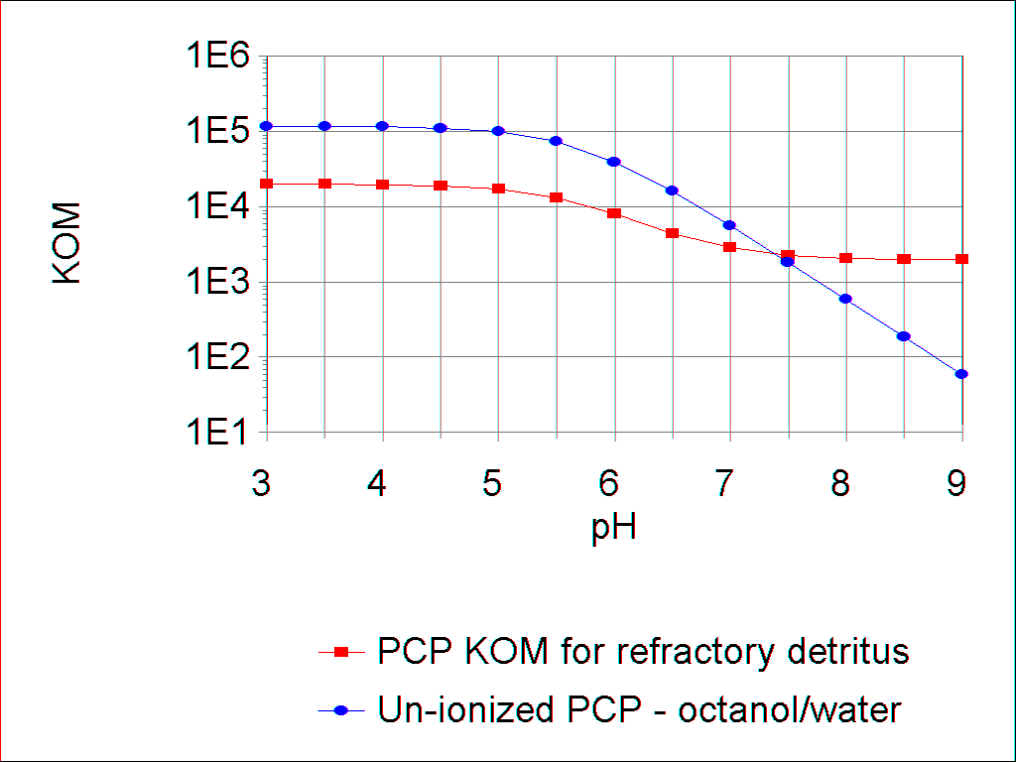

There appears to be a dichotomy in partitioning; data in the literature suggest that labile detritus does not take up hydrophobic compounds as rapidly as refractory detritus. Algal cell membranes contain polar lipids, and it is likely that this polarity is retained in the early stages of decomposition. KOC does not remain the same upon aging, death, and decomposition, probably because of polarity changes. In an experiment using fresh and aged algal detritus, there was a 100% increase in KOC with aging (Koelmans et al., 1995). KOC increased as the C/N ratio increased, indicating that the material was becoming more refractory. In another study, KOC doubled between day 2 and day 34, probably due to deeper penetration into the organic matrix and lower polarity (Cornelissen et al., 1997).

Polar substrates increase the pKa of the compound (Smejtek and Wang, 1993). This is represented in the model by lowering the pH of polar particulate material by one pH unit, which changes the dissociation accordingly.

The partition equation for labile detritus (non-dissolved) is based on a study by Koelmans et al. (1995) using fresh algal detritus (N = 3, r2 = 1.0):

 **(335)**

In the model, the equation is generalized to polar compounds and transformed to an organic matter partition coefficient:

 **(336)**

where:

*KOCLabPart* = partition coefficient for labile particulate organic carbon (L/kg);

*KOMLabDetr* = partition coefficient for labile detritus (L/kg);

*IonCorr* = correction factor for decreased sorption, 0.01 for chemicals that are bases and 0.1 for acids. (unitless); and

0.526 = conversion from KOC to KOM (g OC/g OM).

O’Connor and Connolly (1980; see also Ambrose et al., 1991) found that the sediment partition coefficient is the inverse of the mass of suspended sediment, and Di Toro (1985) developed a construct to represent the relationship. However, AQUATOX models partitioning directly to organic detritus and ignores inorganic sediments, which are seldom involved directly in sorption of neutral organic pollutants. Therefore, the partition coefficient is not corrected for mass of sediment.

Association of hydrophobic compounds with colloidal and dissolved organic matter (DOM) reduces bioavailability; such contaminants are unavailable for uptake by organisms (Stange and Swackhamer 1994, Gilek et al. 1996). Therefore, it is imperative that complexation of organic chemicals with DOM be modeled correctly. In particular, contradictory research results can be reconciled by considering that DOM is not homogeneous. For instance, refractory humic acids, derived from decomposition of terrestrial and wetland organic material, are quite different from labile exudates from algae and other indigenous organisms.

Humic acids exhibit high polarity and do not readily complex neutral compounds. Natural humic acids from a Finnish lake with extensive marshes were spiked with a PCB, but a PCB-humic acid complex could not be demonstrated (Maaret et al. 1992). In another study, Freidig et al. (1998) used artificially prepared Aldrich humic acid to determine a humic acid-DOC partition coefficient (n = 5, r2, = 0.80), although they cautioned about extrapolation to the field. Landrum et al. (1984) found that KOC values for natural dissolved organic matter were approximately one order of magnitude less than for Aldrich humic acids (Gobas and Zhang 1994); incorporating that factor into the equation of Freidig et al. (1998) yields:

 **(337)**

where:

*KOCRefrDOM* = refractory dissolved organic carbon partition coefficient (L/kg).

Until a better relationship is found, we are using a generalization of this equation to include polar compounds, transformed from organic carbon to organic matter, in AQUATOX:

 **(338)**

where:

*KOMRefrDOM* = refractory dissolved organic matter partition coefficient (L/kg).

**Algae**

Nonpolar lipids in algae occur in the cell contents, and it is likely that they constitute part of the labile dissolved exudate, which may be both excreted and lysed material. Therefore, the stronger relationship reported by Koelmans and Heugens (1998) for partitioning to algal exudate (n = 6, r2 = 0.926) is:

 **(339)**

which we also generalized for polar compounds and transformed:

 **(340)**

where:

*KOCLabDOC* = partition coefficient for labile dissolved organic carbon (L/kg); and

*KOMLabDOM* = partition coefficient for labile dissolved organic matter (L/kg).

Unfortunately, older data and modeling efforts failed to distinguish between hydrophobic compounds that were truly dissolved and those that were complexed with DOM. For example, the PCB water concentrations for Lake Ontario, reported by Oliver and Niimi (1988) and used by many subsequent researchers, included both dissolved and DOC-complexed PCBs (a fact which they recognized). In their steady-state model of PCBs in the Great Lakes, Thomann and Mueller (1983) defined “dissolved” as that which is not particulate (passing a 0.45 micron filter). In their Hudson River PCB model, Thomann et al. (1991) again used an operational definition of dissolved PCBs. AQUATOX distinguishes between truly dissolved and complexed compounds; therefore, the partition coefficients calculated by AQUATOX may be larger than those used in older studies.

Bioaccumulation of PCBs in algae depends on solubility, hydrophobicity and molecular configuration of the compound, and growth rate, surface area and type, and content and type of lipid in the alga (Stange and Swackhamer 1994). Phytoplankton may double or triple in one day and periphyton turnover may be so rapid that some PCBs will not reach equilibrium (cf. Hill and Napolitano 1997).

Hydrophobic compounds partition to lipids in algae, but the relationship is not a simple one. Phytoplankton lipids can range from 3 to 30% by weight (Swackhamer and Skoglund 1991), and not all lipids are the same. Polar phospholipids occur on the surface. Hydrophobic compounds preferentially partition to internal neutral lipids, but those are usually a minor fraction of the total lipids, and they vary depending on growth conditions and species (Stange and Swackhamer 1994). Algal lipids have a much stronger affinity for hydrophobic compounds than does octanol, so that the algal BCFlipid > KOW (Stange and Swackhamer 1994, Koelmans et al. 1995, Sijm et al. 1998).

For algae, the approximation to estimate the dry-weight bioaccumulation factor (r2 = 0.87), computed from Swackhamer and Skoglund’s (1993) study of numerous PCB congeners, is:

 **(341)**

where:

*BCFAlga* = partition coefficient between algae and water (L/kg).

Rearranging and extending to hydrophilic and ionized compounds:

 **(342)**

Comparing the results of using these coefficients, we see that they are consistent with the relative importance of the various substrates in binding organic chemicals (Figure 140). Binding capacity of detritus is greater than dissolved organic matter in Great Lakes waters (Stange and Swackhamer 1994, Gilek et al. 1996). In a study using Baltic Sea water, less than 7% PCBs were associated with dissolved organic matter and most were associated with algae (Björk and Gilek 1999). In contrast, in a study using algal exudate and a PCB, 98% of the dissolved concentration was as a dissolved organic matter complex and only 2% was bioavailable (Koelmans and Heugens 1998).

The influence of substrate polarity is evident in Figure 139, which shows the effect of ionization on binding of pentachlorophenol to various types of organic matter. The polar substrates, such as algal detritus, have an inflection point which is one pH unit higher than that of nonpolar substrates, such as refractory detritus. The relative importance of the substrates for binding is also demonstrated quite clearly.

**Macrophytes**

For macrophytes, an empirical relationship reported by Gobas et al. (1991) for 9 chemicals with *LogKOW*s of 4 to 8.3 (r2 = 0.97) is used:

 **(343)**

Again, rearranging and extending to hydrophilic and ionized compounds:

 **(344)**

**Invertebrates**

For the invertebrate bioconcentration factor, the following empirical equation is used for nondetritivores, based on 7 chemicals with *LogKOW*s ranging from 3.3 to 6.2 and bioconcentration factors for *Daphnia pulex* (r2 = 0.85; Southworth et al., 1978; see also Lyman et al., 1982), converted to dry weight:

 **(345)**

where:

*BCFInvertebrate* = partition coefficient between invertebrates and water (L/kg); and

*WetToDry* = wet to dry conversion factor (unitless, default = 5).

Extending and generalizing to ionized compounds:

 **(346)**

For invertebrates that are detritivores the following equation is used, based on Gobas 1993:

 **(347)**

where:

*BCFInvertebrate* = partition coefficient between invertebrates and water (L/kg);

*FracLipid* = fraction of lipid within the organism;

*FracOCDetritus* = fraction of organic carbon in detritus (= 0.526);

*KOMRefrDetr* = partition coefficient for refractory sediment detritus (L/kg), see **(334)**.

Figure 139. Partitioning to Various Types of Organic Matter as Function of Kow

Figure 140. Partitioning to Various Types of Organic Matter as a Function of pH

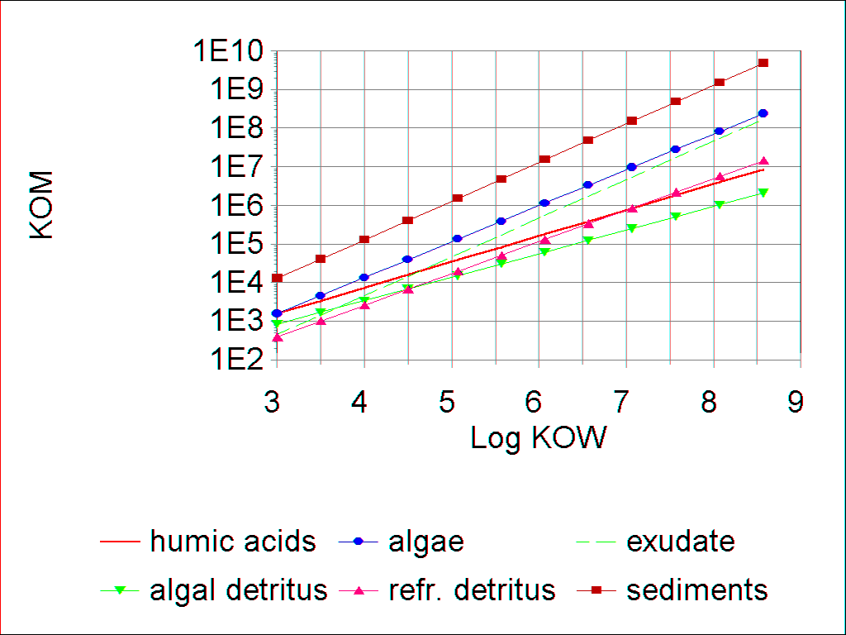 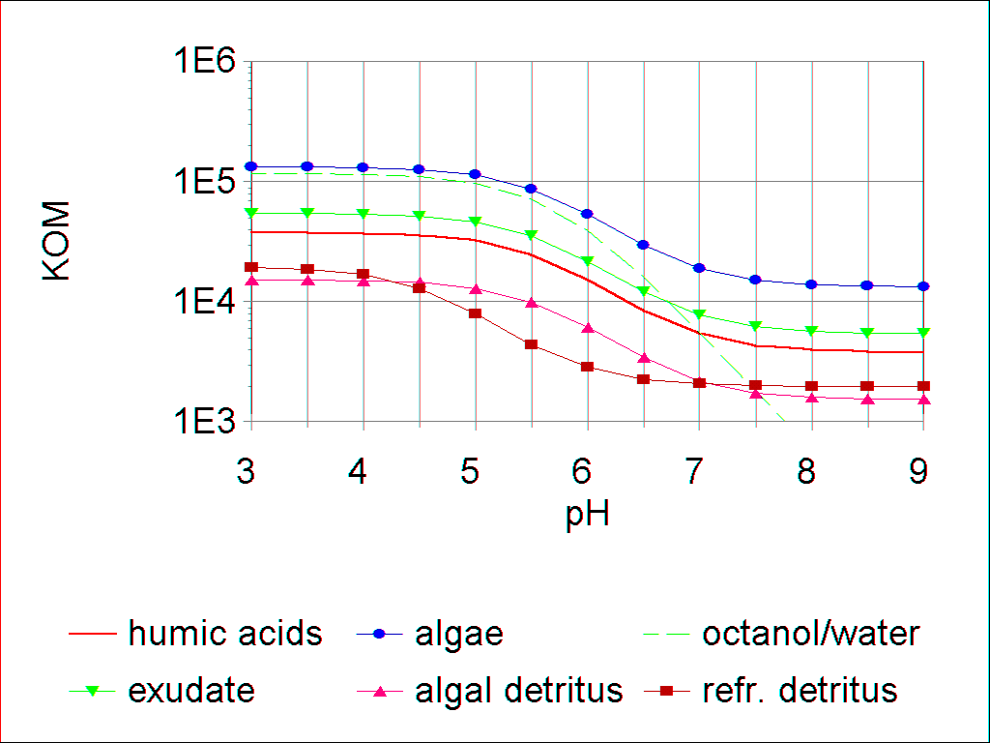

**Fish**

Fish take longer to reach equilibrium with the surrounding water; therefore, a nonequilibrium bioconcentration factor is used. For each pollutant, a whole-fish bioconcentration factor is based on the lipid content of the fish extended to hydrophilic chemicals (McCarty et al., 1992), with provision for ionization:

 **(348)**

where:

*KBFish* = partition coefficient between whole fish and water (L/kg);

*Lipid* = fraction of fish that is lipid (g lipid/g fish); and

*WetToDry* = wet to dry conversion factor (unitless, default = 5).

The bioconcentration factor is adjusted for the time to reach equilibrium as a function of the clearance or elimination rate and the time of exposure (Hawker and Connell, 1985; Connell and Hawker, 1988; Figure 144):

 **(349)**

where:

*BCFFish* = quasi-equilibrium bioconcentration factor for fish (L/kg);

*TElapsed* = time elapsed since fish was first exposed (d); and

*Depuration* = clearance, which may include biotransformation, see **(372)** (1/d).

Figure 144. Bioconcentration factor for fish as a function   
of time and log KOW

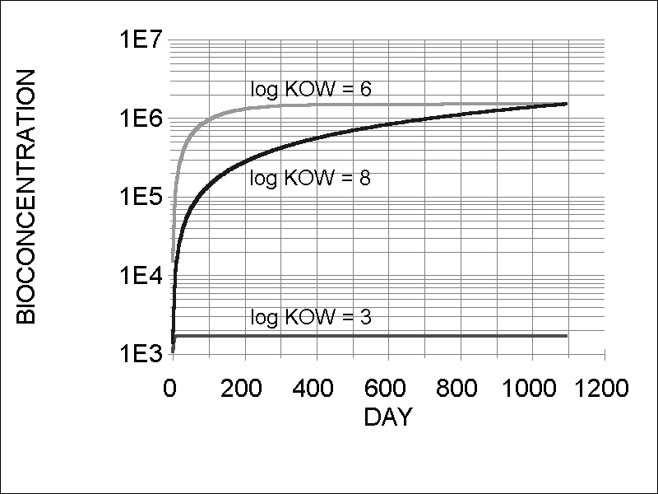

**8.7 Nonequilibrium Kinetics**

Often there is an absence of equilibrium due to growth or insufficient exposure time, metabolic biotransformation, dietary exposure, and nonlinear relationships for very large and/or superhydrophobic compounds (Bertelsen et al. 1998). Although it is important to have a knowledge of equilibrium partitioning because it is an indication of the condition toward which systems tend (Bertelsen et al. 1998), it is often impossible to determine steady-state potential due to changes in bioavailability and physiology (Landrum 1998). For example, PCBs may not be at steady state even in large systems such as Lake Ontario that have been polluted over a long period of time. In fact, PCBs in Lake Ontario exhibit a 25-fold disequilibrium (Cook and Burkhard 1998). The challenge is to obtain sufficient data for a kinetic model (Gobas et al. 1995).

**Sorption and Desorption to Detritus**

Partitioning to detritus appears to involve rapid sorption to particle surfaces, followed by slow movement into, and out of, organic matter and porous aggregates (Karickhoff and Morris, 1985). Therefore attainment of equilibrium may be slow. Because of the need to represent sorption and desorption separately in detritus, kinetic formulations are used (Thomann and Mueller, 1987), with provision for ionization:

 **(350)**

 **(351)**

where:

*Sorption* = rate of sorption to given detritus compartment (μg/L⋅d);

*k1Detr* = sorption rate constant (user-editable, default value of 1.39 L/kg⋅d), see **(355)**;

*Nondissoc* = fraction not ionized (unitless), see **(311)**;

*ToxicantWater* = concentration of toxicant in water (μg/L);

*Org2C* = conversion factor for organic matter to carbon (= 0.526 g C/g organic matter);

*Detr* = mass of each of the detritus compartments per unit volume (mg/L);

1e -6 = units conversion (kg/mg);

*Desorption* = rate of desorption from given sediment detritus compartment (μg/L⋅d);

*k2Detr* = desorption rate constant (1/d), see **(354)**;

*UptakeLimit* = factor to limit uptake as equilibrium is reached (unitless) see **(352)**; and

*ToxicantDetr* = mass of toxicant in each of the detritus compartments (μg/L).

In order to limit sorption to detritus and algae as equilibrium is reached, *UptakeLimit* is computed as:

 **(352)**

where:

*UptakeLimitCarrier* = factor to limit uptake as equilibrium is reached (unitless);

*kpCarrier* = partition coefficient (KOM) or bioconcentration factor (BCF) for each carrier (L/kg), see **(333)** to **(342)**;

*PPBCarrier* = concentration of toxicant in each carrier (μg/kg), see **(310)**.

Desorption of the detrital compartments is the reciprocal of the reaction time, which Karickhoff and Morris (1985) found to be a linear function of the partition coefficient over three orders of magnitude (*r2* = 0.87):

 **(353)**

So *k2* is taken to be:

 **(354)**

where:

*KOM* = detritus-water partition coefficient (L/kg OM, see section 8.6); and

24 = conversion from hours to days.

Because the kinetic definition of the detrital partition coefficient *KOM* is:

 **(355)**

the sorption rate constant *k1* is set by the user (*K1 Detritus*). The default value is 1.39 L/kg⋅d.

**Bioconcentration in Macrophytes and Algae**

**Macrophytes****:** As Gobas et al. (1991) have shown, submerged aquatic macrophytes take up and release organic chemicals over a measurable period of time at rates related to the octanol-water partition coefficient. Uptake and elimination are modeled assuming that the chemical is transported through both aqueous and lipid phases in the plant, with rate constants using empirical equations fit to observed data (Gobas et al., 1991), modified to account for ionization effects (Figure 145, Figure 146):

 **(356)**

 **(357)**

 **(358)**

If the user selects to estimate the elimination rate constant based on KOW (see section 8.8), the following equation is used:

 **(359)**

where:

*MacroUptake* = uptake of toxicant by plant (μg/L⋅d);

*DepurationPlant* = clearance of toxicant from plant (μg/L⋅d);

*StVarPlant* = biomass of given plant (mg/L);

1 e -6 = units conversion (kg/mg);

*ToxicantPlant* = mass of toxicant in plant (μg/L);

*k1* = sorption rate constant (L/kg⋅d);

*k2* = elimination rate constant (1/d).

*KOW* = octanol-water partition coefficient (unitless); and

*Nondissoc* = fraction of un-ionized toxicant (unitless).

Figure 145. Uptake rate constant for macrophytes

(after Gobas et al., 1991)

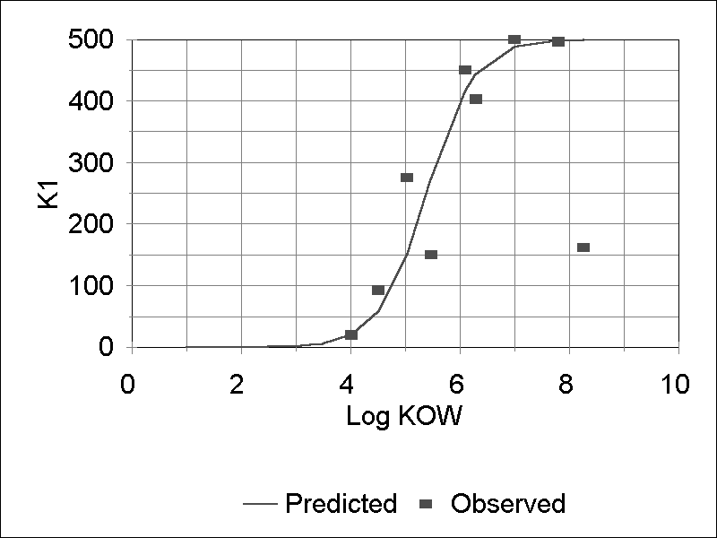

Figure 146. Elimination rate constant for macrophytes

(after Gobas et al., 1991)

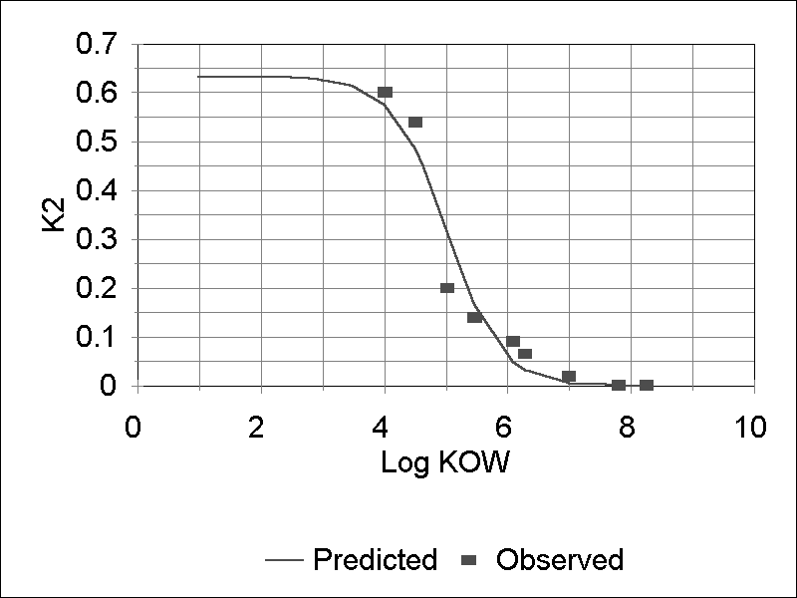

**Algae****:** Aside from obvious structural differences, algae may have very high lipid content (20% for *Chlorella* sp. according to Jørgensen et al., 1979) and macrophytes have a very low lipid content (0.2% in *Myriophyllum spicatum* as observed by Gobas et al. (1991), which affect both uptake and elimination of toxicants. However, the approach used by Gobas et al. (1991) in modeling bioaccumulation in macrophytes provides a useful guide to modeling kinetic uptake in algae.

There is probably a two-step algal bioaccumulation mechanism for hydrophobic compounds, with rapid surface sorption of 40-90% within 24 hours and then a small, steady increase with transfer to interior lipids for the duration of the exposure (Swackhamer and Skoglund 1991). Uptake increases with increase in the surface area of algae (Wang et al. 1997). Therefore, the smaller the organism the larger the uptake rate constant (Sijm et al. 1998). However, in small phytoplankton, such as the nannoplankton that dominate the Great lakes, a high surface to volume ratio can increase sorption, but high growth rates can limit internal contaminant concentrations (Swackhamer and Skoglund 1991). The combination of lipid content, surface area, and growth rate results in species differences in bioaccumulation factors among algae (Wood et al. 1997). Uptake of toxicants is a function of the uptake rate constant and the concentration of toxicant truly dissolved in the water, and is constrained by competitive uptake by other compartments; also, because it is fast, it is limited as it approaches equilibrium, similar to sorption to detritus :

 **(360)**

where:

*AlgalUptake* = rate of sorption by algae (μg/L-d);

*k1* = uptake rate constant (L/kg-d), see **(361)**;

*UptakeLimitAlga* = factor to limit uptake as equilibrium is reached (unitless), see **(352)**;

*ToxState* = concentration of dissolved toxicant (μg/L);

*Carrier* = biomass of algal compartment (mg/L); and

1e-6 = conversion factor (kg/mg).

The kinetics of partitioning of toxicants to algae is based on studies on PCB congeners in The Netherlands by Koelmans, Sijm, and colleagues and at the University of Minnesota by Skoglund and Swackhamer. Both groups found uptake to be very rapid. Sijm et al. (1998) presented data on several congeners that were used in this study to develop the following relationship for phytoplankton (Figure 147):

 **(361)**

Because size-dependent passive transport is indicated (Sijm et al., 1998), uptake by periphyton is set arbitrarily at ten percent of that for phytoplankton.

Depuration is modeled as a linear function; it does not include loss due to excretion of photosynthate with associated toxicant, which is modeled separately:

 **(362)**

where:

*Depuration* = elimination of toxicant (μg/L-d);

*State* = concentration of toxicant associated with alga (μg/L); and

*k2* = elimination rate constant (1/d).

As a simplifying assumption, the depuration rate for periphyton is assumed to be two orders of magnitude less:

 **(363)**

The elimination rate in plants may be input in the toxicity record by the user or it may be estimated using the following equation based in part on Skoglund et al. (1996). Unlike Skoglund, this equation ignores surface sorption and recognizes that growth dilution is explicit in AQUATOX (see Figure 148):

 **(364)**

where:

*k2Akgae* = desorption rate constant (1/d);

*LFrac* = fraction lipid (wet weight), entered in the “chemical toxicity” screen; and

*WetToDry* = translation from wet to dry weight (user input).

Figure 147. Algal sorption rate constant as a function

of octanol-water partition coefficient

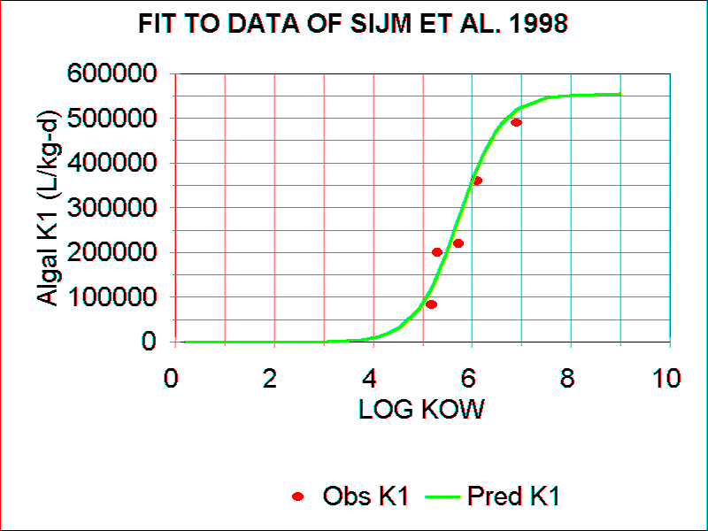

Figure 148. Rate of elimination by algae as a function of

octanol-water partition coefficient

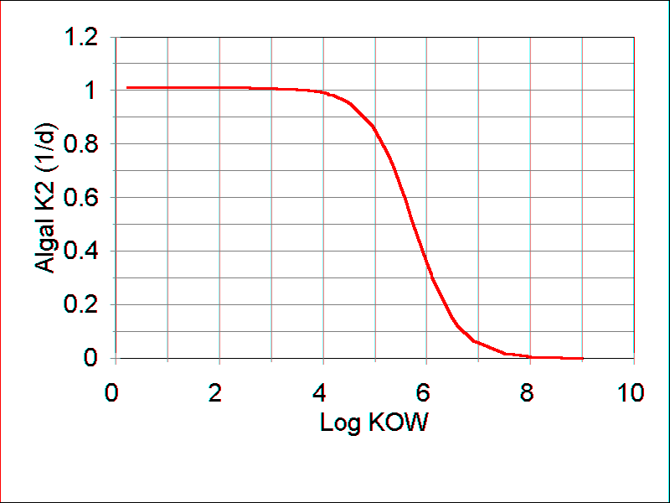

**Bioaccumulation in Animals**

Animals can absorb toxic organic chemicals directly from the water through their gills and from contaminated food through their guts. Direct sorption onto the body is ignored as a simplifying assumption in this version of the model. Reduction of body burdens of organic chemicals is accomplished through excretion and biotransformation, which are often considered together as empirically determined elimination rates. “Growth dilution” occurs when growth of the organism is faster than accumulation of the toxicant. Gobas (1993) includes fecal egestion, but in AQUATOX egestion is merely the amount ingested but not assimilated; it is accounted for indirectly in *DietUptake*. However, fecal loss is important as an input to the detrital toxicant pool, and it is considered later in that context. Inclusion of mortality and promotion terms is necessary for mass balance, but emphasizes the fact that average concentrations are being modeled for any particular compartment.

**Gill Sorption**:An important route of exposure is by active transport through the gills (Macek et al., 1977). This is the route that has been measured so often in bioconcentration experiments with fish. As the organism respires, water is passed over the outer surface of the gill and blood is moved past the inner surface. The exchange of toxicant through the gill membrane is assumed to be facilitated by the same mechanism as the uptake of oxygen, following the approach of Fagerström and Åsell (1973, 1975), Weininger (1978), and Thomann and Mueller (1987; see also Thomann, 1989). Therefore, the uptake rate for each animal can be calculated as a function of respiration (Leung, 1978; Park et al., 1980):

 **(365)**

 **(366)**

where:

*GillUptake* = uptake of toxicant by gills (μg/L - d);

*KUptake* = uptake rate (1/d);

*ToxicantWater* = concentration of toxicant in water (μg/L);

*FracWaterColumn* = fraction of organism in water column (unitless), differentiates from pore-water uptake if the multi-layer sediment model is included;

*WEffTox* = withdrawal efficiency for toxicant by gills (unitless), see **(367)**;

*Respiration* = respiration rate (mg biomass/L⋅d), see **(100)**;

*O2Biomass* = ratio of oxygen to organic matter (mg oxygen/mg biomass; 0.575);

*Oxygen* = concentration of dissolved oxygen (mg oxygen/L), see **(186)**; and

*WEffO2* = withdrawal efficiency for oxygen (unitless, generally 0.62);

The oxygen uptake efficiency *WEffO2* is assigned a constant value of 0.62 based on observations of McKim et al. (1985). The toxicant uptake efficiency, *WEffTox*, can be expected to have a sigmoidal relationship to the log octanol-water partition coefficient based on aqueous and lipid transport (Spacie and Hamelink, 1982). This is represented by an inelegant but reasonable, piece-wise fit (Figure 149) to the data of McKim et al. (1985) using 750-g fish, corrected for ionization:

 **(367)**

where:

*LogKOW* = log octanol-water partition coefficient (unitless); and

*Nondissoc* = fraction of toxicant that is un-ionized (unitless), see **(311)**.

Figure 149. Piece-wise fit to observed toxicant uptake data;

Modified from McKim et al., 1985

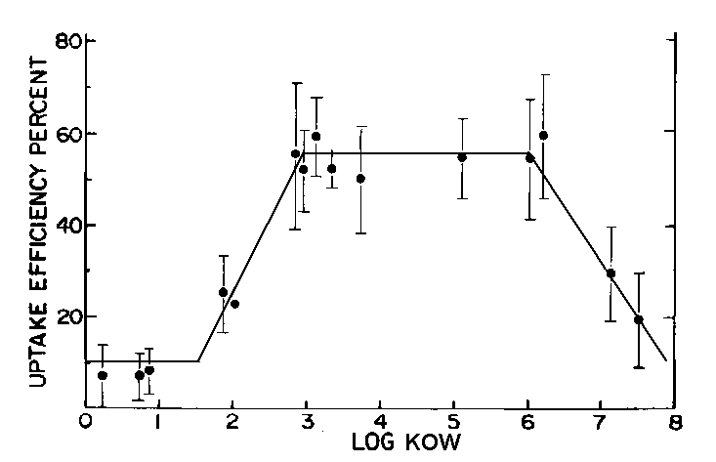

Ionization decreases the uptake efficiency (Figure 147). This same algorithm is used for invertebrates. Thomann (1989) has proposed a similar construct for these same data and a slightly different construct for small organisms, but the scatter in the data does not seem to justify using two different constructs.

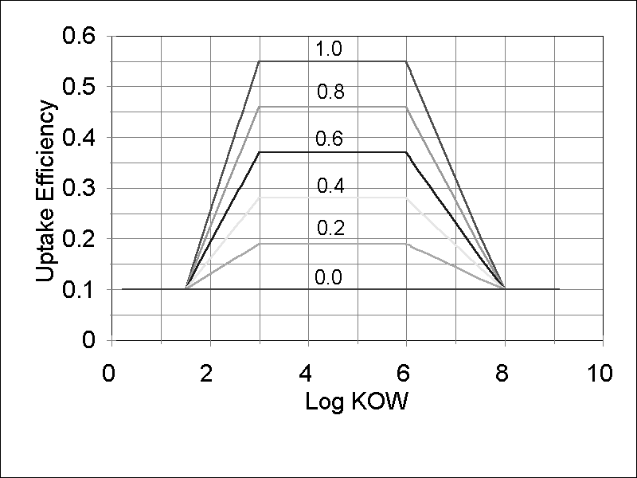

Figure 147. The Effect of Differing Fractions of Un-ionized Chemical on Uptake Efficiency

The user input *FracWaterColumn* parameter is only relevant if the multi-layer sediment model is included. If so, this parameter determines how much gill uptake comes from the water column and how much from the pore waters of the active layer. Gill uptake from pore waters is calculated as follows and added to gill uptake from the water column:

 **(368)**

where:

*GillUptake* = uptake of toxicant by gills (μg/LWaterCol - d);

*ToxicantPoreWater* = concentration of toxicant in pore waters (μg/LPoreWater);

*VolumePoreWater*= volume of pore water (LPoreWater); and

*VolumeWaterCol*= volume of water column (LWaterCol).

**Dietary Uptake:** Hydrophobic chemicals usually bioaccumulate primarily through absorption from contaminated food. Persistent, highly hydrophobic chemicals demonstrate biomagnification or increasing concentrations as they are passed up the food chain from one trophic level to another; therefore, dietary exposure can be quite important (Gobas et al., 1993). Uptake from contaminated prey can be computed as (Thomann and Mueller, 1987; Gobas, 1993):

 **(369)**

where:

 **(370)**

and:

*DietUptakePrey* = uptake of toxicant from given prey (μg toxicant/L⋅d);

*KDPrey* = dietary uptake rate for given prey (mg prey/L⋅d);

*PPBPrey* = conc. of toxicant in given prey (μg toxicant/kg prey), see **(310)**;

1 e-6 = units conversion (kg/mg);

*GutEffTox* = efficiency of sorption of toxicant from gut (unitless);

*GutEffRed* = reduction in *GutEffTox* due to non-lethal effects, see **(371)** ; and

*IngestionPrey =* ingestion of given prey (mg prey/L⋅d), see **(91)**.

Gobas (1993) presents an empirical equation for estimating *GutEffTox* as a function of the octanol-water partition coefficient. However, data published by Gobas et al. (1993) suggest that there is no trend in efficiency between *LogKOW* 4.5 and 7.5 (Figure 151); this is to be expected because the digestive system has evolved to assimilate a wide variety of organic molecules. Therefore, the mean value of 0.62 is used in AQUATOX as a constant for small fish. Nichols et al. (1998) demonstrated that uptake is more efficient in larger fish; therefore, a value of 0.92 is used for large game fish because of their size. Invertebrates generally exhibit lower efficiencies; Landrum and Robbins (1990) showed that values ranged from 0.42 to 0.24 for chemicals with log KOWs from 4.4 to 6.7; the mean value of 0.35 is used for invertebrates in AQUATOX. These values cannot be edited at this time. (Note, the PFA model uses a relationship to chain length, see **(403)** and **(404)**.)

Figure 151. GutEffTox constant based on mean value for data

from Gobas et al., 1993

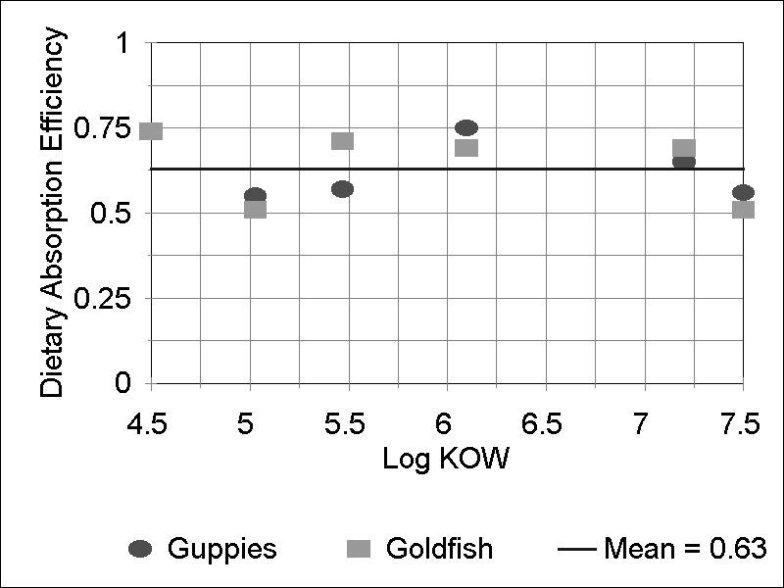

One potential non-lethal effect of toxicant exposure is an increase in the rate of egestion, see **(425)**. If *GutEffTox* is kept constant at the same time that the egestion rate is increased, toxicant concentrations will increase too much within organisms (biomass falls but toxicant uptake remains constant). To avoid this problem, and to reflect that the rate of toxicant uptake is more a function of assimilated rather than total ingested food, the *GutEffTox* must be reduced by the same quantity that assimilated food is decreased.

 **(371)**

where:

*GutEffRed* = reduction in *GutEffTox* due to toxicant induced increased egestion (unitless);

*RedGrow* = factor for reduced assimilation of food in animals (unitless); see **(422)**.

Despite this adjustment, if overall species growth rates become negative due to the reduced assimilation of food in animals, toxicant concentrations in animals will still increase (a process that is best conceived as the opposite of growth dilution.)

**Elimination****:** Elimination or clearance includes both excretion (depuration) and biotransformation of a toxicant by organisms. Biotransformation may cause underestimation of elimination (McCarty et al., 1992). An overall elimination rate constant is estimated and reported in the toxicity record. The user may then modify the value based on observed data; that value is used in subsequent simulations. If, known, biotransformation also can be explicitly modeled.

For any given time the clearance rate is:

 **(372)**

where:

*DepurationAnimal* = clearance rate (μg/L⋅d);

*k2* = elimination rate constant (1/d);

*ToxicantAnimal* = mass of toxicant in given animal (μg/L); and

*TCorr* = correction for suboptimal temperature (unitless), see **(59)**.

If the multi-layer sediment model is included, the amount of depuration that goes to the water column vs. the active layer of pore waters is determined by the user input “Frac. in Water Column” parameter.

Estimation of the elimination rate constant *k2* is based on a slope related to log *KOW* and an intercept that is a direct function of respiration, assuming an allometric relationship between respiration and the weight of the animal (Thomann, 1989), and an inverse function of the lipid content in a construct unique to AQUATOX:

If *WetWt* < 5 g then

 **(373)**

else

 **(374)**

where

*KOW* = octanol-water partition coefficient (unitless);

*NonDissoc* = fraction of toxicant that is un-ionized (unitless), see **(311);**

*LipidFrac* = fraction of lipid in organism (g lipid/g organism wet);

*WetWt* = mean wet weight of organism (g);

*RB* = allometric exponent for respiration (unitless).

Figure 152. Depuration rate constants for invertebrates and fish   
based on AQUATOX “classic” formulation (equations 373 and 374)



In AQUATOX Release 3.1, an alternative *k2* estimation procedure is available based on Barber (2003):

 **(374b)**

where

*C* = constant of 445 for fish and 890 for invertebrates;

*WetWt* = mean wet weight of organism (g);

*LipidFrac* = fraction of lipid in organism (g lipid/g organism wet);

*KOW* = octanol-water partition coefficient (unitless);

Barber’s (2003) formulation is based on uptake rates divided by *LipidFrac×KOW (*as a surrogate for BCF). The uptake rate equation utilized is based on an allometric analysis of 517 data points, though there is a high degree of uncertainty in this relationship. Figure153 shows that the AQUATOX and Barber formulations have different relationships between predicted elimination rates and Kow. Our testing suggests that some studies benefit from one uptake formulation and some benefit from the other; however, at this point there is no general guidance as to which formulation to use in a given application.

**Figure 153.** *k2* predictions by Log KOW for a 100g fish with 5% lipid



**Biotransformation:** Biotransformation can cause the conversion of a toxicant to another toxicant or to a harmless daughter product through a variety of pathways. Internal biotransformation to given daughter products by plants and animals is modeled by means of empirical rate constants provided by the user in the “Chemical Biotransformation” screen:

 **(375)**

where

*Biotransformation* = rate of conversion of chemical by given organism (μg/L d),

*BioRateConst* = biotransformation rate constant to a given toxicant, provided by user (1/day)

with the model keeping track of both the loss and the gains to various daughter compartments. A simplifying assumption of the model is that biotransformation occurs at a constant rate throughout a simulation.

Biotransformation also can take place as a consequence of microbial decomposition. The percentage of microbial biotransformation from and into each of the organic chemicals in a simulation can be specified, with different values for aerobic and anaerobic decomposition. The amount of biotransformation into a given chemical can then be calculated as follows for aerobic conditions:

 **(376)**

and for anaerobic conditions:

 **(377)**

where:

*BiotransformMicrob In* = Biotransformation to a given organic chemical in a given detrital compartment due to microbial decomposition (μg/L d);

*MicrobialDegradn* = total microbial degradation of a different toxicant in this detrital compartment (μg/L d) see **(326)**;

*FracAerobic* = fraction of the microbial degradation that is aerobic (unitless), see **(378)**; and

*FracOrgTox* = user input fraction of the organic toxicant that is transformed to the current organic toxicant (inputs can differ depending on whether the degradation is aerobic or anaerobic).

To calculate the fraction of microbial decomposition that is aerobic, the following equation is used:

 **(378)**

where:

*Factor* = Michaelis-Menten factor (unitless) see **(161)**;

*DOCorrection* = effect of oxygen on microbial decomposition (unitless) see **(160)**.

**Bioaccumulation Factor****:** Customarily, bioaccumulation is expressed as a bioaccumulation factor (BAF), which is the ratio of the concentration in the organism to that in the water. The BAF can be expressed as a wet-weight, dry-weight, or lipid-normalized basis (Gobas and Morrison 2000). In AQUATOX, the BAFs are output as both wet-weight and wet-weight lipid-normalized values. The concentration in an organism is wet-weight, and the lipid fraction is input by the user as a wet-weight value:

 **(378b)**

where:

*PPBOrganism* = concentration of toxicant in given animal (μg/kg wet);

*FracLipid* = fraction of organism that is lipid (g lipid/g organism wet); and

*ToxicantWater* = concentration of toxicant in water (μg/L);

**Linkages to Detrital Compartments**

Toxicants are transferred from organismal to detrital compartments through defecation and mortality. The amount transferred due to defecation is the unassimilated portion of the toxicant that is ingested:

 **(379)**

 **(380)**

where:

:

*DefecationTox* = rate of transfer of toxicant due to defecation (μg/L⋅d);

*KEgestPred, Prey* = fecal egestion rate for given prey by given predator (mg prey/L⋅d);

*PPBPrey* = concentration of toxicant in given prey (μg/kg), see **(310)**;

1 e-6 = units conversion (kg/mg);

*GutEffTox* = efficiency of sorption of toxicant from gut (unitless); and

*GutEffRed* = reduction in *GutEffTox* due to non-lethal effects, see **(371)** ;

*IngestionPred, Prey* = rate of ingestion of given prey by given predator (mg/L⋅d), see **(91)**.

The amount of toxicant transferred due to mortality may be large; it is a function of the concentrations of toxicant in the dying organisms and the mortality rates:

 **(381)**

where:

*MortTox* = rate of transfer of toxicant due to mortality (μg/L⋅d);

*MortalityOrg* = rate of mortality of given organism (mg/L⋅d), see **(66)**, **(87)** and **(112)**;

*PPBOrg* = concentration of toxicant in given organism (μg/kg), see **(310)**; and

1 e-6 = units conversion (kg/mg).

**8.8 Alternative Uptake Model: Entering BCFs, K1, and K2**

When performing bioaccumulation calculations, the default behavior of the AQUATOX model is to allow the user to enter elimination rate constants (K2) for all plants and animals for a particular organic chemical. K2 values may also be estimated based on the Log KOW of the chemical. Uptake in plants is a function of Log KOW while gill uptake in animals is a function of respiration and chemical uptake efficiency. The AQUATOX default model works well for a wide variety of bioaccumulative organic chemicals, but some chemicals that are subject to very rapid uptake and depuration are not efficiently modeled using these relationships; the rapid rates create stiff equations that require shorter time-steps for solution. In addition, because of the rapid rates, the chemical does approach equilibrium quickly.

For this reason, an alternative uptake model is provided to the user. In the chemical toxicity record, the user may enter two of the three factors defining uptake (BCF, K1, K2+Km) and the third factor is calculated using the below relationship (Gobas and Morrison 2000, p204) *(note, if the option to estimate the K2 depuration rate based on BCF and K1 is selected, the elimination rate is estimated as the K2 parameter and the metabolism rate is considered to be zero.)*:

 **(382)**

where: *BCF*  = bioconcentration factor (L/kg dry);

*K1* = uptake rate constant (L/kg dry day);

*K2* = elimination rate constant (1/d);

*Km* = metabolism or biotransformation, see (375).

Given these parameters, AQUATOX calculates uptake and depuration in plants and animals as kinetic processes.

 **(383)**

 **(384)**

where: *Uptake*  = uptake rate within organism (g/L day);

*K1* = uptake rate constant (L/kg dry day);

*ToxState* = concentration of toxicant in organism in water (g/L)

*Biomass* = concentration organism in water (mg/L)

1e-6 = (kg/mg)

*Depuration* = loss rate within organism (g/L day);

*K2* = elimination rate constant (1/d).

Dietary uptake of chemicals by animals is not affected by this alternative parameterization.

**(Sections 8.9 to 8.13 are not part of the HMS AQUATOX Chemical/Bioaccumulation model at this time and are omitted from this document)**

**8.14 Aggregation of Organic Chemicals**

When modeling entire classes of organic chemicals (e.g. Total PCBs), it is often advantageous to break up the classes into individual compounds or bins (binning individual analytes by octonol/water partition coefficient or Kow for example). In this manner, the bioaccumulation and effects of each portion of the chemical class can be governed by its unique chemical properties. To enable this process, the modeling of up to 20 individual compounds (or Kow bins) has always been a capability since AQUATOX 3.0.

However, this type of modeling can create a mismatch when comparing model results to data. If data are collected by chemical class (e.g. TPCB), individual bins must be summed together before performing comparisons. This was always possible to do within AQUATOX but it required a time-consuming export of data into Excel to perform these calculations and comparisons.

Additionally, chemical toxicity data can sometimes be expressed on a single aggregative class basis rather than an individual analyte basis (e.g. a site-specific LC50 for TPCB). Unless the modeled bins are aggregated within the model, these types of toxicity data cannot be used.

To better support the modeling of complex groupings of organic chemicals, AQUATOX Release 3.2 has the capability to model one chemical compartment as an aggregated combination of the other compartments. To trigger this capacity, an organic toxicant must be added to the “T1” compartment and the checkbox in the **Setup** window under **Toxicant Modeling Options** that reads “T1 is an aggregate of all other toxicants in study” must be checked.

When this occurs, the following equations become relevant for the toxicant in water and biota

 **(408b)**

 **(408c)**

where:

*TiCarrier* = concentration of chemical *i* in carrier, ug/L or PPB;

Derivatives for the chemical in T1 become irrelevant as it is set as a function of the derivatives of all of its individual bins (T2 to T20).

Chemical toxicity data may be entered for this aggregated chemical compartment. When this occurs, though, chemical toxicity parameters must be left as blank for the individual analytes or double counting of toxic effects will occur. The choice of whether to use aggregated chemical toxicity data or analyte-specific toxicity data may be made on an organism-by-organism basis.