**HMS AQUATOX Chemical Model Data Requirements**

To model chemical fate in HMS, the HMS AQUATOX water volume model must be implemented so that the impacts of water flows on chemical concentrations can be calculated. Other data requirements are state or driving variables for **temperature** (hydrolysis rate, volatilization rate), **light** (photolysis rate)**,** **oxygen** (volatilization rate), and **pH** (ionization which affects volatilization and sorption). These variables may be modeled within AQUATOX using the derivatives or assumptions listed below or they may be driven with external data or other HMS components.

Two optional state or driving variables that affect volatilization are “salinity” and “wind.” (If these variables are not utilized then volatilization is calculated assuming no salinity or wind effects.)

The interaction of chemicals with organic matter (detritus), animals, and plants is not explicitly modeled in this version of HMS. However, time-series inputs may be used to reflect interactions between chemicals and biota given external models or estimates. The list of time-series linkages into the chemical state-variable derivatives are listed here (all units are µg/L⋅d):

|  |  |  |  |
| --- | --- | --- | --- |
| **State Variable** | **Derivative Linkage** | **Name within JSON** | **Omit if explicitly modeling** |
| ToxicantWater | *GillUptake* | GillUptake_Link | Toxicant Sorbed to Animals |
| ToxicantWater | *DepurationOrg* | Depuration_Link | Toxicant Sorbed to Animals |
| ToxicantWater | *Sorption* | Sorption_Link | Toxicant Sorbed to Detritus |
| ToxicantWater | *Decomposition* | Decomposition_Link | Toxicant Sorbed to Detritus |
| ToxicantWater | *DesorptionDetrTox* | Desorption_Link | Toxicant Sorbed to Detritus |
| ToxicantWater | *MacroUptake and AlgalUptake* | PlantUptake_Link | Toxicant Sorbed to Plants |

Example JSON data files that include chemical models with and without external linkages may be found in the associated DOCS and TEST directories.

The following pages are excerpts from the relevant sections of the AQUATOX Release 3.2 Technical Documentation. The HMS chemical model was not changed from the AQUATOX Release 3.2 implementation and results were verified against AQUATOX Release 3.2 results.

Following the chemical documentation, equations and assumptions for light, and wind are provided. Light and wind may be modeled using AQUATOX equations or as “driving variables” (time-series) from other models or observed data. Salinity is a driving variable within all versions of AQUATOX. The documentation of the oxygen and pH models may be found in the HMS AQUATOX Nutrients documentation or the AQUATOX release 3.2 *Technical Documentation*. Oxygen and pH may also be modeled as driving variables.

**8. TOXIC ORGANIC CHEMICALS**

The chemical fate module of AQUATOX predicts the partitioning of a compound between water, sediment, and biota (Figure 133), and estimates the rate of degradation of the compound (Figure 134). Microbial degradation, biotransformation, photolysis, hydrolysis, and volatilization are modeled in AQUATOX. Each of these processes is described generally, and again in more detail below.

**Toxic Organic Chemicals: Simplifying Assumptions**

* Kinetic model of toxicant fate
* Photolysis in sediments is not included
* A generalized equation is used to calculate partitioning of polar compounds
* Direct sorption onto the body of an animal is ignored
* The exchange of toxicant through the gill membrane is assumed to be facilitated by the same mechanism as the uptake of oxygen
* Estimation of the elimination rate constant k2 may be made based on logKow with two alternative formulations available
* Biotransformation occurs at a constant rate throughout a simulation

Nonequilibrium concentrations, as represented by kinetic equations, depend on sorption, desorption, and elimination as functions of the chemical, and exposure through water and food as a function of bioenergetics of the organism. Equilibrium partitioning is no longer represented in AQUATOX except as a constraint on sorption to detritus and plants and as a basis for computing internal toxicity (not yet included in HMS). Partitioning to inorganic sediments is not modeled unless the multi-layer sediment model is included (not yet included in HMS).

Microbial degradation is modeled by entering a maximum biodegradation rate for a particular organic toxicant, which is subsequently reduced to account for suboptimal temperature, pH, and dissolved oxygen. Biotransformation is represented by user-supplied first-order rate constants with the option of also modeling multiple daughter products (not yet included in HMS).. Photolysis is modeled by using a light screening factor (Schwarzenbach et al., 1993) and the near-surface, direct photolysis first-order rate constant for each pollutant. The light screening factor is a function of both the diffuse attenuation coefficient near the surface and the average diffuse attenuation coefficient for the whole water column. For those organic chemicals that undergo hydrolysis, neutral, acid-, and base-catalyzed reaction rates are entered into AQUATOX as applicable. Volatilization is modeled using a stagnant two-film model, with the air and water transfer velocities approximated by empirical equations based on reaeration of oxygen (Schwarzenbach et al., 1993).

Figure . In-situ uptake and release of chlorpyrifos in a pond, dominated by plants



Figure . In-situ degradation rates for chlorpyrifos in pond 

The mass balance equations follow. The change in mass of toxicant in the water includes explicit representations of mobilization of the toxicant from sediment to water as a result of decomposition of the labile sediment detritus compartment, sorption to and desorption from the detrital sediment compartments, uptake by algae and macrophytes, uptake across the gills of animals, depuration by organisms, and turbulent diffusion between epilimnion and hypolimnion:

 **(300)**

where:

*ToxicantWater* = toxicant in dissolved phase in unit volume of water (μg/L);

*PPBSedDetr* = concentration of toxicant in sediment detritus (μg/kg), see **(310)**;

*PPBSuspDetr* = concentration of toxicant in suspended detritus (μg/kg);

*PPBDissDetr* = concentration of toxicant in dissolved organics (μg/kg);

*PPBAlga* = concentration of toxicant in given alga (μg/kg);

*PPBMacrophyte* = concentration of toxicant in macrophyte (μg/kg);

*PPBAnimal* = concentration of toxicant in given animal (μg/kg);

1 e -6 = units conversion (kg/mg);

*Loading* = loading of toxicant from external sources (μg/L⋅d);

*TurbDiff* = depth-averaged turbulent diffusion between epilimnion and hypolimnion (μg/L⋅d), see **(22)** and **(23)**.

*Washin*  = loadings from linked upstream segments (g/m3·d), see **(30)**;

*WashinToxCarrier* = inflow load of toxicant sorbed to a carrier from an upstream segment (g/L·d), see **(31)**;

*DiffusionSeg* = gain or loss due to diffusive transport over the feedback link between two segments, (g/L⋅d), see **(32)**;

*DiffusionSediment* = gain or loss due to diffusive transport to porewaters in the sediment (g/L⋅d), see **(256)**;

*PorewaterAdvection* = gain or loss of toxicant to porewater due to scour or deposition of sediment (g/Lpw⋅d), see **(394)**, **(395)**;

*Hydrolysis* = rate of loss due to hydrolysis (μg/L⋅d), see **(313)**;

*BiotransformMicrobial* = biotransformation to or from given organic chemical in given detrital compartment due to microbial decomposition (μg/L⋅d), see **(375)**;

*BiotransformOrg* = biotransformation to or from given organic chemical within the given organism (μg/L⋅d); **(375)**

*Photolysis* = rate of loss due to direct photolysis (μg/L⋅d), see **(320)**; assumed not to be significant for bottom sediments;

*MicrobialDegrdn* = rate of loss due to microbial degradation (μg/L⋅d), see **(326)**;

*Volatilization* = rate of loss due to volatilization (μg/L⋅d), see **(331)**;

*Discharge* = rate of loss of toxicant due to discharge downstream (μg/L⋅d), see Table 3;

*Decomposition* = rate of decomposition of given detritus (mg/L⋅d), see **(159)**;

*Depuration* = elimination rate for toxicant due to clearance (μg/L⋅d), see **(362)**, **(363)**,and **(372)**;

*Sorption* = rate of sorption to given organic or inorganic compartment (μg/L⋅d), see **(350)**;

*Desorption* = rate of desorption from given organic or inorganic compartment (μg/L⋅d), see **(351)**;

*DefecationToxPred, Pre* = rate of transfer of toxicant due to defecation of given prey by given predator (μg/L⋅d), see **(379)**;

**8.1 Ionization**

Dissociation of an organic acid or base in water can have a significant effect on its environmental properties. In particular, solubility, volatilization, photolysis, sorption, and bioconcentration of an ionized compound can be affected. Rather than modeling ionization products, the approach taken in AQUATOX is to represent the modifications to the fate and transport of the neutral species, based on the fraction that is not dissociated. The acid dissociation constant is a measure of the strength of the acid or base, and is expressed as the negative log, *pKa*, and the fraction that is not ionized is:

 **(311)**

where:

*Nondissoc* = nondissociated fraction (unitless).

If the compound is a base then the fraction not ionized is:

 **(312)**

Note: If *pKa* is set to zero then ionization is ignored (i.e. *NonDissoc* is set to 1.0).

When *pKa* = *pH* half the compound is ionized and half is not (). At ambient environmental *pH* values, compounds with a *pKa* in the range of 4 to 9 will exhibit significant dissociation ().

Figure 132. Dissociation of pentachlorophenol

(*pKa* = 4.75) at higher ph values

Figure 133. Dissociation as a function of *pKa* at an ambient pH of 7

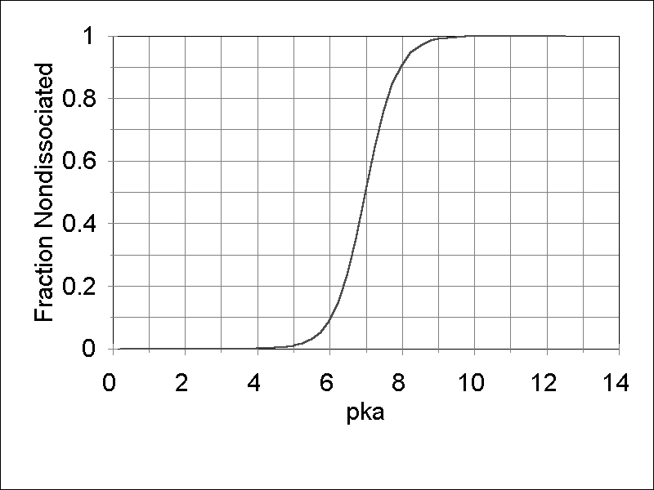

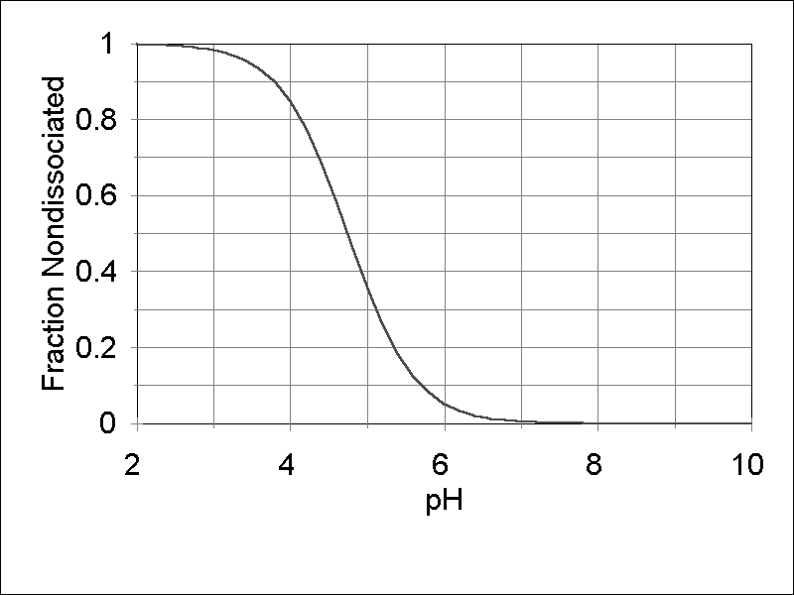

**8.2 Hydrolysis**

Hydrolysis is the degradation of a compound through reaction with water. During hydrolysis, both a pollutant molecule and a water molecule are split, and the two water molecule fragments (H+ and OH-) join to the two pollutant fragments to form new chemicals. Neutral and acid- and base-catalyzed hydrolysis are modeled using the approach of Mabey and Mill (1978) in which an overall pseudo-first-order rate constant is computed for a given pH, adjusted for the ambient temperature of the water:

 **(313)**

where:

 **(314)**

and where:

*KHyd* = overall pseudo-first-order rate constant for a given pH and temperature (1/d);

*KAcidExp* = pseudo-first-order acid-catalyzed rate constant for a given pH (1/d);

*KBaseExp* = pseudo-first-order base-catalyzed rate constant for a given pH (1/d);

*KUncat* = the measured first-order reaction rate at pH 7 (1/d); and

*Arrhen* = temperature adjustment (unitless), see **(319)**.

In neutral hydrolysis reactions, the pollutant reacts with a water molecule (H2O) and the concentration of water is usually included in *KUncat*. In acid-catalyzed hydrolysis, the hydrogen ion reacts with the pollutant, and a first-order decay rate for a given pH can be estimated as follows:

 **(315)**

where:

 **(316)**

and where:

*KAcid* = acid-catalyzed rate constant (L/mol∙d);

*HIon* = concentration of hydrogen ions (mol/L); and

*pH* = pH of water column.

Likewise for base-catalyzed hydrolysis, the first-order rate constant for a reaction between the hydroxide ion and the pollutant at a given pH () can be described as:

 **(317)**

where:

 **(318)**

and where:

*KBase* = base-catalyzed rate constant (L/mol · d); and

*OHIon* = concentration of hydroxide ions (mol/L).

Figure . Base-catalyzed hydrolysis of pentachlorophenol

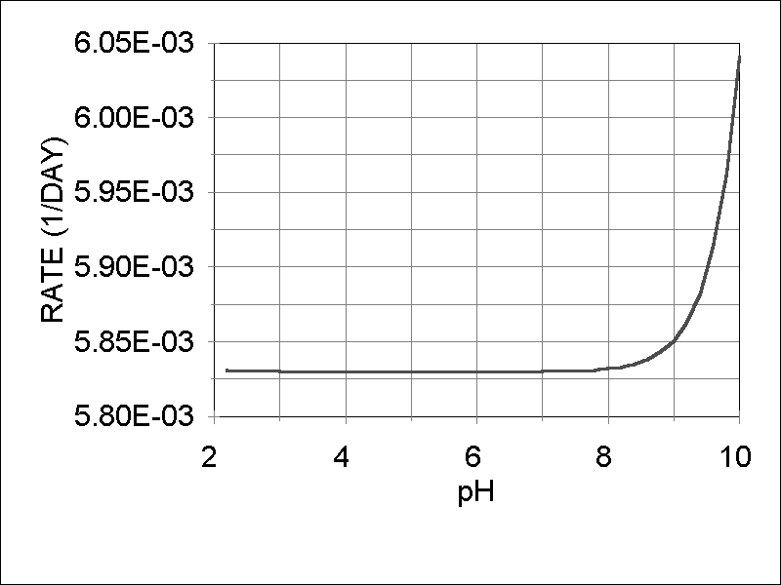

Hydrolysis reaction rates are adjusted for the temperature of the waterbody being modeled by using the Arrhenius rate law (Hemond and Fechner 1994). An activation energy value of 18,000 cal/mol (a mid-range value for organic chemicals) is used as a default:

 **(319)**

where:

*En* = Arrhenius activation energy (cal/mol);

*R* = universal gas constant (cal/mol · Kelvin);

*KelvinT* = temperature for which rate constant is to be predicted (Kelvin); and

*TObs* = temperature at which known rate constant was measured (Kelvin).

**8.3 Photolysis**

Direct photolysis is the process by which a compound absorbs light and undergoes transformation:

 **(320)**

where:

*Photolysis* = rate of loss due to photodegradation (μg/L⋅d); and

*KPhot* = direct photolysis first-order rate constant (1/day).

For consistency, photolysis is computed for both the epilimnion and hypolimnion in stratified systems. However, photolysis is not a significant factor at hypolimnetic depths and is also ignored in sediments.

Ionization may result in a significant shift in the absorption of light (Lyman et al., 1982; Schwarzenbach et al., 1993). However, there is a general absence of information on the effects of light on ionized species. The user provides an observed half-life for photolysis, and this is usually determined either with distilled water or with water from a representative site, so that ionization may be included in the calculated lumped parameter *KPhot*.

Based on the approach of Thomann and Mueller (1987; see also Schwarzenbach et al. 1993), the observed first-order rate constant for the compound is modified by a light attenuation factor for ultraviolet light so that the process as represented is depth-sensitive (Figure 138); it also is adjusted by a factor for time-varying light:

 **(321)**

where:

*PhotRate* = direct, observed photolysis first-order rate constant (1/day);

*ScreeningFactor* = a light screening factor (unitless), see **(322)**; and

*LightFactor* = a time-varying light factor (unitless), see **(323)**.

Figure . Photolysis of pentachlorophenol as a function of

light intensity and depth of water

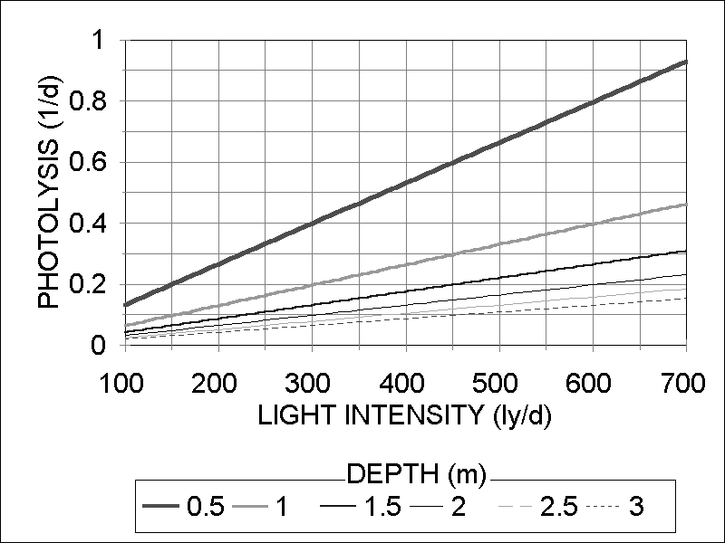

A light screening factor adjusts the observed laboratory photolytic transformation rate of a given pollutant for field conditions with variable light attenuation and depth (Thomann and Mueller, 1987):

 **(322)**

where:

*RadDistr* = radiance distribution function, which is the ratio of the average pathlength to the depth (see Schwarzenbach et al., 1993) (taken to be 1.6, unitless);

*RadDistr0* = radiance distribution function for the top of the segment (taken to be 1.2 for the top of the epilimnion and 1.6 for the top of the hypolimnion, unitless);

*Extinct* = light extinction coefficient (1/m) not including periphyton, see **(40)**;

*Thick* = thickness of the water body segment if stratified or maximum depth if unstratified (m).

The equation presented above implicitly makes the following assumptions:

* quantum yield is independent of wavelength; and,
* the value used for *PhotRate* is a representative near-surface, first-order rate constant for direct photolysis.

The rate is modified further to represent seasonally varying light conditions and the effect of ice cover:

 **(323)**

where:

*Solar0* = time-varying average light intensity at the top of the segment (ly/day); and

*AveSolar* = average light intensity for late spring or early summer, corresponding to time when photolytic half-life is often measured (default = 500 Ly/day).

If the system is unstratified or if the epilimnion is being modeled, the light intensity is the light loading:

 **(324)**

otherwise we are interested in the intensity at the top of the hypolimnion and the attenuation of light is given as a logarithmic decrease over the thickness of the epilimnion:

 **(325)**

where:

*Solar* = incident solar radiation loading (ly/d), see **(25)**; and

*MaxZMix* = depth of the mixing zone (m), see **(17)**.

Because the ultraviolet light intensity exhibits greater seasonal variation than the visible spectrum (Lyman et al., 1982), decreasing markedly when the angle of the sun is low, this construct could predict higher rates of photolysis in the winter than might actually occur. However, the model also accounts for significant attenuation of light due to ice cover (see section 3.6) so that photolysis, as modeled, is not an important process in northern waters in the winter.

**8.4 Microbial Degradation**

Not only can microorganisms decompose the detrital organic material in ecosystems, they also can degrade xenobiotic organic compounds such as fuels, solvents, and pesticides to obtain energy. In AQUATOX this process of biodegradation of pollutants, whether they are dissolved in the water column or adsorbed to organic detritus in the water column or sediments, is modeled using the same equations as for decomposition of detritus, substituting the pollutant and its degradation parameters for detritus in Equation **(159)** and supporting equations:

 **(326)**

where:

*MicrobialDegrdn* = loss due to microbial degradation (g/m3⋅d);

*KMDegrdn* = maximum aerobic microbial degradation rate, either in water column or sediments (1/d), in sediments this is assumed to be four times the user-entered value for water;

*DOCorrection* = effect of anaerobic conditions (unitless), see **(160)**;

*TCorr* = effect of suboptimal temperature (unitless), see **(59)**;

*pHCorr* = effect of suboptimal pH (unitless), see **(162)**; and

*Toxicant* = concentration of organic toxicant (g/m3).

Microbial degradation of toxicants proceeds more quickly if the material is associated with surficial or particulate sediments rather than dissolved in the water column (Godshalk and Barko, 1985); thus, in calculating the loss due to microbial degradation in the sorbed phase, the maximum degradation rate is converted by the model to four times the user entered maximum chemical degradation rate in the water (*Max. Rate of Aerobic Microbial Degradation*). The model assumes that reported maximum microbial degradation rates are for the dissolved phase; if the reported degradation value is from a study with additional organic matter, such as suspended slurry or wet soil samples, then the parameter value that is entered should be one-fourth that reported.

**8.5 Volatilization**

Volatilization is modeled using the "stagnant boundary theory", or two-film model, in which a pollutant molecule must diffuse across both a stagnant water layer and a stagnant air layer to volatilize out of a waterbody (Whitman, 1923; Liss and Slater, 1974). Diffusion rates of pollutants in these stagnant boundary layers can be related to the known diffusion rates of chemicals such as oxygen and water vapor. The thickness of the stagnant boundary layers must also be taken into account to estimate the volatile flux of a chemical out of (or into) the waterbody.

The time required for a pollutant to diffuse through the stagnant water layer in a waterbody is based on the well-established equations for the reaeration of oxygen, corrected for the difference in diffusivity as indicated by the respective molecular weights (Thomann and Mueller, 1987, p. 533). The diffusivity through the water film is greatly enhanced by the degree of ionization (Schwarzenbach et al., 1993, p. 243), and the depth-averaged reaeration coefficient is multiplied by the thickness of the well-mixed zone:

 **(327)**

where:

*KLiq* = water-side transfer velocity (m/d);

*KReaer* = depth-averaged reaeration coefficient for oxygen (1/d), see **(191)**-**(195)**;

*Thick* = thickness of the water body segment if stratified or maximum depth if unstratified (m);

*MolWtO2* = molecular weight of oxygen (g/mol, =32);

*MolWt* = molecular weight of pollutant (g/mol); and

*Nondissoc* = nondissociated fraction (unitless), see **(311)**.

Likewise, the thickness of the air-side stagnant boundary layer is also affected by wind. Wind usually is measured at 10 m, and laboratory experiments are based on wind measured at 10 cm, so a conversion is necessary (Banks, 1975). To estimate the air-side transfer velocity of a pollutant, we used the following empirical equation based on the evaporation of water, corrected for the difference in diffusivity of water vapor compared to the toxicant (Thomann and Mueller, 1987, p. 534):

 **(328)**

where:

*KGas* = air-side transfer velocity (m/d);

*Wind* = wind speed ten meters above the water surface (m/s);

0.5 = conversion factor (wind at 10 cm/wind at 10 m); and

*MolWtH2O* = molecular weight of water (g/mol, =18).

The total resistance to the mass transfer of the pollutant through both the stagnant boundary layers can be expressed as the sum of the resistances- the reciprocals of the air- and water-phase mass transfer coefficients (Schwarzenbach et al., 1993), modified for the effects of ionization:

 **(329)**

where:

*KOVol* = total mass transfer coefficient through both stagnant boundary layers (m/d);

 **(330)**

and where:

*HenryLaw* = Henry's law constant (unitless*);*

*Henry* = Henry's law constant (atm m3 mol-1);

*HLCSaltFactor=* Correction factor for effect of salinity (unitless), see **(444)**.

*R* = gas constant (=8.206E-5 atm m3 (mol K)-1); and

*TKelvin* = temperature in °K.

The Henry’s law constant is applicable only to the fraction that is nondissociated because the ionized species will not be present in the gas phase (Schwarzenbach et al., 1993, p. 179).

The atmospheric exchange of the pollutant can be expressed as the depth-averaged total mass transfer coefficient times the difference between the concentration of the chemical and the saturation concentration:

 **(331)**

where:

*Volatilization* = interchange with atmosphere (μg/L⋅d);

*Thick* = depth of water or thickness of surface layer (m);

*ToxSat* = saturation concentration of pollutant in equilibrium with the gas phase (μg/L), see **(332)**; and

*Toxicantwater* = concentration of pollutant in water (μg/L).

The saturation concentration depends on the concentration of the pollutant in the air, ignoring temperature effects (Thomann and Mueller, 1987, p. 532; see also Schnoor, 1996), but adjusting for ionization and units:

 **(332)**

where:

*Toxicantair* = gas-phase concentration of the pollutant (g/m3); and

*Nondissoc* = nondissociated fraction (unitless).

Theoretically, toxicants can be transferred in either direction across the water-air interface. Often the pollutant can be assumed to have a negligible concentration in the air and *ToxSat* is zero. However, this general construct can represent the transferral of volatile pollutants into water bodies. Volatilization might become negative if toxicant concentrations are high in the air, and concentrations in the water column may increase as a result of this interchange. Because ionized species do not volatilize, the saturation level increases if ionization is occurring.

The nondimensional Henry's law constant, which relates the concentration of a compound in the air phase to its concentration in the water phase, strongly affects the air-phase resistance. Depending on the value of the Henry's law constant, the water phase, the air phase or both may control volatilization. For example, with a depth of 1 m and a wind of 1 m/s, the gas phase is 100,000 times as important as the water phase for atrazine (Henry's law constant = 3.0E-9), but the water phase is 50 times as important as the air phase for benzene (Henry's law constant = 5.5E-3). Volatilization of atrazine exhibits a linear relationship with wind () in contrast to the exponential relationship exhibited by benzene ().

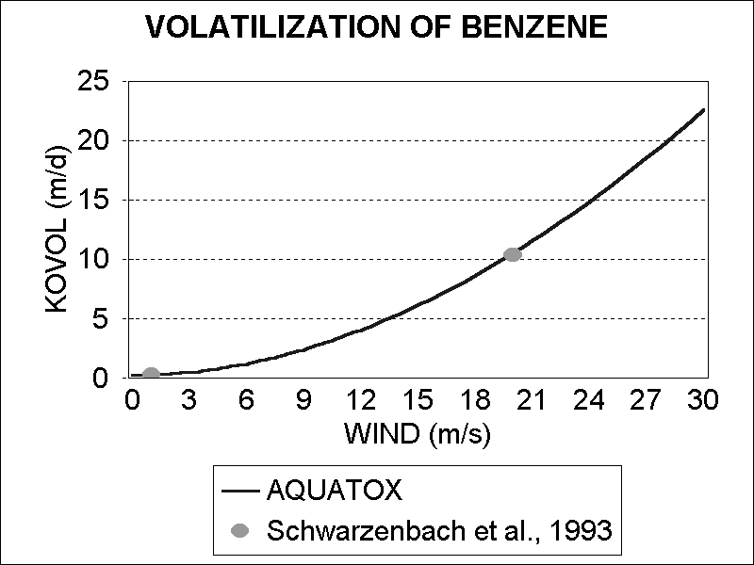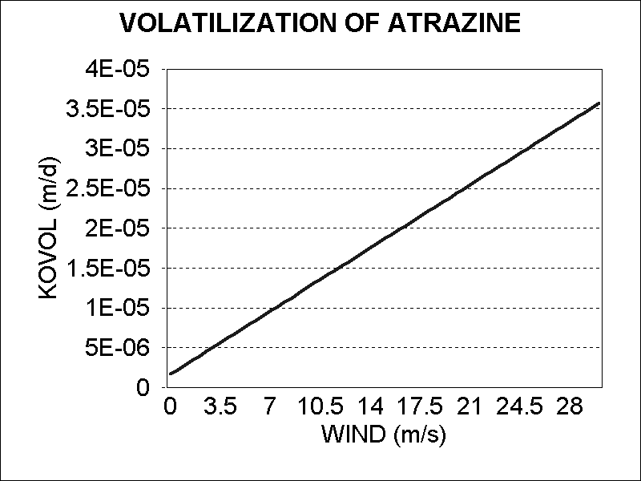

Figure 136. Atrazine *KOVol* as a function of Wind

Figure 137. Benzene *KOVol* as a function of Wind

**3.6 Light**

**Light: Simplifying Assumptions**

* Ice cover is assumed when the average water temperature drops below 3 degrees centigrade.
* Photoperiod is approximated by Julian date (day of year)
* Average daily light is the program default, although hourly light may be simulated

Light is important as the controlling factor for photosynthesis and photolysis. The default incident light function formulated for AQUATOX is a variation on the temperature equation, but without the lag term:

 **(25)**

where:

*Solar* = average daily incident light intensity (ly/d);

*LightMean* = mean annual light intensity (ly/d);

*LightRange* = annual range in light intensity (ly/d);

*Day* = day of year (d, adjusted for hemisphere);

*Frac Light* = fraction of site that is shaded; and

*Canopy*= user input fraction of site that is tree shaded.

The derived values are given as average light intensity in Langleys per day (Ly/d = 10 kcal/m2⋅d). An observed time-series of light also can be supplied by the user; this is especially important if the effects of daily weather conditions are of interest. For standing water, if the average water temperature drops below 3 deg.C, the model assumes the presence of ice cover and decreases transmitted light to 15% of incident radiation. (This has changed from 33% in Release 2.2.) This reduction, due to the reflectivity and transmissivity of ice and snow, is an average of widely varying values summarized by Wetzel (2001). New to Release 3.2 beta, for moving water (streams and rivers), the average water temperature must drop below 0 deg. C before ice cover is assumed. For estuaries, average water temperature must fall below -1.8 deg.C before the model assumes ice cover due to the influence of salinity.

Shade can be an important limitation to light, especially in riparian systems. A user input “fraction of site subject to shade from a canopy” parameter can be entered either as a constant or as a time-series within the “Site” input screen. This parameter can be left as zero for no shading effects on light. Transmission of light through a riparian (stream-side) canopy is a combination of diffuse and direct transmission (Canham et al. 1990). The average of four forest types from closed hemlock to open spruce (and cypress) forests is 2% of incident radiation (Canham et al. 1990). Detailed studies in a Midwestern mixed deciduous forest confirm this value for the summer months, although transmission increased to 40% in winter (Oliphant et al. 2006). A value of 2% transmission for a closed canopy is used in AQUATOX. If the density of canopy varies during the year, then a time-series should be provided, keeping in mind that the 2% transmission will still apply to the fraction of canopy that is indicated.

Photoperiod is an integral part of the photosynthesis formulation. It is approximated using the Julian date following the approach of Stewart (1975) ():

 **(26)**

where:

*Photoperiod* = fraction of the day with daylight (unitless); converted from hours by dividing by 24;

*A* = hours of daylight minus 12 (d); and

*Day* = day of year (d, converted to radians).

*A* is the difference between the number of hours of daylight at the summer solstice at a given latitude and the vernal equinox, and is given by a linear regression developed by Groden (1977):

 **(27)**

where:

*Latitude* = latitude (deg., decimal), negative in southern hemisphere; and

*Sign* = 1.0 in northern hemisphere, -1.0 in southern hemisphere.

Figure 45. Annual Temperature

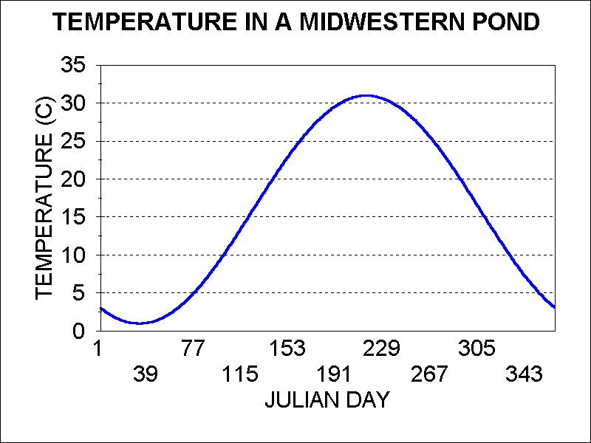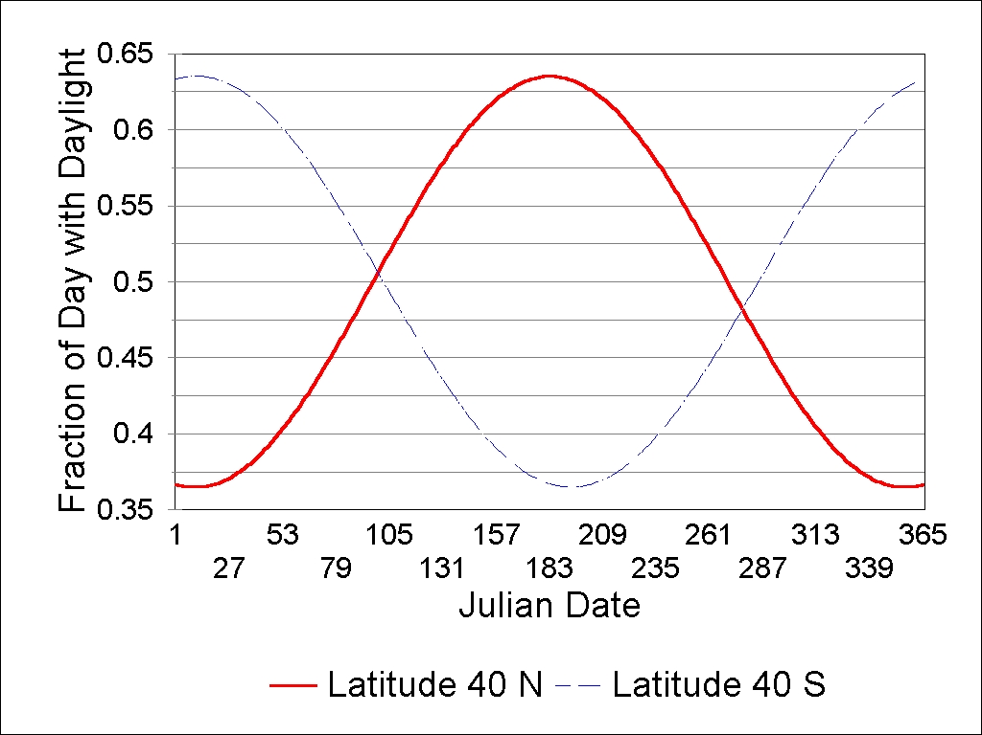

Figure 46. Photoperiod as a Function of Date

**Hourly Light**

When the model is run with an hourly time-step, solar radiation is calculated as variable during the course of each day. The following equation is used to distribute the average daily incident light intensity over the portion of the day with daylight hours.

 **(28)**

where:

*Solarhourly* *=* solar radiation at the given time-step (ly/d);

*Solardaily* *=* average daily incident light intensity (ly/d), see **(25);**

*Photoperiod =* fraction of the day with daylight (unitless); see **(26);**

*FracDayPassed =* fraction of the day that has passed (unitless)

*Frac­Light**=* fraction of site that is un-shaded, (frac., 1.0-user input shade);

A user may enter a constant or time-series shade variable in the site window (“Fraction of Site that is Shaded”). When this input is utilized then the *FracLight* variable is calculated.

Figure : Average light per day is distributed during daylight hours

in a semi-sinusoidal pattern based on photoperiod.



**3.7 Wind**

Wind is an important driving variable because it determines the stability of blue-green algal blooms, affects reaeration or oxygen exchange, and controls volatilization of some organic chemicals. Wind also can affect the depth of stratification for estuaries. Wind is usually measured at meteorological stations at a height of 10 m and is expressed as m/s. If site data are not available, default variable wind speeds are represented through a Fourier series of sine and cosine terms; the mean and twelve additional harmonics seem to effectively capture the variation ():

**Wind: Simplifying Assumptions**

* If site data are not available a Fourier series is used to represent wind loadings

 **(29)**

where:

*Wind* = wind speed; amplitude of the Fourier series (m/s);

*CosCoeff0* = cosine coefficient for the 0-order harmonic, which is the mean wind speed (default = 3 m/s);

*CosCoeffn* = cosine coefficient for the nth-order harmonic;

*Day* = day of year (d);

*SinCoeffn* = sine coefficient for the nth-order harmonic;

*Freqn* = selected frequency for the nth- order harmonic.

This default loading is based on an annual cycle of data taken from the Buffalo, NY airport. Therefore, it has a 365-day repeat, representative of seasonal variations in wind. Frequencies were selected to ensure that the standard deviation of the Fourier series and the data were closely matched. The frequency of wind-speeds of less than three meters per second were also precisely matched to observed data as well as the periodicity of wind-events. The Fourier approach is quite useful because the mean can be specified by the user and the variability will be imposed by the function.

If ice cover is predicted, wind is set to 0. A user also may input a site-specific time series, which may be important where the timing of a cyanobacteria bloom or reaeration is of interest.

Figure . Default wind loadings for Onondaga Lake with mean = 4.17 m/s.



*(wind drops to zero under predicted ice cover)*