4/20/2020 Alternative BCF uptake

Set up model using Skensved Denmark TCE.aps saved as Skensved Denmark TCE Results.JSON

Set animal uptake to enter K1 & K2 (calculate BCF)and plant uptake to enter K2 and BCF (calculate K1)

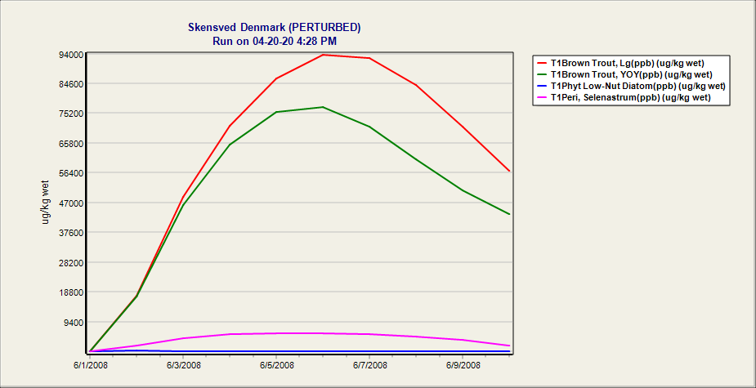

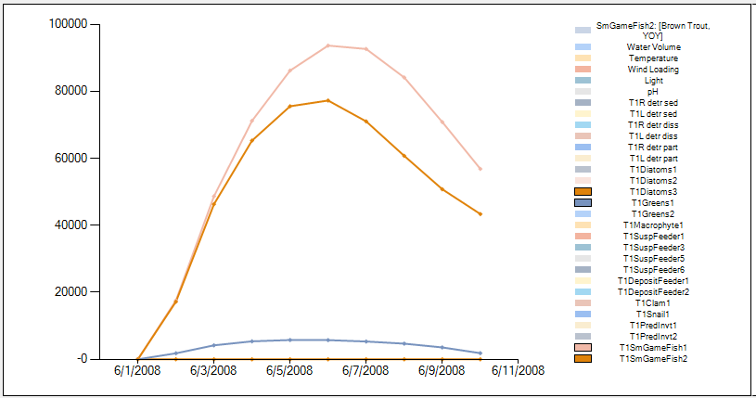

3/25/2020 Biotransformation Test: HCB Tank_biotransform.aps

Set up model with daughter products of Hexachlorobenzene (T2 -- 1,3 Dichlorobenzene and T3 1,3,5 Trichlorobenzene)

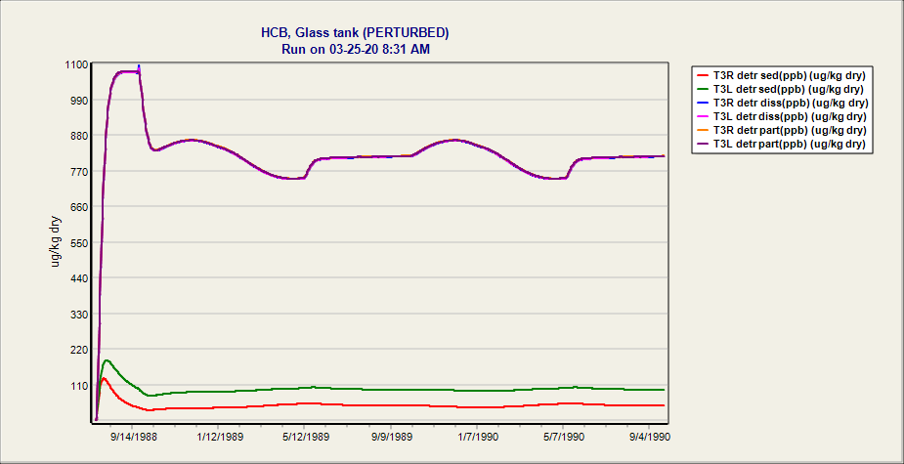 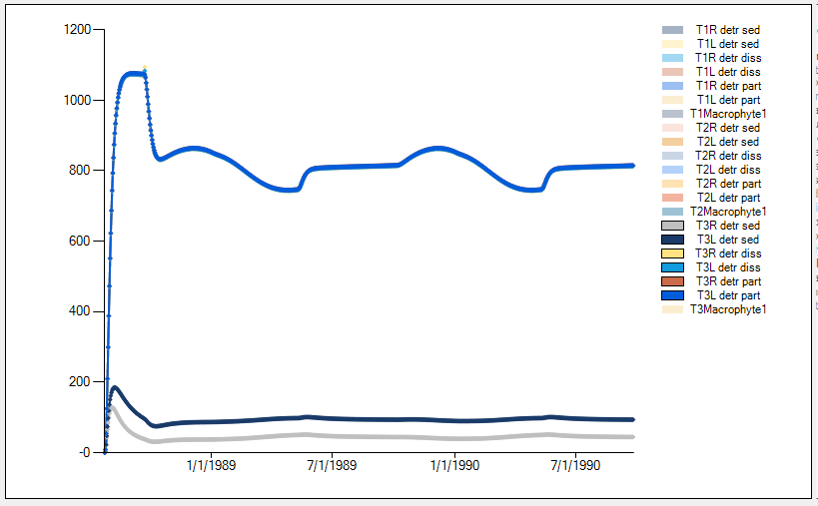

1,3,5 Trichlorobenzene conc in detritus

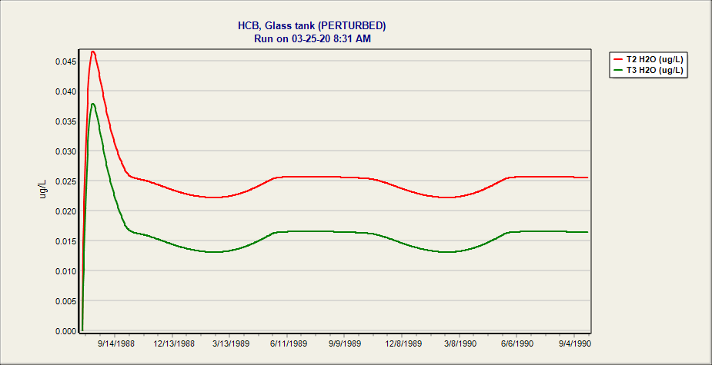

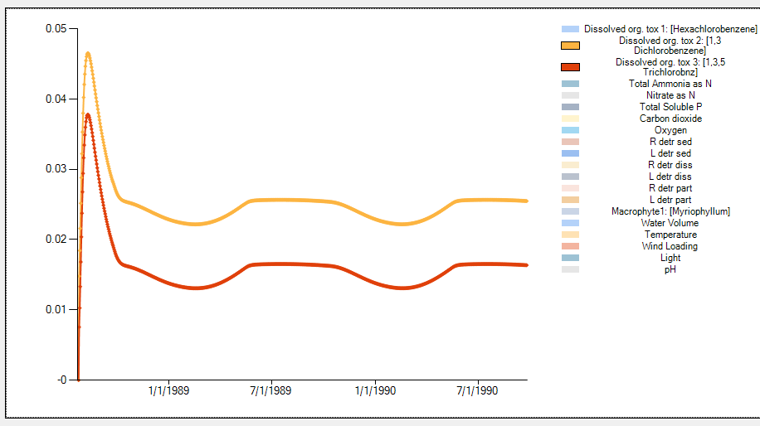

Daughter products in water

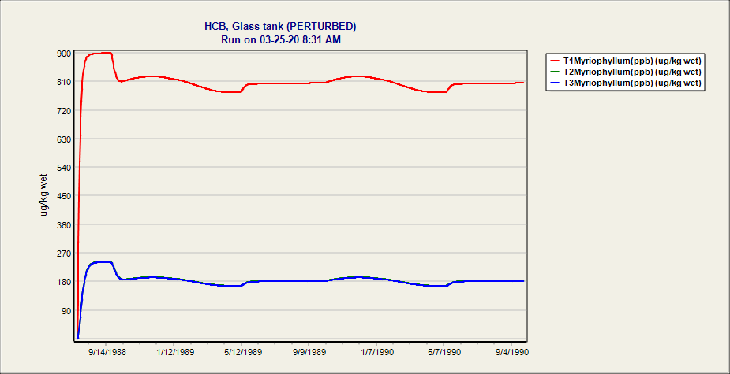

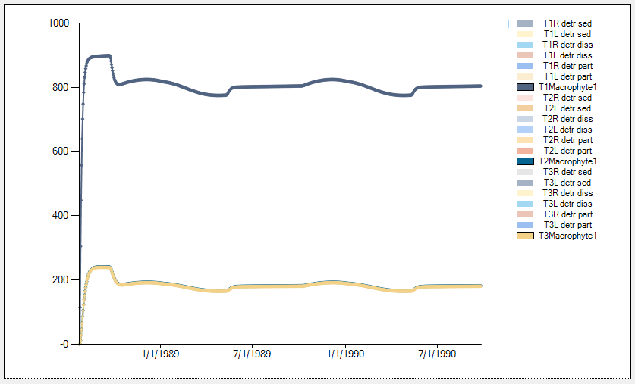

Chemical PPB in Macrophytes

3/24/2020 East Fork Poplar Creek TN PCBs.aps: Complex test case 7 animals & 6 plants

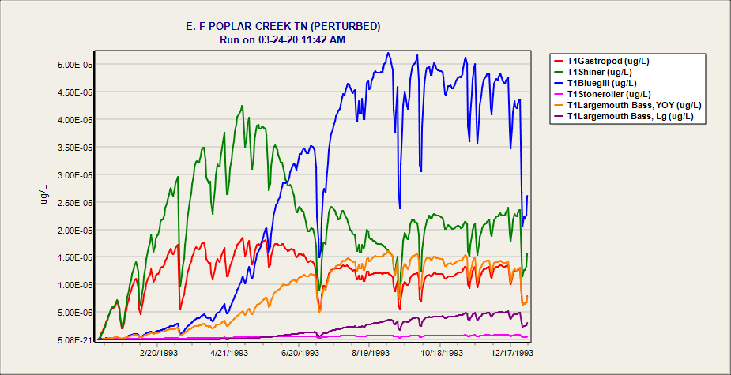

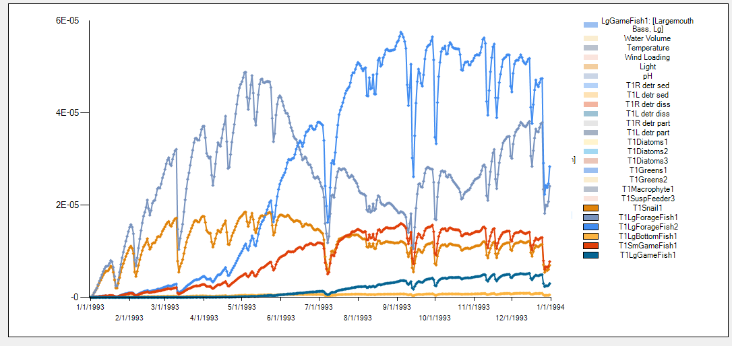

PCB Mass in animals (also checked organic matter)

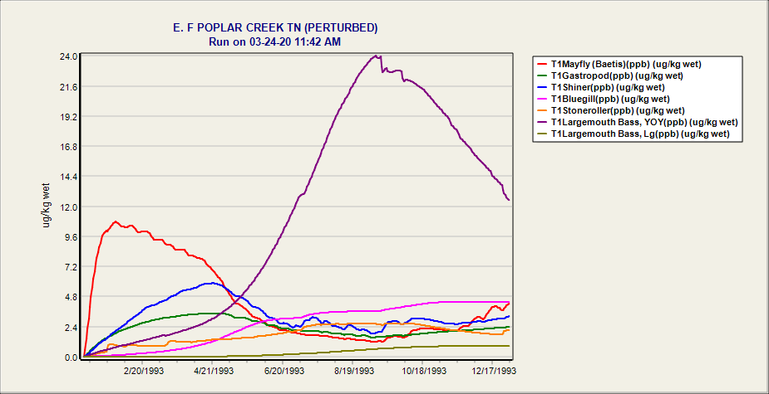

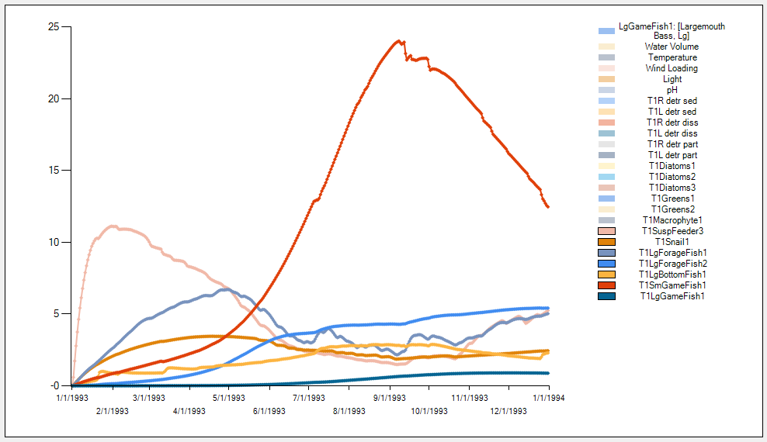

PCB PPB in animals (also checked plants and organic matter)

3/23/2020 Farm Pond Missouri Esfenvalerate

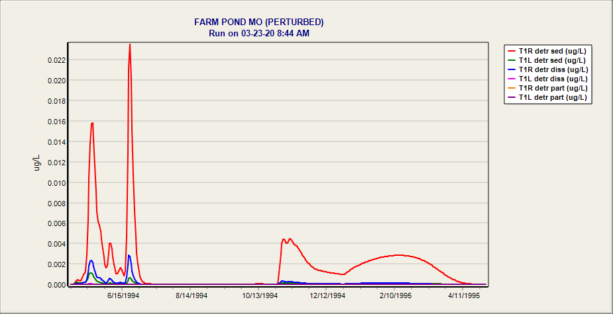

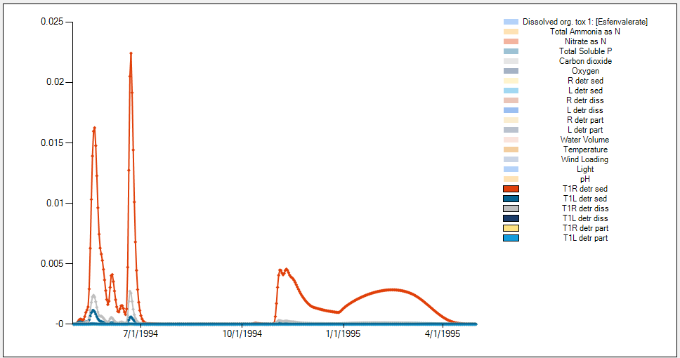

Farm Pond MO Esfenval NoPlntsorAnimals.JSON (3/23/2020) -- Mass in Detritus

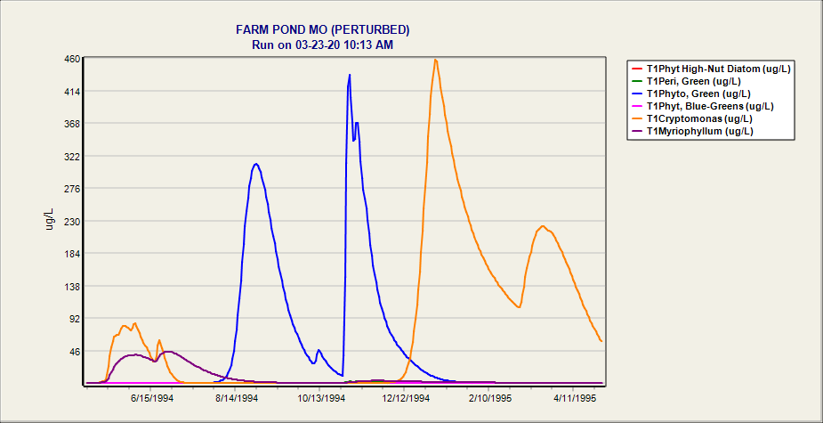

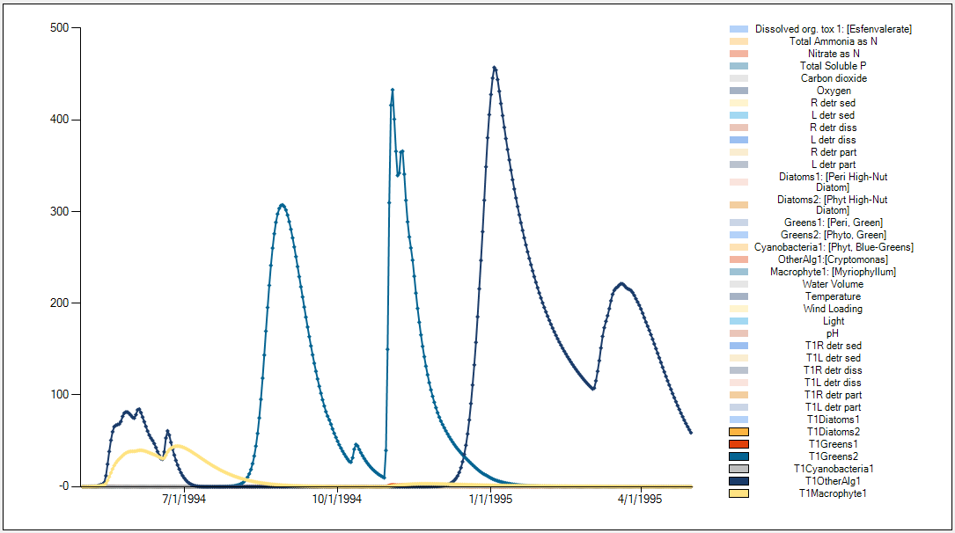

Farm Pond MO Esfenval NoAnimals.aps (3/23/2020) -- Mass in Plants

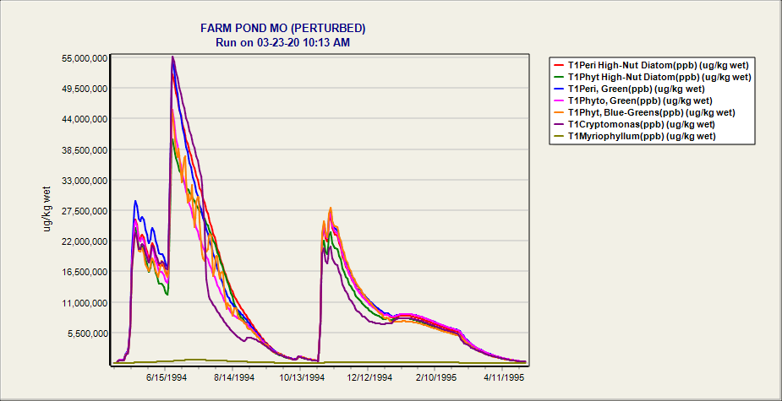

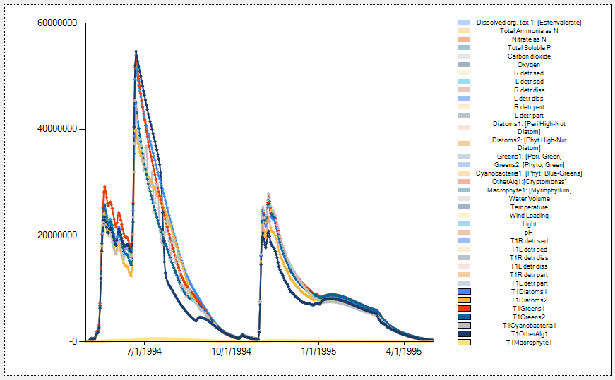

Farm Pond MO Esfenval NoAnimals.aps (3/23/2020) -- PPB in Plants

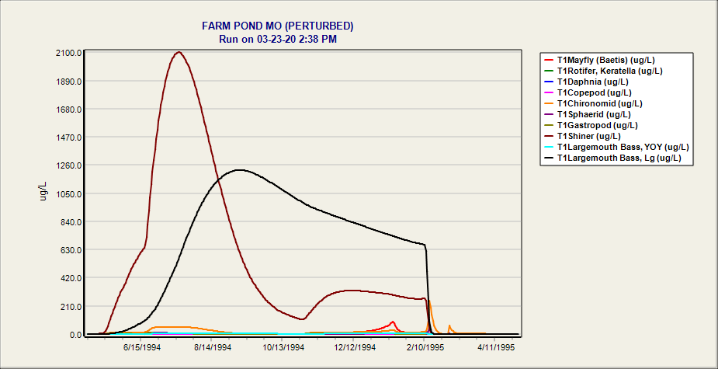

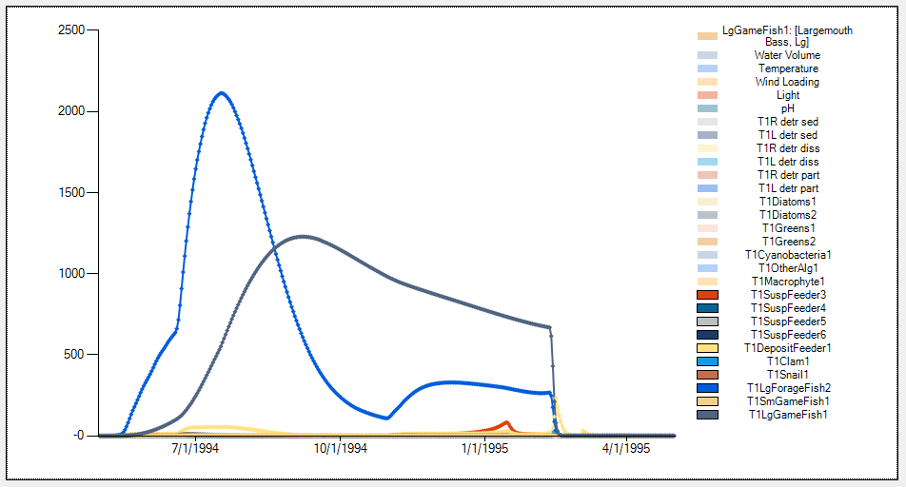

Farm Pond MO Esfenval NoToxicity.aps

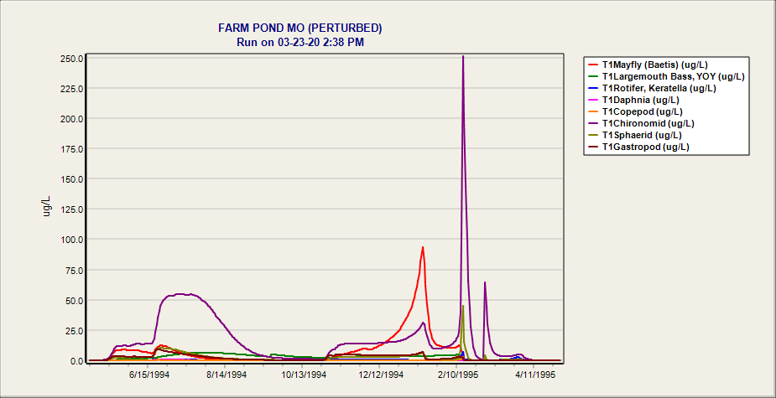

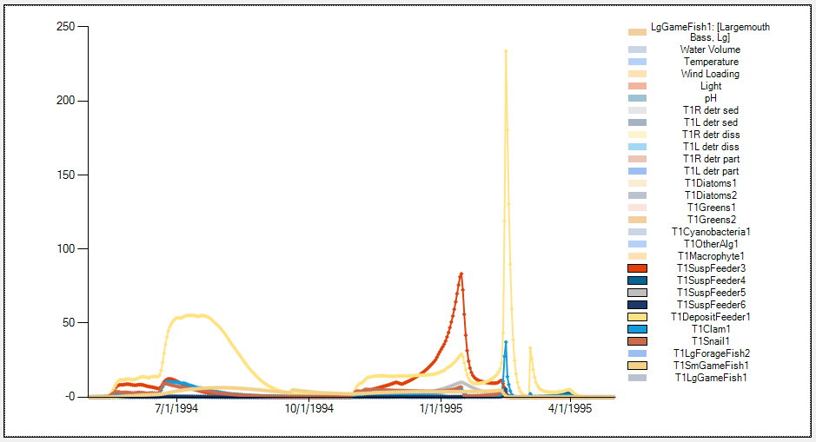

Farm Pond MO Esfenval NoToxicity.aps Mass of chemical

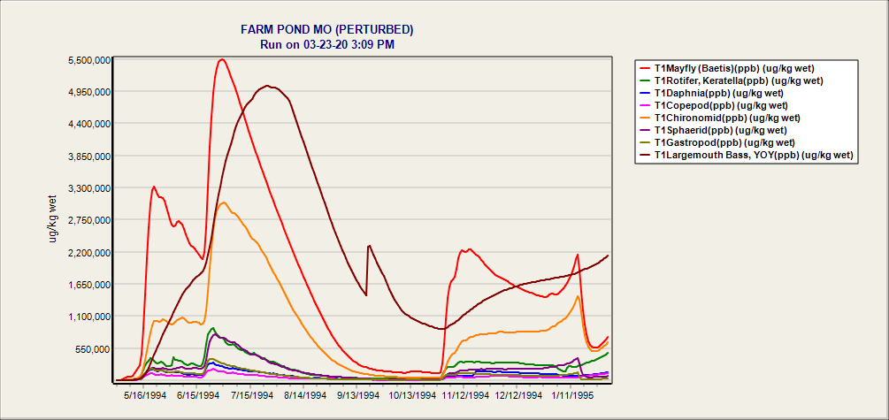

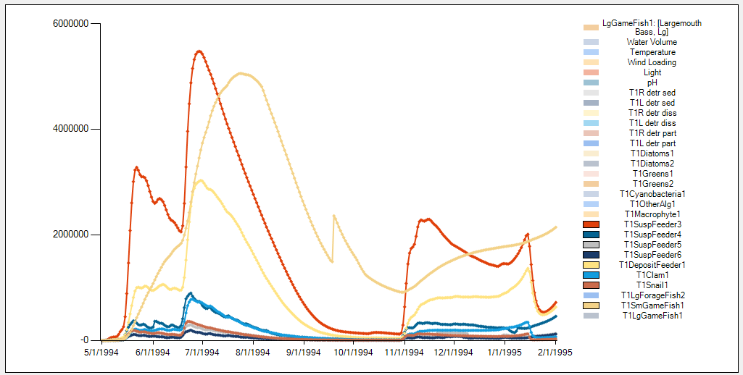

Farm Pond MO Esfenval NoToxicity.aps PPB of chemical

Tests from 3-11-20, simple tests with HCBTank

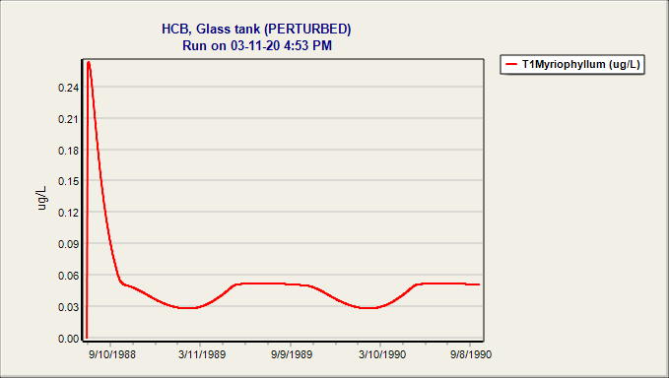

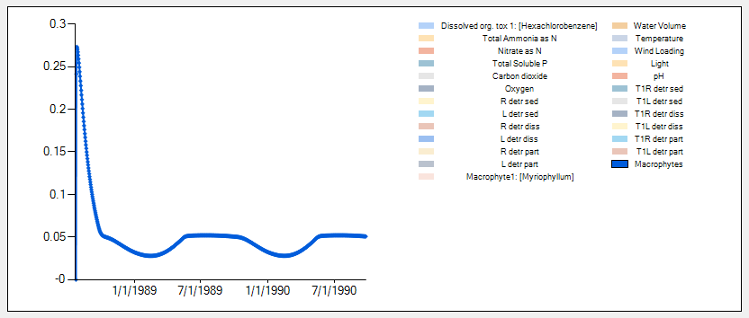

Mass of toxicant within macrophytes in simple tank experiment

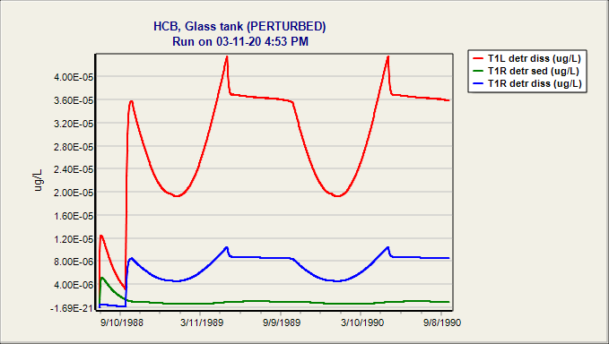

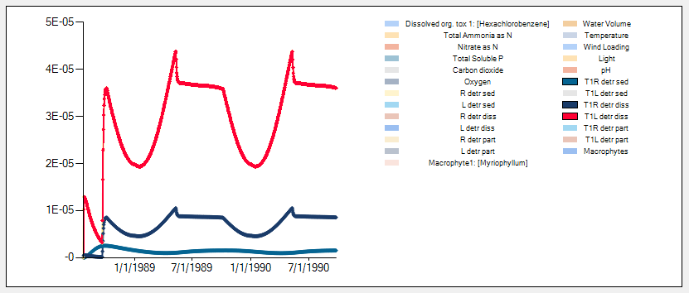

Mass of toxicant within organic matter (labile, refractory) in simple tank experiment

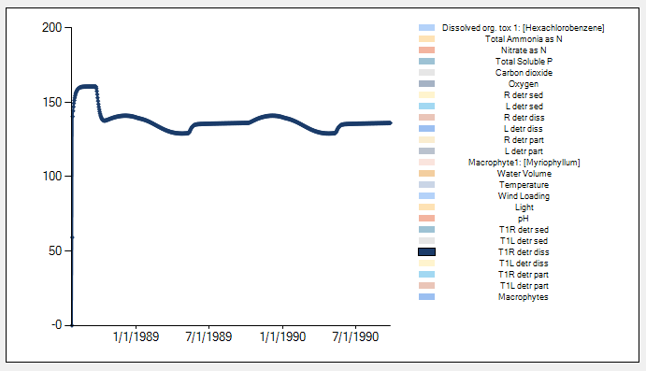

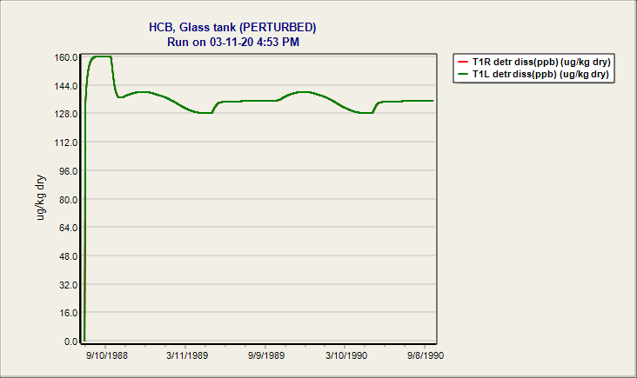

Parts per billion output