Farm Pond Missouri Esfenvalerate

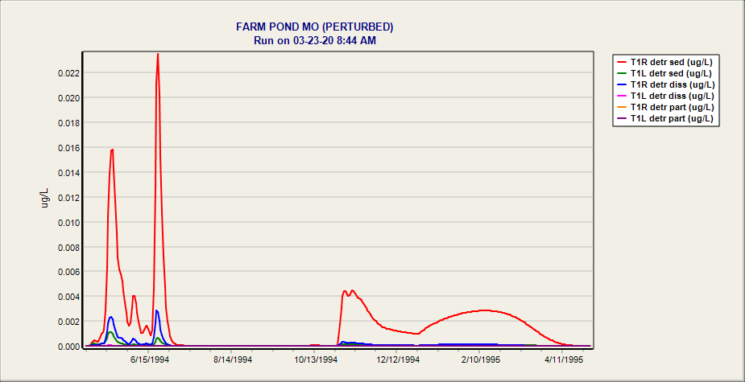

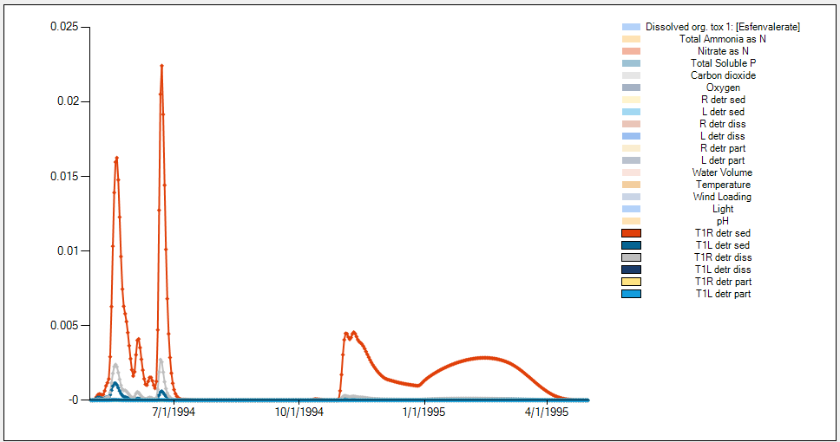

Farm Pond MO Esfenval NoPlntsorAnimals.JSON (3/23/2020) -- Mass in Detritus

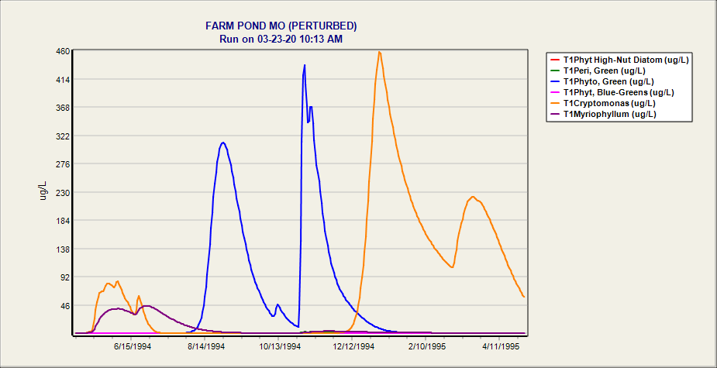

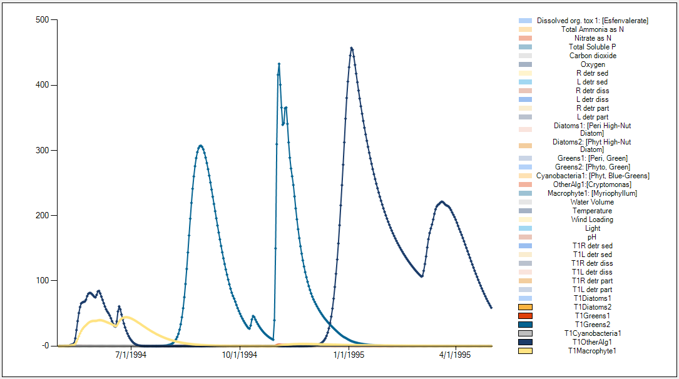

Farm Pond MO Esfenval NoAnimals.aps (3/23/2020) -- Mass in Plants

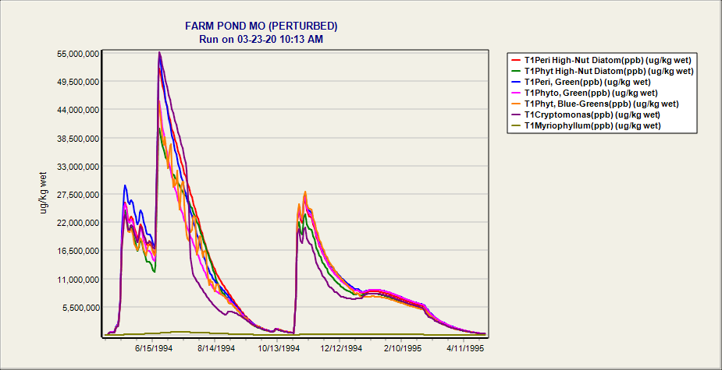

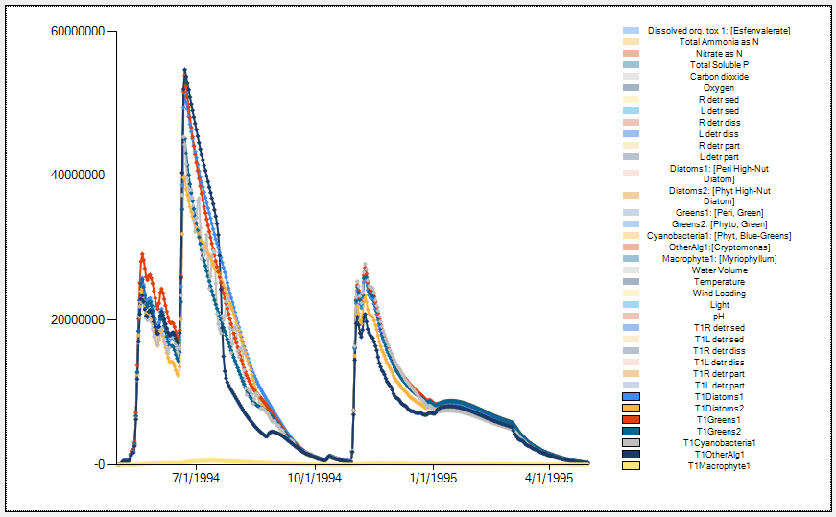

Farm Pond MO Esfenval NoAnimals.aps (3/23/2020) -- PPB in Plants

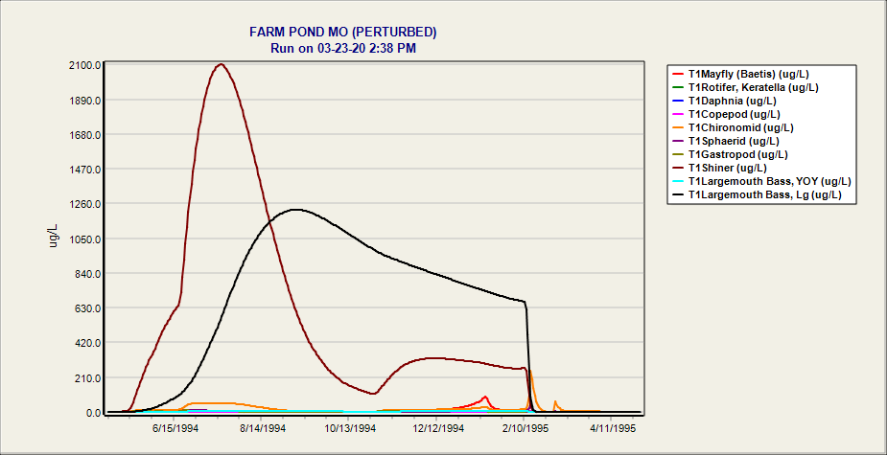

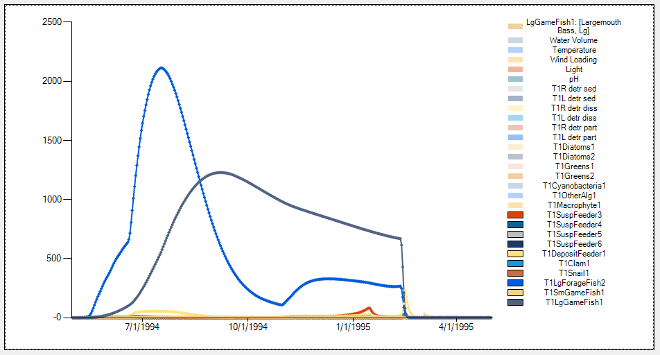

Farm Pond MO Esfenval NoToxicity.aps

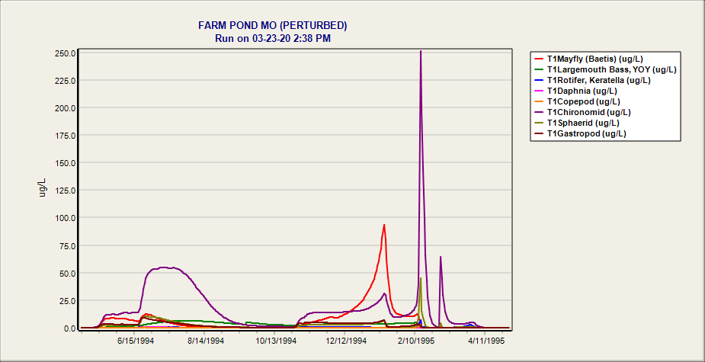

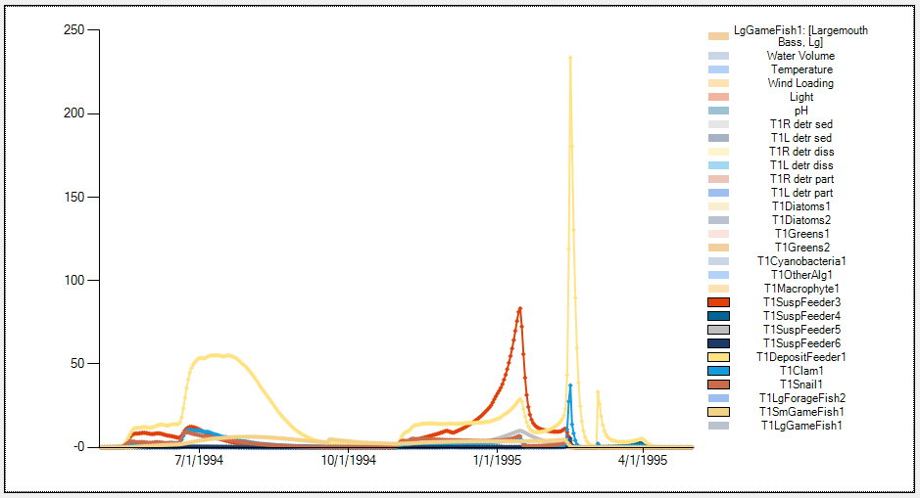

Farm Pond MO Esfenval NoToxicity.aps Mass of chemical

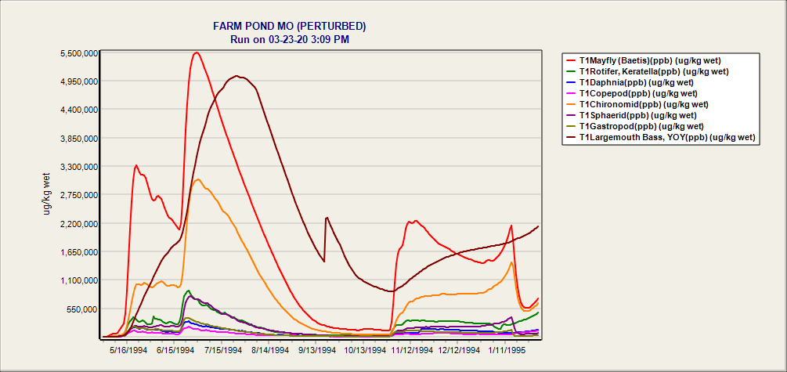

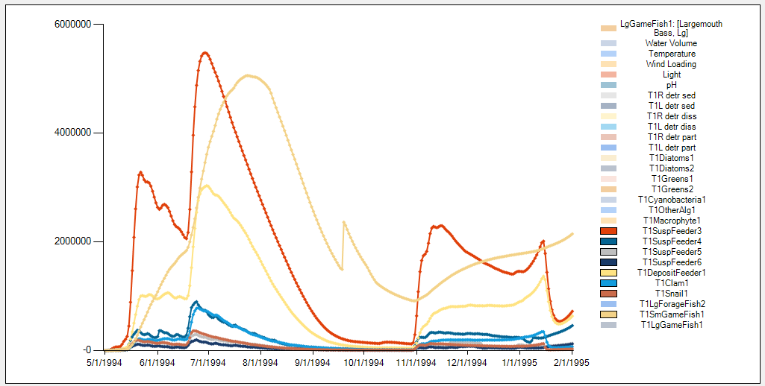

Farm Pond MO Esfenval NoToxicity.aps PPB of chemical

**Tests from 3-11-20, simple tests with HCBTank**

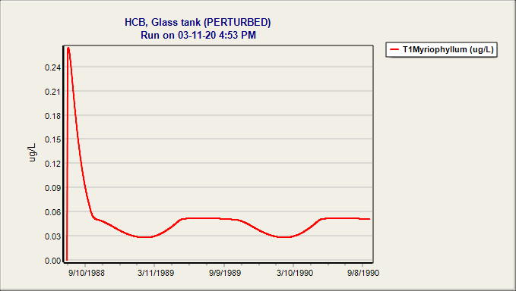

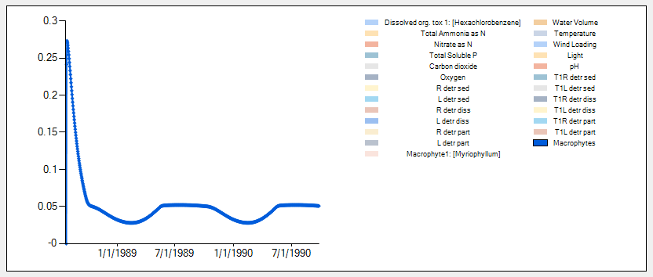

**Mass of toxicant within macrophytes in simple tank experiment**

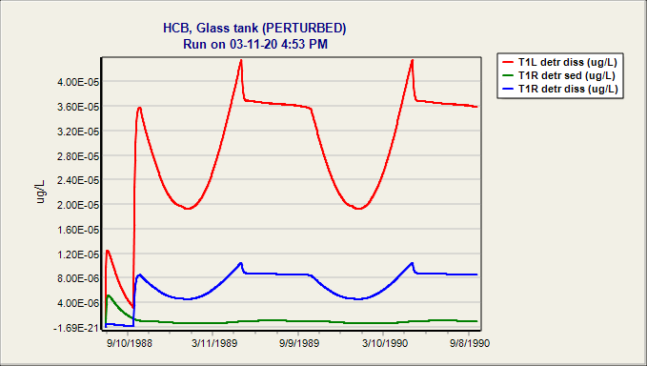

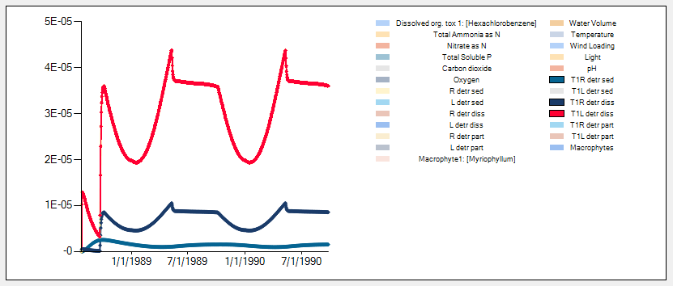

**Mass of toxicant within organic matter (labile, refractory) in simple tank experiment**

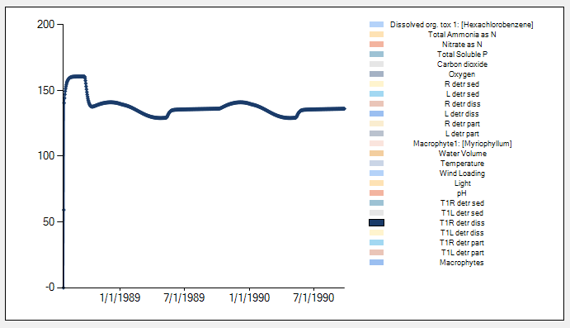

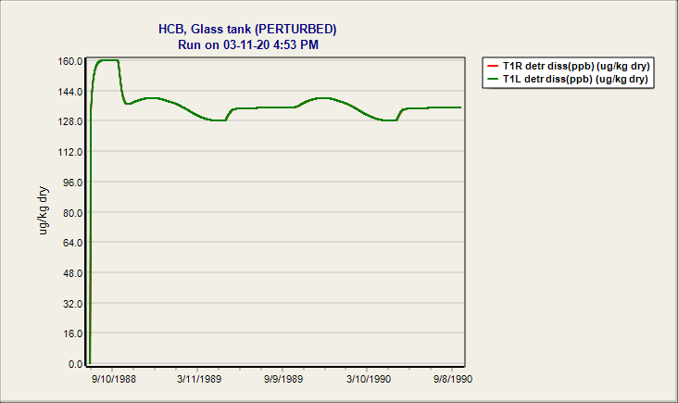

**Parts per billion output**