**Chemicals Programmer test log – ChemicalFateModel, HMS JSON vs. AQUATOX 3.2**

**Chemical “simple” mode (no linkage to plants or animals) 8/17/2018**

AQUATOX 3.2 file**: Pond_MN_Chlorpyrifos_Simple2.aps**HMS Input file: **Pond_MN_Chlorpyrifos_Simple2.JSON**

All state variables match precisely by eye and precisely based on Excel calculations: **P_Pond_MN_Chlorpyrifos_Simple_Table.xlsx**

Chemical and Toxicant Fate:

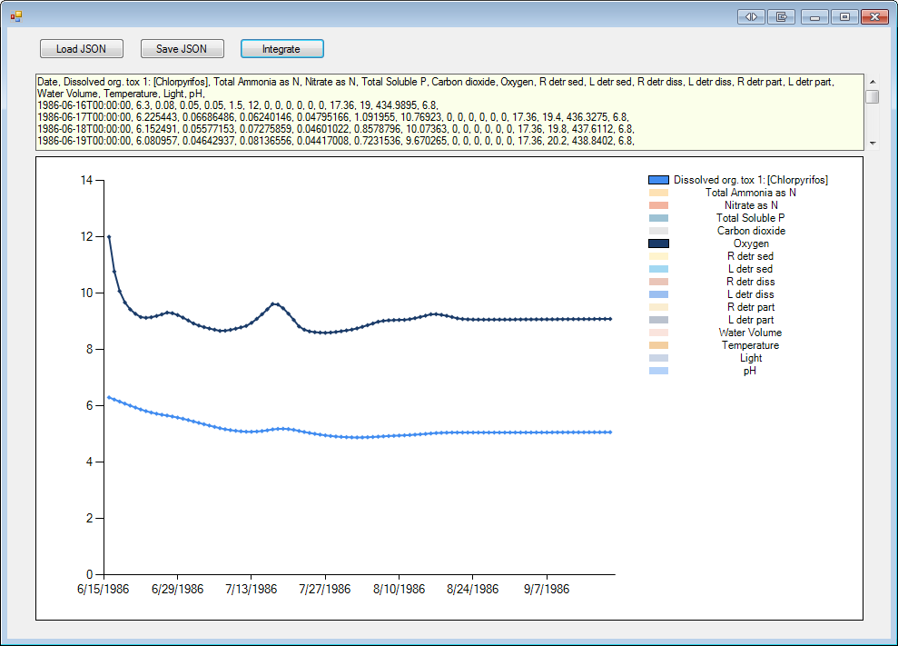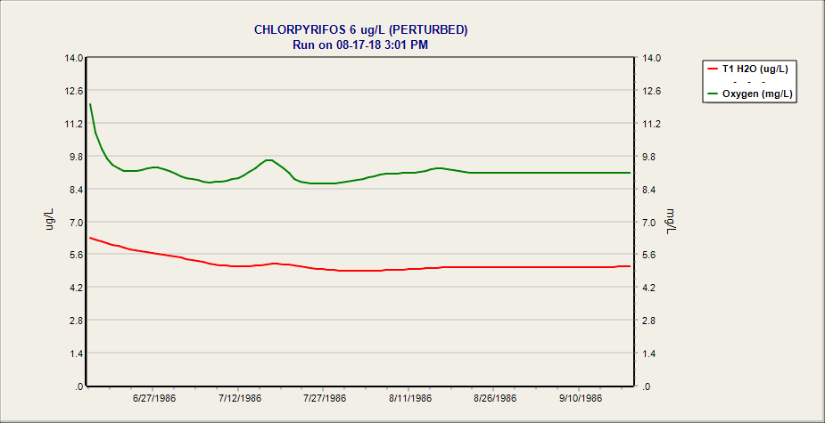

AQUATOX 3.2 file**: Pond_MN_Chlorpyrifos_Simple_Wind.aps**HMS Input file: **Pond_MN_Chlorpyrifos_Simple_wind.JSON**

All state variables match precisely by eye and precisely based on Excel calculations: **P_Pond_MN_Chlorpyrifos_Simple_Wind.xlsx**

Chemical and Toxicant Fate:

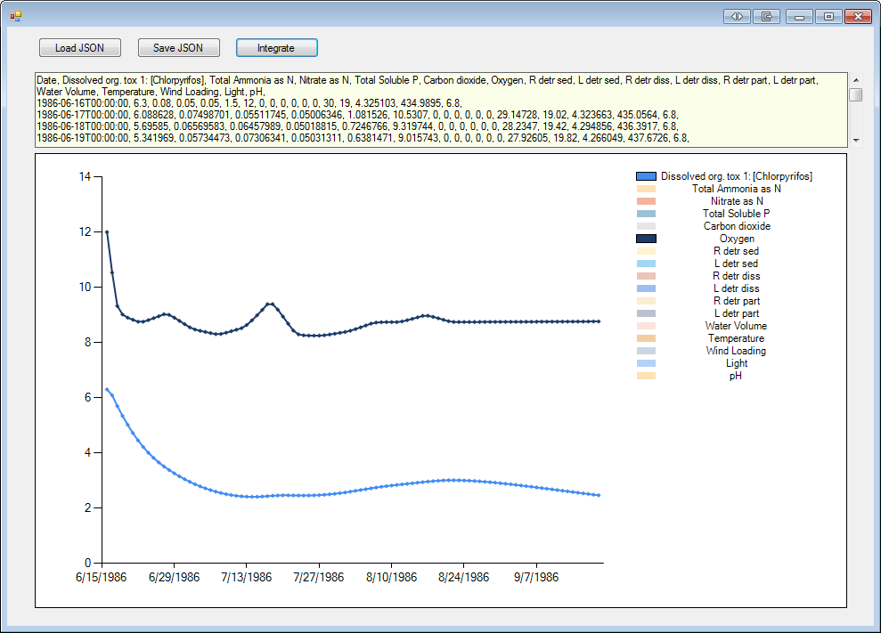 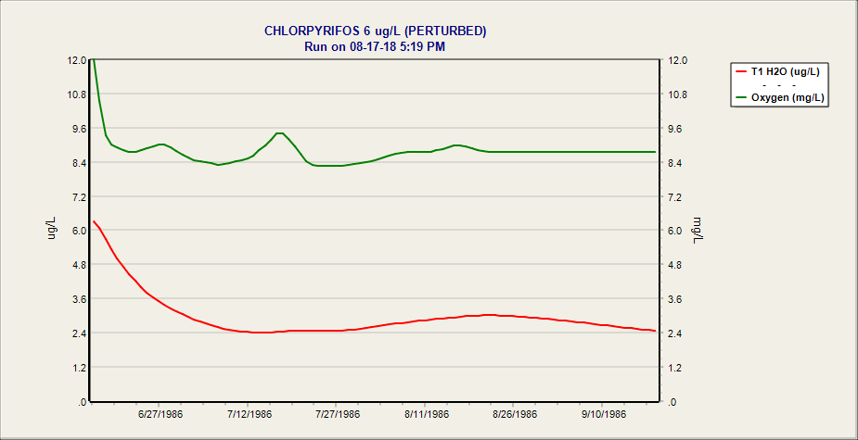

**8/22/2018: Complex Test case with Daily Rates Linkage**

Prior to adding HMS linkages, model results were different. As was the case with the previous tests, linkage (with daily rates passage) results in a small percentage error, but graphs of model behavior that look identical to the eye.

Stepped through the model in debug mode to ensure that rates time-series are being received and interpreted properly within HMS AQUATOX.