**Organic Matter Programmer test log – AQUATOXVolumeModel, HMS JSON vs. AQUATOX 3.2**

**Diagenesis “simple” mode (no linkage to plants or animals) 6/29/2019**

AQUATOX 3.2 file**: Onondaga_Diagenesis_NoStrat_NoBiota.aps**

HMS Input file: **Onondaga_Diagenesis_NoStrat_NoBiota.JSON**

All state variables match precisely by eye and precisely based on Excel calculations: **Fixed_SSOnondaga_Diagenesis_NoStrat_NoBiota_Table.xlsx**

Layer 2 nutrients:

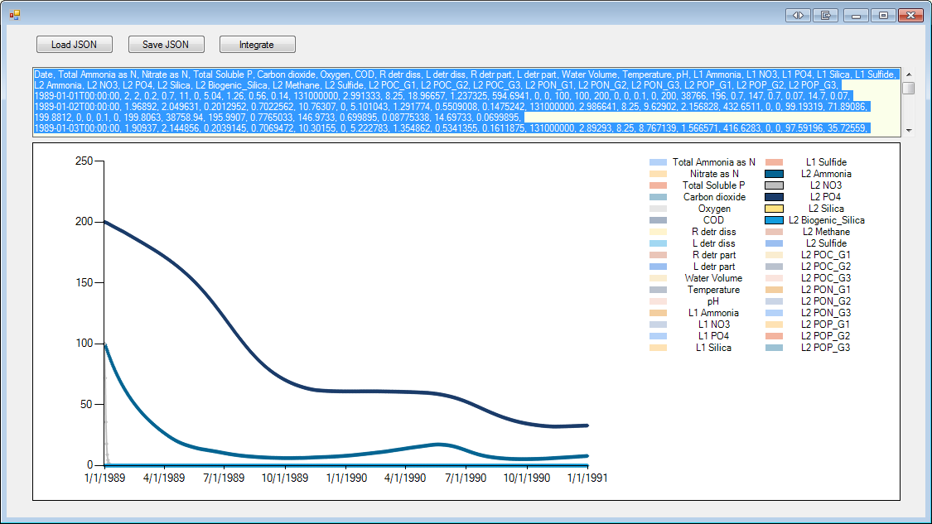



**Layer 1—steady state nutrients**

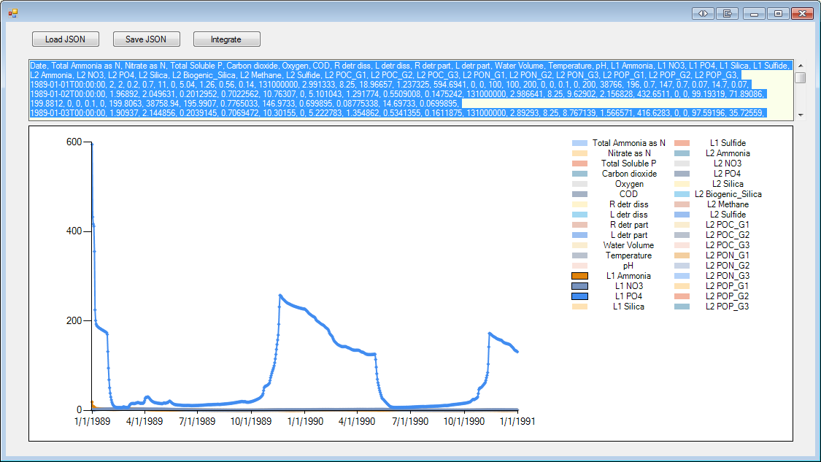

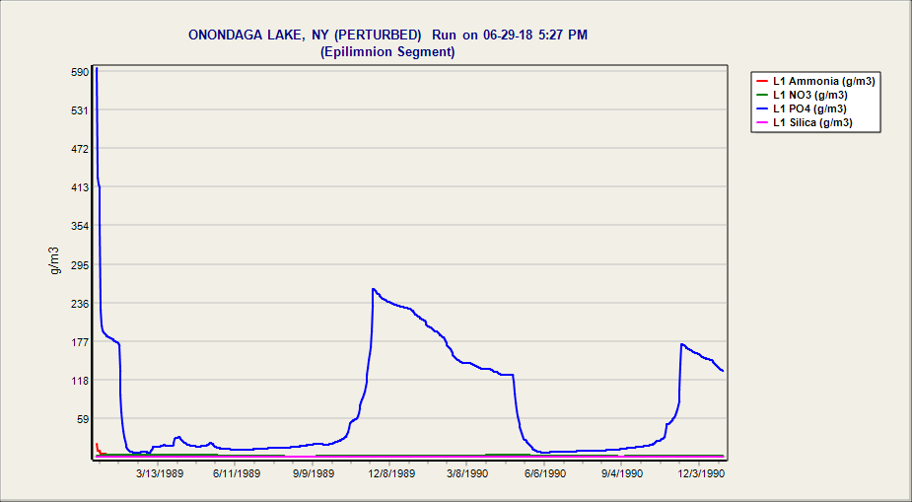

**Layer 2 -- POC**

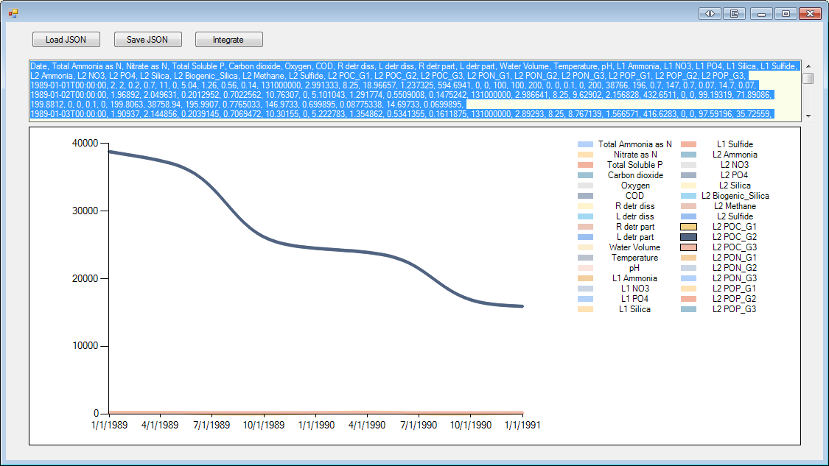



**Waer column Detritus and Oxygen that interacts via SOD from diagenesis layers**



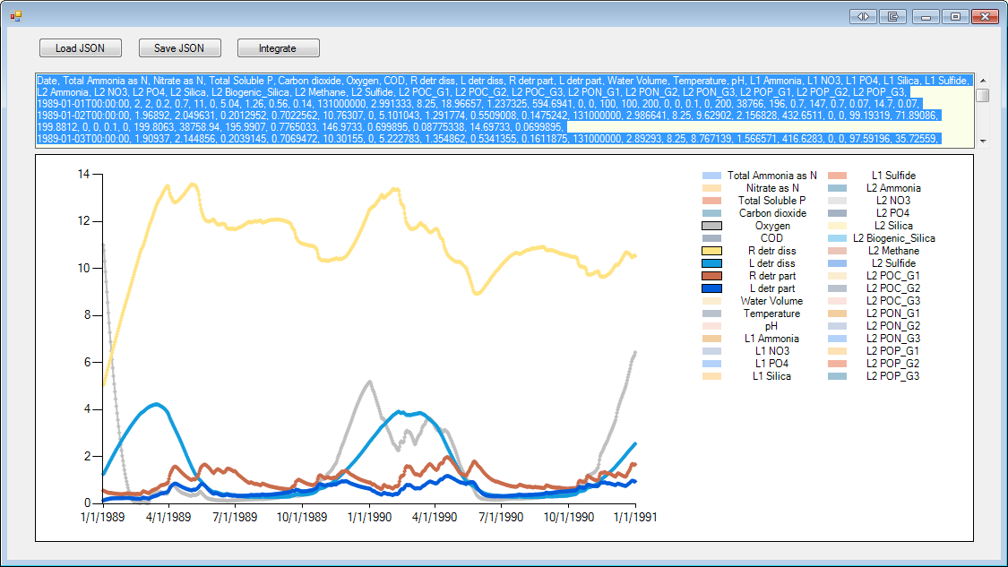

**Sediment Layer 2, POP**

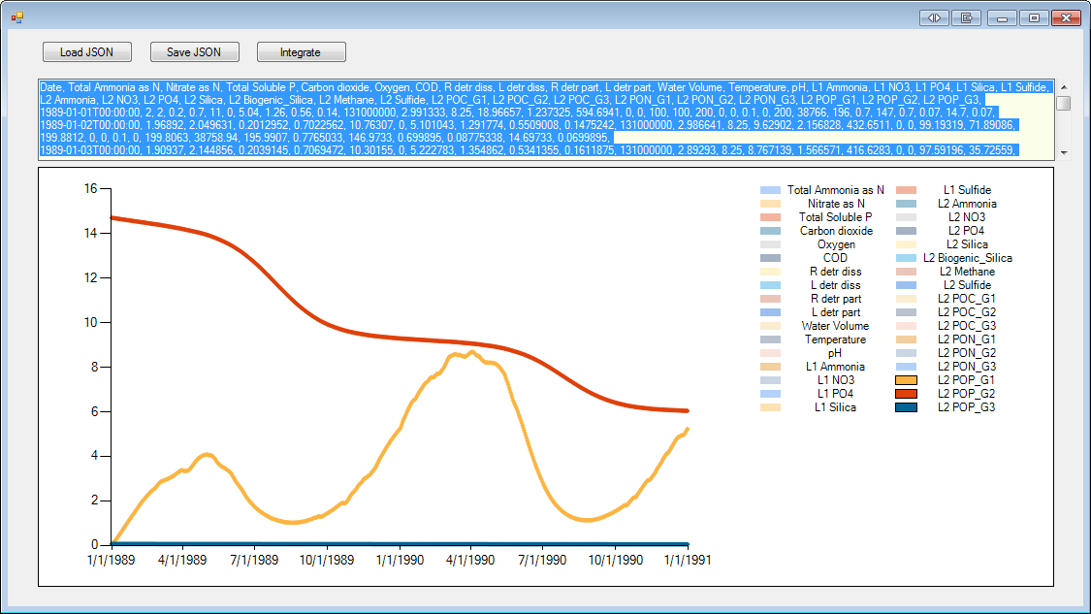****

**Nutrients that interact with mineralization and release from sediment layer**



