To be added to the AQUATOX.Net User’s Manual once adequately tested and refined:

## Tutorial

### Simple Tutorial

This tutorial introduces basic concepts and gets a user started with the AQUATOX interface.

#### Tutorial-- Step 1:  Deleting and Adding a Plant

Open the file **Farm Pond MO Esfenval**.  (see Loading a Study)

This study represents a generic pond built to USDA specifications. Esfenvalerate loadings are the worst-case scenario using runoff from an adjacent corn field predicted by the PRZM model.

First remove the macrophyte compartment by highlighting it in the list, and clicking on the **Delete** button.  The variable will disappear from the state variable list.

Likewise, state variables can be added by clicking on the **Add** button and choosing from the list.  Let’s add macrophytes back to the list of state variables.

Click on the Add Button and scroll down the list until you see the **Macrophyte1** to **Macrophyte6** compartments.  AQUATOX has the capacity to model up to six unique macrophyte species.  Select **Macrophyte1** and click on OK.

You will then be prompted as to which database you will load parameters from. Select the “default database” which is called “**PlantLib.JSON**. You will then see another dialog box allowing you to select from a list of plant-parameter datasets. This relates to the fact that the names of the taxonomic groups and ecologic guilds on the state variables list (on the main study screen) are followed by the names of the specific groups in brackets.  We therefore have to specify the type of macrophyte we are adding.  Select *Myriophyllum* on the list at the left and click on **OK**.

Next, Setting an Initial Condition

#### Tutorial-- Step 2:  Setting an Initial Condition

To continue with our macrophyte example, we should enter a value for the biomass of macrophytes present at the beginning of the simulation; if the value is left as 0 and there is no loading, then macrophytes would not be simulated.  The initial condition will depend on when the simulation starts (which is specified in **Setup**).  In this example we will enter a value of 0.1 g/m2, which is appropriate for *Myriophyllum* in a temperate pond at the beginning of the growing season.

Double click on the state variable list on “Macrophytes1: [Myriophyllum].”

The Loadings Form is then displayed. There are three things we are looking at in this screen. First, the initial condition for the state variable is shown at the top left of the window. Ongoing plant loadings from up-river are shown in the panel below that. The drop-down list specifying Loading Type can be changed to view chemical concentrations within the macrophyte and chemical concentrations within any macrophytes being loaded into the system. For now, leave the Loading Type as “In inflow Water”

Enter 0.1 into the initial condition in g/m2 dry weight

 ww

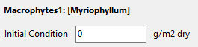

You may also enter a loading in inflow water for macrophytes in this simulation.

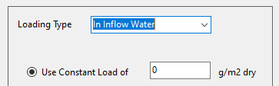

Ordinarily we think of loadings as pertaining only to chemicals and freely moving organisms such as plankton and fish.  However, it is usually desirable to enter a small constant loading to serve as a “seed” if the population or group is killed off entirely by a toxicant or adverse environmental conditions. The “seed” will allow the biota to recover or recolonize, if and when conditions become favorable.  This is especially important for macrophytes that suffer winter die-back

To add this “seed” loading add the value of 1E-5 g/m2 as a constant loading.  This is small enough that it will not affect the results during the growing season, but it is large enough to prevent extinction.

See Also: Initial Conditions and Loadings

next, Viewing Parameters

#### Tutorial-- Step 3:  Viewing Parameters in A Simulation

In the following examples we will examine the parameters associated with the animals, plants, and chemicals in this simulation. Parameters can be loaded from databases of parameters when adding a state variable as we did above (when we loaded *Myriophyllum*). Records can also be loaded from a **database** by choosing **Read from DB** when looking at parameters associated with the animal, plant, and chemical state variables.

We will examine first the plants parameters associated with Myriophyllum. From the loadings form, select the **Parameters** button at top of the screen.



Plant parameters for *Myriophyllum* will then appear. Two fields near the top of the screen require explanation.  If you click on the drop down menu to the right of **Plant type**, you will be given a choice. The choice of **Plant type** is important because different types have different physical or biological processes that apply to them.  For instance, phytoplankton are subject to sinking, but not periphyton, which are attached to a surface.  Conversely periphyton are limited somewhat by very slow current velocity; but not phytoplankton, which are adapted to still water.

Less obvious is the **Toxicity Record**; again, clicking on the arrow to the right of the field will give you several choices.  The intent is to associate this modeled organism record with one of the limited number of organisms that have some toxicity data or procedures for estimating toxicity.  In this instance, if you choose **Macrophytes** the model will utilize the toxicity data (e.g., EC50) for Esfenvalerate to “Macrophytes.”

Parameter values within the model’s databases are provided to get you started; if you have more appropriate or locally-measured values, you should use them.

The primary parameters are shown on the input window by default, but the screen can be modified to display other subsets of parameters by selecting the “Expand” button next to each subheading.

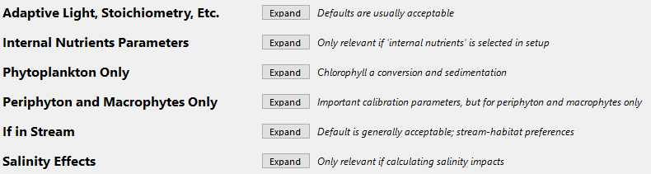

Next, we will locate the parameters for the Chironomid (DepFeeder1) within the simulation. Hit **Cancel** to leave the plant parameters screen and then select OK to return to the main window and save your changes to the organism’s initial condition and loadings.

Double click on the Chironomid about 2/3 of the way down the state variable list and again, select “Parameters”

Click on **Animal Type** to see the pull-down menu.  Chironomids have aquatic larvae, so **Benthic insect** is chosen; this is important because emergence is simulated by AQUATOX for insects as a loss term, but does not apply to other animals.

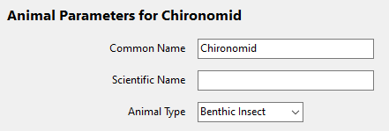

Finally, we will examine the organic matter data for this study.  To do this, return to the main screen, and select the **Org. Matter** button. Many of the parameters on this screen are global and there is little need to change them for a site, unless the organic material is quite different or there is some reason that the microflora might have adapted to abnormal conditions, such as a thermal spring or acid mine drainage.  For more information about the three different types of Remineralization records included with AQUATOX see the section entitled Remineralization**.**

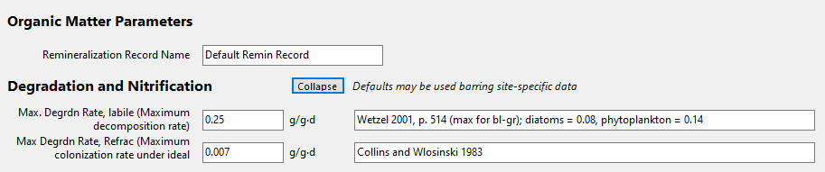

At the upper right of the main simulation window are buttons that will take you to matrices that show the available site, animal, organic matter (remin.), chemical, and plant parameters that are included with the AQUATOX model. Unless these parameters are loaded into a simulation, as discussed above, they will have no impact on a model’s result.

Next, Viewing Toxicant Loadings

#### Tutorial-- Step 4:  Viewing Toxicant Loadings

Following the tutorial to this point, we should still have **FarmPond MO Esfenval.aps** loaded from back in **Step 1**.  Return to the main screen.

In the “State and Driving Variables” list, double-click on **Dissolved org. tox 1** to bring up the loadings form for the chemical, and to examine the options for loadings to the system.  Pollutant loadings can be entered as constant or dynamic loadings in several different forms. The pollutant can be entered as a concentration in the dissolved phase or loosely bound to suspended sediment; the water inflow and the site volume are then used by the model to compute the loading per unit volume.

Click on the Loading Type drop down box to toggle between loadings types.

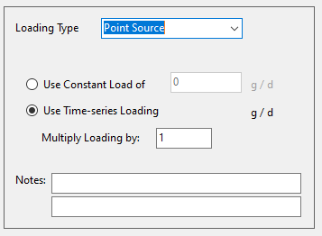

Point-source loadings are mass per day (g/d) for the entire site; they are divided by the site volume to obtain the loading per unit volume.  In this example, dynamic loadings from a point discharge as calculated by the PRZM model are entered.  Note that the dynamic loadings are interpolated, so if the intent is to represent a spike such as from storm runoff on a particular day, then the loadings should be bracketed by “0" loadings.  The model assumes that the loadings “wrap around” with an annual cycle and that the last loading can be interpolated to the first loading as if it were in the succeeding year.   Exercise caution when modeling multiple years with only loadings data from one or a few years.  Sporadic loadings, which could only be expected in one particular year might inappropriately be repeated in successive years.  If you do not wish loadings to be repeated, enter values (“0" or otherwise) for the first and last days of the simulation.  The dynamic loadings in this example were entered by hand; an excellent alternative is to download or prepare a file external to the model and import it into the study using the **Import** button.  See also Important Note about Dynamic Loadings.

Another potential pollution loading source is from direct precipitation.  These loads are given as g/m2 day because AQUATOX does not explicitly consider precipitation.

Next, Running the Simulation

#### Tutorial-- Step 5:  Running the Simulation

To run the simulation, select the **Integrate** button at the upper left portion of the main screen. (Soon to read “Run”)

You will be asked for an optional text string to define the run. Multiple runs can be saved within each AQUATOX JSON and then can be compared graphically or have their results compared within the output window. The date of each simulation will be also saved.

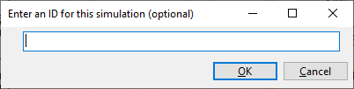

A progress bar will appear showing the status of the model run. This run should take a minute or two.

Next, Viewing Output

#### Tutorial-- Step 6:  Viewing Output

When a study has been executed, results for various state variables are stored in memory. These results will be saved as an updated JSON if the simulation is saved.  After the simulation has completed the **Output** window will pop up. (To view the output at another time, select the “Output’ button on the main window.)

By selecting “**Save CSV**” all model results may be exported to a comma-separated text-file format for import into spreadsheet or database software.

By selecting “**New Graph**” a set of model results can be exported.

* To see the chemical concentration in water, name the graph “Chemical in Water”, and then use the arrow buttons to move “Dissolved org tox 1:” to the box on the right.

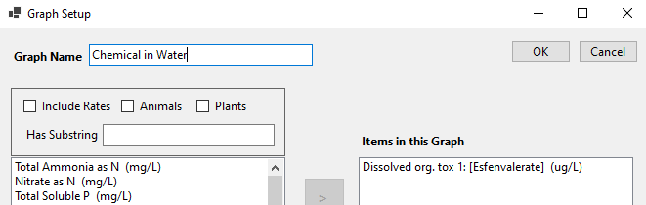

After selecting OK you will see a graph of predicted water-column concentrations of Esfenvalerate given the PRZM based inputs.

* To see results for all the animals in a simulation, click “New Graph” again, name the graph “Animals,” click on the “Animals” check box on top of the output list, and use the double right arrow to move all of the animals onto the graph.

Clicking on any of the results in the graph will identify the state variable and provide a snapshot of its concentration in time. Also, items on the graph may be toggled by clicking the colored rectangles within the legend.

For more information about the output window see: Viewing Graphical Output