**HMS Nutrients Data Requirements**

To model nutrients in HMS (nitrogen and phosphorus), the HMS AQUATOX water volume model must be implemented so that the impacts of water flows on nutrient concentrations can be calculated. (Linkage to alternative volume models is coming soon.) Other data requirements are state variables for temperature, oxygen, and pH. These variables may be modeled within AQUATOX using the derivatives listed below or they may be driven with external data or other HMS components.

The following diagram shows the relevant state variable or model components and the data requirements for the nitrogen model.



The formation of nutrients via remineralization and the uptake of nutrients via assimilation (and TSP by calcium carbonite precipitation) can be estimated either by modeling organic matter animals and plants explicitly (when these units become available). Alternatively, for flexibility, time-series inputs may be used to reflect rates of change given external models or estimates.

The list of time-series linkages into the nutrient state variable derivatives are listed here (all units are g/m3⋅d):

|  |  |  |  |
| --- | --- | --- | --- |
| **State Variable** | **Derivative Linkage** | **Name within JSON** | **Omit if explicitly modeling** |
| Ammonia | *Assimilation* | "Assimilation_Link" | Plants |
| Ammonia | *Remineralization* (Animal Component) | "Animal_Remin_Link" | Animals |
| Ammonia | *Remineralization* (Plant Component) | "Plant_Remin_Link" | Plants |
| Ammonia | *Remineralization* (Organic Matter Component) | "OM_Remin_Link" | Organic Matter (detritus) |
| Nitrate | *Assimilation* | "Assimilation_Link" | Plants |
| Phosphate | *Assimilation* | "Assimilation_Link" | Plants |
| Phosphate | *Remineralization* (Animal Component) | "Animal_Remin_Link" | Animals |
| Phosphate | *Remineralization* (Plant Component) | "Plant_Remin_Link" | Plants |
| Phosphate | *Remineralization* (Organic Matter Component) | "OM_Remin_Link" | Organic Matter (detritus) |
| Phosphate | *SorptionP* | "CalcitePcpt_Link" | Plants |
| Carbon Dioxide | *Decompose* | "OM_Decomp_Link" | Organic Matter (detritus) |
| Carbon Dioxide | *Respired* | "Respiration_Link" | Animals/Plants |
| Carbon Dioxide | *Assimilation* | "Assimilation_Link" | Plants |
| Oxygen | *Photosynthesized* | "Photosynthesis_Link" | Plants |
| Oxygen | *Respiration* | "Respiration_Link" | Animals/Plants |
| Oxygen | *NitroDemand* | "Nitrification_Link" | Nitrogen |
| Oxygen | *BOD* | "CBOD_Link" | Organic Matter (detritus) |
| Oxygen | *SOD* | "SOD_Link" | Org. Matter or Diagenesis |

Example JSON data files that include nutrient models with and without external linkages may be found in the associated DOCS directory.

The following pages are excerpts from the relevant sections of the AQUATOX Release 3.2 Technical Documentation. The HMS nutrient model was not changed from the AQUATOX Release 3.2 implementation and results were verified against AQUATOX Release 3.2 results.

**5.2 Nitrogen**

**Nitrogen: Simplifying Assumptions**

* Nitrite is not explicitly modeled
* Both nitrogen fixation and denitrification are subject to environmental controls; therefore, the nitrogen cycle is represented with considerable uncertainty.
* Lethal effects from un-ionized and ionized ammonia are assumed additive.
* Ammonia makes up stoichiometric imbalances between trophic levels.

In the water column, two nitrogen compartments, ammonia and nitrate, are modeled. Nitrite occurs in very low concentrations and is rapidly transformed through nitrification and denitrification (Wetzel, 1975); therefore, it is modeled with nitrate. Un-ionized ammonia (NH3) is not modeled as a separate state variable but is estimated as a fraction of ammonia **(177)**. In the sediment bed, if the optional sediment diagenesis model is included (see chapter 7), nitrogen is explicitly modeled; otherwise inorganic nitrogen in the sediment bed is ignored, but organic nitrogen is implicitly modeled as a component of sedimented detritus.

In the water column, ammonia is assimilated by algae and macrophytes and is converted to nitrate as a result of nitrification:

 **(168)**

where:

*dAmmonia/dt* = change in concentration of ammonia with time (g/m3⋅d);

*Loading* = loading of nutrient from inflow (g/m3⋅d);

*Remineralization* = ammonia derived from detritus and biota (g/m3⋅d), see **(169)**;

*Nitrify* = nitrification (g/m3⋅d), see **(174)**;

*Assimilation* = assimilation of nutrient by plants (g/m3⋅d), see **(171)**;

*Washout* = loss of nutrient due to being carried downstream (g/m3⋅d), see **(16)**

*Washin*  = loadings from linked upstream segments (g/m3·d), see **(30)**;

*DiffusionSeg* = gain or loss due to diffusive transport over the feedback link between two segments, (g/m3⋅d), see **(32)**;

*TurbDiff* = depth-averaged turbulent diffusion between epilimnion and hypolimnion if stratified (g/m3⋅d), see **(22)** and **(23)**;

*FluxDiagenesis* = potential flux from the sediment diagenesis model, (g/m3⋅d), see **(273)**

*Remineralization* includes all processes by which ammonia is produced from animal, plants, and detritus, including decomposition and excretion required to maintain variable stoichiometry (see Table 14):

  **(169)**

where:

*PhotoResp* = algal excretion of ammonia due to photo respiration (g/m3⋅d);

*DarkResp* = algal excretion of ammonia due to dark respiration (g/m3⋅d);

*AnimalResp* = excretion of ammonia due to animal respiration (g/m3⋅d);

*AnimalExcr* = animal excretion of excess nutrients to ammonia to maintain constant org. to N ratio as required (g/m3⋅d);

*DetritalDecomp* = nitrogen release due to detrital decomposition (g/m3⋅d);

*AnimalPredation* = change in nitrogen content necessitated when an animal consumes prey with a different nutrient content (g/m3⋅d), see discussion in “Mass Balance of Nutrients” in Section 5.4;

*NutrRelDefecation =*  ammonia released from animal defecation (g/m3⋅d);

*NutrRelPlantSink =*  ammonia balance from sinking of plants and conversion to detritus (g/m3⋅d);

*NutrRelMortality =*  ammonia balance from biota mortality and conversion to detritus (g/m3⋅d);

*NutrRelGameteLoss =*  ammonia balance from gamete loss and conversion to detritus (g/m3⋅d);

*NutrRelColonization =*  ammonia balance from colonization of refractory detritus into labile detritus (g/m3⋅d);

*NutrRelPeriScour =*  ammonia balance when periphyton is scoured and converted to phytoplankton and suspended detritus. (g/m3⋅d);

Nitrate is assimilated by plants and is converted to free nitrogen (and lost) through denitrification:

 **(170)**

where:

*dNitrate*/d*t* = change in concentration of nitrate with time (g/m3⋅d);

*Washin*  = loadings from linked upstream segments (g/m3·d), see **(30)**;

*DiffusionSeg* = gain or loss due to diffusive transport over the feedback link between two segments, (g/m3⋅d), see **(32)**;

*Loading* = user entered loading of nitrate, including atmospheric deposition;

*Denitrify* = denitrification (g/m3⋅d), see **(175)**;

*FluxDiagenesis* = potential flux from the sediment diagenesis model, (g/m3⋅d), see **(273)**

Free nitrogen can be fixed by cyanobacteria. Both nitrogen fixation and denitrification are subject to environmental controls and are difficult to model with any accuracy; therefore, the nitrogen cycle is represented with considerable uncertainty.

Figure . Components of nitrogen remineralization

 .

**Fixation**

**Free N (not in model domain)**

AQUATOX will estimate and output total nitrogen (TN) in the water column. Total nitrogen is the sum of ammonia and nitrate in the water column as well as nitrogen associated with dissolved and suspended particulate organic matter and phytoplankton (see section 5.4 for further details).

**Assimilation**

Nitrogen compounds are assimilated by plants as a function of photosynthesis in the respective groups (Ambrose et al., 1991):

 **(171)**

  **(172)**

When internal nutrients are modeled, the equations are slightly different

 **(171b)**

 **(172b)**

where:

*Assimilation* = assimilation rate for given nutrient (g/m3⋅d);

*Photosynthesis* = rate of photosynthesis (g/m3⋅d), see **(35)**;

*N2Org Plant* = fraction of photosynthate that is nitrogen (unitless, user input as part of plant underlying data);

*PhytoUpN* = uptake of internal nutrients (mg/m3⋅d), see **(55e)**;

*NH4Pref* = ammonia preference factor (unitless).

Only 23 percent of nitrate is nitrogen, but 78 percent of ammonia is nitrogen. This results in an apparent preference for ammonia. The preference factor is calculated with an equation developed by Thomann and Fitzpatrick (1982) and cited and used in WASP (Ambrose et al., 1991):

 **(173)**

where:

*N2NH4* = ratio of nitrogen to ammonia (0.78);

*N2NO3* = ratio of nitrogen to nitrate (0.23);

*KN* = half-saturation constant for nitrogen uptake (g N/m3);

*Ammonia* = concentration of ammonia (g/m3); and

*Nitrate* = concentration of nitrate (g/m3).

For algae other than cyanobacteria, *Uptake* is the Redfield (1958) ratio; although other ratios (cf. Harris, 1986) may be used by editing the parameter screen. At this time nitrogen-fixation by cyanobacteria is represented by using a smaller uptake ratio, thus "creating" nitrogen. Nitrogen fixation is not tracked explicitly as a separate rate in the plant’s derivative.

**Nitrification and Denitrification**

Nitrification is the conversion of ammonia to nitrite and then to nitrate by nitrifying bacteria; it occurs at the sediment-water interface (Effler et al., 1996) and in the water column (Schnoor 1996). The maximum rate of nitrification is reduced by limitation factors for suboptimal dissolved oxygen and pH, similar to the way that decomposition is modeled, but using the more restrictive correction for suboptimal temperature used for plants and animals:

 **(174)**

where:

*Nitrify* = nitrification rate (g/m3⋅d);

*KNitri* = maximum rate of nitrification (m/d);

*DOCorrection* = correction for anaerobic conditions (unitless) see **(160)**;

*TCorr* = correction for suboptimal temperature (unitless); see **(59)**;

*pHCorr* = correction for suboptimal pH (unitless), see **(162)**; and

*Ammonia* = concentration of ammonia (g/m3).

If the Sediment Diagenesis model is used, the *KNitri* value may need to be decreased to account for sediment nitrification being represented separately. The nitrifying bacteria have narrow environmental optima; according to Bowie et al. (1985) they require aerobic conditions with a pH between 7 and 9.8, an optimal temperature of 30̊, and minimum and maximum temperatures of 10 ̊ and 60 ̊ respectively (Figure 101, Figure 102).

Figure . Response to pH, nitrification

Figure . Response to temperature, nitrification

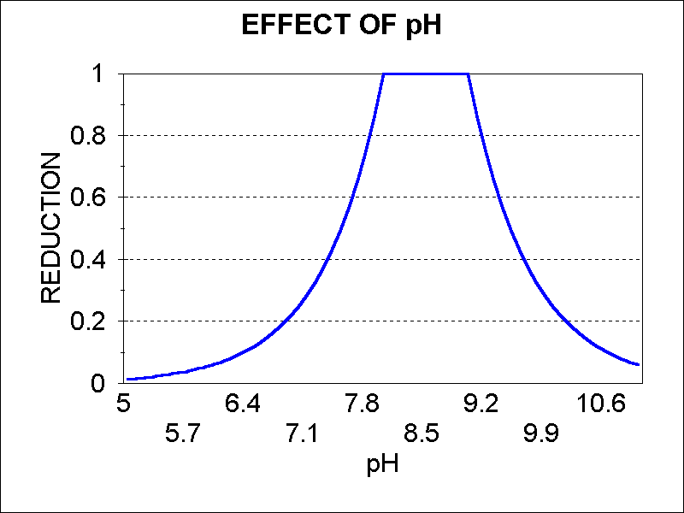 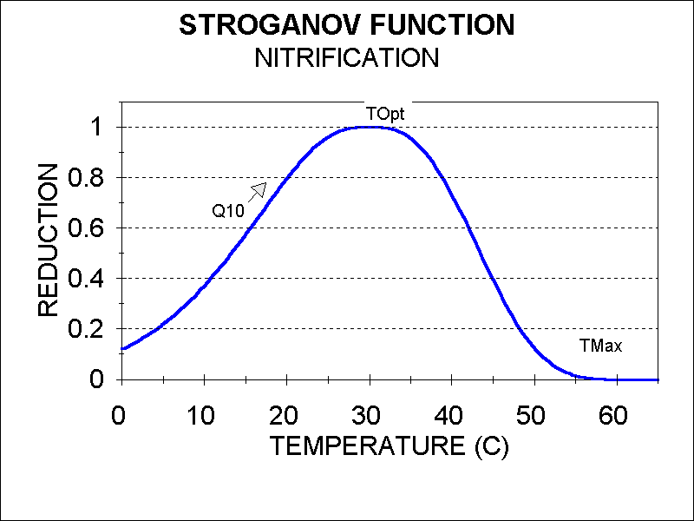

Denitrification is the conversion of nitrate and nitrite to free nitrogen and occurs as an anaerobic process. However, only a small part of the denitrification occurs at the sediment-water interface and it can also occur in the water column due to “anoxic microsites” such as the interior of detrital particles (Di Toro 2001). Therefore, AQUATOX follows the convention of other models in representing denitrification as a bulk process (by combining sediment and water-column denitrification). This approach is a change from earlier model versions, including AQUATOX Release 3.0, where denitrification processes at the sediment-water interface and in the water column were considered separately. Low oxygen levels enhance the denitfification process (Ambrose et al., 1991):

 **()**

where:

*Denitrify* = denitrification rate (g/m3⋅d);

*KDenitri* = user-input maximum rate of denitrification (1/d);

*TCorr* = effect of suboptimal temperature (unitless), see **(59)**;

*pHCorr* =effect of suboptimal pH (unitless), see **(162)**; and

*Nitrate* = concentration of nitrate (g/m3).

*KDenitri* might need to be reduced when the sediment diagenesis model is included, because denitrification in the sediment bed is explicitly tracked within that model (see **(278)**)

Furthermore, denitrification is accomplished by a large number of reducing bacteria under anaerobic conditions and with broad environmental tolerances (Bowie et al., 1985; Figure 103**,** Figure 104).

Figure . Response to pH, denitrification

Figure . Response to temperature, denitrif.

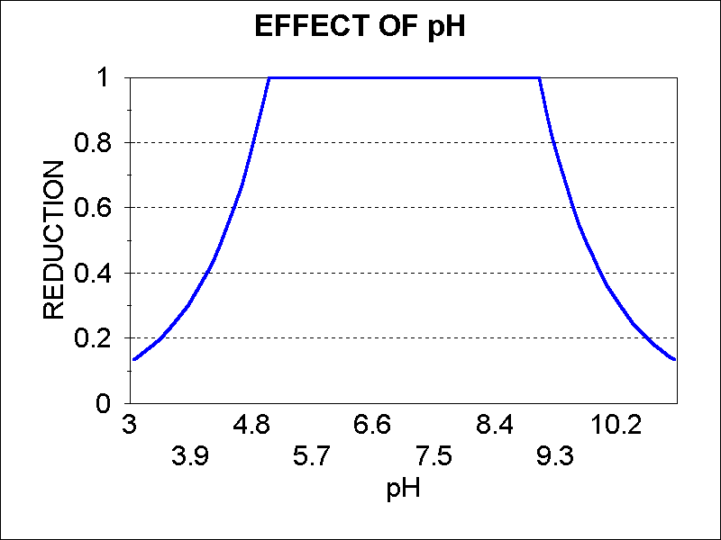 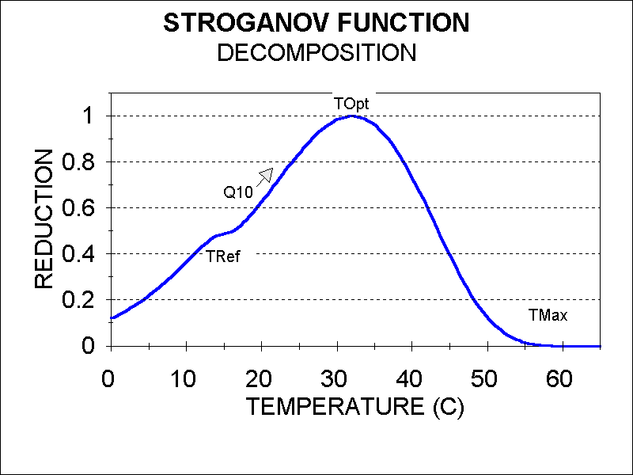

**Ionization of Ammonia**

The un-ionized form of ammonia, NH3, is toxic to invertebrates and fish. Therefore, it is often singled out as a water quality criterion. Un-ionized ammonia is in equilibrium with the ammonium ion, NH4+, and the proportion is determined by pH and temperature. It is useful to report NH3 as well as total ammonia (NH3 + NH4+).

The computation of the fraction of total ammonia that is un-ionized is relatively straightforward (Bowie et al. 1985):

 **(176)**

 **(177)**

 **(178)**

where:

*FracNH3* = fraction of un-ionized ammonia (unitless);

*pkh* = hydrolysis constant;

*NH3* = un-ionized ammonia (mg/L);

*Ammonia* = total ammonia (mg/L) see **(168)**;

*TKelvin* = temperature (ºK).

The relative contributions of temperature and pH can be seen by graphing the fraction of un-ionized ammonia against each of those variables in simulations of Lake Onondaga (Figure 108

and Figure 109). As inspection of the construct would suggest, un-ionized ammonia has a linear relationship to temperature and a logarithmic relationship to pH, which causes it to be sensitive to extremes in pH.

Figure . Fraction of un-ionized ammonia roughly following temperature.



Figure . Fraction of un-ionized ammonia affected by extreme values of pH.



The construct was verified with the same set of data from Lake Onondaga as was used for the pH verification (Effler et al. 1996), see section 5.7. It fits the observed data well (Figure 110).

Figure . Comparison of predicted and observed fraction of NH3 for Lake Onondaga, NY.   
Data from (Effler et al. 1996).



**Ammonia Toxicity**

Lethal effects of ammonia on animals have been implemented in AQUATOX based on *Update of Ambient Water Quality Criteria for Ammonia* (U.S. Environmental Protection Agency, 1999). Based on this document, it is preferable to base toxicity on total ammonia, taking into account the contributions from the un-ionized and ionized ammonia (*LC50u* and *LC50i*):

 **(179)**

 **(180)**

where:

*LC50u* =LC50 for the unionized concentrations of ammonia

*LC50i* =LC50 for the ionized concentrations of ammonia.

*LC50total ammonia* = *LC50u* + *LC50i*

*pHT* =transition pH at which LC50 is the average of the high- and low-pH intercepts (7.204);

*R* = shape parameter defined as the ratio of the high- and low-pH intercepts (0.00704), along with pHT, defines the shape of the curve;

LC50t,8 = user-input *LC50total ammonia* at 20 degrees centigrade and pH of 8.

LC50 parameters derived with the equations above are then applied to the external toxicity formulation (see section 9.3, equations **(429)-(431)**). The slope of the Weibull curve is a constant 0.7 for both forms of ammonia. This value produces the best general match of data from Appendix 6 from the Ammonia Criteria update (U.S. Environmental Protection Agency, 1999). Lethal effects from un-ionized and ionized ammonia are assumed to be additive.

**5.3 Phosphorus**

**Phosphorus: Simplifying Assumption**

* Total bioavailable soluble phosphorus is modeled
* A constant sorption rate for calcite is used
* Soluble phosphorus makes up stoichiometric imbalances between trophic levels.

The phosphorus cycle is simpler than the nitrogen cycle. Decomposition, excretion, and assimilation are important processes that are similar to those described above. As was the case with ammonia and nitrate, if the optional sediment diagenesis model is included (see Chapter 7), flux of phosphate from the sediment bed may be added to the water column, especially under anoxic conditions. Additionally, sorption to calcite may have a significant effect on phosphate predictions in high pH systems due to precipitation of calcium carbonate. This optional formulation is important to adequately simulate marl lakes.

 **(181)**

 **(182)**

where:

*dPhosphate/dt* = change in concentration of phosphate with time (g/m3⋅d);

*Loading* = loading of nutrient from inflow and atmospheric deposition (g/m3⋅d);

*Remineralization* = phosphate derived from detritus and biota (g/m3⋅d), see **(183)**;

*Assimilation* = assimilation by plants (g/m3⋅d);

*TurbDiff* = depth-averaged turbulent diffusion between epilimnion and hypolimnion if stratified (g/m3⋅d), see **(22)** and **(23)**;

*Washout* = loss of nutrient due to being carried downstream (g/m3⋅d), see **(16)** *Washin*  = loadings from linked upstream segments (g/m3·d), see **(30)**;

*DiffusionSeg* = gain or loss due to diffusive transport over the feedback link between two segments, (g/m3⋅d), see **(32)**;

*SorptionP* = rate of sorption of phosphorus to calcite (mgP/L⋅d), see **(218)**;

*FluxDiagenesis* = potential flux from the sediment diagenesis model, (g/m3⋅d), see **(273)**

*Photosynthesis* = rate of photosynthesis (g/m3⋅d), see **(35)**, and

*Uptake* = fraction of photosynthate that is phosphate (unitless, 0.018).

As was the case with ammonia, *Remineralization* includes all processes by which phosphate is produced from animal, plants, and detritus, including decomposition, excretion, and other processes required to maintain mass balance given variable stoichiometry (see Table 15):

 **(183)**

where:

*PhotoResp* = algal excretion of phosphate due to photo-respiration (g/m3⋅d);

*DarkResp* = algal excretion of phosphate due to dark respiration (g/m3⋅d);

*AnimalResp* = excretion of phosphate due to animal respiration (g/m3⋅d);

*AnimalExcr* = animal excretion of excess nutrients to phosphate to maintain constant org. to P ratio as required (g/m3⋅d);

*DetritalDecomp* = phosphate release due to detrital decomposition (g/m3⋅d);

*AnimalPredation* = change in phosphate content necessitated when an animal consumes prey with a different nutrient content (g/m3⋅d), see discussion in “Mass Balance of Nutrients” below;

*NutrRelDefecation =*  phosphate released from animal defecation (g/m3⋅d);

*NutrRelPlantSink =*  phosphate balance from sinking of plants and conversion to detritus (g/m3⋅d);

*NutrRelMortality =*  phosphate balance from biota mortality and conversion to detritus (g/m3⋅d);

*NutrRelGameteLoss =*  phosphate balance from gamete loss and conversion to detritus (g/m3⋅d);

*NutrRelColonization =*  phosphate balance from colonization of refractory detritus into labile detritus (g/m3⋅d);

*NutrRelPeriScour =*  phosphate balance when periphyton is scoured and converted to phytoplankton and suspended detritus. (g/m3⋅d);

At this time AQUATOX models only phosphate available for plants; a correction factor in the loading screen allows the user to scale total phosphate loadings to available phosphate. A default value is provided for average atmospheric deposition, but this should be adjusted for site conditions. In particular, entrainment of dust from tilled fields and new highway construction can cause significant increases in phosphate loadings. As with nitrogen, the default uptake parameter is the Redfield (1958) ratio; it may be edited if a different ratio is desired (cf. Harris, 1986).

AQUATOX estimates and outputs total phosphate (TP) in the water column. TP is the sum of dissolved phosphate in the water column as well as phosphate associated with dissolved and suspended particulate organic matter and phytoplankton(see section 5.4 for further details).

**5.4 Nutrient Mass Balance**

**Nutrient Mass Balance: Simplifying Assumptions**

* Stoichiometry within each model compartment is constant over time
* Free nitrogen is not tracked within AQUATOX
* Nutrients taken up by macrophyte roots come from sources that are outside the modeled system
* Mass balance may fail if total nutrients in the water column drop to zero (due to inter-organism interactions)
* Ammonia loadings are assumed to be 12 to 15% when total nitrate loadings are input by the user.
* Dissolved nutrients make up stoichiometric imbalances between trophic levels.

**Variable Stoichiometry**

The ratios of elements in organic matter are allowed to vary among but not within compartments. This is accomplished by providing editable fields for N:organic matter and P:organic matter for each compartment. Furthermore, the wet to dry ratio is editable for all compartments; it has a default value of 5.

In order to maintain the specified ratios for each compartment, the model explicitly accounts for processes that balance the ratios during transfers, such as excretion coupled with consumption and nutrient uptake coupled with detrital colonization. Nutritional value is not automatically related to stoichiometry in the model, but it is implicit in default egestion values provided with various food sources. Table 13 shows the default stoichiometric values suggested for the model, although these can be edited.

Table 13: Default stochiometric values in AQUATOX

|  |  |  |  |
| --- | --- | --- | --- |
| **Compartment** | **Frac. N (dry)** | **Frac. P (dry)** | **Reference** |
| Refrac. detritus | 0.002 | 0.0002 | Sterner & Elser 2002 |
| Labile detritus | 0.079 | 0.018 | Redfield (1958) ratios |
| Phytoplankton | 0.059 | 0.007 | Sterner & Elser 2002 |
| Cyanobacteria | 0.059 | 0.007 | same as phytoplankton for now |
| Periphyton | 0.04 | 0.0044 | Sterner & Elser 2002 |
| Macrophytes | 0.018 | 0.002 | Sterner & Elser 2002 |
| Cladocerans | 0.09 | 0.014 | Sterner & Elser 2002 |
| Copepods | 0.09 | 0.006 | Sterner & Elser 2002 |
| Zoobenthos | 0.09 | 0.014 | same as cladocerans for now |
| Minnows | 0.097 | 0.0149 | Sterner & George 2000 |
| Shiner | 0.1 | 0.025 | Sterner & George 2000 |
| Perch | 0.1 | 0.031 | Sterner & George 2000 |
| Smelt | 0.1 | 0.016 | Sterner & George 2000 |
| Bluegill | 0.1 | 0.031 | same as perch for now |
| Trout | 0.1 | 0.031 | same as perch for now |
| Bass | 0.1 | 0.031 | same as perch for now |

**Nutrient Loading Variables**

Often water quality data are given as total nitrogen and phosphorus. In order to improve agreement with monitoring data, AQUATOX can accept both loadings and initial conditions as “Total N” and “Total P.” This approach is made possible by accounting for the nitrogen and phosphorus contributed by suspended and dissolved detritus and phytoplankton and back-calculating the amount that must be available as freely dissolved nutrients. The precision of this conversion is aided by the model’s variable stoichiometry. For nitrogen:

 **(184)**

where:

*NDissolved* = bioavailable dissolved nitrogen (g/m3 d); see **(170)**;

*NTotal* = loadings of total nitrogen as input by the user (g/m3 d);

*NSuspendedDetritus* = nitrogen in suspended detritus loadings (g/m3 d);

*NSuspendedPlants =* nitrogen in suspended plant loadings (g/m3 d).

When Total N inputs are used, ammonia is assumed to be a fixed percentage of bioavailable dissolved nitrogen, based on the type of input:

* Inflow waters: Ammonia content of dissolved inorganic nitrogen = 12%
* Point sources: Ammonia content of dissolved inorganic nitrogen = 15%
* Non-point sources: Ammonia content of dissolved inorganic nitrogen = 12%

These percentages are based on professional judgement, they are averages from several large data sets. However, if the user wishes to use a different percentage, separate ammonia and nitrate data sets can be derived from the Total N time-series and input individually.

In acknowledgment of the way it is used in the model, the phosphorus state variable is designated “Total Soluble P.” Phosphorus that is not bioavailable (i.e. immobilized phosphorus and acid-soluble phosphorus) may be specified using the *FracAvail* parameter as shown here:

 **(185)**

where:

*TSP* = bioavailable phosphorus (g/m3 d); see **(181)**;

*FracAvail* = user-input bioavailable fraction of phosphorus;

*PTotal* = loadings of total phosphorus (g/m3 d);

*PSuspendedDetritus* = phosphorus in suspended detritus loadings (g/m3 d);

*PSuspendedPlants =* phosphorus in suspended plant loadings (g/m3 d).

**Nutrient Output Variables**

In order to compare model results with monitoring data, total phosphorus, and total nitrogen are calculated as output variables. This approach is accomplished by the reverse of the calculations for the loadings: the contributions of the nutrient in the freely dissolved state and tied up in phytoplankton and dissolved and particulate organic matter are calculated and summed.

Carbonaceous biochemical oxygen demand (CBOD5) is estimated considering the sum of detrital decomposition. The contributions from phytoplankton and labile dissolved and particulate organic matter are included using an oxygen to biomass conversion factor entered in the remineralization record.

Simplified diagrams of the nitrogen and phosphorus cycles can be found in Figure 108 and Figure 109. A full accounting of the 18 nutrient linkages and all external loads and losses for nitrogen and phosphorus is also provided in Table 14 and Table 15.

There are instances in which nutrients can be moved to and from compartments that are not in the model domain. For example, when NO3 undergoes denitrification and becomes free nitrogen the free nitrogen is no longer tracked within AQUATOX. An example of nutrients entering the model domain comes with the growth of macrophytes. Rooted macrophytes are not limited by a lack of nutrients in the water column as nutrients are derived from the sediment. Therefore, when photosynthesis of macrophytes produces growth, the nutrient content within the leaves of the macrophytes is assumed to originate from the pore waters of the sediments. However, this implicit “nutrient pumping” is tracked in the mass balance output. Nitrogen fixation is another addition of nutrients from outside of the model domain that is tracked with the mass balance output varaible called “N fixation.”

Additionally, some simplifications are required as a result of dietary imbalances. For example, herbivores generally have higher nutrient concentrations than the plants that they are consuming. When biomass is converted from a plant into an animal through consumption the imbalance has to be satisfied to maintain mass balance. Sterner and Elser (2002) state: “There is no single way that consumers maintain their stoichiometry in the face of imbalanced resources.” As a simplification, AQUATOX takes nutrients from the dissolved water-column compartments to make up this difference (see *AnimalPredation* in **(169)**). However, these same herbivores ingest plants with higher nutrient concentrations than the fecal matter that they defecate. When biomass is converted from plants to detrital matter through defecation the model simulates a release of nutrients into the water column (see *NutrRelDefecation* in **(169)**). These two simplifying algorithms, therefore, balance each other for the most part, and such interactions will have only a minor effect on predicted water-column nutrient concentrations. Likewise, nutrient-poor refractory detritus is converted to labile detritus through microbial colonization and growth; this is stimulated by uptake of nutrients from the water column (Sterner and Elser 2002) and is represented in the model.



**Figure 108**

**Table 14**



**Figure 109**



**Table 15**

In some cases, when concentrations of nutrients in the water column drop to zero, perfect mass balance of nutrients will not be maintained. Nutrient to organic matter ratios within organisms do not vary over time, therefore transformation of organic matter (e.g. consumption, mortality, sloughing, and sedimentation) occasionally requires that a nutrient difference be made up from the water column. If there are no available nutrients in the water column, a slight loss of mass balance is possible.

The mass associated with each component can be plotted, as in Figure 113.

Figure Distribution of predicted mass of nitrogen in Lake Onondaga NY.



**5.5 Dissolved Oxygen**

**Oxygen: Simplifying Assumptions**

* Reaeration is set to zero if ice cover is predicted
* Cyanobacteria blooms limit the depth of oxygen reaeration

Oxygen is an important regulatory endpoint; very low levels can result in mass mortality for fish and other organisms, mobilization of nutrients and metals, and decreased degradation of toxic organic materials. Dissolved oxygen is usually simulated as a daily average and does not account for diurnal fluctuations (however, see **Diel Oxygen** below). It is a function of reaeration, photosynthesis, respiration, decomposition, and nitrification:

 **(186)**

 **(187)**

 **(188)**

 **(189)**

where:

*dOxygen*/d*t* = change in concentration of dissolved oxygen (g/m3⋅d);

*Loading* = loading from inflow (g/m3⋅d);

*Reaeration* = atmospheric exchange of oxygen (g/m3⋅d), see **(190)**;

*Photosynthesized* = oxygen produced by photosynthesis (g/m3⋅d);

*O2Photo* = ratio of oxygen to photosynthesis (1.6, unitless);

*BOD* = instantaneous biochemical oxygen demand (g/m3⋅d);

*NitroDemand* = oxygen taken up by nitrification (g/m3⋅d);

*Washout* = loss due to being carried downstream (g/m3⋅d), see **(16)**;

*Washin*  = loadings from linked upstream segments (g/m3·d), see **(30)**;

*DiffusionSeg* = gain or loss due to diffusive transport over the feedback link between two segments, (g/m3⋅d), see **(32)**;

*O2Biomass* = ratio of oxygen to organic matter (unitless);

*Photosynthesis* = rate of photosynthesis (g/m3⋅d), see **(35)**, **(85)**;

*Decomposition* = rate of decomposition (g/m3⋅d), see **(159)**;

***∑*** *Respiration* = sum of respiration for all organisms (g/m3⋅d), **(63)** and **(100)**;

*O2N* = ratio of oxygen to nitrogen (unitless); and

*Nitrify* = rate of nitrification (g N/m3⋅d) see **(174)**.

Reaeration is a function of the depth-averaged mass transfer coefficient *KReaer*, corrected for ambient temperature, multiplied by the difference between the dissolved oxygen level and the saturation level (cf. Bowie et al., 1985):

 **(190)**

where:

*Reaeration* = mass transfer of oxygen (g/m3⋅d);

*KReaer* = depth-averaged reaeration coefficient (1/d);

*O2Sat* = saturation concentration of oxygen (g/m3), see **(198)**; and

*Oxygen* = concentration of oxygen (g/m3).

For reaeration in estuaries, see Chapter 10 and equation **(445)**.

In conditions where ice cover is assumed, as well as in the hypolimnetic segment of a stratified simulation, *Reaeration* is generally set to zero. However, to prevent excessive oxygen buildup under these conditions, oxygen is not allowed to exceed two times saturation (*O2Sat)*. Any oxygen buildup beyond two times saturation is added to *Reaeration* as a loss term.

*KReaer* may be entered as a constant value within the site’s “underlying data.” Alternatively, AQUATOX will calculate *KReaer* based on the site-type and other characteristics. In standing water *KReaer* is computed as a minimum transfer velocity plus the effect of wind on the transfer velocity (Schwarzenbach et al., 1993) divided by the thickness of the mixed layer to obtain a depth-averaged coefficient (Figure 111):

 **(191)**

where:

*Wind* = wind velocity 10 m above the water (m/sec);

864 = conversion factor (cm/sec to m/d); and

*Thick* = thickness of mixed layer (m).

Algal blooms can generate dissolved oxygen levels that are as much as 400% of saturation (Wetzel, 2001). However, near-surface cyanobacteria blooms, which are modeled as being in the top 0.1 m, produce high levels of oxygen that do not extend significantly into deeper water. An adjustment is made in the code so that if the cyanobacteria biomass exceeds 1 mg/L and is greater than other phytoplankton biomass, the thickness subject to oxygen reaeration is set to 0.1 m. This does not affect the *KReaer* that is used in computing volatilization (see section 8.5).

In streams, reaeration is a function of current velocity and water depth (Figure 112) following the approach of Covar (1978, see Bowie et al., 1985) and used in WASP (Ambrose et al., 1991). The decision rules for which equation to use are taken from the WASP5 code (Ambrose et al., 1991).

If *Vel* < 0.518 m/sec:

 **(192)**

else:

 **(193)**

where:

*Vel* = velocity of stream (converted to m/sec) see **(14)**; and

*TransitionDepth =* intermediate variable (m).

If *Depth* < 0.61 m (but > 0.06), the equation of Owens et al. (1964, cited in Ambrose et al., 1991) is used:

 **(194)**

where:

*Depth* = mean depth of stream (m).

Otherwise, if *Depth* is > *TransitionDepth*, the equation of O'Connor and Dobbins (1958, cited in Ambrose et al., 1991) is used:



Else, if *Depth* ≤ *TransitionDepth* but not <0.60 m, the equation of Churchill et al. (1962, cited in Ambrose et al., 1991) is used:

 **(195)**

In extremely shallow streams, especially experimental streams where depth is < 0.06 m, an equation developed by Krenkel and Orlob (1962, cited in Bowie et al. 1985) from flume data is used:

 **(196)**

where:

*U* = velocity (converted to fps);

*Slope* = longitudinal channel slope (m/m); and

*H* = water depth (converted to ft).

If reaeration due to wind exceeds that due to current velocity, the equation for standing water is used. Reaeration is set to 0 if ice cover is expected (i.e., when the depth-averaged temperature < 3deg. C).

Figure . Reaeration as a Function of Wind

Figure . Reaeration in Streams

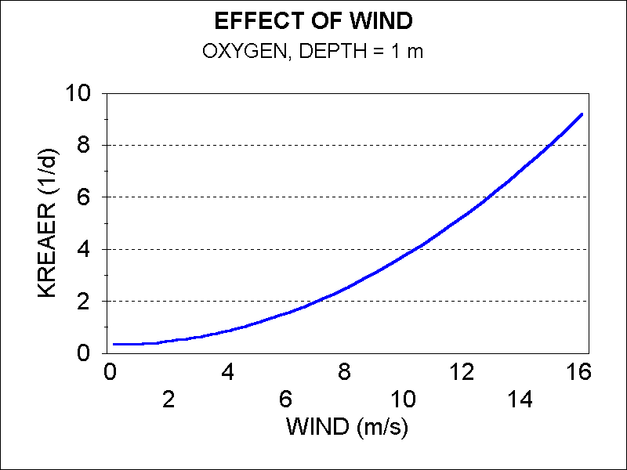 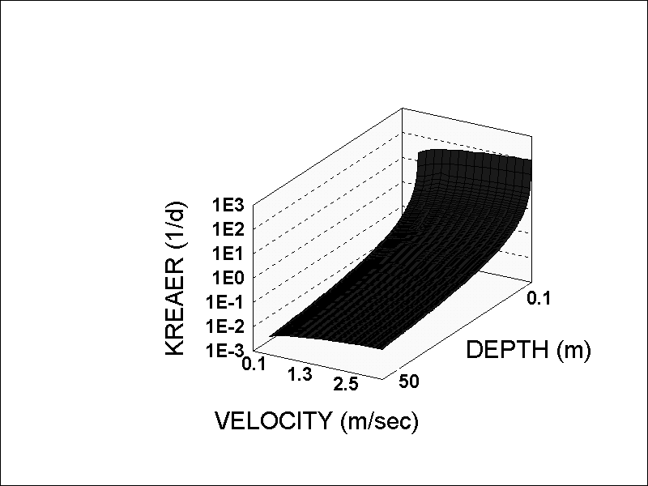

Reaeration is assumed to be representative of 20 deg. C, so it is adjusted for ambient water temperature using (Thomann and Mueller 1987):

 **(197)**

where:

*KReaerT* = Reaeration coefficient at ambient temperature (1/d);

*Kreaer20* = Reaeration coefficient for 20deg. C (1/d);

*Theta* = temperature coefficient (1.024); and

*Temperature* = ambient water temperature (deg. C).

In Release 3, oxygen saturation is calculated using the formulation of Thomann and Mueller (1987, p 277), see also APHA et al (1995). Oxygen saturation is calculated as a function of temperature (Figure 113), salinity (Figure 114), and altitude (Figure 118):

 **(198)**

and where:

*AltEffect* = Fractional reduction in oxygen saturation due to the effects of altitude (Thomann and Mueller 1987, from Zison et al. 1978);

*TKelvin* = Kelvin temperature;

*S* = salinity driving variable, set to zero if not included in model (ppt); and

*Altitude* = site specific altitude (m).

Figure . Saturation as a Function of Temp.

Figure . Saturation as a Function of Salinity

Figure . Saturation as a function of altitude

**Diel Oxygen**

Significant fluctuations in oxygen are possible over the course of each day, particularly under eutrophic conditions. This type of fluctuation may now be captured within AQUATOX when the model is run with an hourly time-step. If the model is run with a larger reporting time step (but an hourly integration time-step) the minimum and maximum oxygen concentrations will be output on the basis of the hourly results.

The instantaneous light climate **(28)** affects the photosynthesis within the system and this, in turn, affects the amount of oxygen released into the water column **(187)**. To assist in this simulation, hourly oxygen loadings may be input into AQUATOX if such data are available. Alternatively, the effects of oxygen loadings and washout may be turned off, assuming that upstream processes governing oxygen are producing water concentrations identical to the current stream segment being modeled; in this way, in-stream processes can be analyzed without being dominated by upstream loadings.

**5.6 Inorganic Carbon**

**Carbon Dioxide: Simplifying Assumptions**

* Atmospheric exchange is treated similar to that for oxygen.
* For saltwater systems, an alternative option is to import a time-series of equilibrium CO2 levels.

Many models ignore carbon dioxide as an ecosystem component (Bowie et al., 1985). However, it can be an important limiting nutrient. Similar to other nutrients, it is produced by decomposition and is assimilated by plants; it also is respired by organisms:

 **(207)**

where:

 **(208)**

 **(209)**

 **(210)**

and where:

*dCO2/dt* = change in concentration of carbon dioxide (g/m3⋅d);

*Loading*  = loading of carbon dioxide from inflow (g/m3⋅d);

*Respired* = carbon dioxide produced by respiration (g/m3⋅d);

*Decompose* = carbon dioxide derived from decomposition (g/m3⋅d);

*Assimilation* = assimilation of carbon dioxide by plants (g/m3⋅d);

*Washout* = loss due to being carried downstream (g/m3⋅d), see **(16)**;

*Washin*  = loadings from linked upstream segments (g/m3·d), see **(30)**;

*DiffusionSe* = gain or loss due to diffusive transport over the feedback link between two segments, (g/m3⋅d), see **(32)**;

*CO2AtmosExch* = interchange of carbon dioxide with atmosphere (g/m3⋅d);

*CO2Biomass* = ratio of carbon dioxide to organic matter (unitless);

*Respiration* = rate of respiration (g/m3⋅d), see **(63)** and **(100)**;

*Decomposition* = rate of decomposition (g/m3⋅d), see **(159)**;

*Photosynthesis* = rate of photosynthesis (g/m3⋅d), see **(35)**; and

*UptakeCO2* = ratio of carbon dioxide to photosynthate (= 0.53).

Carbon dioxide also is exchanged with the atmosphere; this process is important, but is not instantaneous: significant undersaturation and oversaturation are possible (Stumm and Morgan, 1996). The treatment of atmospheric exchange is similar to that for oxygen:

 **(211)**

In fact, the mass transfer coefficient is based on the well-established reaeration coefficient for oxygen, corrected for the difference in diffusivity of carbon dioxide as recommended by Schwarzenbach et al. (1993):

 **(212)**

where:

*CO2AtmosExch* = interchange of carbon dioxide with atmosphere (g/m3⋅d);

*KLiqCO2* = depth-averaged liquid-phase mass transfer coefficient (1/d);

CO2 = concentration of carbon dioxide (g/m3);

*CO2Equil* = equilibrium concentration of carbon dioxide (g/m3), see **(213)**;

*KReaer* = depth-averaged reaeration coefficient for oxygen (1/d), see **(191)**-**(195)**;

*MolWtO2* = molecular weight of oxygen (=32); and

*MolWtCO2* = molecular weight of carbon dioxide (= 44).

Keying the mass-transfer coefficient for carbon dioxide to the reaeration coefficient for oxygen is very powerful in that the effects of wind (Figure 123) and the velocity and depth of streams can be represented, using the oxygen equations (Equations **(191)**-**(195)**).

Figure . Carbon dioxide mass transfer

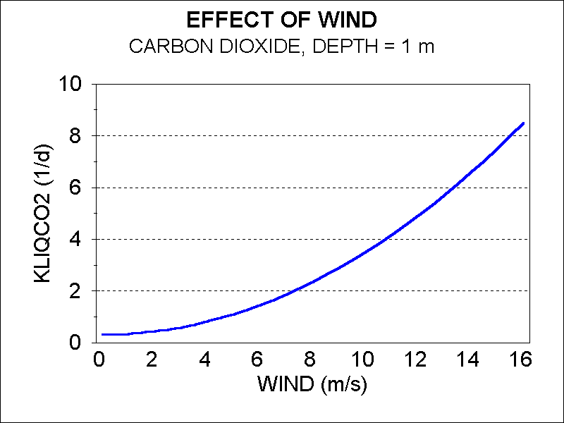

Based on this approach, the predicted mass transfer under still conditions is 0.92, compared to the observed value of 0.89 ± 0.03 (Lyman et al., 1982). This same approach is used, with minor modifications, to predict the volatilization of other chemicals (see Section 8.5). Computation of equilibrium of carbon dioxide is based on the method in Bowie et al. (1985; see also Chapra and Reckhow, 1983) using Henry's law constant, with its temperature dependency (Figure 124), and the partial pressure of carbon dioxide:

 **(213)**

where:

 **(214)**

 **(215)**

and where:

*CO2Equil* = equilibrium concentration of carbon dioxide (g/m3);

*CO2Henry* = Henry's law constant for carbon dioxide (g/m3-atm):

*pCO2* = atmospheric partial pressure of carbon dioxide (= 0.00035);

*MCO2* = mg carbon dioxide per mole (= 44000);

*TKelvin* = temperature in deg.K, and

*Temperature* = ambient water temperature (deg. C).

Figure . Saturation of carbon dioxide

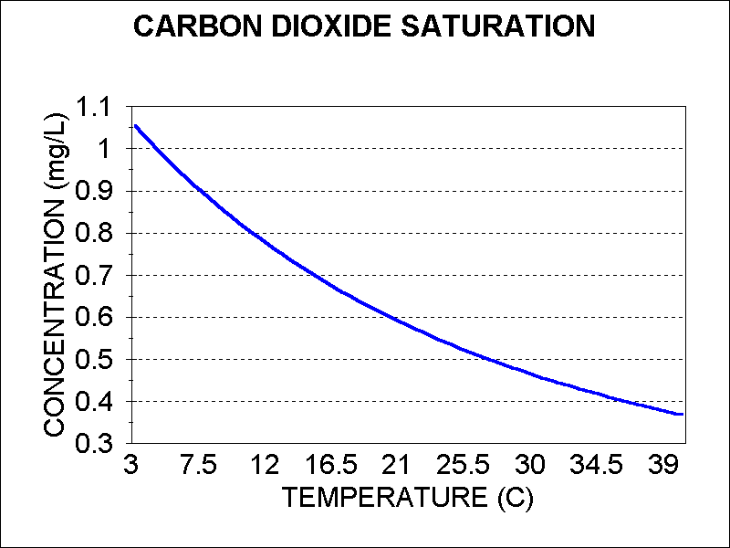

The equilibrium CO2 equations described above cannot be applied to a seawater system as the chemistry in seawater is significantly different from freshwater. Over the years, several models and constants used to describe the dissociation of carbon dioxide in seawater have been proposed by investigators.

For saline conditions, the equilibrium parameters of the CO2 system can be derived by using CO2SYS (Yuan, 2006) or CO2calc (USGS, 2010) and the results used as inputs for *CO2Equil* in the AQUATOX simulation. Within these models, the user needs to provide two of the five measurable CO2 system parameters: Total alkalinity (TA), Total carbon dioxide (TCO2), pH and Partial pressure of carbon dioxide (pCO2) or fugacity of carbon dioxide (fCO2); along with temperature (T), pressure (P) and salinity (S). The user can then select appropriate constants from proposed literature values and the program will calculate the remaining carbonate system parameters including a time-series of CO2 concentrations in water.

For maximum flexibility, AQUATOX 3.1 has an interface that will accept these time-series of *CO2Equil*. In this manner, the user can select the most appropriate model for their site and import these values into the AQUATOX interface. A time-series of pH can also be estimated by these ocean-water chemistry models.

**5.7 Modeling Dynamic pH**

**Dynamic pH: Simplifying Assumptions**

* Simple semi-empirical formulation
* Computation is good for the pH range of 3.75 to 8.25

Dynamic pH is important in simulations for several reasons:

* + pH affects the ionization of ammonia and potential resulting toxicity;
  + pH affects the hydrolysis and ionization of organic chemicals which potentially has effects on chemical fate and the degree of toxicity;
  + pH also affects the decay of organic matter and denitrification of nitrate which could eventually feed back to the animals;
  + if pH exceeds 7.5, calcite precipitation can take place which has a significant effect on the food-web.

A user-input time-series of pH levels may be used to drive the model or AQUATOX can calculate pH levels.

Many models follow the example of Stumm and Morgan (1996) and solve simultaneous equations for pH, alkalinity, and the complete carbonate-bicarbonate equilibrium system. However, this approach requires more data than are often available, and the iterative solution of the equations entails an additional computational burden—all for a precision that is unnecessary for ecosystem models. The alternative is to restrict the range of simulated pH to that of normal aquatic systems and to make simplifying assumptions that allow a semi-empirical computation of pH (Marmorek et al. 1996, Small and Sutton 1986). That is the approach taken for AQUATOX.

The computation is good for the pH range of 3.75 to 8.25, where the carbonate ion is negligible and can thus be ignored. (Any predictions above 8.25 are truncated to 8.25 and any predictions below 3.75 are set to 3.75.) The derivation is given by Small and Sutton (1986), with a correction for dissolved organic carbon (Marmorek et al. 1996). It incorporates a quadratic function of carbon dioxide; and it is a nonlinear function of mean alkalinity and the concentration of refractory dissolved organic carbon (humic and fulvic acids), by means of an inverse hyperbolic sine function:

 **(216)**

where:

*pHCalc* = pH;

*ArcSinH* = inverse hyperbolic sine function;

*Alkalinity* = mean Gran alkalinity (μeq CaCO3/L);

*DOC* = refractory dissolved organic carbon (mg/L); sum of **(143)**, **(144)**;

5.1 = average μeq of organic ions per mg of *DOC;*











where:

*H2CO3\** = first acidity constant;

*CCO2* = CO2 expressed as μeq/L; see **(207)** multiplied by conversion factor of 22.73 (ueq/mg);

*pkw* = ionization constant for water (1e-14);

*T* = temperature (ºC); see **(24)**;

0.92 = correction factor for dissolved CO2.

Calibration and verification of the construct used data from nine lakes and ponds in the National Eutrophication Survey (U.S. Environmental Protection Agency, 1977), two observations on Lake Onondaga, NY, from before and after closure of a chlor-alkali plant (Effler et al., 1996), and one observation in a river (Figure 128). The correction factor for CO2 was obtained by fitting the data to the unity line, but ignoring the two highest points because the construct does not predict pH above 8.25.

Figure . Comparison of predicted and observed pHs from selected lakes.



The construct also was verified using time-series data from Lake Onondaga, NY (Figure 129). The observed data were interpolated from the 2-m depth pH isopleths on a graph (Effler et al. 1996), introducing some uncertainty into the comparison.

Figure . Comparison of predicted and observed pH values for Lake Onondaga, NY.   
 Data from (Effler et al. 1996).



**5.8 Modeling Calcium Carbonate Precipitation and Effects**

Precipitation of calcium carbonate (mostly calcite in freshwater), with the potential for sorption and removal of phosphorus, is modeled as an extension of the pH approach. The prediction of pH in AQUATOX does not extend past 8.25 because the carbonate-bicarbonate system becomes dominant. We use a predicted pH of 7.5 as a threshold for precipitation of calcium carbonate in freshwater ecosystems. Almost all calcite is formed biogenically, primarily by plants using bicarbonate as a source of carbon (McConnaughey et al. 1994). Even “whitings” (sudden precipitation of fine-grained calcite) have been shown to be a consequence of cyanobacteria photosynthesis (Thompson et al. 1997). Calcareous plants are characterized by pH polarization with acidic and alkaline poles; calcification occurs at the alkaline pole (McConnaughey et al. 1994). Proton generation leads to formation of twice as much CO2 than is used in the process, providing CO2 that is immediately taken up for photosynthesis. As a result, calcification and photosynthesis use equivalent moles of C, as shown by both theory and experiments (McConnaughey et al. 1994). Three chemical reactions represent this process:

**Calcite Precipitation: Simplifying Assumptions**

* Biogenic origin
* pH of 7.5 is considered as a threshold for precipitation
* Dissolved phosphate sorbs to calcium carbonate but desorption is not modeled

Ca2+ + CO2 + H2O 🡪 CaCO3 + 2H+

2H+ + 2HCO3- 🡪 2CO2 + 2H2O

Ca2+ + 2HCO3- 🡪 CaCO3 + CO2 + H2O

Not all plants can use bicarbonate. However, it is difficult to generalize; mosses do not and many chrysophytes (golden algae) do not. Evidence suggests that other groups, including greens, cyanobacteria, diatoms, and macrophytes, have species that do use bicarbonate and that these will dominate in alkaline systems.

The algorithm simulates precipitation of calcite as being the molar equivalent to photosynthesis of most plants and as occurring when the threshold pH of 7.5 is reached:

 **(217)**

where:

*pH* = pH calculated by Eq. 204 or observed time series;

*CalcitePcpt* = calcite precipitated (mg calcite/Ld);

*C2Calcite* = stoichiometric constant for C and calcite (8.33, g calcite /g C);

*Photosynthesis* = rate of photosynthesis for a subset of plants (g/m3d);

*PlantSubset* = all plants except Bryophytes and Other Algae;

*C2OM* = stoichiometric constant for C and organic matter (1.9, g C/g OM).

Precipitated calcite is protected, in part, by sorbed organic material. Therefore, it is assumed to be insoluble—an assumption also made in the sediment diagenesis model (Di Toro 2001). Because the settling rate is fast, it is also assumed that the calcite goes directly to the sediment.

Phosphorus is adsorbed to the surface and coprecipitates with calcium carbonate (Wetzel 2001). The rate of coprecipitation seems to be dependent on the rate of calcite precipitation (Otsuki and Wetzel 1972). However, the sorption is weak and can be reversed easily (Murphy et al. 1983). Therefore, the default partition coefficient (300 L/kg) is based on equilibration experiments with sediments from a marl lake (Van Rees et al. 1991).

 **(218)**

where:

*SorptionP* = rate of sorption of phosphorus to calcite (mgP/Ld);

*KDPCalcite* = partition coefficient for phosphorus to calcite (L/kg);

*Phosphate* = concentration of phosphorus in water (mg P/L) (see **(181))**;

1 e-6 = conversion factor (kg/mg).

Ironically, precipitation is impeded by phosphorus levels that are too high. The threshold for inhibition is about 30 mg-P/L (Neal 2001). Furthermore, dissolved organic matter also can inhibit precipitation, with 120 mg C/L being the threshold (Neal 2001). However, these concentrations are so high that they are ignored in the model.