**Nutrients Programmer test log – AQUATOXVolumeModel, JSON vs. AQUATOX 3.2**

**JSON test logs in the hms_backend\Nutrients\AQUATOX\TEST folder**

4/2/2018 Lake Jesup FL Simplified_NoResults.aps, Lake Jesup FL trimmed2.JSON



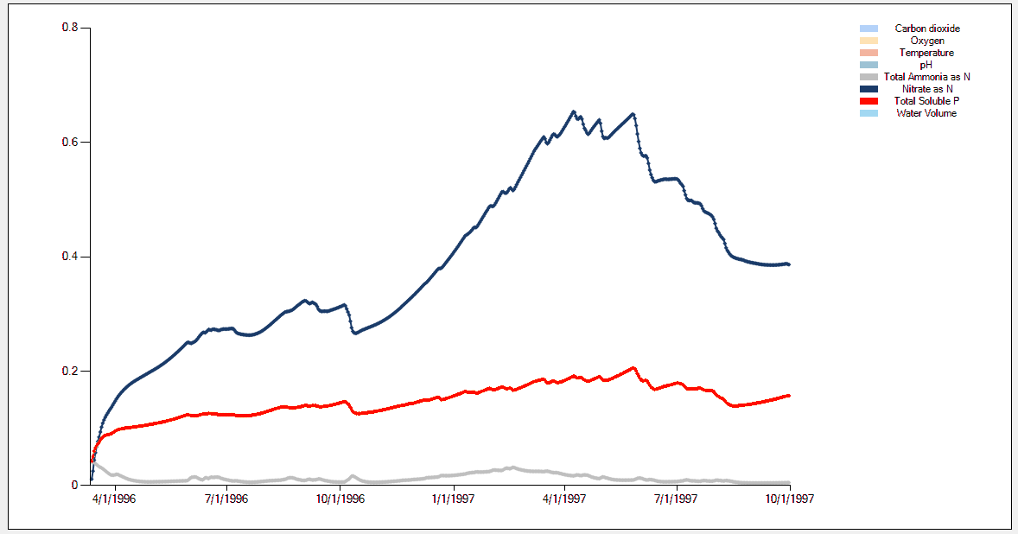

Ammonia, Nitrate, TSP Precisely matched 4/2/2018

Lake Jesup FL Simplified_NoResults.aps, Lake Jesup FL trimmed2.JSON

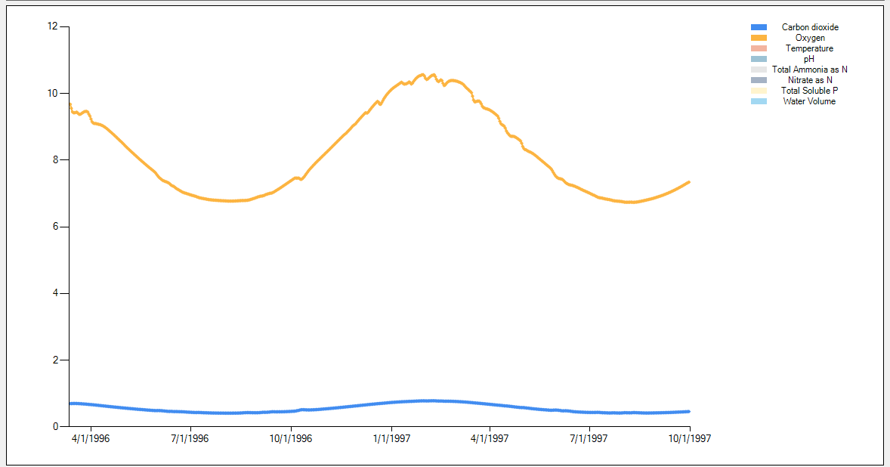

Oxygen, CO2 Precisely matched 4/2/2018

Lake Jesup FL Simplified_NoResults.aps, Lake Jesup FL trimmed2.JSON



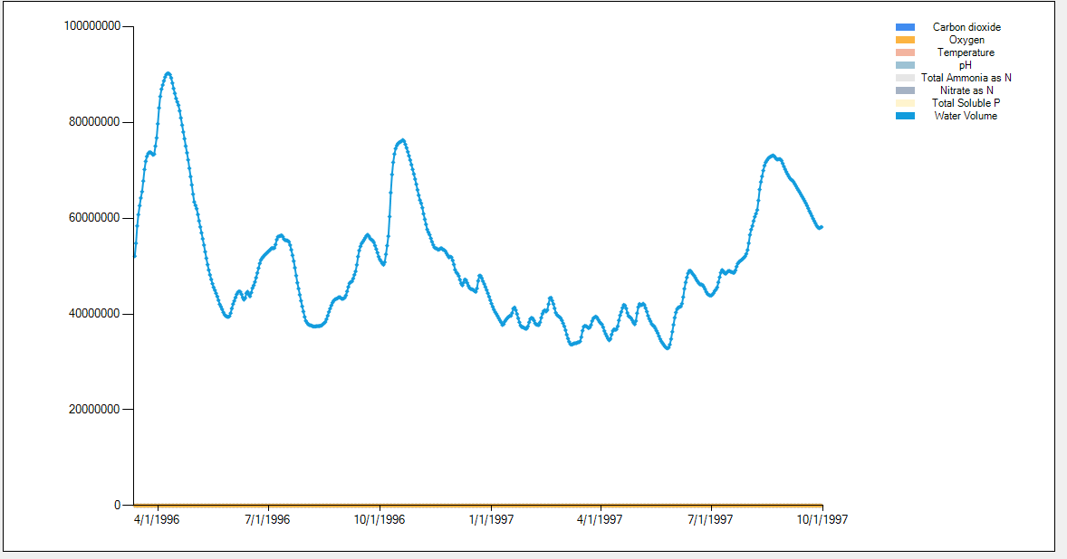

Water Volume Precisely matched 4/2/2018

Added linkages to AQUATOX animal / plant linkages:

* NH3 & NH4+ ASSIM_JSONLINK (mg/L d)
* NH3 & NH4+ ANREMIN_JSONLINK (mg/L d)
* NH3 & NH4+ PLREMIN_JSONLINK (mg/L d)
* NH3 & NH4+ OMREMIN_JSONLINK (mg/L d)
* NO3 ASSIM_JSONLINK (mg/L d)
* TOT. SOL. P ASSIM_JSONLINK (mg/L d)
* TOT. SOL. P ANREMIN_JSONLINK (mg/L d)
* TOT. SOL. P PLREMIN_JSONLINK (mg/L d)
* TOT. SOL. P OMREMIN_JSONLINK (mg/L d)
* CO2 DETDECMP_JSONLINK (mg/L d)
* CO2 RESPIRATION_JSONLINK (mg/L d)
* CO2 CO2ASSIM_JSONLINK (mg/L d)
* OXYGEN PHOTOSYN_JSONLINK (mg/L d)
* OXYGEN RESPIRATION_JSONLINK (mg/L d)
* OXYGEN NITRIFIC_JSONLINK (mg/L d)
* OXYGEN CBOD_JSONLINK (mg/L d)

Inputs are integrated over a day’s AQUATOX solution (stair-stepped) whereas when all state variables are included, inputs are included in sub-day timestep differential equations (4th & 5th order solutions)

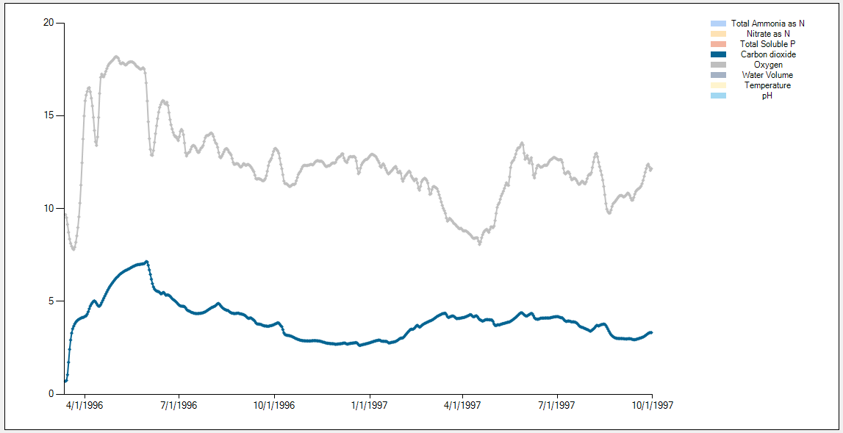

Oxygen and CO2 predictions are pretty much identical in magnitude and pattern

Top is LJ_Complex2.JSON bottom is Lake Jesup FL.aps





Results are close but not precise, especially TSP and NO3. I will spend some time to determine if this is a function of step nature of derivative rates or another error.

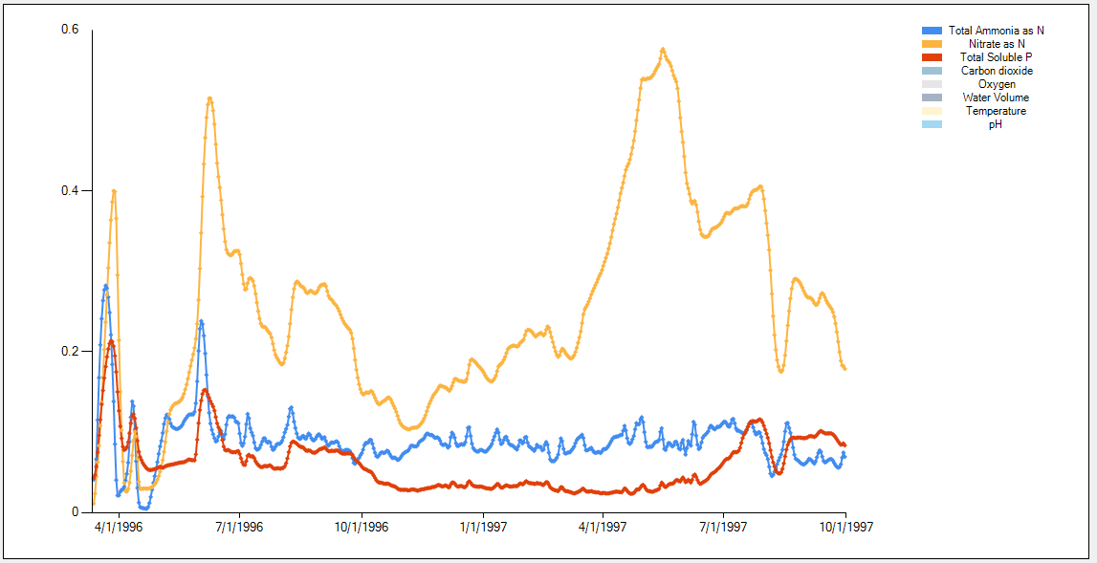



This graph shows the lack of precision between NO3 and TSP results. I will run hourly simulations and save rates hourly to see if this increases precision.

Tested hourly time steps in both simulations-- no additional conformance. Passed hourly rates in – a good test of hourly-rate interface, but NO3 results are not significantly different: LJ_Complex3_hourlyNO3.JSON





Fixed a problem with JSON writing/reading loadings multipliers. This made results closer but still not precise. Looking into TSP discrepancy next.



Missing Calcite precipitation linkage. When added in, makes the results even closer!

4/4/2018: Confirmed that differences are caused by passage of daily data for intermediate derivative rates (e.g. assimilation rates for nutrients from algae). Switched to 1/10th of a day passage of data between AQUATOX 3.2 and AQUATOX HMS and the differences between the simulations disappear

(shortened simulation period as passage of data becomes burdensome.)

Lake Jesup FL_0.1d_rates.aps compared to LJ_Complex3_hourly_rates.JSON