**HMS Organic Matter Data Requirements**

The HMS AQUATOX organic matter model is comprised of six state variables. These variables include slow reacting or “refractory” detritus and fast reacting or “labile” detritus, in three different forms: dissolved in the water column, suspended as particulate matter in the water column, and in the active layer of sediment.



To calculate organic-matter concentrations, the HMS AQUATOX water volume model must be implemented so that the impacts of water flows on nutrient concentrations can be calculated. (Linkage to alternative volume models is coming soon.) Other data requirements are state variables for temperature, oxygen, and pH. These variables may be modeled within AQUATOX using the derivatives listed below or they may be driven with external data or other HMS components.

There are potential interactions between the AQUATOX organic matter model and animal and plants state variables/models. If these state variables are not explicitly modeled within HMS, then time-series linkages from other models or estimates of impacts of animals, plants, and on organic matter derivatives may be input into the model directly within the JSON files.

The list of time-series linkages into the organic matter state variable derivatives are listed here (all units are g/m3⋅d):

|  |  |  |  |
| --- | --- | --- | --- |
| **State Variable** | **Derivative Linkage** | **Name within JSON** | **Omit if explicitly modeling** |
| Sedimented Detritus | *DetrFm Mortality* | "DF_Mort_Link" | Animals |
| Sedimented Detritus | *DetrFm Excretion* | "DF_Excr_Link" | Animals |
| Sedimented Detritus | *DetrFm Sedimentation* | "DF_Sed_Link" | Plants |
| Sedimented Detritus | *DetrFm GameteLoss* | "DF_Gameteloss_Link" | Animals |
| Sedimented Detritus | *Ingestion* | "Predation_Link" | Animals |
| Dissolved Detritus | *DetrFm Mortality* | "DF_Mort_Link" | Animals |
| Dissolved Detritus | *DetrFm Excretion* | "DF_Excr_Link" | Animals |
| Dissolved Detritus | *DetrFm Sedimentation* | "DF_Sed_Link" | Plants |
| Dissolved Detritus | *DetrFm GameteLoss* | "DF_Gameteloss_Link" | Animals |
| Particulate Detritus | *DetrFm Mortality* | "DF_Mort_Link" | Animals |
| Particulate Detritus | *DetrFm Excretion* | "DF_Excr_Link" | Animals |
| Particulate Detritus | *DetrFm Sedimentation* | "DF_Sed_Link" | Plants |
| Particulate Detritus | *DetrFm GameteLoss* | "DF_Gameteloss_Link" | Animals |
| Particulate Detritus | *Ingestion* | "Predation_Link" | Animals |

Example JSON data files for an organic-matter model may be found in the associated DOCS directory.

The following pages are excerpts from the relevant sections of the AQUATOX Release 3.2 Technical Documentation. The HMS organic matter model was not changed from the AQUATOX Release 3.2 implementation and results were verified against AQUATOX Release 3.2 results.

**5. REMINERALIZATION**

**5.1 Detritus**

For the purposes of AQUATOX, the term "detritus" is used to include all non-living organic material and associated decomposers (bacteria and fungi). As such, it includes both particulate and dissolved material in the sense of Wetzel (1975), but it also includes the microflora and is analogous to “biodetritus” of Odum and de la Cruz (1963) . Detritus is modeled as eight compartments: refractory (resistant) dissolved, suspended, sedimented, and buried detritus; and labile (readily decomposed) dissolved, suspended, sedimented, and buried detritus (Figure 98). This degree of disaggregation is considered necessary to provide more realistic simulations of the detrital food web; the bioavailability of toxicants, with orders-of-magnitude differences in partitioning; and biochemical oxygen demand, which depends largely on the decomposition rates. Buried detritus is considered to be taken out of active participation in the functioning of the ecosystem. In general, dissolved organic material is about ten times that of suspended particulate matter in lakes and streams (Saunders, 1980), and refractory compounds usually predominate; however, the proportions are modeled dynamically.

**Detritus: Simplifying Assumptions**

* Refractory detritus does not decompose directly but is converted to labile detritus through colonization
* Detrital sedimentation is modeled with simplifying assumptions (unless the sediment submodel for streams is included)
* Biomass of bacteria is not explicitly modeled

Figure 98. Detritus compartments in AQUATOX

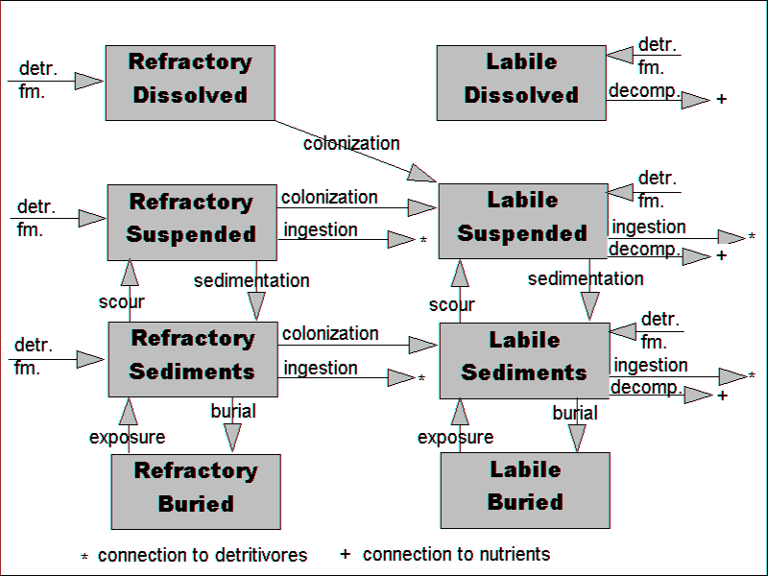

**Note, the simple buried detritus model is not yet implemented as part of HMS.**

The concentrations of detritus in these eight compartments are the result of several competing processes:

 **(141)**

 **(142)**

 **(143)**

 **(144)**

 **(145)**

 **(146)**

where:

*dSuspRefrDetr/dt* = change in concentration of suspended refractory detritus with respect to time (g/m3⋅d);

*dSuspLabileDetr/dt* = change in concentration of suspended labile detritus with respect to time (g/m3⋅d);

*dDissRefrDetr/dt* = change in concentration of dissolved refractory detritus with respect to time (g/m3⋅d);

*dDissLabDetr/dt* = change in concentration of dissolved labile detritus with respect to time (g/m3⋅d);

*dSedRefrDetr/dt* = change in concentration of sedimented refractory detritus with respect to time (g/m3⋅d);

*dSedLabileDetr/dt* = change in concentration of sedimented labile detritus with respect to time (g/m3⋅d);

*Loading* = loading of given detritus from nonpoint and point sources, or from upstream (g/m3⋅d);

*DetrFm* = detrital formation (g/m3⋅d);

*Colonization* = colonization of refractory detritus by decomposers (g/m3⋅d), see **(155)**;

*Decomposition* = loss due to microbial decomposition (g/m3⋅d), see **(159)**;

*Sedimentation* = transfer from suspended detritus to sedimented detritus by sinking (g/m3⋅d); in streams with the inorganic sediment model attached see **(235)**, for all other systems see **(165)**;

*Scour* = resuspension from sedimented detritus (g/m3⋅d); in streams with the inorganic sediment model attached see **(233)**, for all other systems see **(165)** (resuspension);

*Exposure* = transfer from buried to sedimented by scour of overlying sediments (g/m3⋅d); Not yet implemented in HMS.

*Burial =* transfer from sedimented to deeply buried (g/m3⋅d), see **(167b)**; Not yet implemented in HMS.

*Washout* = loss due to being carried downstream (g/m3⋅d), see **(16)**;

*Washin*  = loadings from upstream segments (g/m3·d), see **(30)**;

*DiffusionSeg* = gain or loss due to diffusive transport over the feedback link between two segments, (g/m3⋅d), see **(32)**;

*Ingestion* = loss due to ingestion by detritivores and filter feeders (g/m3⋅d), see **(91)**;

*Sinking* = detrital sinking from epilimnion and to hypolimnion under stratified conditions, see **(165)**; and

*TurbDiff* = transfer between epilimnion and hypolimnion due to turbulent diffusion (g/m3⋅d), see **(22)** and **(23)**.

As a simplification, refractory detritus is considered not to decompose directly, but rather to be converted to labile detritus through microbial colonization. Labile detritus is then available for both decomposition and ingestion by detritivores (organisms that feed on detritus). Because detritivores digest microbes and defecate the remaining organic material, detritus has to be conditioned through microbial colonization before it is suitable food. Therefore, the assimilation efficiency of detritivores for refractory material is usually set to 0.0, and the assimilation efficiency for labile material is increased accordingly.

Sedimentation and scour (resuspension) are opposite processes. In shallow systems there may be no long-term sedimentation (Wetzel et al., 1972), while in deep systems there may be little resuspension. In the classic AQUATOX model, sedimentation is a function of flow, ice cover and, in very shallow water, wind based on simplifying assumptions. Scour and exposure of organic matter are applicable only in streams where they are keyed to the behavior of clay and silt. Scour as an explicit function of wave and current action is not implemented, however, the capability to link to hydrodynamic models is provided. See chapter 6 for a discussion of the various inorganic sediment models and their implications to organic sediments.

Within AQUATOX, the user must specify the percentage particulate and percentage refractory for each source of organic matter. Table 10 presents some guidance on populating these variables based on Allan (1995), Hessen and Tranvik (1998), and Wetzel (2001). These percentages can be specified as constant variables or by using a time-series.

**Table 10. Suggested detrital boundary conditions based on literature and in the absence of data**

|  |  |  |  |
| --- | --- | --- | --- |
| **Ecosystem** | **Particulate %** | **Refractory %** | **OM conc. (mg/L)** |
| Oligotrophic lakes | 10% | 90% | 4 |
| Eutrophic lakes | 15% | 86% | 24 |
| Forested streams | 20% | 60% | 5 |
| Rivers | 30% | 60% | 14 |
| Blackwater stream | 5% | 95% | 26 |

AQUATOX simulates detritus as organic matter (dry weight); however, the user can input data as organic carbon or carbonaceous biochemical oxygen demand (CBOD) and the model will make the necessary conversions. Organic matter is assumed to be 1.90 · organic carbon as derived from stoichiometry (Winberg 1971). The conversion from BOD includes the simplifying assumption that any BOD data input into the model are primarily based on carbonaceous oxygen demand:

 **(148b)**

where:

 **(148c)**

and:

*OM =* organic matter input as required by AQUATOX (g OM/m3);

*CBOD =* carbonaceous biochemical demand 5-day from user input (g O2 /m3);

*CBOD5_CBODu* = CBOD5 to ultimate carbonaceous BOD conversion factor, also defined as CBODU:CBOD5 ratio;

*PercentRefr Time* = user-defined percent refractory matter for given source of organic matter, may be a time series; and

*O2Biomass* = ratio O­2 to organic matter (*OM*). (remineralization parameter, the default is 0.575 based on Winberg (1971));

AQUATOX has always assumed that user-input BOD5 loadings are primarily composed of carbonaceous oxygen demand but this assumption has been made more explicit in Release 3.1. The equations above are used by AQUATOX when converting initial conditions and loadings in CBOD5 to organic matter, when estimating CBOD5 from organic matter for simulation output, and when linking HSPF BOD data. Equations **(148b**) and **(148c)** are new to AQUATOX Release 3.1 and a warning message is displayed if an older study that utilizes BOD loadings is imported into the current version.

**Detrital Formation**

Detritus is formed in several ways: through mortality, gamete loss, sinking of phytoplankton, excretion and defecation:

 **(149)**

 **(150)**

 **(151)**

 **(152)**

 **(153)**

 **(154)**

where:

*DetrFm* = formation of detritus (g/m3⋅d);

*Mort2*detr, biota = fraction of given dead organism that goes to given detritus (unitless);

*Excr2detr, biota* = fraction of excretion that goes to given detritus (unitless), see Table 11;

*Mortalitybiota*  = death rate for organism (g/m3⋅d), see **(66)**, **(87)** and **(112)**;

*Excretion* = excretion rate for organism (g/m3⋅d), see **(64)** and **(111)** for plants and animals, respectively;

*GameteLoss* = loss rate for gametes (g/m3⋅d), see **(126)**;

*Def2detr, biota* = fraction of defecation that goes to given detritus (unitless);

*Defecation*pred = defecation rate for organism (g/m3⋅d), see **(97)**;

*Sedimentation* = loss of phytoplankton to bottom sediments (g/m3⋅d), see **(69)**; and

*PlantSinkToDetr* = labile and refractory portions of phytoplankton (unitless, 0.92 and 0.08 respectively).

A fraction of mortality, including sloughing of leaves from macrophytes, is assumed to go to refractory detritus; a much larger fraction goes to labile detritus. Excreted material goes to both refractory and labile detritus, while gametes are considered to be labile. Half the defecated material is assumed to be labile because of the conditioning due to ingestion and subsequent inoculation with bacteria in the gut (LeCren and Lowe-McConnell, 1980); fecal pellets sink rapidly (Smayda, 1971), so defecation is treated as if it were directly to sediments. Phytoplankton that sink to the bottom (that are not linked to periphyton compartments) are considered to become detritus; most are consumed quickly by zoobenthos (LeCren and Lowe-McConnell, 1980) and are not available to be resuspended.

**Table 11.** Mortality and Excretion to Detritus

|  |  |  |  |  |
| --- | --- | --- | --- | --- |
|  | **Algal Mortality** | **Macrophyte Mortality** | **Bryophyte Mortality** | **Animal Mortality** |
| Dissolved Labile Detritus | 0.27 | 0.24 | 0.00 | 0.27 |
| Dissolved Refractory Detritus | 0.03 | 0.01 | 0.25 | 0.03 |
| Suspended Labile Detritus | 0.65 | 0.38 | 0.00 | 0.56 |
| Suspended Refractory Detritus | 0.05 | 0.37 | 0.75 | 0.14 |
|  |  |  |  |  |
|  | **Algal Excretion** | **Macrophyte Excretion** | **Bryophyte Excretion** | **Animal Excretion** |
| Dissolved Labile Detritus | 0.9 | 0.8 | 0.8 | 1.0 |
| Dissolved Refractory Detritus | 0.1 | 0.2 | 0.2 | 0.0 |

**Colonization**

Refractory detritus is converted to labile detritus through microbial colonization. When bacteria and fungi colonize dissolved refractory organic matter, they are in effect turning it into particulate matter. Detritus is usually refractory because it has a deficiency of nitrogen compared to microbial biomass. In order for microbes to colonize refractory detritus, they have to take up additional nitrogen from the water (Saunders et al., 1980). Thus, colonization is nitrogen-limited, as well as being limited by suboptimal temperature, pH, and dissolved oxygen:

 **(155)**

where:

*Colonization* = rate of conversion of refractory to labile detritus (g/m3⋅d);

*ColonizeMax* = maximum colonization rate under ideal conditions (g/g⋅d);

*Nlimit* = limitation due to suboptimal nitrogen levels (unitless), see **(157)**;

*DecTCorr* = the effect of temperature (unitless), see **(156)**;

*pHCorr* = limitation due to suboptimal pH level (unitless), see **(162)**;

*DOCorrection* = limitation due to suboptimal oxygen level (unitless), see **(160)**; and

*RefrDetr* = concentration of refractory detritus in suspension, sedimented, or dissolved (g/m3).

Because microbial colonization and decomposition involves microflora with a wide range of temperature tolerances, the effect of temperature is modeled in the traditional way (Thomann and Mueller, 1987), taking the rate at an observed temperature and correcting it for the ambient temperature up to a user-defined, high maximum temperature, at which point it drops to 0:

 **(156)**

The resulting curve has a shoulder similar to the Stroganov curve, but the effect increases up to the maximum rate (Figure 99).

Figure 99. Colonization and decomposition as an effect of temperature



The nitrogen limitation construct, which is original with AQUATOX, is parameterized using an analysis of data presented by Egglishaw (1972) for Scottish streams. It is computed by:

 **(157)**

 **(158)**

where:

*N* = total available nitrogen (g/m3);

*MinN* = minimum level of nitrogen for colonization (= 0.1 g/m3);

*HalfSatN* = half-saturation constant for nitrogen stimulation (= 0.15 g/m3);

*Ammonia* = concentration of ammonia (g/m3); and

*Nitrate* = concentration of nitrite and nitrate (g/m3).

Although it can be changed by the user, a default maximum colonization rate of 0.007 (g/g⋅d) is provided, based on McIntire and Colby (1978, after Sedell et al., 1975). The rates of decomposition (or colonization) of refractory dissolved organic matter are comparable to those for particulate matter. Saunders (1980) reported values of 0.007 (g/g⋅d) for a eutrophic lake and 0.008 (g/g⋅d) for a tundra pond. Anaerobic rates were reported by Gunnison et al. (1985).

**Decomposition**

Decomposition is the process by which detritus is broken down by bacteria and fungi, yielding constituent nutrients, including nitrogen, phosphorus, and inorganic carbon. Therefore, it is a critical process in modeling nutrient recycling. In AQUATOX, following a concept first advanced by Park et al. (1974), the process is modeled as a first-order equation with multiplicative limitations for suboptimal environmental conditions (see section 4.1 for a discussion of similar construct for photosynthesis):

 **(159)**

where:

*Decomposition* = loss due to microbial decomposition (g/m3⋅d);

*DecayMax* = maximum decomposition rate under aerobic conditions (g/g⋅d);

*DOCorrection* = correction for anaerobic conditions (unitless), see **(160)**;

*DecTCorr* = the effect of temperature (unitless), see **(156)**;

*pHCorr* = correction for suboptimal pH (unitless), see **(162)**; and

*Detritus* = concentration of detritus, including dissolved but not buried (g/m3).

Note that biomass of bacteria is not explicitly modeled in AQUATOX. In some models (for example, EXAMS, Burns et al., 1982) decomposition is represented by a second-order equation using an empirical estimate of bacteria biomass. However, using bacterial biomass as a site constant would constrain the model, potentially forcing the rate. Decomposers were modeled explicitly as a part of the CLEAN model (Clesceri et al., 1977). However, if conditions are favorable, decomposers can double in 20 minutes; this can result in stiff equations, adding significantly to the computational time. Ordinarily, decomposers will grow rapidly as long as conditions are favorable. The only time the biomass of decomposers might need to be considered explicitly is when a new organic chemical is introduced and the microbial assemblage requires time to become adapted to using it as a substrate.

The effect of temperature on biodegradation is represented by Equation **(156)**, which also is used for colonization. The function for dissolved oxygen, formulated for AQUATOX, is:

 **(160)**

where the predicted DO concentrations are entered into a Michaelis-Menten formulation to determine the extent to which degradation rates are affected by ambient DO concentrations (Clesceri, 1980; Park et al., 1982):

 **(161)**

and:

*Factor* = Michaelis-Menten factor (unitless);

*KAnaerobic* = decomposition rate at 0 g/m3 oxygen (g/m3⋅d or μg/L⋅d); Set to 0.3 g/m3⋅d for microbial degradation of sediments. For chemicals, **(160)** is also used and the “rate of anaerobic microbial degr.” from the chemical underlying data is used (*KMDegrAnaerobic*).

*Oxygen* = dissolved oxygen concentration (g/m3); and

*HalfSatO* = half-saturation constant for oxygen (g/m3) (0.5 g/m3 in the water column or 8.0 g/m3 for sedimented detritus).

*DOCorrection* accounts for both decreased and increased (Figure 100) degradation rates under anaerobic conditions, with *KAnaerobic/DecayMax* having values less than one and greater than one, respectively. Detritus will always decompose more slowly under anaerobic conditions; but some organic chemicals, such as some halogenated compounds (Hill and McCarty, 1967), will degrade more rapidly. Half-saturation constants of 0.1 to 1.4 g/m3 have been reported (Bowie et al., 1985); a value of 0.5 g/m3 is used in the water column and a calibrated value of 8.0 g/m3 is used for the sediments to force anoxic conditions.

Figure 100. Correction for dissolved oxygen



Another important environmental control on the rate of microbial degradation is pH. Most fungi grow optimally between pH 5 and 6 (Lyman et al., 1990), and most bacteria grow between pH 6 to about 9 (Alexander, 1977). Microbial oxidation is most rapid between pH 6 and 8 (Lyman et al., 1990). Within the pH range of 5 and 8.5, therefore, pH is assumed to not affect the rate of microbial degradation, and the suboptimal factor for pH is set to 1.0. In the absence of good data on the rates of biodegradation under extreme pH conditions, biodegradation is represented as decreasing exponentially beyond the optimal range (Park et al., 1980a; Park et al., 1982). If the pH is below the lower end of the optimal range, the following equation is used:

 **(162)**

where:

*pH* = ambient pH, and

*pHMin* = minimum pH below which limitation on biodegradation rate occurs.

If the pH is above the upper end of the optimal range for microbial degradation, the following equation is used:

 **(163)**

where:

*pHMax* = maximum pH above which limitation on biodegradation rate occurs.

These responses are shown in Figure 101.

Figure 101. Limitation due to pH

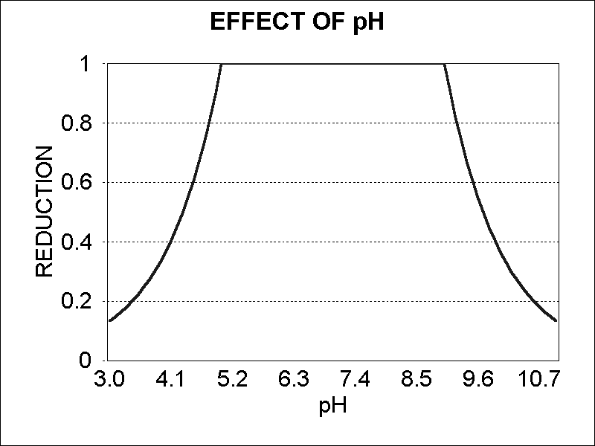

Sediment oxygen demand (SOD in g O2/m2 d) is also calculated by taking the sum of detrital decomposition and then multiplying by *O2Biomass* (the ratio of oxygen to organic matter). This can be compared with SOD values derived from the optional sediment diagenesis model (Chapter 7).

**Sedimentation**

Depending upon which options the user chooses, sedimentation (i.e., the sinking of suspended particles to the sediment bed) is calculated differently (Table 12). When the inorganic-sediment model (sand-silt-clay) is included, the sedimentation and deposition of detritus is assumed to mimic the sedimentation and resuspension of silt (see **(235)** and **(233)**). If the multi-layer sediment model is included (using user-input erosion and deposition time-series) the sedimentation of detritus is calculated using the deposition velocity for cohesives (assumed to be a surrogate for organic matter) as follows:

 **(164)**

When the inorganic-sediment model or the multiple-layer sediment model are not included in a simulation (i.e. “classic” AQUATOX formulations are used), the sedimentation of suspended particulate detritus to bottom sediments can be modeled using simplifying assumptions **(165)**. The constructs are intended to provide general responses to environmental factors, but they could be considerably improved upon by linkage to a hydrodynamic model (currently only available with the multi-layer sediment model).

 **(165)**

where:

*Sedimentation* = transfer from suspended to sedimented by sinking (g/m3⋅d), if negative is effectively *Resuspension* (see below);

*KSed* = sedimentation rate (m/d);

*DepVel* = user input time-series of deposition velocities for cohesives (multi-layer model only; m/d);

*Thick* = depth of water or thickness of layer if stratified (m);

*Decel* = deceleration factor (unitless), see **(166)**;

*State* = concentration of particulate detrital compartment (g/m3); and

*DensityFactor* = if salinity is modeled, correction factor for water densities based on salinity and temperature, see **(442)**.

Table 12: Summary of Detrital Deposition and Resuspension in AQUATOX

|  |  |  |
| --- | --- | --- |
| **Deposition of Suspended Detritus & Phytoplankton** | |  |
|  | **Assumption** | **Equation** |
| "Classic" AQUATOX model | Sedimentation is a function of Mean Discharge | **(165)** |
| Sand-Silt-Clay submodel | Follows "silt" as calculated by the Sand-Silt-Clay submodel | **(235)** |
| Multi-layer Sediment Model | Follows "cohesives" class, (which may be user input or calculated using the sand-silt-clay model) | **(164)**; **(235)** |
| Sediment Diagenesis | Choice of "Classic" AQUATOX or Sand-Silt-Clay assumptions |  |
|  |  |  |
| **Resuspention of Sedimented Detritus** | |  |
|  | **Assumption** | **Equation** |
| "Classic" AQUATOX model | Resuspension is a function of Mean Discharge | **(165)** |
| Sand-Silt-Clay submodel | Follows "silt" in inorganic sediments model | **(233)** |
| Multi-layer Sediment Model | Follows "cohesives" class, (which may be user input or calculated using the sand-silt-clay model) | **(167)**; **(233)** |
| Sediment Diagenesis | Resuspension is not enabled. |  |

If the discharge exceeds the mean discharge then sedimentation is slowed proportionately (Figure 102):

 **(166)**

where:

*TotDischarge* = total epilimnetic and hypolimnetic discharge (m3/d); and

*MeanDischarge* = mean discharge, recalculated on an annual basis at the beginning of each year of the simulation (m3/d).

Figure 102. Relationship of *decel* to discharge with a mean discharge of 5 m3/s.

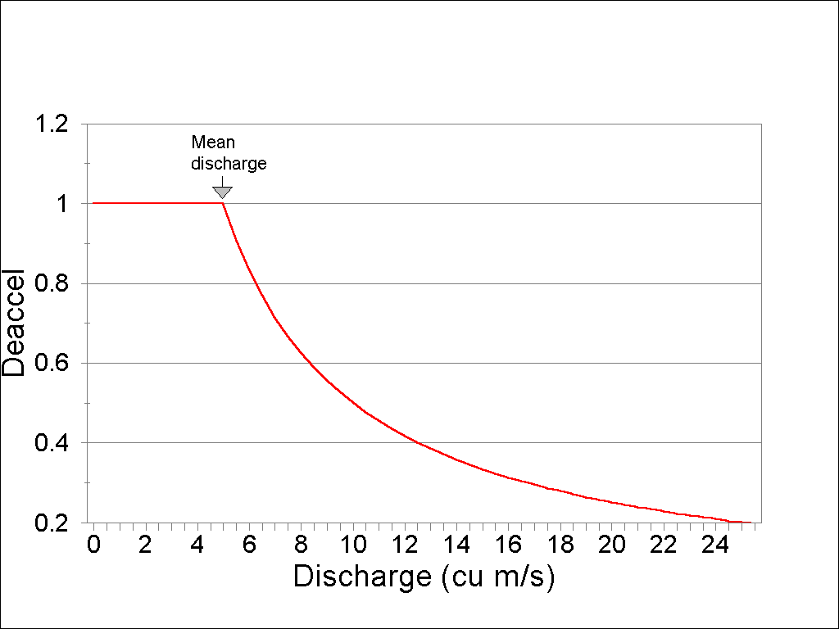

If the depth of water is less than or equal to 1.0 m and wind speed is greater than or equal to 5.5 m/s then the sedimentation rate is negative, effectively becoming the rate of resuspension. For plants, if the depth of water is is less than or equal to 1.0 m and wind speed is greater than or equal to 2.5 m/s then the sedimentation rate is assumed to be zero. If there is ice cover, then the sedimentation rate is doubled to represent the lack of turbulence.

If the multi-layer sediment model is included (using user-input erosion and deposition time-series) the resuspension of detritus is calculated using the erosion velocity for cohesives (assumed to be surrogate for organics) as follows

 **(167)**

where:

*Resuspension* = transfer from sediment to suspended by erosion (g/m3⋅d);

*ErodeVel* = user input time-series of cohesives erosion velocities (multi-layer model only m/d);

*Thick* = depth of water or thickness of layer if stratified (m);