**Organic Matter Programmer test log – AQUATOXVolumeModel, JSON vs. AQUATOX 3.2**

**Organic Matter “simple” mode (no linkage to plants or animals) 4/23/2018**

Precise replication of results between “**Lake Jesup OM Simple.aps”** and Lake “**Jesup OM Simple.JSON”**



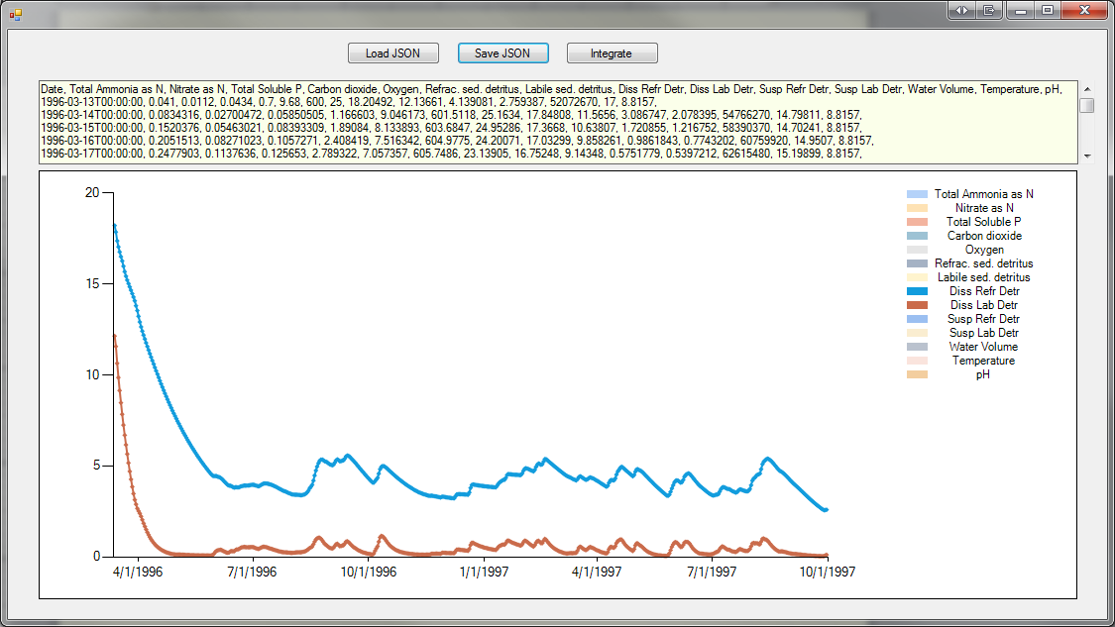

Export to Excel to show conformance: P_Lake Jesup OM Simple_Table_compare.xlsx

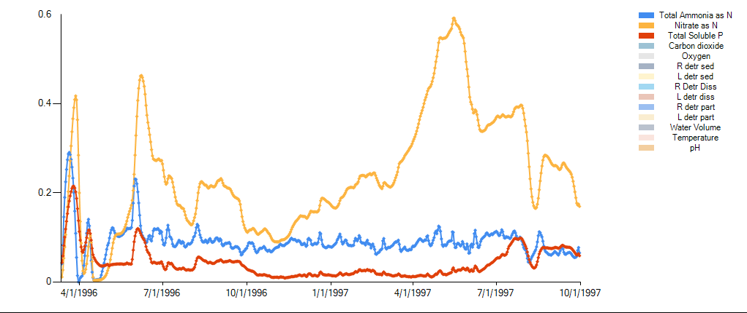



**Lake Jesup FL.aps** vs. **Lake Jesup FL_withJSONLinks.JSON**

4/25/2018, complex (animal and plant linkages) test case results look identical.



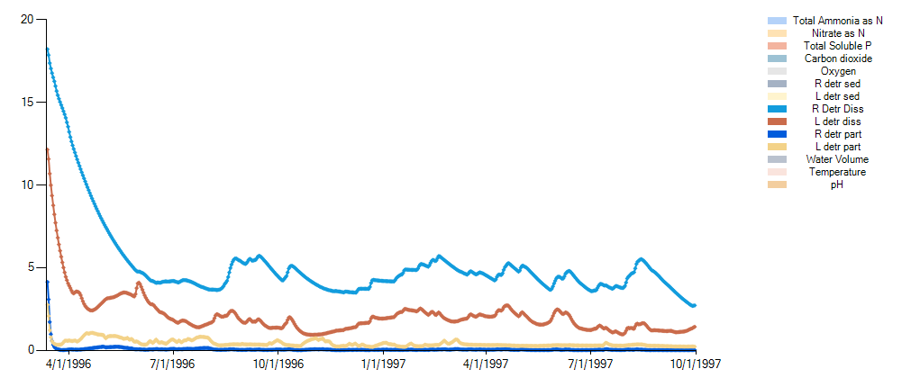

4/25/2018, complex (animal and plant linkages) test case. Graphs look identical; small percentage error when export to Excel, assume caused by passing rates daily. Passing rates on 1/10th of a day time step to test.

Error value is significantly reduced and results plot on top of one another:

(Lake Jesup FL_complex_0.1d_Instantaneous.xlsx)