**HMS Plant Model Data Requirements**

The HMS AQUATOX plant model consists of two new JSON objects.

* **TPlant** is an object used to model phytoplankton and periphyton
* **TMacrophyte** is a specialized TPlant object that is used to model benthic, rooted-floating, and free-floating macrophytes, along with bryophytes.

To calculate changes in algal biomass, the following other state variables or driving variables (i.e. modeled using observed data or linkage from other HMS components) must be included in the HMS AQUATOX JSON.

* An AQUATOX water volume model to define the spatial characteristics of the model and also account for the impacts of water flows on predicted algal biomass (TVolume).
* CO2 must be included in the simulation to account for the impact of carbon dioxide on photosynthesis (TCO2Obj).
* An AQUATOX nutrients model or driving variables for Ammonia (TNH4Obj), Nitrate (TNO3Obj), and Phosphate (TPO4Obj) must be included as nutrients affect algal growth.
* Temperature must be included in the JSON due to its effects on biological processes (TTemperature).
* An input of light loadings (TLight) must be included in the model.
* pH must be included to account for the potential for calcium carbonate precipitation by plants (TpHObj).

If animals are not explicitly modeled within HMS AQUATOX, a user may still wish to model the impact of predation on plant biomasses in the model. Time-series (or constant) linkages from other models (or user estimates) may be input into the model directly within the JSON files as summarized here (all units are g/m3⋅d):

|  |  |  |  |
| --- | --- | --- | --- |
| **State Variable** | **Derivative Linkage** | **Name within JSON** | **Omit if explicitly modeling** |
| TPlant | *Predation* | "Predation_Link" | Animals |
| TMacrophyte | *Predation* | "Predation_Link " | Animals |

Example JSON data files for an AQUATOX plant model may be found in the associated DOCS directory. For a summary of general HMS AQUATOX JSON characteristics please see the document “AQUATOX_JSON_Structure” within the Data.Simulate.AQUATOX/DOCS folder.

The many biological characteristics governing aquatic plants make for a relatively complicated set of derivatives. The following pages are excerpts from the relevant sections of the AQUATOX Release 3.2 Technical Documentation. The HMS plant model was not changed from the AQUATOX Release 3.2 implementation and model results were carefully verified against AQUATOX Release 3.2 results.

**4. BIOTA**

The biota consists of two main groups, plants and animals; each is represented by a set of process-level equations. In turn, plants are differentiated into algae and macrophytes, represented by slight variations in the differential equations. Algae may be either phytoplankton or periphyton. Phytoplankton are subject to sinking and washout, while periphyton are subject to substrate limitation and scour by currents. Bryophytes and freely-floating macrophytes are modeled as special classes of macrophytes, limited by nutrients in the water column. These differences are treated at the process level in the equations (Table 5). All are subject to habitat availability, but to differing degrees.

**Biota: Simplifying Assumptions**

* Biomass is simulated but not numbers of individual organisms
* Responses are simulated as averages for the entire group

**Table 5.**  Significant Differentiating Processes for Plants

|  |  |  |  |  |  |  |  |  |  |  |
| --- | --- | --- | --- | --- | --- | --- | --- | --- | --- | --- |
| **Plant Type** | **Nutrient Lim.** | | **Current Lim.** | | **Light Lim.** | **Sinking** | **Washout** | **Sloughing** | **Breakage** | **Habitat** |
| Phytoplankton | | | ❑ | |  | ❑ | ❑ | ❑ |  |  | ❑ |
| Periphyton | | | ❑ | | ❑ | ❑ |  |  | ❑ |  | ❑ |
| Benthic Macrophytes | | |  | |  | ❑ |  |  |  | ❑ | ❑ |
| Rooted-Floating Macrophytes | | |  | |  |  |  |  |  | ❑ | ❑ |
| Free-Floating Macrophytes | | | ❑ | |  |  |  | ❑ |  | ❑ | ❑ |
| Bryophytes | | | ❑ | |  | ❑ |  |  |  | ❑ | ❑ |

**Anti-Extinction Code**

Plants or animals with non-zero initial conditions are assumed to be “seeded” in the case that their biomass drops to zero. This allows for species recovery in the aftermath of a physical or chemical shock to a system. Each time a plant or animal has a biomass that falls to below 1x10-10 mg/L that organism is re-seeded with a loading of 1x10-7 mg/L.

**4.1 Algae**

The change in algal biomass—expressed as g/m3 for phytoplankton, but as g/m2 for periphyton—is a function of the loading (especially phytoplankton from upstream), photosynthesis, respiration, excretion or photorespiration, nonpredatory mortality, grazing or predatory mortality, sloughing, and washout. As noted above, phytoplankton also are subject to sinking. If the system is stratified, turbulent diffusion also affects the biomass of phytoplankton.

**Plants: Simplifying Assumptions**

* Photosynthesis is modeled as a maximum observed rate multiplied by reduction factors. The reduction factors are assumed to be independent of one another.
* There are two options for modeling nutrient effects on plants. Intracellular storage of nutrients may be modeled as a new option to Release 3.2 beta; otherwise constant stoichiometry within species is assumed and nutrient limitation is calculated as a function of nutrients in the water column.
* For each individual nutrient, saturation kinetics is assumed
* Algae exhibit a nonlinear, adaptive response to temperature changes
* Low temperatures are assumed not to affect algal mortality
* The ratio between biovolume and biomass is assumed to be constant for a given growth form
* Constant chlorophyll a to biomass ratios are assumed within algae groups

**Phytoplankton-specific**

* Phytoplankton other than cyanobacteria are assumed to be mixed throughout the well-mixed layer unless specified as “surface floating.”
* In the event of ice cover, all phytoplankton will occur in the top 2 m
* Sinking of phytoplankton is modeled as a function of physiological state
* Phytoplankton are subject to downstream drift as a simple function of discharge
* To model phytoplankton (and zooplankton) residence time, an implicit assumption may be made that upstream reaches included in the *“Total River Length”* have identical environmental conditions as the reach being modeled

**Cyanobacteria-specific**

* By default cyanobacteria are specified as “surface floating” in which case they are assumed to be located in the top 0.1 m unless limited by lack of nutrients or sufficient wind occurs in which case they are located within the top 3 m. This default assumption (that cyanobacteria float) can be changed by the user.
* The averaging depth for “surface floating” plants is three meters to more closely correspond to monitoring data.
* Cyanobacteria are not severely limited by nitrogen due to facultative nitrogen fixation (if N less than ½ KN)

**Periphyton-specific**

* Periphyton are limited by slow currents that do not replenish nutrients and carry away senescent biomass
* Periphyton are assumed to adapt to the ambient conditions of a particular channel
* Periphyton are defined as including associated detritus; non-living biomass is modeled implicitly

**Macrophyte-specific**

* Macrophytes occupy the littoral zone
* Rooted macrophytes and benthic macrophytes are not limited by nutrients but are assumed to take up necessary nutrients from bottom sediments (located outside the AQUATOX domain)
* Rooted floating macrophytes are differentiated from benthic macrophytes in that rooted-floating macrophytes are assumed to occur near the surface and are not limited by low light
* Non-rooted, floating macrophytes are limited by nutrients but not by low light. These macrophytes can wash out of a system.
* Bryophytes are limited by nutrients, can tolerate low light, and contain a high percentage of refractory material

 **(33)**

 **(34)**

where:

*dBiomass/dt* = change in biomass of phytoplankton and periphyton with respect to time (g/m3⋅d and g/m2⋅d);

*Loading* = boundary-condition loading of algal group (g/m3⋅d and g/m2⋅d);

*Photosynthesis* = rate of photosynthesis (g/m3⋅d and g/m2⋅d), see **(35)**;

*Respiration* = respiratory loss (g/m3⋅d and g/m2⋅d), see **(63)**;

*Excretion* = excretion or photorespiration (g/m3⋅d and g/m2⋅d), see **(64)**;

*Mortality* = nonpredatory mortality (g/m3⋅d and g/m2⋅d), see **(66)**;

*Predation* = herbivory (g/m3⋅d and g/m2⋅d), see **(99)**;

*Washout* = loss due to being carried downstream (g/m3⋅d), see **(129)**;

*Washin*  = loadings from upstream segments (linked segment version only, g/m3·d), see **(30)**;

*Sinking* = loss or gain due to sinking between layers and sedimentation to bottom (g/m3⋅d), see **(69)**;

*Floating* = loss from the hypolimnion or gain to the epilimnion due to the floatation of “surface-floating” phytoplankton. 100% of “surface-floating” phytoplankton that arrive in the hypolimnion through loadings or water flows are set to immediately float.

*TurbDiff* = turbulent diffusion (g/m3⋅d), see **(22)** and **(23)**;

*DiffusionSeg* = gain or loss due to diffusive transport over the feedback link between two segments, (g/m3⋅d), see **(32)**;

*Slough* = Scour loss of Periphyton or addition to linked Phytoplankton, see **(75)**; and

*SedPeri* = Sedimentation of Phytoplankton to Periphyton, see **(83).**

Figure 50 and Figure 51 are examples of the predicted changes in biomass and the processes that contribute to these changes in a eutrophic lake. Note that photosynthesis and predation dominate the diatom rates, with respiration much less important during the growing season.

Figure 50. Predicted algal biomass in Lake Onondaga, New York



Figure 51. Predicted process rates for diatoms in Lake Onondaga, New York



Photosynthesis is modeled as a maximum observed rate multiplied by reduction factors for the effects of toxicants, habitat, and suboptimal light, temperature, current, and nutrients:

 **(35)**

The limitation of primary production in phytoplankton is:

 **(36)**

Periphyton have an additional limitation based on available substrate, which includes the littoral bottom and the available surfaces of macrophytes. The macrophyte surface area conversion is based on the observation of 24 m2 periphyton/m2 bottom (Wetzel, 1996) and assumes that the observation was made with 200 g/m3 macrophytes.

 **(37)**

where:

*Pmax* = maximum photosynthetic rate (1/d);

*LtLimit* = light limitation (unitless), see **(38)**;

*NutrLimit* = nutrient limitation (unitless), see **(55)** and **(55b)** ;

*Vlimit* = current limitation for periphyton (unitless), see **(56)**;

*TCorr* = limitation due to suboptimal temperature (unitless), see **(59)**;

*HabitatLimit* = in streams, habitat limitation based on plant habitat preferences (unitless), see **(13)**.

*SaltEffect* = effect of salinity on photosynthesis (unitless);

*FracPhoto* = reduction factor for effect of toxicant on photosynthesis (unitless), see **(421)**;

*FracLittoral* = fraction of area that is within euphotic zone (unitless) see **(11)**;

*SurfAreaConv* = surface area conversion for periphyton growing on macrophytes (0.12 m2/g);

*BiomassMacro* = total biomass of macrophytes in system (g/m2); and

*BiomassPeri* = biomass of periphytic algae (g/m2).

Under optimal conditions, a reduction factor has a value of 1; otherwise, it has a fractional value. Use of a multiplicative construct implies that the factors are independent. Several authors (for example, Collins, 1980; Straškraba and Gnauck, 1983) have shown that there are interactions among the factors. However, we feel the data are insufficient to generalize to all algae; therefore, the simpler multiplicative construct is used, as in many other models (Chen and Orlob, 1975; Lehman et al., 1975; Jørgensen, 1976; Di Toro et al., 1977; Kremer and Nixon, 1978; Park et al., 1985; Ambrose et al., 1991). Default parameter values for the various processes are taken primarily from compilations (for example, Jørgensen, 1979; Collins and Wlosinski, 1983; Bowie et al., 1985); they may be modified as needed.

**Light Limitation**

Because it is required for photosynthesis, light is a very important limiting variable. It is especially important in controlling competition among plants with differing light requirements. Similar to many other models (for example, Di Toro et al., 1971; Park et al., 1974, 1975, 1979, 1980; Lehman et al., 1975; Canale et al., 1975, 1976; Thomann et al., 1975, 1979; Scavia et al., 1976; Bierman et al., 1980; O'Connor et al., 1981), AQUATOX uses the Steele (1962) formulation for light limitation. Light is specified as average daily radiation. The average radiation is multiplied by the photoperiod, or the fraction of the day with sunlight, based on a simplification of Steele's (1962) equation proposed by Di Toro et al. (1971). The equation is slightly different when the model is run with a daily versus an hourly time-step:

 **(38)**

 **(39)**

where:

*LtLimitTimeStep* = light limitation (unitless);

*e* = the base of natural logarithms (2.71828, unitless);

*Photoperiod* = fraction of day with daylight (unitless), see **(26)**;

*Extinct* = total light extinction (1/m), see **(40)**, **(41)**;

*DepthBottom* = maximum depth or depth of bottom of layer if stratified (m); if periphyton or macrophyte then limited to euphotic depth;

*DepthTop* = depth of top of layer (m);

*LtAtTop* = limitation of algal growth due to light, (unitless) see **(44)**, **(45)**;

*LtAtDepth* = limitation due to insufficient light, (unitless), see **(43)**;

*PeriphytExt* = extinction due to periphyton; only affects periphyton and macrophytes (unitless), see **(42)**.

Because the equation overestimates by 15 percent the cumulative effect of light limitation over a 24-hour day, a correction factor of 0.85 is applied to the daily formulation (Kremer and Nixon, 1978). When AQUATOX is run with an hourly time-step, the correction factor of 0.85 is not relevant, nor the inclusion of photoperiod.

Light limitation does not apply to free-floating macrophytes as these are assumed to be located at the surface of the water.

Even when the model is run with an hourly time-step, two algal equations utilize the daily light limit equation **(38)** as most appropriate. First, when calculating algal mortality, the stress factor for suboptimal light and nutrients **(68)** is expecting the input of daily light limitation (i.e. the plants do not all die each night).Secondly, when calculating the sloughing of benthic algae **(75)** the calculation of suboptimal light is calibrated to daily light limitation, not the instantaneous absence or presence of light (i.e. sloughing is not more likely to occur when it is dark).

Extinction of light is based on several additive terms: the baseline extinction coefficient for water (which may include suspended sediment if it is not modeled explicitly), the so-called "self-shading" of plants, attenuation due to suspended particulate organic matter (POM) and inorganic sediment, and attenuation due to dissolved organic matter (DOM):

 **(40)**

where:

*WaterExtinction* = user-supplied extinction due to water (1/m);

*PhytoExtinction* = user-supplied extinction due to phytoplankton and macrophytes (1/m), see **(41)**, **(42)**;

*ECoeffDOM* = attenuation coefficient for dissolved detritus 1/(m·g/m3);

*DOM* = concentration of dissolved organic matter (g/m3), see **(143)** and **(144)**;

*ECoeffPOM* = attenuation coefficient for particulate detritus 1/(m·g/m3);

*PartDetr* = concentration of particulate detritus (g/m3), see **(141)** and **(142)**;

*ECoeffSed* = attenuation coefficient for suspended inorganic sediment 1/(m·g/m3); and

*InorgSed* = concentration of total suspended inorganic sediment (g/m3), see **(244)**.

For computational reasons, the value of *Extinct* is constrained between 5-19 and 25. Self-shading by phytoplankton, periphyton, and macrophytes is a function of the biomass and attenuation coefficient for each group. Extinction by periphyton is computed differently because it is not depth-dependent but rather pertains to the growing surface:

and

 **(41)**

 **(42)**

where:

*EcoeffPhytoalga* = attenuation coefficient for given phytoplankton or macrophyte (1/m-g/m3),

*EcoeffPhytoperi* = attenuation coefficient for given periphyton (1/m-g/m2),

*Biomass* = concentration of given plant (g/m3 or g/m2), and

The light limitation at depth is computed by:

 **(43)**

Light limitation at the surface of the water body is computed by:

 **(44)**

and light limitation at the top of the hypolimnion is computed by:

 **(45)**

where:

*LtAtTop* = limitation of algal growth due to light, (unitless multiplier, *0 being no limitation, 1 being 100% limitation*)

*LtAtDepth* = limitation due to insufficient light, (unitless, see *LtAtTop*)

*Extinct* = overall extinction of light in relevant vertical segment (1/m), **(40)**

*LightTimeStep* = photosynthetically active radiation (ly/d), **(46)**;

*LightCorr*  = Correction factor, 1.0 for a daily time-step, 1.25 for an hourly time-step. *LightSat* is increased by 25% to account for instantaneous solar radiation as opposed to daily averages;

*LightSat* = light saturation level for photosynthesis (ly/d).

Phytoplankton not specified as “surface floating” are assumed to be mixed throughout the well mixed layer, although subject to sinking. However, healthy cyanobacteria (and some other algal species) tend to float. Therefore, if the phytoplankton is specified as “surface floating” and the nutrient limitation is greater than 0.25 (Equation **(55)**) and the wind is less than 3 m/s then *DepthBottom* for surface floating algae is set to 0.1 m to account for buoyancy. Otherwise it is set to 3 m to represent downward transport by Langmuir circulation. When calculating self-shading for surface-floating algae the model accounts for more intense self shading in the upper layer of the water column due to the floating concentration of algae there. The *Extinct* term in equation **(43)** is multiplied by the segment thickness and divided by the thickness over which the floating algae occur so that the more intense self-shading effects of these algae concentrated at the top of the system are properly accounted for. Rather than average the biomass of “surface floating” plants over the entire water column, the biomass is normalized to the top 3 m to more closely correspond with monitoring data.

Under the ice, all phytoplankton are represented as occurring in the top 2 m (cf. LeCren and Lowe-McConnell, 1980). As discussed in Section3.6, light is decreased to 15% of incident radiation if ice cover is predicted. Approximately half the incident solar radiation is photosynthetically active (Edmondson, 1956):

 **(46)**

where:

*SolarTimeStep* = daily light intensity on a daily **(25)** or hourly **(28)** basis (ly/d).

The light-limitation function represents both limitation for suboptimal light intensity and photoinhibition at high light intensities (Figure 52). When considered over the course of the year, photoinhibition can occur in very clear, shallow systems during summer mid-day hours (Figure 54), but it often is not a factor when considered over 24 hours (Figure 55).

To help understand the occurrence of photoinhibition as opposed to insufficient light, two new output “photosynthetic limitation variables” are available—“LowLt_LIM” and “HighLt_LIM.” These output variables are same as the overall light limitation factor (Lt_LIM) but are modified to indicate photoinhibition as opposed to insufficient light. When low-light limitation causes light conditions to be sub-optimal then the "high-light limitation" is set to zero.  When photoinhibition is occurring then the "low-light limitation" is set to zero.  To determine this difference AQUATOX differentiates the equations used to produce the curves in Figures 50 and 51 (see **(38)** and **(39)**) and and determines whether the current light is greater than or less than the maximum value.

It is also worth noting that in simulations with a one-day time step, the light limitation factor (Lt_LIM) represents a *daily* light limitation and is therefore subject to the photoperiod. In other words, if the sun is shining only 50% of the day, the maximum the LtLimit can be is 0.5. This is because Lt_LIM is a limitation on the maximum daily photosynthesis rate for a plant which would be based on 24-hours of light exposure.

The extinction coefficient for pure water varies considerably in the photosynthetically-active 400-700 nm range (Wetzel, 1975, p. 55); a value of 0.016 (1/m) correspond to the extinction of green light. In many models dissolved organic matter and suspended sediment are not considered separately, so a much larger extinction coefficient is used for "water" than in AQUATOX. The attenuation coefficients have units of 1/m-(g/m3) because they represent the amount of extinction caused by a given concentration (**Table 7**).

**Table 7. Light Extinction and Attenuation Coefficients**

|  |  |  |
| --- | --- | --- |
| ***WaterExtinction*** | 0.02 1/m | Wetzel, 1975 |
| ***ECoeffPhytodiatom*** | 0.14 1/m-(g/m3) | calibrated |
| ***ECoeffPhytoblue-green*** | 0.099 1/m-(g/m3) | Megard et al., 1979 (calc.) |
| ***ECoeffDOM*** | 0.03 1/m-(g/m3) | Effler et al., 1985 (calc.) |
| ***ECoeffPOM*** | 0.12 1/m-(g/m3) | Verduin, 1982 |
| ***ECoeffSed*** | 0.17 1/m-(g/m3) | Straškraba and Gnauck, 1985 |

*All coefficients may be user-supplied in the plant or site underlying data.*

Figure 52. Instantaneous Light Response Function

Figure 53. Daily Light Response Function

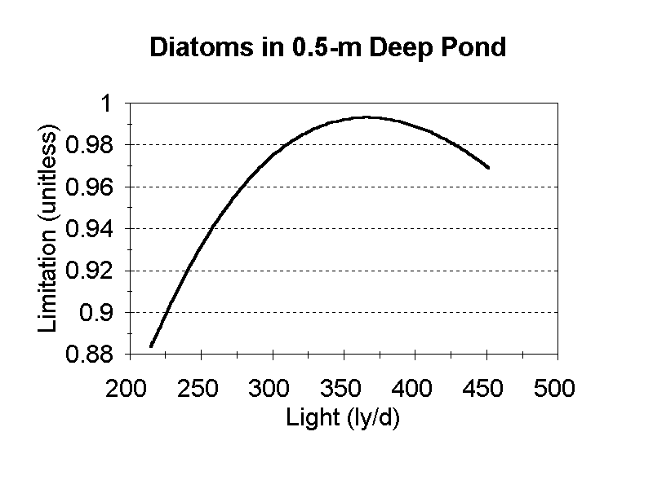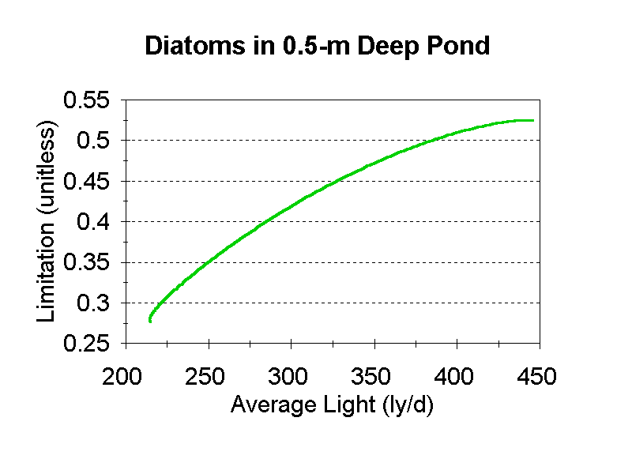

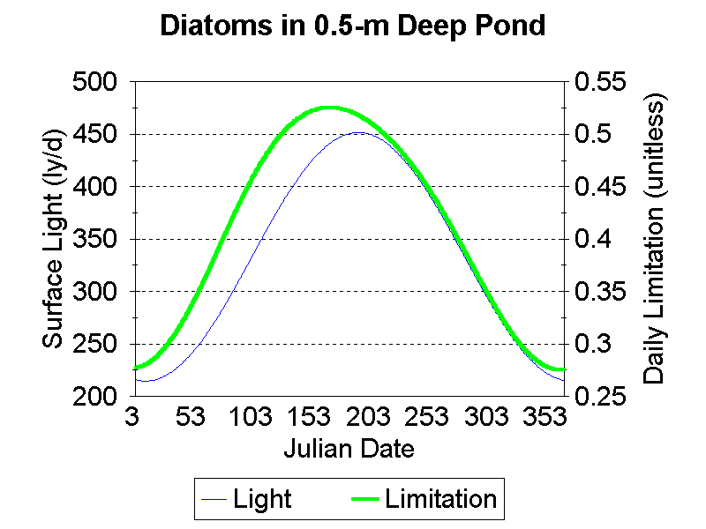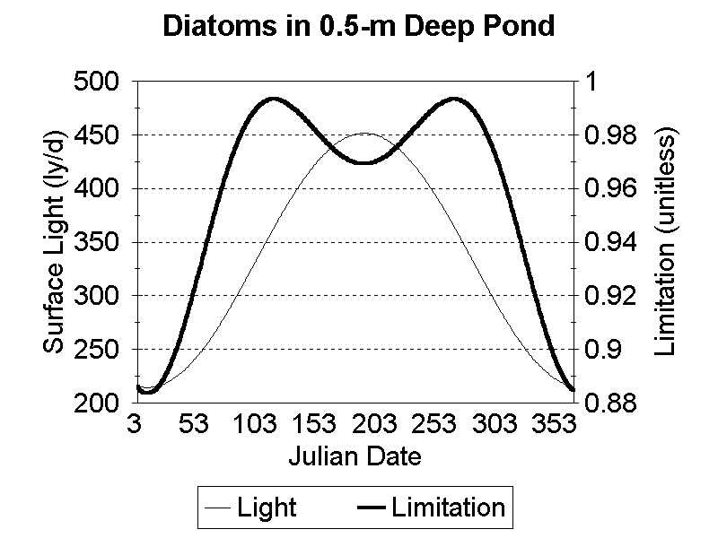

Figure 54. Mid-day Light Limitation

Figure 55. Daily Light Limitation

The Secchi depth, the depth at which a Secchi disk disappears from view, is a commonly used indication of turbidity. It is computed as (Straškraba and Gnauck, 1985):

 **(47)**

where:

*Secchi* = Secchi depth (m).

This relationship also could be used to back-calculate an overall Extinction coefficient if only the Secchi depth is known for a site.

It should be noted that although Secchi depth can be computed for the hypolimnion segment, based on the suspended material, it is a relatively meaningless value for the hypolimnion and generally should be ignored. Light extinction in the hypolimnion is calculated based on the light that has first filtered through the epilimnion as shown in equation **(45)**.

As a verification of the extinction computations, the calculated and observed Secchi depths were compared for Lake George, New York. The Secchi depth is estimated to be 8.3 m in Lake George, based on site data for the various components (Figure 56). This compares favorably with observed values of 7.5 to 11 (Clifford, 1982).

Figure 56. Contributions to light extinction in Lake George NY.

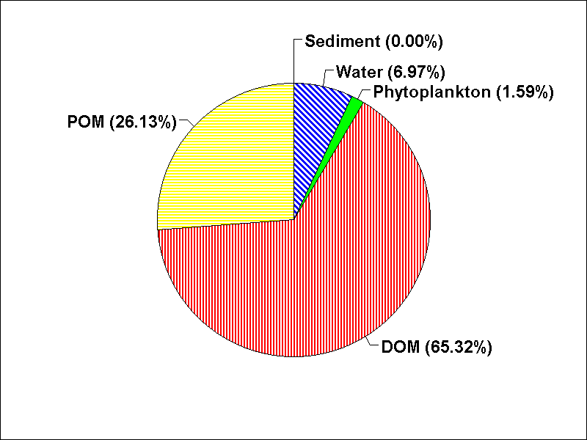

**Adaptive Light**

Saturating light can be specified as a constant for each plant taxonomic group (classic AQUATOX approach) or it can be adaptive based on Kremer and Nixon (1978) and similar to the approach used in EFDC. The adaptive light saturation is the weighted average of photosynthetically active solar radiation (PAR) at the optimal depth for growth of a given plant group, using an approximation based on the user-specified light saturation and site solar radiation and turbidity at the beginning of the simulation:

 **(48)**

 **(49)**

where:

*LightSatCalc* = adaptive light saturation (Ly/d)

*LightHistn* = photosynthetically active radiation at optimum depth for plant growth *n* days prior to simulation date (Ly/d)

*PAR* = photosynthetically active radiation, *Solar* * 0.5 (Ly/d)

*Solar* = incident solar radiation (Ly/d)

*Extinct* = total light extinction computed dynamically **(40).**

If the *LightSatCalc* is greater or less than the user-entered maximum and minimum light saturation coefficients (“Plant underlying data” screen) then the *LightSatCalc* is set to the user-entered maximum or minimum. This *LightSatCalc* variable is then used in the *LtAtDepth* and *LtAtTop* calculations **(43)**-**(45)**.

 **(50)**

where:

*ZOpt Plant* = optimum depth for a given plant (a constant approximated at the beginning of the simulation in meters);

*LightSat* = user entered light saturation coefficient (Ly/d);

*MaxDailyLight* = maximum daily-averaged incident solar radiation for one calendar year forward from the start date (Ly/d);

*ExtinctInitCond* = initial condition total light extinction (unitless);

**Nutrient Limitation**

There are several ways that nutrient limitation has been represented in models. Algae are capable of taking up and storing sufficient nutrients to carry them through several generations, and models have been developed to represent this. However, if the timing of algal blooms is not critical, intracellular storage of nutrients can be ignored, constant stoichiometry can be assumed, and the model is much simpler. Therefore, based on the efficacy of this simplifying assumption, nutrient limitation by external nutrient concentrations has traditionally been used in AQUATOX, as in many other models (for example, Chen, 1970; Parker, 1972; Lassen and Nielsen, 1972; Larsen et al., 1974; Park et al., 1974; Chen and Orlob, 1975; Patten et al., 1975; Environmental Laboratory, 1982; Ambrose et al., 1991). New to Release 3.1, internal nutrient concentrations may be modeled in AQUATOX; see the section on internal nutrients below.

When modeling nutrient limitations with external nutrients, for an individual nutrient, saturation kinetics is assumed, using the Michaelis-Menten or Monod equation (Figure 57); this approach is founded on numerous studies (cf. Hutchinson, 1967):

 **(51)**

 **(52)**

 **(53)**

where:

*PLimit* = limitation due to phosphorus (unitless);

*Phosphorus* = available soluble phosphorus (gP/m3);

*KP* = half-saturation constant for phosphorus (gP/m3);

*NLimit* = limitation due to nitrogen (unitless);

*Nitrogen* = available soluble nitrogen (gN/m3);

*KN* = half-saturation constant for nitrogen (gN/m3);

*CLimit* = limitation due to inorganic carbon (unitless);

*Carbon* = available dissolved inorganic carbon (gC/m3); and

*KCO2* = half-saturation constant for carbon (gC/m3).

Figure 57. Nutrient limitation

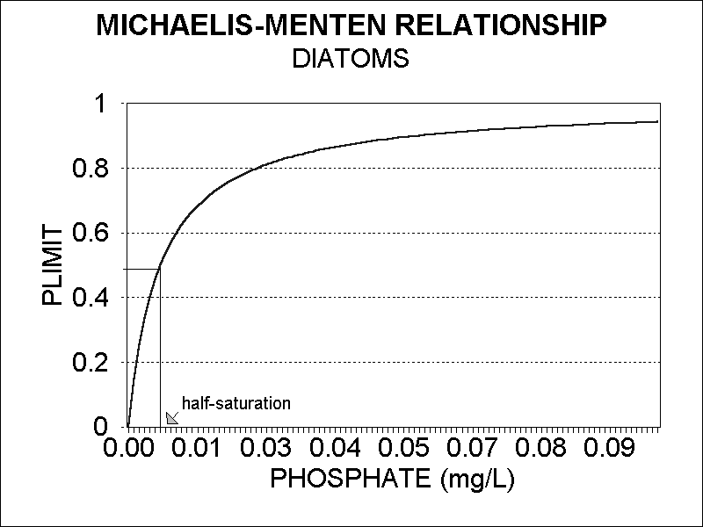

Nitrogen fixation in cyanobacteria is handled by setting *NLimit* to 1.0 if *Nitrogen* is less than half the *KN* value. Otherwise, it is assumed that nitrogen fixation is not operable, and *NLimit* is computed as for the other algae. AQUATOX also provides an option to trigger nitrogen fixation as a function of an input parameter, the ratio of inorganic N to inorganic P, which may be selected and specified in the “Study Setup” screen. When the ratio falls below the threshold, nitrogen fixation is assumed to occur; the default threshold N:P is 7. When internal nutrients are modeled, uptake of nitrogen is set to its maximum rate due to nitrogen fixation when the internal nutrient concentration falls below half of its *internal* half saturation coefficient. See **(55b)** and **(55f)** below.

Concentrations must be expressed in terms of the chemical element. Because carbon dioxide is computed internally, the concentration of carbon is corrected for the molar weight of the element:

 **(54)**

where:

*C2CO2* = ratio of carbon to carbon dioxide (0.27); and

CO2 = inorganic carbon (g/m3).

When modeling with internal or external nutrients, AQUATOX uses the minimum limiting nutrient, whereby the Michaelis-Menten equation is evaluated for each nutrient, and the factor for the nutrient that is most limiting at a particular time is used. This is the approach used in many similar models (for example, Larsen et al., 1973; Baca and Arnett, 1976; Scavia et al., 1976; Smith, 1978; Bierman et al., 1980; Park et al., 1980; Johanson et al., 1980; Grenney and Kraszewski, 1981; Ambrose et al., 1991). The overall nutrient limitation is calculated as follows:

 **(55)**

where:

*NutrLimit* = reduction due to limiting nutrient (unitless).

Alternative formulations used in other models include multiplicative and harmonic-mean constructs, but the minimum limiting nutrient construct is well-founded in laboratory studies with individual species.

**Internal Nutrients Model**

It is well known that many algae are able to take up nutrients even when not required for growth—so-called “luxury uptake.” MS.CLEANER, a precursor to AQUATOX, used internal nutrients (Collins 1980), but this approach was not used in the original AQUATOX because of memory limitations at the time. The present version of AQUATOX has the option of modeling internal nutrients based on the approach of QUAL2K (Chapra et al. 2007) and WASP7 (Ambrose et al. 2006, Martin et al. 2006). When internal nutrients are specified, *NLimit* and *PLimit* are calculated as a function of the internal nutrient concentration in plants, with nitrogen fixation by cyanobacteria being a special case:

 **(55b)**

If the plant is cyanobacteria and

*N_Ratio* < (0.5 ∙ *NHalfSatInternal*)then *NLimit* = 1.0.

where:

*N_Ratio or P_Ratio* = internal nutrient concentration over biomass, (g/g AFDW);

*NHalfSat­Internal* = half-saturation constant for intracellular N (mg/mg AFDW);

*Min_N/P_Ratio* = *N_Ratio* or *P_Ratio* at which growth ceases, a user-input ratio, (g/g AFDW);

Internal nutrients are calculated with independent derivatives for each relevant plant as follows

 **(55c)**

 **(55d)**

where:

*NutrientAlga* = concentration of nutrient within plant compartment, (μg/L);

*N2O* = nutrient to organism ratio, (μg nutrient/mg organism);

*Loading* = external loadings ∙ *N2O;* assumes external loadings have same stoichiometry as current biomass, (μg/L d);

*Uptake* = uptake of nutrients from the water column, see **(55e)** and **(55g)**, (μg/L d);

*Mortality* = mortality of algal biomass ∙ *N2O* (μg/L d);

*Predation* = predation of algal biomass ∙ *N2O* (μg/L d);

*Sinking* *Loss* = sinking loss of algal biomass ∙ *N2O* (μg/L d);

*Sinking* *Gain* = sinking gain of algal biomass ∙ *N2OOther Segment* (μg/L d);

*Floating Loss* = floating loss of algal biomass ∙ *N2O* (μg/L d);

*Floating Gain* = floating gain of algal biomass ∙ *N2OOther Segment* (μg/L d);

*Washout* = washout of algal biomass ∙ *N2O* (μg/L d);

*Washin* = gain from upstream segment of algal biomass,   
*WashoutOther Segment* ∙ *N2OOther Segment* (μg/L d);

*TurbDiff Loss* = turbulent diffusion loss of algal biomass ∙ *N2O* (μg/L d);

*TurbDiff Gain* = turbulent diffusion gain of biomass ∙ *N2OOther Segment* (μg/L d);

*Diffusion* = *diffusionLinked Segment* ∙ *N2OLinked Segment* (μg/L d);

*Slough* = sloughing loss of periphyton biomass ∙ *N2Operiphyton* (μg/L d);

*Sedimentation* = sedimentation of phytoplankton biomass ∙ *N2O* (μg/L d);

*Respiration* = dark respiration of algal biomass ∙ *N2O* (μg/L d);

*Excretion* = photo respiration of algal biomass ∙ *N2O* (μg/L d);

AQUATOX displays internal nutrients in plants as a concentration associated with overlying water (μg/L), and as nutrient-to-organism ratios of grams of nutrient per gram of AFDW organic matter.

Uptake of nutrients is modeled as follows:

 **(55e)**

If the plant is cyanobacteria and is fixing nitrogen then uptake is assumed to occur at the maximum rate.

 **(55f)**

Uptake of phosphorus is modeled with a similar formulation used for the uptake of nitrogen:

 **(55g)**

where:

*PhytoUpNutrient* *=* uptake of internal nutrients (μg of nutrient/L d);

*MaxNutrientUptake* = the maximum uptake rate for the nutrient (mg/mg AFDW∙d);

*NutrientHalfSat* = half-saturation constant for external nutrient (μg nutrient/L);

*NutrientHalfSatInternal* = half-saturation constant for intracellular nutrient (mg/mg AFDW);

*biomass* =algal biomass (mg/L); and

1e3= units conversion (μg/mg).

Some additional observations about the internal nutrients option follow:

* While the internal-nutrient model allows stoichiometry of plants to vary over time, animal and suspended-organic-matter stoichiometry remain constant in the model at this time.
* The internal-nutrient model is not utilized for benthic or rooted macrophytes, which are assumed to get nutrients from sediments and are not assumed to have nutrient limitation for that reason.
* Boundary-condition loadings of plants are assumed to have the same nutrient characteristics as plants currently in the water body.

**Current Limitation**

Because they are fixed in space, periphyton also are limited by slow currents that do not replenish nutrients and carry away senescent biomass. Based on the work of McIntire (1973) and Colby and McIntire (1978), a factor relating photosynthesis to current velocity is used for periphyton:

 **(56)**

where:

*VLimit* = limitation or enhancement due to current velocity (unitless);

*RedStillWater* = user-entered reduction in photosynthesis in absence of current (unitless);

*VelCoeff* = empirical proportionality coefficient for velocity (0.057, unitless); and

*Velocity* = flow rate (converted to m/s), see **(14)**.

*VLimit* has a minimum value for photosynthesis in the absence of currents and increases asymptotically to a maximum value for optimal current velocity (Figure 58). In high currents scour can limit periphyton; see **(75)**. The value of *RedStillWater* depends on the circumstances under which the maximum photosynthesis rate was measured; if *PMax* was measured in still water then *RedStillWater* = 1, otherwise a value of 0.2 is appropriate (Colby and McIntire, 1978).

Figure 58. Effect of current velocity on periphyton photosynthesis.

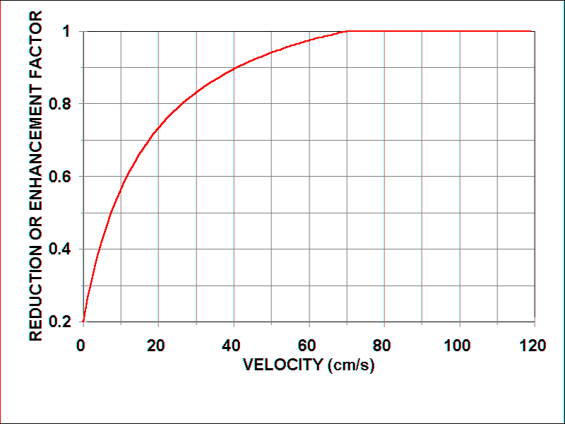

**Adjustment for Suboptimal Temperature**

AQUATOX uses a general but complex formulation to represent the effects of temperature. All organisms exhibit a nonlinear, adaptive response to temperature changes (the so-called Stroganov function). Process rates other than algal respiration increase as the ambient temperature increases until the optimal temperature for the organism is reached; beyond that optimum, process rates decrease until the lethal temperature is reached. This effect is represented by a complex algorithm developed by O'Neill et al. (1972) and modified slightly for application to aquatic systems (Park et al., 1974). An intermediate variable *VT* is computed first; it is the ratio of the difference between the maximum temperature at which a process will occur and the ambient temperature over the difference between the maximum temperature and the optimal temperature for the process:

 **(57)**

where:

*Temperature* = ambient water temperature (deg. C);

*TMax* = maximum temperature at which process will occur (deg. C);

*TOpt* = optimal temperature for process to occur (deg. C); and

*Acclimation* = temperature acclimation (deg. C), as described below.

Acclimation to both increasing and decreasing temperature is accounted for with a modification developed by Kitchell et al. (1972):

 **(58)**

where:

*XM* = maximum acclimation allowed (2.0 deg. C);

*KT* = coefficient for decreasing acclimation as temperature approaches *Tref* (value is 0.5 and unitless);

*ABS* = function to obtain absolute value; and

*TRef* = “adaptation” temperature below which there is no acclimation (deg. C).

The mathematical sign of the variable *Acclimation* is negative if the ambient temperature is below the temperature at which there is no acclimation; otherwise, it is positive.

If the variable *VT* is less than zero, in other words, if the ambient temperature exceeds (*TMax* + *Acclimation*), then the suboptimal factor for temperature is set equal to zero and the process stops. Otherwise, the suboptimal factor for temperature is calculated as (Park et al., 1974):

 **(59)**

where:

 **(60)**

where:

 **(61)**

and,

 **(62)**

where:

*Q10* = slope or rate of change per 10°C temperature change (unitless).

This well-founded, robust algorithm for *TCorr* is used in AQUATOX to obtain reduction factors for suboptimal temperatures for all biologic processes in animals and plants, with the exception of decomposition and plant respiration. By varying the parameters, organisms with both narrow and broad temperature tolerances can be represented (Figure 59**,** Figure 60).

Figure 59. Temperature response of cyanobacteria

Figure 60. Temperature response of diatoms

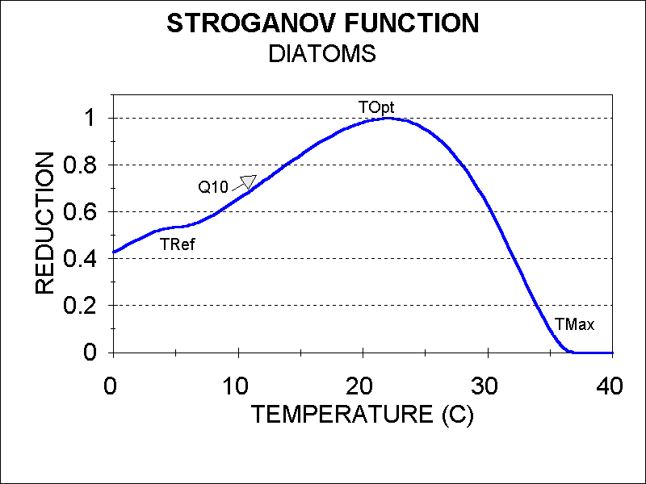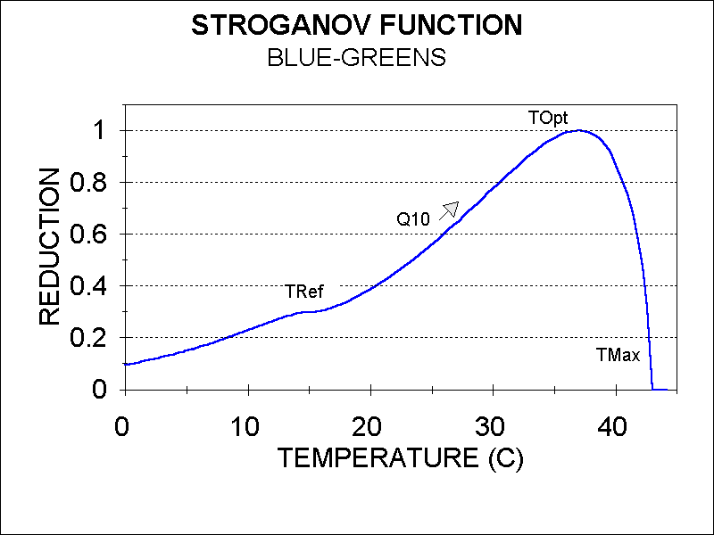

**Algal Respiration**

Endogenous or dark respiration is the metabolic process whereby oxygen is taken up by plants for the production of energy for maintenance and carbon dioxide is released (Collins and Wlosinski, 1983). Although it is normally a small loss rate for the organisms, it has been shown to be exponential with temperature (Aruga, 1965). Riley (1963, see also Groden, 1977) derived an equation representing this relationship. Based on data presented by Collins (1980), maximum respiration is constrained to 60% of photosynthesis. Laboratory experiments in support of the CLEANER model confirmed the empirical relationship and provided additional evidence of the correct parameter values (Collins, 1980), as demonstrated by Figure 61:

 **(63)**

where:

*Respiration* = dark respiration (g/m3⋅d);

*Resp20* = user input respiration rate at 20°C (g/g⋅d);

*1.045* = exponential temperature coefficient (/°C);

*Temperature* = ambient water temperature (°C); and

*Biomass* = plant biomass (g/m3).

This construct also applies to macrophytes.

Figure 61. Respiration (Data From Collins, 1980)

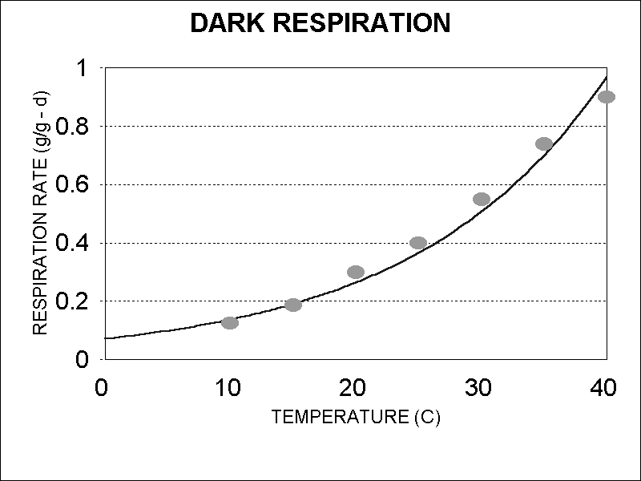

**Photorespiration**

Algal excretion, also referred to as photorespiration, is the release of photosynthate (dissolved organic material) that occurs in the presence of light. Environmental conditions that inhibit cell division but still allow photoassimilation result in release of organic compounds. This is especially true for both low and high levels of light (Fogg et al., 1965; Watt, 1966; Nalewajko, 1966; Collins, 1980). AQUATOX uses an equation modified from one by Desormeau (1978) that is the inverse of the light limitation:

 **(64)**

where:

*Excretion* = release of photosynthate (g/m3⋅d);

*KResp* = coefficient of proportionality between excretion and photosynthesis at optimal light levels (unitless); and

*Photosynthesis* = photosynthesis (g/m3⋅d), see **(35)**,

and where:

 **(65)**

where:

*LtLimit* = light limitation for a given plant (unitless), see **(38)**.

*Excretion* is a continuous function (Figure 62) and has a tendency to overestimate excretion slightly at light levels close to light saturation where experimental evidence suggests a constant relationship (Collins, 1980). The construct for photorespiration also applies to macrophytes.

Figure 62. *Excretion* as a fraction of photosynthesis

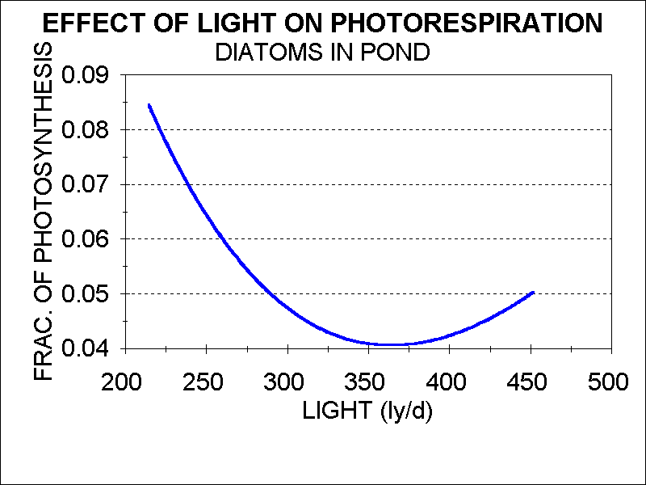

**Algal Mortality**

Nonpredatory algal mortality can occur as a response to toxic chemicals (discussed in **Chapter 8**) and as a response to unfavorable environmental conditions. Phytoplankton under stress may suffer greatly increased mortality due to autolysis and parasitism (Harris, 1986). Therefore, most phytoplankton decay occurs in the water column rather than in the sediments (DePinto, 1979). The rapid remineralization of nutrients in the water column may result in a succession of blooms (Harris, 1986). Sudden changes in the abiotic environment may cause the algal population to crash; stressful changes include nutrient depletion, unfavorable temperature, and damage by light (LeCren and Lowe-McConnell, 1980). These are represented by a mortality term in AQUATOX that includes toxicity, high temperature (Scavia and Park, 1976), and combined nutrient and light limitation (Collins and Park, 1989):

 **(66)**

where:

*Mortality* = nonpredatory mortality (g/m3⋅d);

*Poisoned* = mortality rate due to toxicant (g/m3⋅d), see **(417)**;

*KMort* = intrinsic mortality rate (g/g⋅d); and

*Biomass* = plant biomass (g/m3),

and where:

 **(67)**

and:

 **(68)**

where:

*ExcessT* = factor for high temperatures (g/g⋅d);

*TMax =* maximum temperature tolerated (° C);

*Stress* = factor for suboptimal light and nutrients (g/g⋅d),

*Emort* = approximate maximum fraction killed per day with total limitation (g/g⋅d);

*NutrLimit =* reduction due to limiting nutrient (unitless), see **(55)**

*LtLimit =* light limitation (unitless), see **(38)**.

Exponential functions are used so that increasing stress leads to rapid increases in mortality, especially with high temperature where mortality is 50% per day at the *TMax* (Figure 61), and, to a much lesser degree, with suboptimal nutrients and light (Figure 64). This simulated process is responsible in part for maintaining realistically high levels of detritus in the simulated water body. Low temperatures are assumed not to affect algal mortality.

Figure 63. Mortality due to high temperatures Figure 64. Mortality due to light limitation

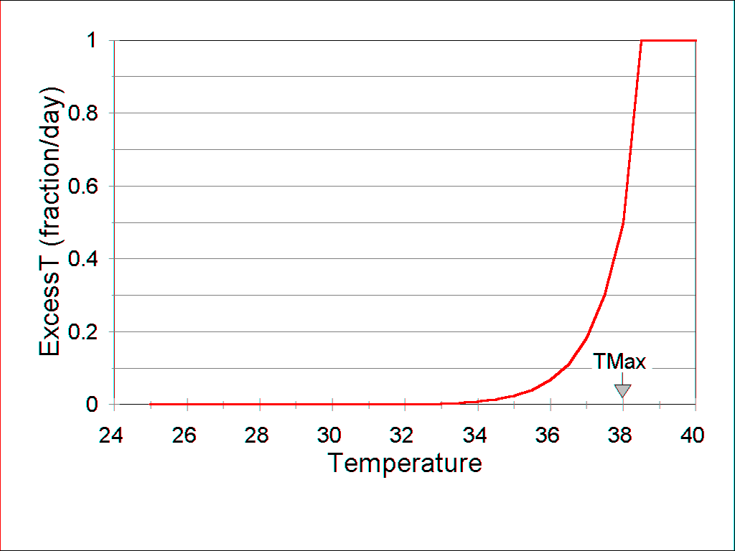 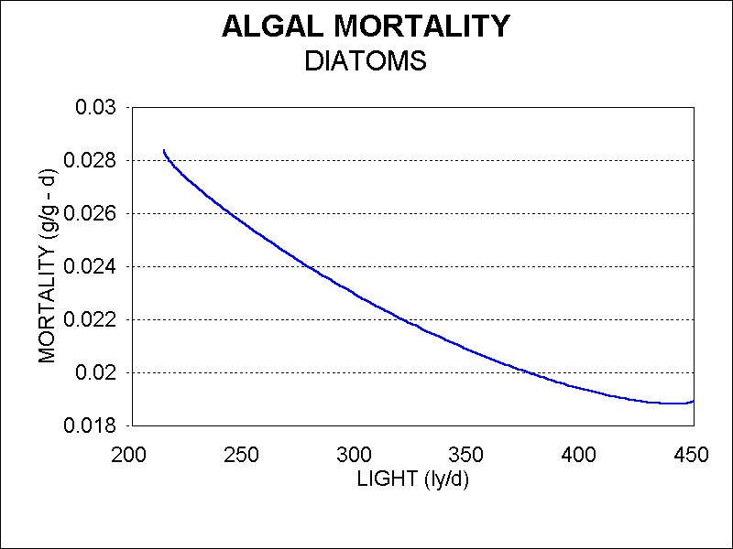

**Sinking**

Sinking of phytoplankton, either between layers or to the bottom sediments, is modeled as a function of physiological state, similar to mortality. Phytoplankton that are not stressed are considered to sink at given rates, which are based on field observations and implicitly account for the effects of averaged water movements (cf. Scavia, 1980). Sinking also is represented as being impeded by turbulence associated with higher discharge (but only when discharge exceeds mean discharge):

 **(69)**

where:

*Sink* = phytoplankton loss due to settling (g/m3⋅d);

*KSed* = intrinsic settling rate (m/d);

*Depth* = depth of water or, if stratified, thickness of layer (m);

*MeanDischarge* = mean annual discharge (m3/d);

*Discharge* = daily discharge (m3/d), see Table 3;

*DensityFactor* = if salinity is modeled, correction factor for water densities based on salinity and temperature, see **(442)**; and

*Biomass* = phytoplankton biomass (g/m3).

The model is able to mimic high sedimentation loss associated with the crashes of phytoplankton blooms, as discussed by Harris (1986). As the phytoplankton are stressed by toxicants and suboptimal light, nutrients, and temperature, the model computes an exponential increase in sinking (Figure 65), as observed by Smayda (1974), and formulated by Collins and Park (1989):

 **(70)**

where:

*SedAccel* = increase in sinking due to physiological stress (unitless);

*ESed* = exponential settling coefficient (unitless);

*LtLimit* = light limitation (unitless), see **(38)**;

*NutrLimit* = nutrient limitation (unitless), see **(55)**; and

*FracPhoto* = reduction factor for effect of toxicant on photosynthesis (unitless), see **(421)**;

*TCorr* = temperature limitation (unitless), see **(59)**.

Figure 65. Sinking as a function of nutrient stress

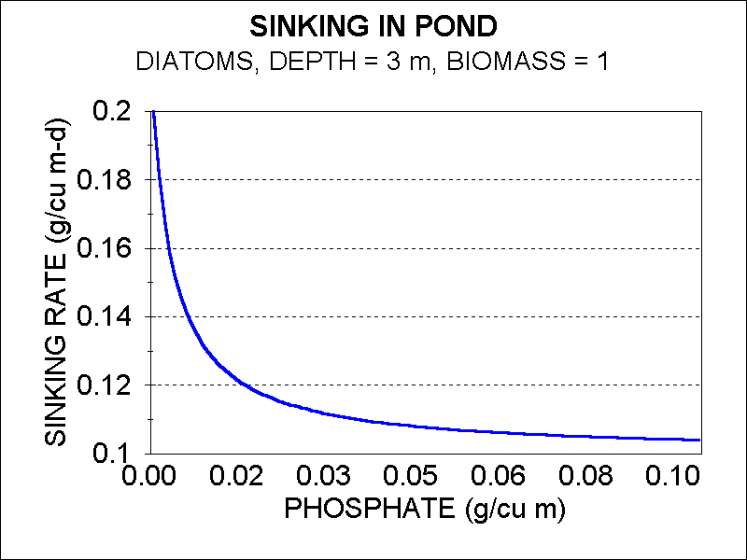

**Washout and Sloughing**

Phytoplankton are subject to downstream drift. In streams and in lakes and reservoirs with low retention times this may be a significant factor in reducing or even precluding phytoplankton populations (LeCren and Lowe-McConnell, 1980). The process is modeled as a simple function of discharge:

 **(71)**

where:

*Washout­phytoplankton* = loss due to downstream drift (g/m3⋅d),

*Discharge* = daily discharge (m3/d);

*Volume* = volume of site (m3); and

*Biomass* = biomass of phytoplankton (g/m3).

Periphyton often exhibit a pattern of buildup and then a sharp decline in biomass due to sloughing. Based on extensive experimental data from Walker Branch, Tennessee (Rosemond, 1993), a complex sloughing formulation, extending the approach of Asaeda and Son (2000), was implemented. This function was able to represent a wide range of conditions better (Figure 66and Figure 67).

 **(72)**

where:

*WashoutPeriphyton* = loss due to sloughing (g/m3∙d);

*Slough* = loss due to natural causes (g/m3∙d), see **(75)**; and

*Dislodgeperi, Tox* = loss due to toxicant-induced sloughing (g/m3∙d), see **(427)**.

Figure 66. Comparison of predicted biomass of periphyton, constituent algae, and observed biomass of periphyton (Rosemond, 1993) in Walker Branch, Tennessee, with addition of both N and P and removal of grazers in Spring, 1989.

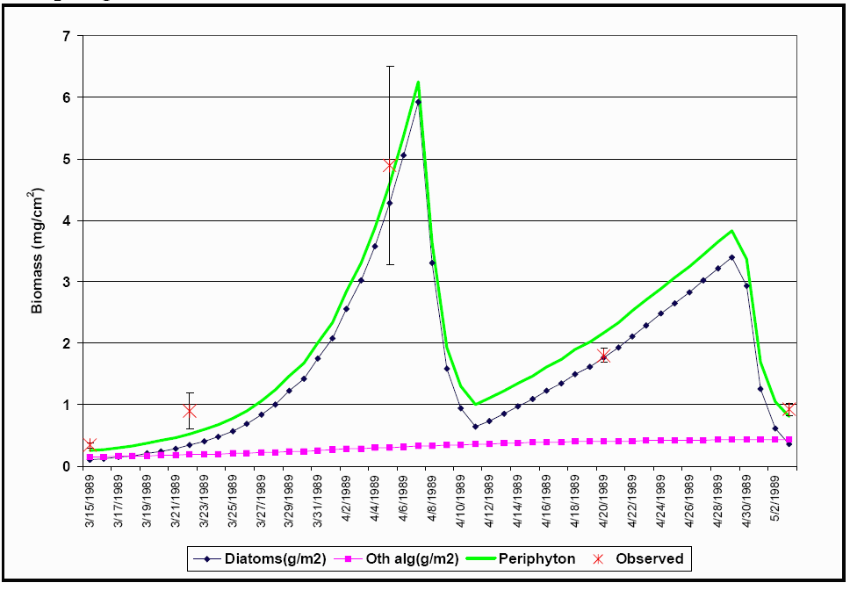

Figure 67. Predicted rates for diatoms in Walker Branch, Tennessee, with addition of both N and P and removal of grazers in Spring, 1989. Note the importance of periodic sloughing. Rates expressed as g/m2 d.

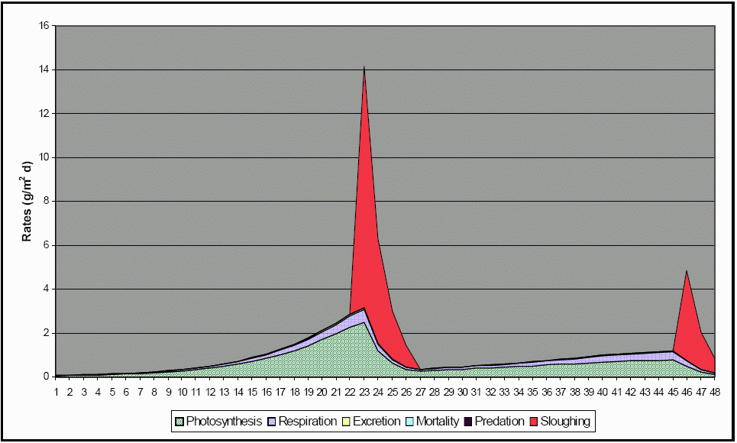

Natural sloughing is a function of senescence due to suboptimal conditions and the drag force of currents acting on exposed biomass. Drag increases as both biomass and velocity increase:

 **(73)**

where:

*DragForce* = drag force (kg m/s2);

*Rho* = density of water (kg/m3);

*DragCoeff* = drag coefficient (2.53E-4, unitless);

*Vel* = velocity (converted to m/s) see **(14)**;

*BioVol* = biovolume of algae (mm3/mm2);

*UnitArea* = unit area (mm2);

1E-6 = conversion factor (m2/mm2).

Biovolume is not modeled directly by AQUATOX, so a simplifying assumption is that the empirical relationship between biomass and biovolume is constant for a given growth form, based on observed data from Rosemond (1993):

 **(74)**

where:

*BiovolDia* = biovolume of non-filamentous algae (mm3/mm2);

*BiovolFil* = biovolume of filamentous algae (mm3/mm2);

*Biomass* = biomass of given algal group (g/m2);

*ZMean =* mean depth (m).

Suboptimal light, nutrients, and temperature cause senescence of cells that bind the periphyton and keep them attached to the substrate. This effect is represented by a factor, *Suboptimal*, which is computed in modeling the effects of environmental conditions on photosynthesis. *Suboptimal* decreases the critical force necessary to cause sloughing. If the drag force exceeds the critical force for a given algal group modified by the *Suboptimal* factor and an adaptation factor, then sloughing occurs:

 **(75)**

where:

*SuboptimalOrg* = factor for suboptimal nutrient, light, and temperature effect on senescence of given periphyton group (unitless);

*FCritOrg* = critical force necessary to dislodge given periphyton group (kg m/s2);

*Adaptation* = factor to adjust for mean discharge of site compared to reference site (unitless);

*Slough* = biomass lost by sloughing (g/m3);

*FracSloughed* = fraction of biomass lost at one time, editable.

 **(76)**

where:

*NutrLimit* = nutrient limitation for given algal group (unitless) computed by AQUATOX; see **(55)**;

*LtLimitOrg* = light limitation for given algal group (unitless) computed by AQUATOX; see **(38)**; and

*TCorr* = temperature limitation for a given algal group (unitless) computed by AQUATOX; see **(59)**.

20 = factor to desensitize construct.

The sloughing construct was tested and calibrated (U.S. E.P.A., 2001) with data from experiments with artificial and woodland streams in Tennessee (Rosemond, 1993, Figure 66). However, in modeling periphyton at several sites, it was observed that sloughing appears to be triggered at greatly differing mean velocities. The working hypothesis is that periphyton adapt to the ambient conditions of a particular channel. Therefore, a factor is included to adjust for the mean discharge of a given site compared to the reference site in Tennessee. It is still necessary to calibrate *FCrit* for each site to account for intangible differences in channel and flow conditions, analogous to the calibration of shear stress by sediment modelers, but the range of calibration needed is reduced by the *Adaptation* factor:

 **(77)**

where:

*Vel* = velocity for given site (m/s), see **(14)**;

0.006634 = mean velocity2 for reference experimental stream (m/s).

**Detrital Accumulation in Periphyton**

In phytoplankton, mortality results in immediate production of detritus, and that transfer is modeled. However, for purposes of modeling, periphyton are defined as including associated detritus. The accumulation of non-living biomass is modeled implicitly by not simulating mortality due to suboptimal conditions. Rather, in the simulation biomass builds up, causing increased self-shading, which in turn makes the periphyton more vulnerable to sudden loss due to sloughing. The fact that part of the biomass is non-living is ignored as a simplification of the model.

**Chlorophyll *a***

Chlorophyll *a* is not simulated directly. However, because chlorophyll *a* is commonly measured in aquatic systems and because water quality managers are accustomed to thinking of it as an index of water quality, the model converts phytoplankton biomass estimates into approximate values for chlorophyll *a*. The ratio of carbon to chlorophyll *a* exhibits a wide range of values depending on the nutrient status of the algae (Harris, 1986); cyanobacteria often have higher values (cf. Megard et al., 1979). Conversion factors between phytoplankton and chlorophyll *a* are now editable on a species by species basis within each plants “underlying data.” In the absence of species-specific data, AQUATOX uses default values of 45 μgC/μg chlorophyll *a* for cyanobacteria and a value of 28 for other phytoplankton as reported in the documentation for WASP (Ambrose et al., 1991). The values are more representative for blooms than for static conditions, but managers are usually most interested in the maxima. Results are presented as total chlorophyll *a* in μg/L; therefore, the computation is:

 **(78)**

where:

*ChlA* = estimated biomass as chlorophyll *a* (μg/L);

*Biomass* = biomass of given alga (mg/L);

*CToOrg* = ratio of carbon to biomass (0.526, unitless);

*CToChl*a = ratio of carbon to chlorophyll a (g carbon/g chl *a*); and

1000 = conversion factor for mg to μg (unitless).

Periphytic chlorophyll *a* is computed as a conversion from the ash-free dry weight (AFDW) of periphyton; because periphyton can collect inorganic sediments, it is important to measure and model it as AFDW. The conversion factor is based on the observed average ratio of chlorophyll *a* to AFDW for the Cahaba River near Birmingham, Alabama (unpub. data) and also based on data published in Biggs (1996)and Rosemond (1993).

 **(79)**

where:

*PeriChlor* = periphytic chlorophyll *a* (mg/m2);

*AFDW*  = ash free dry weight (g/m2).

Moss chlorophyll *a* is output for all plants designated with the plant type “Bryophytes.” In this case, ash free dry weight is multiplied by 8.91 to get the estimate of chlorophyll *a* in mg/m2 (Stream Bryophyte Group, 1999, p. 160). Total benthic chlorophyll *a* is also output in units of mg/m2 (the sum of periphyton and moss chlorophyll *a*).

**Phytoplankton and Zooplankton Residence Time**

Phytoplankton and zooplankton can quickly wash out of a short reach, but they may be able to grow over an extensive reach of a river, including its tributaries. Somehow the volume of water occupied by the phytoplankton needs to be taken into consideration. To solve this problem, AQUATOX takes into account the “Total Length” of the river being simulated, as opposed to the length of the river reach, or “SiteLength” so that phytoplankton and zooplankton production upstream can be estimated. This parameter can be directly entered on the “Site Data” screen or estimated from the watershed area based on Leopold et al. (1964).

 **(80)**

where:

*TotLength* = total river length (km);

*Watershed* = land surface area contributing to flow out of the reach (square km);

1.609 = km per mile;

0.386 = square miles per square km.

If Enhanced Phytoplankton Retention is not chosen (or the total length or watershed area is entered as zero,) the phytoplankton and zooplankton residence time equations are not used and Equations **(71)** and **(129)** are used to calculate washout. In this case, the phytoplankton residence time is equal to the retention time of the system.

Otherwise, to simulate the inflow of plankton from upstream reaches plankton upstream loadings are estimated as follows:

 **(81)**

where:

*Loadingupstream* = loading of plankton due to upstream production (mg/L);

*Washoutbiota* = washout of plankton from the current reach (mg/L);

*TotLength* = total river length (km);

*SiteLength* = length of the modeled reach (km).

An integral assumption in this approach is that upstream reaches included in the total river length have identical environmental conditions as the reach being modeled and that plankton production in each mile up-stream will be identical to plankton production in the given reach. Residence time for plankton within the total river length is estimated as follows:

 **(82)**

where:

*tresidence* = residence time for floating biota within the total river length (d);

*Volume* = volume of modeled segment reach (m3); see **(2)**;

*Discharge*= discharge of water from modeled reach (m3/d); see Table 3;

*TotLength* = total river length (km);

*SiteLength* = length of the modeled reach (km).

**Periphyton-Phytoplankton Link**

Periphyton may slough or be physically scoured, contributing to the suspended (sestonic) algae; this may be reflected in the chlorophyll *a* observed in the water column. Periphyton may be linked to a phytoplankton compartment so that sestonic chlorophyll *a* reflects the results of periphyton sloughing. One-third of periphyton is assumed to become phytoplankton and two thirds is assumed to become suspended detritus in a sloughing event. The default is linkage to detritus with a warning.

Additionally, when phytoplankton undergoes sedimentation it will now be incorporated into the linked periphyton layer if such a linkage exists. If multiple periphyton species are linked to a single phytoplankton species, biomass is distributed to periphyton weighted by the mass of each periphyton compartment. (A single periphyton compartment cannot be linked to multiple phytoplankton compartments.)

 **(83)**

where:

*SedPeriphyton A* = sedimentation that goes to periphyton compartment A;

*SinkPhyto* = total sedimentation of linked phytoplankton compartment, see **(69)**;

*MassPeriphyton A* = mass of periphyton compartment A;

*MassAll Linked Peri* = mass of all periphyton compartments linked to the

relevant phytoplankton compartment.

If no linkage is present, settling phytoplankton are assumed to contribute to sedimented detritus.

**4.2 Macrophytes**

Submersed aquatic vegetation or macrophytes can be an important component of shallow aquatic ecosystems. It is not unusual for the majority of the biomass in an ecosystem to be in the form of macrophytes during the growing season. Seasonal macrophyte growth, death, and decomposition can affect nutrient cycling, and detritus and oxygen concentrations. By forming dense cover, they can modify habitat and provide protection from predation for invertebrates and smaller fish (Howick et al., 1993); this function is represented in AQUATOX (see Figure 73). Macrophytes also provide direct and indirect food sources for many species of waterfowl, including swans, ducks, and coots (Jupp and Spence, 1977b).

AQUATOX represents rooted macrophytes as occupying the littoral zone, that area of the bottom surface that occurs within the euphotic zone (see **(11)** for computation). Similar to periphyton, the macrophyte compartment has units of g/m2. In nature, macrophytes can be greatly reduced if phytoplankton blooms or higher levels of detritus increase the turbidity of the water (cf. Jupp and Spence, 1977a). Because the depth of the euphotic zone is computed as a function of the extinction coefficient (*ZEuphotic =* 4.605/*Extinct*), the area predicted to be occupied by macrophytes can increase or decrease depending on the clarity of the water.

The macrophyte equations are based on submodels developed for the International Biological Program (Titus et al., 1972; Park et al., 1974) and CLEANER models (Park et al., 1980) and for the Corps of Engineers' CE-QUAL-R1 model (Collins et al., 1985):

 **(84)**

and:

 **(85)**

where:

*dBiomass/dt* = change in biomass with respect to time (g/m2⋅d);

*Loading* = loading of macrophyte, usually used as a “seed” (g/m2⋅d);

*Photosynthesis* = rate of photosynthesis (g/m2⋅d);

*Respiration* = respiratory loss (g/m2⋅d), see **(63)**;

*Excretion* = excretion or photorespiration(g/m2⋅d), see **(64)**;

*Mortality* = nonpredatory mortality (g/m2⋅d), see **(87)**;

*Predation* = herbivory (g/m2⋅d), see **(99)**;

*Breakage* = loss due to breakage (g/m2⋅d), see **(88)**;

*PMax* = maximum photosynthetic rate (1/d);

*LtLimit* = light limitation (unitless), see **(38)**;

*TCorr* = correction for suboptimal temperature (unitless), see **(59)**;

*HabitatLimit* = in streams, habitat limitation based on plant habitat preferences (unitless), see **(13)**;

*FracLittoral* = fraction of bottom that is in the euphotic zone(unitless) see **(11)**;

*NutrLimit* = nutrient limitation for bryophytes or freely-floating macrophytes (unitless), see **(55)**;

*FracPhoto* = reduction factor for effect of toxicant on photosynthesis (unitless), see **(421)**;

 *=* washout of freely floating macrophytes, see **(86)**; and

 = loadings from linked upstream segments (g/m3·d), see **(30)**;

They share many of the constructs with the algal submodel described above. Temperature limitation is modeled similarly, but with different parameter values. Light limitation also is handled similarly, using the Steele (1962) formulation; the application of this equation has been verified with laboratory data (Collins et al., 1985). Periphyton are epiphytic in the presence of macrophytes; by growing on the leaves they contribute to the light extinction for the macrophytes (Sand-Jensen, 1977). Extinction due to periphyton biomass is computed in AQUATOX, by inclusion in *LtLimit*. For rooted macrophytes, nutrient limitation is not modeled at this time because macrophytes can obtain most of their nutrients from bottom sediments (Bristow and Whitcombe, 1971; Nichols and Keeney, 1976; Barko and Smart, 1980). Bryophytes and freely floating macrophytes assimilate nutrients from water and are subject to nutrient limitation.

Release 3 includes free-floating macrophytes. These macrophytes are assumed to be floating at the upper layer of the water column and therefore are not subject to light limitation. Furthermore, free-floating macrophytes are not subject to the *FracLittoral* limitation to macrophyte photosynthesis **(85)**. On the other hand the washing of macrophytes out of the system is affected by the carrying capacity for the species:

 **(86)**

where:

 = loss due to being carried downstream (g/m3 ⋅d),

*State* = concentration of dissolved or floating state variable (g/m3),

*KCap* = carrying capacity (g/m2);

*ZMean* = mean depth from site underyling data (m);

*Discharge* = discharge (m3/d), see Table 3; and

*Volume* = volume of site (m3), see **(2)**;

Simulation of macrophyte respiration and excretion utilize the same equations as algae; excretion in rooted macrophytes results in "nutrient pumping" because the nutrients are assumed to come from the sediments but are excreted to the water column[1]. Non-predatory mortality is modeled similarly to algae as a function of suboptimal temperature (but not light). However, mortality is a function of low as well as high temperatures, and winter die-back is represented as a result of this control; the response is the inverse of the temperature limitation (Figure 68):

 **(87)**

where:

*KMort* = intrinsic mortality rate(g/g⋅d)*;*

*Poisoned* = mortality rate due to toxicant (g/g⋅d) **(417)**, and

*EMort* = maximum mortality due to suboptimal temperature (g/g⋅d).

Sloughing of dead leaves can be a significant loss (LeCren and Lowe-McConnell, 1980); it is simulated as an implicit result of mortality (Figure 68).

Figure 68. Mortality as a function of temperature

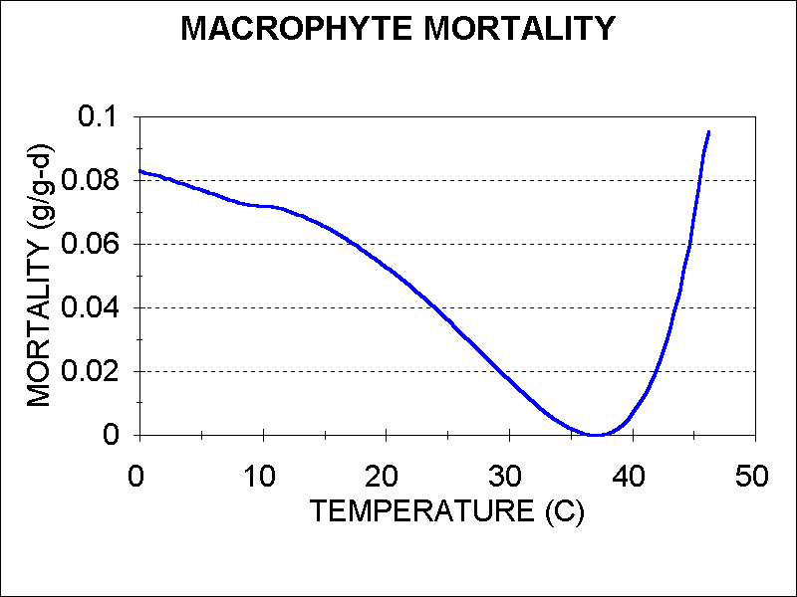

Macrophytes are subject to breakage due to higher water velocities; this breakage of live material is different from the sloughing of dead leaves. Although breakage is a function of shoot length and growth form as well as currents (Bartell et al., 2000; Hudon et al., 2000), a simpler construct was developed for AQUATOX (Figure 69):

 **(88)**

where:

*Breakage* = macrophyte breakage (g/m2 ⋅d);

*Velocity* = current velocity (cm/s) see **(14)**;

*VelMax* = velocity at which total breakage occurs (cm/s);

*Gradual* = velocity scaling factor (20 cm/s);

*UnitTime* = unit time for simulation (1 d);

*Biomass* = macrophyte biomass (g/m2).

Figure 69. Breakage of macrophytes as a function of current

velocity; *VelMax* set to 300 cm/s.



The *Breakage* formulation also applies to freely floating macrophytes and may be considered entrainment in periods of high flow. As such, *VelMax* should be set to a relatively high value for these organisms.

Bryophytes (mosses and liverworts) are a special class of macrophytes that attach to hard substrates, are stimulated by and take up nutrients directly from the water, are resistant to breakage, and decompose very slowly (Stream Bryophyte Group, 1999)*.* Nutrient limitation is enabled when the “Bryophytes” plant type is selected, just as it is for algae. The model assumes that when a bryophyte breaks or dies the result is 75% particulate and 25% dissolved refractory detritus; in contrast, other macrophytes are assumed to yield 62% labile detritus. All other differences between bryophytes and other macrophytes in AQUATOX are based on differences in parameter values. These include low saturating light levels, low optimum temperature, very low mortality rates, moderate resistance to breakage, and resistance to herbivory (Arscott et al., 1998; Stream Bryophyte Group, 1999). Because in the field it is difficult to separate bryophyte chlorophyll from that of periphyton, it is computed so that the two can be combined and related to field values:

 **(89)**

where:

*MossChlor* = bryophytic chlorophyll *a* (mg/m2);

*BryoConv* = conversion from bryophyte AFDW to chlorophyll *a* (8.9 mg/m2: g/m2);

*BiomassBryo* = biomass of given bryophyte (AFDW in g/m2).

Currents and wave agitation can both stimulate and retard macrophyte growth. These effects will be modeled in a future version. Similar to the effect on periphyton, water movement can stimulate photosynthesis in macrophytes (Westlake, 1967); the same function could be used for macrophytes as for periphyton, although with different parameter values. Jupp and Spence (1977b) have shown that wave agitation can severely limit macrophytes; time-varying breakage eventually will be modeled when wave action is simulated.

1. Because nutrients are not usually explicitly modeled in bottom sediments, macrophyte root uptake can result in loss of mass balance, particularly in shallow ponds. The optional sediment diagenesis model *does* include nutrients but linkage to macrophytes through root uptake has not yet been specified and implemented. However, the total mass of nutrients taken into the water column through macrophyte uptake can be tracked as a model output (N and P “Root Uptake” in kg).