**Volume**

Volume is a state variable and can be computed in several ways depending on availability of data and the site dynamics. It is important for computing the dilution or concentration of pollutants, nutrients, and organisms; it may be constant, but usually it is time varying. In the model, ponds, lakes, and reservoirs are treated differently than streams, especially with respect to computing volumes. The change in volume of ponds, lakes, and reservoirs is computed as:

**(2)**



where:

*dVolume/dt* = derivative for volume of water (m3/d),

*Inflow* = inflow of water into waterbody (m3/d),

*Discharge* = discharge of water from waterbody (m3/d), and

*Evap* = evaporation (m3/d), see **(3)**.

AQUATOX cannot successfully run if the volume of water in a site falls to zero. To avoid this condition, if the site’s water volume falls below a minimum value (which is defined as a fraction of the initial condition using the parameter “Minimum Volume Frac.” from the “Site” screen), all differentiation of state variables is suspended (except for the water volume derivative) until the water volume again moves above the minimum value. Differentiation of all state variables then resumes.

A time series of evaporation may be entered in the “Site” screen in units of cubic meters per day. Otherwise, evaporation is converted from an annual value for the site to a daily value using the simple relationship:

**(3)**



where:

*Evap* = mean daily evaporation (m3/d)

*MeanEvap* = mean annual evaporation (in/yr),

*365* = days per year (d/yr),

*0.0254* = conversion from inches to meters (m/in), and

*Area* = area of the waterbody (m2).

The user is given several options for computing volume including keeping the volume constant; making the volume a dynamic function of inflow, discharge, and evaporation; using a time series of known values; and, for flowing waters, computing volume as a function of the Manning’s equation. Depending on the method, inflow and discharge are varied, as indicated in Table 3. As shown in equation **(2)**, an evaporation term is present in each of these volume calculation options. In order to keep the volume constant, given a known inflow loading, evaporation must be subtracted from discharge. This will reduce the quantity of state variables that wash out of the system. In the dynamic formulation, evaporation is part of the differential equation, but neither inflow nor discharge is a function of evaporation as they are both entered by the user. When setting the volume of a water body to a known value, evaporation must again be subtracted from discharge for the volume solution to be correct. Finally, when using the Manning's volume equation, given a known discharge loading, the effects of evaporation must be added to the inflow loading so that the proper Manning's volume is achieved. (This could increase the amount of inflow loadings of toxicants and sediments to the system, although not significantly.)

**Table 3. Computation of Volume, Inflow, and Discharge**

|  |  |  |
| --- | --- | --- |
| **Method** | **Inflow** | **Discharge** |
| Constant | *InflowLoad* | *InflowLoad - Evap* |
| Dynamic | *InflowLoad* | *DischargeLoad* |
| Known values | *InflowLoad* | *InflowLoad - Evap + (State - KnownVals)/dt* |
| Manning | *ManningVol - State/dt + Discharge + Evap* | *DischargeLoad* |

The variables are defined as:

*InflowLoad* = user-supplied inflow loading (m3/d);

*DischargeLoad* = user-supplied discharge loading (m3/d);

*State* = computed state variable value for volume (m3);

*KnownVals* = time series of known values of volume (m3);

*dt* = incremental time in simulation (d); and

*ManningVol* = volume of stream reach (m3), see **(4)**.

Figure 35illustrates time-varying volumes and inflow loadings specified by the user and discharge computed by the model for a run-of-the-river reservoir. Note that significant drops in volume occur with operational releases, usually in the spring, for flood control purposes.

Figure 35. Volume, inflow, and discharge for a 4-year period

in Coralville Reservoir, Iowa.

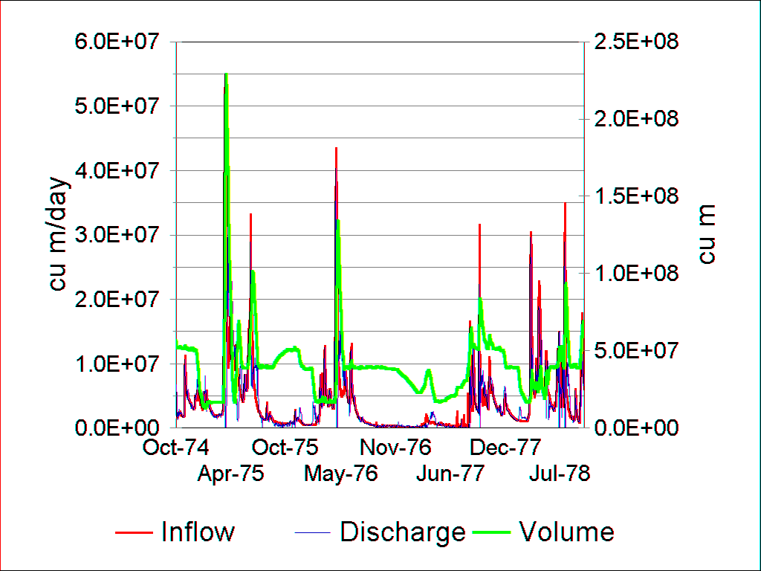

The time-varying volume of water in a stream channel is computed as:

**(4)**



where:

*Y* = dynamic mean depth (m), see **(5)**;

*CLength* = length of reach (m); and

*Width* = width of channel (m).

In streams the depth of water and flow rate are key variables in computing the transport, scour, and deposition of sediments. Time-varying water depth is a function of the flow rate, channel roughness, slope, and channel width using Manning’s equation (Gregory, 1973), which is rearranged to yield:

**(5)**



where:

*Q* = flow rate (m3/s);

*Manning* = Manning’s roughness coefficient (s/m1/3);

*Slope* = slope of channel (m/m); and

*Width* = channel width (m).

The Manning’s roughness coefficient is an important parameter representing frictional loss, but it is not subject to direct measurement. The user can choose among the following stream types:

* concrete channel (with a default Manning’s coefficient of 0.020);
* dredged channel, such as ditches and channelized streams (default coefficient of 0.030); and
* natural channel (default coefficient of 0.040).

These generalities are based on Chow’s (1959) tabulated values as given by Hoggan (1989). The user may also enter a value for the coefficient.

In the absence of inflow data, the flow rate is computed from the initial mean water depth, assuming a rectangular channel and using a rearrangement of Manning’s equation:

**(6)**



where:

*QBase* = base flow (m3/s); and

*Idepth* = mean depth as given in site record (m).

The dynamic flow rate is calculated from the inflow loading by converting from m3/d to m3/s:

**(7)**



where:

*Q* = flow rate (m3/s); and

*Inflow* = water discharged into channel from upstream (m3/d).

**Bathymetric Approximations**

The depth distribution of a water body is important because it determines the areas and volumes subject to mixing and light penetration. The shapes of ponds, lakes, reservoirs, and streams are represented in the model by idealized geometrical approximations, following the topological treatment of Junge (1966; see also Straškraba and Gnauck, 1985). The shape parameter *P* (Junge, 1966) characterizes the site, with a shape that is indicated by the ratio of mean to maximum depth.:

**(8)**



Where:

*ZMean* = mean depth (m);

*ZMax* = maximum depth (m); and

*P* = characterizing parameter for shape (unitless); P is constrained between -1.0 and 1.0

Shallow constructed ponds and ditches may be approximated by an ellipsoid where *Z/ZMax* = 0.6 and *P =* 0.6. Reservoirs and rivers generally are extreme elliptic sinusoids with values of *P* constrained to -1.0. Lakes may be either elliptic sinusoids, with *P* between 0.0 and -1.0, or elliptic hyperboloids with *P* between 0.0 and 1.0. Not all water bodies fit the elliptic shapes, but the model generally is not sensitive to the deviations.

Based on these relationships, fractions of volumes and areas can be determined for any given depth (Junge, 1966). The *AreaFrac* function returns the fraction of surface area that is at depth *Z* given *Zmax* and *P*, which defines the morphometry of the water body. For example, if the water body were an inverted cone, when horizontal slices were made through the cone looking down from the top one could see both the surface area and the water/sediment boundary where the slice was made. This would look like a circle within a circle, or a donut (Figure 36). *AreaFrac* calculates the fraction that is the donut (not the donut hole). To get the donut hole, 1 - *AreaFrac* is used.

**(9)**



**(10)**



where:

*AreaFrac =* fraction of area of site above given depth (unitless);

*VolFrac* = fraction of volume of site above given depth (unitless); and

*Z* = depth of interest (m).

For example, the fraction of the volume that is epilimnion can be computed by setting depth *Z* to the mixing depth. Furthermore, by setting *Z* to the depth of the euphotic zone, where primary production exceeds respiration, the fraction of the area available for colonization by macrophytes and periphyton can be computed:

**(11)**



A relatively deep, flat-bottomed basin would have a small littoral area and a large sublittoral area (Figure 36).

Figure 36.



If the site is an artificial enclosure then the available area is increased accordingly:

**(12)**



where:

*FracLittoral* = fraction of site area that is within the euphotic zone (unitless);

*ZEuphotic* = depth of the euphotic zone, is assumed to be 1% of surface light and calculated as 4.605/*Extinct* (m) see **(40)**;

*Area* = site area (m2); and

*EnclWallArea* = area of experimental enclosure’s walls (m2).

Figure 37. Area as a function of depth Figure 38. Volume as a function of depth

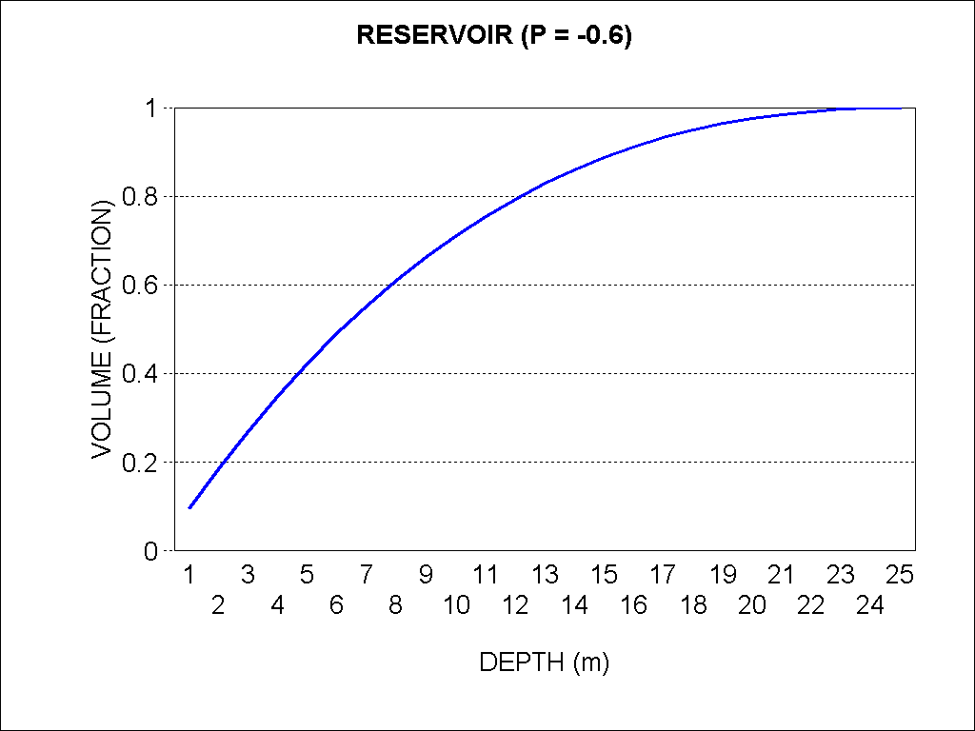 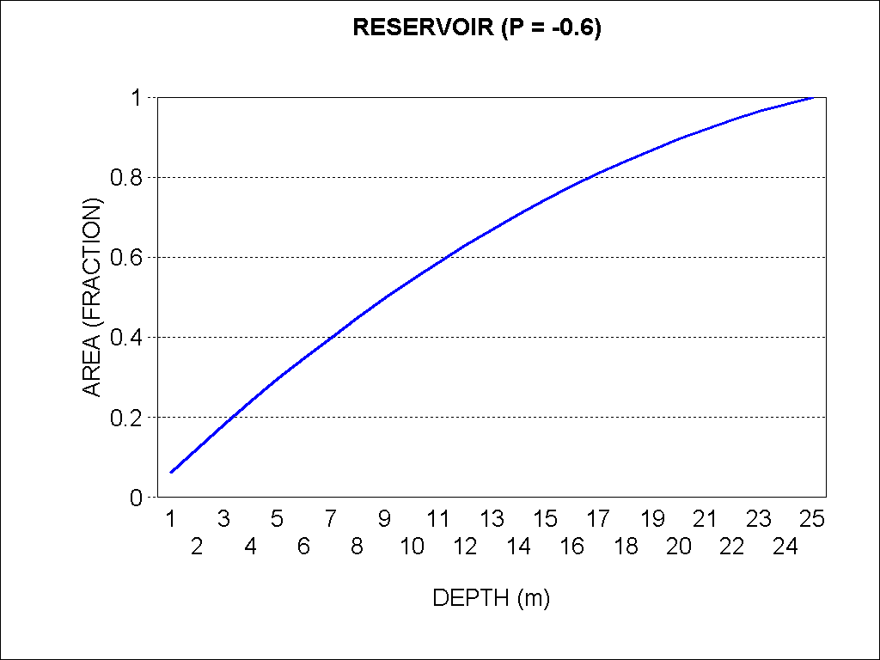

If a user wishes to model a simpler system, the bathymetric approximations may be bypassed in favor of a more rudimentary set of assumptions via an option in the “site data” screen.

When the user chooses not to “use bathymetry”

* the system is assumed to have vertical walls;
* the system is assumed to have a constant area as a function of depth;
* the system’s depth may be calculated at any time as water volume divided by surface area.

This option may be useful when linking data from other models to AQUATOX as the horizontal spatial domain of AQUATOX remains unchanged over time. However, a system will not undergo dynamic stratification based on water temperature unless the more complex bathymetric approximations are utilized (**(8)** to **(11)**).