**Programmer test log – AQUATOXVolumeModel, JSON vs. AQUATOX 3.2**

**JSON test logs in the hms_backend\Stream.Hydrology\AQUATOX\TEST folder**

12/20/2017, AQUATOXVolume model reproduces results from East Fork Poplar Creek TN from AQUATOX 3.2

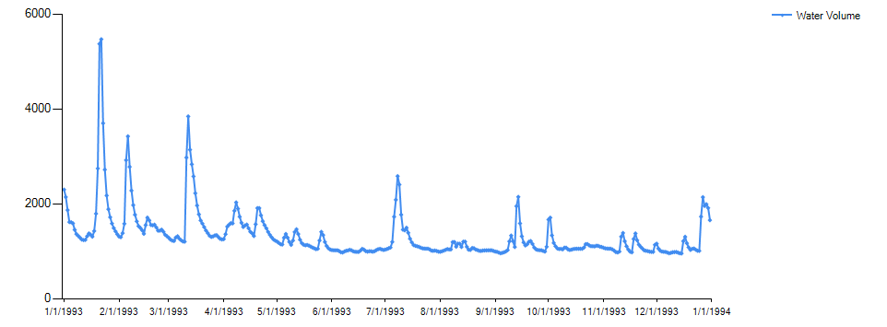

Results from AQUATOX_Volume_Model_PTest1.JSON above



Results from AQUATOX 3.2

1/26/2018, testing of AQUATOX trapezoidal integration and instantaneous output

100-day timestep



Results from AQUATOX_Volume_Model_PTest2.JSON below

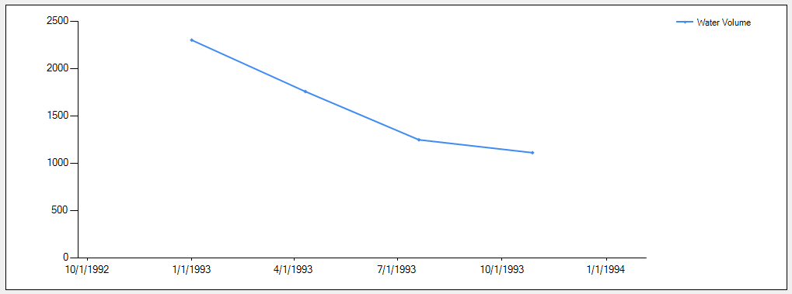

Results are essentially identical -- AQUATOX does print final time step though it does not have a 100-day averaging period.

1/26/2018, test instantaneous conc vs. AQUATOX output

Results from AQUATOX_Volume_Model_PTest3.JSON above (re-run 3/9/2018)

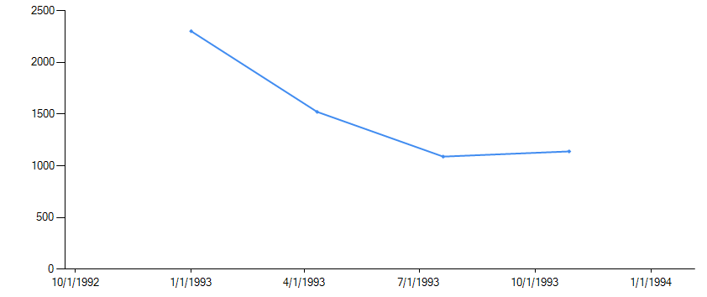

1/26/2018, test hourly output, run for two days – results evenly spaced and consistent with trapezoidal integration, (30 day test in AQUATOX_Volume_Model_PTest4.JSON)

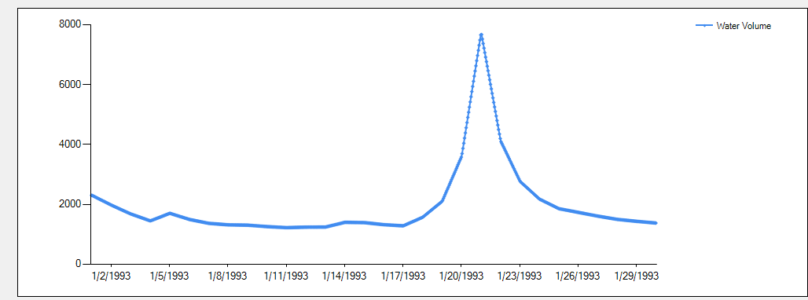

And with instantaneous concs (1 year test in AQUATOX_Volume_Model_PTest5.JSON)

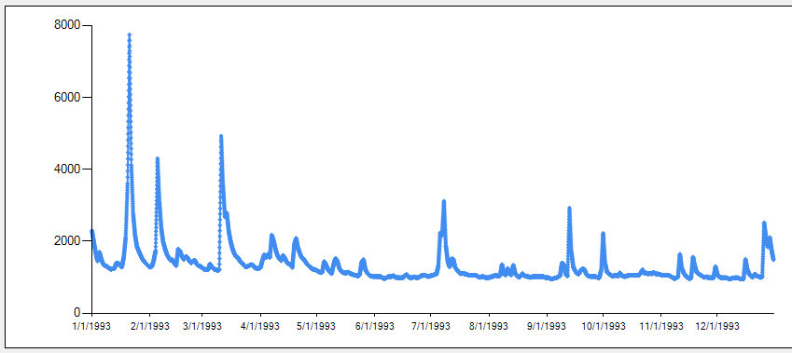

3/9/2018, Re run of AQUATOXVolume model using new JSON format (JSON.NET): Model reproduces results from East Fork Poplar Creek TN from AQUATOX 3.2

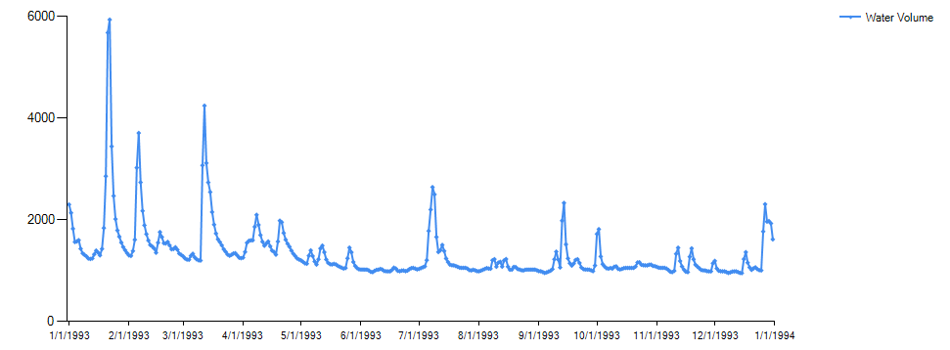

Results from AQUATOX_Volume_Model_PTest1.JSON above **– re-run 3/9/18**



Results from AQUATOX 3.2

1/26/2018, testing of AQUATOX trapezoidal integration and instantaneous output

100-day timestep



Results from AQUATOX_Volume_Model_PTest2.JSON below **– re-run 3/9/18**

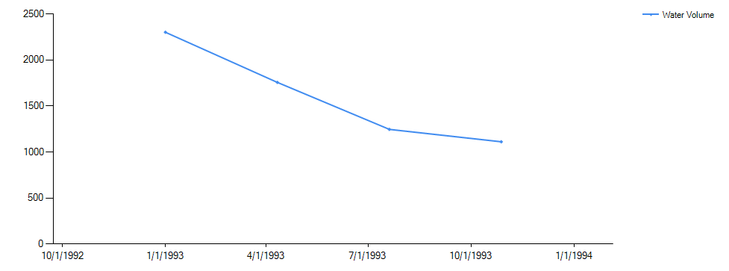

Results are essentially identical -- AQUATOX 3.2 does print final time step though it does not have a 100-day averaging period. HMS does not.

1/26/2018, test hourly output, run for thirty days – results evenly spaced and consistent with trapezoidal integration, (30 day test in AQUATOX_Volume_Model_PTest4.JSON) **– re-run 3/9/18**

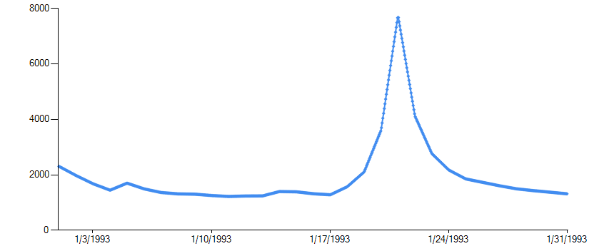

And hourly test with instantaneous concs (1 year test in AQUATOX_Volume_Model_PTest5.JSON) **– re-run 3/9/18**

