6/2 update, Farm Pond MO precise replication of results
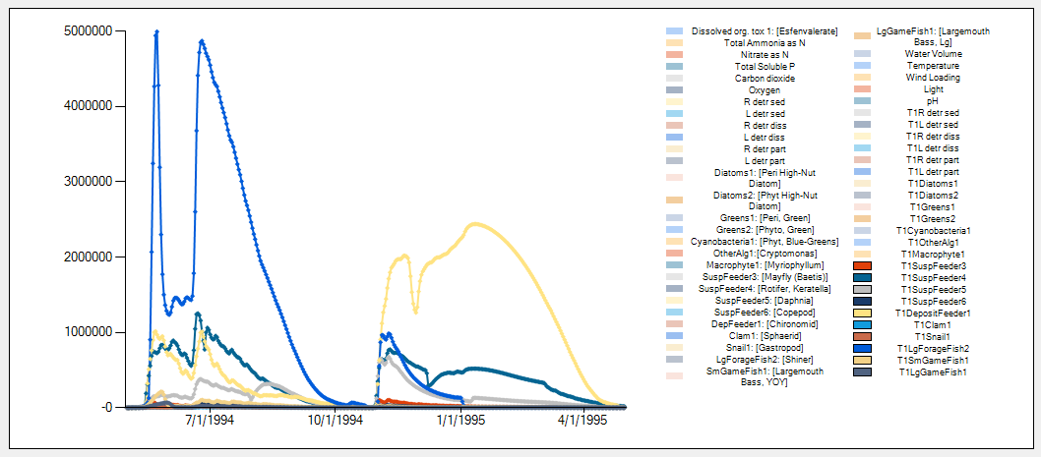
Bioaccumulation in animals precise
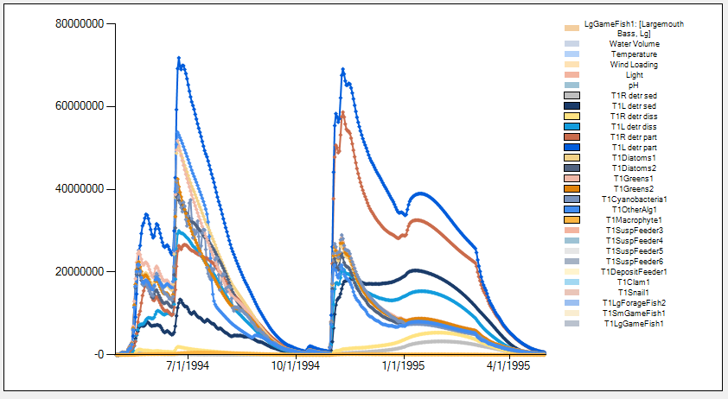
Bioaccumulation in plants precise

Impact on animals is precise (high lethality)

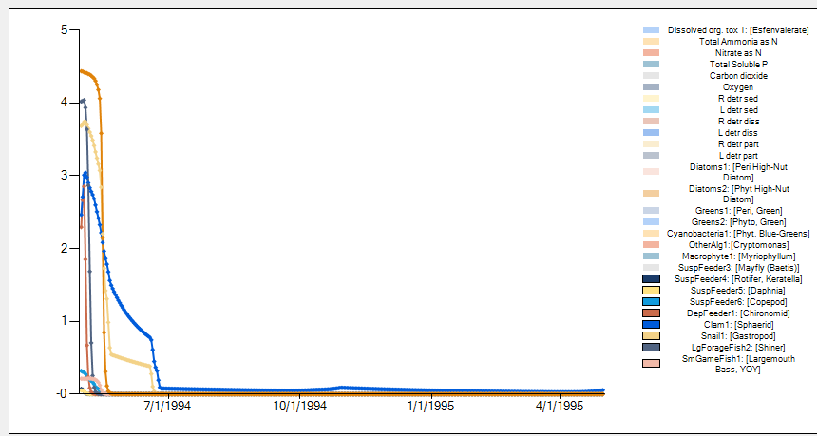
Impact on plants is precise (minimal)

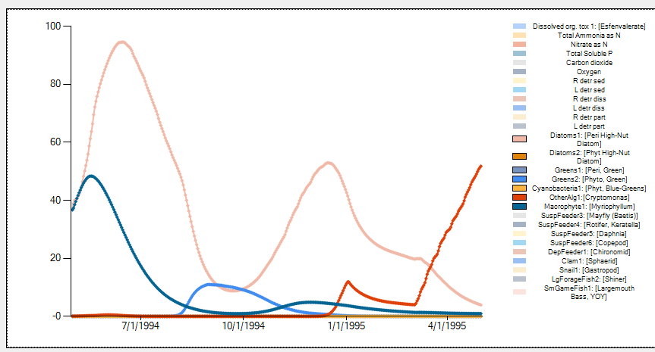

External Toxicity, lower toxicant loading
Impact on animals is precisely replicated, non 100% lethality
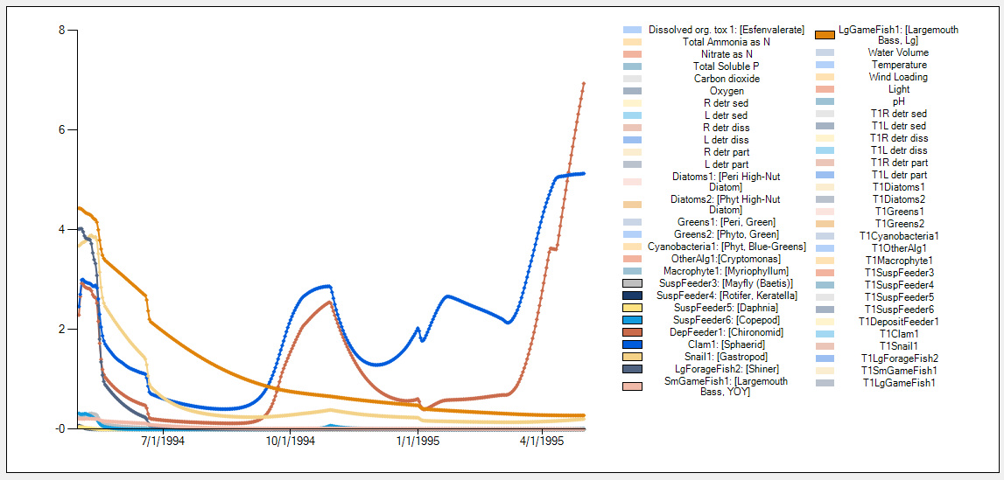

Animal PPB is precise

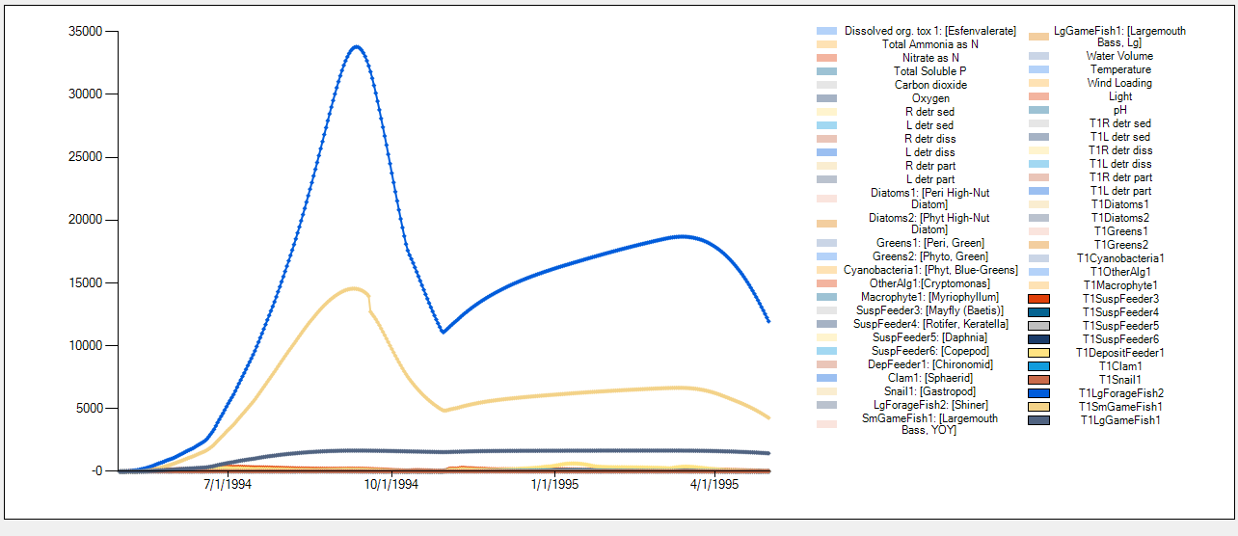

Ohio stream Chlorpyrifos pulsed2.aps. Precise replication of impacts from internal mode of toxicity.
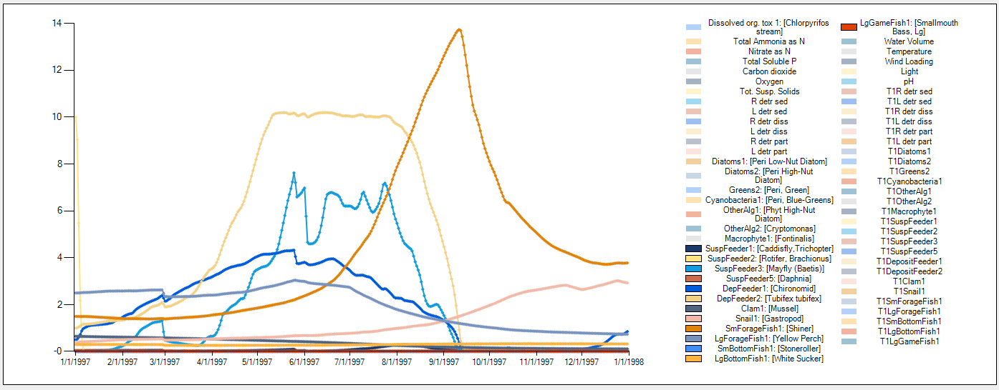

Ohio stream Chlorpyrifos pulsed2.aps. Further verification of bioaccumulation code
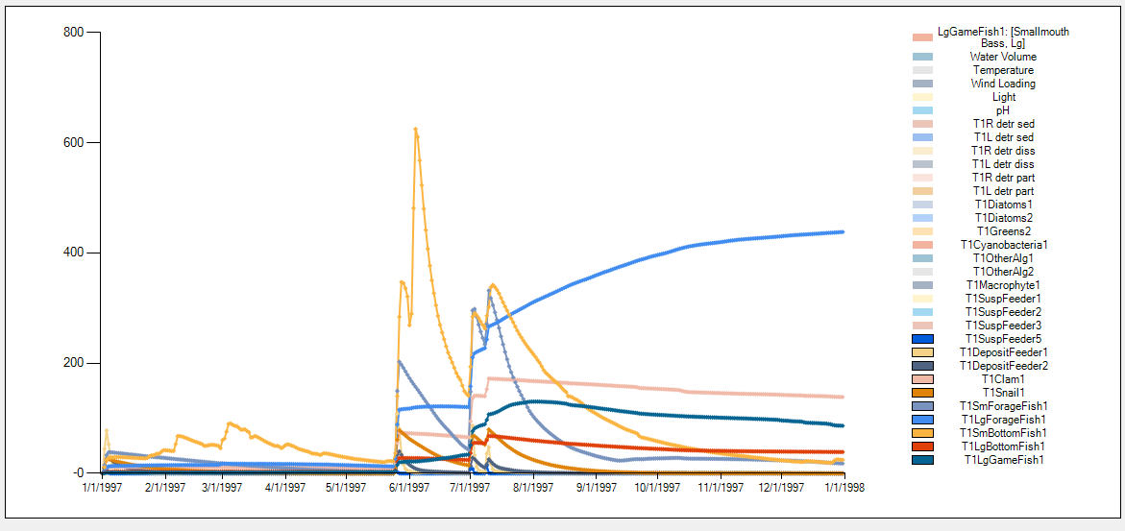
Ohio stream Chlorpyrifos GrowthTest.JSON
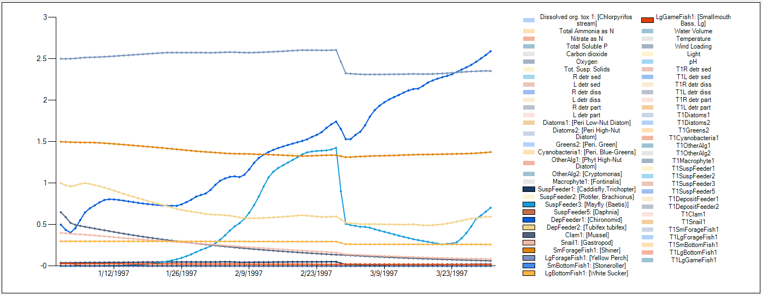

Ohio stream Chlorpyrifos pulsed_DriftTest.JSON
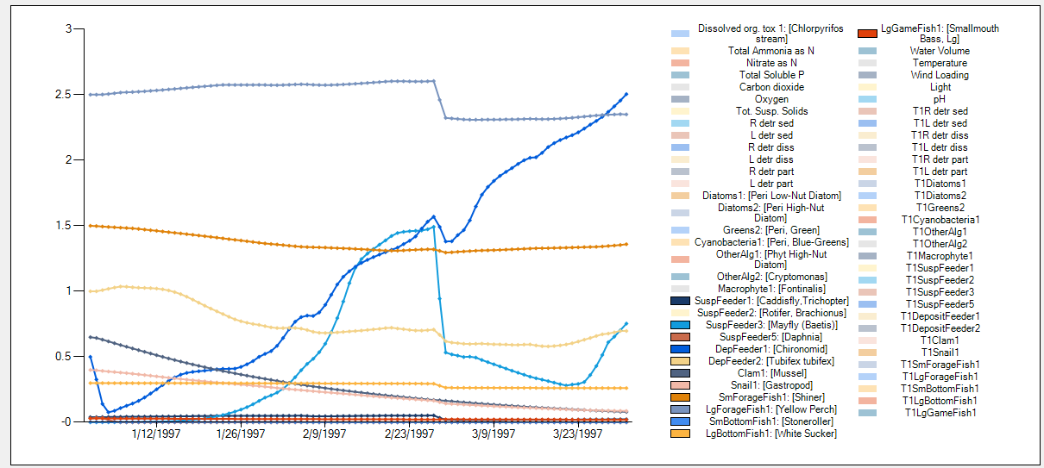

Verified results from Pond_MN_Chlor_6ugL.aps
Then verified results from Pond_MN_Chlor_Repro_6ugL.JSON
