Creating standardised grids for New Zealand marine science outputs

New Zealand Aquatic Environment and Biodiversity Report No.…..

S. Mormede

D.N. Webber

C. Edwards

ISSN 1176-9440 (print)

ISSN 1179-6480 (online)

ISBN XXXX (online)

Month 2021

Requests for further copies should be directed to:

Publications Logistics Officer

Ministry for Primary Industries

PO Box 2526

WELLINGTON 6140

Email: [brand@mpi.govt.nz](mailto:brand@mpi.govt.nz)

Telephone: 0800 00 83 33

Facsimile: 04-894 0300

This publication is also available on the Ministry for Primary Industries websites at:

http://www.mpi.govt.nz/news-and-resources/publications

<http://fs.fish.govt.nz> go to Document library/Research reports

© Crown Copyright – Fisheries New Zealand

TABLE OF CONTENTS

Executive Summary 1

1. Introduction 2

2. Methods 2

3. Discussion 5

4. References 5

5. Appendix 5

# Executive Summary

**Mormede, S.; Webber, D.N.; Edwards, E. (2022). Creating standardised grids for New Zealand marine science outputs.**

**New Zealand Aquatic Environment and Biodiversity Report No. XX. XX p.**

Spatially explicit marine science research outputs are increasingly being generated in New Zealand. The integration of the results of these research projects can be facilitated when the different outputs use the same spatial projection and spatial grids which can nest into each other.

Wood et al. (2020) developed an equal area projection for the New Zealand marine environment and proposed a central point through which all grids should intersect. For these grids to be nested in each other, the grid size must be one of 250 m, 500 m, 1 km, 2 km, 4 km, 8 km, 16 km, 32 km, 64 km, and so forth.

We provide the R code and reference to an R package which creates such grids as a baseline for future researchers. This work was carried out as part of the Fisheries New Zealand projects ENV2020-04 and PRO2019-09.

# Introduction

Wood et al. (2020) developed an equal area projection for the New Zealand marine environment (registered as EPSG:9191, see <https://epsg.io/9191>), defined as:

+proj=aea +lat_0=-40 +lon_0=175 +lat_1=-30 +lat_2=-50 +x_0=0 +y_0=0 +datum=WGS84 +units=m +no_defs

Wood et al. (2020) also proposed an origin located at the centre of the projection which should be used for producing gridded outputs in Fisheries New Zealand research projects – this origin is   
{0, -4226000}. They suggested that the size of the grid cells should be one of the following sizes, depending on user requirements: 250 m, 500 m, 1 km, 2 km, 4 km, 8 km, 16 km, 32 km, 64 km, etc. This is so that whatever resolution is chosen, different sized grids will nest into each other.

Functions were developed to produce grids based on a user-defined grid size and an area of interest. These functions are publicly available in the R package ‘nzsf’ (see <https://github.com/quantifish/nzsf>). The vignette for this package provides examples on how to use ‘nzsf’.

Examples making use of the ‘nzsf’ package are provided below and standalone versions of the relevant ‘nzsf’ functions for producing standard grids are provided in the appendix. Throughout this document, R code is easily identified by a grey background.

# Methods

Two example uses of the ‘nzsf’ package are provided below including:

1. an example where two different sized grids are generated; and
2. an example where both a raster grid and a grid of polygons are generated.

First, the required R packages are loaded including:

* ‘nzsf’ which contains helper functions for producing standard grids and generating maps using ‘ggplot’;
* ‘ggspatial’ for adding scales to plots using the ‘annotation_scale’ function; and
* ‘stars’ for plotting rasters using ‘ggplot’.

To generate different sized girds, two different polygons are loaded using the ‘nzsf’ function ‘get_statistical_areas’: the New Zealand Exclusive Economic Zone (EEZ) and the CRA 1 Quota Management Area (QMA).

library(nzsf)

library(ggspatial)

library(stars)

EEZ <- get_statistical_areas(area = "EEZ", proj = proj_nzsf())

CRA1 <- get_statistical_areas(area = "CRA", proj = proj_nzsf()) %>%

filter(QMA %in% "CRA1")

The 9191 equal area projection is contained within the function ‘proj_nzsf’. Using the EEZ and CRA 1 polygons, polygons of standard grids at 64 km and 256 km resolutions are created using the ‘nzsf’ function ‘get_standard_grid’:

grd256_cra1 <- get_standard_grid(cell_size = 256,

bounding_box = st_bbox(CRA1),

return_raster = FALSE)

grd064_cra1 <- get_standard_grid(cell_size = 64,

bounding_box = st_bbox(CRA1),

return_raster = FALSE)

grd256_eez <- get_standard_grid(cell_size = 256,

bounding_box = st_bbox(EEZ),

return_raster = FALSE)

The grid covering the EEZ and the two CRA 1 grids that were generated can be plotted easily using a combination of ‘ggplot’, the R package ‘sf’, and ‘nzsf’:

ggplot() +

geom_sf(data = grd256_eez, colour = "lightblue", fill = NA, alpha = 0.5) +

geom_sf(data = grd256_cra1, colour = "blue", fill = NA, alpha = 0.5, linetype = "dashed") +

geom_sf(data = grd064_cra1, colour = "tomato", fill = NA, alpha = 0.5) +

plot_coast(resolution = "medium", fill = "black", colour = "black", size = 0.3) +

geom_point(aes(x = 0, y = -422600), colour = "green") +

annotation_scale(location = "tr", unit_category = "metric") +

coord_sf(xlim = c(-5e+05, 2.5e+05), ylim = c(-422600, 895400))

The plot generated by this code illustrates a 256 km grid covering the EEZ, a 256 km grid covering the extent of the CRA 1 QMA, a 64 km grid covering the CRA 1 QMA, and the origin point (Figure 1).

The second example illustrates how a standard grid can be created as a raster by specifying ‘return_raster = TRUE’. This raster is then filled with random values for display purposes, and converted to a ‘stars’ object so that the ‘geom_stars’ function with the R package ‘stars’ can be used for plotting the raster using ‘ggplot’:

ras256 <- get_standard_grid(cell_size = 256,

bounding_box = st_bbox(EEZ),

return_raster = TRUE)

ras256[] <- rnorm(n = ncell(ras256))

rstar <- st_as_stars(ras256)

ggplot() +

geom_stars(data = rstar) +

geom_sf(data = grd256_eez, fill = NA, colour = “red”, linetype = “dotted”) +

plot_coast(resolution = “large”, fill = "black", colour = "black", size = 0.3) +

plot_statistical_areas(area = "EEZ", colour = "black", fill = NA) +

geom_point(aes(x = 0, y = -422600), colour = "green") +

plot_clip("NZ")

The plot generated by this code illustrates two 256 km grids covering the EEZ – one grid is polygons and the other grid is a raster (Figure 2).

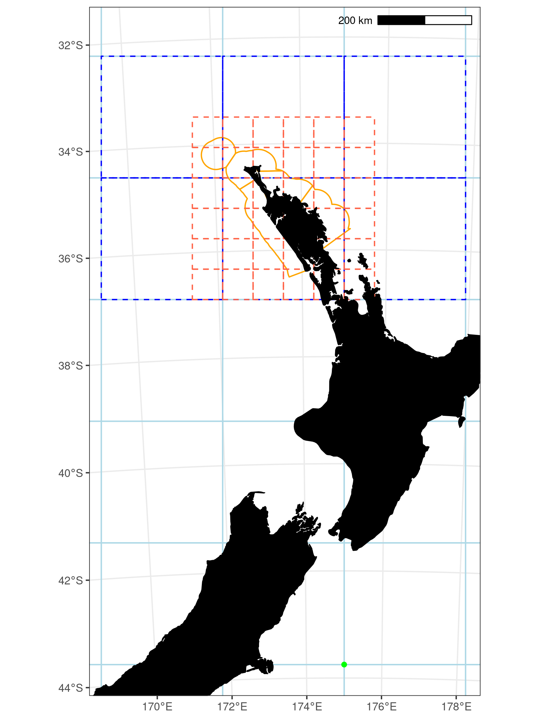

Figure 1: A 256 km grid covering the EEZ (light blue squares), a 256 km grid covering the extent of the CRA 1 QMA (dashed blue squares), a 64 km grid covering the CRA 1 QMA (dashed red squares), and the CRA 1 QMA (orange lines). The origin is also shown (green point).

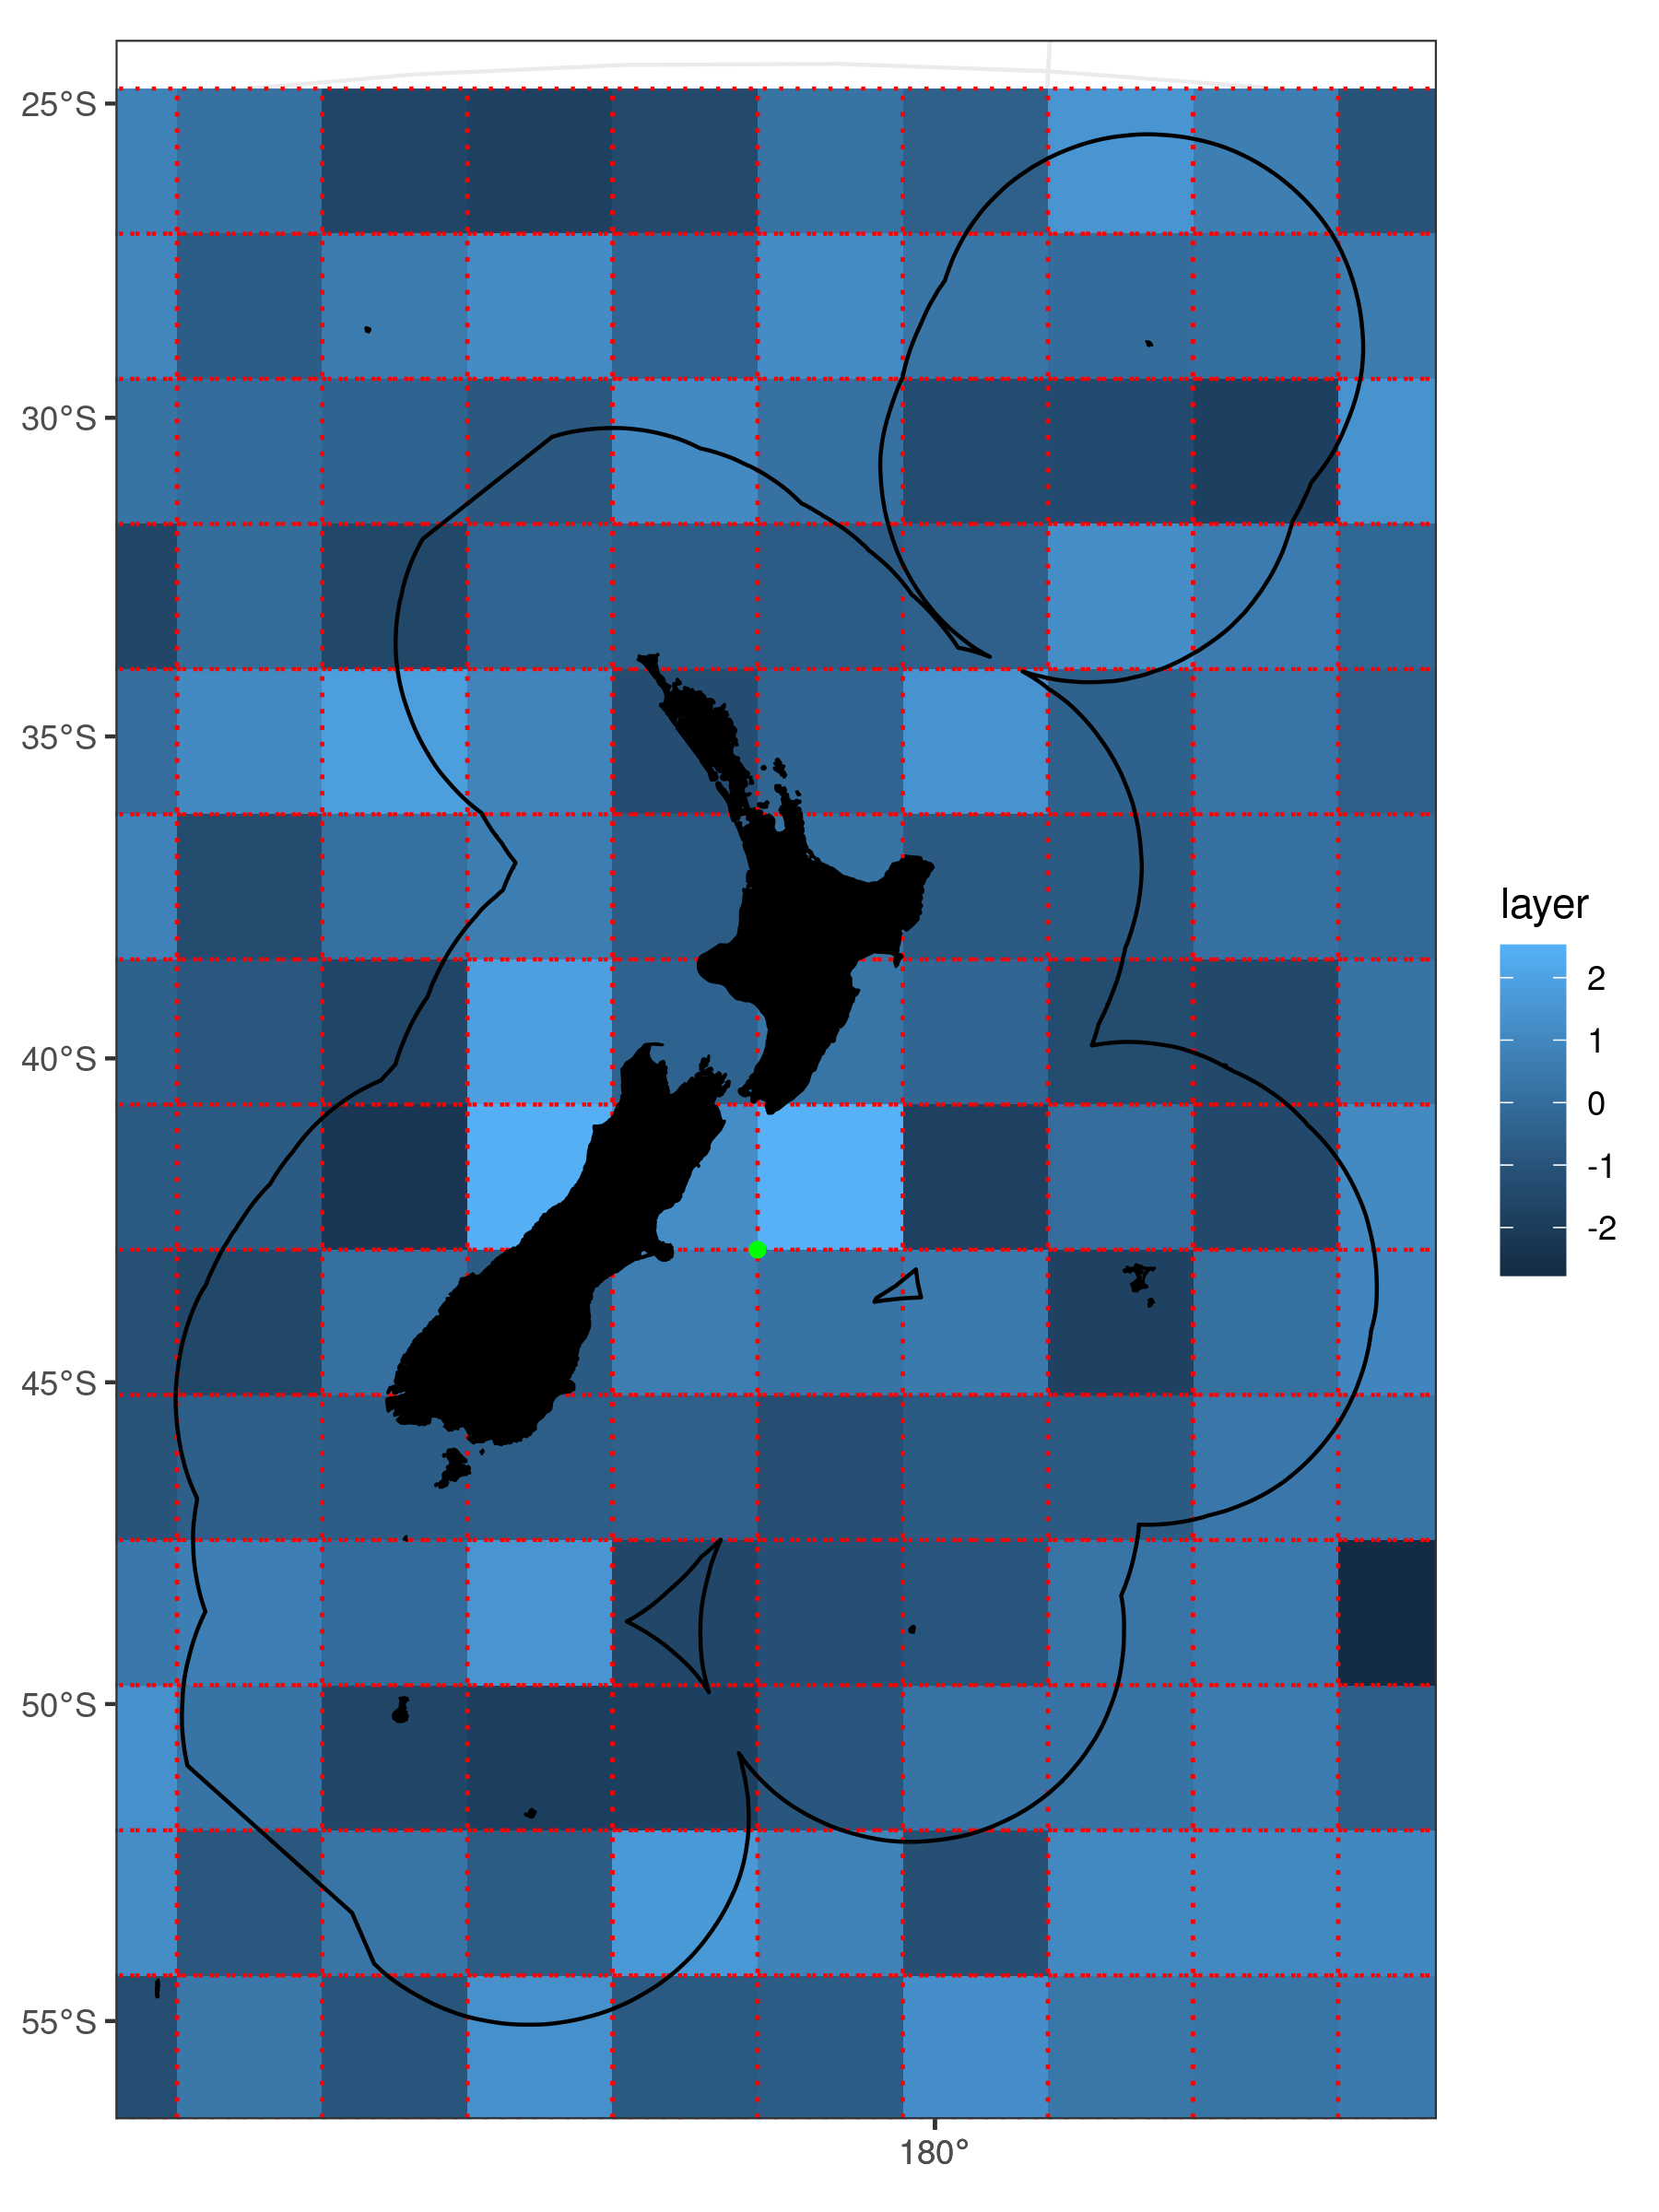

Figure 2: Example of a raster grid (blue squares) and a polygon grid (dashed red squares). The origin is also shown (green point).

# Discussion

Wood et al. (2020) have suggested that a standard grid should be used so that resampling issues are minimised compared with trying to resample grids created in different projections enabling data from different research projects to be easily reused or integrated in subsequent research . However, resampling issues are likely to be outweighed by any error associated with various spatial data sets in marine research (e.g., seabird distribution maps estimated using observer and/or tracking data). Despite this, it is still useful to share some common attributes of spatial outputs across some Fisheries New Zealand and central government projects. The R package ‘nzsf’ enables users to easily generate standard grids and provides several other useful functions for developing plots of these standard grids.

# Acknowledgements

We thank Fisheries New Zealand who awarded the contracts ENV2020-04 and PRO2019-09 to XXX and Quantifish Ltd, respectively.

# References

Wood, B.; Finucci, B.; Black, J. (2020). A standardised approach for creating spatial grids for New Zealand marine environment and species data, Technical Report, National Institute of Water and Atmospheric Research.

# Appendix

Code written in R is supplied here so that the ‘get_standard_grid’ function can be replicated without using the ‘nzsf’ package.

library(sf)

library (raster)

# Get Fisheries New Zealand standard grid origin

#

# cell_size: square grid boundary length in km

# bounding_box: limits generated from call to sf::st_bbox()

# anchor: the origin point

#

get_standard_grid_origin <- function(cell_size, bounding_box, anchor = c(0, 422600)) {

cell_size_m <- cell_size * 1000

stnd_cell_size <- c(250, 500, 1000, 2000, 4000, 8000, 16000, 32000, 64000)

if (!cell_size_m %in% stnd_cell_size) {

warning(paste0("The chosen grid size does not conform to the standard grid specification,

consider setting cell_size to one of: ", paste(stnd_cell_size / 1000, collapse = ", "), "."))

}

bb_xmin <- as.numeric(bounding_box$xmin)

bb_xmax <- as.numeric(bounding_box$xmax)

bb_ymin <- as.numeric(bounding_box$ymin)

bb_ymax <- as.numeric(bounding_box$ymax)

x <- data.frame(cell_size_m = cell_size_m,

cell_size_m2 = cell_size_m^2,

grid_size_km = cell_size,

grid_size_km2 = cell_size^2,

xmin = -ceiling((-bb_xmin - anchor[1]) / cell_size_m) * cell_size_m - anchor[1],

xmax = -floor((-(bb_xmax + anchor[1])) / cell_size_m) * cell_size_m - anchor[1],

ymin = -ceiling((-bb_ymin - anchor[2]) / cell_size_m) * cell_size_m - anchor[2],

ymax = -floor((-(bb_ymax + anchor[2])) / cell_size_m) * cell_size_m - anchor[2])

return(x)

}

# Get Fisheries New Zealand standard grid

#

# return_raster: return a raster or polygons

#

get_standard_grid <- function(cell_size,

bounding_box,

anchor = c(0, 422600),

return_raster = TRUE) {

grid_origin <- get_standard_grid_origin(cell_size = cell_size,

bounding_box = bounding_box,

anchor = anchor)

if (return_raster) {

x <- raster(crs = 9191,

xmn = grid_origin$xmin,

ymn = grid_origin$ymin,

xmx = grid_origin$xmax,

ymx = grid_origin$ymax,

res = grid_origin$cell_size_m)

} else {

x <- bounding_box %>%

st_make_grid(cellsize = as.numeric(grid_origin["grid_size_km"]) * 1000,

offset = as.numeric(grid_origin[c("xmin", "ymin")]),

crs = 9191) %>%

st_as_sf()

}

return(x)

}