## A standardised approach for creating spatial grids for New Zealand marine environment and species data

## B. Wood1, B. Finucci1, J. Black2

1. NIWA, Wellington, 2. GNS Science, Lower Hutt

**Abstract.**

This document describes an approach for standardising spatial grids used to subset or analyse fisheries and related datasets in New Zealand. The traditional approach where researchers or analysts create custom grids for specific analyses results in project specific datasets that can be difficult to reuse in overlay analyses with data from other analyses using other grids of different scales, origins and Coordinate Reference Systems (CRSs). The approach described here specifies an origin and an appropriate Equal Area New Zealand centric projection. Cell sizes from 250m x 250m to 64km x 64km are supported, with any grid cell of any size either completely containing or completely contained by other cells. This allows for resampling and overlay analyses minimising artefacts caused by the actual grids (such as moire patterns). Typical analyses include data describing fish, seabird or marine mammal distributions, along with a variety of geological and environmental data in the wider New Zealand region. NIWA staff have successfully generated a variety of grids compliant with this specification using a variety of software packages, including ArcMap, R, GDAL and Postgis.

**Coordinate Reference System.**

All grids will be created using a standard New Zealand centric Albers Equal Area projection (coordinate system) already widely used by NIWA, GNS and other New Zealand-based research agencies. The parameters defining this CRS are:

Projection type: Albers Equal Area

Standard Parallel 1: 30 S

Standard Parallel 2: 50 S

Central Meridian: 175 E

Latitude of Origin: 40 S

False Easting: 0

False Northing: 0

Datum: WGS84

For users of the Proj.4 software libraries used by tools such as Postgis, Spatialite, R and QGIS this is specified by:

+proj=aea +lat_1=-30 +lat_2=-50 +lat_0=-40 +lon_0=175 +x_0=0+y_0=0 +ellps=WGS84 +datum=WGS84 +units=m +no_defs

For users of ESRI Arc software, the equivalent specification is:

PROJCS["Albers",GEOGCS["GCS_WGS_1984",DATUM["D_WGS_1984",SPHEROID["WGS_1984",6378137.0,298.257223563]],PRIMEM["Greenwich",0.0],UNIT["Degree",0.0174532925199433]],PROJECTION["Albers"],PARAMETER["False_Easting",0.0],PARAMETER["False_Northing",0.0],PARAMETER["Central_Meridian",175.0],PARAMETER["Standard_Parallel_1",-30.0],PARAMETER["Standard_Parallel_2",-50.0],PARAMETER["Latitude_Of_Origin",-40.0],UNIT["Meter",1.0]]

This CRS has been formally registered by EPSG as EPSG:9191 (see: <https://epsg.io/9191> which includes the formal OGP XML specification).

Using this CRS ensures that grid cells will have very similar areas anywhere in the wider New Zealand region, minimizing any latitudinal or other CRS based distortion. The centre of the projection is near the geographical centre of New Zealand to further minimise distortion. Note, however, that as with any coordinate reference system, any distortion present will increase with distance from the centre.

Given that this CRS will have significantly wider use than the New Zealand Exclusive Economic Zone (EEZ), it is intended primarily for maritime rather than terrestrial use, and will generally be used with location data derived from GPS, so it uses the same datum and ellipsoid as GPS data (WGS84). Grids created using the specified Albers Equal Area CRS can be transformed (reprojected) to EPSG:4326 without requiring a datum shift or change in ellipsoid.

Once created, grids may be transformed into any other coordinate system (or unprojected latitude/longitude coordinates) for actual use. Note, however, that in any graphical display of the grid using a different CRS, the grids may not appear square, or not the same size throughout the grid. This does not mean they are not square, or the same size in reality, but that the shape and size is distorted to fit the flat screen or page.

**CRS and grid origin.**

To ensure that all grid cells are either entirely contained by cells of a larger scale, or entirely contain cells of a smaller scale, all grids must share a common origin to keep them aligned. The unit of the Albers Equal Area projection is meters. This supports the desired grid sizes which are in meters or kilometres, so integer values (multiples of 1000m) are used for all grid boundaries (including for grids with cells less than 1000m in size).

Given the specified coordinate system is centred at 175oE, 40oS, the point nearest to this with values which are multiples of 1000 is used as the origin of all grids. The coordinates representing this point in the Albers projection defined above are: X=0 Y=-4226000. Note that degrees are commonly described in latitude/longitude order, but other coordinate systems use x/y, or longitude/latitude.

**Grid sizes and registration.**

The size of the grid cells should be one of the following sizes, depending on user requirements: 250m, 500m, 1000m, 2000m, 4000m, 8000m, 16000m, 32000m or 64000m.

When creating a grid with a cell size of less than 1km, the grid extent should be increased in all four directions to the nearest 1000m to maintain the cell alignment with larger grids (Figure 1).

If required for a particular purpose, a grid can be created at a different size, but the principle should still be followed, the grid size should be set to a value which can be derived by iteratively dividing or multiplying 1000 by 2.

Resampling issues are minimised compared with trying to resample grids created in different CRS’s, enabling data to be reused with data from other research projects that followed this approach (Figure 2).

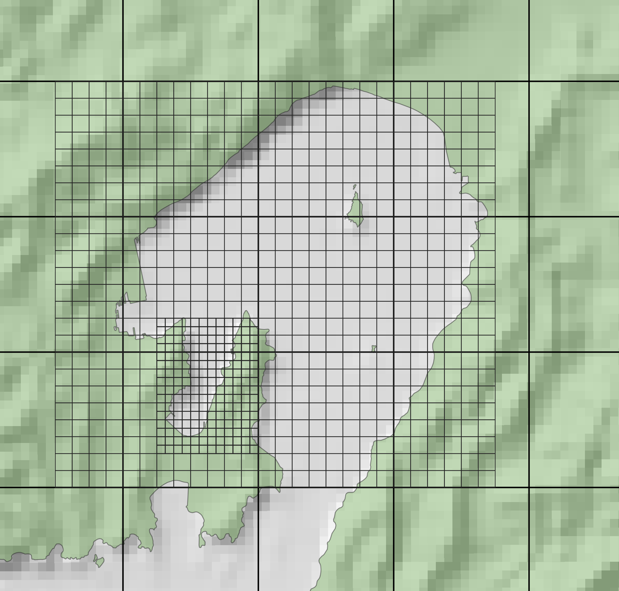Figure 1. Sample grids (250m, 500m, and 4000m cells) around Wellington Harbour. All cells are contained by a single larger cell with this approach, and cell boundaries are common apart from size differences, minimising gridding and resampling artefacts.

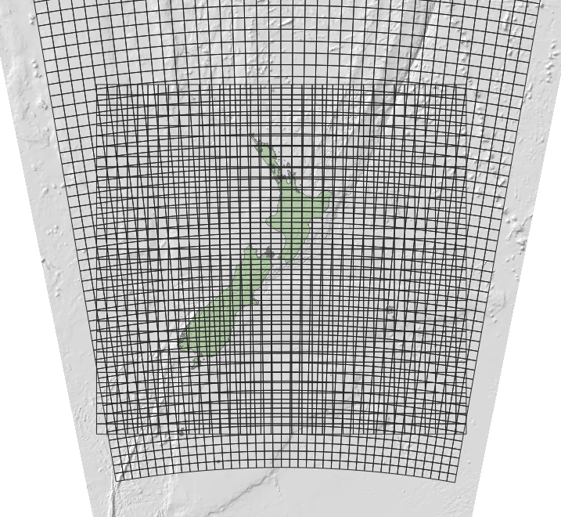Figure 2. The map is rendered in the equal area Coordinate Reference Systems (CRS), showing a 64km native grid created in the same CRS and one created in Mercator 41 (EPSG:3994). Any statistically robust overlay operation is made difficult by the curved lines of latitude and with cell sizes changing with latitude.