


Generative AI Mastermind sessions for website building
Workbook 3 :
BUILDING CUSTOM GPT & AI Bots

TASK 1 | 
Build an AI Assistant Using Gemini
In this task, you will build an AI Assitant to write viral LinkedIn Posts on any topic you want and host
it on Gemini.

FOLLOW THE STEPS TO PERFORM THE ACTIVITY:

Step 1 : Ask ChatGPT to come up with an extensive
prompt for your Gemini Gem which will write viral LinkedIn Posts whenever a topic is given
Example Prompt : You are an expert at writing extensive prompts for Gemini Gems. Please come up with a
detailed prompt which can write viral Linkedin Posts on any topic I want. The posts it writes should always start with a hook, have a storyline & end with a CTA. The assistant should include all parameters that are
important for the post to go viral

Step 2:Now ask it to rewrite the prompt in the
markdown formatting and give the output in a code editor so that formatting is not broken.
Example Prompt :Please rewrite the above prompt in
the markdown formatting and give me the output in a code editor.Here is an example of markdown formatting
Markdown Prompt Template:
Role:
Objective:
Context:
Instructions:
Instruction 1 :

Instruction 2 :

Instruction 3 :
Notes:
Note 1

Note 2

Note 3

Step 3 : Go to gemini.google.com / and open the side

menu bar to find “Gem Manager”

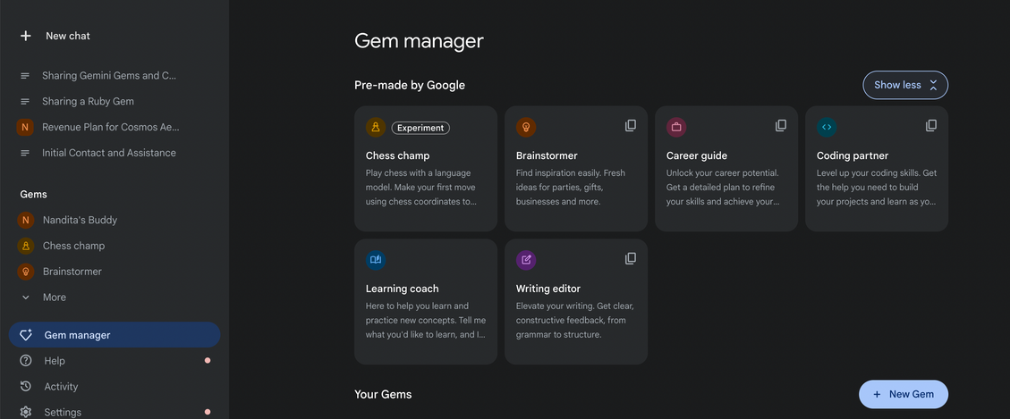

Step 4 : Click on “New Gem”
Step 5 : Give a name to your Gem ; eg : Viral Linkedin
Post Generator
Step 6 : Paste the markdown prompt you had
generated using ChatGPT into the “Instructions” box
Step 7 : Click on Save & Test Your AI Assistant!

