Online supporting information for : Hunting experience shapes individual foraging specialisation and predator-prey interactions in an online videogame

need to talk about priors here for the gamms etc

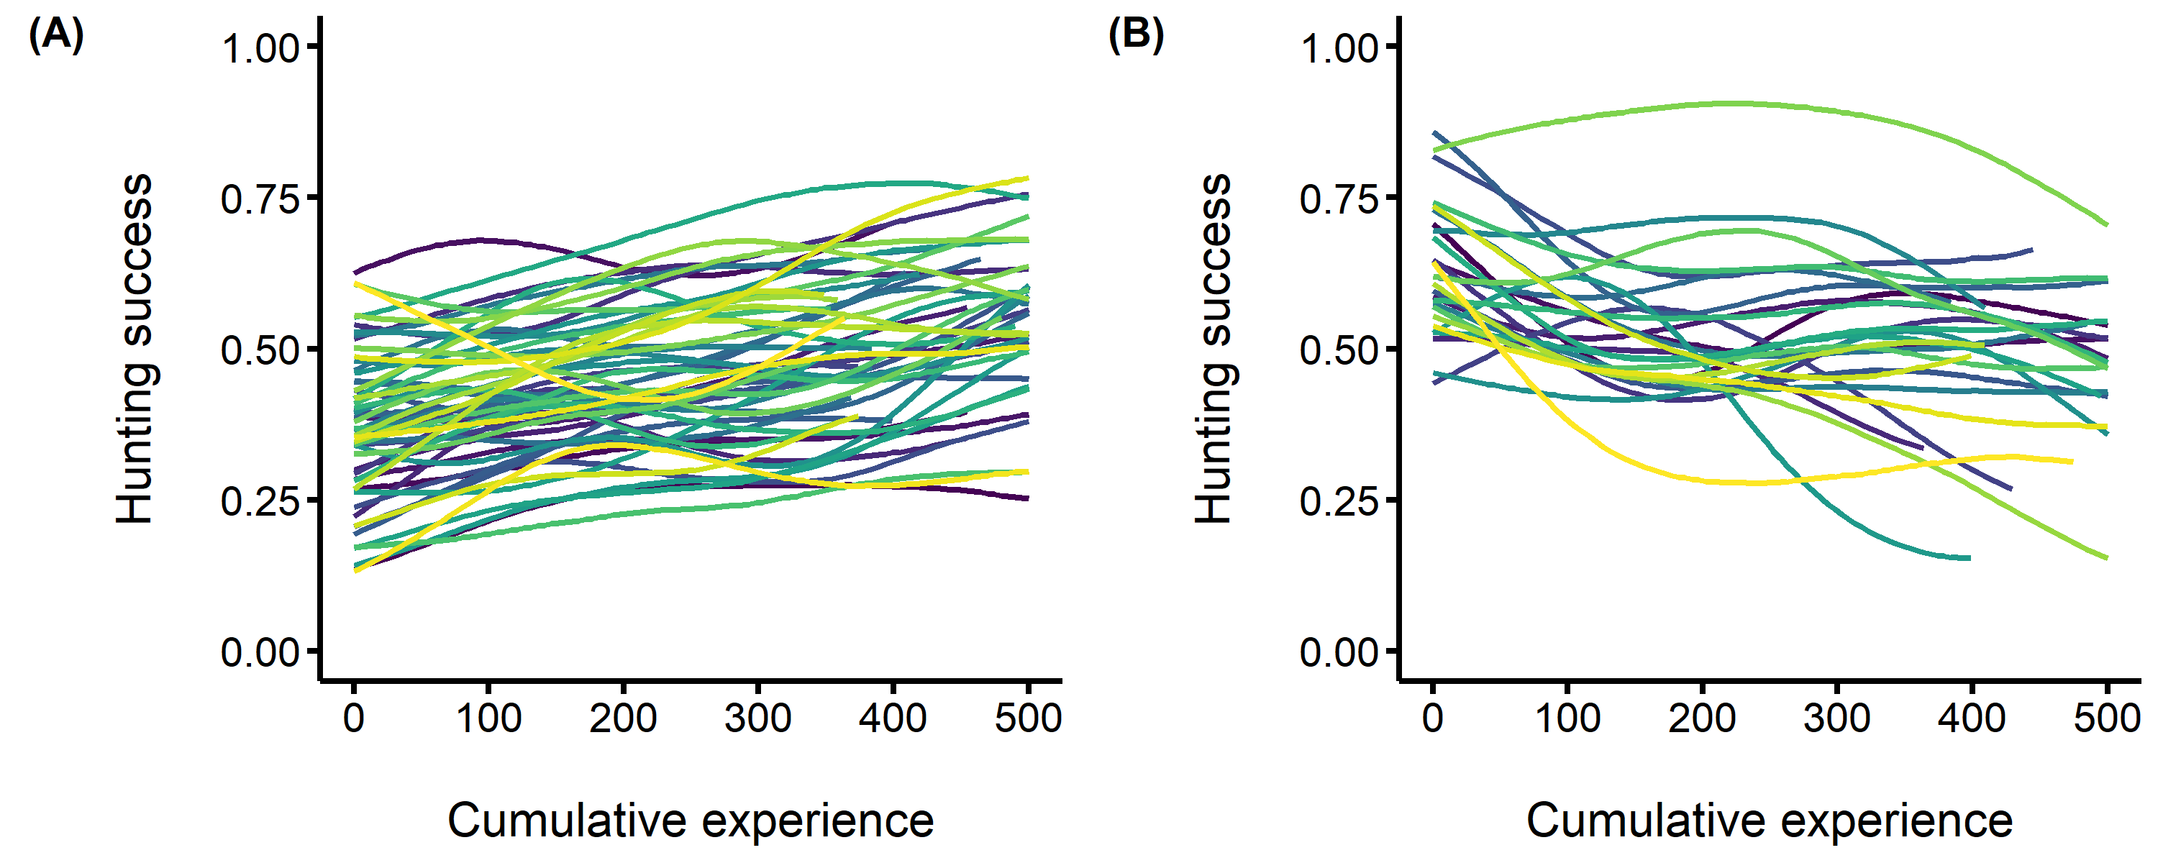

**Figure S1.** Among individual differences in the development of hunting expertise. The predators’ hunting success (i.e. the probability of capturing the four prey) is on the y axis, and the predators’ cumulative experience (i.e. the number of matches played prior to each observation) is on the x axis. Each fitted curve represents an individual predator. (A) Individuals with the greatest increase in hunting success with experience (B) Individuals with the greatest decrease in hunting success with experience.

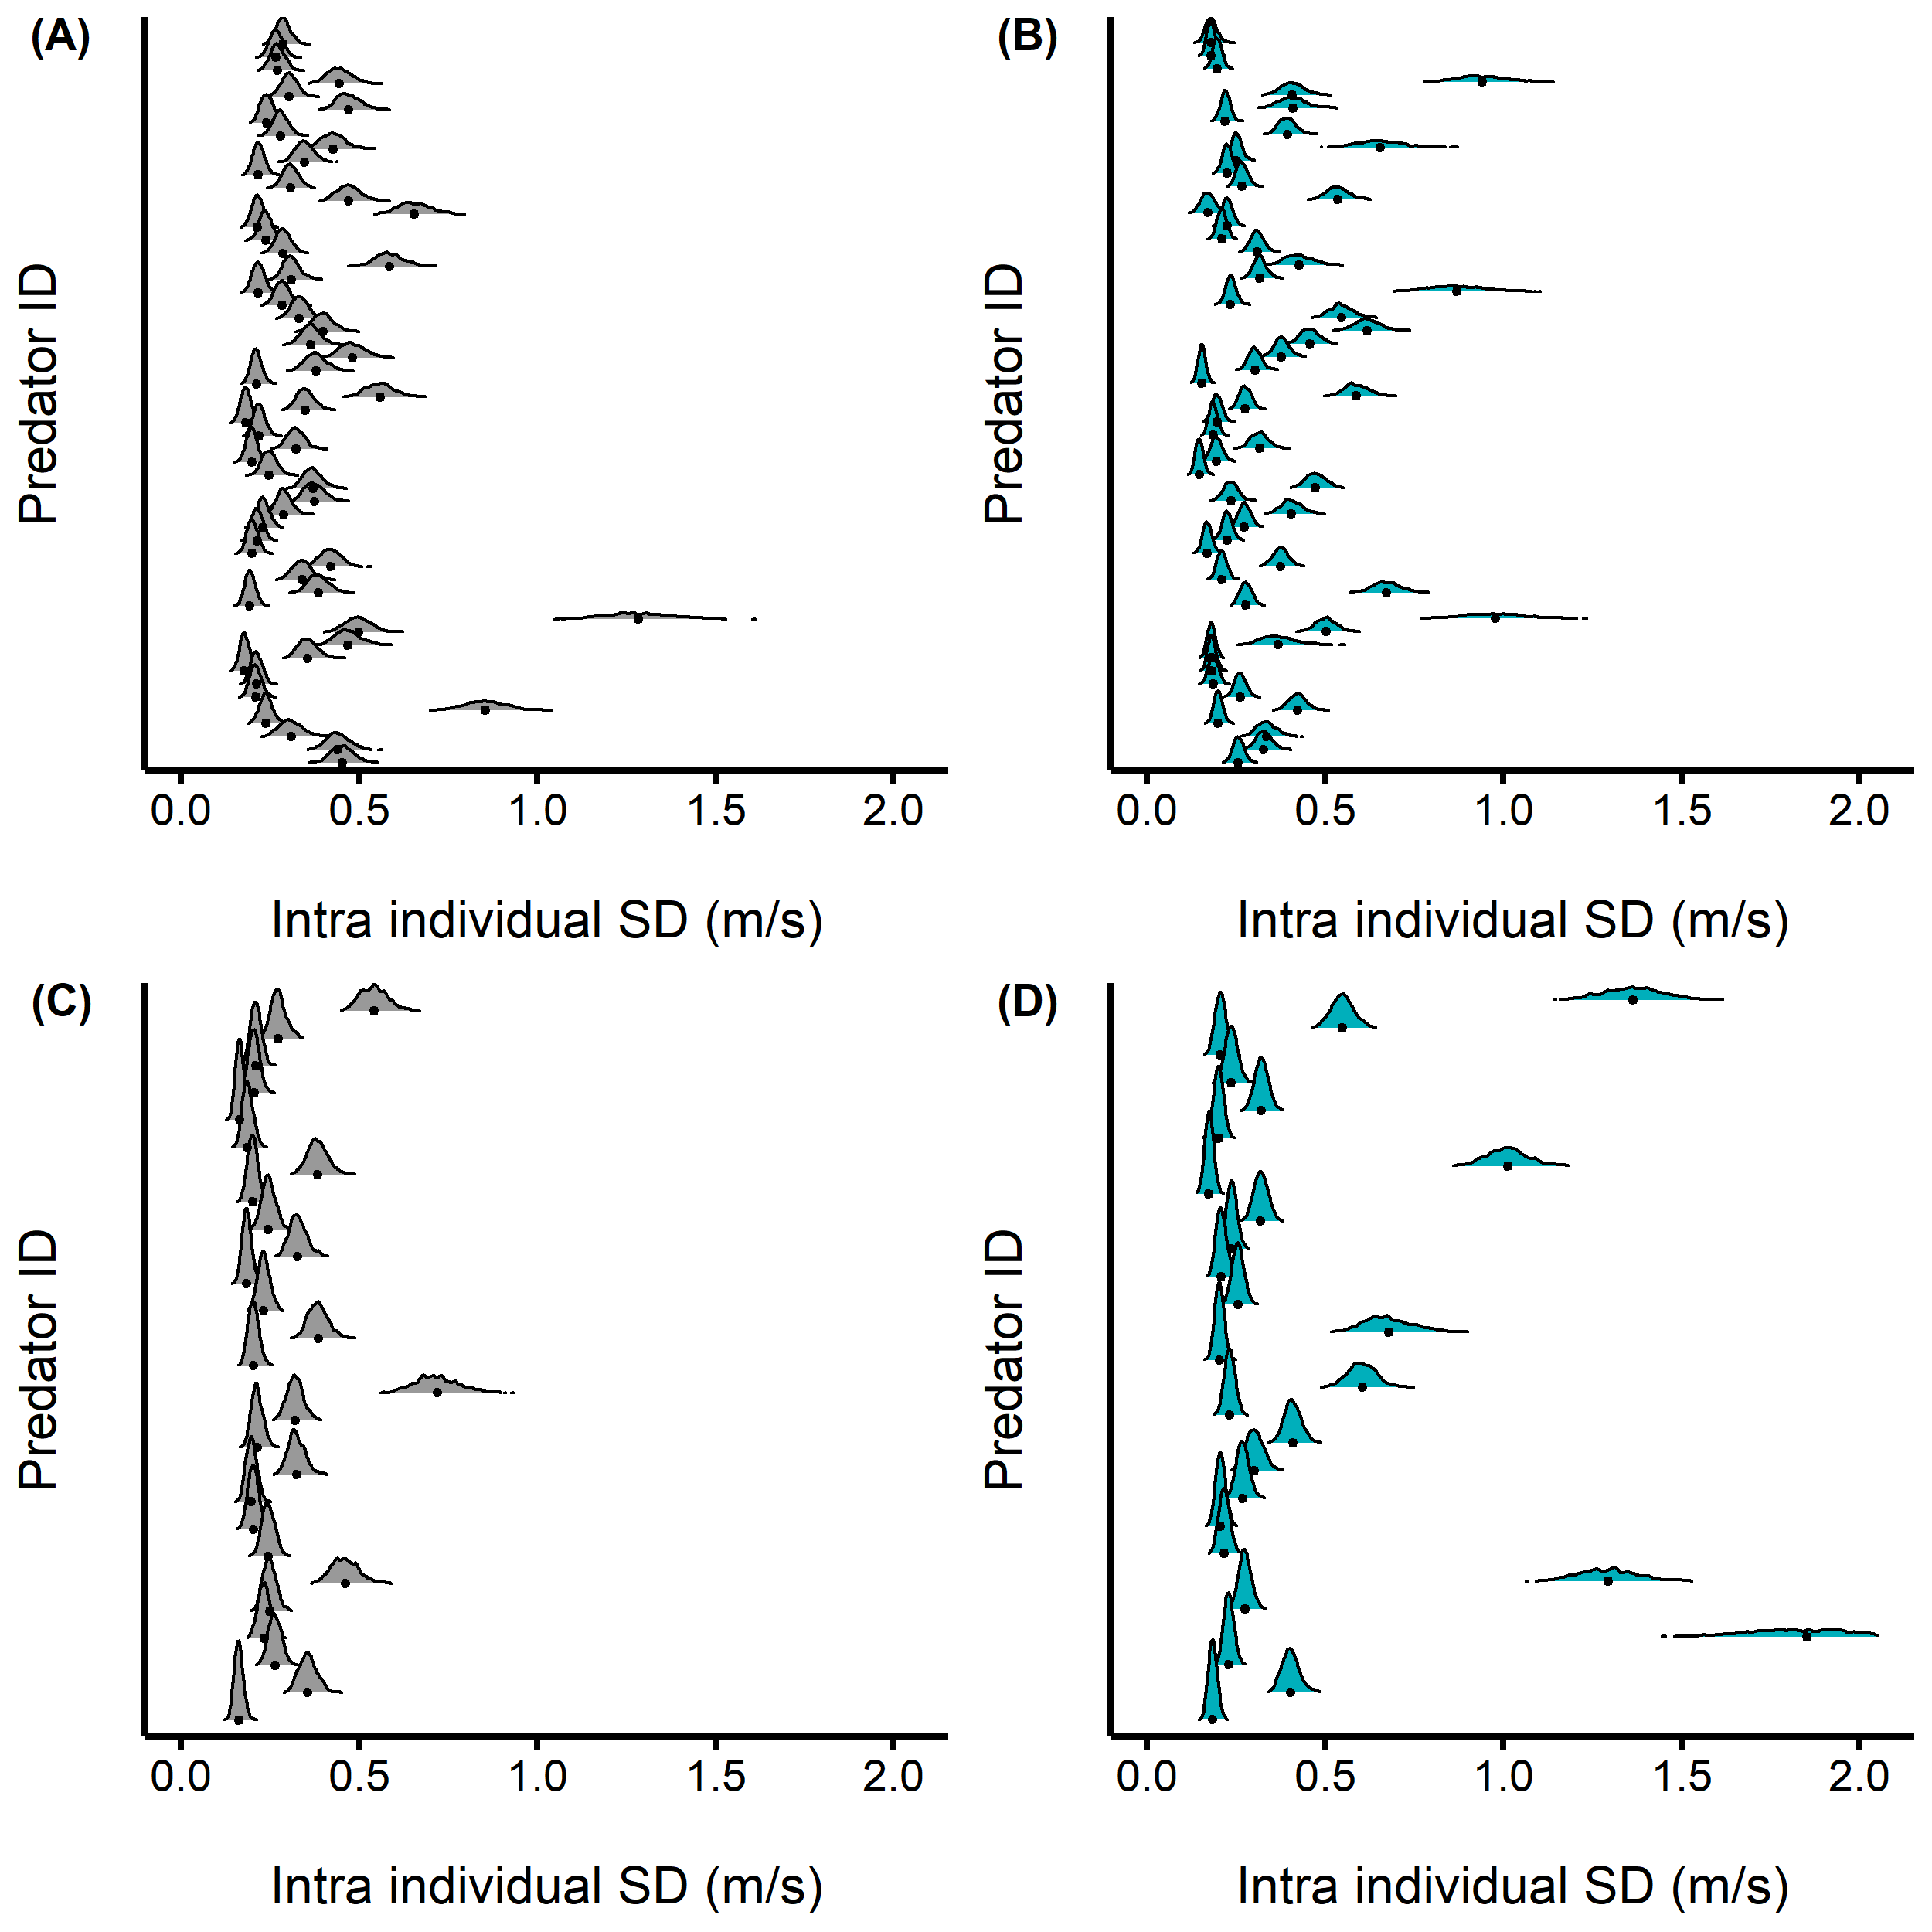

**Figure S2.** Distribution of the intra individual behavioural variation (i.e. specialization) of predators with the greatest increase in hunting success (A and B) and greatest decrease (B and C) in hunting success when they were novices (A and C) and then (B and D) advanced hunters.

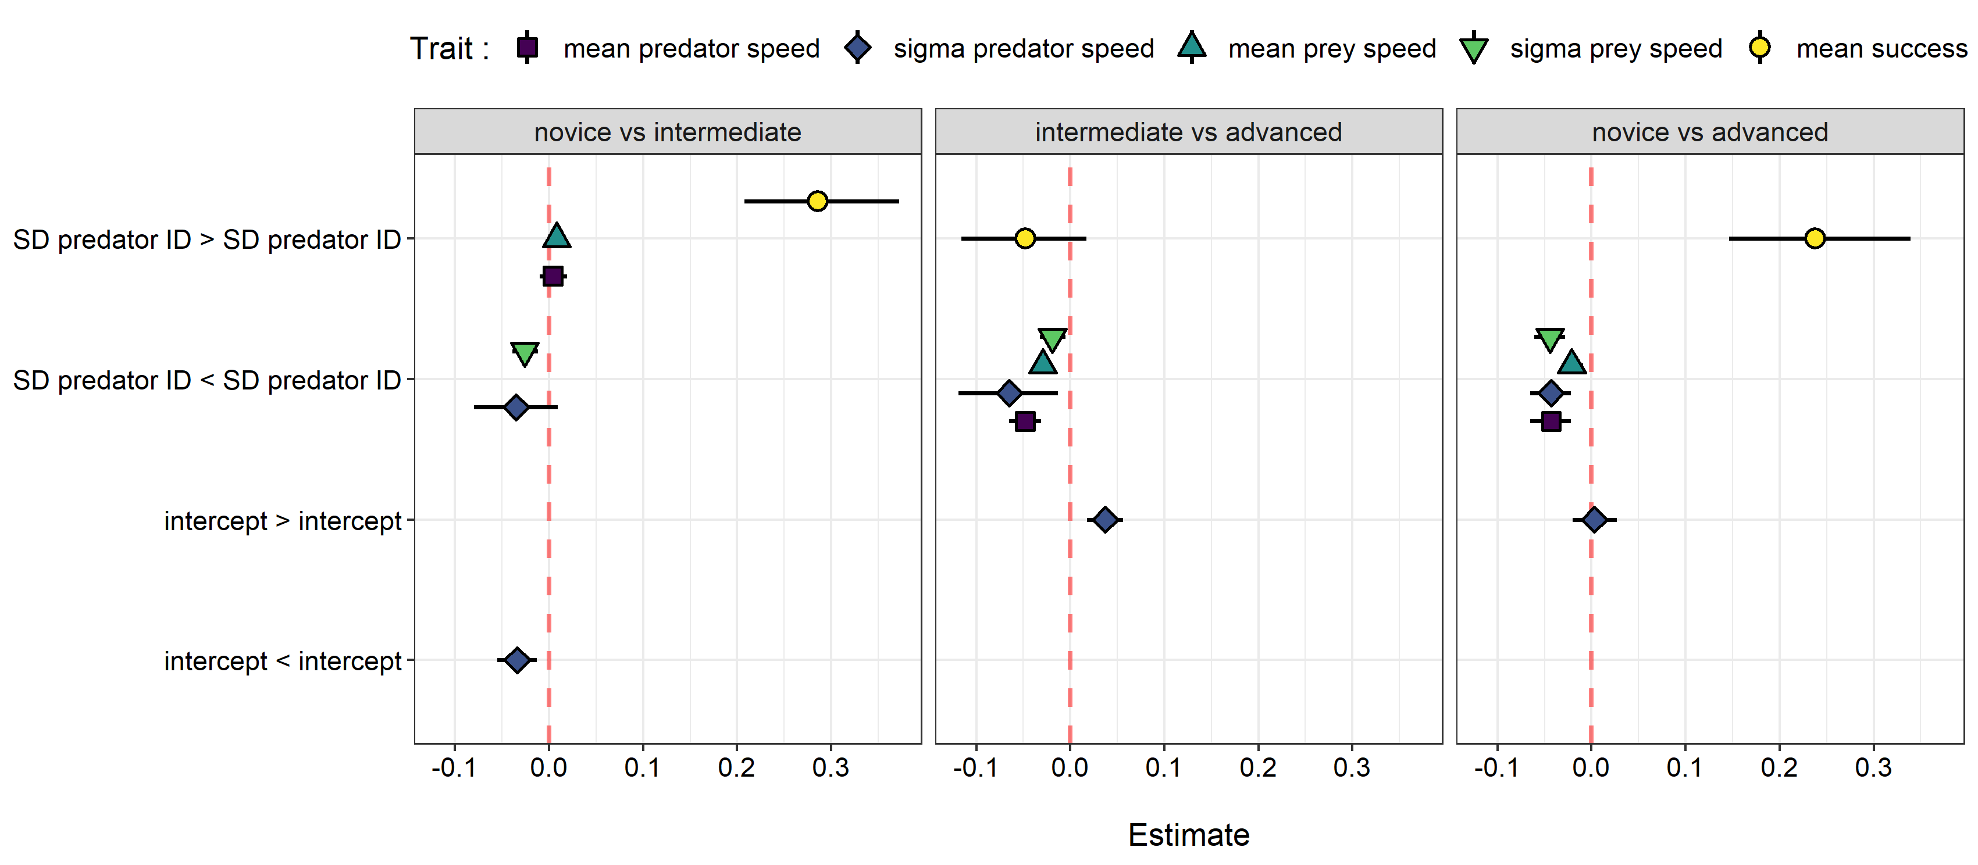

**Figure S4.** Posterior median differences and 95% credible intervals between the parameter values of each predator experience level predicted by the MDHGLM.