Hunting experience shapes individual foraging specialisation and predator-prey interactions in an online videogame:  
Appendix 1

Journal name : Ecology

Authors : Maxime Fraser Franco, Francesca Santostefano, Julien G. A. Martin, Clint D. Kelly, Pierre-Olivier Montiglio

Table S1. Posterior medians and 95% credible intervals of the fixed effects estimated by the MDHGLM of predator speed, prey speed, and predator hunting success.

| Trait | Parameter | Novice | Intermediate | Advanced |
| --- | --- | --- | --- | --- |
| predator speed | intercept (mean) | 3.29 ( 3.16, 3.41) | 3.29 ( 3.13, 3.42) | 3.28 ( 3.13, 3.43) |
| prey rank (mean) | -0.02 (-0.02, -0.01) | -0.02 (-0.03, -0.02) | -0.03 (-0.04, -0.03) |
| intercept (sigma) | 0.28 ( 0.26, 0.29) | 0.30 ( 0.28, 0.31) | 0.29 ( 0.27, 0.30) |
| prey rank (sigma) | 0.99 ( 0.98, 1.01) | 0.98 ( 0.97, 0.99) | 1.00 ( 0.98, 1.01) |
| prey speed | intercept (mean) | 2.34 ( 2.31, 2.37) | 2.42 ( 2.39, 2.46) | 2.42 ( 2.39, 2.45) |
| prey rank (mean) | -0.11 (-0.12, -0.11) | -0.11 (-0.12, -0.11) | -0.11 (-0.12, -0.11) |
| intercept (sigma) | 0.29 ( 0.29, 0.29) | 0.27 ( 0.27, 0.28) | 0.27 ( 0.27, 0.27) |
| prey rank (sigma) | 1.07 ( 1.05, 1.08) | 1.07 ( 1.06, 1.08) | 1.07 ( 1.05, 1.08) |
| hunting success | intercept (mean) | 0.49 ( 0.47, 0.52) | 0.51 ( 0.49, 0.53) | 0.54 ( 0.52, 0.56) |
|  | match duration (mean) | 0.65 ( 0.64, 0.65) | 0.65 ( 0.64, 0.65) | 0.64 ( 0.64, 0.65) |
| a We exponentiated the dispersion parameters (i.e. sigma) which are estimated on a log scale. We back-transformed the hunting success values, estimated on a logit scale, back to a probability scale. b The intercept values on the mean part of the equation for all traits indicate mean behaviour and success at the population level. The intercept values on the dispersion (i.e. sigma) part of the equation for predator speed indicate behavioural specialization at the population level. | | | | |

Table S2. Posterior medians and 95% credible intervals of the random effects estimated by the MDHGLM of predator speed, prey speed, and predator hunting success. All the reported values are standard deviations.

| Trait | Parameter | Novice | Intermediate | Advanced |
| --- | --- | --- | --- | --- |
| predator speed | avatar (mean) | 0.30 (0.22, 0.41) | 0.36 (0.26, 0.49) | 0.37 (0.27, 0.50) |
| environment (mean) | 0.02 (0.02, 0.03) | 0.03 (0.02, 0.03) | 0.03 (0.02, 0.03) |
| predator ID (mean) | 0.16 (0.14, 0.17) | 0.15 (0.14, 0.17) | 0.17 (0.15, 0.18) |
| predator ID (sigma) | 1.49 (1.44, 1.54) | 1.52 (1.46, 1.57) | 1.59 (1.53, 1.65) |
| prey speed | avatar (mean) | 0.05 (0.04, 0.07) | 0.06 (0.04, 0.08) | 0.06 (0.05, 0.08) |
| environment (mean) | 0.06 (0.04, 0.07) | 0.05 (0.04, 0.07) | 0.05 (0.04, 0.07) |
| predator ID (mean) | 0.09 (0.08, 0.10) | 0.08 (0.07, 0.09) | 0.10 (0.09, 0.10) |
| predator ID (sigma) | 1.06 (1.05, 1.07) | 1.07 (1.06, 1.08) | 1.10 (1.08, 1.11) |
| hunting success | predator ID (mean) | 0.72 (0.66, 0.79) | 0.58 (0.53, 0.63) | 0.59 (0.54, 0.64) |
| a We exponentiated the dispersion parameters (i.e. sigma) which are estimated on a log scale. All the reported values are standard deviations. b The standard deviation values on the mean part of the equation indicate, for all traits, among individual differences in mean behaviour, prey encountered, and success. c Values on the dispersion (i.e. sigma) for predator speed indicate among individual differences in behavioural specialization. For prey speed, they indicate among individual differences in the variability of prey encounters. | | | | |

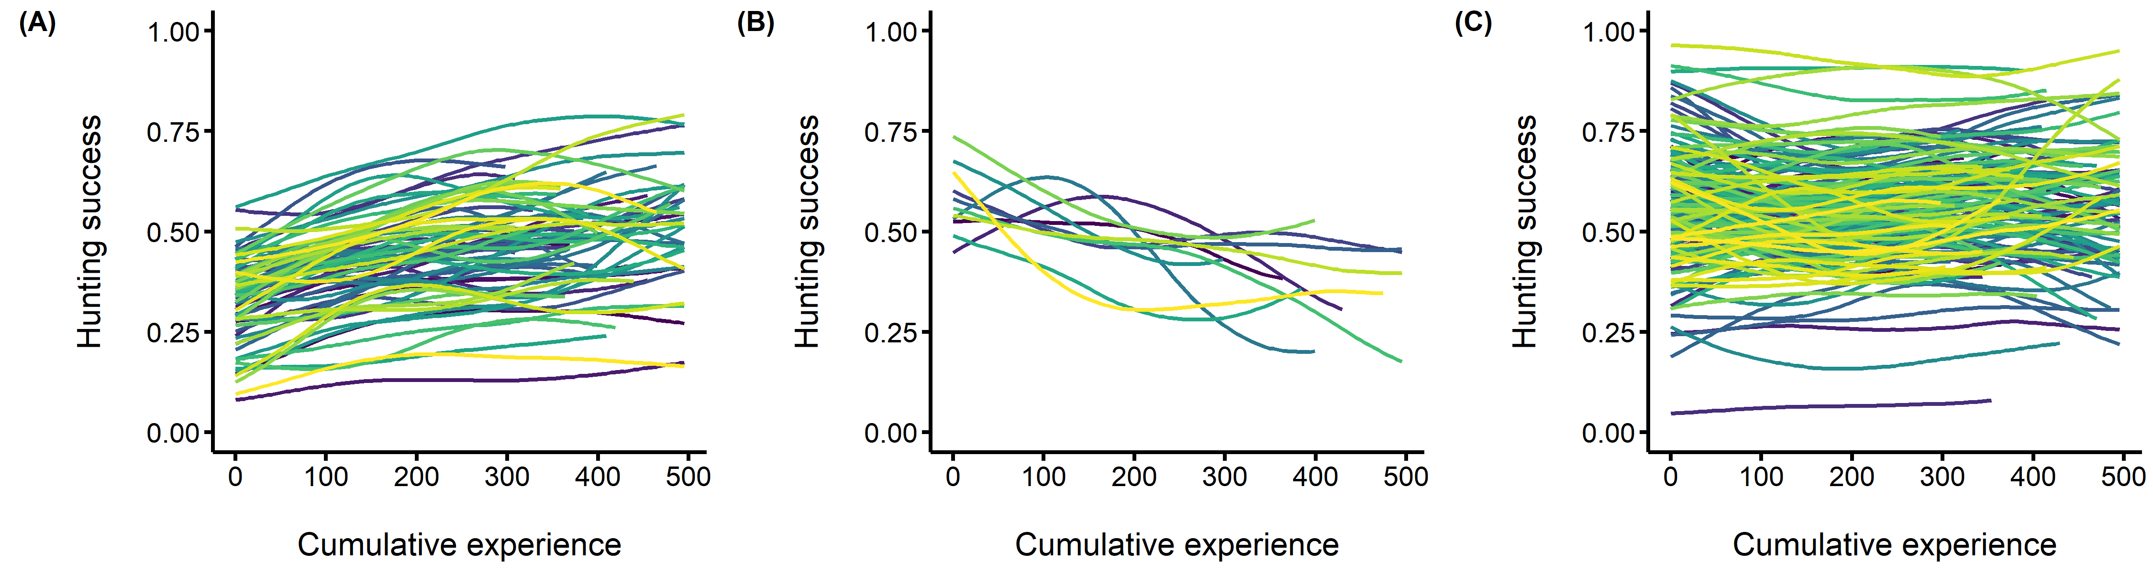

**Figure S1.** Among individual differences in the development of hunting expertise in the model where we do not account for prey speed and average rank. The predators’ hunting success (i.e. the probability of capturing the four prey) is on the y axis, and the predators’ cumulative experience (i.e. the number of matches played prior to each observation) is on the x axis. Each fitted curve represents an individual predator. (A) Individuals with a >0.5 unit increase in hunting success with experience (B) Individuals with a <-0.5 unit decrease in hunting success with experience. (C) Individuals that maintained a stable hunting success (between -0.5 and 0.5 unit change in hunting success)

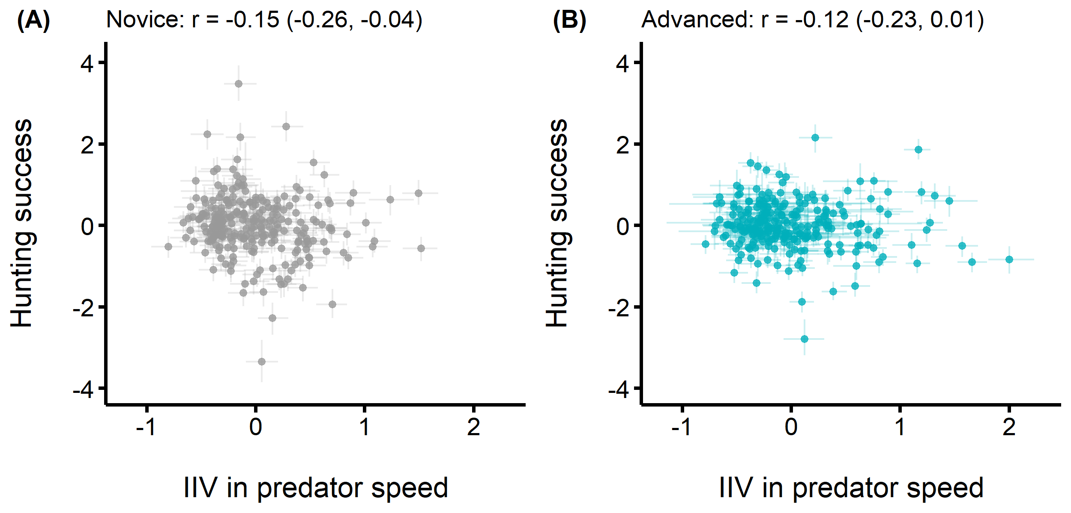

**Figure S2.** Correlations between the predators’ mean hunting success (y axis) and intra individual variance in speed (x axis) to test for differences in success between specialist and flexible hunters. Individuals with lower IIV are specialist hunters, while individuals with higher IIV are flexible hunters. (A) Correlation when predators were novice (B) Correlation when predators were advanced