Hunting experience shapes individual foraging specialisation and predator-prey interactions in an online videogame:  
Appendix 3

Journal name : Ecology

Authors : Maxime Fraser Franco, Francesca Santostefano, Julien G. A. Martin, Clint D. Kelly, Pierre-Olivier Montiglio

Table S1. Posterior medians and 95% HPD intervals of the fixed effects estimated by the MDHGLM of predator speed, prey speed, and predator hunting success. The coefficients are from the model that includes the outlier.

| Trait | Parameter | Novice | Intermediate | Advanced |
| --- | --- | --- | --- | --- |
| predator speed | intercept (mean) | 3.28 ( 3.17, 3.42) | 3.28 ( 3.11, 3.41) | 3.26 ( 3.12, 3.41) |
|  | prey rank (mean) | -0.02 (-0.02, -0.02) | -0.02 (-0.03, -0.02) | -0.03 (-0.03, -0.03) |
|  | intercept (sigma) | 0.28 ( 0.27, 0.29) | 0.30 ( 0.28, 0.32) | 0.29 ( 0.27, 0.31) |
|  | prey rank (sigma) | 0.99 ( 0.98, 1.00) | 0.98 ( 0.97, 0.99) | 1.00 ( 0.98, 1.01) |
| prey speed | intercept (mean) | 2.34 ( 2.30, 2.37) | 2.42 ( 2.39, 2.45) | 2.42 ( 2.39, 2.45) |
|  | prey rank (mean) | -0.11 (-0.12, -0.11) | -0.11 (-0.12, -0.11) | -0.11 (-0.12, -0.11) |
|  | intercept (sigma) | 0.29 ( 0.29, 0.29) | 0.27 ( 0.27, 0.28) | 0.27 ( 0.27, 0.27) |
|  | prey rank (sigma) | 1.07 ( 1.06, 1.08) | 1.07 ( 1.06, 1.08) | 1.07 ( 1.06, 1.08) |
| hunting success | intercept (mean) | 0.49 ( 0.46, 0.52) | 0.51 ( 0.48, 0.54) | 0.54 ( 0.51, 0.57) |
|  | match duration (mean) | 0.64 ( 0.64, 0.65) | 0.64 ( 0.64, 0.65) | 0.64 ( 0.64, 0.65) |
|  | prey rank (mean) | 0.60 ( 0.60, 0.61) | 0.65 ( 0.64, 0.65) | 0.65 ( 0.65, 0.66) |
| a We exponentiated the dispersion parameters (i.e. sigma) which are estimated on a log scale. We back-transformed the hunting success values, estimated on a logit scale, back to a probability scale. b The intercept values on the mean part of the equation for all traits indicate mean behaviour and success at the population level. The intercept values on the dispersion (i.e. sigma) part of the equation for predator speed indicate behavioural specialization at the population level. | | | | |

Table S2. Posterior medians and 95% HPD intervals of the random effect standard deviations estimated by the MDHGLM of predator speed, prey speed, and predator hunting success. The coefficients are from the model that includes the outlier.

| Trait | Parameter | Novice | Intermediate | Advanced |
| --- | --- | --- | --- | --- |
| predator speed | avatar (mean) | 0.30 (0.22, 0.39) | 0.36 (0.26, 0.49) | 0.37 (0.27, 0.49) |
| environment (mean) | 0.02 (0.02, 0.03) | 0.03 (0.02, 0.03) | 0.03 (0.02, 0.03) |
| predator ID (mean) | 0.16 (0.15, 0.17) | 0.15 (0.14, 0.17) | 0.20 (0.18, 0.22) |
| predator ID (sigma) | 1.48 (1.43, 1.53) | 1.52 (1.47, 1.58) | 1.59 (1.53, 1.65) |
| prey speed | avatar (mean) | 0.05 (0.04, 0.07) | 0.06 (0.05, 0.08) | 0.06 (0.04, 0.08) |
| environment (mean) | 0.06 (0.04, 0.07) | 0.05 (0.04, 0.07) | 0.05 (0.04, 0.07) |
| predator ID (mean) | 0.09 (0.08, 0.10) | 0.08 (0.07, 0.09) | 0.11 (0.10, 0.12) |
| predator ID (sigma) | 1.06 (1.04, 1.07) | 1.08 (1.07, 1.09) | 1.10 (1.09, 1.11) |
| hunting success | predator ID (mean) | 0.89 (0.82, 0.98) | 0.90 (0.83, 0.97) | 0.93 (0.86, 1.02) |
| a We exponentiated the dispersion parameters (i.e. sigma) which are estimated on a log scale. b The standard deviation values on the mean part of the equation indicate, for all traits, among individual differences in mean behaviour, prey encountered, and success. c The standard deviation values on the dispersion part of the equation (i.e. sigma) for predator speed indicate among individual differences in behavioural specialization. For prey speed, they indicate among individual differences in the variability of prey encounters. | | | | |

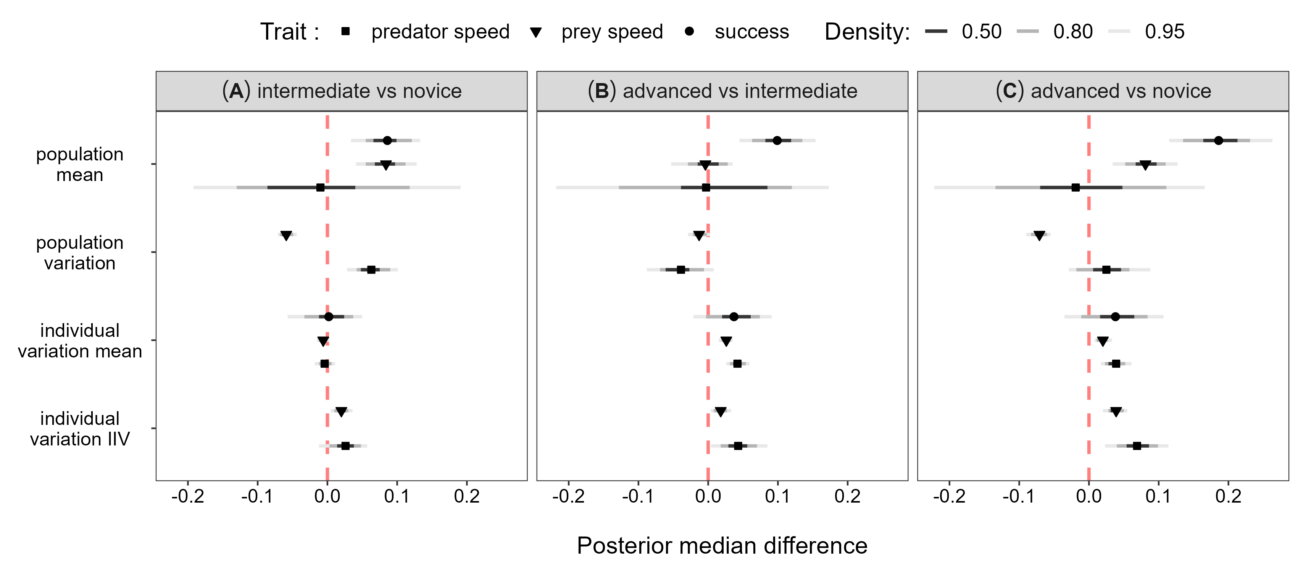

**Figure S1.** Posterior median differences between the parameter values of each predator experience level predicted by the MDHGLM along with their and 95% HPD intervals. The test is displayed on the y axis (i.e. whether the experience level of interest has a greater or smaller value), and the parameter value is displayed on the x axis. Each panel represent the experience levels being compared. The results are from the model that includes the outlier.

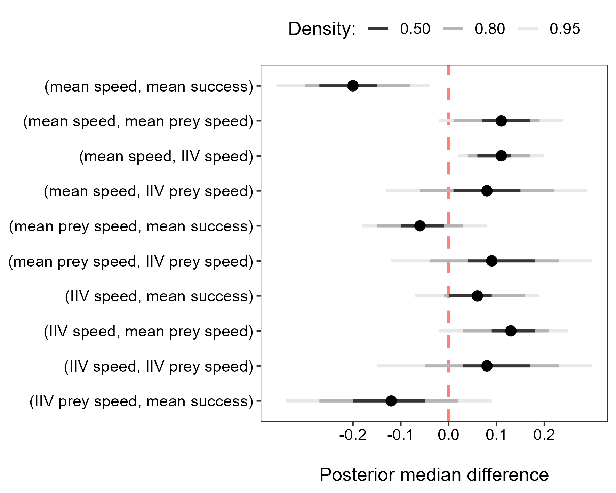

**Figure S2.** Posterior median differences in the correlations of players when they were advanced vs novice along with their 95% HPD intervals. The difference is displayed on the x axis and the parameter correlations are displayed on the y axis. Positive values indicate that the correlation was greater when predators where advanced, while negative values indicate that the correlation was greater when predators where novices. The results are from the MDHGLM that includes the outlier.