Hunting experience and prey variability jointly shape individual foraging specialisation in a predator-prey videogame

# ABSTRACT

Keywords: foraging behavior, individual specialization, experience, learning, prey predictability, online videogames

# INTRODUCTION

Individual variation in predator foraging behavior is increasingly recognized as a major driver of trophic interactions and community dynamics (Griffen *et al.* 2012; Michalko & Pekár 2016; Moran *et al.* 2017; Michalko *et al.* 2021). Indeed, predator populations are often composed of assemblages of individuals specializing in different foraging strategies or resources irrespective of sexual, morphological, or age-related differences (Estes *et al.* 2003; Tinker *et al.* 2008; Kernaléguen *et al.* 2015; Phillips *et al.* 2017). A growing body of evidence suggests that ecological interactions, such as predator-prey interactions, can be major drivers of such individual foraging specialization (Araújo *et al.* 2011; Toscano *et al.* 2016). When they hunt, predators often use techniques that are fine-tuned to the type of prey that they encounter (Davoren *et al.* 2003; Estes *et al.* 2003; Woo *et al.* 2008; Courbin *et al.* 2018), and their capacity to use them effectively is contingent on periods of extensive practice (i.e. expertise). While the development of hunting expertise may be essential to maintain foraging success, we have have limited evidence for its role in predator foraging specialization, and the ecological/fitness consequences of such among individual behavioral differences for predator-prey interactions (Dukas 2019).

The integration of individual behavioral variation in the study of predator-prey interactions has gained traction in recent years, with empirical studies revealing important consequences for habitat use, functional responses, prey choice, and foraging rate (Kobler *et al.* 2009; Patrick & Weimerskirch 2014b; Toscano & Griffen 2014; Matsumura & Miyatake 2022). However, an important and recurring challenge impeding research on predator-prey behavioral interactions, at the individual level, is the need of collecting data simultaneously on both the predator and prey. We have recently demonstrated with behavioral data from an online predator-prey videogame that virtual systems can help in overcoming this challenge, and uncover subtle details on the mechanisms shaping these interactions (Fraser Franco *et al.* 2022). For instance, we tested the classical locomotor crossover hypothesis championed by Huey & Pianka (1981), and found support of its predictions only for active hunters, which concords with a recent experiment involving assassin bugs (Matsumura & Miyatake 2022). Thus, virtual systems may be useful in identifying general ecological patterns, which may in turn help in advancing the current gaps in predator-prey research. Other examples of virtual ecological studies show that predation regimes can drive individual variation in risk perception (Beauchamp 2020), that familiarity between prey has a positive indirect effect on survival (Céré *et al.* 2021), and that prey face contrasting natural and social selection regimes (Santostefano et al. in prep). Because virtual systems generate large volumes of data on prey and predators simultaneously throughout their lifetime in the game, they offer the opportunity to tackle fundamental questions about the role of expertise and prey behavior on individual predator foraging specialization, and its potential fitness consequences.

The development of foraging strategies is crucial for young predators to reach adulthood and survive (Phillips *et al.* 2017; Heithaus *et al.* 2018). Theory predicts that foraging specialization may emerge via learning, limitations in memorizing multiple complex hunting skills, and expertise (Tinker *et al.* 2009; Dukas 2019). Dukas (2019) defines expertise as the characteristics, skills, and knowledge allowing individuals with extensive experience to outperform novices on complex tasks. This body of work suggests that the development of expertise is an optimizing process that promotes foraging specialization. Empirical studies on human and non-human hunters show that expertise optimizes the efficiency (e.g. search and handling times, return rates) of their foraging tactics potentially via associative images or reliance on prey and environmental cues (Edwards & Jackson 1994; Morse 2000; MacDonald 2007; Reid *et al.* 2010; Wilson-Rankin 2015). Such optimization may thus reinforce the use of the same tactic (i.e. specialization) if its success is constant each time a prey is encountered. It may also be costly to attempt different hunting tactics when prey are scarce or highly unpredictable (Estes *et al.* 2003; Mery & Burns 2010). An alternative mechanism is that expertise may offset the costs/risks of switching foraging tactics as individuals gain experience and information on their prey or their environment, leading to increased individual foraging flexibility (Ishii & Shimada 2010; Mery & Burns 2010; Snell-Rood 2013). In this case, switching between foraging tactics would be advantageous when resources are variable, as behavioral flexibility is often key for survival in novel environments (reviewed in Snell-Rood 2013). *revoir cette phrase ça ressemble trop à l’autre. plutôt parler des processus cognitifs qui modulent cela*

There is currently a lack of consensus on the fitness advantages of specialized vs flexible foraging. Importantly, we have little information on the ecological contexts - except for competition - that favors one strategy over the other. This is reflected in the literature showing contrasting results in the links between specialization and fitness. For instance, some studies report increasing benefits of specializing (Patrick & Weimerskirch 2014a; van den Bosch *et al.* 2019), some report that flexible foraging has greater benefits (Paull *et al.* 2012; Manlick *et al.* 2021), and others find equal benefits depending on timescales (Woo *et al.* 2008; Potier *et al.* 2015). While identifying the relevant contexts mediating these fitness benefits is a daunting task, in predator-prey systems, some clues indicate that fluctuations in the predictability of prey (e.g. abundance, availability, behavior) encounters throughout a predator’s lifetime may be a key factor mediating the benefits of specializing (Weimerskirch 2007; Woo *et al.* 2008; Chang *et al.* 2017; Phillips *et al.* 2017; Courbin *et al.* 2018). The resource-predictability hypothesis advances that when resources are predictable, individual specialists should have higher delivery rates by reducing the energy and time required to search for and handle prey. In contrast, individual generalists should be advantaged when resources fluctuate, as fine adjustments to prey are key for a predator’s success and survival.

In this study, we analyze individual behavioral data from players in *Dead by Daylight* to test how hunting expertise and prey behavior shape predator foraging specialization. *Dead by Daylight* is an online videogame simulating a predator-prey interaction, where one predator player hunts four prey players in different virtual environments. The data grants a high degree of precision on the behavioral interaction as both the predator and the four prey were measured simultaneously in each trial. First, we investigate how predators developed their individual hunting expertise. We hypothesize that predators should differ in the development of their expertise because they encounter varying levels of difficulty with the prey that they hunt. Second, we test the hypothesis that individual variation in foraging behavior will change with expertise. If expertise reduces the costs of switching between hunting tactics, we predict that individual predators should become more flexible with time. Alternatively, if expertise enables the refinement of the hunting tactics, then individuals may instead specialize. Third, we evaluate how predator foraging specialization interacts with variation in prey behavior. Whether predators specialize or not with expertise may depend on the behavior of their prey, for instance, as it may be harder to specialize when encounters are less predictable. Lastly, if individuals differ in their degree of foraging specialization, then we expect that the success of specialists and generalists will be equal. Specialist hunters should fare better when prey variability is lower, while flexible hunters should fare better when prey variability is higher.

# MATERIALS AND METHODS

## Study system

## Data collection

## Behaviors

## Statistical analyses

### Software and computer components

### Effect of experience on hunting success

### Foraging tactics at each level of experience

# RESULTS

## Effect of experience on hunting success

Contrary to our predictions, individual predators did not differ in the development of their expertise, as the best model was the one with a general population trend with varying intercepts only (Table x.). Moreover, we did not detect a relationship between experience (i.e. the cumulative amount of matches played) and hunting success, such that players did not optimize their success with increasing experience as we expected (Figure 1 A). However, predators did differ in their average hunting success across the study period (Figure 1 B).

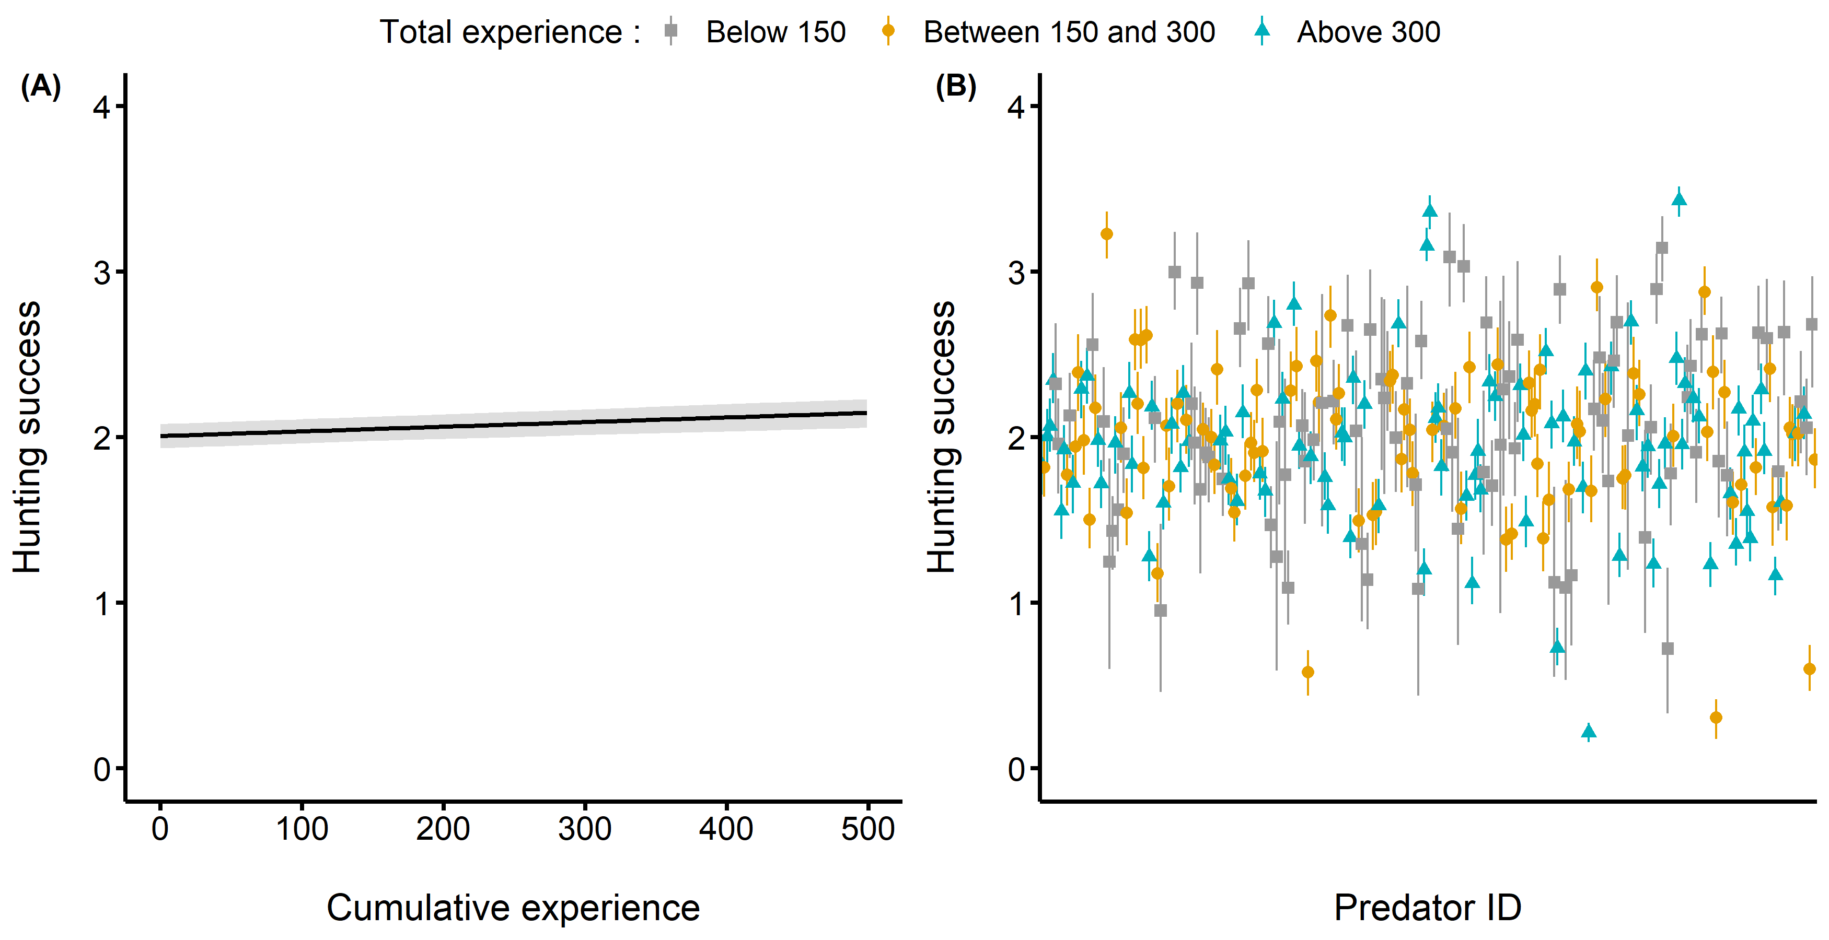

**Figure 1.** Results from the Bayesian generalized linear mixed model. (A) Fitted (solid) line displaying the posterior predicted values relating the predators’ hunting success to their cumulative experience. Here, we transformed the hunting success and cumulative experience back to their original scale (i.e. the amount of prey captured and the number of matches played respectively). The band around the solid line represents the 95% credible intervals. (B) The estimated posterior predicted mean hunting success of each predator player. We display the hunting success back-transformed to its original scale.

blablabla figure 2

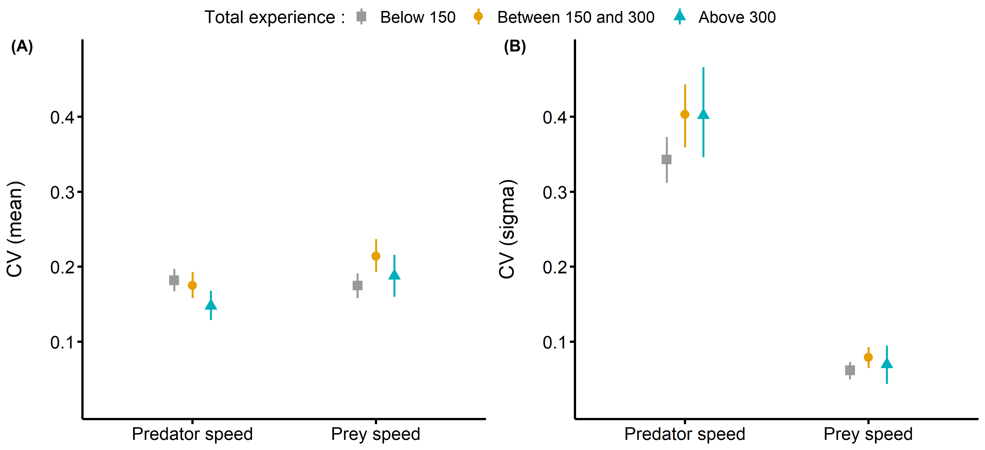

**Figure 2.** Coefficient of variation for the predator’s speed and for the speed of the prey encountered at each level of experience. (A) Coefficient of variation for the among individual differences in average behavior. (B) Coefficient fo variation for the among individual differences in within individual variance (i.e. specialization).

blablabla figure 3

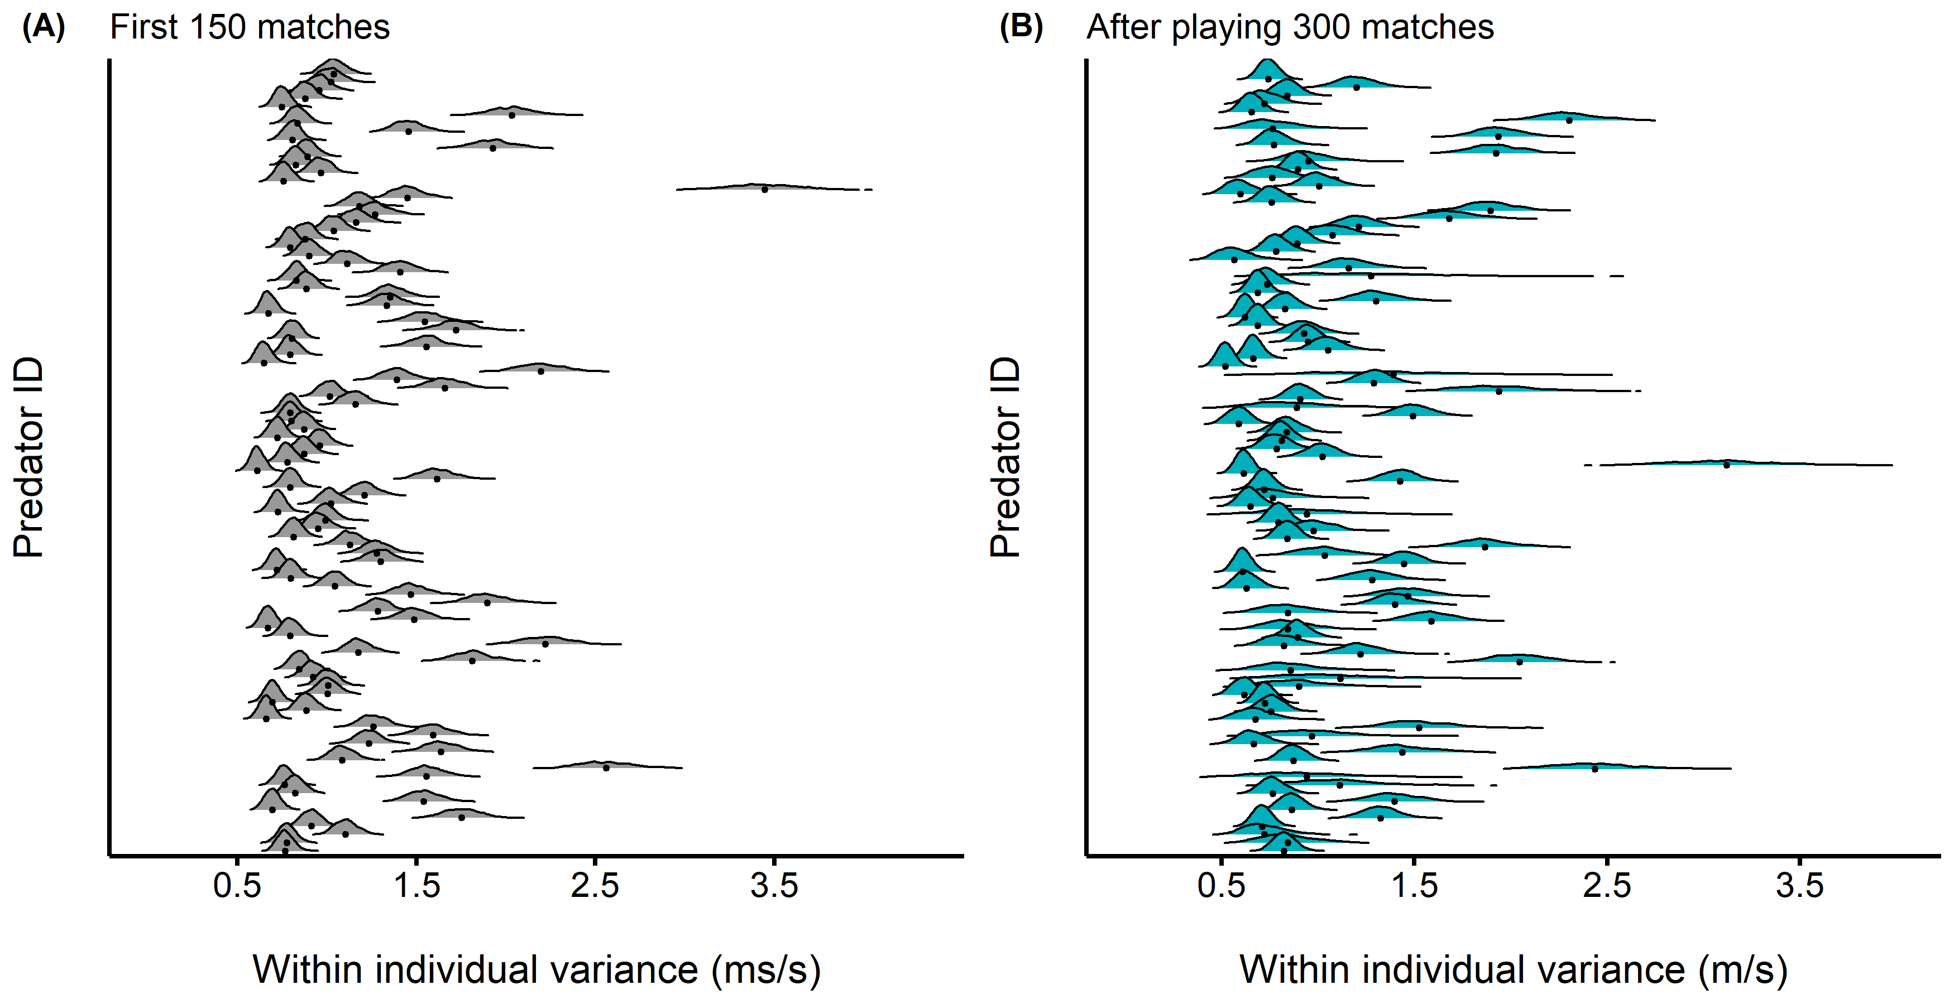

**Figure 3.** Title (A) Novice. (B) Advanced.

# LITTERATURE CITED

Araújo, M.S., Bolnick, D.I. & Layman, C.A. (2011). [The ecological causes of individual specialisation](https://doi.org/10.1111/j.1461-0248.2011.01662.x). *Ecol. Lett.*, 14, 948–958.

Beauchamp, G. (2020). [Predator attack patterns influence vigilance in a virtual experiment](https://doi.org/10.1007/s00265-020-02833-0). *Behav Ecol Sociobiol*, 74, 49.

Céré, J., Montiglio, P.-O. & Kelly, C.D. (2021). [Indirect effect of familiarity on survival: A path analysis on video game data](https://doi.org/10.1016/j.anbehav.2021.06.010). *Animal Behaviour*, 181, 105–116.

Chang, C., Teo, H.Y., Norma-Rashid, Y. & Li, D. (2017). [Predator personality and prey behavioural predictability jointly determine foraging performance](https://doi.org/10.1038/srep40734). *Sci. Rep.*, 7, 40734.

Courbin, N., Besnard, A., Péron, C., Saraux, C., Fort, J., Perret, S., *et al.* (2018). [Short-term prey field lability constrains individual specialisation in resource selection and foraging site fidelity in a marine predator](https://doi.org/10.1111/ele.12970). *Ecol. Lett.*, 21, 1043–1054.

Davoren, G.K., Montevecchi, W.A. & Anderson, J.T. (2003). [Search Strategies of a Pursuit-Diving Marine Bird and the Persistence of Prey Patches](https://doi.org/10.1890/02-0208). *Ecol. Monogr.*, 73, 463–481.

Dukas, R. (2019). [Animal expertise: Mechanisms, ecology and evolution](https://doi.org/10.1016/j.anbehav.2018.05.010). *Animal Behaviour*, 147, 199–210.

Edwards, G.B. & Jackson, R.R. (1994). [The role of experience in the development of predatory behaviour in Phidippus regius, a jumping spider (Araneae, Salticidae) from Florida](https://doi.org/10.1080/03014223.1994.9517994). *N. Z. J. Zool.*, 21, 269–277.

Estes, J.A., Riedman, M.L., Staedler, M.M., Tinker, M.T. & Lyon, B.E. (2003). [Individual variation in prey selection by sea otters: Patterns, causes and implications](https://doi.org/10.1046/j.1365-2656.2003.00690.x). *J. Anim. Ecol.*, 72, 144–155.

Fraser Franco, M., Santostefano, F., Kelly, C.D. & Montiglio, P.-O. (2022). [Studying predator foraging mode and hunting success at the individual level with an online videogame](https://doi.org/10.1093/beheco/arac063). *Behavioral Ecology*, arac063.

Griffen, B.D., Toscano, B.J. & Gatto, J. (2012). [The role of individual behavior type in mediating indirect interactions](https://doi.org/10.1890/11-2153.1). *Ecology*, 93, 1935–1943.

Heithaus, M.R., Dill, L.M. & Kiszka, J.J. (2018). [Feeding strategies and tactics](https://doi.org/10.1016/B978-0-12-804327-1.00126-6). In: *Encyclopedia of Marine Mammals (Third Edition)* (eds. Würsig, B., Thewissen, J.G.M. & Kovacs, K.M.). Academic Press, pp. 354–363.

Huey, R.B. & Pianka, E.R. (1981). [Ecological consequences of foraging mode](https://doi.org/10.2307/1936998). *Ecology*, 62, 991–999.

Ishii, Y. & Shimada, M. (2010). [The effect of learning and search images on predatorprey interactions](https://doi.org/10.1007/s10144-009-0185-x). *Popul. Ecol.*, 52, 27.

Kernaléguen, L., Arnould, J.P.Y., Guinet, C. & Cherel, Y. (2015). [Determinants of individual foraging specialization in large marine vertebrates, the Antarctic and subantarctic fur seals](https://doi.org/10.1111/1365-2656.12347). *J. Anim. Ecol.*, 84, 1081–1091.

Kobler, A., Klefoth, T., Mehner, T. & Arlinghaus, R. (2009). [Coexistence of behavioural types in an aquatic top predator: A response to resource limitation?](https://doi.org/10.1007/s00442-009-1415-9) *Oecologia*, 161, 837–847.

MacDonald, K. (2007). [Cross-cultural Comparison of Learning in Human Hunting](https://doi.org/10.1007/s12110-007-9019-8). *Hum Nat*, 18, 386–402.

Manlick, P.J., Maldonado, K. & Newsome, S.D. (2021). [Competition shapes individual foraging and survival in a desert rodent ensemble](https://doi.org/10.1111/1365-2656.13583). *J. Anim. Ecol.*, 90, 2806–2818.

Matsumura, K. & Miyatake, T. (2022). [Effects of individual differences in the locomotor activity of assassin bugs on predatorprey interactions](https://doi.org/10.1111/eth.13272). *Ethology*, 128, 395–401.

Mery, F. & Burns, J.G. (2010). [Behavioural plasticity: An interaction between evolution and experience](https://doi.org/10.1007/s10682-009-9336-y). *Evol. Ecol.*, 24, 571–583.

Michalko, R., Gibbons, A.T., Goodacre, S.L. & Pekár, S. (2021). [Foraging aggressiveness determines trophic niche in a generalist biological control species](https://doi.org/10.1093/beheco/araa123). *Behavioral Ecology*, 32, 257–264.

Michalko, R. & Pekár, S. (2016). [Different hunting strategies of generalist predators result in functional differences](https://doi.org/10.1007/s00442-016-3631-4). *Oecologia*, 181, 1187–1197.

Moran, N.P., Wong, B.B.M. & Thompson, R.M. (2017). [Weaving animal temperament into food webs: Implications for biodiversity](https://doi.org/10.1111/oik.03642). *Oikos*, 126, 917–930.

Morse, D.H. (2000). [The effect of experience on the hunting success of newly emerged spiderlings](https://doi.org/10.1006/anbe.2000.1546). *Animal Behaviour*, 60, 827–835.

Patrick, S.C. & Weimerskirch, H. (2014a). [Consistency pays: Sex differences and fitness consequences of behavioural specialization in a wide-ranging seabird](https://doi.org/10.1098/rsbl.2014.0630). *Biol. Lett.*, 10, 20140630.

Patrick, S.C. & Weimerskirch, H. (2014b). [Personality, Foraging and Fitness Consequences in a Long Lived Seabird](https://doi.org/10.1371/journal.pone.0087269). *PLOS ONE*, 9, e87269.

Paull, J.S., Martin, R.A. & Pfennig, D.W. (2012). [Increased competition as a cost of specialization during the evolution of resource polymorphism](https://doi.org/10.1111/j.1095-8312.2012.01982.x). *Biological Journal of the Linnean Society*, 107, 845–853.

Phillips, R.A., Lewis, S., González-Solís, J. & Daunt, F. (2017). [Causes and consequences of individual variability and specialization in foraging and migration strategies of seabirds](https://doi.org/10.3354/meps12217). *Mar. Ecol. Prog. Ser.*, 578, 117–150.

Potier, S., Carpentier, A., Grémillet, D., Leroy, B. & Lescroël, A. (2015). [Individual repeatability of foraging behaviour in a marine predator, the great cormorant, Phalacrocorax carbo](https://doi.org/10.1016/j.anbehav.2015.02.008). *Animal Behaviour*, 103, 83–90.

Reid, A., Seebacher, F. & Ward, A. (2010). [Learning to hunt: The role of experience in predator success](https://doi.org/10.1163/000579509X12512871386137). *Behaviour*, 147, 223–233.

Snell-Rood, E.C. (2013). [An overview of the evolutionary causes and consequences of behavioural plasticity](https://doi.org/10.1016/j.anbehav.2012.12.031). *Anim. Behav.*, Including Special Section: Behavioural Plasticity and Evolution, 85, 1004–1011.

Tinker, M.T., Bentall, G. & Estes, J.A. (2008). [Food limitation leads to behavioral diversification and dietary specialization in sea otters](https://doi.org/10.1073/pnas.0709263105). *PNAS*, 105, 560–565.

Tinker, M.T., Mangel, M. & Estes, J.A. (2009). Learning to be different: Acquired skills, social learning, frequency dependence, and environmental variation can cause behaviourally mediated foraging specializations. *Evol. Ecol. Res.*, 11, 841–869.

Toscano, B.J., Gownaris, N.J., Heerhartz, S.M. & Monaco, C.J. (2016). [Personality, foraging behavior and specialization: Integrating behavioral and food web ecology at the individual level](https://doi.org/10.1007/s00442-016-3648-8). *Oecologia*, 182, 55–69.

Toscano, B.J. & Griffen, B.D. (2014). [Trait-mediated functional responses: Predator behavioural type mediates prey consumption](https://doi.org/10.1111/1365-2656.12236). *J. Anim. Ecol.*, 83, 1469–1477.

van den Bosch, M., Baert, J.M., Müller, W., Lens, L. & Stienen, E.W.M. (2019). [Specialization reduces foraging effort and improves breeding performance in a generalist bird](https://doi.org/10.1093/beheco/arz016). *Behavioral Ecology*, 30, 792–800.

Weimerskirch, H. (2007). [Are seabirds foraging for unpredictable resources?](https://doi.org/10.1016/j.dsr2.2006.11.013) *Deep Sea Research Part II: Topical Studies in Oceanography*, Bio-logging Science: Logging and Relaying Physical and Biological Data Using Animal-Attached Tags, 54, 211–223.

Wilson-Rankin, E.E. (2015). [Level of experience modulates individual foraging strategies of an invasive predatory wasp](https://doi.org/10.1007/s00265-014-1861-1). *Behav Ecol Sociobiol*, 69, 491–499.

Woo, K.J., Elliott, K.H., Davidson, M., Gaston, A.J. & Davoren, G.K. (2008). [Individual specialization in diet by a generalist marine predator reflects specialization in foraging behaviour](https://doi.org/10.1111/j.1365-2656.2008.01429.x). *J. Anim. Ecol.*, 77, 1082–1091.