Individual foraging specialization and success change across experience in a virtual predator-prey system:  
Appendix 1

**Table S1.** Posterior medians and 95% HPD intervals of the fixed effects estimated by the MDHGLM of predator speed, prey speed, and predator hunting success.

| Trait | Parameter | Novice | Intermediate | Advanced |
| --- | --- | --- | --- | --- |
| predator speed | intercept (mean) | 3.29 ( 3.15, 3.41) | 3.27 ( 3.10, 3.42) | 3.27 ( 3.12, 3.43) |
|  | prey rank (mean) | -0.02 (-0.02, -0.01) | -0.02 (-0.03, -0.02) | -0.03 (-0.03, -0.03) |
|  | intercept (sigma) | 0.28 ( 0.27, 0.29) | 0.30 ( 0.28, 0.31) | 0.29 ( 0.27, 0.30) |
|  | prey rank (sigma) | 0.99 ( 0.98, 1.00) | 0.98 ( 0.97, 0.99) | 0.99 ( 0.98, 1.00) |
| prey speed | intercept (mean) | 2.34 ( 2.31, 2.36) | 2.42 ( 2.39, 2.46) | 2.42 ( 2.39, 2.46) |
|  | prey rank (mean) | -0.11 (-0.12, -0.11) | -0.11 (-0.12, -0.11) | -0.11 (-0.12, -0.11) |
|  | intercept (sigma) | 0.29 ( 0.29, 0.29) | 0.27 ( 0.27, 0.28) | 0.27 ( 0.27, 0.27) |
|  | prey rank (sigma) | 1.07 ( 1.05, 1.08) | 1.07 ( 1.06, 1.08) | 1.07 ( 1.05, 1.08) |
| hunting success | intercept (mean) | 0.49 ( 0.46, 0.52) | 0.51 ( 0.48, 0.54) | 0.54 ( 0.51, 0.57) |
|  | match duration (mean) | 0.64 ( 0.64, 0.65) | 0.64 ( 0.64, 0.65) | 0.64 ( 0.64, 0.65) |
|  | prey rank (mean) | 0.60 ( 0.60, 0.61) | 0.65 ( 0.64, 0.65) | 0.65 ( 0.65, 0.66) |
| a We exponentiated the dispersion parameters (i.e. sigma) which are estimated on a log scale. We back-transformed the hunting success values, estimated on a logit scale, back to a probability scale. b The intercept values on the mean part of the equation for all traits indicate mean behaviour and success at the population level. The intercept values on the dispersion (i.e. sigma) part of the equation for predator speed indicate behavioural specialization at the population level. | | | | |

**Table S2**. Posterior medians and 95% HPD intervals of the random effect standard deviations estimated by the MDHGLM of predator speed, prey speed, and predator hunting success.

| Trait | Parameter | Novice | Intermediate | Advanced |
| --- | --- | --- | --- | --- |
| predator speed | avatar (mean) | 0.31 (0.22, 0.41) | 0.36 (0.25, 0.48) | 0.36 (0.26, 0.49) |
| environment (mean) | 0.02 (0.02, 0.03) | 0.03 (0.02, 0.03) | 0.03 (0.02, 0.03) |
| predator ID (mean) | 0.16 (0.14, 0.17) | 0.15 (0.14, 0.17) | 0.17 (0.15, 0.18) |
| predator ID (sigma) | 1.48 (1.44, 1.54) | 1.52 (1.47, 1.57) | 1.59 (1.53, 1.65) |
| prey speed | avatar (mean) | 0.05 (0.04, 0.07) | 0.06 (0.04, 0.08) | 0.06 (0.04, 0.08) |
| environment (mean) | 0.06 (0.04, 0.07) | 0.05 (0.04, 0.07) | 0.05 (0.04, 0.07) |
| predator ID (mean) | 0.09 (0.08, 0.10) | 0.08 (0.07, 0.09) | 0.10 (0.09, 0.11) |
| predator ID (sigma) | 1.06 (1.04, 1.07) | 1.07 (1.06, 1.08) | 1.10 (1.09, 1.11) |
| hunting success | predator ID (mean) | 0.90 (0.83, 0.98) | 0.90 (0.82, 0.97) | 0.93 (0.85, 1.01) |
| a We exponentiated the dispersion parameters (i.e. sigma) which are estimated on a log scale. b The standard deviation values on the mean part of the equation indicate, for all traits, among individual differences in mean behaviour, prey encountered, and success. c The standard deviation values on the dispersion part of the equation (i.e. sigma) for predator speed indicate among individual differences in behavioural specialization. For prey speed, they indicate among individual differences in the variability of prey encounters. | | | | |

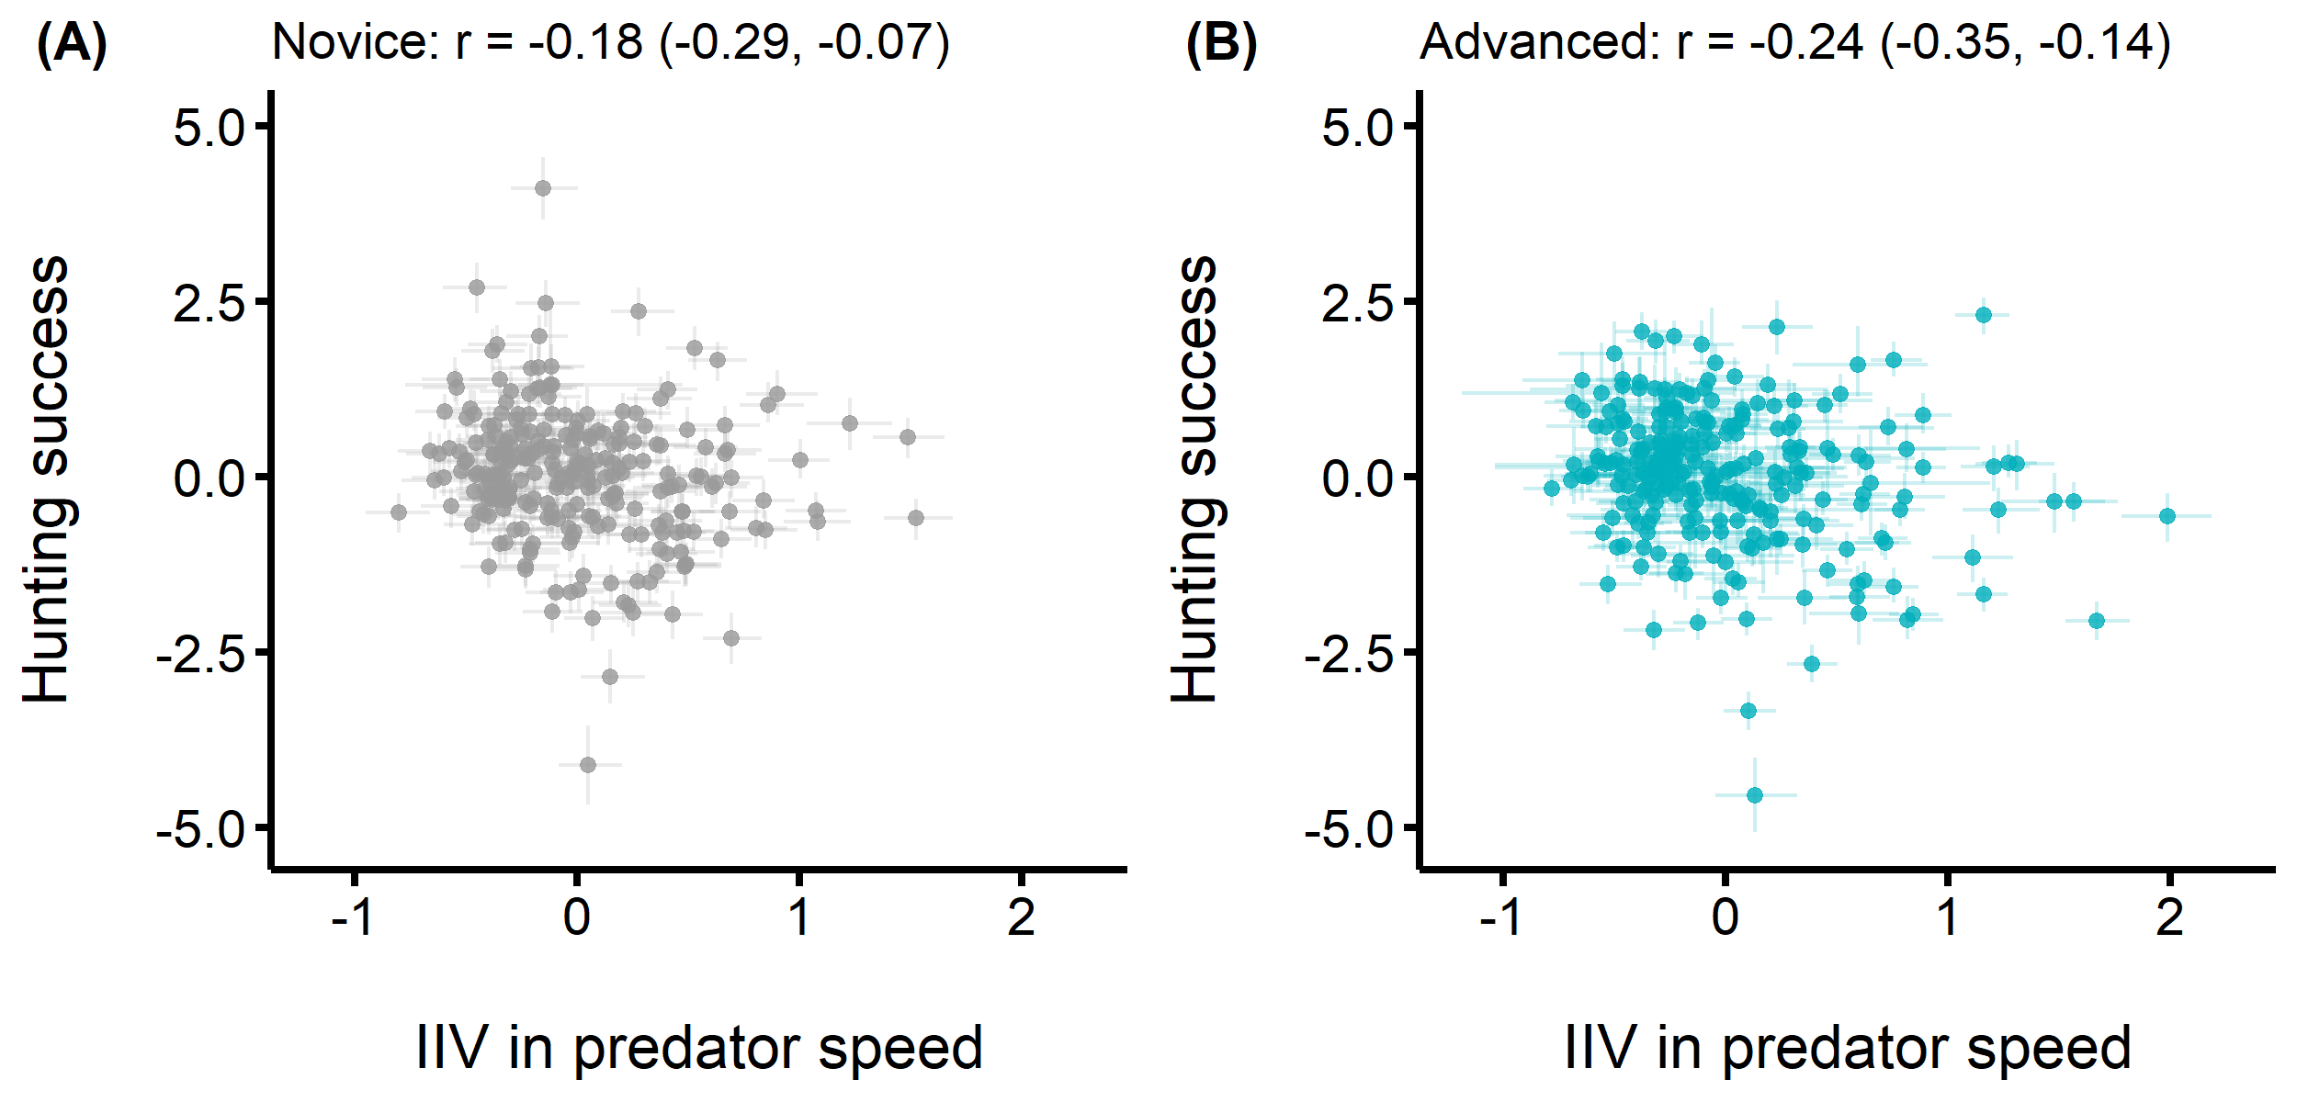

**Figure S1.** Correlations between the predators’ mean hunting success (y axis) and intra individual variance in speed (x axis) to test for differences in success between individuals along the flexible-specialist hunter continuum. Each point represents the posterior median predicted value of an individual predator along with its 95% HPD interval. Individuals with lower IIV are specialist hunters, while individuals with higher IIV are flexible hunters. (A) Correlation when predators were novice (B) Correlation when predators were advanced