Individual foraging specialization and success change across experience in a virtual predator-prey system:  
Appendix 3

Table S1. Posterior medians and 95% HPD intervals of the fixed effects estimated by the MDHGLM of predator speed, prey speed, and predator hunting success. The coefficients are from the model that includes the outlier.

| Trait | Parameter | Novice | Intermediate | Advanced |
| --- | --- | --- | --- | --- |
| predator speed | intercept (mean) | 3.28 ( 3.17, 3.42) | 3.28 ( 3.11, 3.41) | 3.26 ( 3.12, 3.41) |
|  | prey rank (mean) | -0.02 (-0.02, -0.02) | -0.02 (-0.03, -0.02) | -0.03 (-0.03, -0.03) |
|  | intercept (sigma) | 0.28 ( 0.27, 0.29) | 0.30 ( 0.28, 0.32) | 0.29 ( 0.27, 0.31) |
|  | prey rank (sigma) | 0.99 ( 0.98, 1.00) | 0.98 ( 0.97, 0.99) | 1.00 ( 0.98, 1.01) |
| prey speed | intercept (mean) | 2.34 ( 2.30, 2.37) | 2.42 ( 2.39, 2.45) | 2.42 ( 2.39, 2.45) |
|  | prey rank (mean) | -0.11 (-0.12, -0.11) | -0.11 (-0.12, -0.11) | -0.11 (-0.12, -0.11) |
|  | intercept (sigma) | 0.29 ( 0.29, 0.29) | 0.27 ( 0.27, 0.28) | 0.27 ( 0.27, 0.27) |
|  | prey rank (sigma) | 1.07 ( 1.06, 1.08) | 1.07 ( 1.06, 1.08) | 1.07 ( 1.06, 1.08) |
| hunting success | intercept (mean) | 0.49 ( 0.46, 0.52) | 0.51 ( 0.48, 0.54) | 0.54 ( 0.51, 0.57) |
|  | match duration (mean) | 0.64 ( 0.64, 0.65) | 0.64 ( 0.64, 0.65) | 0.64 ( 0.64, 0.65) |
|  | prey rank (mean) | 0.60 ( 0.60, 0.61) | 0.65 ( 0.64, 0.65) | 0.65 ( 0.65, 0.66) |
| a We exponentiated the dispersion parameters (i.e. sigma) which are estimated on a log scale. We back-transformed the hunting success values, estimated on a logit scale, back to a probability scale. b The intercept values on the mean part of the equation for all traits indicate mean behaviour and success at the population level. The intercept values on the dispersion (i.e. sigma) part of the equation for predator speed indicate behavioural specialization at the population level. | | | | |

Table S2. Posterior medians and 95% HPD intervals of the random effect standard deviations estimated by the MDHGLM of predator speed, prey speed, and predator hunting success. The coefficients are from the model that includes the outlier.

| Trait | Parameter | Novice | Intermediate | Advanced |
| --- | --- | --- | --- | --- |
| predator speed | avatar (mean) | 0.30 (0.22, 0.39) | 0.36 (0.26, 0.49) | 0.37 (0.27, 0.49) |
| environment (mean) | 0.02 (0.02, 0.03) | 0.03 (0.02, 0.03) | 0.03 (0.02, 0.03) |
| predator ID (mean) | 0.16 (0.15, 0.17) | 0.15 (0.14, 0.17) | 0.20 (0.18, 0.22) |
| predator ID (sigma) | 1.48 (1.43, 1.53) | 1.52 (1.47, 1.58) | 1.59 (1.53, 1.65) |
| prey speed | avatar (mean) | 0.05 (0.04, 0.07) | 0.06 (0.05, 0.08) | 0.06 (0.04, 0.08) |
| environment (mean) | 0.06 (0.04, 0.07) | 0.05 (0.04, 0.07) | 0.05 (0.04, 0.07) |
| predator ID (mean) | 0.09 (0.08, 0.10) | 0.08 (0.07, 0.09) | 0.11 (0.10, 0.12) |
| predator ID (sigma) | 1.06 (1.04, 1.07) | 1.08 (1.07, 1.09) | 1.10 (1.09, 1.11) |
| hunting success | predator ID (mean) | 0.89 (0.82, 0.98) | 0.90 (0.83, 0.97) | 0.93 (0.86, 1.02) |
| a We exponentiated the dispersion parameters (i.e. sigma) which are estimated on a log scale. b The standard deviation values on the mean part of the equation indicate, for all traits, among individual differences in mean behaviour, prey encountered, and success. c The standard deviation values on the dispersion part of the equation (i.e. sigma) for predator speed indicate among individual differences in behavioural specialization. For prey speed, they indicate among individual differences in the variability of prey encounters. | | | | |

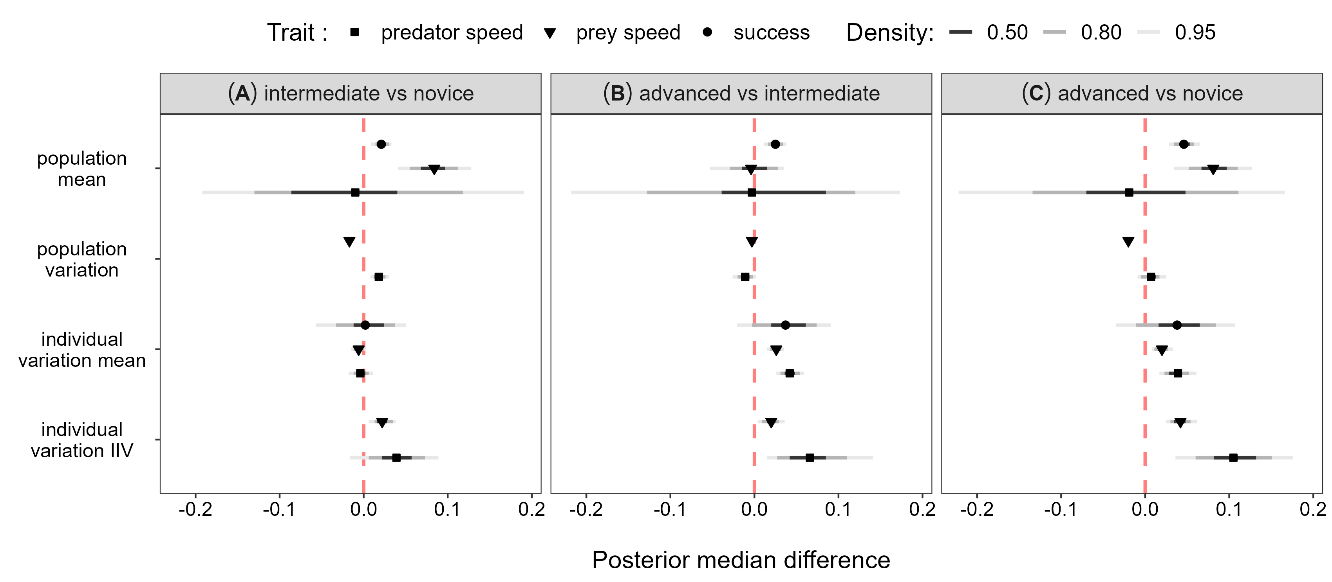

**Figure S1.** Posterior median differences and HPD intervals comparing the parameter values predicted by the MDHGLM among all predator experience levels. The parameter being compared is on the y axis, and the difference in parameter values between two experience levels is displayed on the x axis. The pairwise comparisons between experience levels are displayed across the three panels A, B, and C. The results are from the model that includes the outlier.

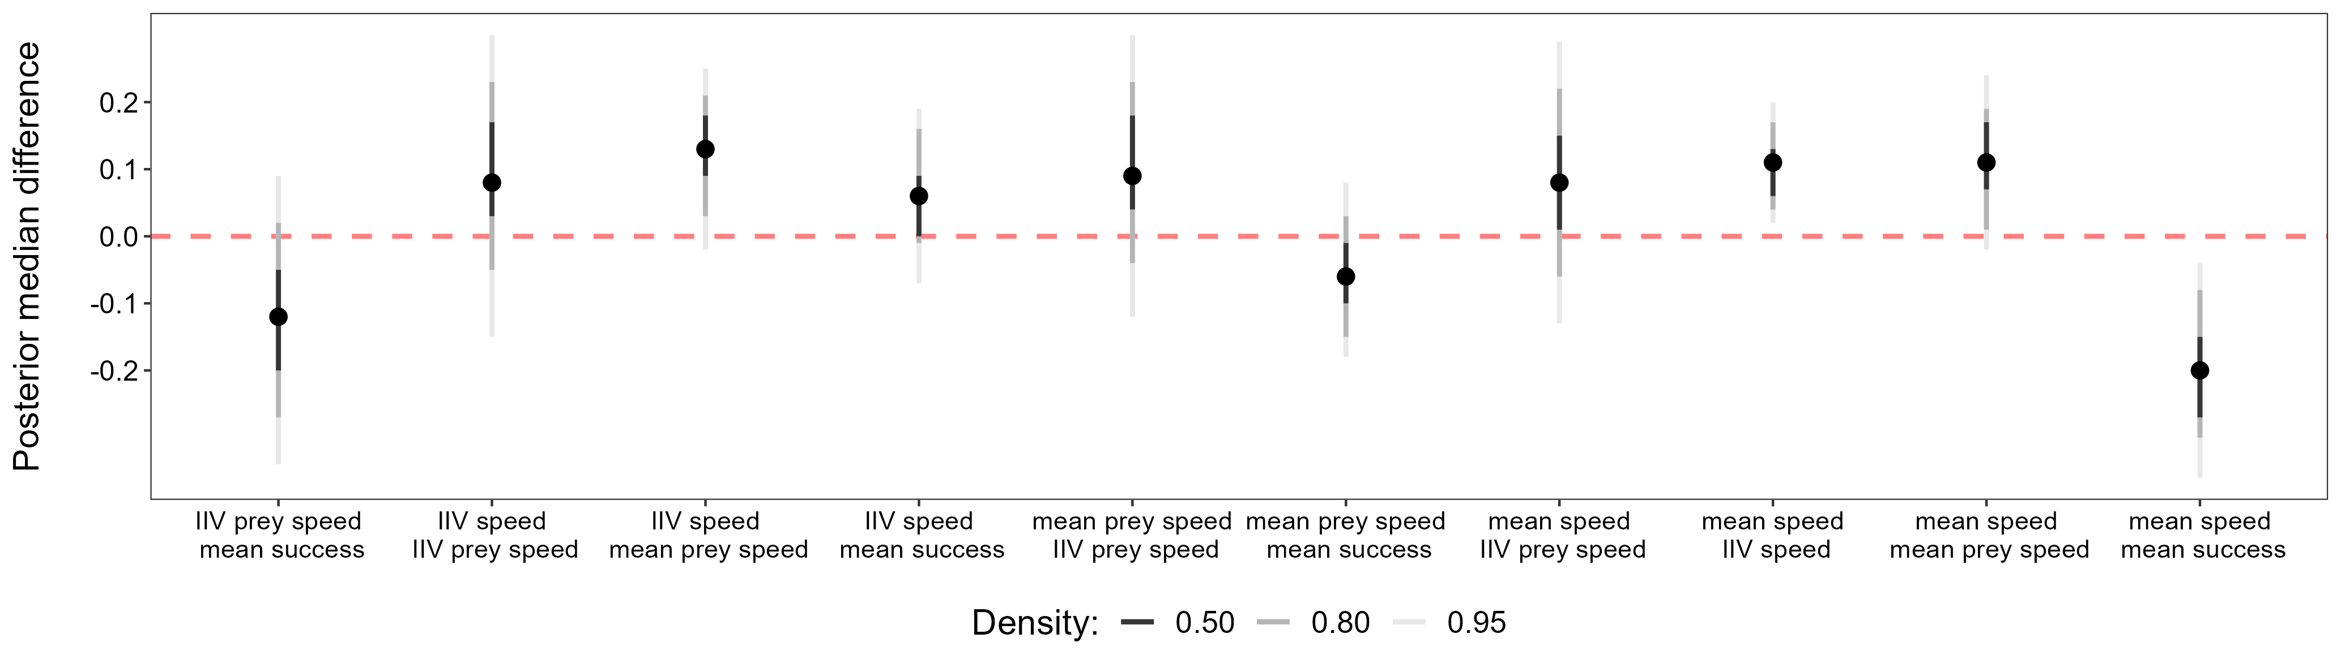

**Figure S2.** Posterior median differences and HPD intervals comparing the trait correlations predicted by the MDHGLM between the advanced and novice levels. The difference is displayed on the y axis and the correlated parameters are displayed on the x axis. Positive values indicate that the correlation was greater when predators where advanced, while negative values indicate that the correlation was greater when predators where novices. The results are from the MDHGLM that includes the outlier.