Individual foraging specialization and success change across experience in a virtual predator-prey system

# ABSTRACT

The capacity of predators to match their tactic to their prey and to optimize their skills at implementing a given tactic are expected to drive the outcome of predator-prey interactions. Hence, successive interactions of predators with their prey may result in increased flexibility in tactic use or in individual foraging specialization. Yet, there are limited empirical assessments showing links between past experience, foraging specialization, and hunting success at the individual level, due to the challenges of monitoring direct interactions in the wild. Here, we used a virtual predator-prey system (the game *Dead by Daylight*) to investigate how individual predator foraging specialization and success developed across repeated interactions with their prey. We found that 68% of predators became either increasingly specialized by always moving at a fast pace, or flexible by transitioning between slow and fast speeds. The predators’ strategies were partially matched to their prey’s speed, suggesting that changes in hunting behaviour were driven by repeated encounters with their prey. Flexible and specialist foragers achieved similar success overall. Hence, our findings suggest that experience may promote behavioural diversification in predator-prey systems.

Keywords: foraging behaviour, reciprocal behavioural plasticity, learning, antipredator behaviour, virtual ecology, Dead by Daylight

# INTRODUCTION

Predators express a diverse array of foraging tactics to capture their prey. In natural populations, individuals differ in the use of tactics such as ambushing and roaming, often resulting in differences in prey consumption (Toscano and Griffen 2014; Patrick and Weimerskirch 2014a; Toscano et al. 2016). This variation in foraging behaviour has been shown to emerge from reciprocal behavioural interactions between predators and their prey. For example, prey reduce their activity to avoid predators, while predators match their hunting tactic to their prey based on their profitability **add ref for pred** (Kelley and Magurran 2011). For a long time, these observations have prompted ecologists to hypothesize that predators learn from experience to become efficient hunters through repeated encounters and may unveil links between foraging specialization and prey capture (Estes et al. 2003; Woo et al. 2008; Phillips et al. 2017). Hence, while it remains challenging to monitor individual predator experience through time, uncovering how it shapes foraging behaviour is essential to predict hunting success because of its implications for community and ecosystem dynamics (Wooster et al. 2023).

Recent evidence suggests that resource fluctuations (e.g., temporal changes in prey behaviour) may be a key mechanism underlying the emergence of behavioural specialization with experience and its fitness consequences (Patrick and Weimerskirch 2014b; van den Bosch et al. 2019; Santoro, Hartley, and Lester 2019; Manlick, Maldonado, and Newsome 2021). Theory suggests two contrasting scenarios with their outcome defined by the degree of resource variability. In the first scenario, individuals should gradually specialize in a foraging tactic (e.g., always moving fast) if it allows them to maintain successful prey captures at each attempt (Tinker, Mangel, and Estes 2009; Dukas 2019). This should occur when predators learn to hunt in environments where resources are predictable (or stable) because they require less energy and time to search for, capture, and handle prey (Weimerskirch 2007; Woo et al. 2008; Potier et al. 2015). Such conditions favor specialist hunters because there would be higher costs to switch tactics for the same type of prey. For example, habitat specialization under stable resources is associated with reduced foraging effort and increased offspring growth rates in Herring Gulls (*Larus argentatus*) (van den Bosch et al. 2019). In the second scenario, predators are expected to increase behavioural flexibility by using a variety of hunting tactics (i.e. generalists) when they hunt in highly variable environments. Indeed, while there can be costs to attempt novel tactics by trial and error, predators can reduce the consequences of uncertainty in environments under fluctuating resources by learning to adjust their tactic to the prey that they encounter (Dall 2010; Mathot et al. 2012; Stephens 1993; Ishii and Shimada 2010; Kelley and Magurran 2011). Szopa-Comley and Ioannou (2022) showed that predatory blue acaras (*Andinoacara pulcher*) reduce their maximum approach speed when repeatedly exposed to prey that escape unpredictably, enabling them to be as successful as those exposed to predictable prey. Given these two scenarios, the relationship between individual foraging specialization and prey capture likely depends on a predator’s ability to learn and adapt its hunting tactics to the prey it encounters. If predators can adjust their tactics to match the prey fluctuation regime they experience, then both specialist and generalist hunters should achieve similar hunting success and coexist (Phillips et al. 2017). Empiricists should therefore examine how foraging specialization influences prey capture across time and different ecological scenarios.

In this study, we use data from players in the online videogame *Dead by Daylight* to investigate 1) how repeated interactions with prey shape predator foraging specialization and 2) how the relationship between specialization and foraging success changes over time. *Dead by Daylight* simulates a predator-prey interaction across complex virtual environments, providing a system to test ecological hypotheses on foraging behaviour, group selection, and social interactions (reviewed in Montiglio, Fraser Franco, and Santostefano 2025). In this game, four prey players forage for resources while avoiding predation by a fifth player. The predator population is composed of individuals that vary consistently in their use of hunting tactics along an ambush-cursorial continuum: at one extreme hunters move more slowly and ambush prey; at the other extreme, hunters roam the virtual environment at high velocities (Fraser Franco et al. 2022). Predators also acquire expertise through extensive practice, and the behaviour of the prey they encounter influences the rate at which they gain expertise (Fraser Franco et al. 2024). To assess how foraging specialization emerges throughout experience, we define the level of individual foraging specialization as the intra-individual variance (i.e. IIV) in movement speed across matches following the definition by Cleasby, Nakagawa, and Schielzeth (2015). Low IIV describes individual foraging specialization (i.e., always using an ambush or cursorial tactic) whereas high IIV describes a flexible use of foraging tactics (i.e., generalist predators switching between ambush and cursorial tactics).

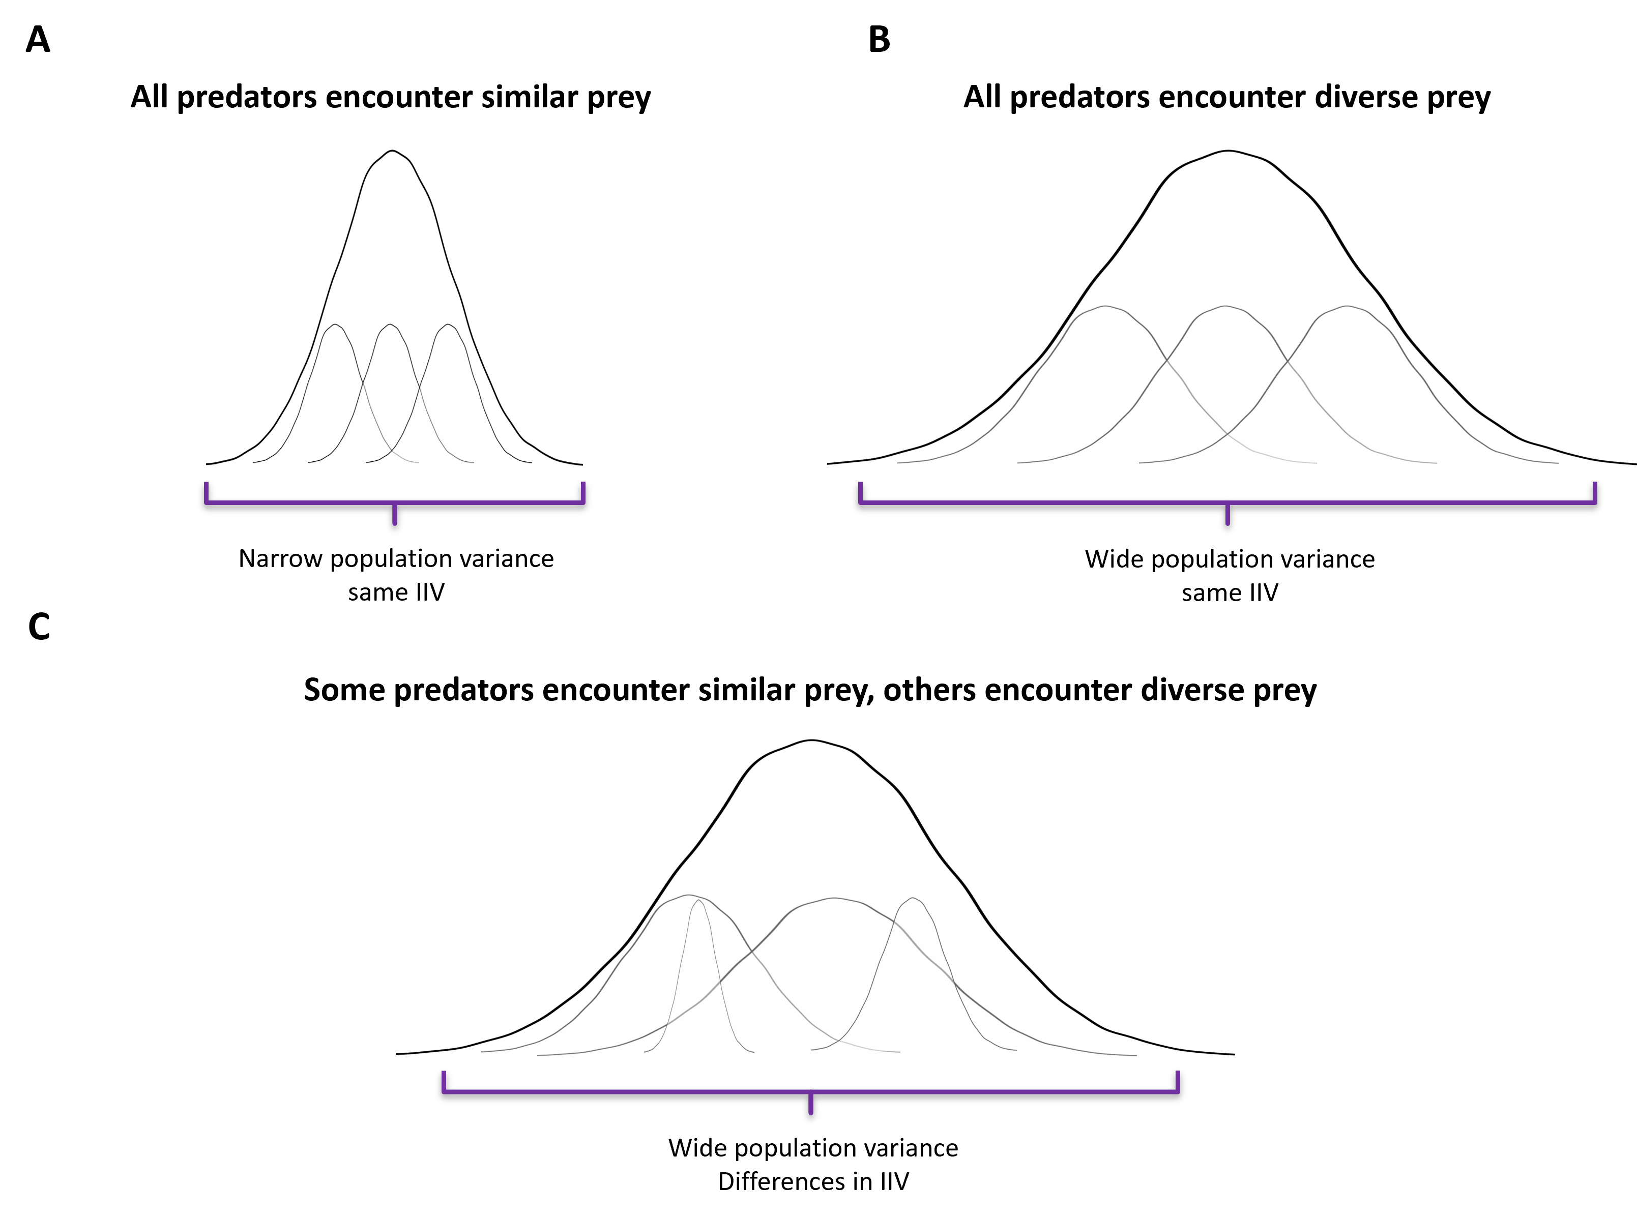

**Figure 1**. Hypothesis describing the outcome of prey-mediated individual foraging specialization. Panels A and B display two scenarios with different outcomes at the population level, but similar outcomes at the individual level. On panel A, all predators encounter prey with similar attributes (e.g., prey encountered were always fast) through time, such that they all display similar degrees of individual foraging specialization. This results in the population being specialized. Similarly, on panel B, all individuals encounter varying types of prey (e.g., in some encounters the prey were fast, in others the prey were slower), such that they also display similar degrees of individual foraging specialization. In this case, they all become generalist hunters, resulting in the population distribution being wider. Panel C shows a different and more plausible scenario, where predators display varying degrees of foraging specialization. In this case, some individuals encounter similar prey, and thus specialize, while others encounter varying groups of prey, thus becoming generalists.

To test the hypothesis that repeated interactions with prey shape predator foraging specialization, we analyze the movement behaviour of both predators and their prey using their speed of movement. We predict that if all predators consistently encounter prey moving at similar speeds, then the population as a whole (i.e., all individuals) should specialize on moving at similar speeds, resulting in a narrow foraging behavioural niche (Figure 1A). In contrast, if all predators encounter groups of prey moving at varying speeds, then they should instead become more flexible in their tactic (i.e., generalists), adjusting their speed to the prey, resulting in a higher population variance in foraging behaviour (Figure 1B). In both scenarios, differences among individuals in IIV across experience should be low (i.e., similar individual foraging specialization, Figure 1 A-B). Alternatively, differences among individuals in foraging specialization may emerge if they experience different interactions with their prey. In this case, predators that encountered similar groups of prey across experience should specialize on moving at a more fixed speed, while predators that encountered heterogeneous groups across matches should adopt a generalist movement strategy, resulting in an increase in among individual differences in IIV with experience (Figure 1C). If we detect such prey-dependent fine-tuning with experience, then specialist and generalist hunters should attain equal success, resulting in no apparent relationship between foraging specialization and prey capture.

# MATERIALS AND METHODS

## Study system

*DBD* is an asymmetric multiplayer survival game developed by Behaviour Interactive Inc. In this game, participants take on roles as either a predator or one of the prey, with each match consisting of one predator and four prey. A matchmaking system pairs groups of players with similar skill such that individuals should all have similar experience. The predator’s primary goal is to hunt and capture the prey, while the prey aim to locate and collect resources in the form of power generators. When all generators are activated, the prey can escape through one of two exit gates and win the match. A match concludes when the predator eliminates all remaining prey that have not escaped or when the final prey successfully exits the virtual environment. Players, whether predator or prey, select avatars with distinct abilities tailored to specific playstyles (e.g. stealthy vs evasive prey, or stalking vs patrolling predators). During the study period, the game featured 23 predator avatars. The virtual environments in the game vary in size and structural complexity, combining fixed and procedurally generated elements such as vegetation, buildings, and maze-like structures. Troughout the study period, there were 35 virtual game environments available for gameplay.

## Data collection

The videogame company provided six months of gameplay data, encompassing all player activity from 2020-12-01 to 2021-06-01. We focused exclusively on matches played in “Online” mode, where players were strangers to one another. We excluded matches where players were inactive, as indicated by mean movement speeds that were zero or nearly zero. Additionally, matches where players were suspected of hacking or engaging in unintended gameplay behaviour were also removed based on our knowledge of the game mechanics. We then selected a cohort of players that played 300 matches or more, and monitored all their matches from the first to a maximum of 500 matches.

Our dataset includes 253 unique predator players, collectively accounting for 100 412 matches. The number of matches played by predator players ranged from 301 to 500. Match durations varied between 3 and 70 minutes, with an average duration of 11 minutes. The following details were recorded for each match: the anonymous player ID, the chosen predator avatar, the game environment, the predator’s level of experience, their speed, the average speed of the prey group they encountered, and the average rank of those prey (used as a proxy for prey skill). The game’s ranking system, designed to match players of similar skill levels (<https://deadbydaylight.fandom.com/wiki/Rank>), was incorporated into our analysis to detect any relationship between predator experience and foraging success (see Fraser Franco et al. 2024).

We analyzed the predator’s mean speed and the mean speed of the prey group encountered by the predator. The predator’s mean speed is measured as the mean distance traveled per second during a match (mean= 3.31 ± 0.49 m/s). We measured the preys’ speed as the mean travel speed of the four individual prey in a match (mean = 2.40 ± 0.32 m/s). We defined hunting success as the number of prey consumed during the match (min = 0, max = 4). Lastly, we categorized predators for each match based on their cumulated experience (see Fraser Franco et al. 2024). We labeled predators as novices for matches where they had cumulated less than 100 matches, intermediate for matches where they had cumulated between 100 and 299 matches, and advanced for matches where they had cumulated more than 299 matches (max 500). Since our goal was to monitor predator players throughout their experience and that they all played at least 300 matches, they all appeared in each of the three experience categories.

## Statistical analyses

### Foraging behaviour and predator-prey interactions across experience

We tested whether foraging behaviour changed with experience, and compared the success of predators along the flexible-specialist hunter continuum, using a multivariate double-hierarchical generalized linear model (MDHGLM) (Lee and Nelder 2006; Cleasby, Nakagawa, and Schielzeth 2015; Mitchell et al. 2016). For each experience level, we fitted the model on three traits: the predator’s speed ($Y_{1}$) and the prey’s speed ($Y_{2}$) using a Gaussian error distribution, and the predator’s hunting success ($Y_{3}$) using a beta-binomial error distribution. Fixed and random effect structure were trait-specific and the same for all experience levels. The predator and the prey speed included a mean and a dispersion part (eqn 1.1, 1.2 and 2.1, 2.2). For both traits, we controlled for the standardized prey rank on both the mean and the dispersion parts of the model. We included game environment, predator avatar, and individual predator identity random effects on the mean part of the model. The dispersion part included individual predator identity random effects exclusively. For hunting success, we modeled the mean part only (eqn 3) and controlled for the standardized prey rank and game duration, and included an individual identity random effect.

The model simultaneously estimated five among-individual variance components with their covariances for each experience level, resulting in a 15x15 (co)variance matrix. For each experience level, the model estimated among individual variance in mean predator speed, mean prey speed, and mean hunting success. This allows us to test for individual differences in tactic use (i.e. along the slow-fast continuum), in the mean speed of the prey encountered, and in mean prey consumption. The model also estimated among individual variance in intra-individual variation (IIV) for both prey and predator speed. This allows us to test if predators do not experience the same degree of prey heterogeneity and if they differ in individual specialization. Finally, the model estimated all pairwise covariances at the individual level among traits, among experience, and across traits and experience. The resulting 15x15 (co)variance matrix thus provides the structure of the predator-prey trait interactions as well as the relationship between specialization and success across experience at the individual-level.

The model can be written as:

|  |  |
| --- | --- |
|  | (eqn. 1.1) |
|  | (eqn. 1.2) |
|  | (eqn. 2.1) |
|  | (eqn. 2.2) |
|  | (eqn. 3) |

where $j$ is the index of the three experience levels (i.e. novice, intermediate, advanced). The $d$ subscript indicates that a term is from the dispersion part of the model. The $b$ terms are vectors of fixed effects with their design matrices $X$ specific to each trait and experience level. The terms $en$, $av$, and $id$ are the vectors of random environment, random avatar, and random individual identity effects associated with their design matrices $M$, $N$, and $Z$ specific to each trait and experience level. For all experience levels of $Y_{1}$ and $Y_{2}$, we assumed that the game environment and avatar random effects followed a Gaussian distribution with estimated standard deviation ( $en_{12j}∼N(0, I σ_{en_{12j}}^{2})$ and $av_{12j}∼N(0, I σ_{av_{12j}}^{2})$). $I$ is the identity matrix, with $Iσ^{2}$ indicating that the random effects are independently and identically distributed. In addition, we assumed that the residuals follow a Gaussian distribution with observation-specific variance $e_{12j}∼N(0, Diag\{σ_{e_{12j}}^{2}\})$. The 15 individual identity random effects $id_{ij}$ across all response variables and experience levels (five for each of the three experience levels) are indexed in vector $α$. The $α$ vector follows a multivariate Gaussian distribution $α∼MVN(0, Σ)$ where $Σ$ is a 15x15 (co)variance matrix of among individual variation across all response variables and experience levels, with $σ_{id_{ij}}^{2}$ on the diagonal and covariances off-diagonal.

We performed our analyses under a Bayesian framework. We used weakly informative Gaussian priors for the prey rank ($N(0, 1^{2})$: eqn. 1.1 to 2.2) and game duration ($N(0.5, {0.5}^{2})$: eqn. 3). Based on previous results showing that the mean predator speed revolves around 3 m/s (Fraser Franco et al. 2022), we applied a weakly informative Gaussian prior on the intercept for predator and prey speed ($N(3, {0.5}^{2})$: eqn. 1.1 and 2.1). Similarly, we used a weakly informative Gaussian prior on the intercept for the dispersion part ($N(0, 1^{2})$: eqn 1.2 and 2.2). For hunting success, we applied a positive Gaussian prior on the precision parameter ($N(2, 1^{2})$: eqn. 3) and a negative Gaussian prior ($N(−4, 1^{2})$: eqn 3) on the intercept because hunting success should be close to 0 at the lowest game duration. For every predicted variable, we applied a weakly informative half-Gaussian prior ($N(0, 1^{2})$) on the random effects for the mean part and the dispersion part of the model. We used a regularizing $LKJ(2)$ prior on the correlation matrix.

### Model specifications

We fitted the model in R (version 4.1.2) using Hamiltonian Monte Carlo (HMC) sampling with the package “brms” version 2.16.3 (Bürkner 2017), an R front-end for the STAN software (Team 2023), and “cmdstanr” version 0.4.0 (Gabry and Češnovar 2021) as the back-end for estimation (cmdstan installation version 2.28.2). We ran te model on on Cedar (Operating system: CentOS Linux 7), a computer cluster maintained by the Digital Research Alliance of Canada (<https://docs.alliancecan.ca/wiki/Cedar>).

We parametrized the MDHGLM to run 2500 iterations with a thinning set to eight, with the first 500 used as warm up iterations (yielding 1000 posterior samples for each parameter). We assessed the convergence of the chains using trace plots, R-hat diagnostics with a threshold of <1.01, and effective sample sizes (ESS) with a threshold of >100 (Vehtari et al. 2021). We also performed posterior predictive checks which showed an adequate fit of the models (for details, see <https://github.com/quantitative-ecologist/experience-hunting-tactics>). We report all the posterior parameter estimates using the median of the posterior distribution with the highest posterior density (HPD) intervals at 50%, 80%, and 95%.

After inspection of the results, we found that key parameter values for our hypotheses were in the direction of our predictions, but they were largely driven by the very slow speed of one predator. Removing this individual reduced the estimates by a significant margin. To remain conservative, we thus present the results of the model without this individual in the main text, and provide the results of the model including it in the Appendix 2.

# RESULTS

## Changes in foraging behaviour, prey behaviour, and hunting success

The mean speed of the predator population remained stable with experience (Figure 2 and Appendix 1: Table S1). Likewise, the variation in speed did not change with experience, indicating that foraging specialization remained stable at the population level (Figure 2 and Appendix 1: Table S1). At the individual level, predators differed slightly in their mean speed across experience levels, indicating marginal differences in hunting tactics (Figure 2 and Appendix 1: Table S2). However, they displayed important differences in foraging specialization (Appendix 1: Table S2) which also increased slightly with experience as there was a 0.11 unit increase in among individual differences in IIV from novice to advanced (Figure 1). 12% of the population switched from a flexible to a specialized hunting tactic, and vice-versa, as predators gained experience (i.e. >0.2 change in standard deviation; Figure 2). In contrast, 44% displayed lower changes (i.e. >0.05 and <0.2 change in standard deviation) and 44% showed almost no change with experience (i.e. <0.05 change in standard deviation).

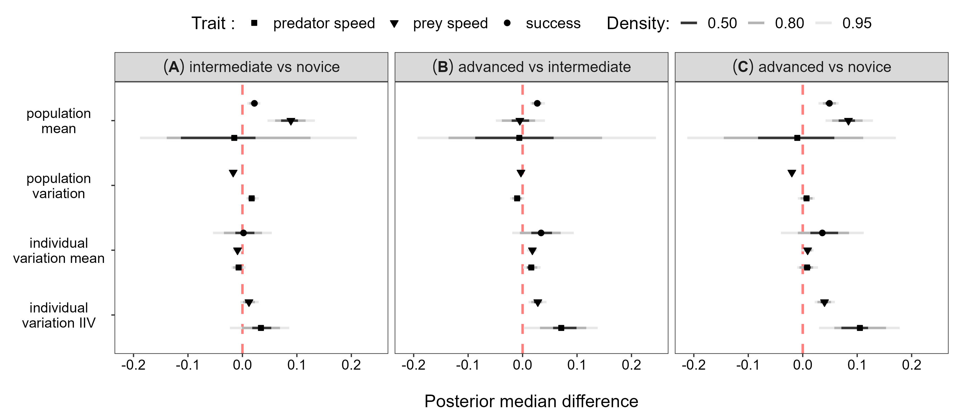

**Figure 2**. Median posterior differences and HPD intervals comparing predator foraging behaviour at the population and individual level across experience stages. The behavioural parameter predicted by the MDHGLM being compared is on the y axis, and the difference in parameter values between two experience stages is on the x axis. The pairwise comparisons between experience stages are displayed across the three panels A, B, and C. We compare the mean speed of the predator population, the speed of the prey it encountered, and its hunting success across experience (population mean). We also compare the population’s foraging specialization and variation in speed of the prey it encountered across experience (population variance). At the individual level, we compare among individual differences in speed, the speed of the prey encountered, and hunting success (individual variation mean). Lastly, we compare individual variation in IIV across experience, indicating whether individual differences in foraging specialization and in the variation of the groups of prey encountered changed with experience (individual variation IIV).

As the predator population gained experience, there was strong evidence that the prey increased their speed, although slightly (Figure 1 and Appendix 1: Table S1). The population also encountered groups of prey using different speeds through time (Figure 1 and Appendix 1: Table S1). At the individual level, all predators encountered prey with similar average speeds throughout experience (Figure 1 and Appendix 1: Table S2). Yet, even if they experienced similar average prey speeds across all groups encountered, there were important differences among predators in how (dis)similar were the groups they encountered (Appendix 1: Table S2). Thus, some predators encountered similar groups (i.e. all groups using similar speeds) while others encountered distinct groups (i.e. some slower and some faster). These differences among individuals in IIV for prey encounters increased only marginally with experience (Figure 1).

The predator population’s mean hunting success increased with experience (Figure 1 and Appendix 1: Table S1), with mean prey consumption revolving around two prey. There were also important differences among individuals in mean hunting success (Appendix 1: Table S2), but they remained stable across experience (Figure 1).

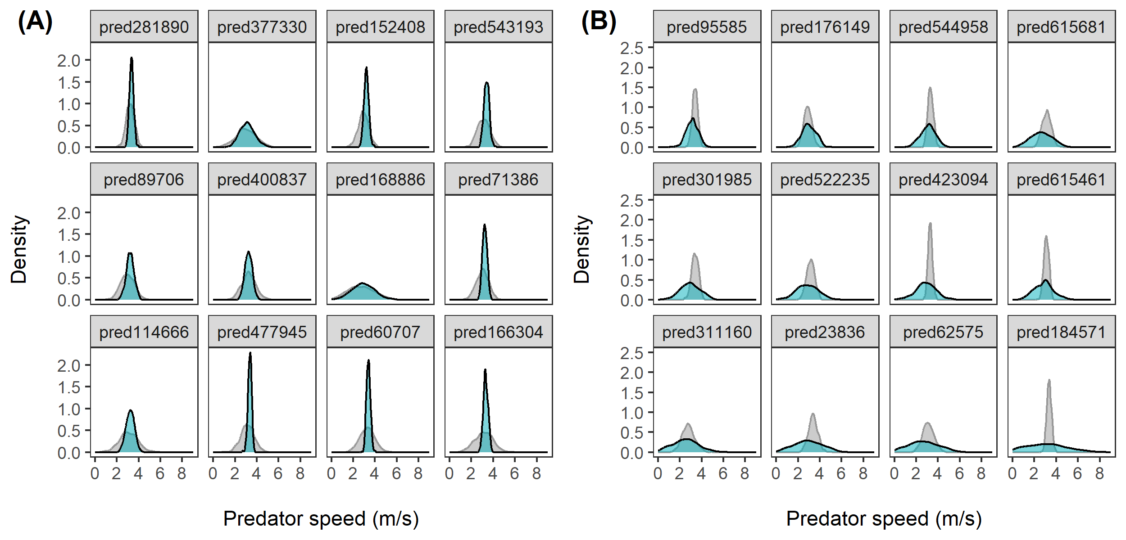

**Figure 3**. Individual behavioural distribution of the predators’ speed drawn from the MDHGLM estimates for individuals that had (A) the greatest increase in specialization and (B) the greatest increase in flexibility. The background (gray) distributions are for when individuals were novice hunters, and the foreground (blue) distributions with solid contour lines are for when they were advanced hunters. Both figure panels are ordered by ascending degree of increase in either specialization or flexibility. We built the figure by first subtracting the estimated standard deviation of all individuals as novices with their standard deviation as advanced hunters, and then selected those with the greatest difference using the 25% and 75% quantiles. Individuals on panel A have an increase in specialization equal or greater than 0.2 standard deviations, while those on panel B have an increase in flexibility equal to or greater than 0.2 standard deviations.

## Predator-prey interactions across experience

Predators that were on average faster had lower IIV in speed (Figure 3A-B). Thus, faster predators specialized on fast movement, while slower predators were more flexible in their movement. As predators gained experience, these strategies were increasingly defined as the correlation changed by 0.16 units, from -0.62 (-0.70, -0.55 ) for when predators were novices to -0.78 (-0.83, -0.72 ) as they reached the advanced stage (Figure 3C). Predators that were on average faster also tended to encounter groups of prey that were on average faster and more similar (Figure 3A-B). There was however no evidence that these correlations increased with experience (Figure 3C)

There was no correlation (-0.02 (-0.14, 0.01 )) between mean prey speed and IIV in predator speed when predators were novice (Figure 3A), but the correlation increased to -0.16 (-0.27, -0.04 ) at the advanced stage (Figure 3B), such that advanced hunters that encountered faster prey tended to be more specialized (Figure 3C). The predators’ IIV in speed and IIV in prey speed were weakly positively correlated (Figure 3A-B). Hence, predators that encountered groups of prey with similar speeds tended to be more specialized in their tactic, while those that encountered groups of prey with varying speeds tended to be more flexible. We did not find evidence that this correlation increased with experience (Figure 3C).

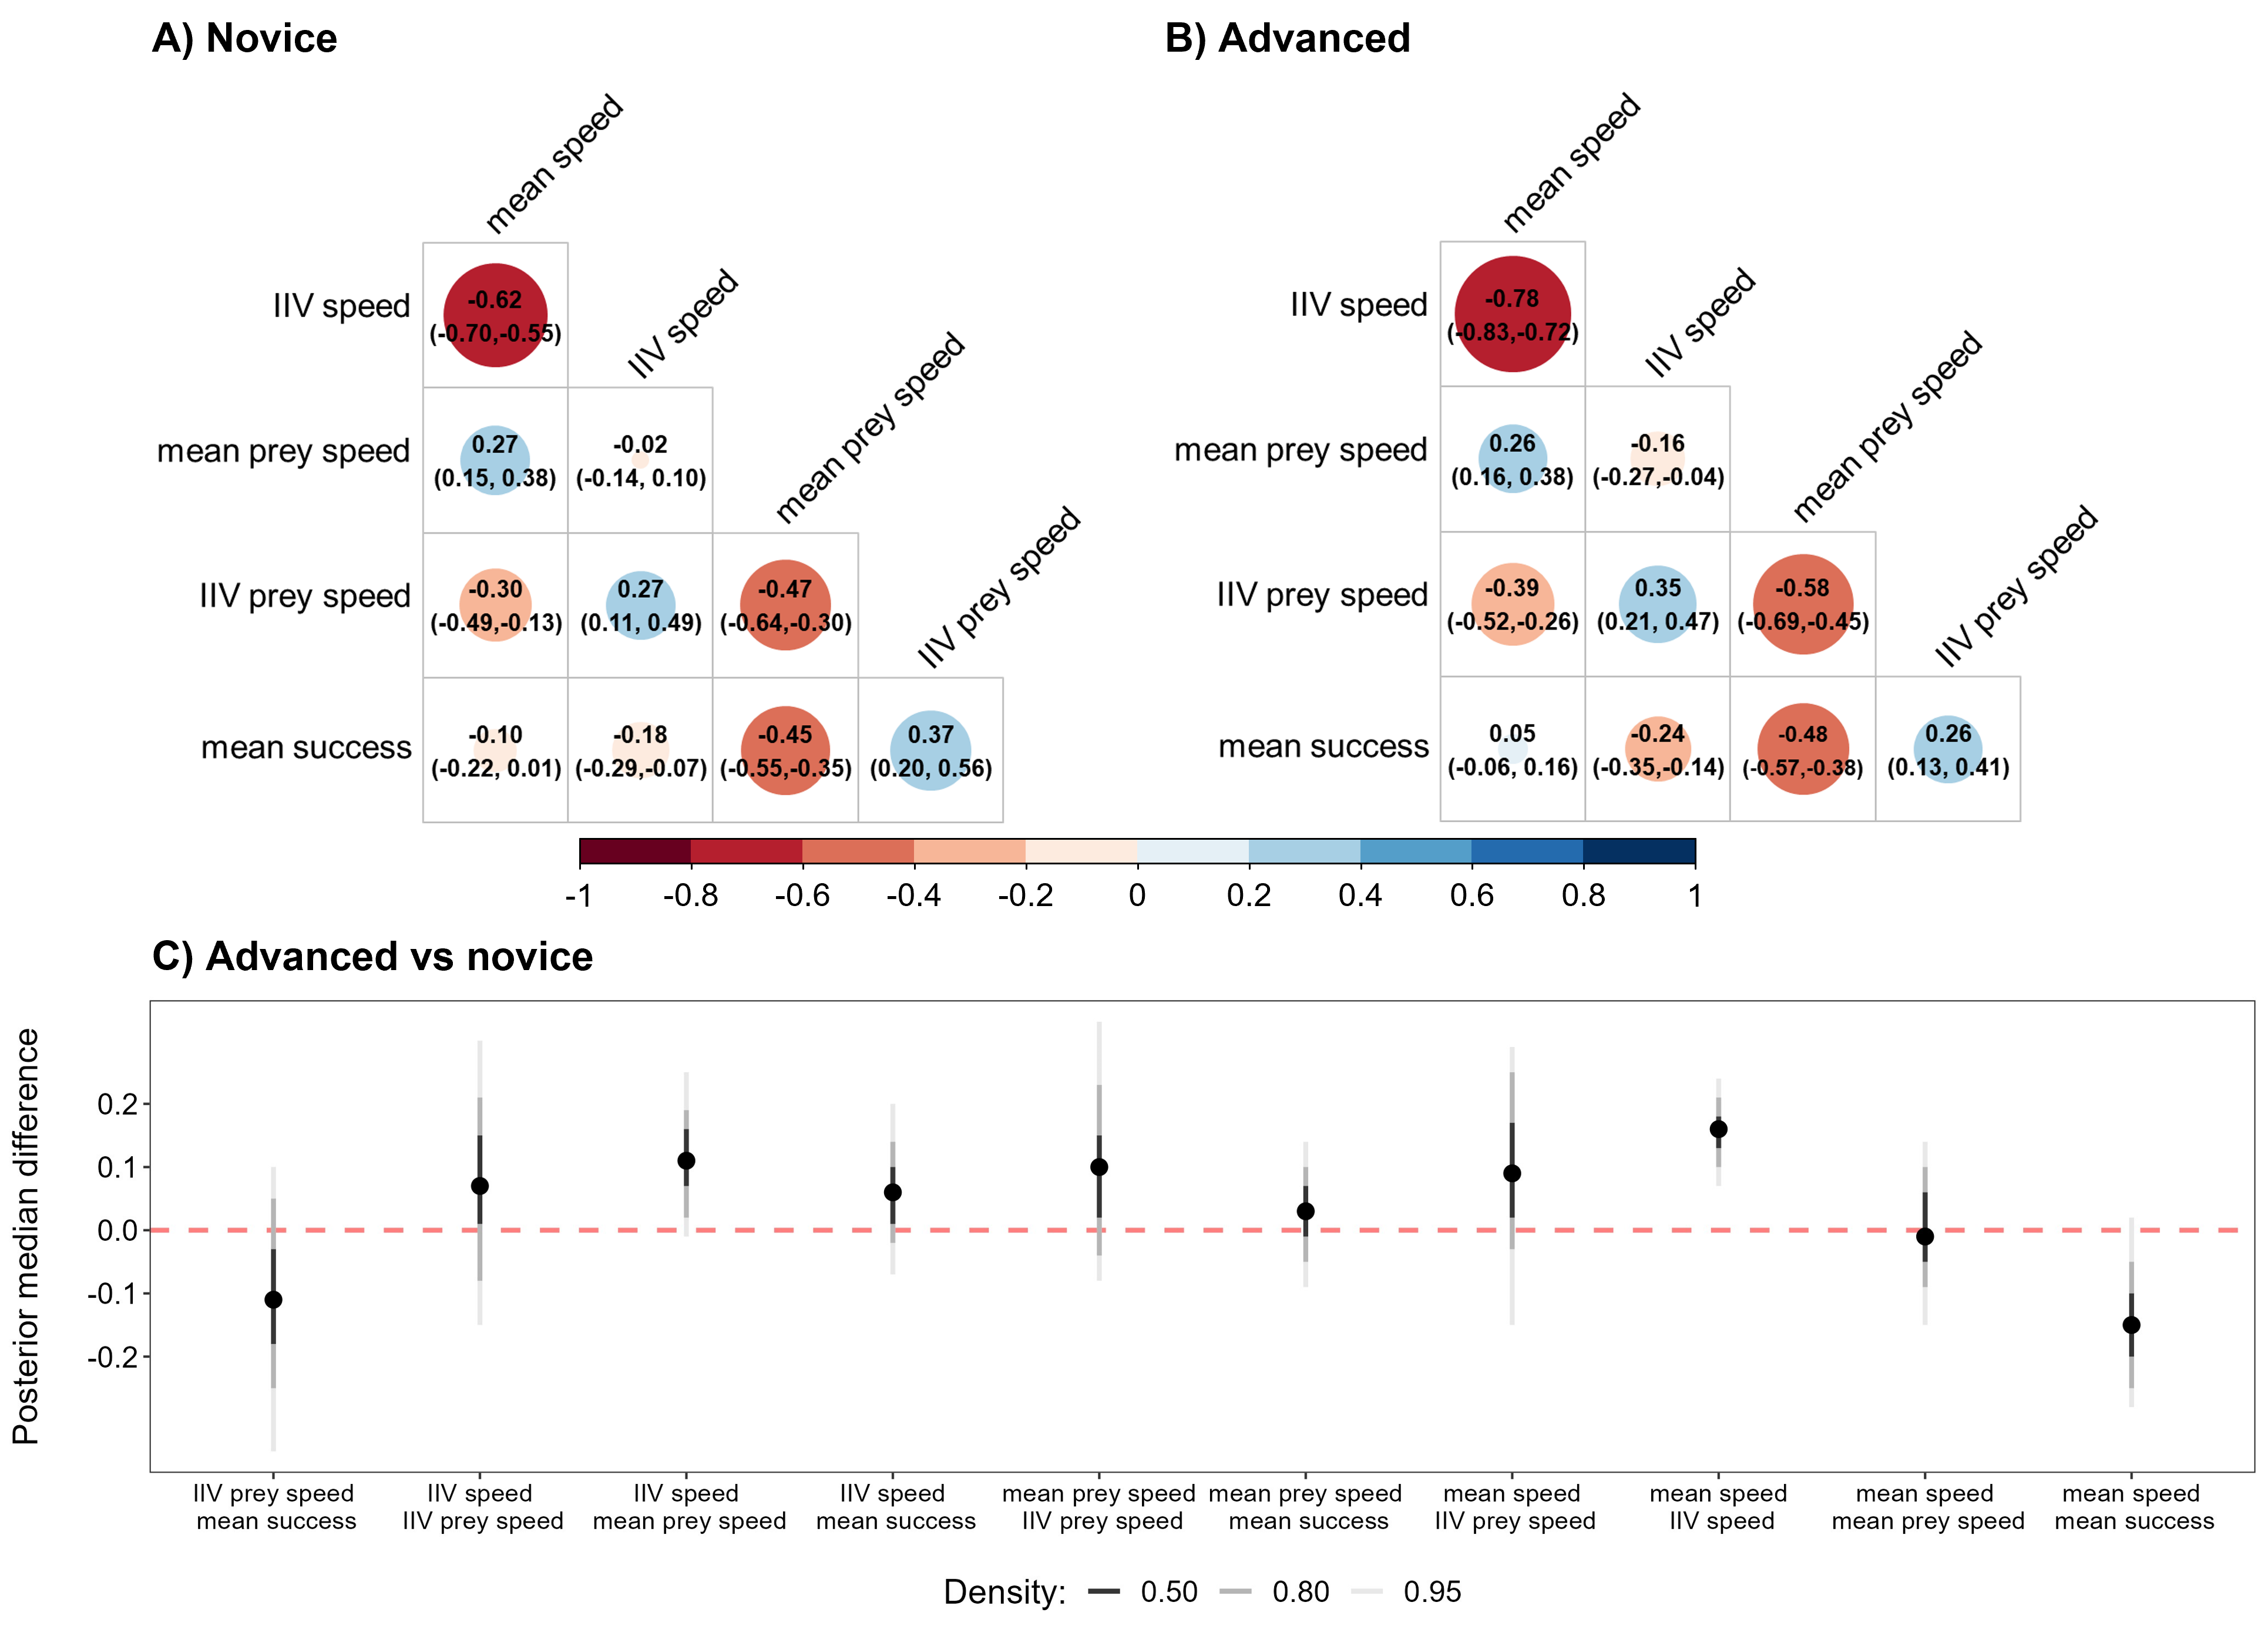

**Figure 4**. Correlation matrices of the MDHGLM relating the mean and IIV in speed of the predators, the mean and IIV in speed of the prey they encountered, and mean hunting success. Larger dark blue circles indicate stronger positive correlations (positive values on the colour legend), while larger dark red circles indicate stronger negative correlations (negative values on the colour legend). A) Correlations when predators were novice hunters. B) Correlations when predators were advanced hunters. C) Posterior median differences and HPD intervals comparing the trait correlations predicted by the MDHGLM between the advanced and novice levels. The difference is displayed on the y axis and the correlated traits being compared are displayed on the x axis. Positive values indicate an increase in correlation strength from novice to the advanced stage, while negative values indicate stronger correlations when predators were novice.

## Success along the foraging specialization continuum

The predator’s mean speed and IIV were only weakly negatively correlated with hunting success across experience (Figure 3), suggesting that slower/flexible and faster/specialist predators were overall both equally successful. There was however a slight increase in the correlation between the predator’s IIV in speed and success (Figure 3C), suggesting that flexible foragers at the advanced stage were marginally less successful (Appendix 1: Figure S2). We also found strong evidence that individuals who encountered groups of prey with faster speeds were less successful (Figure 3A-B). Predators also had greater success across the study when encountering more variable groups of prey (Figure 3A-B). Both relationships remained structurally stable across experience (Figure 3C).

# DISCUSSION

A general assumption of predator-prey studies is that predators maximize success by matching their tactic to their prey (Abrams 2000), yet, it has remained largely unknown whether this results from predators learning how to hunt their prey in part because of the challenges of investigating direct interactions in the wild. By capitalizing on a virtual predator-prey system where interactions were directly monitored, we found that while predators in *Dead by Daylight* did not show any increase in either behavioural specialization or flexibility with experience at the population level, individual predators developed their own behavioural trajectories over successive encounters with the prey. This was characterized by a continuum of hunting styles ranging from a slower and flexible strategy to a highly specialized fast-paced strategy, with some predators switching between the two across experience. The behavioural strategies of predators and prey tended to match across experience, suggesting that both were adjusting to each other. Specialized cursorial hunters encountered similar groups of prey, while slower and flexible hunters encountered varying groups of prey. Overall, predators along the flexible-specialist continuum achieved similar success, although flexible hunters were slightly less successful as advanced hunters.

The predator population maintained its speed and degree of specialization throughout the study period, and individuals differed only slightly in their average speeds. However, differences in specialization among individuals were important and increased slightly with experience. Predators hunting at higher speeds specialized in this tactic and tended to encounter groups of prey with similar speeds, while those hunting at slower speeds were flexible and tended to encounter varying groups of prey. On one hand, this pattern could arise if some predators adjusted their strategy to their prey, because fast-paced hunting is a specialized tactic suited for prey that use rapid evasive movements, while a slower and flexible tactic can be useful to minimize the consequences of uncertainty when prey escape unpredictably (Endler 1991; Bro-Jørgensen 2013; Wilson et al. 2018; Szopa-Comley and Ioannou 2022). However, we observed that 44% of the predator population showed close to no change in specialization with experience. Since these individuals were already specialized as novices (Fraser Franco, personal observation), there would be no point in them changing their tactic with experience if they were already successful, or there could have been costs to switch their strategy if they encountered faster prey more often. This could explain why the behavioural interactions between the predator and the prey remained stable across the predator’s experience. Yet, because prey can also learn how to avoid predation (Kelley and Magurran 2003; Turner, Turner, and Lappi 2006; McComb et al. 2011), we believe that the predator-prey phenotype matching more likely emerged from reciprocal adjustments in speed by predators and prey as they interacted (Kishida, Mizuta, and Nishimura 2006; Kishida, Trussell, and Nishimura 2009; Edgell and Rochette 2009; McGhee, Pintor, and Bell 2013). Indeed, 56% of the predator population altered its behaviour with experience to different degrees, including 12% that even switched between flexibility and specialization. Hence, if the prey also learned through repeated interactions with the predators, it is possible that experience contributed in stabilizing the system as both were adjusting to each other, similar to Red Queen dynamics (Brockhurst et al. 2014).

Classical theory predicts that individual foraging specialization should maximize prey consumption by optimizing foraging efficiency (Stephens and Krebs 1986), but other work suggests that flexibility and specialization could both be adaptive as resources fluctuate (Woo et al. 2008; Phillips et al. 2017). Our results support empirical findings indicating that flexible and specialist foragers obtained similar success (Weimerskirch 2007; Woo et al. 2008; Potier et al. 2015; Phillips et al. 2017; Courbin et al. 2018), although flexible foragers were slightly less successful. Both strategies appeared to emerge in part from individuals learning how to hunt their prey, resulting in a general increase in success in the population. However, there were still considerable differences in success among individuals through time, suggesting that some predators were limited in their capacity to match their tactic to their prey or to increase their success through other means.

Specialist foragers were faster and probably better equipped to hunt the faster and more difficult prey in *DBD*. However, if the prey responded to fast predators by also being faster, then hunting at high speeds resulted in challenging encounters for these predators too, thereby decreasing the benefits of using this tactic (Figure 3). Thus, specializing probably compensated for the difficulty of hunting prey at high speeds by helping predators to better predict the location and movement of their prey. On the other hand, flexible foragers encountered a larger range of prey moving at slower speeds. Yet, because the prey increased their speed with experience, the benefits of being able to hunt multiple prey types for flexible hunters may have come at the cost of not being adept at capturing faster prey (Pintor et al. 2014). Such trade-offs may reflect limitations in learning all the skills required to successfully hunt all types of prey (Healy 1992; Bélisle and Cresswell 1997; Dukas 2019), particularly if the skills required to hunt slower prey are nontransferable to faster prey. As the benefits of each hunting style changed under different scenarios, the combination of predatory styles in this virtual system reflects how resource fluctuations can maintain fitness equilibrium within populations, resulting in behavioural diversity in predator-prey systems (Tinker, Bentall, and Estes 2008; Woo et al. 2008; Mougi and Kishida 2009).

## Conclusions

We found support for our prediction that individual foraging specialization changed across experience and predator-prey interactions. Our results suggest that predators learned with experience, as their success increased and their speed remained matched to the speed of their prey. Even though individuals were not all equally successful, both specialized and flexible hunters achieved similar success overall. A potential caveat is that the more flexible hunters might have experimented with various tactics out of boredom, which could impede ecologically realistic interpretations of our data. However, the consistent association between this tactic and heterogeneous prey groups gives us confidence that it emerged from their interactions. One limitation of our study was that we couldn’t monitor all the matches of the prey, which prevented us from assessing their responses to the predator through their experience. Hence, future studies should aim at monitoring reciprocal behavioural dynamics through time, which may reveal important insights on the mechanisms driving predator-prey systems.

# REFERENCES

Abrams, Peter A. 2000. “The Evolution of Predator-Prey Interactions: Theory and Evidence.” *Annual Review of Ecology and Systematics* 31 (1): 79–105. <https://doi.org/10.1146/annurev.ecolsys.31.1.79>.

Bélisle, Claude, and James Cresswell. 1997. “The Effects of a Limited Memory Capacity on Foraging Behavior.” *Theoretical Population Biology* 52 (1): 78–90. <https://doi.org/10.1006/tpbi.1997.1319>.

Brockhurst, Michael A., Tracey Chapman, Kayla C. King, Judith E. Mank, Steve Paterson, and Gregory D. D. Hurst. 2014. “Running with the Red Queen: The Role of Biotic Conflicts in Evolution.” *Proceedings of the Royal Society B: Biological Sciences* 281 (1797): 20141382. <https://doi.org/10.1098/rspb.2014.1382>.

Bro-Jørgensen, Jakob. 2013. “Evolution of Sprint Speed in African Savannah Herbivores in Relation to Predation.” *Evolution* 67 (11): 3371–76. <https://doi.org/10.1111/evo.12233>.

Bürkner, Paul-Christian. 2017. “Brms: An R Package for Bayesian Multilevel Models Using Stan.” *Journal of Statistical Software* 80 (1): 1–28. <https://doi.org/10.18637/jss.v080.i01>.

Cleasby, Ian R., Shinichi Nakagawa, and Holger Schielzeth. 2015. “Quantifying the Predictability of Behaviour: Statistical Approaches for the Study of Between-Individual Variation in the Within-Individual Variance.” *Methods in Ecology and Evolution* 6 (1): 27–37. <https://doi.org/10.1111/2041-210X.12281>.

Courbin, Nicolas, Aurélien Besnard, Clara Péron, Claire Saraux, Jérôme Fort, Samuel Perret, Jérémy Tornos, and David Grémillet. 2018. “Short-Term Prey Field Lability Constrains Individual Specialisation in Resource Selection and Foraging Site Fidelity in a Marine Predator.” *Ecology Letters* 21 (7): 1043–54. <https://doi.org/10.1111/ele.12970>.

Dall, Sasha R. X. 2010. “Managing Risk: The Perils of Uncertainty.” In *Evolutionary Behavioral Ecology*, edited by David F. Westneat and Charles W. Fox, 194–206. Oxford, New York: Oxford University Press.

Dukas, Reuven. 2019. “Animal Expertise: Mechanisms, Ecology and Evolution.” *Animal Behaviour* 147: 199–210. <https://doi.org/10.1016/j.anbehav.2018.05.010>.

Edgell, Timothy C., and Rémy Rochette. 2009. “Prey-Induced Changes to a Predator’s Behaviour and Morphology: Implications for Shell in the Northwest Atlantic.” *Journal of Experimental Marine Biology and Ecology* 382 (1): 1–7. <https://doi.org/10.1016/j.jembe.2009.10.004>.

Endler, J. A. 1991. “Interactions Between Predators and Prey.” In *Behavioural Ecology*, edited by J. R. Krebs and N. B. Davies, Third, 169–96. Oxford: Blackwell.

Estes, J. A., M. L. Riedman, M. M. Staedler, M. T. Tinker, and B. E. Lyon. 2003. “Individual Variation in Prey Selection by Sea Otters: Patterns, Causes and Implications.” *Journal of Animal Ecology* 72 (1): 144–55. <https://doi.org/10.1046/j.1365-2656.2003.00690.x>.

Fraser Franco, Maxime, Francesca Santostefano, Clint D Kelly, and Pierre-Olivier Montiglio. 2022. “Studying Predator Foraging Mode and Hunting Success at the Individual Level with an Online Videogame.” *Behavioral Ecology* 33 (5): 967–78. <https://doi.org/10.1093/beheco/arac063>.

Fraser Franco, Maxime, Francesca Santostefano, Julien G. A. Martin, Clint D. Kelly, and Pierre-Olivier Montiglio. 2024. “Prey Movement Shapes the Acquisition of Predator Expertise in a Virtual Bi-Trophic System.” *bioRxiv*. <https://doi.org/10.1101/2024.11.15.621573>.

Gabry, Jonah, and Rok Češnovar. 2021. “Cmdstanr: R Interface to "CmdStan".”

Healy, Sue. 1992. “Optimal Memory: Toward an Evolutionary Ecology of Animal Cognition?” *Trends in Ecology & Evolution* 7 (12): 399–400. <https://doi.org/10.1016/0169-5347(92)90019-8>.

Ishii, Yumiko, and Masakazu Shimada. 2010. “The Effect of Learning and Search Images on Predator-Prey Interactions.” *Population Ecology* 52 (1): 27–35. <https://doi.org/10.1007/s10144-009-0185-x>.

Kelley, Jennifer L, and Anne E Magurran. 2003. “Learned Predator Recognition and Antipredator Responses in Fishes.” *Fish and Fisheries* 4 (3): 216–26. <https://doi.org/10.1046/j.1467-2979.2003.00126.x>.

Kelley, Jennifer L, and Anne E. Magurran. 2011. “Learned Defences and Counterdefences in Predator-Prey Interactions.” In *Fish Cognition and Behavior*, 36–58. John Wiley & Sons, Ltd. <https://doi.org/10.1002/9781444342536.ch3>.

Kishida, Osamu, Yuuki Mizuta, and Kinya Nishimura. 2006. “Reciprocal Phenotypic Plasticity in a Predator-Prey Interaction Between Larval Amphibians.” *Ecology* 87 (6): 1599–1604. <https://doi.org/10.1890/0012-9658(2006)87[1599:RPPIAP]2.0.CO;2>.

Kishida, Osamu, Geoffrey C. Trussell, and Kinya Nishimura. 2009. “Top-Down Effects on Antagonistic Inducible Defense and Offense.” *Ecology* 90 (5): 1217–26. <https://doi.org/10.1890/08-0238.1>.

Lee, Youngjo, and John A. Nelder. 2006. “Double Hierarchical Generalized Linear Models (With Discussion).” *Journal of the Royal Statistical Society: Series C (Applied Statistics)* 55 (2): 139–85. <https://doi.org/10.1111/j.1467-9876.2006.00538.x>.

Manlick, Philip J., Karin Maldonado, and Seth D. Newsome. 2021. “Competition Shapes Individual Foraging and Survival in a Desert Rodent Ensemble.” *Journal of Animal Ecology* 90 (12): 2806–18. <https://doi.org/10.1111/1365-2656.13583>.

Mathot, Kimberley J., J. Wright, B. Kempenaers, and N. J. Dingemanse. 2012. “Adaptive Strategies for Managing Uncertainty May Explain Personality-Related Differences in Behavioural Plasticity.” *Oikos* 121 (7): 1009–20. <https://doi.org/10.1111/j.1600-0706.2012.20339.x>.

McComb, Karen, Graeme Shannon, Sarah M. Durant, Katito Sayialel, Rob Slotow, Joyce Poole, and Cynthia Moss. 2011. “Leadership in Elephants: The Adaptive Value of Age.” *Proceedings of the Royal Society B: Biological Sciences* 278 (1722): 3270–76. <https://doi.org/10.1098/rspb.2011.0168>.

McGhee, Katie E., Lauren M. Pintor, and Alison M. Bell. 2013. “Reciprocal Behavioral Plasticity and Behavioral Types During Predator-Prey Interactions.” *The American Naturalist* 182 (6): 704–17. <https://doi.org/10.1086/673526>.

Mitchell, David J., Benjamin G. Fanson, Christa Beckmann, and Peter A. Biro. 2016. “Towards Powerful Experimental and Statistical Approaches to Study Intraindividual Variability in Labile Traits.” *Royal Society Open Science* 3 (10): 160352. <https://doi.org/10.1098/rsos.160352>.

Montiglio, Pierre-Olivier, Maxime Fraser Franco, and Francesca Santostefano. 2025. “Multiplayer Videogames to Analyze Behavior During Ecological Interactions.” *Trends in Ecology & Evolution* 0 (0). <https://doi.org/10.1016/j.tree.2025.02.003>.

Mougi, Akihiko, and Osamu Kishida. 2009. “Reciprocal Phenotypic Plasticity Can Lead to Stable Predator.” *Journal of Animal Ecology* 78 (6): 1172–81. <https://doi.org/10.1111/j.1365-2656.2009.01600.x>.

Patrick, Samantha C., and Henri Weimerskirch. 2014a. “Personality, Foraging and Fitness Consequences in a Long Lived Seabird.” *PLOS ONE* 9 (2): e87269. <https://doi.org/10.1371/journal.pone.0087269>.

———. 2014b. “Consistency Pays: Sex Differences and Fitness Consequences of Behavioural Specialization in a Wide-Ranging Seabird.” *Biology Letters* 10 (10): 20140630. <https://doi.org/10.1098/rsbl.2014.0630>.

Phillips, Richard A., Sue Lewis, Jacob González-Solís, and Francis Daunt. 2017. “Causes and Consequences of Individual Variability and Specialization in Foraging and Migration Strategies of Seabirds.” *Marine Ecology Progress Series* 578: 117–50. <https://doi.org/10.3354/meps12217>.

Pintor, Lauren M., Katie E. McGhee, Daniel P. Roche, and Alison M. Bell. 2014. “Individual Variation in Foraging Behavior Reveals a Trade-Off Between Flexibility and Performance of a Top Predator.” *Behavioral Ecology and Sociobiology* 68 (10): 1711–22. <https://doi.org/10.1007/s00265-014-1779-7>.

Potier, Simon, Alexandre Carpentier, David Grémillet, Boris Leroy, and Amélie Lescroël. 2015. “Individual Repeatability of Foraging Behaviour in a Marine Predator, the Great Cormorant, Phalacrocorax Carbo.” *Animal Behaviour* 103: 83–90. <https://doi.org/10.1016/j.anbehav.2015.02.008>.

Santoro, Davide, Stephen Hartley, and Philip J. Lester. 2019. “Behaviourally Specialized Foragers Are Less Efficient and Live Shorter Lives Than Generalists in Wasp Colonies.” *Scientific Reports* 9 (1): 5366. <https://doi.org/10.1038/s41598-019-41791-0>.

Stephens, David W. 1993. “Learning and Behavioral Ecology: Incomplete Information and Environmental Predictability.” In *Insect Learning: Ecology and Evolutionary Perspectives*, edited by Daniel R. Papaj and Alcinda C. Lewis, 195–218. Boston, MA: Springer US. <https://doi.org/10.1007/978-1-4615-2814-2_8>.

Stephens, David W., and John R. Krebs. 1986. *Foraging Theory*. Vol. 1. Princeton University Press. <https://doi.org/10.2307/j.ctvs32s6b>.

Szopa-Comley, Andrew W., and Christos C. Ioannou. 2022. “Responsive Robotic Prey Reveal How Predators Adapt to Predictability in Escape Tactics.” *Proceedings of the National Academy of Sciences* 119 (23): e2117858119. <https://doi.org/10.1073/pnas.2117858119>.

Team, Stan Development. 2023. *Stan Modeling Language Users Guide and Reference Manual*. 2.31 ed.

Tinker, M. Tim, Gena Bentall, and James A. Estes. 2008. “Food Limitation Leads to Behavioral Diversification and Dietary Specialization in Sea Otters.” *Proceedings of the National Academy of Sciences* 105 (2): 560–65. <https://doi.org/10.1073/pnas.0709263105>.

Tinker, M. Tim, Marc Mangel, and James A. Estes. 2009. “Learning to Be Different: Acquired Skills, Social Learning, Frequency Dependence, and Environmental Variation Can Cause Behaviourally Mediated Foraging Specializations.” *Evolutionary Ecology Research* 11 (6): 841–69.

Toscano, Benjamin J., Natasha J. Gownaris, Sarah M. Heerhartz, and Cristián J. Monaco. 2016. “Personality, Foraging Behavior and Specialization: Integrating Behavioral and Food Web Ecology at the Individual Level.” *Oecologia* 182 (1): 55–69. <https://doi.org/10.1007/s00442-016-3648-8>.

Toscano, Benjamin J., and Blaine D. Griffen. 2014. “Trait-Mediated Functional Responses: Predator Behavioural Type Mediates Prey Consumption.” *Journal of Animal Ecology* 83 (6): 1469–77. <https://doi.org/10.1111/1365-2656.12236>.

Turner, Andrew M., Sarah E. Turner, and Heidi M. Lappi. 2006. “Learning, Memory and Predator Avoidance by Freshwater Snails: Effects of Experience on Predator Recognition and Defensive Strategy.” *Animal Behaviour* 72 (6): 1443–50. <https://doi.org/10.1016/j.anbehav.2006.05.010>.

van den Bosch, Merijn, Jan M Baert, Wendt Müller, Luc Lens, and Eric W M Stienen. 2019. “Specialization Reduces Foraging Effort and Improves Breeding Performance in a Generalist Bird.” *Behavioral Ecology* 30 (3): 792–800. <https://doi.org/10.1093/beheco/arz016>.

Vehtari, Aki, Andrew Gelman, Daniel Simpson, Bob Carpenter, and Paul-Christian Bürkner. 2021. “Rank-Normalization, Folding, and Localization: An Improved $\Widehat{}R{}$ for Assessing Convergence of MCMC (with Discussion).” *Bayesian Analysis* 16 (2): 667–718. <https://doi.org/10.1214/20-BA1221>.

Weimerskirch, Henri. 2007. “Are Seabirds Foraging for Unpredictable Resources?” *Deep Sea Research Part II: Topical Studies in Oceanography*, Bio-logging Science: Logging and Relaying Physical and Biological Data Using Animal-Attached Tags, 54 (3): 211–23. <https://doi.org/10.1016/j.dsr2.2006.11.013>.

Wilson, Alan M., Tatjana Y. Hubel, Simon D. Wilshin, John C. Lowe, Maja Lorenc, Oliver P. Dewhirst, Hattie L. A. Bartlam-Brooks, et al. 2018. “Biomechanics of Predator-Prey Arms Race in Lion, Zebra, Cheetah and Impala.” *Nature* 554 (7691): 183–88. <https://doi.org/10.1038/nature25479>.

Woo, Kerry J., Kyle Hamish Elliott, Melissa Davidson, Anthony J. Gaston, and Gail K. Davoren. 2008. “Individual Specialization in Diet by a Generalist Marine Predator Reflects Specialization in Foraging Behaviour.” *Journal of Animal Ecology* 77 (6): 1082–91. <https://doi.org/10.1111/j.1365-2656.2008.01429.x>.

Wooster, Eamonn I. F., Kaitlyn M. Gaynor, Alexandra J. R. Carthey, Arian D. Wallach, Lauren A. Stanton, Daniel Ramp, and Erick J. Lundgren. 2023. “Animal Cognition and Culture Mediate Predatorprey Interactions.” *Trends in Ecology & Evolution*. <https://doi.org/10.1016/j.tree.2023.09.012>.