Hunting experience and prey variability jointly shape individual foraging specialisation in a predator-prey videogame

# ABSTRACT

Keywords: foraging behaviour, individual specialization, experience, learning, prey predictability, online videogames

# INTRODUCTION

Individual variation in predator foraging behaviour is increasingly recognized as a major driver of trophic interactions and community dynamics (Griffen *et al.* 2012; Michalko & Pekár 2016; Moran *et al.* 2017; Michalko *et al.* 2021). Indeed, predator populations often comprise assemblages of individuals specializing in different foraging strategies or resources irrespective of sexual, morphological, or age-related differences (Estes *et al.* 2003; Tinker *et al.* 2008; Kernaléguen *et al.* 2015; Phillips *et al.* 2017). A growing body of evidence suggests that ecological interactions, such as predator-prey interactions, can be major drivers of such individual foraging specialization (Araújo *et al.* 2011; Toscano *et al.* 2016). When they hunt, predators often use techniques that are fine-tuned to the type of prey that they encounter (Davoren *et al.* 2003; Estes *et al.* 2003; Woo *et al.* 2008; Courbin *et al.* 2018), and their capacity to use them effectively is contingent on periods of extensive practice (i.e. experience). While hunting experience may be essential to maintain or improve foraging success, we have have limited evidence for either its role in predator foraging specialization or the ecological/fitness consequences of such among individual behavioural differences on predator-prey interactions (Dukas 2019).

The integration of individual behavioural variation in the study of predator-prey interactions has gained traction in recent years, with empirical studies revealing important consequences for habitat use, functional responses, prey choice, and foraging rate (Kobler *et al.* 2009; Patrick & Weimerskirch 2014b; Toscano & Griffen 2014; Matsumura & Miyatake 2022). However, an important and recurring challenge impeding research on predator-prey behavioural interactions, at the individual level, is the need to collect data simultaneously on both the predator and prey. We recently demonstrated with behavioural data from an online predator-prey videogame that virtual systems can overcome this challenge, and uncover details of the mechanisms shaping these interactions (Fraser Franco *et al.* 2022). For instance, we found that the classical locomotor crossover hypothesis (Huey & Pianka 1981) applied only for cursorial hunters (see also: Matsumura & Miyatake 2022), suggesting that virtual systems could be useful in identifying general ecological patterns, which might in turn help to advance the current gaps in predator-prey research. Other studies on virtual predator-prey systems show that predation regimes can drive individual variation in risk perception (Beauchamp 2020), that familiarity between prey has a positive indirect effect on survival (Céré *et al.* 2021), and that prey face contrasting natural and social selection regimes (Santostefano et al. in prep). Because virtual predator-prey systems generate large volumes of data on interacting players throughout their lifetime in the game, they offer the opportunity to tackle fundamental questions about the role of experience and prey behaviour on individual predator foraging specialization along with its potential fitness consequences.

The development of foraging strategies is crucial for young predators to reach adulthood and survive (Phillips *et al.* 2017; Heithaus *et al.* 2018). Theory predicts that foraging specialization may emerge via learning, limitations in memorizing multiple complex hunting skills, and expertise (Tinker *et al.* 2009; Dukas 2019). Dukas (2019) defines expertise as the characteristics, skills, and knowledge allowing individuals with extensive experience to outperform novices on complex tasks. This body of work suggests that the development of expertise is an optimizing process that promotes foraging specialization. Empirical studies on human and non-human hunters show that experience optimizes the efficiency (e.g. search and handling times, return rates) of their foraging tactics potentially via associative images or reliance on prey and environmental cues (Edwards & Jackson 1994; Morse 2000; MacDonald 2007; Reid *et al.* 2010; Wilson-Rankin 2015). Such optimization may thus reinforce the use of the same tactic (i.e. specialization) if its success is constant each time a prey is encountered. It may also be costly to attempt different hunting tactics by trial and error when prey are scarce or highly unpredictable (Dukas 1998; Estes *et al.* 2003; Mery & Burns 2010). An alternative mechanism is that the costs/risks faced by hunters when switching foraging tactics may be offset by gaining experience and information on their prey, leading to increased individual foraging flexibility (Ishii & Shimada 2010; Mery & Burns 2010; Snell-Rood 2013). To develop proper responses to fluctuating resources, individuals would need to sample their environment broadly during an extensive period of time, followed by higher performance at later stages of development (reviewed in Snell-Rood 2013).

There is currently a lack of consensus on the fitness advantages of specialized vs flexible foraging (REFERENCES). Importantly, we have limited information on the ecological contexts - except for competition - that favour one strategy over the other. This is reflected in the literature showing contrasting results in the links between specialization and fitness. For instance, some studies report increasing benefits of specialization (Patrick & Weimerskirch 2014a; van den Bosch *et al.* 2019), some report that flexible foraging has greater benefits (Paull *et al.* 2012; Manlick *et al.* 2021), and others find equal benefits depending on timescales (Woo *et al.* 2008; Potier *et al.* 2015). While quantifying the fitness consequences of specialization is a daunting task, in predator-prey systems, some clues indicate that fluctuations in the predictability of prey encounters throughout a predator’s lifetime may be a key factor (Weimerskirch 2007; Woo *et al.* 2008; Chang *et al.* 2017; Phillips *et al.* 2017; Courbin *et al.* 2018). The resource-predictability hypothesis argues that when resources are predictable, individual specialists should have higher delivery rates by reducing the energy and time required to search for and handle prey. In contrast, individual generalists should benefit when resources fluctuate, as fine adjustments to resources are key for a predator’s success and survival (Karkarey *et al.* 2017; Holm *et al.* 2019; Santoro *et al.* 2019). This hypothesis has, however, not been tested in systems where behavioural interactions are simultaneously monitored between predator and prey individuals.

In this study, we analyze individual behavioural data from players in *Dead by Daylight* (*DBD*) to test how hunting experience and prey behaviour shape predator foraging specialization. *DBD* is an online videogame simulating a predator-prey interaction, where one predator player hunts four prey players in different virtual environments. The data grants a high degree of precision on the behavioural interaction as both the predator and the four prey are measured simultaneously in each trial. First, we investigate how predators developed their individual hunting expertise. We hypothesize that predators should differ in the development of their expertise because they encounter varying levels of difficulty with the prey that they pursue. Second, we test the hypothesis that individual variation in foraging behaviour will change with experience. If experience reduces the costs of switching between hunting tactics, we predict that individual predators should become more flexible with time. Alternatively, if experience enables the refinement of the hunting tactics, then individuals may instead specialize. Third, we evaluate how predator foraging specialization interacts with variation in prey behaviour. Whether predators specialize or not with experience may depend on the behaviour of their prey, for instance, as it may be harder to specialize when encounters are less predictable. Lastly, if individuals differ in their degree of foraging specialization, then we expect specialist hunters to fare better when prey variability is lower, while flexible hunters should fare better when prey variability is higher.

# MATERIALS AND METHODS

## Study system

*DBD* is a survival asymmetric multiplayer online game developed by Behaviour Interactive Inc. In this game, players get to choose if they wish to play as a predator or a prey. The objective of the predator-player is to hunt and capture the four prey players across a virtual environment. The objective of the four prey players is to forage for resources while avoiding the predator. The resources are in the form of power generators that, once activated, will enable the prey to escape through one of two exit doors. The composition of the predator and prey group for a match is determined by a skill-based matchmaking algorithm. A match ends when the predator kills all the prey available (i.e. that have not escaped), or when the last remaining prey escapes the virtual environment. Each player, predator or prey, can choose an avatar with abilities that encourage specific play styles (e.g. bold vs cautious prey, or ambush vs roaming predator). During our study period, the game offered 23 playable predator avatars. The virtual environment where matches take place is composed of fixed and procedurally generated habitat components, such as vegetation, mazes, and buildings. Some of these environments are larger than others, with varying structural complexity. However, we have previously shown that predators display only minimal changes in behaviour and hunting success across the environments, probably due to a game feature enabling predators to have visual cues of the generators (Fraser Franco *et al.* 2022). There were 35 virtual game environments available for play during our study period.

Individual predators in *DBD* display variation in the hunting strategies that they use. Some specialize at hunting at high speeds and covering space in the environment, while others prefer to stalk and ambush their prey (Fraser Franco *et al.* 2022). They also display flexibility in the use of these tactics by switching between them across matches. The expression of these tactics and their success is also shaped by the behaviour of the prey group. The prey need to forage for resources while paying attention to the predator to avoid being detected and chased. Some prey contribute to the group’s success by healing or helping others escape the predator, while others play alone and attempt to escape by themselves (Céré *et al.* 2021). Predators must be wary of how the prey behave to choose the right way to capture them. Thus, *DBD* simulates a highly dynamic system where both predators and prey must constantly adjust to each other to be successful.

## Data collection

The videogame company provided data that spanned a period of 6 months of gameplay recorded for every player. The first recorded match was played on 2020-12-01, and the last one on 2021-06-01. We cleaned and filtered the raw data to produce a dataset appropriate for our analyses. We analyzed only matches where players did not know each other (i.e. “Online” mode). We filtered any matches where players were inactive, such as when speed values were equal to, or very close to, zero. Moreover, we used our knowledge of the game to remove any matches where players were potentially hacking, or not playing the game has it is supposed to be played. We then partitioned the player population by total experience, and sampled players that played 300 matches or more. To optimize the representation of gameplay experience at advanced levels, we set the maximum number of matches at 500 for these players. For instance, there could be a large difference in gameplay between 300-500 and 500-1000 matches. Players that played above 500 matches represented only ~2% of the population.

Our population consists of 253 predator players with a total record of 100 412 matches. The predator-players’ experience varied between 301 and 500 matches played. These matches lasted between 3 and 70 minutes (mean = 11 minutes). The following information is collected and reported for every match : the player’s anonymous ID, its avatar, the game environment, the predator-player’s experience along with its speed, and the average speed of the group of prey it encountered.

## Variables

We analyzed the predator’s average speed and the average speed of the prey encountered by the predator. The predator’s average speed is measured as the average distance per second traveled during a match ( $\overline{x}$ = 3.31 ± 0.49). For the prey, we averaged the travel speed of the four individuals within a match to obtain the average speed of the group ( $\overline{x}$ = 2.40 ± 0.32). Hunting success was defined as the number of prey consumed during the match (min = 0, max = 4). Lastly, the predator’s cumulative experience was defined as the number of matches played prior to the match being monitored. For example, the first match of a player would have a cumulative experience value of 0, while the tenth match would have a value of 9.

## Statistical analyses

### Software and computer specifications

All our statistical analyses were executed on Cedar (<https://docs.alliancecan.ca/wiki/Cedar>), a computer cluster maintained by the Digital Research Alliance of Canada. The operating system for Cedar is CentOS Linux 7. The models were fitted in R (version 4.1.2) using Markov chain Monte Carlo sampling with the package “brms” version 2.16.3 (Bürkner 2017), and “cmdstanr” version 0.4.0 (Gabry & Češnovar 2021) as the backend for estimation (cmdstan installation version 2.28.2).

### Effect of experience on hunting success

We tested whether predators varied in the development of their expertise using three Bayesian generalized additive mixed models (GAMM) with thin plate regression splines. These models estimate the relationship between hunting success (i.e. number of prey captured) and the predators’ cumulative experience (i.e. number of matches played before the current match). We parametrized the models following the method of Pedersen *et al.* (2019). The first model was the simplest, with a common global smoothing function for all observations and random intercepts for the predator ID. In this model, we assume that individuals have the same development of expertise, with the model estimating a trend for the average individual (i.e. global smoother). For the second model, we included varying group-level smoothers for the predator ID. In this model, we assume that individuals share a similar relationship between success and experience, but that this relationship can vary (e.g. individual 1 has a steeper curve than individual 2). This enabled us to test whether predators differed in the development of their expertise. In the third model, we kept the group-level smoothers for the predators, but removed the global smoother. This allows each individual to have a unique relationship between success and experience without penalization by the global smoother. Thus, this model assumes that predators do not share a common relationship between success and experience. We included match duration as a covariate in all three models.

Because a maximum of four prey can be captured in the game, and to control for overdispersion, we computed the three models using a modified version of the beta-binomial distribution implemented in “brms”. Thus, hunting success was estimated as the probability of capturing the four prey ($μ_{i}$), drawn from a Beta distribution ($Beta\left(μ_{i},ϕ\right)$) with mean ($μ∈\left[0,1\right]$) and precision ($ϕ>0$) parameters. We used a logit link function to estimate $μ_{i}$ where $μ_{i}=\frac{exp\left(η_{i}\right)}{exp\left(η_{i}\right)+1}$ and $η_{i}$ is the linear predictor, while the precision parameter ($ϕ$) was estimated with an identity link for all models.

We used the default number of basis functions (K) in “brms” for the models to estimate the relationship between hunting success and experience. We assumed that the random intercepts for the predator ID ($id$) followed a Gaussian distribution with estimated variance ($id∼N\left(0, I σ_{id}^{2}\right)$). We defined all models to run four MCMC chains with 1000 posterior samples for each parameter. To do so, we ran 2500 iterations for the first model with a thinning set to eight, and 1500 iterations with a thinning set to four for the second and third models; burn-in was set to 500 iterations in each model. We provide a description of how we specified the priors for each model in the supporting information. After fitting the three models, we proceeded to select the one with the best predictive accuracy using approximate leave-one-out cross-validation with Pareto-smoothed importance sampling (Piironen & Vehtari 2017; Vehtari *et al.* 2017; Vehtari *et al.* 2022).

### Foraging behaviour and success, prey behaviour, and their relationships, at each level of experience

We tested whether foraging behaviour changed with experience, and compared the success of generalists vs specialists, using a multivariate, double-hierarchical generalized linear model (MDHGLM) (Lee & Nelder 2006; Westneat *et al.* 2014; Cleasby *et al.* 2015; Mitchell *et al.* 2016; O’Dea *et al.* 2022). We categorized the predators by their experience based on the number of matches they played (i.e. their cumulative experience). We assigned the status of “novice” to any predator-player that had a cumulative experience below 100 matches. For example, a predator player that played 500 matches in total would be labelled as a novice in its first 100 matches. Following this logic, we labelled predators as “intermediate” hunters when they had a cumulative experience between 100 and 299 and matches. For the third and last group, we defined predators as “advanced” hunters when they had a cumulative experience equal or above 300, with a maximum of 499 cumulated matches.

For each level of experience (i.e. novice, intermediate, advanced), we estimated the mean speed of individual predators, and a heterogeneous structure of the residuals such that we could estimate their intra-individual variance (IIV) in speed (i.e. specialization). We followed the same structure for the preys’ speed to estimate among individual differences in the mean and variance in speed of the prey encountered by predators. For hunting success, we only modeled the mean part of the equation to estimate among individual differences in mean hunting success. For all variables, we controlled for the duration of the match standardized in mean and unit variance. The model has the following form, with each equation repeated three times (i.e. one for each level of experience) :

$$\begin{matrix}speed_{pred} & = X_{m} b_{m}+M env_{m}+N av_{m}+Z id_{m}+e \\ log\left(σ_{e, pred}^{2}\right) & =X_{d}+Z id_{d}\end{matrix} \left(1\right)$$

$$\begin{matrix}speed_{prey} & = X_{m} b_{m}+M env_{m}+N av_{m}+Z id_{m}+e \\ log\left(σ_{e, prey}^{2}\right) & =X_{d}+Z id_{d}\end{matrix} \left(2\right)$$

$$\begin{matrix}success_{pred} & = X_{m} b_{m}+Z id_{m}+e\end{matrix} \left(3\right)$$

where $env∼N\left(0, I σ_{env}^{2}\right)$, $av∼N\left(0, I σ_{av}^{2}\right)$, and $id∼N\left(0, I σ_{id}^{2}\right)$. $b$ is the vector of fixed effects with its incidence matrix $X$. $env$, $av$, and $id$ are the vectors of random environment, random avatar, and random individual identity effects associated with their incidence matrices $M$, $N$, and $Z$. The variance parameters $σ_{env}^{2}$, $σ_{av}^{2}$, and $σ_{id}^{2}$, correspond to the among environment, among avatar, and among individual variances, respectively. $I$ is the identity matrix, with $Iσ^{2}$ indicating that the random effects are independently and identically distributed. The $m$ and $d$ subscripts indicate that an estimate is from the mean or dispersion part of the model, respectively. Equations (1) and (2) were parametrized with a Gaussian distribution family (predator and prey speed), while equation (3) was parametrized with a beta-binomial distribution family (predator hunting success). We parametrized the model to run four MCMC chains with 1000 posterior samples for each parameter. To do so, we ran 2500 iterations with a thinning set to 8, with the first 500 iterations used as warmups. We explain how we specified the priors of the MDHGLM in the supporting information.

We estimated the correlation between the individual random effect on the mean and on the dispersion within each trait (e.g. $cor\left(σ_{id_{m} pred}^{2} σ_{id_{d} pred}^{2}\right)$ ) and among each trait (e.g. $cor\left(σ_{id_{m} pred}^{2} σ_{id_{d} prey}^{2}\right)$ ) within a level of experience. We also evaluated these correlations among the different levels of experience (e.g. $cor\left(σ_{id_{m} pred novice}^{2} σ_{id_{d} pred intermediate}^{2}\right)$ ). The latter “character-state” approach (Via & Lande 1985; Via *et al.* 1995), enables us to investigate whether predators express similar behaviours across each developmental stage. The correlations were estimated using a multivariate Gaussian distribution.

Lastly we calculated the coefficient of variation in the mean (termed $CV_{I}$) and dispersion (termed $CV_{p}$) part of the predator’s speed for each stage of experience, allowing us to report standardized effect sizes of individual variance for comparison across traits and studies (Cleasby *et al.* 2015; Holtmann *et al.* 2017; Dingemanse *et al.* 2022). This also allowed us to evaluate whether predators displayed increasing/decreasing differences in specialization at each stage of experience.

# RESULTS

## Effect of experience on hunting success

Our results confirm that individual predators displayed important differences in the development of their expertise, as the best model was the one with group-level smoothers exclusively (Table I). For instance, with experience, some predators steadily increased their hunting success while others displayed a decrease in prey capture (Figure 1A). Otherwise, there were players that maintained either a high or low success across their experience (Figure 1A). Another pattern that emerged was that some individuals optimized their success at an experience level that was below what we considered as “advanced” (i.e. >300 matches played).

**Table** : Leave-one-out cross-validation table of the three hierarchical GAMMs relating hunting success to player experience.

| model | elpd  difference | sd  difference | elpd loo  value | elpd loo  standard error |
| --- | --- | --- | --- | --- |
| Group-level smoothers only | 0.00 | 0.00 | -146 338.37 | 166.96 |
| Global smoother + group-level smoothers | -101.47 | 6.28 | -146 439.84 | 167.21 |
| Global smoother only | -840.42 | 42.67 | -147 178.79 | 163.31 |
| * 'elpd' refers to the 'expected log pointwise density' and is the value chosen to select the best model | | | | |

We predicted that the relationship between hunting success and experience would differ among predators because they should encounter different prey. However, after controlling for prey speed, we did not find evidence confirming our hypothesis, such that differences among predators in the relationship between hunting success and experience remained mostly the same (Figure 1B).

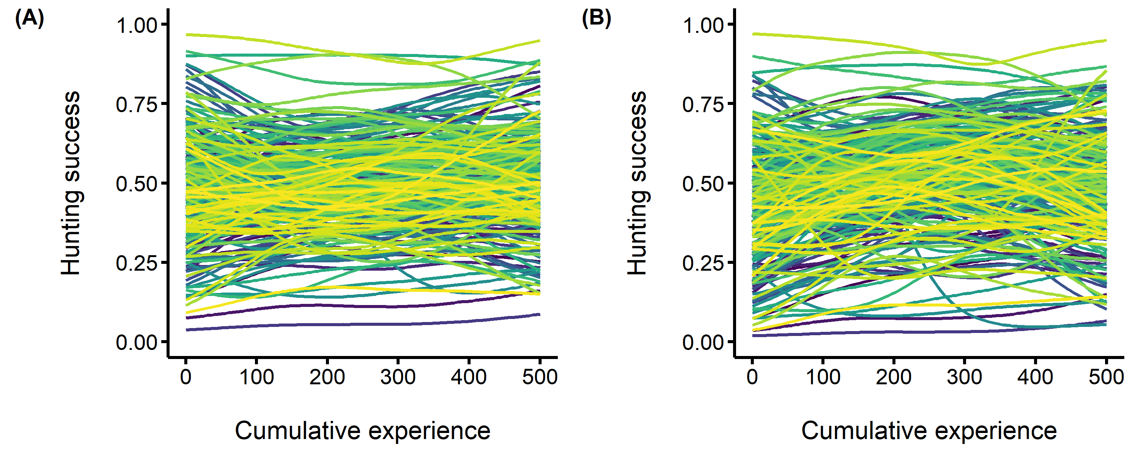

**Figure 1.** Among individual differences in the development of hunting expertise. The predators’ hunting success (i.e. the probability of capturing the four prey) is on the y axis, and the predators’ cumulative experience (i.e. the number of matches played prior to each observation) is on the x axis. Each fitted curve represents an individual predator. (A) A generalized additive mixed model where we do not control for prey speed (B) A generalized additive model where we control for prey speed.

## Effect of experience on the development of behavioural specialization

Contrary to our predictions, we detected only minimal differences in movement speed among individual predators, and these differences did not change with experience (Figure 2A). However, individuals differed in their degree of flexibility, and these differences tended to increase, yet marginally, with experience (Figure 2B). Overall, individual predators appeared to have encountered prey with similar average speeds (Figure 2A), and our results do not support our prediction that predators would encounter prey with varying levels of speed (Figure 2B).

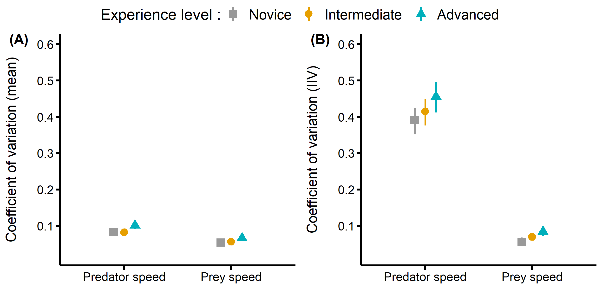

**Figure 2.** Coefficient of variation for the predator’s speed and for the speed of the prey encountered at each level of experience. (A) Coefficient of variation of the among individual differences in average behaviour. (B) Coefficient fo variation of the among individual differences in intra individual variance (i.e. specialization).

We predicted that, with experience, predators would become either increasingly flexible, or, more specialized. Here, we found that predators became generally more flexible with experience, but this increase in flexibility was only minimal (Figure 3 A and B). Thus we cannot conclude that experience had an important effect on behavioural specialization. Yet, as we have outlined in Figure 2, it appears that among individual differences in specialization increase when individuals are advanced compared to when they are novice (Figure 3 A and B).

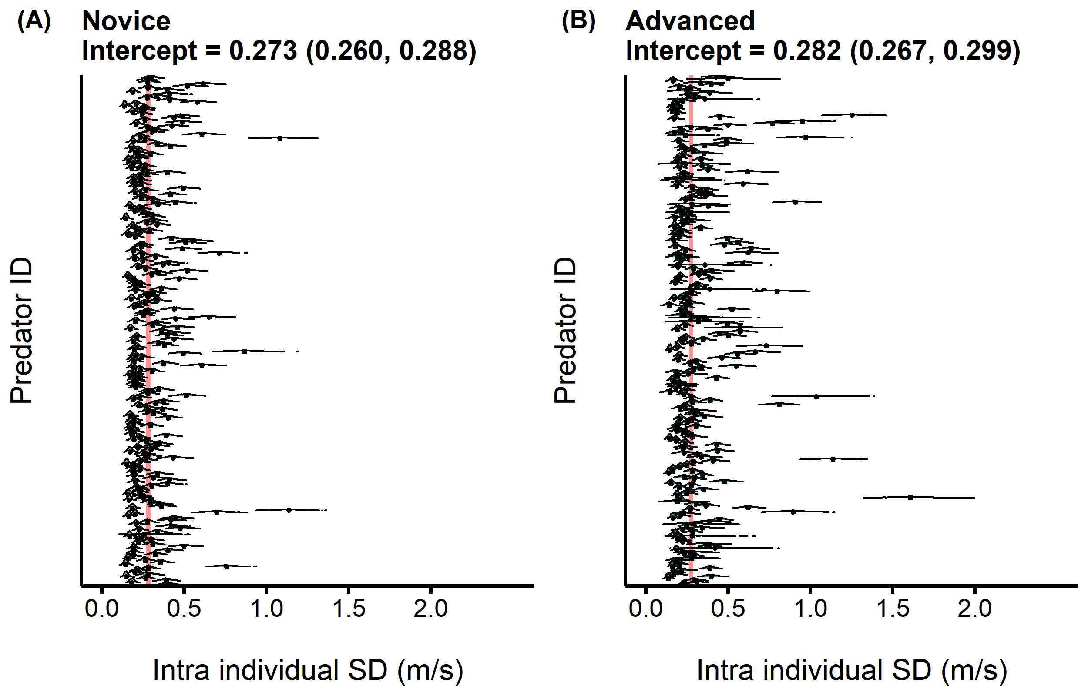

**Figure 3.** Distribution of the intra individual behavioural variation (i.e. specialization) of predators when they were (A) novices and then (B) advanced hunters. The red band displays the 95% CI of the intercept for the intra individual standard deviation in predator speed.

## Relationship between behavioural specialization and prey variability

At all experience levels, predators that were on average faster were also travelling faster in all their matches (i.e. they were more specialized at travelling fast). Thus, slower predators were also more flexible in their movement through time (Figure 4). This pattern became stronger as predators gained experience (Figure 4). In general, predators tended to be faster and also more specialized in this strategy when they encountered prey that were on average faster (Figure 4). Moreover, predators favored and specialized in a faster foraging mode when encounters with prey were more predictable, and these relationships also became stronger with experience (Figure 4).

The foraging strategies of predators, that is, the correlations between the mean and variance of speed, remained structurally stable among the levels of experience. For instance, novice predators that tended to be faster also kept this strategy as they gained experience (Figure 4 inside the black squares). Overall, we detected the same patterns for within-experience state correlations. The correlations between trait values were also stronger among novice-intermediate and intermediate-advanced states than between novice-advanced states, indicating that behavioural changes in predators occurred as they gained experience.

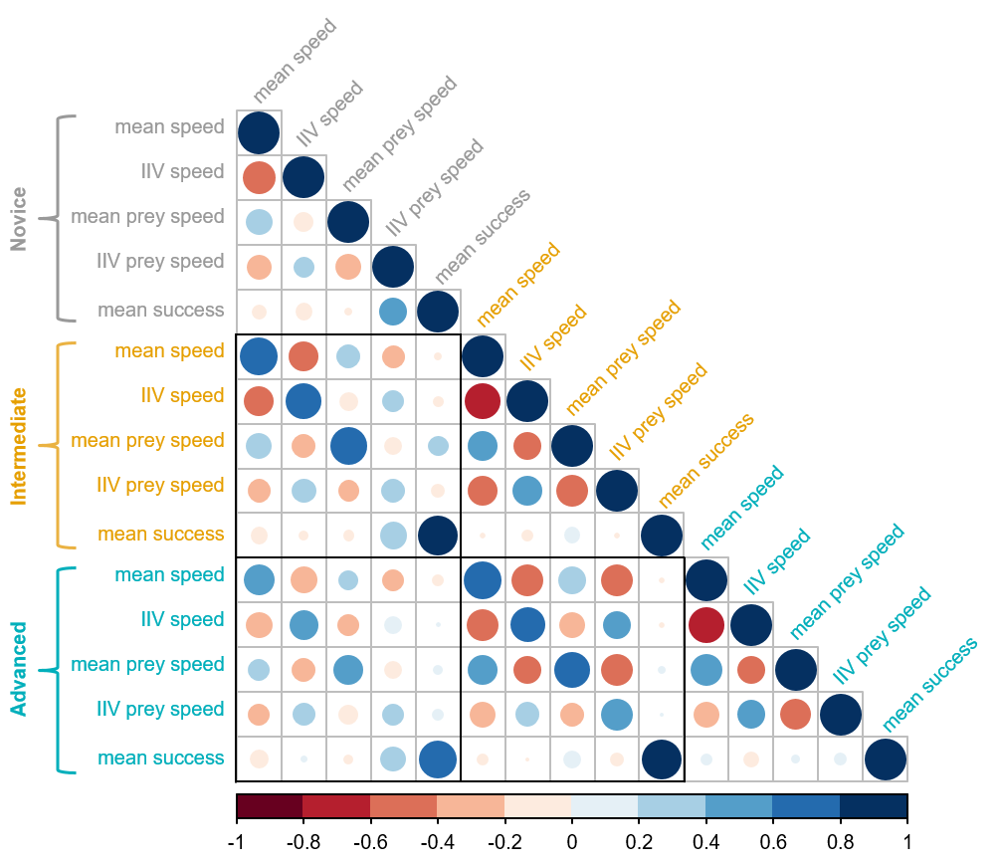

**Figure 4.** Full correlation matrix of the MDHGLM relating the mean and IIV speed of the predators, the mean and IIV in speed of the prey they encountered, and mean hunting success. Starting from the upper part of the plot are displayed the five parameters for novice predators (gray), the five for intermediate predators (yellow), and the five for advanced predators (blue). Larger dark blue circles indicate stronger positive correlations, while larger dark red circles indicate stronger negative correlations. The black squares indicate correlations between different experience levels (i.e. character states).

## Hunting success of behavioural specialists vs generalists

We did not detect significant relationships between the predators’ average nor intra individual variation in speed and hunting success (Figure 4), indicating that both slow/flexible and fast/specialist predators were both equally successful. However, when predators were novice, there was a strong positive correlation between the variation in prey that they encountered and their hunting success. Hence, novice individuals that experienced more unpredictable prey encounters at this stage were also more successful. This relationship was decoupled at the later experience levels, such that unpredictable encounters at intermediate and advanced stages were not associated with hunting success anymore.

# LITTERATURE CITED

Araújo, M.S., Bolnick, D.I. & Layman, C.A. (2011). [The ecological causes of individual specialisation](https://doi.org/10.1111/j.1461-0248.2011.01662.x). *Ecology Letters*, 14, 948–958.

Beauchamp, G. (2020). [Predator attack patterns influence vigilance in a virtual experiment](https://doi.org/10.1007/s00265-020-02833-0). *Behavioral Ecology and Sociobiology*, 74, 49.

Bürkner, P.-C. (2017). [Brms: An R Package for Bayesian Multilevel Models Using Stan](https://doi.org/10.18637/jss.v080.i01). *Journal of Statistical Software*, 80, 1–28.

Céré, J., Montiglio, P.-O. & Kelly, C.D. (2021). [Indirect effect of familiarity on survival: A path analysis on video game data](https://doi.org/10.1016/j.anbehav.2021.06.010). *Animal Behaviour*, 181, 105–116.

Chang, C., Teo, H.Y., Norma-Rashid, Y. & Li, D. (2017). [Predator personality and prey behavioural predictability jointly determine foraging performance](https://doi.org/10.1038/srep40734). *Scientific Reports*, 7, 40734.

Cleasby, I.R., Nakagawa, S. & Schielzeth, H. (2015). [Quantifying the predictability of behaviour: Statistical approaches for the study of between-individual variation in the within-individual variance](https://doi.org/10.1111/2041-210X.12281). *Methods in Ecology and Evolution*, 6, 27–37.

Courbin, N., Besnard, A., Péron, C., Saraux, C., Fort, J., Perret, S., *et al.* (2018). [Short-term prey field lability constrains individual specialisation in resource selection and foraging site fidelity in a marine predator](https://doi.org/10.1111/ele.12970). *Ecology Letters*, 21, 1043–1054.

Davoren, G.K., Montevecchi, W.A. & Anderson, J.T. (2003). [Search Strategies of a Pursuit-Diving Marine Bird and the Persistence of Prey Patches](https://doi.org/10.1890/02-0208). *Ecological Monographs*, 73, 463–481.

Dingemanse, N.J., Hertel, A.G. & Royauté, R. (2022). [Moving away from repeatability: A comment on Stuber et al.](https://doi.org/10.1093/beheco/arac006) *Behavioral Ecology*, 33, 488–489.

Dukas, R. (1998). Evolutionary ecology of learning. In: *Cognitive ecology: The evolutionary ecology of information processing and decision making*. University of Chicago Press, Chicago, pp. 129–174.

Dukas, R. (2019). [Animal expertise: Mechanisms, ecology and evolution](https://doi.org/10.1016/j.anbehav.2018.05.010). *Animal Behaviour*, 147, 199–210.

Edwards, G.B. & Jackson, R.R. (1994). [The role of experience in the development of predatory behaviour in Phidippus regius, a jumping spider (Araneae, Salticidae) from Florida](https://doi.org/10.1080/03014223.1994.9517994). *New Zealand Journal of Zoology*, 21, 269–277.

Estes, J.A., Riedman, M.L., Staedler, M.M., Tinker, M.T. & Lyon, B.E. (2003). [Individual variation in prey selection by sea otters: Patterns, causes and implications](https://doi.org/10.1046/j.1365-2656.2003.00690.x). *Journal of Animal Ecology*, 72, 144–155.

Fraser Franco, M., Santostefano, F., Kelly, C.D. & Montiglio, P.-O. (2022). [Studying predator foraging mode and hunting success at the individual level with an online videogame](https://doi.org/10.1093/beheco/arac063). *Behavioral Ecology*, 33, 967–978.

Gabry, J. & Češnovar, R. (2021). Cmdstanr: R Interface to "CmdStan".

Griffen, B.D., Toscano, B.J. & Gatto, J. (2012). [The role of individual behavior type in mediating indirect interactions](https://doi.org/10.1890/11-2153.1). *Ecology*, 93, 1935–1943.

Heithaus, M.R., Dill, L.M. & Kiszka, J.J. (2018). [Feeding strategies and tactics](https://doi.org/10.1016/B978-0-12-804327-1.00126-6). In: *Encyclopedia of Marine Mammals (Third Edition)* (eds. Würsig, B., Thewissen, J.G.M. & Kovacs, K.M.). Academic Press, pp. 354–363.

Holm, M.W., Rodríguez-Torres, R., Hansen, B.W. & Almeda, R. (2019). [Influence of behavioral plasticity and foraging strategy on starvation tolerance of planktonic copepods](https://doi.org/10.1016/j.jembe.2018.11.002). *Journal of Experimental Marine Biology and Ecology*, 511, 19–27.

Holtmann, B., Lagisz, M. & Nakagawa, S. (2017). [Metabolic rates, and not hormone levels, are a likely mediator of between-individual differences in behaviour: A meta-analysis](https://doi.org/10.1111/1365-2435.12779). *Functional Ecology*, 31, 685–696.

Huey, R.B. & Pianka, E.R. (1981). [Ecological consequences of foraging mode](https://doi.org/10.2307/1936998). *Ecology*, 62, 991–999.

Ishii, Y. & Shimada, M. (2010). [The effect of learning and search images on predator-prey interactions](https://doi.org/10.1007/s10144-009-0185-x). *Population Ecology*, 52, 27.

Karkarey, R., Alcoverro, T., Kumar, S. & Arthur, R. (2017). [Coping with catastrophe: Foraging plasticity enables a benthic predator to survive in rapidly degrading coral reefs](https://doi.org/10.1016/j.anbehav.2017.07.010). *Animal Behaviour*, 131, 13–22.

Kernaléguen, L., Arnould, J.P.Y., Guinet, C. & Cherel, Y. (2015). [Determinants of individual foraging specialization in large marine vertebrates, the Antarctic and subantarctic fur seals](https://doi.org/10.1111/1365-2656.12347). *Journal of Animal Ecology*, 84, 1081–1091.

Kobler, A., Klefoth, T., Mehner, T. & Arlinghaus, R. (2009). [Coexistence of behavioural types in an aquatic top predator: A response to resource limitation?](https://doi.org/10.1007/s00442-009-1415-9) *Oecologia*, 161, 837–847.

Lee, Y. & Nelder, J.A. (2006). [Double hierarchical generalized linear models (with discussion)](https://doi.org/10.1111/j.1467-9876.2006.00538.x). *Journal of the Royal Statistical Society: Series C (Applied Statistics)*, 55, 139–185.

MacDonald, K. (2007). [Cross-cultural Comparison of Learning in Human Hunting](https://doi.org/10.1007/s12110-007-9019-8). *Human Nature*, 18, 386–402.

Manlick, P.J., Maldonado, K. & Newsome, S.D. (2021). [Competition shapes individual foraging and survival in a desert rodent ensemble](https://doi.org/10.1111/1365-2656.13583). *Journal of Animal Ecology*, 90, 2806–2818.

Matsumura, K. & Miyatake, T. (2022). [Effects of individual differences in the locomotor activity of assassin bugs on predatorprey interactions](https://doi.org/10.1111/eth.13272). *Ethology*, 128, 395–401.

Mery, F. & Burns, J.G. (2010). [Behavioural plasticity: An interaction between evolution and experience](https://doi.org/10.1007/s10682-009-9336-y). *Evolutionary Ecology*, 24, 571–583.

Michalko, R., Gibbons, A.T., Goodacre, S.L. & Pekár, S. (2021). [Foraging aggressiveness determines trophic niche in a generalist biological control species](https://doi.org/10.1093/beheco/araa123). *Behavioral Ecology*, 32, 257–264.

Michalko, R. & Pekár, S. (2016). [Different hunting strategies of generalist predators result in functional differences](https://doi.org/10.1007/s00442-016-3631-4). *Oecologia*, 181, 1187–1197.

Mitchell, D.J., Fanson, B.G., Beckmann, C. & Biro, P.A. (2016). [Towards powerful experimental and statistical approaches to study intraindividual variability in labile traits](https://doi.org/10.1098/rsos.160352). *Royal Society Open Science*, 3, 160352.

Moran, N.P., Wong, B.B.M. & Thompson, R.M. (2017). [Weaving animal temperament into food webs: Implications for biodiversity](https://doi.org/10.1111/oik.03642). *Oikos*, 126, 917–930.

Morse, D.H. (2000). [The effect of experience on the hunting success of newly emerged spiderlings](https://doi.org/10.1006/anbe.2000.1546). *Animal Behaviour*, 60, 827–835.

O’Dea, R.E., Noble, D.W.A. & Nakagawa, S. (2022). [Unifying individual differences in personality, predictability and plasticity: A practical guide](https://doi.org/10.1111/2041-210X.13755). *Methods in Ecology and Evolution*, 13, 278–293.

Patrick, S.C. & Weimerskirch, H. (2014a). [Consistency pays: Sex differences and fitness consequences of behavioural specialization in a wide-ranging seabird](https://doi.org/10.1098/rsbl.2014.0630). *Biology Letters*, 10, 20140630.

Patrick, S.C. & Weimerskirch, H. (2014b). [Personality, Foraging and Fitness Consequences in a Long Lived Seabird](https://doi.org/10.1371/journal.pone.0087269). *PLOS ONE*, 9, e87269.

Paull, J.S., Martin, R.A. & Pfennig, D.W. (2012). [Increased competition as a cost of specialization during the evolution of resource polymorphism](https://doi.org/10.1111/j.1095-8312.2012.01982.x). *Biological Journal of the Linnean Society*, 107, 845–853.

Pedersen, E.J., Miller, D.L., Simpson, G.L. & Ross, N. (2019). [Hierarchical generalized additive models in ecology: An introduction with mgcv](https://doi.org/10.7717/peerj.6876). *PeerJ*, 7, e6876.

Phillips, R.A., Lewis, S., González-Solís, J. & Daunt, F. (2017). [Causes and consequences of individual variability and specialization in foraging and migration strategies of seabirds](https://doi.org/10.3354/meps12217). *Marine Ecology Progress Series*, 578, 117–150.

Piironen, J. & Vehtari, A. (2017). [Comparison of Bayesian predictive methods for model selection](https://doi.org/10.1007/s11222-016-9649-y). *Statistics and Computing*, 27, 711–735.

Potier, S., Carpentier, A., Grémillet, D., Leroy, B. & Lescroël, A. (2015). [Individual repeatability of foraging behaviour in a marine predator, the great cormorant, Phalacrocorax carbo](https://doi.org/10.1016/j.anbehav.2015.02.008). *Animal Behaviour*, 103, 83–90.

Reid, A., Seebacher, F. & Ward, A. (2010). [Learning to hunt: The role of experience in predator success](https://doi.org/10.1163/000579509X12512871386137). *Behaviour*, 147, 223–233.

Santoro, D., Hartley, S. & Lester, P.J. (2019). [Behaviourally specialized foragers are less efficient and live shorter lives than generalists in wasp colonies](https://doi.org/10.1038/s41598-019-41791-0). *Scientific Reports*, 9, 5366.

Snell-Rood, E.C. (2013). [An overview of the evolutionary causes and consequences of behavioural plasticity](https://doi.org/10.1016/j.anbehav.2012.12.031). *Animal Behaviour*, Including Special Section: Behavioural Plasticity and Evolution, 85, 1004–1011.

Tinker, M.T., Bentall, G. & Estes, J.A. (2008). [Food limitation leads to behavioral diversification and dietary specialization in sea otters](https://doi.org/10.1073/pnas.0709263105). *Proceedings of the National Academy of Sciences*, 105, 560–565.

Tinker, M.T., Mangel, M. & Estes, J.A. (2009). Learning to be different: Acquired skills, social learning, frequency dependence, and environmental variation can cause behaviourally mediated foraging specializations. *Evolutionary Ecology Research*, 11, 841–869.

Toscano, B.J., Gownaris, N.J., Heerhartz, S.M. & Monaco, C.J. (2016). [Personality, foraging behavior and specialization: Integrating behavioral and food web ecology at the individual level](https://doi.org/10.1007/s00442-016-3648-8). *Oecologia*, 182, 55–69.

Toscano, B.J. & Griffen, B.D. (2014). [Trait-mediated functional responses: Predator behavioural type mediates prey consumption](https://doi.org/10.1111/1365-2656.12236). *Journal of Animal Ecology*, 83, 1469–1477.

van den Bosch, M., Baert, J.M., Müller, W., Lens, L. & Stienen, E.W.M. (2019). [Specialization reduces foraging effort and improves breeding performance in a generalist bird](https://doi.org/10.1093/beheco/arz016). *Behavioral Ecology*, 30, 792–800.

Vehtari, A., Gelman, A. & Gabry, J. (2017). [Practical Bayesian model evaluation using leave-one-out cross-validation and WAIC](https://doi.org/10.1007/s11222-016-9696-4). *Statistics and Computing*, 27, 1413–1432.

Vehtari, A., Simpson, D., Gelman, A., Yao, Y. & Gabry, J. (2022). [Pareto Smoothed Importance Sampling](https://doi.org/10.48550/arXiv.1507.02646).

Via, S., Gomulkiewicz, R., De Jong, G., Scheiner, S.M., Schlichting, C.D. & Van Tienderen, P.H. (1995). [Adaptive phenotypic plasticity: Consensus and controversy](https://doi.org/10.1016/S0169-5347(00)89061-8). *Trends in Ecology & Evolution*, 10, 212–217.

Via, S. & Lande, R. (1985). [Genotype-Environment Interaction and the Evolution of Phenotypic Plasticity](https://doi.org/10.1111/j.1558-5646.1985.tb00391.x). *Evolution*, 39, 505–522.

Weimerskirch, H. (2007). [Are seabirds foraging for unpredictable resources?](https://doi.org/10.1016/j.dsr2.2006.11.013) *Deep Sea Research Part II: Topical Studies in Oceanography*, Bio-logging Science: Logging and Relaying Physical and Biological Data Using Animal-Attached Tags, 54, 211–223.

Westneat, D.F., Wright, J. & Dingemanse, N.J. (2014). [The biology hidden inside residual within-individual phenotypic variation](https://doi.org/10.1111/brv.12131). *Biological Reviews*, 90, 729–743.

Wilson-Rankin, E.E. (2015). [Level of experience modulates individual foraging strategies of an invasive predatory wasp](https://doi.org/10.1007/s00265-014-1861-1). *Behavioral Ecology and Sociobiology*, 69, 491–499.

Woo, K.J., Elliott, K.H., Davidson, M., Gaston, A.J. & Davoren, G.K. (2008). [Individual specialization in diet by a generalist marine predator reflects specialization in foraging behaviour](https://doi.org/10.1111/j.1365-2656.2008.01429.x). *Journal of Animal Ecology*, 77, 1082–1091.