Hunting experience shapes individual foraging specialization and predator-prey interactions in an online videogame

Journal name : Ecology

Manuscript type : article

Authors : Maxime Fraser Franco1, Francesca Santostefano1,2, Julien G. A. Martin3, Clint D. Kelly1, Pierre-Olivier Montiglio1

Affiliations : 1 Département des Sciences Biologiques, Université du Québec à Montréal, Montréal, QC, Canada. 2 Centre for Ecology and Conservation, Penryn Campus, University of Exeter, Cornwall, United Kingdom. 3 Department of Biology, University of Ottawa, Ottawa, ON, Canada.

Corresponding author : [fraser_franco.maxime@courrier.uqam.ca](mailto:fraser_franco.maxime@courrier.uqam.ca)

Open research statement : The data and code used to produce the results in this manuscript are freely available on GitHub <https://github.com/quantitative-ecologist/experience-hunting-tactics>

Keywords: foraging behaviour, individual specialization, learning, behavioural plasticity, prey predictability, online videogames

# ABSTRACT

# INTRODUCTION

Individual variation in predator foraging behaviour is increasingly recognized as a major driver of trophic interactions and community dynamics (Griffen et al. 2012, Michalko and Pekár 2016, Moran et al. 2017, Michalko et al. 2021). Indeed, predator populations often comprise assemblages of individuals specializing in different foraging tactics or resources irrespective of sexual, morphological, or age-related differences (Estes et al. 2003, Tinker et al. 2008, Kernaléguen et al. 2015, Phillips et al. 2017). A growing body of evidence suggests that ecological interactions, such as predator-prey interactions, can be major drivers of such individual foraging specialization (Araújo et al. 2011, Toscano et al. 2016). When they hunt, predators often use techniques that are fine-tuned to the type of prey that they encounter (Davoren et al. 2003, Estes et al. 2003, Woo et al. 2008, Courbin et al. 2018), and their capacity to use them effectively is contingent on periods of extensive practice (i.e. experience). While hunting experience may be essential to maintain or improve foraging success, we have limited empirical assessments of its role in predator foraging specialization (Dukas 2019), nor its consequences on predator-prey interactions.

The development of foraging tactics is crucial for young predators to reach adulthood and survive (Phillips et al. 2017, Heithaus et al. 2018). Theory predicts that foraging specialization may emerge via learning, limitations in memorizing multiple complex hunting skills, and expertise (Tinker et al. 2009, Dukas 2019). Dukas (2019) defines expertise as the characteristics, skills, and knowledge allowing individuals with extensive experience to outperform novices on complex tasks. This body of work suggests that the development of expertise through extensive practice is an optimizing process that promotes foraging specialization. Empirical studies on human and non-human hunters show that experience optimizes the efficiency (e.g. search and handling times, return rates) of their foraging tactics potentially via associative images or reliance on prey and environmental cues (Edwards and Jackson 1994, Morse 2000, MacDonald 2007, Reid et al. 2010, Wilson-Rankin 2015). Such optimization may thus reinforce the use of the same tactic (i.e. specialization) if its success is constant each time a prey is encountered. It may also be costly to attempt different hunting tactics by trial and error when prey are scarce or highly unpredictable (Dukas 1998, Estes et al. 2003, Mery and Burns 2010). An alternative mechanism is that the costs/risks faced by hunters when switching foraging tactics may be offset by gaining experience and information on their prey, leading to increased individual foraging flexibility [Stephens (1993);Ishii and Shimada (2010);Mery and Burns (2010);[Kelley.Magurran2011;@Snell-Rood2013](mailto:Kelley.Magurran2011;@Snell-Rood2013)]. To develop proper responses to fluctuating resources, individuals would need to sample their environment broadly during an extensive period of time, followed by higher performance at later stages of development (reviewed in Snell-Rood 2013). However, individuals may differ in the challenges that they face during their lifetime, which could lead to both mechanisms operating at the same time within a predator population.

There is currently a lack of consensus on the fitness advantages of specialized vs flexible foraging. Importantly, we have limited information on the ecological contexts - except for competition - that favour specialization over flexibility. This is reflected in the literature showing contrasting results in the links between specialization and fitness. For instance, some studies report increasing benefits of specialization (Patrick and Weimerskirch 2014b, Pintor et al. 2014, van den Bosch et al. 2019), some report that flexible foraging has greater benefits (Paull et al. 2012, Manlick et al. 2021), and others find equal benefits depending on timescales (Woo et al. 2008, Potier et al. 2015). While quantifying the fitness consequences of specialization is a daunting task, in predator-prey systems, some clues indicate that fluctuations in the predictability of prey encounters throughout a predator’s lifetime may be a key factor (Weimerskirch 2007, Woo et al. 2008, Chang et al. 2017, Phillips et al. 2017, Courbin et al. 2018). The resource-predictability hypothesis argues that when resources are predictable, individual specialists should have higher delivery rates by reducing the energy and time required to search for and handle prey. In contrast, individual generalists should benefit when resources fluctuate, as fine adjustments to resources are key for a predator’s success and survival (Karkarey et al. 2017, Holm et al. 2019, Santoro et al. 2019). At the phenotypic interface, empirical evidence shows coevolutionary patterns of predator-prey phenotypic matching across space and time (Kishida et al. 2006, Hanifin et al. 2008, Reimche et al. 2020). However, we do not know how experience influences these interactions in systems where behavioural interactions between predators and prey are directly monitored. Thus, uncovering how learning mechanisms shape direct predator-prey interactions would enable researchers to better predict the behavioural decisions that predators take when they are hunting.

The integration of individual behavioural variation in the study of predator-prey interactions has gained traction in recent years, with empirical studies revealing important consequences for habitat use, functional responses, prey choice, and foraging rate (Kobler et al. 2009, Toscano and Griffen 2014, Patrick and Weimerskirch 2014a, Matsumura and Miyatake 2022). However, an important and recurring challenge impeding research on predator-prey behavioural interactions, at the individual level, is the need to collect data simultaneously on both the predator and prey. We recently demonstrated with behavioural data from an online predator-prey videogame that virtual systems can overcome this challenge and help uncovering the mechanisms that shape predator-prey interactions (Fraser Franco et al. 2022). For instance, we found that the classical locomotor crossover hypothesis (Huey and Pianka 1981) applied only for cursorial hunters (see also: Matsumura and Miyatake 2022), suggesting that virtual systems could be useful in identifying general ecological patterns, which might in turn help to advance the current gaps in predator-prey research. Other studies on virtual predator-prey systems show that predation regimes can drive individual variation in risk perception (Beauchamp 2020), that familiarity between prey has a positive indirect effect on survival (Céré et al. 2021), and that prey face contrasting natural and social selection regimes (Santostefano et al. in prep). Because virtual predator-prey systems generate large volumes of data on interacting players throughout their lifetime in the game, they offer the opportunity to tackle fundamental questions about the role of experience and prey behaviour on individual predator foraging specialization along with its potential fitness consequences.

In this study, we test how hunting experience shapes predator foraging specialization using individual behavioural data from players in the online videogame *Dead by Daylight* (*DBD*). *DBD* simulates a direct predator-prey interaction, where one predator player hunts four prey players in different virtual environments. The data grants a high degree of precision on the behavioural interaction, as the behaviour of both the predator and the four prey is monitored simultaneously in each trial. First, we investigate how predators develop their individual hunting expertise. We hypothesize that predators should differ in the development of their expertise, partly because they encounter varying levels of difficulty with the prey that they pursue. For example, a predator may face greater difficulty than other individuals if it more often encountered prey that were elusive (Fraser Franco et al. 2022). Second, we test the hypothesis that experience will shape foraging specialization. If experience reduces the costs of switching between hunting tactics, we predict that the predator population should become more flexible. Alternatively, if experience enables the refinement of the hunting tactics, then the predator population may instead specialize. Otherwise, if both mechanisms operate at the same time, then we should see no change with experience at the population level, but differences in specialization among individuals should increase. Third, we evaluate how predator foraging specialization emerges from behavioural interactions with prey. Whether predators specialize or not with experience should depend on the behaviour of their prey. We expect that predators that experienced more predictable encounters with their prey will specialize, while predators that experienced unpredictable encounters with their prey should adopt a flexible hunting strategy. If we detect such prey-dependent fine-tuning, then specialist and flexible hunters should attain equal success.

# MATERIALS AND METHODS

## Study system

*DBD* is a survival asymmetric multiplayer online game developed by Behaviour Interactive Inc. In this game, players can play as a predator or a prey. The objective of the predator is to hunt and capture the four prey across a virtual environment. The objective of the four prey is to forage for resources while avoiding the predator. The resources are in the form of power generators that, once they are all activated, will enable the prey to escape through one of two exit doors. The composition of the predator and prey group for a match is determined by a skill-based matchmaking algorithm. A match ends when the predator kills all the prey available (i.e. that have not escaped), or when the last remaining prey escapes the virtual environment. Each player, predator or prey, can choose an avatar with abilities that encourage specific play styles (e.g. bold vs cautious prey, or ambush vs roaming predator). During our study period, the game offered 23 predator avatars. The virtual environment where matches take place is composed of fixed and procedurally generated habitat components, such as vegetation, mazes, and buildings. Some of these environments are larger than others, with varying structural complexity. However, we have previously shown that predators display only minimal changes in behaviour and hunting success across the environments, probably due to a game feature enabling predators to have visual cues of the generators (Fraser Franco et al. 2022). There were 35 virtual game environments available for play during our study period.

In *DBD*, some individual predators specialize on hunting at high speeds and covering space in the environment, while others prefer to stalk and ambush their prey (Fraser Franco et al. 2022). Individuals are also flexible in the use of these tactics by switching between them across matches. The expression of these tactics and their success is also shaped by the behaviour of the prey group. The prey need to forage for resources while paying attention to the predator to avoid being detected and chased. Some prey contribute to the group’s success by healing or helping others escape the predator, while others play alone and attempt to escape by themselves (Céré et al. 2021). Predators must be wary of how the prey behave to choose the right way to capture them. Thus, *DBD* simulates a highly dynamic system where both predators and prey must constantly adjust to each other to be successful.

## Data collection

The videogame company provided data that spanned a period of 6 months of gameplay recorded for every player. The first recorded match was played on 2020-12-01, and the last one on 2021-06-01. We cleaned and filtered the raw data to produce a dataset appropriate for our analyses. We analyzed only matches where players did not know each other (i.e. “Online” mode). We filtered any matches where players were inactive, such as when speed values were equal to, or very close to, zero. Moreover, we used our knowledge of the game to remove any matches where players were potentially hacking, or not playing the game has it is supposed to be played. We then partitioned the player population by total experience, and sampled players that played 300 matches or more. To optimize the representation of gameplay experience at advanced levels, we set the maximum number of matches at 500 for these players. For instance, there could be a large difference in gameplay between 300-500 and 500-1000 matches. Players that played more than 500 matches represented ~2% of the population.

Our population consists of 253 predator players with a total record of 100 412 matches. The predator-players’ experience varied between 301 and 500 matches played. These matches lasted between 3 and 70 minutes (mean = 11 minutes). The following information is collected and reported for every match : the player’s anonymous ID, its avatar, the game environment, the predator-player’s experience along with its speed, and the average speed of the group of prey it encountered.

## Variables

We analyzed the predator’s average speed and the average speed of the prey encountered by the predator. The predator’s average speed is measured as the average distance traveled per second during a match ( = 3.31 ± 0.49). We measured the preys’ average speed as the average travel speed of the four individual prey within a match ( = 2.40 ± 0.32). We defined hunting success as the number of prey consumed during the match (min = 0, max = 4). Lastly, we defined the predator’s cumulative experience as the number of matches played prior to the match being monitored. For example, the first match of a player would have a cumulative experience value of 0, while the tenth match would have a value of 9.

## Statistical analyses

### Software and computer specifications

All our statistical analyses were executed on Cedar (<https://docs.alliancecan.ca/wiki/Cedar>), a computer cluster maintained by the Digital Research Alliance of Canada. The operating system for Cedar is CentOS Linux 7. The models were fitted in R (version 4.1.2) using Markov chain Monte Carlo (MCMC) sampling with the package “brms” version 2.16.3 (Bürkner 2017), an R front-end for the STAN software (Team 2023), and “cmdstanr” version 0.4.0 (Gabry and Češnovar 2021) as the back-end for estimation (cmdstan installation version 2.28.2).

### Effect of experience on hunting success

We tested whether predators varied in the development of their expertise using three Bayesian generalized additive mixed models (GAMM) with thin plate regression splines. These models estimate the relationship between hunting success (i.e. number of prey captured) and the predators’ cumulative experience (i.e. number of matches played before the current match). We parametrized the models following the method of Pedersen et al. (2019). The first model was the simplest, with a common global smoothing function for all observations and random intercepts for the predator ID. In this model, we assume that individuals have the same development of expertise, with the model estimating a trend for the average individual (i.e. global smoother). For the second model, we included varying group-level smoothers for the predator ID. In this model, we assume that individuals share a similar relationship between success and experience, but that this relationship can vary (e.g. individual 1 has a steeper curve than individual 2). This enabled us to test whether predators differed in the development of their expertise. In the third model, we kept the group-level smoothers for the predators, but removed the global smoother. This allows each individual to have a unique relationship between success and experience without penalization by the global smoother. Thus, this model assumes that predators do not share a common relationship between success and experience. We included match duration as a covariate in all three models.

Because a maximum of four prey can be captured in the game, and to control for overdispersion, we computed the three models using a modified version of the beta-binomial distribution implemented in “brms”. Thus, hunting success was estimated as the probability of capturing the four prey (), drawn from a Beta distribution () with mean () and precision () parameters. We used a logit link function to estimate where and is the linear predictor, while the precision parameter () was estimated with an identity link for all models.

We used the default number of basis functions (K) in “brms” for the models to estimate the relationship between hunting success and experience. We assumed that the random intercepts for the predator ID () followed a Gaussian distribution with estimated standard deviation (). We used Gaussian priors for the game duration (), the intercept (), and the precision paremeter (). We employed the default Student t priors for the smoothing parameter (). In all models, we specified four MCMC chains to estimate the parameters, with 1000 posterior samples for each parameter. To do so, we ran 2500 iterations for the first model with a thinning set to eight, and 1500 iterations with a thinning set to four for the second and third models; burn-in was set to 500 iterations in each model. We assessed the convergence of the MCMC chains using trace plots, R-hat diagnostics with a threshold of <1.05, and effective sample sizes (ESS) with a threshold of >100 for the bulk-ESS and tail-ESS (Vehtari et al. 2021). After fitting the three models, we proceeded to select the one with the best predictive accuracy using approximate leave-one-out cross-validation with Pareto-smoothed importance sampling (Piironen and Vehtari 2017, Vehtari et al. 2017, Vehtari et al. 2022).

### Foraging behaviour and success, prey behaviour, and their relationships, at each level of experience

We tested whether foraging behaviour changed with experience, and compared the success of generalists vs specialists, using a multivariate, double-hierarchical generalized linear model (MDHGLM) (Lee and Nelder 2006, Westneat et al. 2014, Cleasby et al. 2015, Mitchell et al. 2016, O’Dea et al. 2022). We categorized the predators by their experience based on the number of matches they played (i.e. their cumulative experience). We assigned the status of “novice” to any predator-player that had a cumulative experience below 100 matches. For example, a predator player that played 500 matches in total would be labelled as a novice in its first 100 matches. Following this logic, we labelled predators as “intermediate” hunters when they had a cumulative experience between 100 and 299 and matches. For the third and last group, we defined predators as “advanced” hunters when they had a cumulative experience equal or above 300, with a maximum of 499 cumulated matches.

For each level of experience (i.e. novice, intermediate, advanced), the model estimated the mean speed of every individual (which we call the mean part of the model), and, employing a heterogeneous structure of the residuals, the intra-individual standard deviation in speed of every individual (which we call the dispersion part of the model). Thus, in the mean part of the model, we could estimate among individual differences in the foraging tactic used by predators (i.e. fast or slow), while in the dispersion part of the model, we could estimate among individual differences in foraging specialization/flexibility (i.e. intra-individual variability). We followed the same structure for the preys’ speed to estimate among individual differences in the mean and standard deviation in speed of the prey encountered by predators. For hunting success, we only modeled the mean part of the equation to estimate among individual differences in mean hunting success. For the predator and the prey’s speed, we controlled for the average rank of the prey that they encountered on both the mean and dispersion part of the equation. The ranking system in *DBD* was implemented by the company to pair players in a match based on their skill (<https://deadbydaylight.fandom.com/wiki/Rank>). We used the mean rank of the four prey and applied a square-root transformation. For the predator’s hunting success, we controlled for the square-root of the duration of the match. The model has the following form, with each equation repeated three times (i.e. one for each level of experience) :

where , , and are the vectors of random environment, random avatar, and random individual identity effects associated with their incidence matrices , , and . is the vector of fixed effects with its incidence matrix . The and subscripts indicate that an estimate is from the mean or dispersion part of the model, respectively. We assumed that all random effects followed a Gaussian distribution with estimated standard deviation (, , and ). The parameters , , and , correspond to the among environment, among avatar, and among individual standard deviations, respectively. is the identity matrix, with indicating that the random effects are independently and identically distributed. Here, we assume that the residuals vary among individuals where , , and is a variance covariance matrix of the individual identity random effect.

We parameterized equations (1) and (2) with a Gaussian distribution family (predator and prey speed), and employed a beta-binomial distribution family for equation (3) (predator hunting success). We employed Gaussian priors for the prey rank () and game duration () on the mean part of the model, and the default priors in “brms” for the dispersion part. We used the default Student t priors in “brms” for the intercepts on the mean and dispersion part of the equation. For hunting success, we applied a Gaussian prior on the precision parameter (). For every predicted variable, we applied a half-Gaussian on the random effects for the mean part of the model (), and the default “brms” Student t prior for the dispersion part of the model. We parametrized the model to run four MCMC chains with 1000 posterior samples for each parameter. To do so, we ran 2500 iterations with a thinning set to 8, with the first 500 iterations used as warmups.

We estimated the correlation between the individual random effect on the mean and on the dispersion within each trait (e.g. ) and among each trait (e.g. ) within a level of experience. In the first case, this allows us to assess, for example, whether predators that are on average slower/faster are more specialized or flexible. In the second case, the correlations enables us to estimate, for example, whether predators that encountered prey that were faster/slower adopted a slower/faster (or more specialized/flexible) tactic, or if slower/faster predators had lower/greater hunting success. We also evaluated these correlations among the different levels of experience (e.g. ). The latter “character-state” approach (Via and Lande 1985, Via et al. 1995), enables us to investigate whether predators express similar behaviours across each developmental stage. The correlations were estimated assuming a multivariate Gaussian distribution. We additionally report variance partitioning and coefficients of variations in the supporting information.

# RESULTS

## Effect of experience on hunting success

Our results confirm that individual predators displayed substantial differences in the development of their expertise, as the best model was the one with group-level smoothers exclusively (Table I). For instance, with experience, some predators steadily increased their hunting success while others displayed a decrease in prey capture (Figure 1A-S1). Otherwise, there were players that maintained either a high or low success across their experience (Figure 1A). Another pattern that emerged was that some individuals optimized their success at an experience level that was below what we considered as “advanced” (i.e. >300 matches played).

**Table** : Leave-one-out cross-validation table of the three hierarchical GAMMs relating hunting success to player experience

| model | elpd  difference | sd  difference | elpd loo  value | elpd loo  standard error |
| --- | --- | --- | --- | --- |
| Group-level smoothers only | 0.00 | 0.00 | -146 338.37 | 166.96 |
| Global smoother + group-level smoothers | -101.47 | 6.28 | -146 439.84 | 167.21 |
| Global smoother only | -840.42 | 42.67 | -147 178.79 | 163.31 |
| * 'elpd' refers to the 'expected log pointwise density' and is the value chosen to select the best model. | | | | |

We predicted that the relationship between hunting success and experience would vary among predators because they should differ in the type of prey that they encounter. However, after controlling for prey speed, we did not find evidence confirming our hypothesis, such that differences among predators in the relationship between hunting success and experience remained stable (Figure 1B).

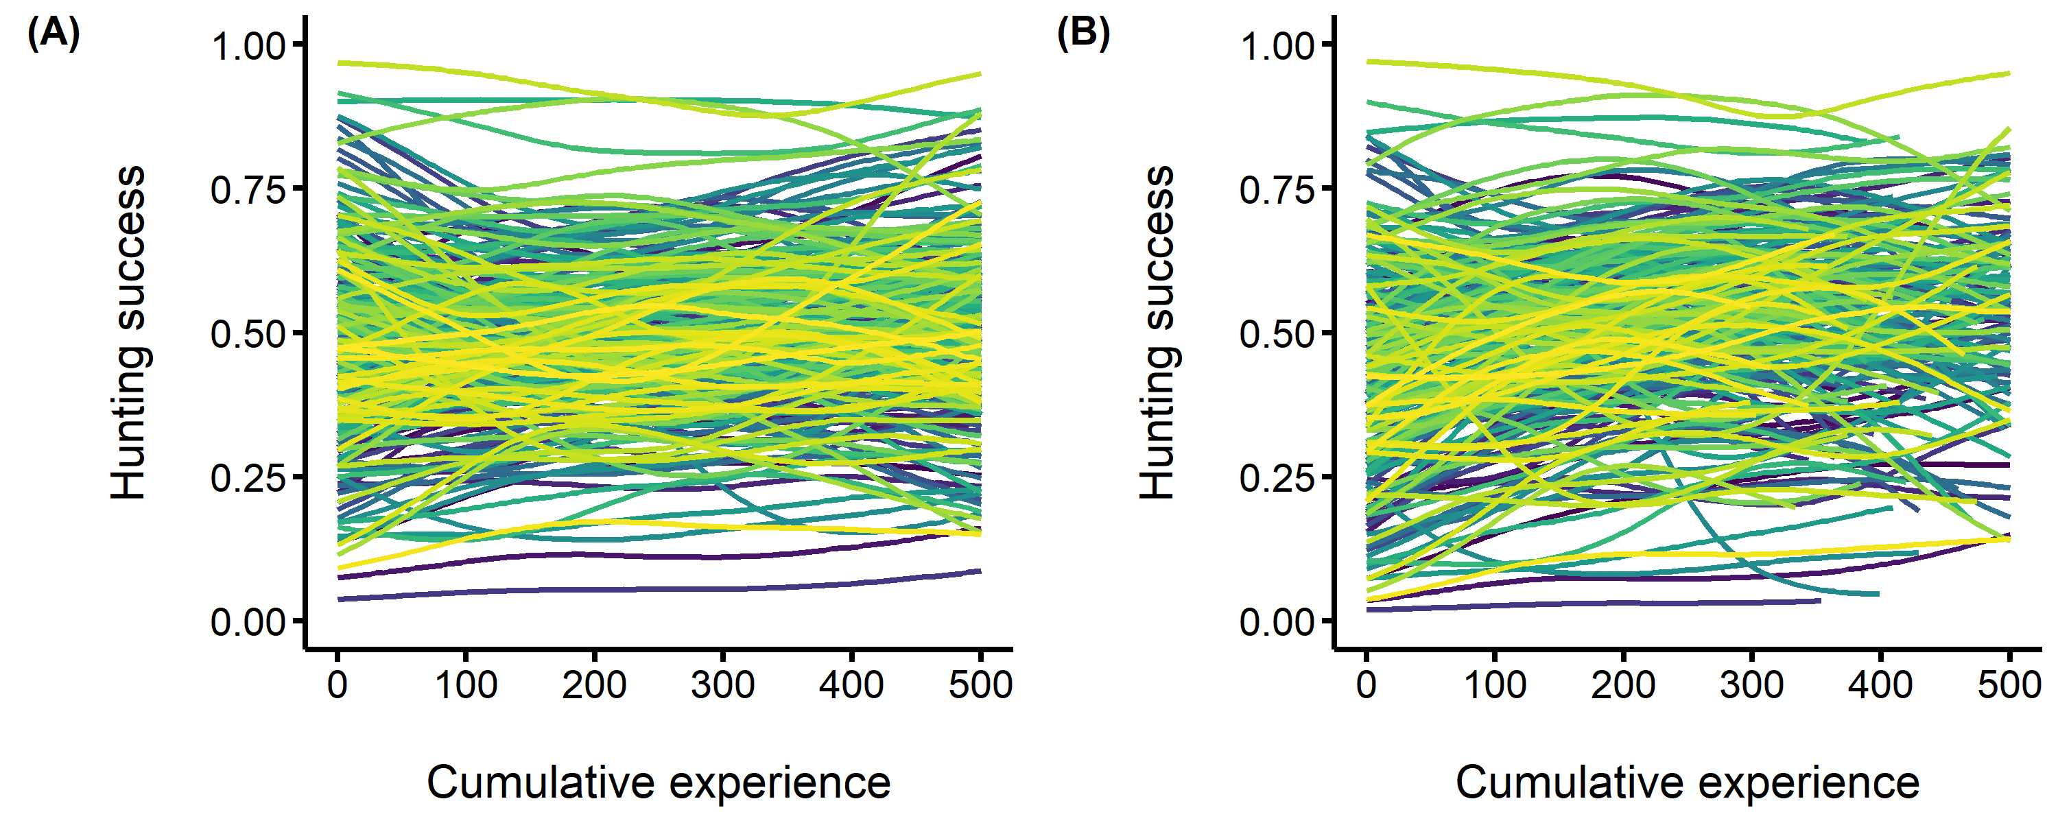

**Figure 1.** Among individual differences in the development of hunting expertise. The predators’ hunting success (i.e. the probability of capturing the four prey) is on the y axis, and the predators’ cumulative experience (i.e. the number of matches played prior to each observation) is on the x axis. Each fitted curve represents an individual predator. (A) A generalized additive mixed model where we do not control for prey speed (B) A generalized additive model where we control for prey speed.

## Effect of experience on the development of behavioural specialization

At the population level, we predicted that with experience, predators would become either increasingly flexible or specialized. However, our results do not support our prediction, as the pattern was more complex. In the dispersion part of the model (i.e. sigma predator speed), we indeed found that predators became more flexible with experience at the intermediate stage (, Table 2 and Figure S4). However, when they became advanced hunters, they expressed a similar level of flexibility to when they were novices (, Table 2 and Figure S4). Thus, instead of increasing linearly, our results suggest that population-level behavioural specialization changed in a nonlinear (quadratic) fashion with experience.

At the individual level, we detected differences in the average movement speed among predators (, Table 2). These differences remained stable (although they decreased minimally) at the intermediate stage (Table 2 and Figure S4), and increased at the advanced stage to a level higher than when predators were novice (Table 2 and Figure S4). For the dispersion part of the model (i.e. sigma predator speed), predators displayed considerable differences in their degree of hunting specialization, which also increased with experience (, Table 2 and Figure S4). Thus, the predator population is composed of both specialist and flexible moving individuals, and they further distinguish themselves as specialist/flexible hunters as they gain experience (Figure 2).

**Table** : Posterior mean estimates and their 95% credible intervals computed from the MDHGLM of predator speed, prey speed, and predator hunting success.

| Trait | Parameter | Novice | Intermediate | Advanced |
| --- | --- | --- | --- | --- |
| *Fixed effects* |  |  |  |  |
| mean predator speed | intercept | 3.392 ( 3.283, 3.511) | 3.387 ( 3.231, 3.559) | 3.388 ( 3.242, 3.546) |
| mean predator speed | mean prey rank | -0.030 (-0.036, -0.024) | -0.037 (-0.042, -0.033) | -0.045 (-0.052, -0.039) |
| sigma predator speed | intercept | 0.292 ( 0.271, 0.315) | 0.326 ( 0.307, 0.347) | 0.289 ( 0.268, 0.311) |
| sigma predator speed | mean prey rank | 0.986 ( 0.969, 1.004) | 0.967 ( 0.953, 0.980) | 0.994 ( 0.978, 1.013) |
| mean prey speed | intercept | 2.948 ( 2.909, 2.986) | 2.899 ( 2.864, 2.933) | 2.837 ( 2.799, 2.873) |
| mean prey speed | mean prey rank | -0.181 (-0.188, -0.174) | -0.171 (-0.176, -0.166) | -0.163 (-0.169, -0.156) |
| sigma prey speed | intercept | 0.200 ( 0.189, 0.212) | 0.201 ( 0.194, 0.209) | 0.208 ( 0.199, 0.217) |
| sigma prey speed | mean prey rank | 1.116 ( 1.097, 1.134) | 1.116 ( 1.102, 1.131) | 1.107 ( 1.089, 1.124) |
| mean success | intercept | 0.018 ( 0.015, 0.021) | 0.017 ( 0.015, 0.019) | 0.018 ( 0.016, 0.021) |
| mean success | match duration | 0.539 ( 0.537, 0.540) | 0.540 ( 0.539, 0.541) | 0.540 ( 0.538, 0.541) |
| *Random effects* |  |  |  |  |
| mean predator speed | SD avatar ID | 0.307 (0.229, 0.407) | 0.366 (0.262, 0.487) | 0.370 (0.270, 0.487) |
| mean predator speed | SD environment ID | 0.024 (0.019, 0.031) | 0.027 (0.020, 0.033) | 0.027 (0.021, 0.034) |
| mean predator speed | SD predator ID | 0.158 (0.143, 0.172) | 0.154 (0.138, 0.166) | 0.194 (0.175, 0.213) |
| sigma predator speed | SD predator ID | 1.486 (1.440, 1.536) | 1.521 (1.468, 1.573) | 1.587 (1.525, 1.649) |
| mean prey speed | SD avatar ID | 0.052 (0.036, 0.069) | 0.062 (0.044, 0.084) | 0.062 (0.045, 0.080) |
| mean prey speed | SD environment ID | 0.057 (0.043, 0.072) | 0.055 (0.042, 0.070) | 0.054 (0.042, 0.069) |
| mean prey speed | SD predator ID | 0.090 (0.081, 0.098) | 0.082 (0.075, 0.089) | 0.109 (0.098, 0.119) |
| sigma prey speed | SD predator ID | 1.058 (1.044, 1.070) | 1.083 (1.073, 1.093) | 1.102 (1.088, 1.116) |
| mean success | SD predator ID | 0.724 (0.660, 0.786) | 0.575 (0.528, 0.622) | 0.601 (0.547, 0.655) |
| * We applied the exponent to the parameter values for sigma (intercepts and predator ID), estimated on a log scale, such that values are mean posterior standard deviations (SD). We back-transformed the hunting success values, estimated on a logit scale, back to a probability scale. | | | | |

As we predicted, predators differed in the speed of the prey that they encountered. Thus, some individuals encountered prey that were on average slower, while others encountered prey that where on average faster throughout the study period (, Table 2). These differences were greater when predators reached an advanced level of hunting experience (Table 2 and Figure S4). In addition, individuals experienced largely distinct degrees of variability among their encounters with the prey (, Table 2). Hence, some predators experienced stable/predictable encounters with their prey, while others experienced unstable/unpredictable encounters with their prey throughout the study period.

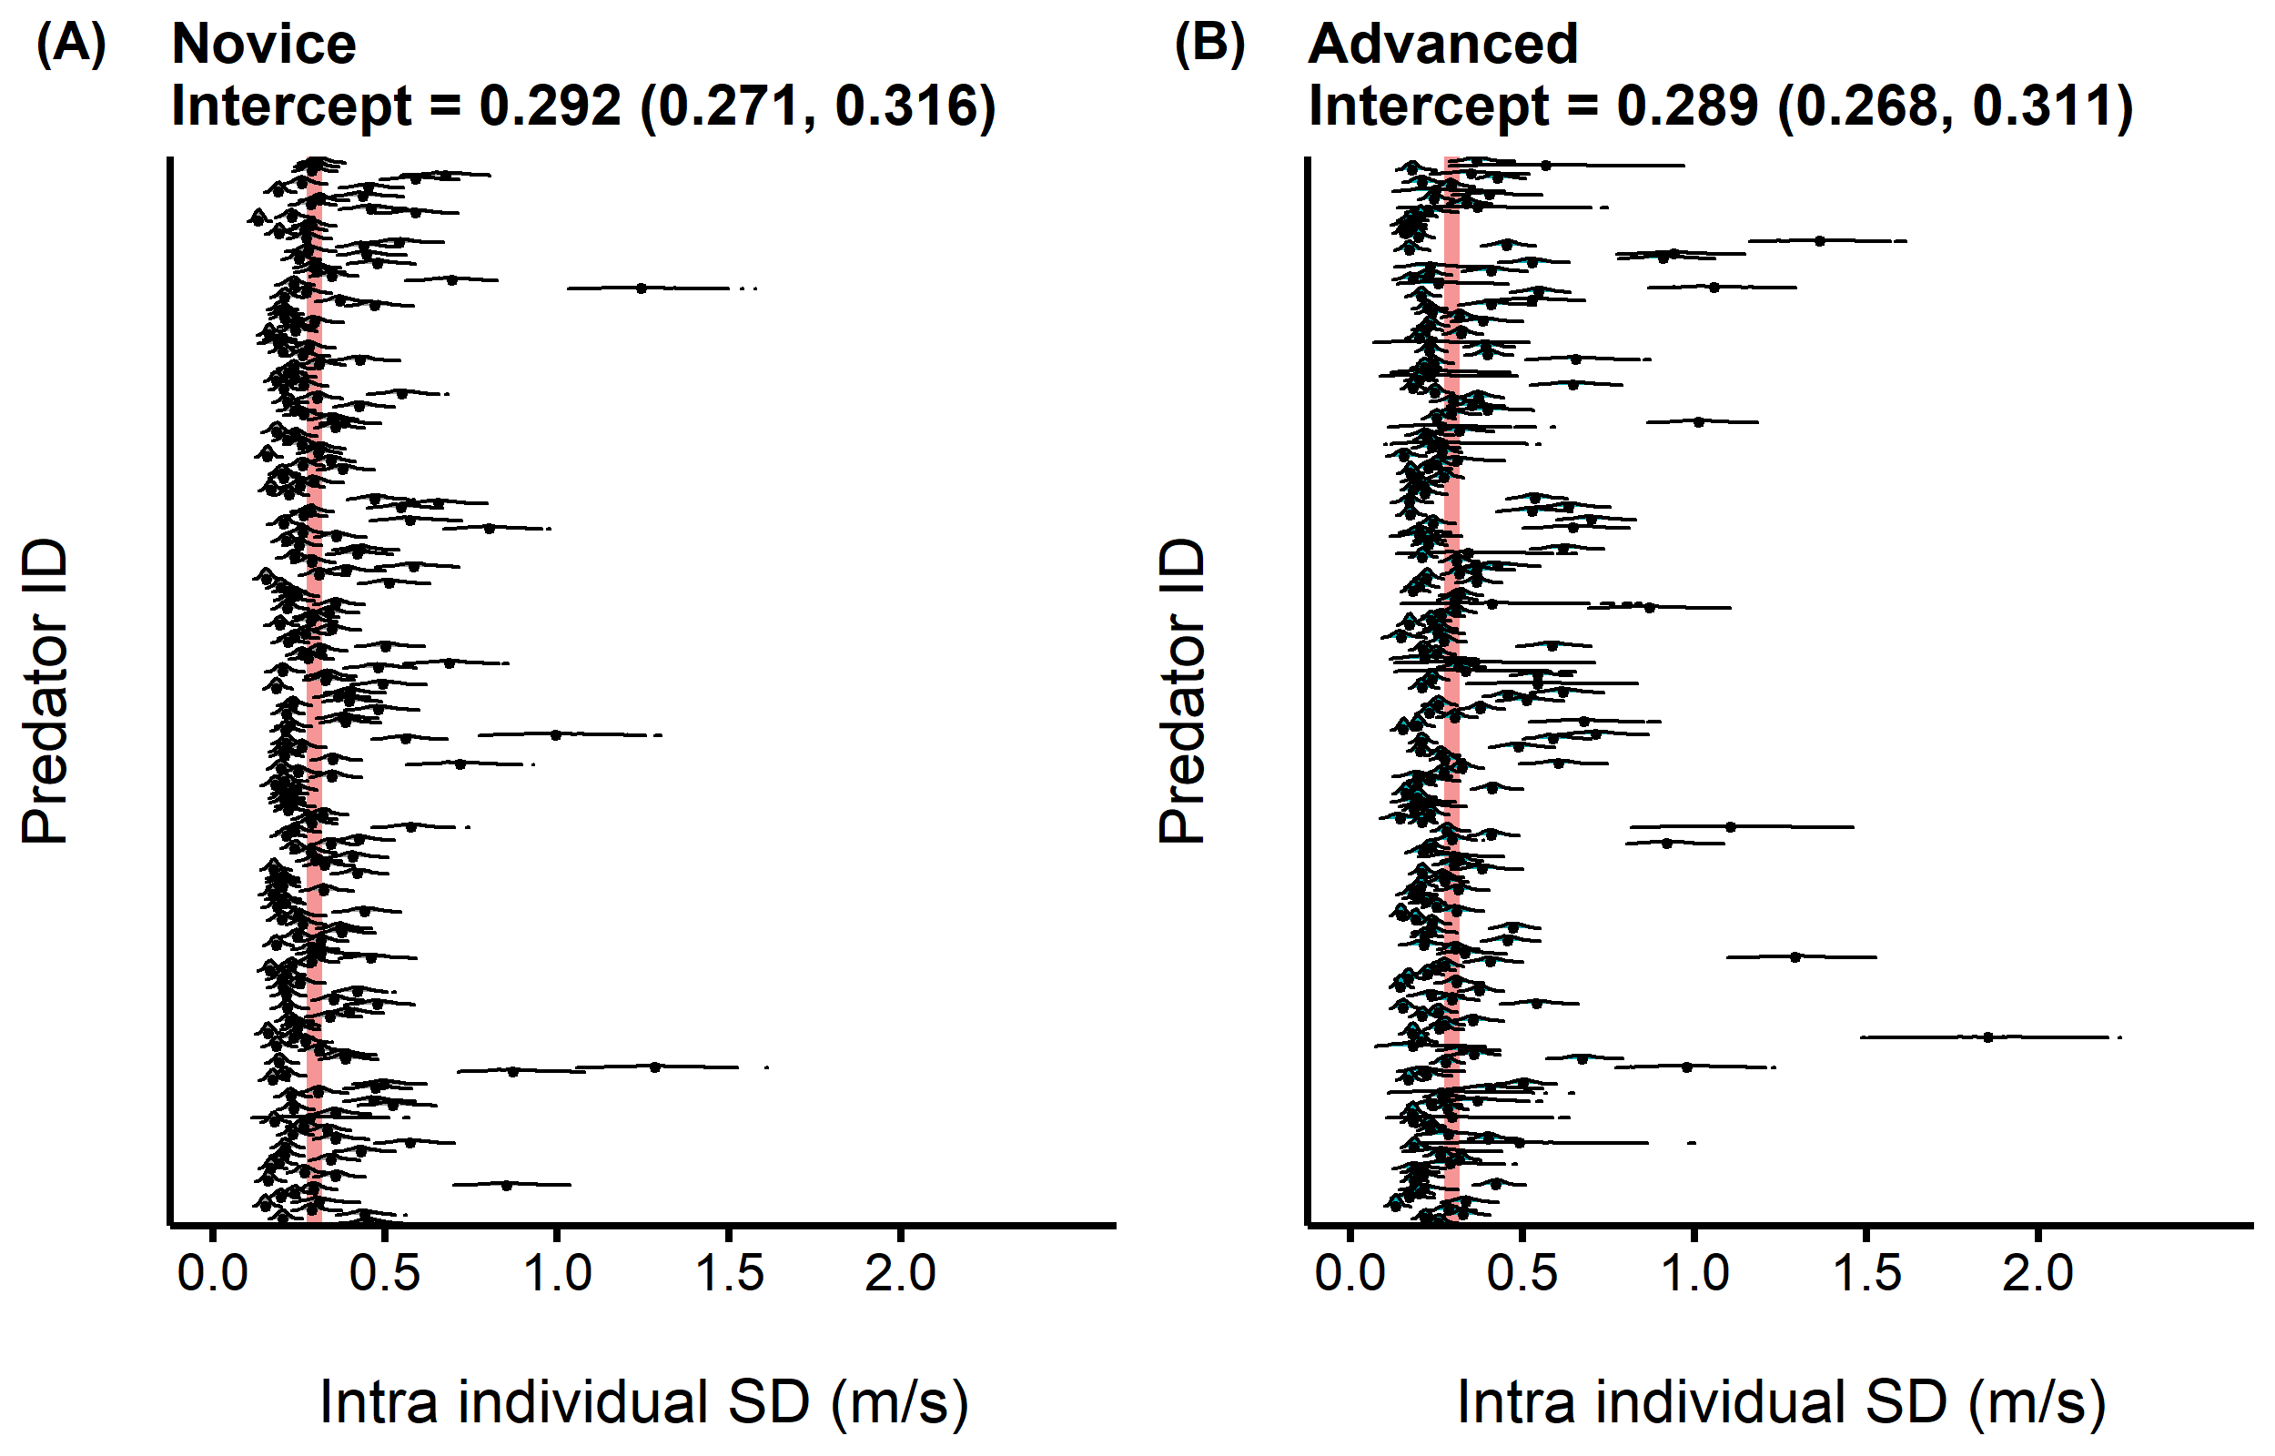

**Figure 2.** Distribution of the intra individual behavioural variation (i.e. specialization) of predators when they were (A) novices and then (B) advanced hunters. The red band displays the 95% CI of the intercept for the intra individual standard deviation in predator speed.

## Relationship between behavioural specialization and prey variability

At all experience levels, predators that were on average faster (mean) had also a lower intra-individual variability (IIV) across their matches (Figure 3 and Table S1). Thus, faster predators specialized at travelling fast, while slower predators were more flexible in their movement through time. In general, predators that encountered prey that were on average faster (mean) tended to be faster (mean) (Figure 3 and Table S1). At the three experience levels, there were only weak correlations between predator IIV and mean prey speed (Figure 3 and Table S1). However, predators that experienced more predictable encounters with their prey (IIV) specialized in a faster hunting tactic (IIV) (Figure 3 and Table S1). For all the results described above, the correlations became stronger as predators gained experience (Figure 3 and Table S1).

The foraging strategies of predators, that is, the correlations between the mean and IIV of speed, remained structurally stable among the levels of experience (Figure 3 inside the black circles and Table S1). For instance, novice predators that tended to be faster also kept this strategy as they gained experience (Figure 3 inside the black squares and Table S1). Overall, we detected the same patterns than those from the within-experience state correlations described above. The correlations between trait values were also stronger among novice-intermediate and intermediate-advanced states than between novice-advanced states, indicating that the behavioural tactics of predators were more similar among experience levels closer in time (Figure 3 inside the black circles and Table S1).

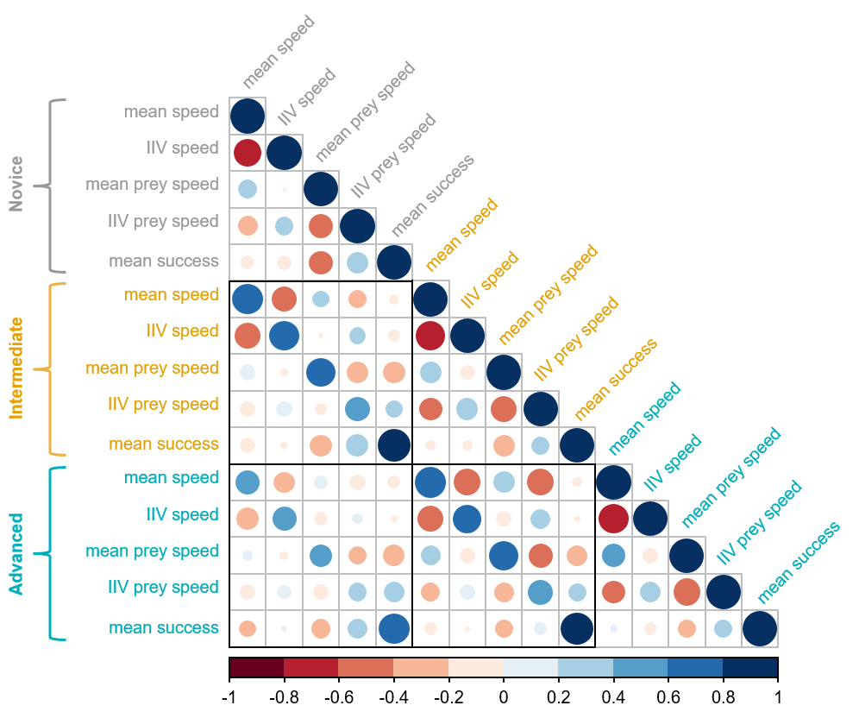

**Figure 3.** Full correlation matrix of the MDHGLM relating the mean and intra individual variability (IIV) in speed of the predators, the mean and IIV in speed of the prey they encountered, and mean hunting success. Starting from the upper part of the plot are displayed the five parameters for novice predators (gray), the five for intermediate predators (yellow), and the five for advanced predators (blue). Larger dark blue circles indicate stronger positive correlations, while larger dark red circles indicate stronger negative correlations. The black squares indicate correlations between different experience levels (i.e. character states).

## Hunting success of behavioural specialists vs generalists

We did not detect strong correlations between the predators’ average speed and their hunting success (Figure 3 and Table S1), nor between the predators’ IIV in speed and their hunting success (Figure 3 and Table S1), suggesting that both slower/flexible and faster/specialist predators were both equally successful. However, when predators were novice, there was a strong negative correlation between the average speed of the prey that they encountered and their hunting success (Figure 3 and Table S1). Hence, novice individuals that encountered faster prey were less successful. This relationship was decoupled at the later experience levels, such that encounters with faster prey at intermediate and advanced stages were not as strongly correlated with hunting success anymore (Figure 3 and Table S1).

# Discussion

Hunting experience is predicted to imbue an increase in predator foraging specialization when resources are predictable (Estes et al. 2003, Tinker et al. 2008, 2009, Dukas 2019). Other lines of research view learning from experience as a form of behavioural plasticity (Ishii and Shimada 2010, Mery and Burns 2010, Snell-Rood 2013, Wright et al. 2022), with theoretical models predicting an increase in flexibility from experience when resources are variable (Stephens 1993). Our results challenge the hypothesis that experience generates population-level behavioural responses. Instead, experience appears to be a property of individuals, such that each predator developed, through extensive practice, their own behavioural trajectory; some specialized at fast-paced hunting, while others adopted a slower and more flexible tactic. The predators’ tactics were matched to prey encounters, such that specialized cursorial hunters experienced more predictable encounters, while slower and flexible hunters experienced more unpredictable encounters, with no difference in success between the two predator-types. This predator-prey behavioural matching grew stronger with predator experience, while the relationship between the prey’s behaviour and hunting success diminished. Together, our observations suggest that predators learn to adjust their hunting tactic with experience, and the degree at which they specialize in it, based on the behaviour of the prey that they encountered throughout their lifetime. Moreover, the intensification of the interaction through experience suggests that learning may be a catalyst for predator-prey’s arms races.

## How hunting experience shapes foraging behaviour

*- Individuals differ in the development of their expertise* One of the main results of our study is that predators develop their own… (parler d’expertise et comportement)

*- Specialization does not change with experience at the population level*

*- Individuals either specialize or increase their flexiblity with experience*

This has important implications for future theoretical models predicting a directional increase in specialization or flexibility. should incorporate individual variation if both mechanisms operate at the same time.

**keep Warburton, 2003 in mind as a ref** **Check Endler 1991 too from Kelley and Magurran** **Try to find again the ref saying that high speed prey are more difficult**

## Consequences of hunting experience for predator-prey interactions

*- Experience strengthens predator-prey interactions*

Contrary to Hanifin et al. 2008, we find a directional symmetry (i.e. trait matching). Our results are similar to Szopa-Comley and Ioannou 2022. Adjustments based on prey. Le predateur s’ajuste dans le traitement unpredictable. In abrams 2000, we read : “The interaction of predator and prey traits in determining capture rate seems to be the most important factor determining the stability of the entire system. Most studies in which cycles are a commonly observed outcome assume that the predator maximizes its rate of capture of the prey by matching the prey’s phenotype” We can also read : “If there is sufficiently strong stabilizing selection based on the costs of extreme trait values in both species, then stable equilibria are likely” In Reimche et al. 2020 : in the discussion we can read that we still don’t understand the factors driving phenotypic (mis)matching. In my case, it appears that learning may play a role. Revoir mes résultats dans le cadre des résultats de Glaudas et al. 2019. Les 2 concordent bien. Voir Miszei comme exemple parmi d’autres pour trait matching. check Mougi etal. 2011 for arms-races based on phenotypic plasticity!

Our results also have implications also for predator-prey models of trait-matching, because such models are usually studied at the evolutionary scale.

*- Experience dampens the relationship between behaviour and success*

**Check if I should add the role of phenotypic matching in the intro, and the role of learning**

# Aknowledgements

…

# Conflict of Interest Statement

The authors declare no conflict of interest

# REFERENCES

Araújo, M. S., D. I. Bolnick, and C. A. Layman. 2011. [The ecological causes of individual specialisation](https://doi.org/10.1111/j.1461-0248.2011.01662.x). Ecology Letters 14:948–958.

Beauchamp, G. 2020. [Predator attack patterns influence vigilance in a virtual experiment](https://doi.org/10.1007/s00265-020-02833-0). Behavioral Ecology and Sociobiology 74:49.

Bürkner, P.-C. 2017. [Brms: An R Package for Bayesian Multilevel Models Using Stan](https://doi.org/10.18637/jss.v080.i01). Journal of Statistical Software 80:1–28.

Céré, J., P.-O. Montiglio, and C. D. Kelly. 2021. [Indirect effect of familiarity on survival: A path analysis on video game data](https://doi.org/10.1016/j.anbehav.2021.06.010). Animal Behaviour 181:105–116.

Chang, C., H. Y. Teo, Y. Norma-Rashid, and D. Li. 2017. [Predator personality and prey behavioural predictability jointly determine foraging performance](https://doi.org/10.1038/srep40734). Scientific Reports 7:40734.

Cleasby, I. R., S. Nakagawa, and H. Schielzeth. 2015. [Quantifying the predictability of behaviour: Statistical approaches for the study of between-individual variation in the within-individual variance](https://doi.org/10.1111/2041-210X.12281). Methods in Ecology and Evolution 6:27–37.

Courbin, N., A. Besnard, C. Péron, C. Saraux, J. Fort, S. Perret, J. Tornos, and D. Grémillet. 2018. [Short-term prey field lability constrains individual specialisation in resource selection and foraging site fidelity in a marine predator](https://doi.org/10.1111/ele.12970). Ecology Letters 21:1043–1054.

Davoren, G. K., W. A. Montevecchi, and J. T. Anderson. 2003. [Search Strategies of a Pursuit-Diving Marine Bird and the Persistence of Prey Patches](https://doi.org/10.1890/02-0208). Ecological Monographs 73:463–481.

Dukas, R. 1998. Evolutionary ecology of learning. Pages 129–174 Cognitive ecology: The evolutionary ecology of information processing and decision making. University of Chicago Press, Chicago.

Dukas, R. 2019. [Animal expertise: Mechanisms, ecology and evolution](https://doi.org/10.1016/j.anbehav.2018.05.010). Animal Behaviour 147:199–210.

Edwards, G. B., and R. R. Jackson. 1994. [The role of experience in the development of predatory behaviour in Phidippus regius, a jumping spider (Araneae, Salticidae) from Florida](https://doi.org/10.1080/03014223.1994.9517994). New Zealand Journal of Zoology 21:269–277.

Estes, J. A., M. L. Riedman, M. M. Staedler, M. T. Tinker, and B. E. Lyon. 2003. [Individual variation in prey selection by sea otters: Patterns, causes and implications](https://doi.org/10.1046/j.1365-2656.2003.00690.x). Journal of Animal Ecology 72:144–155.

Fraser Franco, M., F. Santostefano, C. D. Kelly, and P.-O. Montiglio. 2022. [Studying predator foraging mode and hunting success at the individual level with an online videogame](https://doi.org/10.1093/beheco/arac063). Behavioral Ecology 33:967–978.

Gabry, J., and R. Češnovar. 2021. Cmdstanr: R Interface to "CmdStan".

Griffen, B. D., B. J. Toscano, and J. Gatto. 2012. [The role of individual behavior type in mediating indirect interactions](https://doi.org/10.1890/11-2153.1). Ecology 93:1935–1943.

Hanifin, C. T., E. D. B. Jr, and E. D. B. Iii. 2008. [Phenotypic Mismatches Reveal Escape from Arms-Race Coevolution](https://doi.org/10.1371/journal.pbio.0060060). PLOS Biology 6:e60.

Heithaus, M. R., L. M. Dill, and J. J. Kiszka. 2018. [Feeding strategies and tactics](https://doi.org/10.1016/B978-0-12-804327-1.00126-6). Pages 354–363 *in* B. Würsig, J. G. M. Thewissen, and K. M. Kovacs, editors. Encyclopedia of Marine Mammals (Third Edition). Academic Press.

Holm, M. W., R. Rodríguez-Torres, B. W. Hansen, and R. Almeda. 2019. [Influence of behavioral plasticity and foraging strategy on starvation tolerance of planktonic copepods](https://doi.org/10.1016/j.jembe.2018.11.002). Journal of Experimental Marine Biology and Ecology 511:19–27.

Huey, R. B., and E. R. Pianka. 1981. [Ecological consequences of foraging mode](https://doi.org/10.2307/1936998). Ecology 62:991–999.

Ishii, Y., and M. Shimada. 2010. [The effect of learning and search images on predator-prey interactions](https://doi.org/10.1007/s10144-009-0185-x). Population Ecology 52:27.

Karkarey, R., T. Alcoverro, S. Kumar, and R. Arthur. 2017. [Coping with catastrophe: Foraging plasticity enables a benthic predator to survive in rapidly degrading coral reefs](https://doi.org/10.1016/j.anbehav.2017.07.010). Animal Behaviour 131:13–22.

Kernaléguen, L., J. P. Y. Arnould, C. Guinet, and Y. Cherel. 2015. [Determinants of individual foraging specialization in large marine vertebrates, the Antarctic and subantarctic fur seals](https://doi.org/10.1111/1365-2656.12347). Journal of Animal Ecology 84:1081–1091.

Kishida, O., Y. Mizuta, and K. Nishimura. 2006. [Reciprocal Phenotypic Plasticity in a Predator](https://doi.org/10.1890/0012-9658(2006)87[1599:RPPIAP]2.0.CO;2). Ecology 87:1599–1604.

Kobler, A., T. Klefoth, T. Mehner, and R. Arlinghaus. 2009. [Coexistence of behavioural types in an aquatic top predator: A response to resource limitation?](https://doi.org/10.1007/s00442-009-1415-9) Oecologia 161:837–847.

Lee, Y., and J. A. Nelder. 2006. [Double hierarchical generalized linear models (with discussion)](https://doi.org/10.1111/j.1467-9876.2006.00538.x). Journal of the Royal Statistical Society: Series C (Applied Statistics) 55:139–185.

MacDonald, K. 2007. [Cross-cultural Comparison of Learning in Human Hunting](https://doi.org/10.1007/s12110-007-9019-8). Human Nature 18:386–402.

Manlick, P. J., K. Maldonado, and S. D. Newsome. 2021. [Competition shapes individual foraging and survival in a desert rodent ensemble](https://doi.org/10.1111/1365-2656.13583). Journal of Animal Ecology 90:2806–2818.

Matsumura, K., and T. Miyatake. 2022. [Effects of individual differences in the locomotor activity of assassin bugs on predatorprey interactions](https://doi.org/10.1111/eth.13272). Ethology 128:395–401.

Mery, F., and J. G. Burns. 2010. [Behavioural plasticity: An interaction between evolution and experience](https://doi.org/10.1007/s10682-009-9336-y). Evolutionary Ecology 24:571–583.

Michalko, R., A. T. Gibbons, S. L. Goodacre, and S. Pekár. 2021. [Foraging aggressiveness determines trophic niche in a generalist biological control species](https://doi.org/10.1093/beheco/araa123). Behavioral Ecology 32:257–264.

Michalko, R., and S. Pekár. 2016. [Different hunting strategies of generalist predators result in functional differences](https://doi.org/10.1007/s00442-016-3631-4). Oecologia 181:1187–1197.

Mitchell, D. J., B. G. Fanson, C. Beckmann, and P. A. Biro. 2016. [Towards powerful experimental and statistical approaches to study intraindividual variability in labile traits](https://doi.org/10.1098/rsos.160352). Royal Society Open Science 3:160352.

Moran, N. P., B. B. M. Wong, and R. M. Thompson. 2017. [Weaving animal temperament into food webs: Implications for biodiversity](https://doi.org/10.1111/oik.03642). Oikos 126:917–930.

Morse, D. H. 2000. [The effect of experience on the hunting success of newly emerged spiderlings](https://doi.org/10.1006/anbe.2000.1546). Animal Behaviour 60:827–835.

O’Dea, R. E., D. W. A. Noble, and S. Nakagawa. 2022. [Unifying individual differences in personality, predictability and plasticity: A practical guide](https://doi.org/10.1111/2041-210X.13755). Methods in Ecology and Evolution 13:278–293.

Patrick, S. C., and H. Weimerskirch. 2014a. [Personality, Foraging and Fitness Consequences in a Long Lived Seabird](https://doi.org/10.1371/journal.pone.0087269). PLOS ONE 9:e87269.

Patrick, S. C., and H. Weimerskirch. 2014b. [Consistency pays: Sex differences and fitness consequences of behavioural specialization in a wide-ranging seabird](https://doi.org/10.1098/rsbl.2014.0630). Biology Letters 10:20140630.

Paull, J. S., R. A. Martin, and D. W. Pfennig. 2012. [Increased competition as a cost of specialization during the evolution of resource polymorphism](https://doi.org/10.1111/j.1095-8312.2012.01982.x). Biological Journal of the Linnean Society 107:845–853.

Pedersen, E. J., D. L. Miller, G. L. Simpson, and N. Ross. 2019. [Hierarchical generalized additive models in ecology: An introduction with mgcv](https://doi.org/10.7717/peerj.6876). PeerJ 7:e6876.

Phillips, R. A., S. Lewis, J. González-Solís, and F. Daunt. 2017. [Causes and consequences of individual variability and specialization in foraging and migration strategies of seabirds](https://doi.org/10.3354/meps12217). Marine Ecology Progress Series 578:117–150.

Piironen, J., and A. Vehtari. 2017. [Comparison of Bayesian predictive methods for model selection](https://doi.org/10.1007/s11222-016-9649-y). Statistics and Computing 27:711–735.

Pintor, L. M., K. E. McGhee, D. P. Roche, and A. M. Bell. 2014. [Individual variation in foraging behavior reveals a trade-off between flexibility and performance of a top predator](https://doi.org/10.1007/s00265-014-1779-7). Behavioral Ecology and Sociobiology 68:1711–1722.

Potier, S., A. Carpentier, D. Grémillet, B. Leroy, and A. Lescroël. 2015. [Individual repeatability of foraging behaviour in a marine predator, the great cormorant, Phalacrocorax carbo](https://doi.org/10.1016/j.anbehav.2015.02.008). Animal Behaviour 103:83–90.

Reid, A., F. Seebacher, and A. Ward. 2010. [Learning to hunt: The role of experience in predator success](https://doi.org/10.1163/000579509X12512871386137). Behaviour 147:223–233.

Reimche, J. S., E. D. Brodie Jr., A. N. Stokes, E. J. Ely, H. A. Moniz, V. L. Thill, J. M. Hallas, M. E. Pfrender, E. D. Brodie III, and C. R. Feldman. 2020. [The geographic mosaic in parallel: Matching patterns of newt tetrodotoxin levels and snake resistance in multiple predatorprey pairs](https://doi.org/10.1111/1365-2656.13212). Journal of Animal Ecology 89:1645–1657.

Santoro, D., S. Hartley, and P. J. Lester. 2019. [Behaviourally specialized foragers are less efficient and live shorter lives than generalists in wasp colonies](https://doi.org/10.1038/s41598-019-41791-0). Scientific Reports 9:5366.

Snell-Rood, E. C. 2013. [An overview of the evolutionary causes and consequences of behavioural plasticity](https://doi.org/10.1016/j.anbehav.2012.12.031). Animal Behaviour 85:1004–1011.

Stephens, D. W. 1993. [Learning and Behavioral Ecology: Incomplete Information and Environmental Predictability](https://doi.org/10.1007/978-1-4615-2814-2_8). Pages 195–218 *in* D. R. Papaj and A. C. Lewis, editors. Insect Learning: Ecology and Evolutionary Perspectives. Springer US, Boston, MA.

Team, S. D. 2023. Stan Modeling Language Users Guide and Reference Manual. 2.31 edition.

Tinker, M. T., G. Bentall, and J. A. Estes. 2008. [Food limitation leads to behavioral diversification and dietary specialization in sea otters](https://doi.org/10.1073/pnas.0709263105). Proceedings of the National Academy of Sciences 105:560–565.

Tinker, M. T., M. Mangel, and J. A. Estes. 2009. Learning to be different: Acquired skills, social learning, frequency dependence, and environmental variation can cause behaviourally mediated foraging specializations. Evolutionary Ecology Research 11:841–869.

Toscano, B. J., N. J. Gownaris, S. M. Heerhartz, and C. J. Monaco. 2016. [Personality, foraging behavior and specialization: Integrating behavioral and food web ecology at the individual level](https://doi.org/10.1007/s00442-016-3648-8). Oecologia 182:55–69.

Toscano, B. J., and B. D. Griffen. 2014. [Trait-mediated functional responses: Predator behavioural type mediates prey consumption](https://doi.org/10.1111/1365-2656.12236). Journal of Animal Ecology 83:1469–1477.

van den Bosch, M., J. M. Baert, W. Müller, L. Lens, and E. W. M. Stienen. 2019. [Specialization reduces foraging effort and improves breeding performance in a generalist bird](https://doi.org/10.1093/beheco/arz016). Behavioral Ecology 30:792–800.

Vehtari, A., A. Gelman, and J. Gabry. 2017. [Practical Bayesian model evaluation using leave-one-out cross-validation and WAIC](https://doi.org/10.1007/s11222-016-9696-4). Statistics and Computing 27:1413–1432.

Vehtari, A., A. Gelman, D. Simpson, B. Carpenter, and P.-C. Bürkner. 2021. [Rank-normalization, folding, and localization: An improved $\widehat{}R{}$ for assessing convergence of MCMC](https://doi.org/10.1214/20-BA1221). Bayesian Analysis 16.

Vehtari, A., D. Simpson, A. Gelman, Y. Yao, and J. Gabry. 2022, August. [Pareto Smoothed Importance Sampling](https://doi.org/10.48550/arXiv.1507.02646). arXiv.

Via, S., R. Gomulkiewicz, G. De Jong, S. M. Scheiner, C. D. Schlichting, and P. H. Van Tienderen. 1995. [Adaptive phenotypic plasticity: Consensus and controversy](https://doi.org/10.1016/S0169-5347(00)89061-8). Trends in Ecology & Evolution 10:212–217.

Via, S., and R. Lande. 1985. [Genotype-Environment Interaction and the Evolution of Phenotypic Plasticity](https://doi.org/10.1111/j.1558-5646.1985.tb00391.x). Evolution 39:505–522.

Weimerskirch, H. 2007. [Are seabirds foraging for unpredictable resources?](https://doi.org/10.1016/j.dsr2.2006.11.013) Deep Sea Research Part II: Topical Studies in Oceanography 54:211–223.

Westneat, D. F., J. Wright, and N. J. Dingemanse. 2014. [The biology hidden inside residual within-individual phenotypic variation](https://doi.org/10.1111/brv.12131). Biological Reviews 90:729–743.

Wilson-Rankin, E. E. 2015. [Level of experience modulates individual foraging strategies of an invasive predatory wasp](https://doi.org/10.1007/s00265-014-1861-1). Behavioral Ecology and Sociobiology 69:491–499.

Woo, K. J., K. H. Elliott, M. Davidson, A. J. Gaston, and G. K. Davoren. 2008. [Individual specialization in diet by a generalist marine predator reflects specialization in foraging behaviour](https://doi.org/10.1111/j.1365-2656.2008.01429.x). Journal of Animal Ecology 77:1082–1091.

Wright, J., T. R. Haaland, N. J. Dingemanse, and D. F. Westneat. 2022. [A reaction norm framework for the evolution of learning: How cumulative experience shapes phenotypic plasticity](https://doi.org/10.1111/brv.12879). Biological Reviews 97:1999–2021.