Hunting experience shapes individual foraging specialisation and predator-prey interactions in an online videogame:  
Appendix 3

Journal name : Ecology

Authors : Maxime Fraser Franco, Francesca Santostefano, Julien G. A. Martin, Clint D. Kelly, Pierre-Olivier Montiglio

Table S1. Posterior means and 95% credible intervals of the fixed effects estimated by the MDHGLM of predator speed, prey speed, and predator hunting success. The coefficients are from the model that includes the outlier.

| Trait | Parameter | Novice | Intermediate | Advanced |
| --- | --- | --- | --- | --- |
| predator speed | intercept (mean) | 3.40 ( 3.26, 3.53) | 3.38 ( 3.24, 3.55) | 3.39 ( 3.24, 3.54) |
| prey rank (mean) | -0.03 (-0.04, -0.02) | -0.04 (-0.04, -0.03) | -0.05 (-0.05, -0.04) |
| intercept (sigma) | 0.29 ( 0.27, 0.32) | 0.33 ( 0.31, 0.35) | 0.29 ( 0.27, 0.31) |
| prey rank (sigma) | 0.99 ( 0.97, 1.00) | 0.97 ( 0.95, 0.98) | 0.99 ( 0.98, 1.01) |
| prey speed | intercept (mean) | 2.95 ( 2.91, 2.98) | 2.90 ( 2.87, 2.94) | 2.84 ( 2.80, 2.88) |
| prey rank (mean) | -0.18 (-0.19, -0.17) | -0.17 (-0.18, -0.17) | -0.16 (-0.17, -0.16) |
| intercept (sigma) | 0.20 ( 0.19, 0.21) | 0.20 ( 0.19, 0.21) | 0.21 ( 0.20, 0.22) |
| prey rank (sigma) | 1.12 ( 1.10, 1.13) | 1.12 ( 1.10, 1.13) | 1.11 ( 1.09, 1.13) |
| hunting success | intercept (mean) | 0.02 ( 0.02, 0.02) | 0.02 ( 0.01, 0.02) | 0.02 ( 0.02, 0.02) |
|  | match duration (mean) | 0.54 ( 0.54, 0.54) | 0.54 ( 0.54, 0.54) | 0.54 ( 0.54, 0.54) |
| a We exponentiated the dispersion parameters (i.e. sigma) which are estimated on a log scale. We back-transformed the hunting success values, estimated on a logit scale, back to a probability scale. b The intercept values on the mean part of the equation for all traits indicate mean behaviour and success at the population level. The intercept values on the dispersion (i.e. sigma) part of the equation for predator speed indicate behavioural specialization at the population level. | | | | |

Table S2. Posterior means and 95% credible intervals of the random effects estimated by the MDHGLM of predator speed, prey speed, and predator hunting success. The coefficients are from the model that includes the outlier.

| Trait | Parameter | Novice | Intermediate | Advanced |
| --- | --- | --- | --- | --- |
| predator speed | avatar (mean) | 0.31 (0.22, 0.39) | 0.36 (0.27, 0.49) | 0.37 (0.27, 0.49) |
| environment (mean) | 0.02 (0.02, 0.03) | 0.03 (0.02, 0.03) | 0.03 (0.02, 0.03) |
| predator ID (mean) | 0.16 (0.14, 0.17) | 0.16 (0.14, 0.17) | 0.20 (0.18, 0.22) |
| predator ID (sigma) | 1.49 (1.44, 1.54) | 1.53 (1.47, 1.59) | 1.60 (1.53, 1.66) |
| prey speed | avatar (mean) | 0.05 (0.04, 0.07) | 0.06 (0.04, 0.08) | 0.06 (0.04, 0.08) |
| environment (mean) | 0.06 (0.04, 0.07) | 0.05 (0.04, 0.07) | 0.05 (0.04, 0.07) |
| predator ID (mean) | 0.09 (0.08, 0.10) | 0.08 (0.08, 0.09) | 0.11 (0.10, 0.12) |
| predator ID (sigma) | 1.06 (1.04, 1.07) | 1.08 (1.07, 1.09) | 1.10 (1.09, 1.12) |
| hunting success | predator ID (mean) | 0.72 (0.66, 0.79) | 0.57 (0.53, 0.62) | 0.60 (0.55, 0.66) |
| a We exponentiated the dispersion parameters (i.e. sigma) which are estimated on a log scale. All the reported values are standard deviations. b The intercept values on the mean part of the equation for all traits indicate among individual differences in mean behaviour and success. c The intercept values on the dispersion (i.e. sigma) part of the equation for predator speed indicate among individual differences in behavioural specialization. For prey speed and hunting success, they indicate among individual differences in the variability of prey encounters and variability in hunting success, respectively. | | | | |

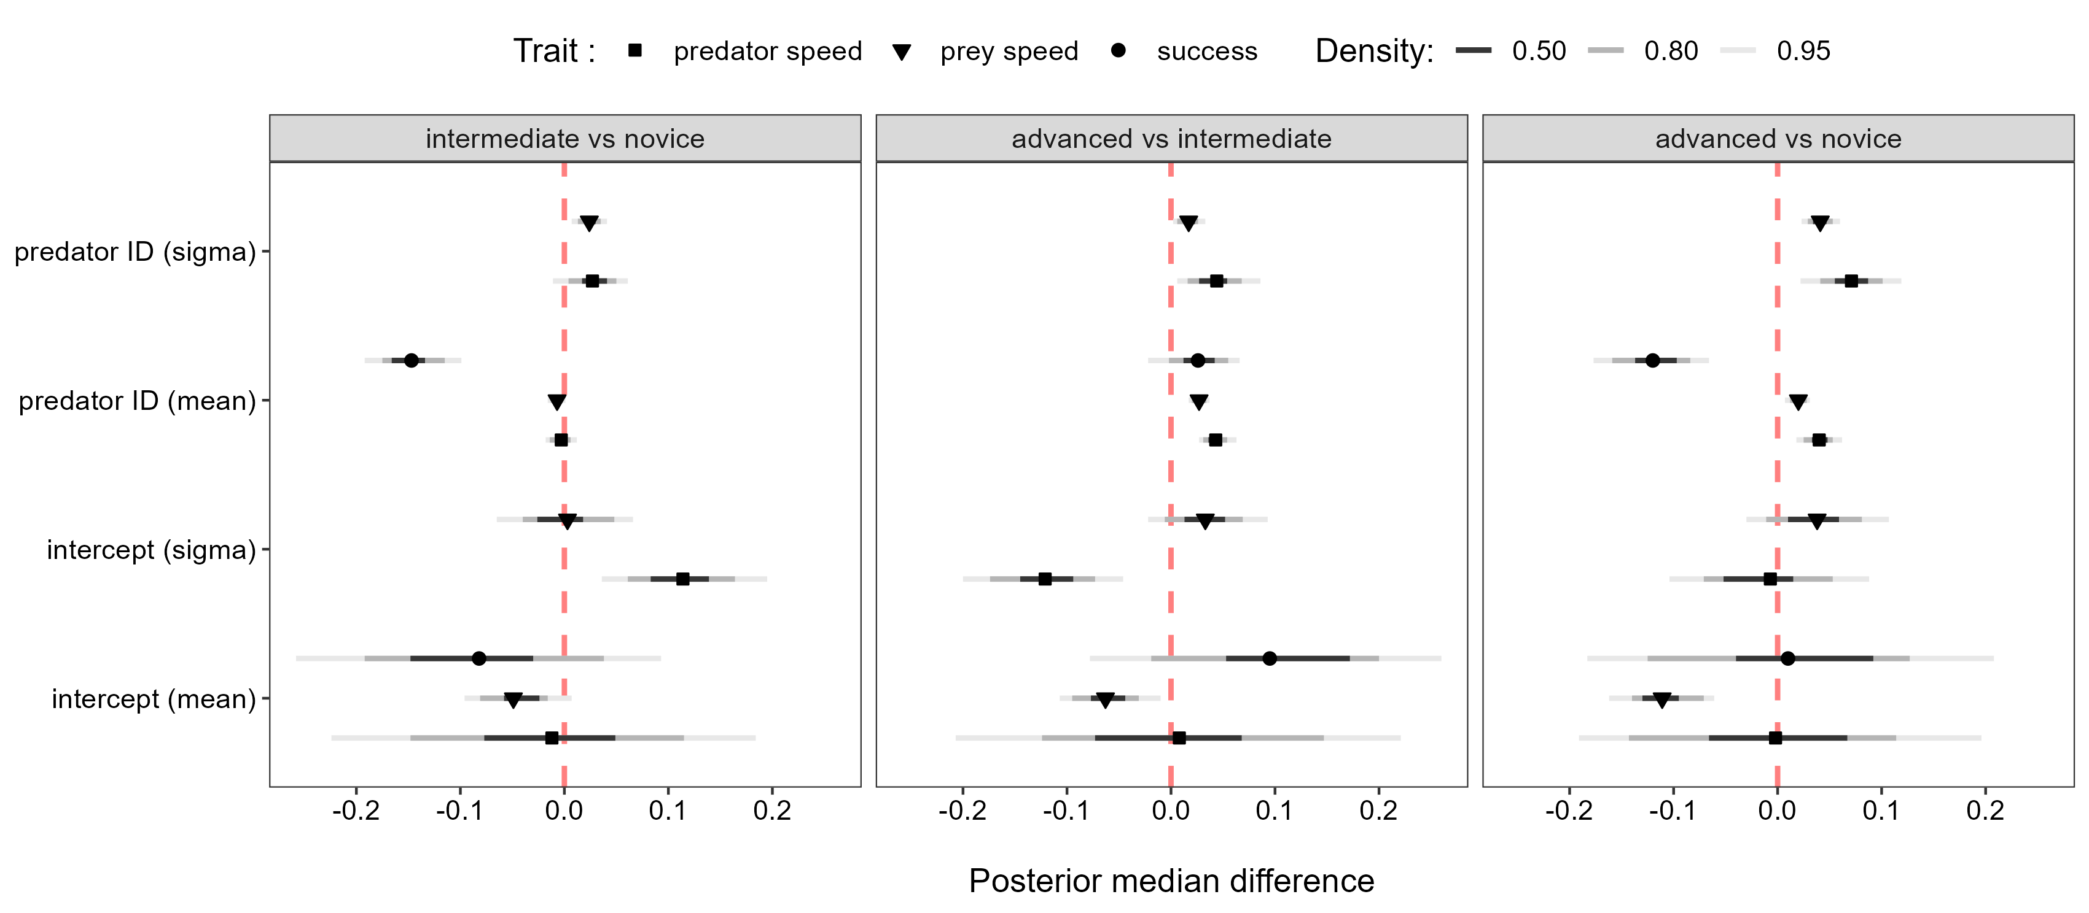

**Figure S1.** Posterior median differences and 95% credible intervals between the parameter values of each predator experience level predicted by the MDHGLM. The test is displayed on the y axis (i.e. whether the group of interest has either a greater or smaller value), and the parameter value is displayed on the x axis. Each panel represent the experience level groups that are being compared. The results are from the model that includes the outlier.

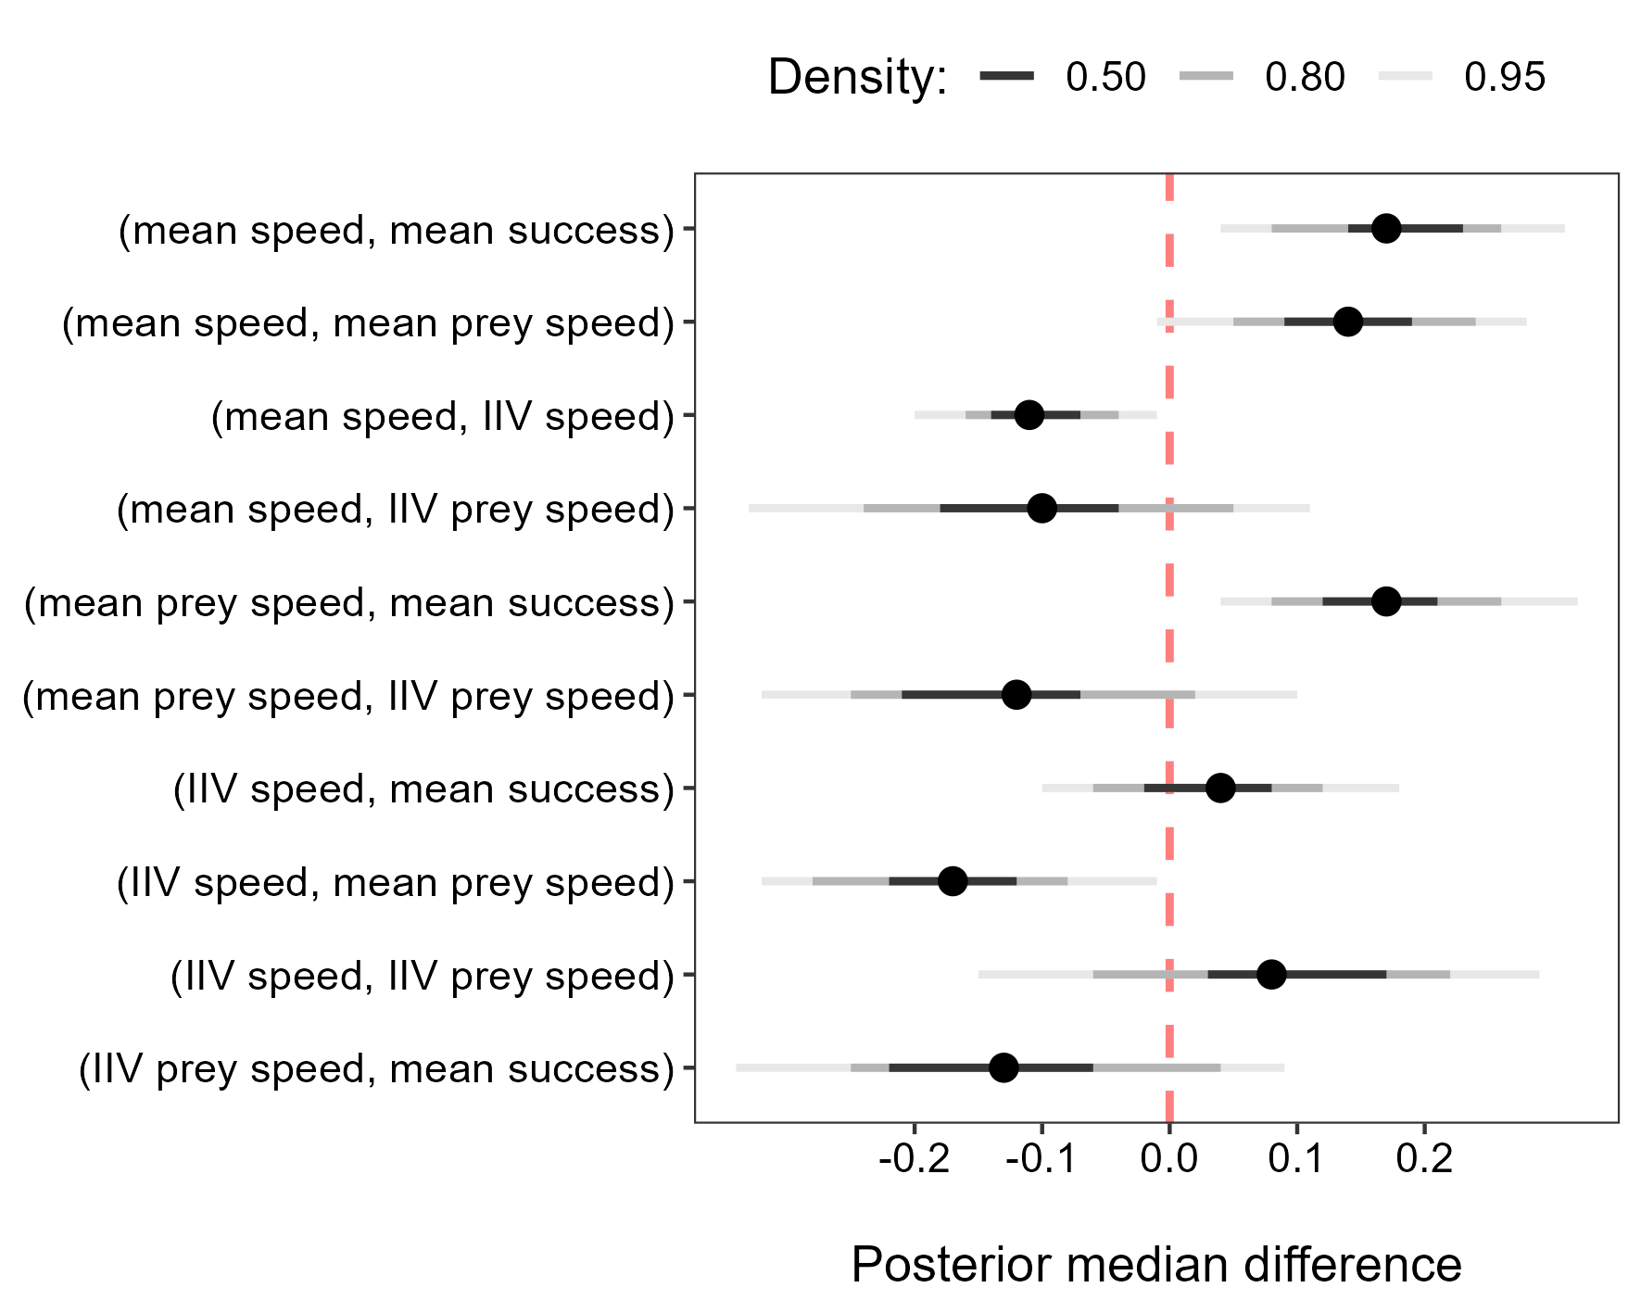

**Figure S2.** Posterior median differences and 95% credible intervals in the correlations of players when they were advanced vs novice. The difference is displayed on the x axis and the parameter correlations are displayed on the y axis. The results are from the MDHGLM that includes the outlier.