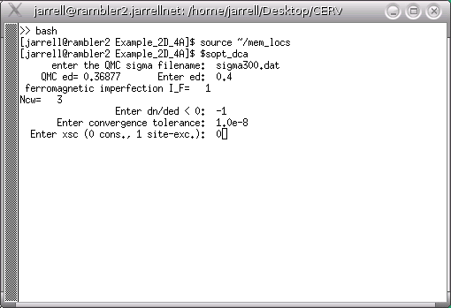
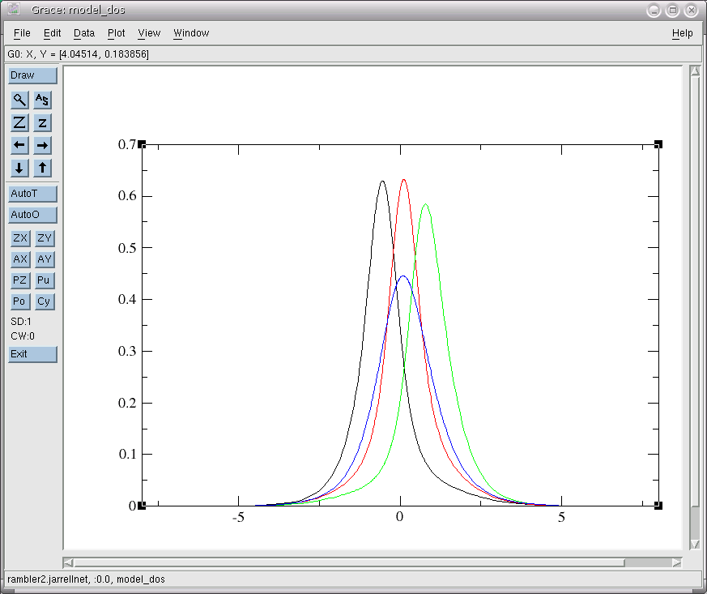
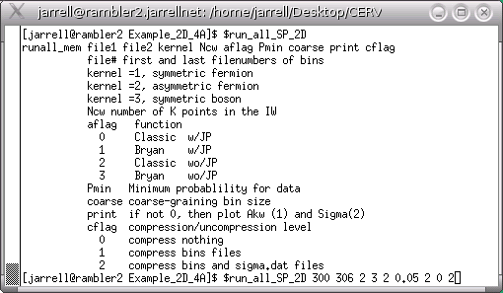
Preliminaries. First, copy the mem_locs file (from MEM/BETTS/run_scripts) into your home directory, and edit it appropriately. Then, make sure that you compile all of the requisit executables (the files in the Environment module may be useful here. Now you are ready to analytically continue the single and two particle spectra.
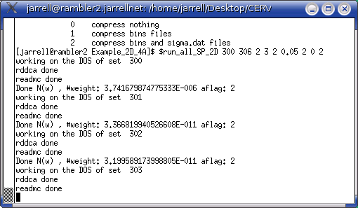
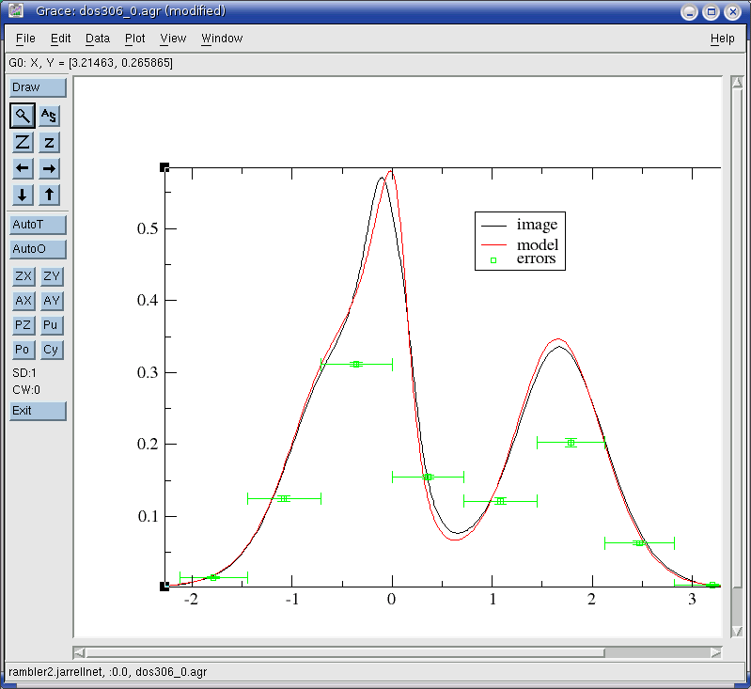
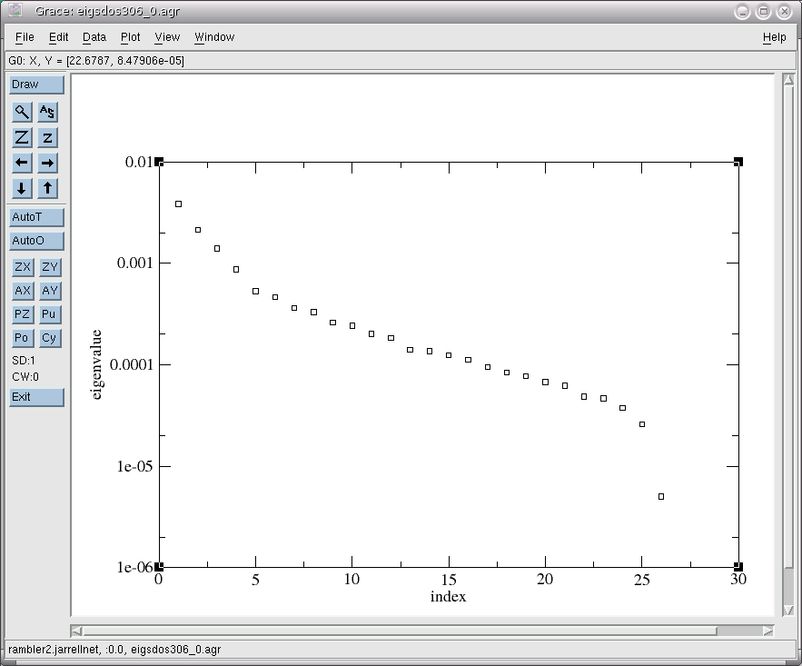
Single-Particle Spectra: To prepare the default model, open a terminal in the directory with the data, source the file mem_locs (it is done by my .bashrc, but repeated for illustration), and run the command $sopt_dca (see the image on the left). You should choose the highest temperature QMC run to generate the default model, since the ideal default model is relatively featureless. For this same reason, generally fully self consistency perturbative approach is used (xsc=0). Once the perturbation calculation converges to the desired accuracy (set by convergence tolerance), you must choose a Pade order. Pade approximants are used to analytically continue the perturbation theory result to real frequencies. Since the model is relatively featureless, the order need not be high (so the Pade may actually work). I generally choose an order of 9 or less. Once sopt_dca finishes, you should plot the results using xmgrace (xmgrace model_Akw* model_dos). A set of boring blobs as shown above is ideal! If any of the models is discontinuous or shows spurious features, you should try again with a lower Pade order (remember, 9 or less). You are now ready to analytically continue the spectra. Here, you have several options (as described in the BETTS module). In each, you must analytically continue a series of QMC files, starting with the highest temperature result (for which the model was constructed, and continuing to the lowest. In each case, the image from the previous calculation will be used as a default model for the next lower T. Here, I will use $run_all_SP_2D . This script analytically continues the spectra for all K and R=0, extracts the self energy and interpolates it using a star interpolation. This is more-or-less explained within the script, some of the codes and in the README files in the BETTS module. As the script runs, you will see output similar to that shown left. Once the script is completed, you should look at the spectra in the dos#_k.agr files to see if the image has any weird or abrupt features, which might indicate that MEM has failed. The image is plotted in back and the model in red. You will also see error bars on the images (green). They actually are plots of the integrated image in different regions. The horizontal width of the error bars indicate the width of the region. The value of the green data point indicates the integrated spectral weight in the region, and the vertical error bar indicates its uncertainty. For example, xmgrace dos306_0.agr plots the density of states, N(w) on the left. It is apparent that the weight in the regions is well characterized, but perhaps the details of the features are not. You should also take a look at the
eigenvalues of the covariance for this data, shown with xmgrace . A good eigenvalue spectrum will be continuous, without any breaks. The plot to the left shows a barely adequate eigenvalue spectrum. A break appears to start around 26. It may be improved by generating more bins of data.

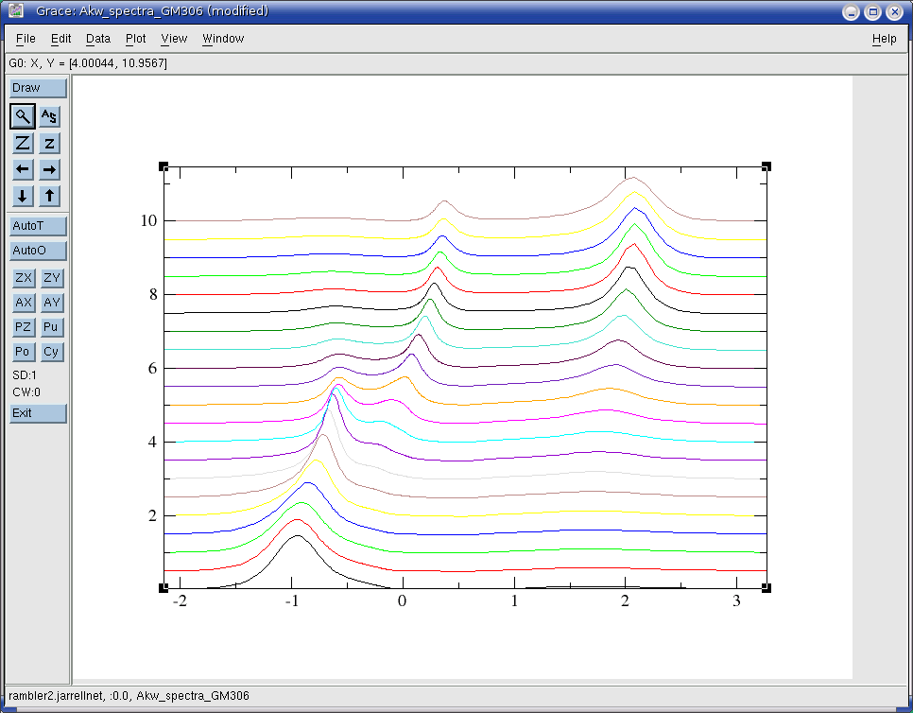
Once you believe the analytically continued spectra is correct, you should look at the interpolated spectra. It is in the files Akw_spectra_*. For example, Akw_spectra_GM306 contains the spectra for K going from Gamma to M in the 2D square Brillouin zone, as shown below..

Two-Particle Spectra: The default model for the two-particle spectra is constructed from the fully-dressed single-particle QMC Green function G(K,w). Thus, you must complete the calculation of the single-particle spectrum, for at least the highest temperature, before you construct the two-particle default models. This is done with the twodefault code, which only requires the number of the run (in this case 300) used. The command $run_all_TP 300 308 3 3 2 0.0 2 0 0 is then used to calculate the two-particle spectra (run it without the arguments to identify them). In this case, we are calculating the dynamic spin susceptibility. These files will share the string “chi” in their names. The output, in the files chi#_ickQMC and chi#_ick.agr. The latter is plotted for Q=(0,pi) in the plot below. The ordinate is actually chi''(Q,w)/(chi(Q,T)w) (so it is normalized to one). You can clearly see the pseudogap in the low frequency spectrum.

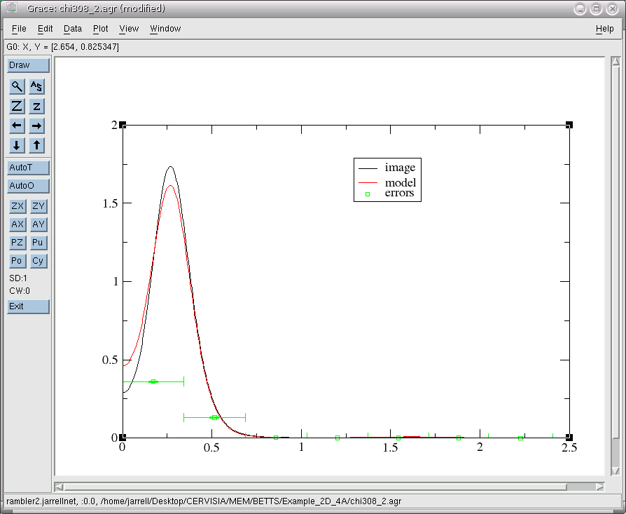
Of course, before trusting this, or any MEM, result, you must carefully explore rebinning, the eigenvalues of the covariance, and systematic improvement of the data. These steps are discussed in my review article.

