**PrCOVID (User Manual v1.0)**

The application described in this user manual is an implementation of the model presented in the manuscript: “Development of an interactive, agent-based local stochastic model of COVID-19 transmission and evaluation of mitigation strategies illustrated for the state of Massachusetts, USA” by Alexander Kirpich, Vladimir Koniukhovskii, Vladimir Shvartc, Pavel Skums, Thomas A. Weppelmann, Evgeny Imyanitov, Semyon Semyonov, Konstantin Barsukov, and Yuriy Gankin. The manuscript is available at MedRhiv (<https://doi.org/10.1101/2020.05.17.20104901>) pending publication at PLOS ONE. The corresponding author for this manuscript is Dr. Yuriy Gankin ([yuriy.gankin@quantori.com](mailto:yuriy.gankin@quantori.com)).

The tool has been written as a Windows application by Dr. Vladimir Koniukhovskii ([vladimir_koniukhovskii@epam.com](mailto:vladimir_koniukhovskii@epam.com)). The latest tool version is freely available together with the source code at <https://github.com/quantori/COVID19-MA-Transmission>

The state of Massachusetts MassGIS data were used to produce the tool map. The data are available for download and are public records from the Bureau of Geographic Information (MassGIS), Commonwealth of Massachusetts, Executive Office of Technology and Security Services. (<https://www.mass.gov/get-massgis-data>)

The application does not require installation and can be launched directly by opening the executable file **PrCOVID.exe** on Windows system or on Windows Virtual Machine in other platforms (MAC, Linux)**.** For the program to run successfully the input data files should be present in the **Data** folder within the program directory.

The application appearance is presented below:

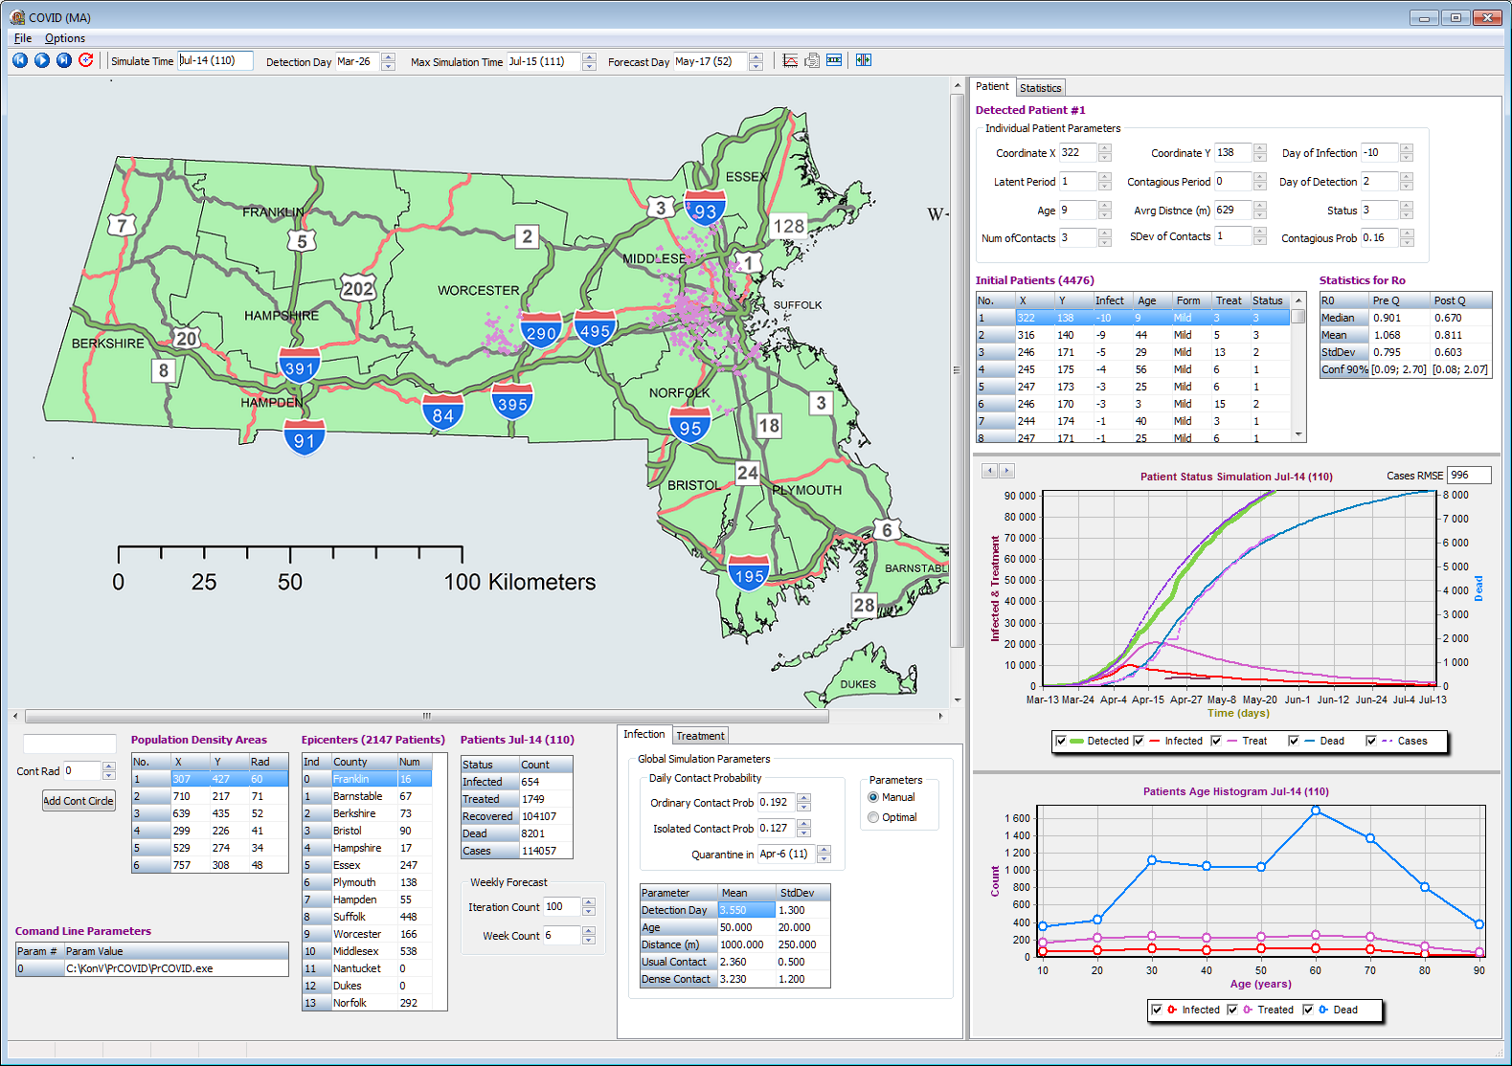

The user has to define the two input calendar dates. The “Detection Day” variable specifies the day up to which the input data will be used, while the “Max Simulation Time” specifies the end date for the model simulations and predictions.

The input data that contain the number of infected individuals are imported from “Epicenters” table within the Data folder.

The tool has multiple customization parameters that affect the model prediction. Those parameters are presented in **Infection** and **Treatment** panels.

The **Infection** panel parameters have the following meaning:

**Ordinary Contact Prob** is the probability of transmission for the infected individual during a day when the quarantine measures are not impended.

**Isolated Contact Prob** is the probability of transmission for the infected patient during a day when the quarantine measures are impended.

**Quarantine in** is the date of the quarantine.

**Detection Day** mean and standard deviation distribution parameters for the time interval from infection onset to detection as such.

**Age** mean and standard deviation parameters for the age distribution of infected individuals within the state.

**Distance** mean and standard deviation parameters for the distribution of the radius of infection spread for a single individual.

**Usual Contact** mean and standard deviation parameters for the distribution of the number of contacts of the infected individuals within a day in normal population density areas.

**Dense Contact** mean and standard deviation parameters for the distribution of the number of contacts of the infected individuals within a day in high population density areas (i.e. those selected on the map).

The visual summary of the **Infection** panel is provided below:

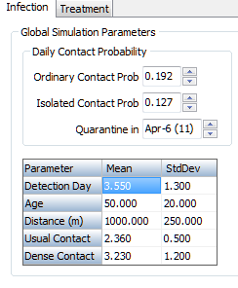

The **Treatment** panel parameters have the following meaning:

**Probability of disease form (%)** the distributions (specified in percent rather than in probabilities) of different disease severities (Lethal, Severe, or Mild) for three different age groups. The values in columns for each age group sum to 100%.

**Treatment duration (day)** mean and standard deviation parameters for the disease duration based on the disease severities (Lethal, Severe, or Mild).

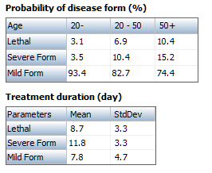

The **Population Density Areas** panel allows the user to manually adjust the high population density areas for the map. Those data values are contained within the input data and the user has an option to change those.

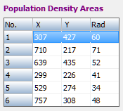

To **create** a new high population density area with the desired radius the user should hold the Shift button on the keyboard and click on the map in the desired center of the future high population density area. The X and Y coordinates that correspond to that click will appear on the form. The user has an option to adjust those coordinates manually by editing them and to define the radius of the future high population density area. The area is added to the table by clicking on **Add Cont Circle** button.

To **delete** any of the existing high population density areas the user should select (highlight) the desired row in the list of **Population Density Areas** by clicking on it. The corresponding area will be highlighted in red on the map. To delete the highlighted area the user should click the Delete button on the keyboard. The area will be deleted with no additional dialogs or warnings.

The button  is used to initialize the simulation process. The buttons  can be used to do simulations step by step and for the entire simulation respectively. The button  restarts and runs the entire simulation until the end.

The **Patients** panel displays interactively the summaries for the given day. Those summaries include infected, treated, recovered and deceased patients for the current day. The filed Cases contains the total number of identified infected individuals by the current date.

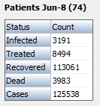

The right side of the tool screen contains various text and visual summaries that are available within the **Patient** and **Statistics** tabs.

Within the **Patient** tab the interactive graph **Patient Status** visualizes the values from the **Patients** panel and compares them with the input data displayed in bold green.

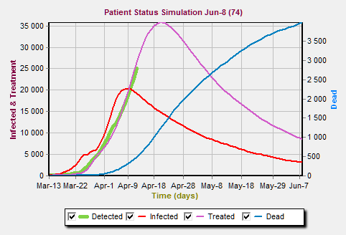

The **Patient** tab also contains the information about the initial individuals within the model and the estimates of the basic reproduction number $R_{0}$ before and after the quarantine measures are implemented.

The **Statistics** tab contains the visual summaries produced by the model (with 90% confidence bands) together with the data that have been used for the input. The visual summaries of the $R_{0}$ probability and density functions estimates before and after the quarantine implementation are also presented.

Within the **Statistics** tab the user can define the **Init Optim Time** and **Term Optim Time** parameters. Those parameters specify the set of dates from the input data which incidence values will be used for model fitting (optimization) as described in the manuscript Supplement.

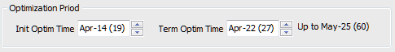

The button  launches the model fitting (optimization) algorithm which fits the model output on the interval specified by **Init Optim Time** and **Term Optim Time** parameters with the input surveillance data by minimizing the least squares between the two. The details of the model fitting are described in the manuscript Supplement.

The switch in the **Infection** panel allows the user to choose between the **Manual** and the **Optimal** parameter settings. For the **Manual** parameter settings the model simulations are performed with the set of parameters that are defied manually by the user, while for the **Optimal** parameter settings the simulations are performed with the fitted (optimized) set of parameters.

The buttons  and  generate the text outputs in csv format that contain daily and weekly prediction summaries produced by the model.

The parameters from the last tool use are store in COVIDSession.txt text file within the **Data** folder. The user has an option to manually change this COVIDSession.txt text file so that the tool will use the values adjusted by the user on the next launch. The changes within the COVIDSession.txt are recommended for experienced users only and the backup of the old version is strongly encouraged. The manual changes should be performed with caution since the potential mistakes during manual parameters change may affect the functionality of the tool.