Momentum Game Theory
Summer Progress and Results
Hugh Hayes | QUANTT, Queen's University | 24 May to 16 August 2026
Over the summer this project went through six distinct strategy designs, rejected three of them on evidence rather than instinct, and converged on a systematic ETF rotation strategy, the Two-Engine Book, that beats both SPY and a 60/40 portfolio on risk-adjusted return over a 25-year backtest. It has been trading live on an Interactive Brokers paper account since the start of August. Everything below is reproducible from the public repository, and every date is timestamped by the commit history.

1. What Was Built
The final strategy trades 20 liquid ETFs and rebalances monthly, across two independent engines. A 65% sleeve rotates between seven broad equity exposures by momentum, holding one at a time, and only while it beats T-bills. A 35% sleeve rotates between eleven US sectors using a game-theoretic selection rule: the sectors are treated as players in a congestion game, each earning its momentum score minus a tax that grows with how much capital already sits in correlated sectors. That stops the sleeve buying four versions of the same trade, and because the tax also counts what the other sleeve holds, it stops the two engines quietly stacking the same bet. Both sleeves step out into Treasuries or cash when their holdings stop trending, and step back in on a faster signal than they stepped out on.
On top of the research code, a full execution pipeline was built connecting the monthly output to a real broker account, so the strategy places orders rather than only backtesting.

2. Proof of Multiple Strategies Tested
This was not one idea built once. Each stage below was implemented, backtested and evaluated before being kept or rejected. The commit history timestamps all of it.
Stage | Design | Outcome
1 (late May) | Single-stock S&P 500 dollar-neutral long/short. Factor-residual momentum, Fama-French adjusted, with a correlation-based crowding gate. | Rejected. Net Sharpe around 0.1 after costs, statistically indistinguishable from zero. Individual large-cap stock momentum has been dead as a tradeable signal since roughly 2009.
2 (mid-June) | Long-only multifactor version of the same S&P 500 universe. | Rejected. A real improvement on Stage 1, but it still trailed the S&P 500 itself. An active strategy losing to its own benchmark is not a strategy.
3 (late June) | Broadened to ETF-level rotation. Country, sector and multi-asset universes, six distinct designs built and compared in the same week. | Three kept, three dropped. From the commit log at the time: "Tried 6 different ones, left with 3 variations, initial strat didnt work, strat 3 kind of, strat 6 works very well."
4 (late June to July) | Cross-asset and equity dual-momentum designs. Hold an asset only if it beats a cash hurdle, not just its peers. | Kept. Identified the T-bill hurdle as the single biggest driver of the whole approach. It is what keeps the strategy out of falling markets.
5 (July) | Multi-sleeve blended books, plus a game-theoretic sector selector: a congestion-game equilibrium solved by replicator dynamics that taxes crowded, overlapping bets. | Kept. The game-theory layer produced a measurable, repeatable improvement in exactly the regime it was designed for, concentrated mega-cap-driven markets.
6 (July, final) | Consolidated into one strategy: 65% style rotation, 35% sector rotation with the game-theoretic selector, and a crash-only volatility throttle. | Adopted. This is what trades today.* The throttle was later switched off, with the cost of that decision documented.

Every stage was evaluated on a disciplined split. Rules were built and tuned on 2001 to 2018 data only, then checked against 2019 onward, which was genuinely held out during development and checked once per major design decision rather than iterated against.

3. Results
Net of 10bps trading costs, executed at the next day's close, with cash earning the real T-bill rate. Sharpe figures are excess of the 3-month T-bill.
Period | Sharpe | Ann. return | Max drawdown | Worst month | t-stat
Book, in sample 2001 to 2018 | +0.92 | +13.0% | -18% | -8.7% | +4.27
Book, 2019 to today | +0.90 | +15.1% | -19% | -7.5% | +3.06
Book, full period 2001 to today | +0.92 | +13.6% | -19% | -8.7% | +5.26
SPY, full period | +0.53 | +9.1% | -51% | -16.5% | +3.32
60/40 portfolio, full period | +0.55 | +6.9% | -32% | -10.8% | +3.78

Full-period alpha is +7.0%/yr at a beta of 0.63, with annual turnover around 6.9 times. The pattern across every crash in the sample is the same: a severe loss for SPY becomes a survivable one for the book. The dot-com bust cost SPY 47.3% and the book 10.1%. The financial crisis cost SPY 55.2% and the book 19.6%. Calendar-year 2008 closed at -1.0% against SPY's -36.8%. That asymmetry is the whole engine of the result: a 51% loss needs a 103% gain to recover, a 19% loss needs 23%.
The chart below is the full equity curve and drawdown profile, regenerated on 16 August 2026 by running strategy/backtest.py. The dashed line marks January 2019, where the held-out period begins.
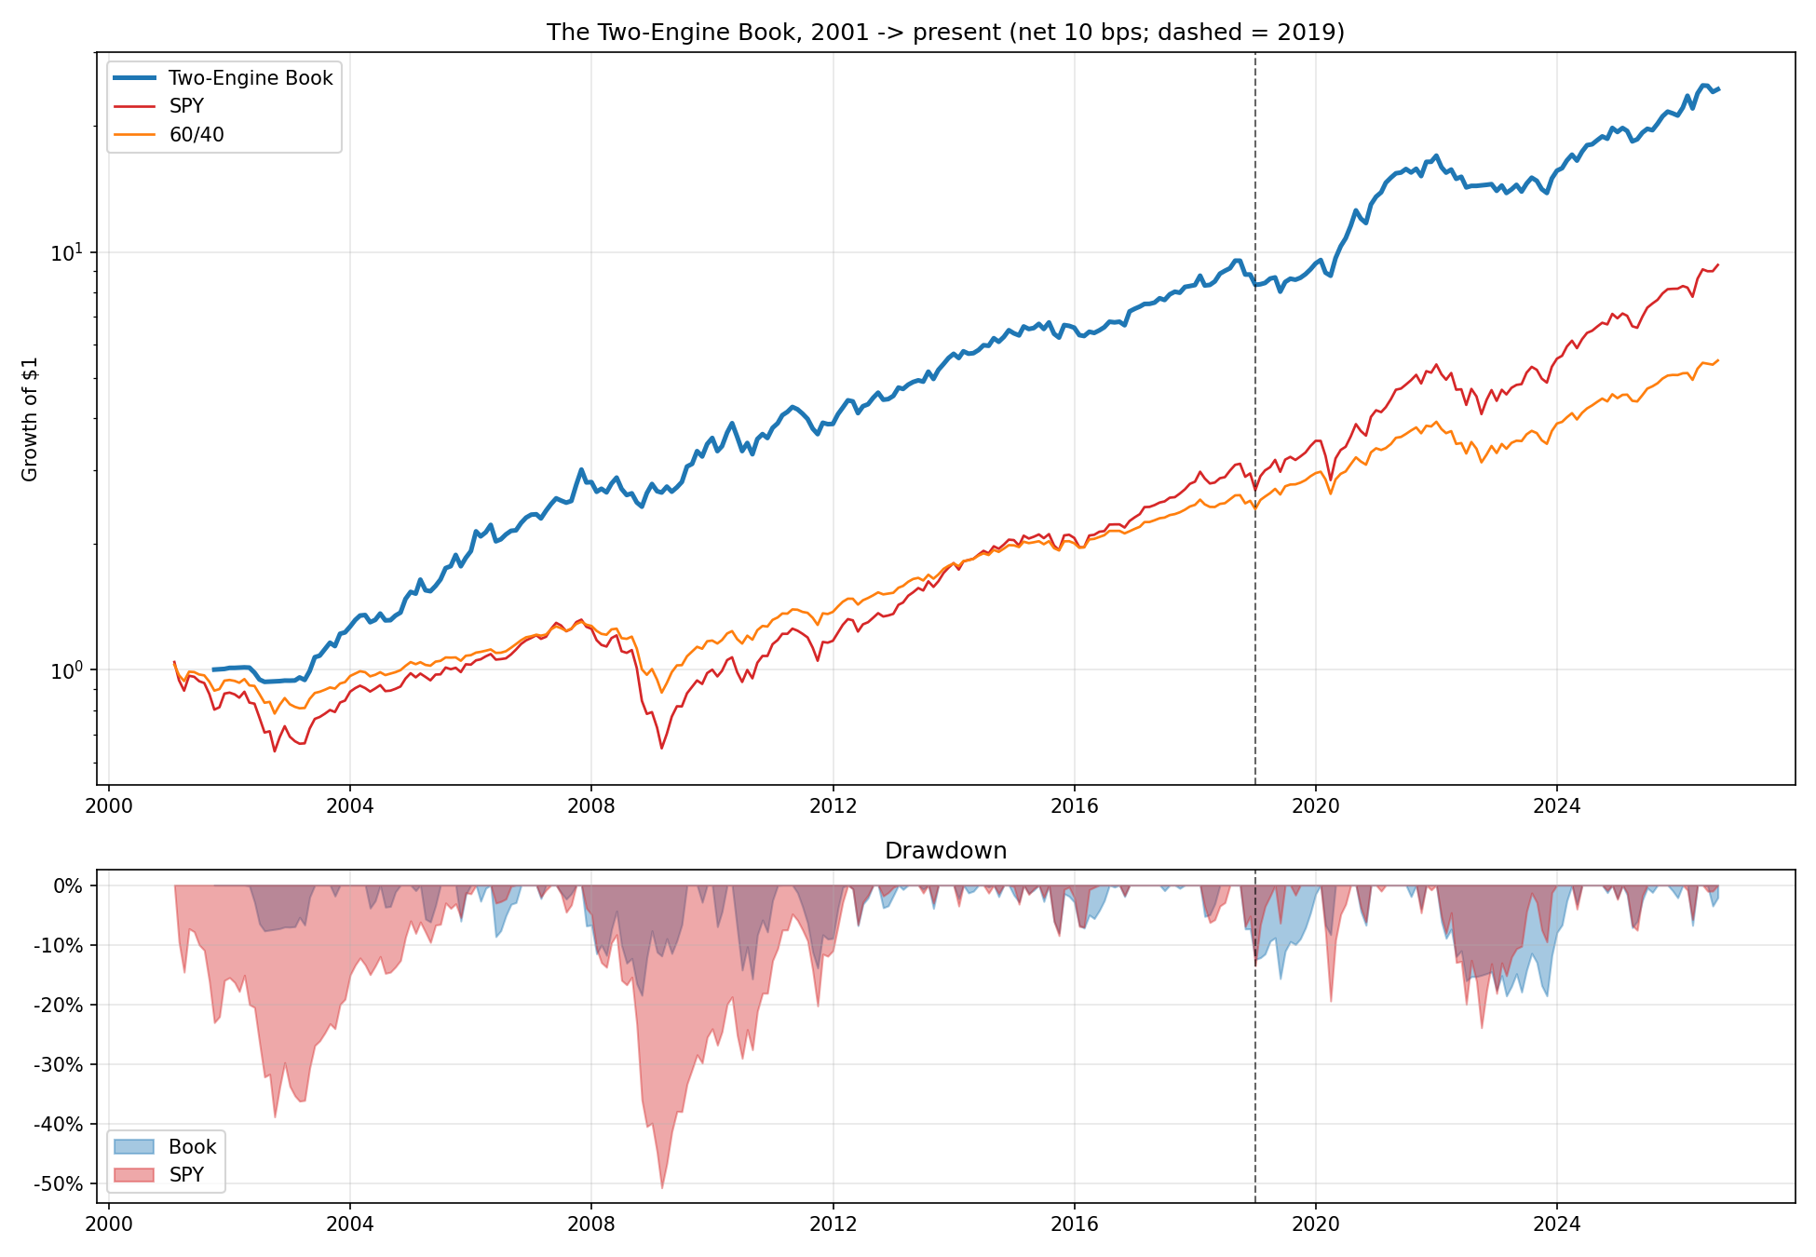
The Two-Engine Book against SPY and 60/40, 2001 to present, growth of $1 on a log scale, net of costs. Lower panel is drawdown.

4. Real History: Live Paper Trading
Backtests are cheap to produce and easy to overstate. The real proof is an account taking real, if simulated, fills. That pipeline was built end to end this summer:
- An Interactive Brokers paper account, connected through Trader Workstation over the ib_async API. The strategy's target weights become actual share orders, sized off live account value and placed as Market-on-Close so they fill in the same auction the backtest assumes.
- Safety rails: dry run by default, a paper-account guard that refuses to trade a non-paper account, a fat-finger guard that aborts any single order over 90% of account value, a time check against the MOC cutoff, and a typed confirmation before anything transmits.
- A currency-aware sizing fix. The paper account is CAD-denominated and every ETF prices in USD, so account value is converted before sizing. Without it, every order would be about 35% too large.
First live paper orders transmitted 1 to 2 August 2026.
[Insert here: TWS screenshot or account statement showing the transmitted orders and resulting positions. Pull it from TWS directly, or run python3 strategy/live/ib_test.py while TWS is open and paste the output. This is the single most convincing piece of evidence for the real history requirement, and it is worth capturing again every month so there is a growing, dated record rather than one data point.]

5. Development Timeline
Dated commit history from the public repository, github.com/quanttqueensu/Momentum-Game-Theory. Independently verifiable, not self-reported.
Date | Milestone
24 May | Project started.
31 May | Data pipeline built.
7 June | Factor residualization implemented, stripping market beta to leave idiosyncratic returns.
15 June | First working strategy layer, plus the in-sample and out-of-sample backtest split.
29 June | Six candidate designs built and compared. Three carried forward.
4 to 5 July | Final strategy locked. Game-theoretic sector selector added via replicator dynamics.
27 July | IBKR paper trading integration built.
1 to 2 August | First live paper trading orders placed.
3 August | Crowding tax made book-aware and locked. Documentation pass.
9 August | Bull-market participation pass: growth/value axis added, faster sector re-entry, throttle switched off.
16 August | Documentation finalized. Backtest re-run and results reproduced.

6. What I Would Flag Honestly
These are the weaknesses a committee should hear from me rather than find themselves.
- Since 2019 the book's Sharpe is +0.90 and SPY's is also +0.90, dead level. The entire risk-adjusted edge in this sample comes from 2001 to 2018, which contains two crashes. The post-2019 sample contains no full-cycle bear market, so the crash protection that drives the result has barely been tested in the held-out period.
- The 2019 onward return is stronger than the in-sample return, which is the opposite of the usual pattern and a reason for suspicion rather than confidence. Two of the three changes made on 9 August were evaluated against that period, so it is no longer a clean holdout for the current configuration.
- It lags in bull markets by design. It won 5 of 13 bull years in the sample, with a mean gap of -2.1%. Since 2019, 32% of rolling 12-month windows trailed SPY by more than 5 points. Anyone judging this over a single strong year will conclude it does not work.
- Alpha is measured against SPY alone, not a factor model, so it is return unexplained by market exposure rather than factor-adjusted alpha. Running that regression is the first project assigned to an incoming analyst.

7. Where This Goes Next
The strategy itself is finished for the summer and locked. The work from here is evidence and infrastructure, not more tuning: run the rebalance every month and build a dated fill record that grows into a real track record, complete the factor regression, add a regression test that pins the backtest numbers so no code change can quietly alter the strategy, and add a second price source so the pipeline does not depend on one free vendor. Two trading analysts are being hired to own that work.

