as51-ETE
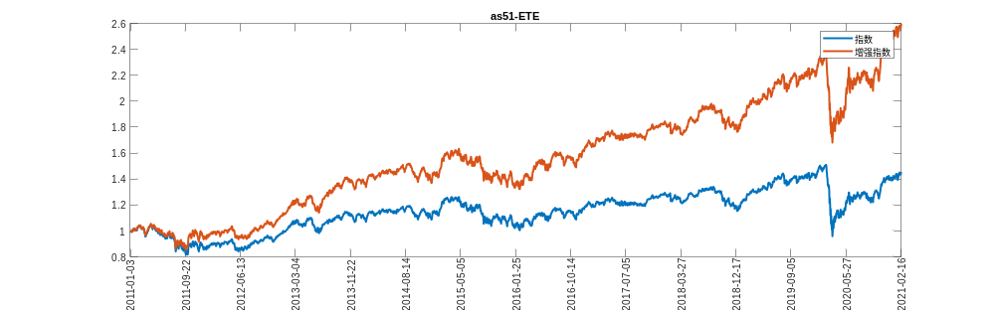
as51-ETE
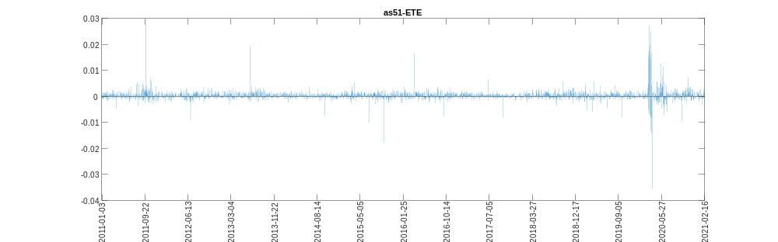
as51-ETE
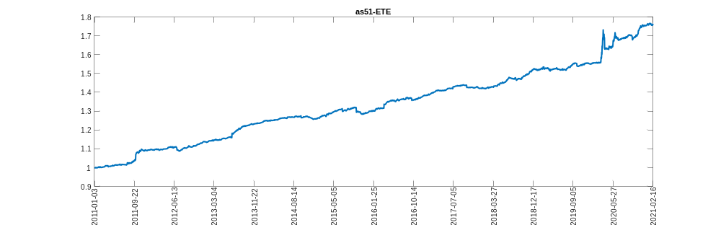
hsce-ETE
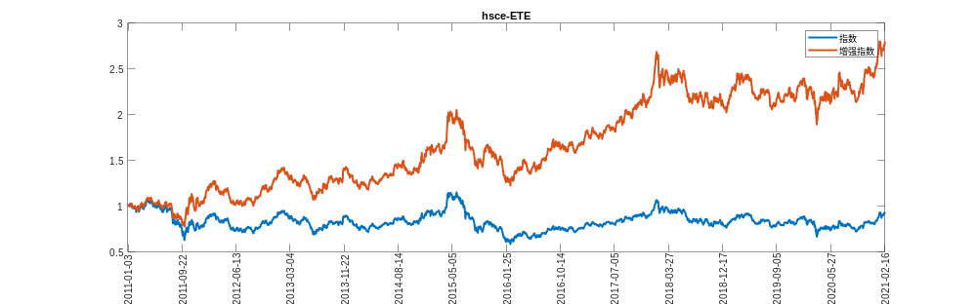
hsce-ETE
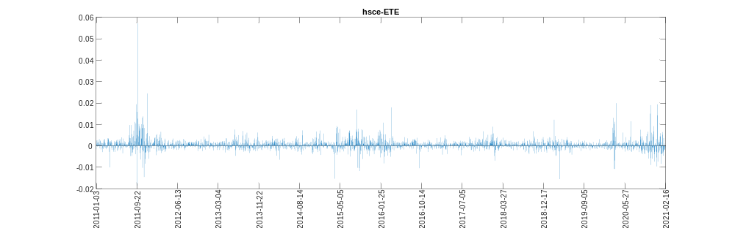
hsce-ETE
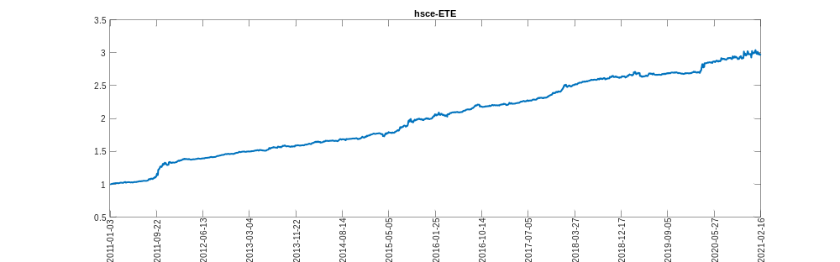
hsi-ETE
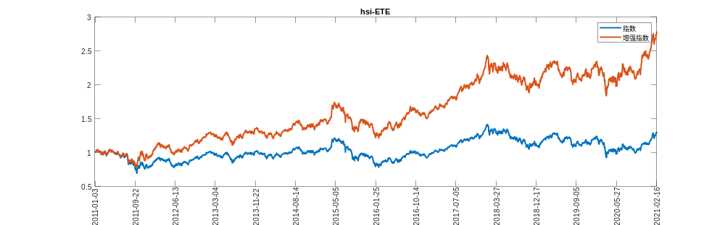
hsi-ETE
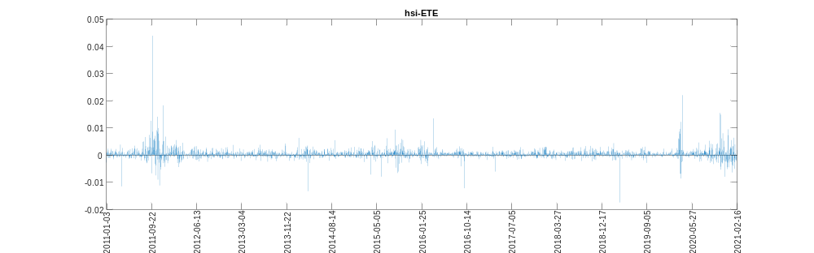
hsi-ETE
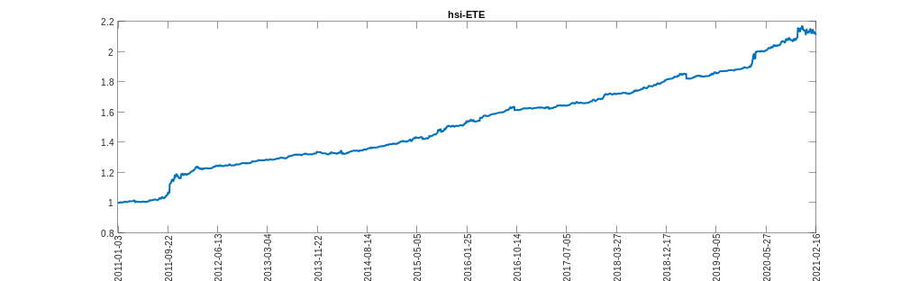
topix-ETE
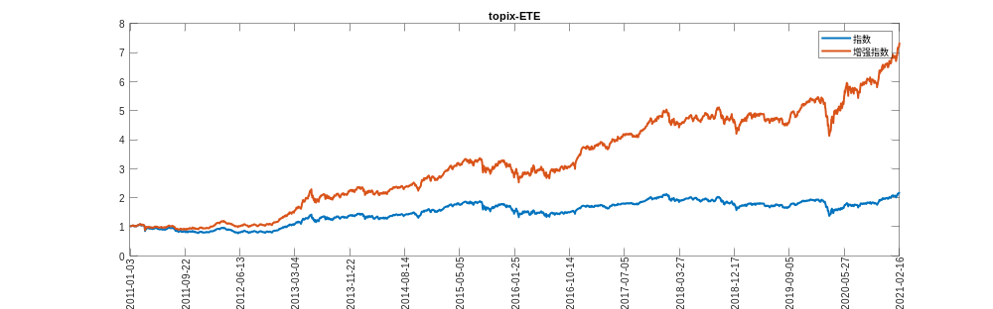
topix-ETE
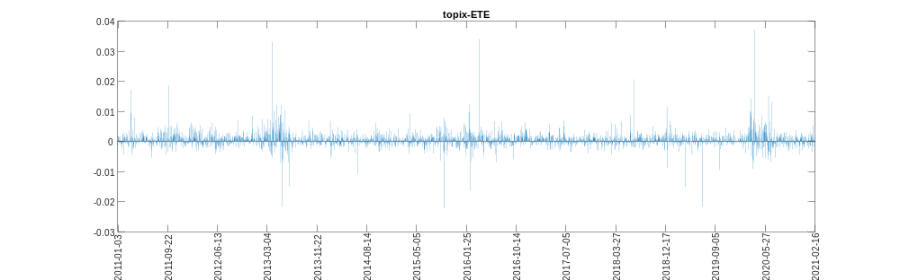
topix-ETE
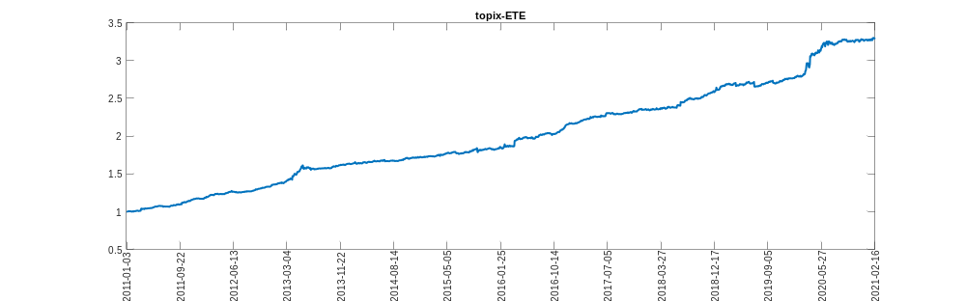
twse-ETE
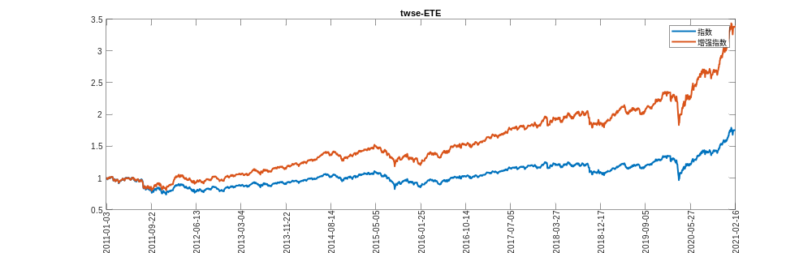
twse-ETE
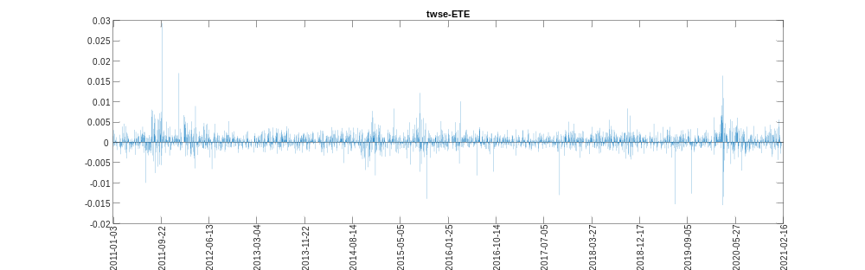
twse-ETE
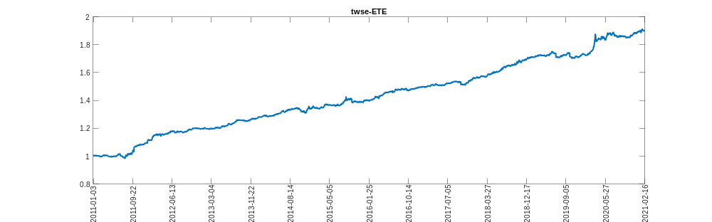
as51-DR
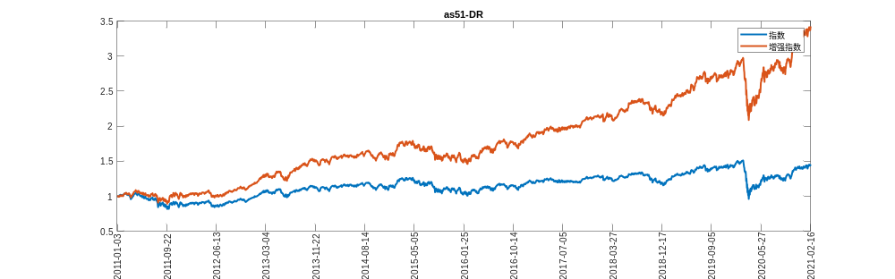
as51-DR
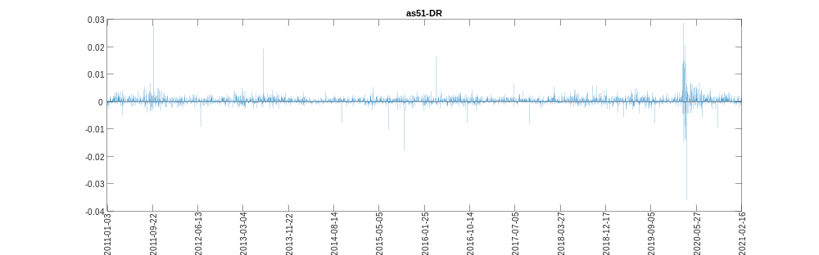
as51-DR
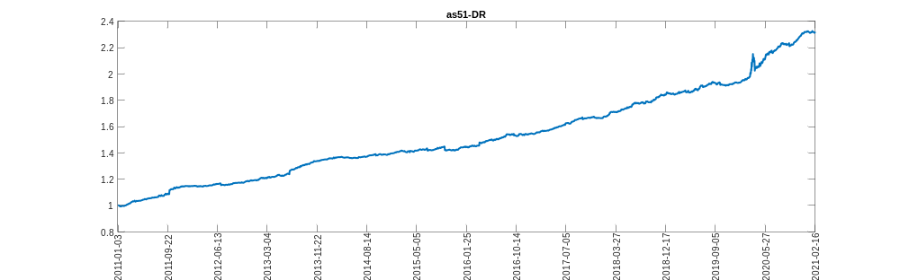
hsce-DR
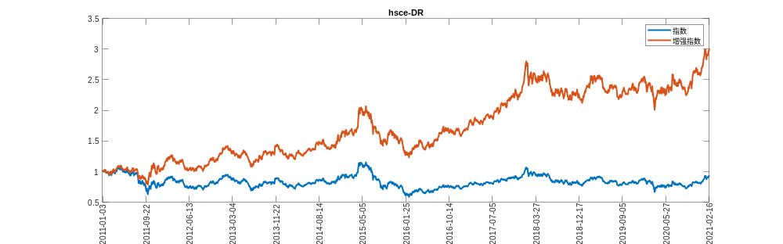
hsce-DR
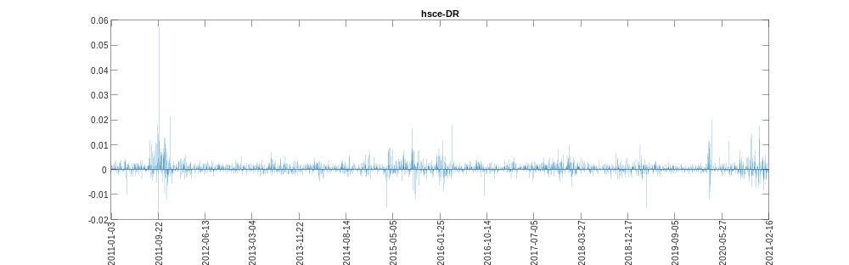
hsce-DR
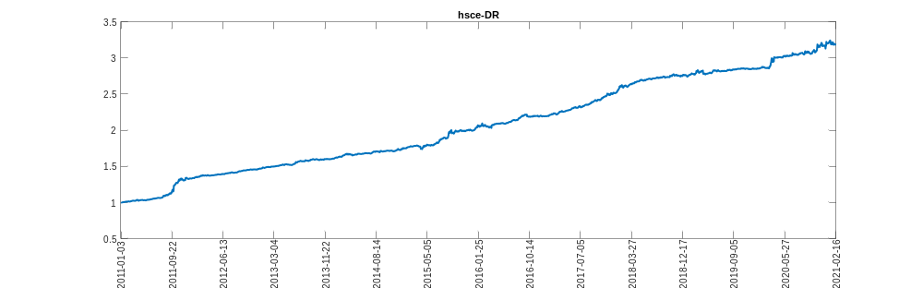
hsi-DR
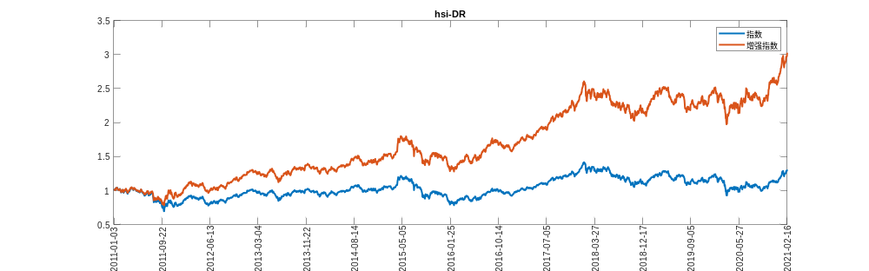
hsi-DR
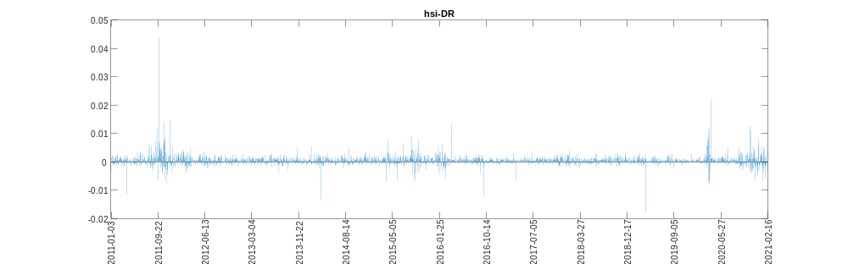
hsi-DR
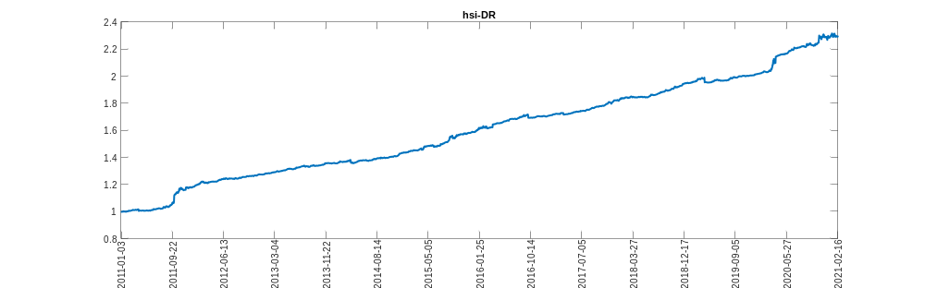
topix-DR
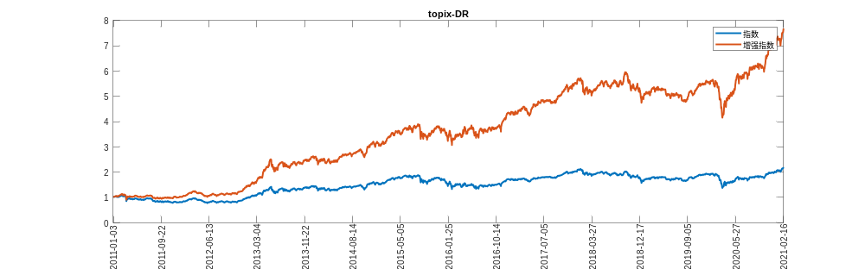
topix-DR
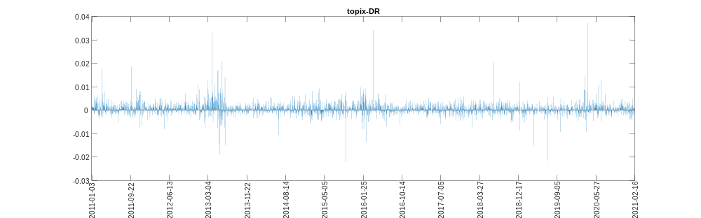
topix-DR
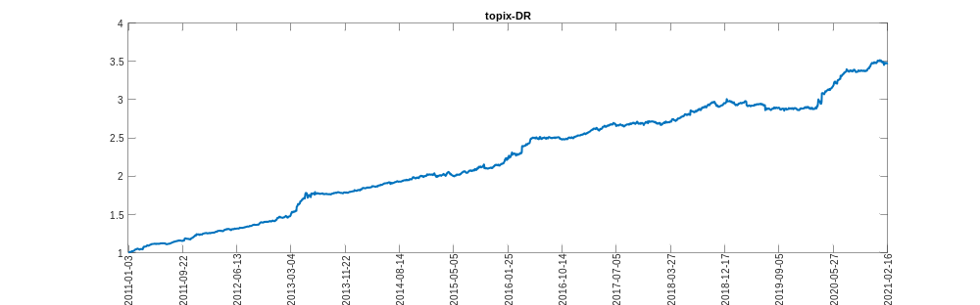
twse-DR
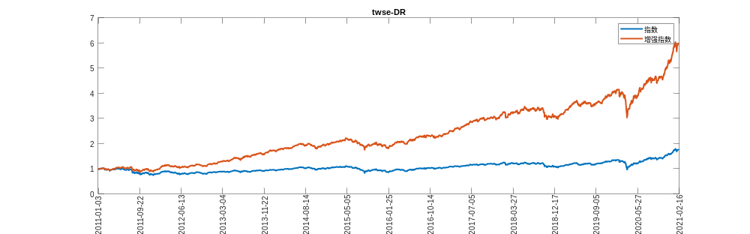
twse-DR
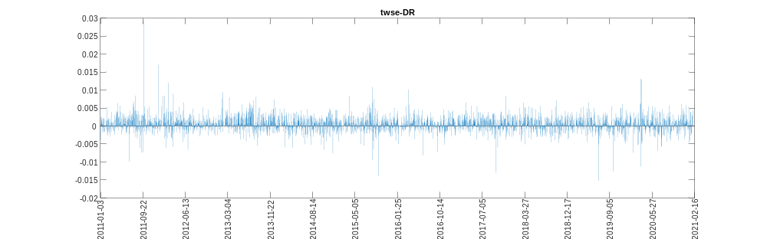
twse-DR
