MAC Automation Suite
End-Stage Diagram and Technical Documentation
LeCroy MAUI acquisition workflow
WF? ALL parser integration
Artifact generation and post-processing flow
Purpose
This package explains how the automation suite executes a run from configuration load through waveform acquisition, binary parsing, storage, prettification, optional post-processing, and Brain-controlled sweep looping.
Intended readers
Researchers and developers maintaining the MATLAB-based MAC automation suite for Teledyne LeCroy oscilloscopes.

Generated by ChatGPT based on the current automation-suite design, the uploaded parser file, and the earlier suite structure discussed in this conversation.

End-Stage Runtime Diagram
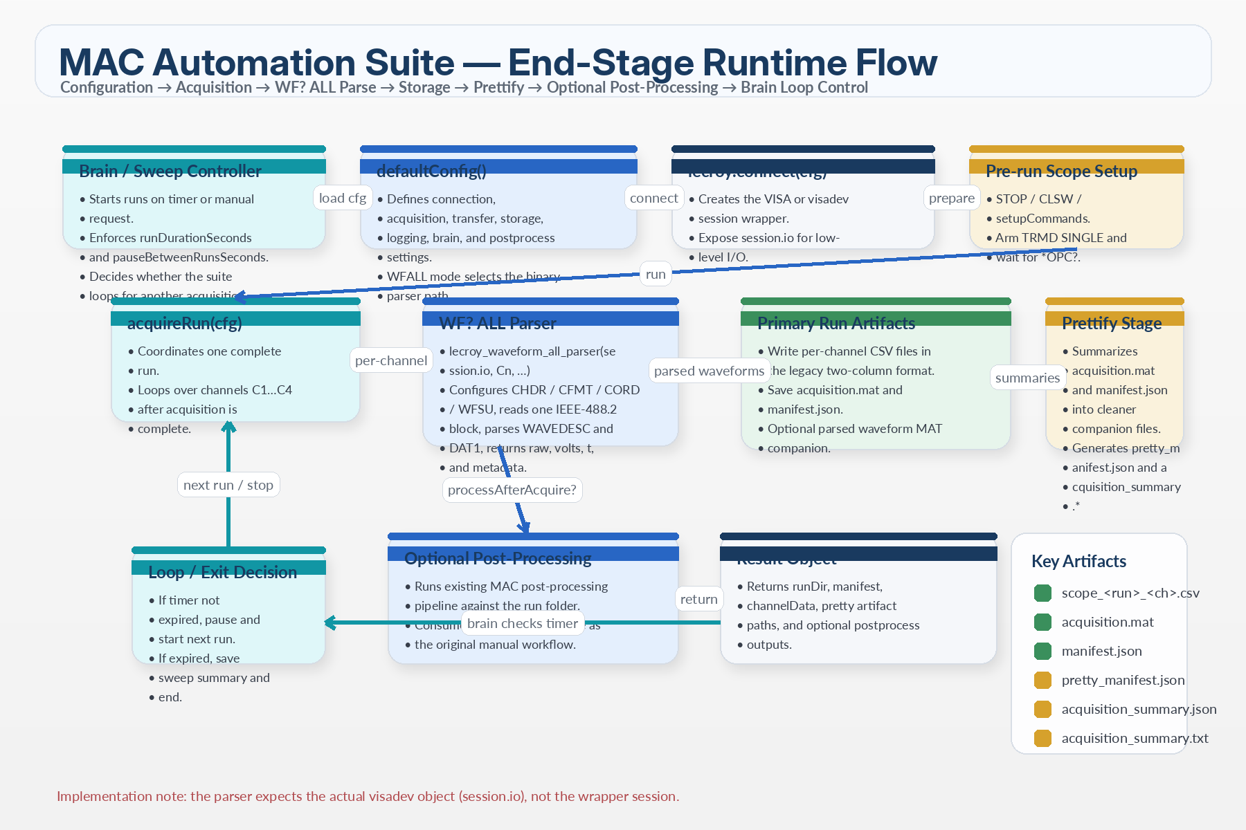
The end-stage flow shows the sequence after a run is requested: configuration, scope session creation, single-shot acquisition, WF? ALL parsing, artifact storage, prettification, optional post-processing, and Brain loop control.

1. Architecture Overview
The automation suite is organized as a layered pipeline. A Brain controller decides when a run begins and when a sweep ends. The acquisition layer opens the LeCroy connection and coordinates a single-shot measurement. The parser layer uses WF? ALL to read a complete binary waveform block, decodes WAVEDESC metadata plus DAT1 samples, and returns volts and time arrays for each channel. The storage layer preserves both machine-oriented and human-oriented artifacts, and the optional post-processing layer consumes the same CSV shape as the legacy workflow.

Major responsibilities
• Configuration defines the behavior of every layer: connection, acquisition, transfer, storage, logging, Brain control, and post-processing.
• acquireRun executes one end-to-end run and writes run-folder artifacts.
• lecroy_waveform_all_parser performs transport setup, binary block reading, and waveform decoding.
• prettifyRunArtifacts creates cleaner companion files that are easier to inspect than the raw MAT/JSON outputs.
• The post-processing package remains logically separate so acquisition and analysis can evolve independently.

2. Core Function Responsibilities

defaultConfig()
defaultConfig produces the master configuration struct consumed by the rest of the suite. It is the single source of truth for the runtime defaults.
• connection: VISA resource string, terminators, timeouts, visadev preference, and clear-on-connect behavior.
• acquisition: channel list, channel labels, run index, setup commands, arm mode, wait timers, and pre/post-arm behavior.
• transfer: parser selection, parser options, and WF? ALL transport settings.
• storage: root directory, run folder pattern, CSV header lines, MAT/JSON writes, and prettified companion artifact toggles.
• brain: sweep duration, inter-run pause, error policy, and whether processing runs automatically after acquisition.
• postprocess: settings passed to the downstream MAC analysis functions.

Brain / runSweep
The Brain layer orchestrates repeated runs over a fixed wall-clock interval. Conceptually, it is a scheduler around acquireRun rather than a replacement for it.
• Starts the first run immediately or on the next scheduled tick.
• Stops after runDurationSeconds elapses.
• Sleeps for pauseBetweenRunsSeconds between runs.
• Optionally launches post-processing after acquisition completes.
• Stops or continues on errors depending on stopOnError.

acquireRun(cfg)
acquireRun is the main run executor. It opens the instrument session, prepares the scope, arms the acquisition, loops over requested channels, calls the parser, and writes artifacts.
• Calls lecroy.connect(cfg) to obtain a session object.
• Uses session.io for low-level reads and writes. This matters because the parser expects the actual visadev object.
• Executes STOP, CLSW, and user-defined setupCommands when enabled.
• Arms TRMD SINGLE and waits for completion using *OPC?.
• Reads each requested channel exclusively through the WF? ALL parser.
• Writes per-channel CSV files, acquisition.mat, manifest.json, and prettified companion outputs.
• Returns a result struct with paths and parsed data.

lecroy.connect(cfg)
The connection layer is responsible for building the communication session wrapper. In the current suite shape, the wrapper exposes session.io as the visadev object used by transport functions.
• Resolves the VISA resource string.
• Applies terminators and session timeout defaults.
• Optionally clears stale I/O state on connect.
• Normalizes the connection into a structure the rest of the suite can consume.

lecroy_waveform_all_parser(io, chan, ...)
The parser is a self-contained file that sets up the transfer, reads a complete IEEE-488.2 arbitrary block, and converts the returned data into MATLAB-friendly arrays and metadata.
• Uses CHDR SHORT, CFMT DEF9,WORD,BIN, CORD LO, and WFSU SP,1,NP,0,FP,0,SN,0 by default.
• Optionally triggers a single-shot acquisition if AcquireSingle is enabled.
• Sends Cn:WF? ALL and reads the entire binary block without relying on line-oriented reads.
• Finds the WAVEDESC anchor in the payload and decodes descriptor fields at fixed offsets.
• Reads DAT1, converts raw sample codes into volts using vertical gain and vertical offset, and computes a time axis from descriptor fields or optional INSPECT? fallback values.
• Returns a struct containing raw samples, scaled volts, block metadata, descriptor metadata, and recommended timeout information.

prettifyRunArtifacts(runDir, result, cfg)
The prettify stage does not replace the raw artifacts. Instead, it generates companion files that summarize the run in a cleaner form.
• pretty_manifest.json reorganizes and normalizes the stored manifest.
• acquisition_summary.json captures the practical run summary and per-channel numeric statistics.
• acquisition_summary.txt provides a plain-language human-readable report for quick review.
• An optional acquisition_pretty.mat can store a lighter-weight summary MAT file.

3. WF? ALL Parser: Internal Mechanics

Transport setup
Before any channel read, the parser configures a deterministic transfer format. The settings are chosen to make the host-side binary decode stable on typical Intel MATLAB systems.
• CHDR SHORT keeps the reply prefix compact.
• CFMT DEF9,WORD,BIN requests binary 16-bit waveform samples.
• CORD LO requests little-endian byte ordering.
• WFSU SP,1,NP,0,FP,0,SN,0 requests a full waveform without sparsing.

Binary block read
WF? ALL returns an IEEE-488.2 arbitrary block. The parser reads it in a length-driven way rather than line-by-line.
• Scan incoming bytes until the # character that marks the start of the arbitrary block header.
• Read the digit count immediately after #.
• Read the decimal payload length encoded by that digit count.
• Read exactly that many payload bytes.
• Optionally consume one trailing terminator byte if present.

Descriptor decode
Inside the payload, the parser locates the literal string WAVEDESC and treats it as the zero-point for the descriptor offsets.
• COMM_ORDER is read first to establish the byte order used for the rest of the descriptor.
• Core sizes are then decoded: waveDescLen, userTextLen, trigtimeLen, risTimeLen, waveArray1Len, and waveArray2Len.
• Useful metadata such as instrumentName, traceLabel, waveArrayCount, verticalGain, verticalOffset, horizInterval, and horizOffset are extracted next.
• The parser walks forward through the payload by descriptor-reported segment lengths until it reaches DAT1.
• DAT1 is interpreted as int8 or int16 depending on COMM_TYPE.
• Scaled volts are computed as raw * verticalGain - verticalOffset.
• The time axis is derived from horizOffset + index * horizInterval when available.

Timeout strategy
The parser can accept a fixed TimeoutSeconds value, but it also returns a recommended timeout estimate based on actual payload size. This allows the suite to adjust future runs for long captures.

4. Artifact Set Written Per Run
Artifact | Purpose | Primary Consumer
scope_<run>_<ch>.csv | Legacy-compatible two-column time and amplitude export. | Post-processing pipeline
acquisition.mat | Machine-oriented archive of channelData and manifest. | Developers and recovery workflows
manifest.json | Structured description of configuration and run context. | Debugging and provenance
pretty_manifest.json | Normalized manifest companion with channel summary. | Human inspection
acquisition_summary.json | Compact run summary with per-channel statistics. | Dashboards and quick checks
acquisition_summary.txt | Readable plain-text summary of the run. | Operators and reviewers

5. Configuration Guide
The most important runtime settings are summarized below. In practice, these should be edited in defaultConfig and overridden per experiment only when necessary.
Config path | What it controls | Typical value / note
cfg.connection.resource | Visa resource string | USB0::…::INSTR
cfg.connection.timeoutSeconds | Session-level default timeout | Increase for long WF? ALL transfers
cfg.acquisition.channels | Channels included in each run | [1 2 3 4]
cfg.acquisition.setupCommands | Scope commands applied before arming | VDIV, OFST, trigger, timebase
cfg.acquisition.acquireMode | Run arm mode | "single"
cfg.transfer.mode | Readback path selector | "WFALL"
cfg.transfer.parser.functionName | Parser function to call | lecroy.lecroy_waveform_all_parser or lecroy_waveform_all_parser
cfg.transfer.parser.commFormat | Binary transfer format | "DEF9,WORD,BIN"
cfg.transfer.parser.waveformSetup | WF? ALL point-selection settings | "SP,1,NP,0,FP,0,SN,0"
cfg.storage.rootDir | Top-level output folder | Experiment data directory
cfg.storage.writePrettyArtifacts | Enable human-readable companion outputs | true
cfg.brain.runDurationSeconds | Sweep wall-clock duration | Operator-chosen
cfg.brain.processAfterAcquire | Run MAC post-processing automatically | true or false

Integration note
If acquireRun obtains a session wrapper rather than a bare visadev object, the parser must receive session.io. Likewise, the parser function name in the config must match the file location on the MATLAB path. If the parser file is moved into +lecroy/, the correct functionName becomes lecroy.lecroy_waveform_all_parser.

6. End-to-End Run Sequence
1. Brain decides a run should start.
2. defaultConfig (or an experiment-specific override) is loaded.
3. lecroy.connect(cfg) opens the communication session.
4. STOP / CLSW / setupCommands prepare the instrument.
5. TRMD SINGLE arms the scope, and *OPC? waits for completion.
6. For each requested channel, acquireRun calls the WF? ALL parser.
7. The parser configures transfer formatting, sends Cn:WF? ALL, and reads the full binary block.
8. The parser decodes WAVEDESC and DAT1, then returns time, amplitude, raw samples, and metadata.
9. acquireRun writes CSV, MAT, and JSON outputs into the run folder.
10. prettifyRunArtifacts generates operator-friendly summaries.
11. If enabled, postprocess.process_run executes on the completed run folder.
12. Brain decides whether to pause and loop or end the sweep.

7. Common Failure Modes and Checks
• Parser function not found: verify the MATLAB path and the package-qualified functionName string in cfg.transfer.parser.functionName.
• Wrong object passed to the parser: pass session.io, not the wrapper session, when the parser expects a visadev object.
• Timeouts during WF? ALL: increase cfg.connection.timeoutSeconds and cfg.transfer.parser.timeoutSeconds, or reduce waveform size.
• Inconsistent reads caused by readline on WF? ALL: always use the binary block reader, never a line reader, for waveform blocks.
• Unexpected scaling: verify VDIV, OFST, COMM_FORMAT, COMM_ORDER, and the descriptor-derived vertical gain and vertical offset.
• Post-processing mismatch: confirm that the CSV files remain two-column exports with time in column one and amplitude in column two.

8. Recommended Maintenance Practices
• Keep defaultConfig conservative and stable. Experimental overrides should live outside the shared baseline.
• Treat the parser as a protocol module. Avoid mixing line-based query helpers into waveform block reads.
• Preserve the raw machine files and write human-readable companion files instead of mutating the originals.
• Review one completed run folder after every major acquisition or parser change before launching a long Brain-controlled sweep.
• When long-memory captures are enabled, validate timeout settings and descriptor fields on a short test run first.

