PRODUCT CONCEPT
Data Collection and Delivery Platform Concept
A product idea for collecting data from diverse sources, normalizing changes, and delivering analytics-ready outputs through CSV, SQL, Parquet, and APIs.
Focus | Product idea and high-level architecture, without exposing internal implementation
Approach | The repository and existing system are treated as a black box
Tech anchors | gRPC/Protobuf for change transfer, Parquet for analytics delivery
Date | June 22, 2026

Core idea: the platform is not just another connector. It is a trusted layer between data sources and analytics consumers: it receives changes once and makes them available to many consumers in the format they need.

1. What this project is
This is a product platform that sits between data sources and analytics consumers. It receives data from different systems, turns it into a shared change model, controls ordering and integrity, and then prepares delivery formats for BI tools, plugins, and partner services.
In this document, the existing repository is treated as a black box. We do not describe internal storage, internal services, or implementation details. The important question is the idea: what problem the system solves and how a similar platform should be framed if built from scratch.
Formula: any data source is connected once, and the result becomes available to many consumers in the form they need.

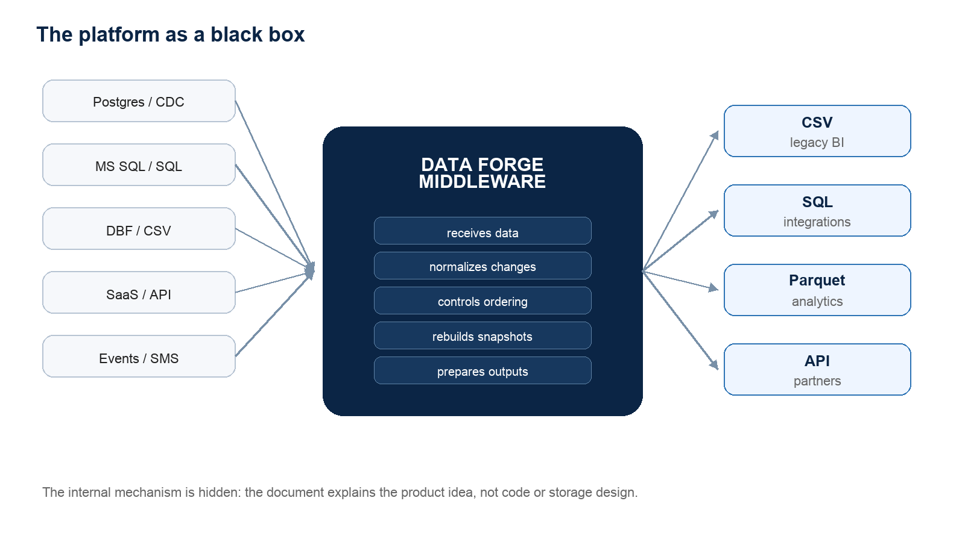
Infographic 1. Product boundary: sources and consumers see the platform as a black box.

2. Why the platform is needed
In practice, data rarely lives in one clean system. One customer may use Postgres, another MS SQL, another DBF or CSV, and another SaaS APIs, webhooks, or event streams. If every consumer builds its own connector, the result is duplicated work, inconsistent logic, and high support cost.
The platform creates a different center of gravity: sources connect through adapters, and consumers read a normalized result. This removes the burden from BI products to understand every historical customer system.

Problem without the platform | Platform idea
Every BI product writes its own connector | Connectors live in the ingest layer; consumers read prepared outputs
Files, databases, and APIs are handled by different rules | All inputs are translated into one change model
It is hard to know what has already been accepted | The platform tracks a watermark and confirms accepted progress
A failure often means a manual reload | Recovery and full re-baseline are explicit product flows

3. The central data idea
The system should not think in terms of one specific source. It should not matter whether data came from Postgres, MS SQL, a file, or a webhook. After the adapter, every change should answer simple questions: where it happened, what changed, which record it belongs to, in what order it arrived, and which schema should be used to understand it.
This creates a shared data language. It lets the platform add new sources without rewriting delivery for Bit BI, Power BI, or a partner API. The reverse is also true: a new output format can be added without forcing sources to change how they send data.
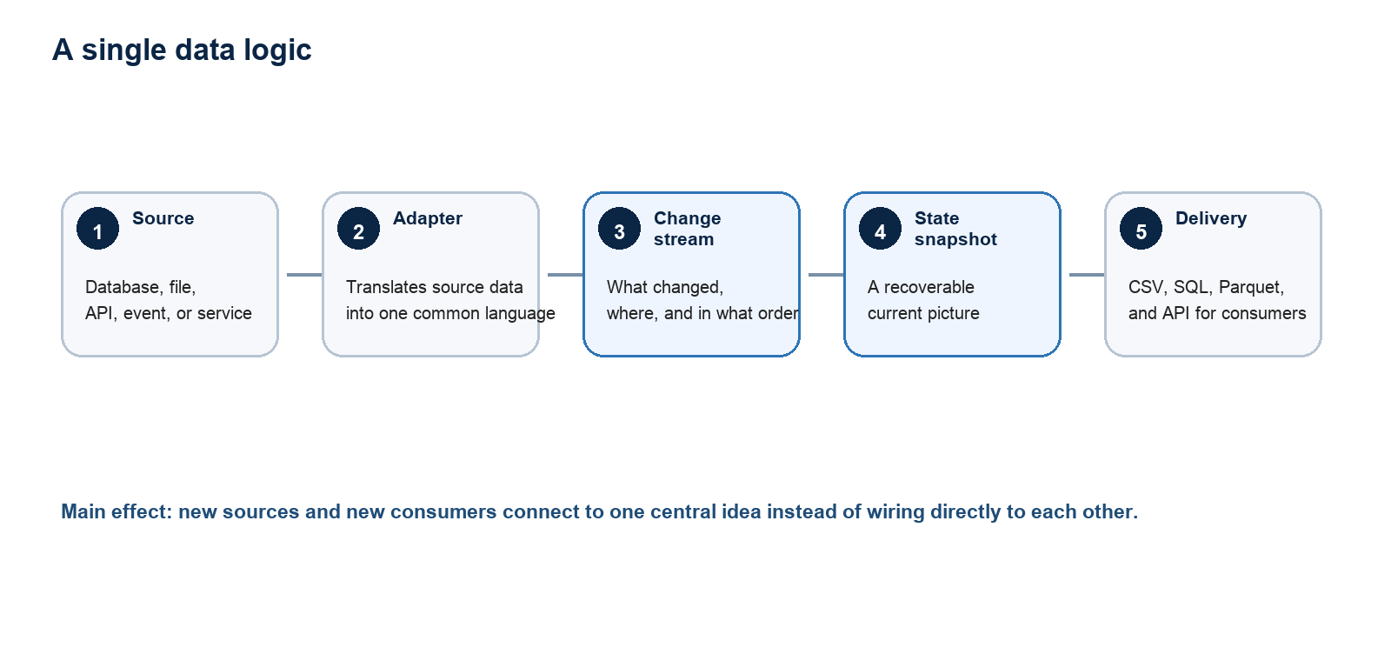
Infographic 2. Source and consumer are decoupled through a shared change language.

4. Which sources can be collected
The phrase "any source" does not mean every source is identical. It means the platform supports a small set of connection patterns, and each concrete source falls into one of them.
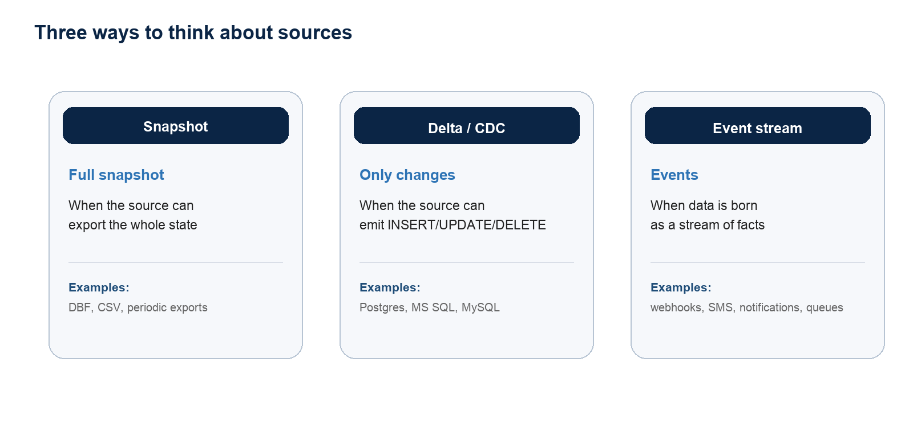
Infographic 3. Sources differ by reading pattern, but converge into one product.
The snapshot path is useful for legacy systems and files. The delta/CDC path reduces traffic and enables faster synchronization. The event-stream path is useful when data is born as events, such as notifications, SMS, webhooks, or queues.

5. Client lifecycle
The platform must be understandable not only to developers but also to data owners. Connecting a source looks like a managed lifecycle: get access, describe the data, load the initial baseline, synchronize only changes afterward, and keep a clear recovery path.
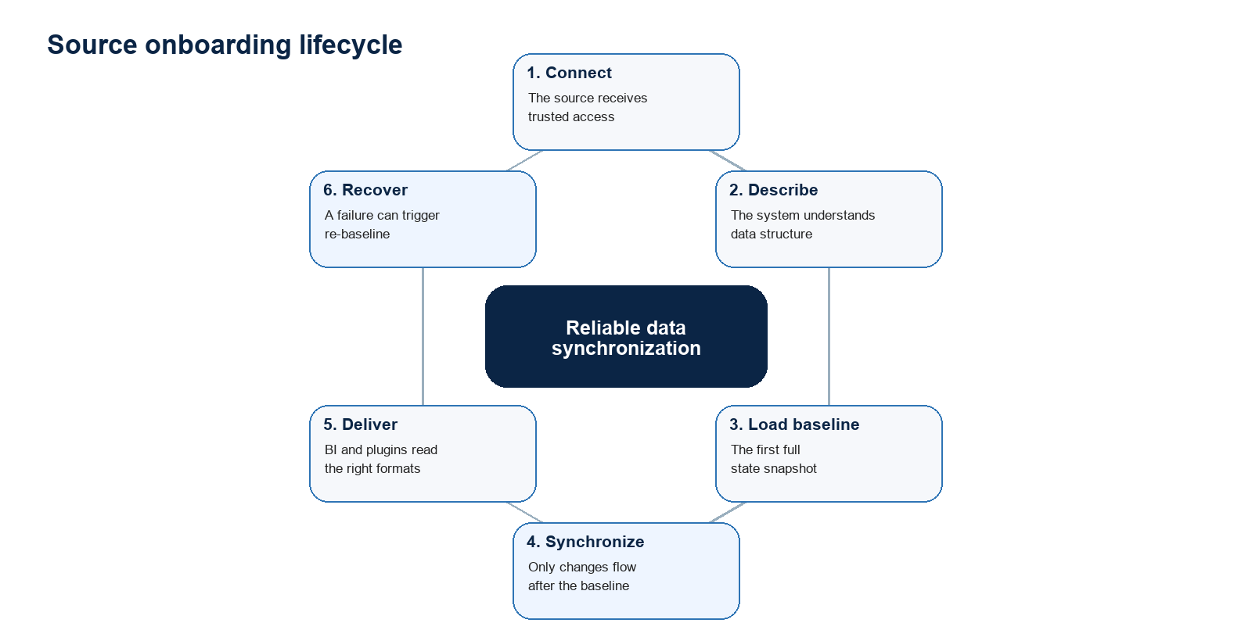
Infographic 4. The system is designed around a lifecycle, not a single endpoint.

6. Why gRPC and Protobuf
In this idea, gRPC matters not as a fashionable technology but as a way to make ingest conversational. The client sends changes, while the server can confirm progress, ask the client to resume from a specific point, or request a full re-baseline. That is a natural model for reliable synchronization.
What it provides | Product meaning
Typed Protobuf contract | Fewer implicit agreements between client and server
Bidirectional stream | Data can be accepted while ack and recovery signals flow back
Code generation | Clients are easier to build across languages and platforms
Explicit session | One change stream becomes a clear synchronization unit

HTTP still remains useful. It is a good choice for administrative APIs, legacy uploads, plugin APIs, and simple control-plane operations. The idea is not to replace everything with gRPC; it is to use the right transport for the data plane.

7. Why Parquet
Parquet is not needed for ingest. It is needed for analytics delivery. It is columnar, typed, highly compressible, and works well with incremental partition-based analytics.
Role separation: gRPC/Protobuf handles reliable change transfer, the changelog handles history, checkpoints handle recoverable state, and Parquet handles efficient analytical reads.

- CSV remains useful for legacy compatibility and products that already expect file snapshots.
- SQL remains useful for integrations where the result should be applicable to a consumer database.
- Parquet becomes the primary format for modern BI and incremental analytics.
- APIs are needed when a consumer wants controlled programmatic access instead of a file.

8. What each role gets
Role | Value
Source owner | Connects a system once and does not design a separate integration for every consumer
BI consumer | Receives data in a familiar format without knowing the source internals
Account administrator | Sees statuses, errors, sync history, and connected integrations
Support team | Gets clear signals for progress, failure, recovery, and repeat baseline loading
New adapter developer | Only translates the source into the shared change language

9. How to build a similar project from scratch
If building a similar product from a blank page, do not start from the database or the first source. Start from the durable product idea: a source reports changes, the platform accepts and confirms them, and consumers receive convenient projections.
- Define the shared change language: source, object, operation, order, key, data, and schema version.
- Separate source adapters from the platform core so Postgres, MS SQL, CSV, and APIs do not dictate architecture.
- Separate the control plane from the data plane: access management is separate from data movement.
- Make recovery part of the product: watermark, ack, resume, and re-baseline should be explicit.
- Design delivery as projections: CSV, SQL, Parquet, and APIs are built over one accepted logic.
- Do not expose internal implementation to consumers: the external contract matters more than how state is stored.

10. Boundaries of the idea
This concept does not require turning the middleware into a large analytical database or lakehouse on day one. The important thing is to keep the right boundaries: sources should not know about BI consumers, consumers should not know source details, and product logic should stay above internal implementation.
- Do not build a separate pipeline for every consumer.
- Do not expose the repository internals as part of the product idea.
- Do not mix data ingest and analytical delivery into one synchronous process.
- Do not force legacy sources to become modern stream clients immediately.
- Do not treat Parquet as an ingest-protocol replacement: it is an output format, not the client's language.

11. Final formulation
Project essence: this is a universal data synchronization layer. It receives data from different sources, translates it into a shared change language, keeps a trusted history, rebuilds the current state, and delivers results in formats needed by analytics and integrations. gRPC, Protobuf, and Parquet support that idea; they are selected tools, not the idea itself.

