(Gap 1.1)
All satellite data for this project will be accessed through the Copernicus Data Space Ecosystem (CDSE).
Primary API Choice: STAC API
The project will use the SpatioTemporal Asset Catalog (STAC) API as the primary access mechanism for both Sentinel-1 and Sentinel-2 datasets.
Rationale:
- STAC provides a standardized, sensor-agnostic metadata model suitable for multi-mission workflows.
- Strong ecosystem support in Python.
- Better aligned with scalable geospatial analytics than OData, which is optimized for transactional queries rather than spatial-temporal discovery.
Catalog-First Workflow:
- Query STAC collections using AOI geometry, date range, platform, and product-level filters.
- Inspect metadata (orbit, polarization, cloud cover, processing level).
- Generate a data availability inventory prior to pixel acquisition.
- Selectively download only assets required for analysis.
Authentication & Token Management:
- CDSE OAuth2 authentication is used to obtain access tokens.
- Tokens are programmatically refreshed within acquisition notebooks using automated renewal logic.
- Long-running batch jobs are segmented into idempotent chunks to prevent token expiration failures.
Rate Limiting & Resilience:
- API request pacing is enforced using client-side throttling.
- Retry logic with exponential backoff is implemented for all network operations.
- Failed downloads are logged and retried without re-querying the catalog.
Artifact Produced:
- A fully documented API Access Notebook demonstrating authentication, catalog queries, filtering logic, and asset retrieval.

(Gap 1.2)
The project will use Sentinel-1 Ground Range Detected (GRD) products.
Product Type Decision:
- GRD selected over SLC due to:
  - Lower preprocessing complexity.
  - Suitability for surface water detection.
  - Reduced storage and compute requirements.
Polarization Selection:
- Dual-polarization VV + VH products are ingested.
  - VV polarization captures smooth open water backscatter suppression.
  - VH provides complementary sensitivity to vegetation–water interactions, useful for floodplain analysis.
Orbit Direction:
- Both ascending and descending orbits are included.
- This improves temporal coverage and reduces acquisition gaps.
- Viewing geometry differences are preserved as metadata attributes for downstream interpretation.
Acquisition Mode:
- Interferometric Wide Swath (IW) mode, as it is the standard mode over land areas.
Documented Tradeoffs:
- Dual-pol GRD increases data volume relative to single-pol but significantly improves flood discrimination robustness.

(Gap 1.3)
Processing Level Decision:
- Level-2A (Bottom-of-Atmosphere reflectance) products are used where available.
- Justification:
  - Eliminates the need for atmospheric correction.
  - Ensures consistency across time.
  - L2A availability is sufficient for the AOI and study period.
Band Selection:
We will mainly use these bands:
Purpose | Bands
Water detection | B3 (Green), B8 (NIR), B11 (SWIR)
Vegetation context | B4 (Red), B8A (Narrow NIR)
Cloud assessment | Scene Classification Layer (SCL)
Spatial Resolution Strategy:
- All bands are resampled to a common 10m grid using nearest-neighbor resampling.
- This ensures spatial alignment with Sentinel-1 GRD products and simplifies feature fusion.
Cloud Handling:
- Cloud-contaminated pixels are masked using the SCL layer prior to analysis.

(Gap 1.4)
Geo json:
How much of the area are we covering? Does is cover enough
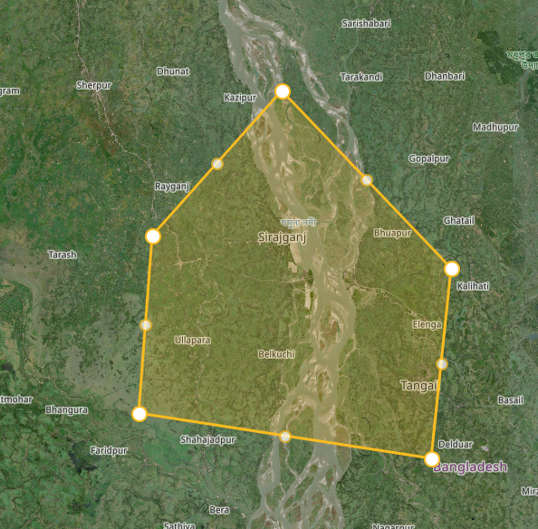
What’s the total area in km²? Storage estimate?

