VACCINE-SPECIFIC STORAGE
MONITORING & FAILURE DETECTION
A Temperature-Centered Educational Proof of Concept
Combining GARDASIL®9 Research with Simulated Cold-Chain Events, a Local Dashboard, and Read-Only ML Analysis

Research Focus: Vaccine Cold Chain, Ultralow-Temperature Distribution Data, and a Local Monitoring Prototype
Prepared for: byteSmart Internship
Date: August 2026

Table of Contents
1. Executive Summary and Research Question ........................................ 3
2. Why GARDASIL 9 Was Selected ..................................................... 4
3. Vaccine Cold Chain Fundamentals ................................................ 5
4. GARDASIL 9 Product-Specific Requirements ................................... 6
5. Refrigeration, HVAC, and Failure Mechanisms ................................. 7
6. Sensor Roles and Measurement Limitations ................................... 8
7. System Concept and Warning Logic .............................................. 9
8. Real-World Impact and Existing-System Comparison ....................... 10
9. Public Dataset Selection and Field Analysis .................................. 12
10. Exploratory Data Analysis Method ............................................. 14
11. Physical Sensor Plan and Software Prototype Status ..................... 20
12. Safe Experimental Plan ............................................................ 21
12.1 Real-World Facility Outreach and Collection Process ............ 22
12.2 Safe Facility Observation and Data-Collection Plan .............. 23
12.3 Clinical-Environment Safety, Data Boundary, and Study Protocol .. 24
13. Limitations, Future Improvements, and Conclusion ....................... 25
References .................................................................................... 27

Abstract
This report documents a staged educational project rather than a deployed vaccine-monitoring system. The completed work now includes exploratory analysis of the public ultralow-temperature COVID-19 vaccine-distribution dataset, a local simulated Temperature-event pipeline, PostgreSQL-backed event persistence, a browser dashboard, and a separate read-only ML inference service. The software prototype is designed for reproducible monitoring demonstrations; it is not a calibrated clinical instrument. The physical DHT22/BMP280 logger, facility observations, and real-vaccine experiments remain planned and have not been used to make clinical or inventory decisions.
The project distinguishes four evidence levels: completed public-dataset analysis; completed local software simulation and dashboard implementation; planned Arduino data collection; and proposed facility outreach. The public dataset supports exploratory analysis of temperature behavior, sensor spread, O₂, and CO₂ in an ultralow-temperature refrigeration test. The software prototype demonstrates event generation, persistence, operational review, and advisory ML analysis, but it does not establish GARDASIL 9 storage compliance, pharmacy performance, humidity effects, location or custody effects, or real cold-chain failures. No facility measurements, patient information, or real-vaccine experiments have been collected for this report.

1. Executive Summary and Research Question
The strongest version of this project is not a generic scanner that recognizes many vaccines. It is a focused case study that asks whether low-cost environmental telemetry can make refrigeration failures easier to detect, explain, and reproduce for one high-impact vaccine. The selected case is GARDASIL 9 because it has substantial public-health relevance, a clearly defined refrigerated storage range, an explicit warning not to freeze, and official manufacturer excursion information. That combination creates meaningful warm-side and cold-side failure scenarios without requiring an ultra-low-temperature laboratory.

Research Question
How effectively can an evidence-labeled educational monitoring workflow combine public temperature data, simulated cold-chain events, and explainable dashboard analysis to detect, describe, and visualize patterns associated with refrigeration failures relevant to GARDASIL 9 without claiming clinical validity?

Project Objectives
- Use one verified vaccine product configuration rather than a broad, error-prone product catalog.
- Make temperature the primary variable and quantify excursion start, duration, severity, and recovery.
- Use humidity to add context around door openings, warm-air entry, condensation risk, and sensor behavior.
- Use the completed notebook's elapsed time, 57 temperature channels, sensor spread, O₂, and CO₂ fields to explain what the public ultralow-temperature dataset can and cannot show, then keep those findings separate from the operational dashboard data path.
- Use deterministic synthetic Temperature events to reproduce normal operation, boundary crossings, failure, recovery, and mixed-phase behavior in a transparent local workflow.
- Demonstrate why low-cost hardware and educational ML are useful for investigation but unsuitable for compliance, potency, release, quarantine, or discard decisions.

System Boundary
Included | Excluded
Environmental sensing, logging, alerting, experiment labels, trend analysis | Patient data, clinical decisions, inventory dispensing, certified compliance
One exact vaccine product and verified limits | Automatic multi-vaccine barcode interpretation
Investigation warnings | Potency estimation or use/discard decisions
Educational cooler or supervised refrigerator tests | Testing with real vaccines
Implemented software boundary: the local prototype uses named Pods, selected vaccine profiles, synthetic Temperature events, scenario controls, uncertainty fields, operational status, PostgreSQL persistence, a read-only dashboard, and advisory inference. It does not control refrigeration equipment or automatically change affected-stock disposition.
Planned physical boundary: the DHT22/BMP280 assembly, safe cooler or supervised refrigerator tests, and permission-based facility observations remain separate from the completed software simulation. No real vaccine, patient information, or restricted facility data is used.

2. Why GARDASIL 9 Was Selected
Three practical candidates were considered: a routine 2–8°C childhood vaccine, an ultra-cold COVID-19 vaccine, and GARDASIL 9. Ultra-cold products create dramatic thermal-management problems but require equipment and temperature ranges that a DHT22 cannot measure safely or credibly. A generic routine vaccine would be easier, but the project would lose product-specific significance. GARDASIL 9 provides the best balance of public-health impact, clear manufacturer documentation, accessible experimental temperatures, and meaningful freeze sensitivity.
Candidate | Strength | Project Limitation | Decision
Ultra-cold mRNA vaccine | High visibility; complex cold chain | Sensor range and safe prototype do not match ultra-cold conditions | Not selected
Generic refrigerated vaccine | Simple 2–8°C model | Too broad; product-specific rules can differ | Not selected
GARDASIL 9, 0.5 mL prefilled syringe | Cancer-prevention relevance; 2–8°C; do not freeze; documented excursions | Prototype still cannot make disposition decisions | Selected

Exact Case-Study Product
Attribute | Verified case-study value
Trade name | GARDASIL 9
Proper name | Human Papillomavirus 9-valent Vaccine, Recombinant
Manufacturer/distributor | Merck Sharp & Dohme LLC, Rahway, New Jersey, USA
Formulation | Suspension for intramuscular injection
Presentation | 0.5 mL single-dose prefilled Luer Lock syringe with tip cap
U.S. package identifier in current labeling | NDC 0006-4121-02 (carton of ten prefilled syringes)
Routine storage | 2°C to 8°C (36°F to 46°F)
Special handling | Do not freeze; protect from light; administer as soon as possible after removal from refrigeration

The report uses the product label as the controlling source for product-specific limits. The monitoring database should record a verification date and source URL because labeling can change. The prototype should never hard-code a product requirement without documenting where it came from and when it was last checked.

3. Vaccine Cold Chain Fundamentals
A vaccine cold chain is the temperature-controlled system that begins at manufacturing, continues through distribution and transport, includes receipt and storage at the provider, and ends at administration. The chain is only as strong as its weakest link. A correctly refrigerated clinic cannot reverse damage that occurred earlier, and a properly shipped vaccine can still be compromised by poor local storage.

3.1 Why Temperature Control Matters
Vaccines are biological products. Their active components and supporting formulation can be altered by excessive heat, freezing, light exposure, repeated excursions, or inappropriate handling. Temperature damage is often invisible: a syringe may look normal even when the product requires evaluation. This is why time-stamped monitoring and documented response procedures matter more than occasional visual checks.

3.2 Cold-Chain Stages
- Manufacturing and quality release under controlled conditions.
- Cold storage at the manufacturer or distributor.
- Temperature-controlled transport with shipment monitoring.
- Receipt inspection and immediate placement into appropriate storage.
- Continuous monitoring in a purpose-built or qualified storage unit.
- Controlled removal, preparation, and administration.
- Excursion documentation, segregation, and manufacturer or immunization-program consultation when limits are exceeded.

3.3 Why Continuous Logging Is Better Than Spot Checks
A morning and afternoon thermometer reading can miss a two-hour overnight failure, repeated compressor cycling, or a brief freezing event near a cold-air outlet. CDC guidance recommends continuous digital data logging, and buffered probes are preferred because they more closely approximate vaccine temperature than a rapidly responding bare-air sensor. The Arduino prototype measures air temperature and therefore must be described as an educational early-warning and pattern-analysis tool, not a compliant substitute.
Monitoring approach | What it can reveal | What it can miss
Twice-daily manual reading | An obvious persistent out-of-range condition | Short or overnight excursions
Continuous bare-air sensor | Fast door and airflow changes | May overreact compared with product temperature
Buffered digital data logger | More representative thermal history | Requires certified device, calibration, and proper placement
Arduino prototype | Transparent data pipeline and experiments | No certification, no traceable calibration, no disposition authority

4. GARDASIL 9 Product-Specific Requirements
The current Merck prescribing information states that GARDASIL 9 should be stored refrigerated at 2°C to 8°C, should not be frozen, and should be protected from light. It also states that the product should be administered as soon as possible after removal from refrigeration. Those statements define the normal storage target for the project.

4.1 Manufacturer Excursion Information
Merck labeling provides additional excursion information: total cumulative time between 8°C and 25°C may not exceed 72 hours, and cumulative time between 0°C and 2°C may not exceed 72 hours. The label explicitly says these allowances are not storage recommendations. The prototype must therefore distinguish routine storage limits from manufacturer excursion-evaluation information.
Temperature zone | Prototype interpretation | Required human response
2°C to 8°C | Normal storage range | Continue monitoring
Above 8°C | Warm excursion condition | Document, isolate affected inventory in real use, follow SOP, contact appropriate authority
0°C to below 2°C | Cold excursion condition | Investigate cumulative duration; do not assume acceptability
Below 0°C | Potential freezing exposure | Urgent investigation; do not use prototype to decide disposition
Sensor missing/invalid | System error | Treat monitoring as unreliable and inspect equipment/device

4.2 Warning Levels for an Educational Prototype
Level | Example logic | Meaning
Green | Valid reading within 2–8°C | Condition is within the configured routine range
Yellow | Approaching limit, rapid rise, repeated door opening, or short valid excursion | Investigate trend before a larger excursion develops
Red | Reading outside 2–8°C for configured persistence or below 0°C | Immediate investigation required
System error | Missing reading, impossible value, sensor disagreement beyond configured tolerance | Data cannot be trusted

Alert thresholds and persistence settings should be configurable and documented. A yellow warning can be triggered before the product limit is crossed—for example, at 7.5°C with a positive temperature rate of change—provided the report clearly distinguishes an engineering early-warning threshold from an official storage limit.

5. Refrigeration, HVAC, and Failure Mechanisms

5.1 Refrigerator Regulation
A vaccine refrigerator removes heat from an insulated storage chamber using a refrigeration cycle. A thermostat or electronic controller monitors temperature and cycles a compressor, fan, or other cooling components. Air circulation reduces local hot and cold zones, while thermal mass helps stabilize temperatures. In professional systems, alarms and data loggers operate independently enough to reveal failures even when the refrigeration controller itself is wrong.

5.2 Room HVAC Is a Different System
Room HVAC controls the ambient room where the refrigerator operates. It does not directly regulate the vaccine compartment. However, a hot room can increase compressor workload, slow recovery after door openings, and contribute to overheating or failure. A cold room can change condensation behavior and, depending on equipment design, affect cycling. The monitoring design should therefore distinguish internal enclosure readings from optional room-ambient readings.

5.3 Common Failures and Expected Data Signatures
Failure or condition | Likely temperature pattern | Humidity/context pattern | Interpretation caution
Power loss | Sustained rise after compressor stops; slope depends on thermal mass | RH may rise or shift as warmer air enters | Pattern can resemble cooling interruption
Door left open | Rapid rise, often followed by recovery after closure | Internal RH may change sharply toward room RH | Magnitude depends on room conditions
Repeated short openings | Sawtooth temperature pattern; incomplete recovery | Repeated RH pulses | May not cross limits but indicates operational stress
Compressor failure | Gradual or accelerating warming with no normal cooling cycles | Humidity may drift | Requires equipment inspection
Fan failure or blocked vent | Local sensor divergence; hot zone near product | Humidity may differ by location | Single sensor can miss spatial variation
Damaged seal | Slow persistent warming and frequent compressor cycling | Moist ambient-air infiltration | Could be confused with high room heat load
Overcrowding/poor placement | Slow recovery and uneven temperatures | Weak diagnostic value | Requires placement audit
Sensor near vent | Artificially cold readings and possible false freeze alarm | Humidity may not resolve error | Placement can dominate data
Sensor near door | Exaggerated warm spikes | Strong RH response | Useful for door detection, poor for product estimate

6. Sensor Roles and Measurement Limitations

6.1 DHT22: Primary Educational Air Sensor
The DHT22 measures air temperature and relative humidity. It is inexpensive and easy to integrate, but it is not a calibrated vaccine data logger. Its response time, sensor-to-sensor variation, condensation behavior, placement, and enclosure airflow all affect results. A two-second minimum sampling interval is adequate for this project, but a 10–30 second interval is often more useful for clean time-series analysis.

6.2 BMP280: Secondary Temperature and Absolute Pressure
The BMP280 can still be useful in the planned physical prototype as a secondary temperature channel and a barometric-pressure sensor. The completed Colab notebook does not use BMP280 readings, humidity, pharmacy location, distribution hops, or a pressure feature. Its model features are elapsed time, mean temperature across channels, sensor spread, O₂, and CO₂. Pressure remains a prototype-design variable, not a completed notebook finding.
Variable | Sensor | Primary use | Major limitation
Temperature | DHT22 | Main excursion and recovery analysis | Air reading, not buffered product temperature
Relative humidity | DHT22 | Door-opening context, moisture pattern, condensation discussion | Not a GARDASIL 9 storage limit
Temperature | BMP280 | Cross-check and sensor-comparison exercise | Not intended as a precision air thermometer
Absolute pressure | BMP280 | Environmental context and data-quality experiment | Cannot diagnose airflow or fan failure directly

6.3 Sensor Placement Strategy
- Place the primary sensor near the center of the enclosure, away from walls, cooling vents, and the door.
- Use an empty water-filled container or other safe thermal buffer nearby to compare air spikes with slower thermal response if available.
- For placement experiments, explicitly label center, door, top, bottom, wall, and vent positions.
- Keep wires from preventing the door or lid from sealing.
- Log room temperature separately when analyzing HVAC influence.
- Never claim that one sensor location represents every point in the refrigerator.

7. System Concept and Warning Logic
The project now has two connected but distinct layers. The implemented local software prototype uses synthetic Temperature events to demonstrate cold-chain monitoring, while the DHT22/BMP280 logger remains a planned physical extension. The software does not claim that a simulated event is a measurement of GARDASIL 9 or of a real storage unit.

7.1 Implemented Software Data Flow and Planned Sensor Flow
- Generate deterministic synthetic Temperature events for a selected Pod, vaccine profile, and scenario.
- Publish events through the local MQTT path and validate or enrich them in the subscriber.
- Calculate profile-based status and temperature-uncertainty context, including borderline readings.
- Persist generic raw telemetry and vaccine-specific event fields in PostgreSQL when database writing is enabled.
- Serve the persisted event data through a read-only dashboard bridge.
- Present operational monitoring first, with all Pods as the default scope and filters for the available event dimensions.
- Expose Raw Events as the evidence view behind the operational status and trends.
- Send one inference request with optional recent context to the separately started saved-model service.
- Keep ML output advisory; it cannot release, quarantine, discard, or otherwise change affected-stock disposition.

7.2 Example Logic
if sensor_error:
alert = "SYSTEM_ERROR"
elif temperature_c < 0.0 or temperature_c > 8.0:
alert = "RED"
elif temperature_c < 2.0:
alert = "RED" # cold excursion requiring investigation
elif temperature_c >= 7.5 and rate_c_per_min > 0.1:
alert = "YELLOW" # engineering early warning, not a product limit
else:
alert = "GREEN"
# Never output "safe" or "discard".
# Output only: within configured range, excursion detected, or system error.

7.3 Failure-Detection Features Beyond Simple Thresholds
Feature | Why it matters
Persistence window | Reduces false alarms from one bad sample
Rate-of-change alert | Warns before the upper limit is crossed
Frozen-value detection | Finds a sensor that repeats the same value unrealistically
Sensor disagreement | Highlights placement or sensor faults
Recovery-time calculation | Measures how long cooling takes to restore the range
Excursion severity | Combines duration and distance beyond the limit for comparison
Door/cooling state labels | Supports controlled experiments and supervised analysis

7.4 Read-Only ML-Assisted Analysis
Exploratory data analysis and model training remain explicit offline steps. The training workflow reads the public CSV and saves model artifacts once; the local inference service loads those artifacts, accepts one Temperature event with optional recent context, and returns advisory analysis without retraining or writing to the event store.
The Inference view presents logistic regression as the primary out-of-range context and may show linear regression and k-means results as secondary context. It identifies the algorithm, model version, sample basis, and validation information when available, and reports unavailable, missing-model, invalid-request, or insufficient-data states instead of fabricating a prediction.
This software boundary is intentionally read-only. An inference request does not create or alter a stored Temperature event, operational status, affected-stock record, or disposition decision.

8. Real-World Impact and Existing-System Comparison

8.1 Where the Idea Is Useful
Setting | Potential educational or operational value
Clinic or pharmacy | Training staff to recognize excursions, placement errors, and recovery delays
Hospital | Demonstrating independent monitoring concepts and escalation workflows
Mobile vaccination program | Studying cooler behavior during repeated access and transport
Rural facility | Exploring power-loss patterns and thermal resilience where service response may be delayed
Laboratory or school | Safe, reproducible sensor experiments without real vaccines
Cold-chain training program | Visualizing why time, placement, and cumulative excursions matter

8.2 What Existing Systems Already Do Well
Certified digital data loggers, pharmaceutical refrigerators, and commercial remote-monitoring platforms already provide calibrated sensors, buffered probes, min/max history, audit trails, alarm relays, cloud dashboards, notification escalation, and regulatory support. Barcode inventory platforms can identify products and track lots, expirations, and transactions. These systems are built for reliability, traceability, validation, and service support—areas where a student Arduino prototype is intentionally weak.

8.3 What This Project Adds
- Complete visibility into how synthetic Temperature events are generated, enriched, persisted, and displayed.
- A PostgreSQL-backed evidence path linking generic raw telemetry with vaccine-specific event fields.
- An operational monitoring view that prioritizes excursions, sensor/data context, scenarios, and trends.
- A read-only Raw Events view for inspecting the persisted evidence behind dashboard status.
- A separate Inference view that exposes explainable, advisory ML results without changing operational data.
- Reproducible local scenarios for normal operation, warning, recovery, mixed phases, and deterministic outliers.

8.4 Impact Metrics That Can Be Measured Honestly
Metric | Definition
Detection delay | Time from controlled failure start to first warning
Excursion duration | Time outside the configured 2–8°C range
Peak deviation | Maximum distance above 8°C or below 2°C
Recovery time | Time from cooling restoration or door closure until stable return to range
Warning lead time | Time between yellow early warning and official-limit crossing
False-warning rate | Warnings during labeled normal operation
Sensor disagreement | Absolute DHT22–BMP280 temperature difference

9. Public Dataset Selection and Field Analysis

9.1 Primary Dataset
The primary completed analysis uses “Dataset of ultralow temperature refrigeration for COVID-19 vaccine distribution solution,” published by Sun et al. in Scientific Data and hosted on figshare. The study reports laboratory tests of a refrigerated container, including air-temperature distribution, vaccine-package temperature measurements, O₂ and CO₂ concentrations, and dry-ice observations. The notebook supplied with this report loads Test1_TempCO2O2.csv after the first two metadata rows, so the machine-learning results reported here are specifically about that Test 1 file. This is an ultralow-temperature COVID-19 distribution dataset, not a GARDASIL 9 pharmacy-refrigerator dataset.
Dataset characteristic | Description
Source | Scientific Data article with public figshare files
Format | Two comma-separated value (CSV) files
Core measurements | Air-temperature distribution, temperatures inside vaccine packages, and in one platform CO₂ and O₂ concentration
Test context | Refrigerated container platforms, dry-ice packages, multiple thermocouple locations
Use in this project | Develop EDA methods; do not transfer ultra-cold limits to GARDASIL 9
Main limitation | Not a clinic refrigerator and not a GARDASIL 9 dataset; field names and sampling structure are test-specific

9.2 Backup Dataset
A secondary or backup dataset may be useful later, but no backup dataset is used for the reported model results. The previous discussion of a Kaggle vaccine-distribution dataset should therefore be treated as a possible future source rather than evidence in this report. Any new dataset must be documented with its source, field definitions, sensor method, units, known limitations, and whether it contains confirmed operational events.

9.3 Why the Project Should Create Its Own Dataset
A strong vaccine-specific, openly documented dataset containing DHT22 temperature, humidity, BMP280 temperature and pressure, door state, cooling state, sensor position, controlled-failure labels, and recovery periods is difficult to find. Creating that dataset is therefore one of the most valuable outputs of the internship. The novelty is not claiming medical validity; it is producing a transparent, labeled educational dataset that future students can reproduce and critique.

9.4 Proposed Dataset Field Dictionary
Field | Type | Unit | Meaning | Cleaning | Analytical purpose
timestamp | datetime | ISO 8601 | Sample time | Parse, timezone check | Time axis and durations
trial_id | text | — | Experiment run identifier | Trim/validate | Group comparisons
vaccine_id | text | — | Fixed project vaccine record | Validate constant | Trace configuration
dht22_temp_c | float | °C | Primary air temperature | Coerce numeric; range check | Excursions
relative_humidity_pct | float | % RH | Supporting humidity | 0–100 check | Door/moisture context
bmp280_temp_c | float | °C | Secondary temperature | Coerce numeric | Sensor comparison
bmp280_pressure_hpa | float | hPa | Absolute pressure | Optional; range check | Exploratory context
sensor_location | category | — | Center, door, vent, etc. | Normalize labels | Placement analysis
door_state | category | open/closed | Manual or switch label | Validate values | Door-event comparison
cooling_state | category | on/off/unknown | Controlled condition | Validate values | Failure comparison
operating_condition | category | — | Normal or experiment label | Normalize | Box plots/groups
alert_level | category | green/yellow/red/error | Calculated state | Recalculate to verify | Alert analysis
excursion_status | boolean | — | Outside routine range | Calculate | Event grouping
excursion_duration_s | float | seconds | Current event duration | Nonnegative check | Severity
notes | text | — | Manual observations | Standardize | Interpretation context

10. Exploratory Data Analysis Method

10.1 Data Preparation in the Provided Colab Notebook
- Locate the 14888121 dataset archive in Google Drive, extract it, and load Test1_TempCO2O2.csv.
- Skip the first two metadata rows, then convert the “Time Elapsed” field to elapsed hours.
- Convert candidate measurement columns to numeric values, coercing invalid entries to missing values.
- Identify usable temperature columns while excluding hours, O₂, CO₂, Ambient, and unnamed non-measurement columns.
- Create a modeling table with elapsed hours, O₂, CO₂, and all usable temperature channels.
- Calculate mean temperature across the usable channels and sensor spread as the warmest channel minus the coldest channel.
- Drop rows missing mean temperature, sensor spread, O₂, or CO₂ before fitting the notebook models.

10.2 Feature Construction and Next-Reading Target
data['mean_temperature'] = data[temp_columns].mean(axis=1)
data['sensor_spread'] = data[temp_columns].max(axis=1) - data[temp_columns].min(axis=1)
data['next_temperature'] = data['mean_temperature'].shift(-1)
data['next_change'] = data['next_temperature'] - data['mean_temperature']
features = ['hours', 'mean_temperature', 'sensor_spread', 'O2', 'CO2']

10.3 Core Colab Questions and Units
The provided Colab can examine whether existing temperature channels are related, what available features are associated with the next temperature change, whether unusually large changes can be flagged for review, whether the next reading is relatively warm within this dataset, and whether rows form descriptive temperature-pattern groups. It does not establish product-specific vaccine excursions, recovery time, freezing exposure, confirmed door events, or real-facility performance because the necessary thresholds and verified event labels are absent.
Core questions: (1) Can one existing temperature sensor help estimate another? (2) Which available factors are associated with the next mean-temperature change? (3) Can a dataset-relative label identify windows that need investigation? (4) What is the probability that the next reading is relatively warm? (5) Can K-means group similar rows using mean temperature and sensor spread?
Unit check: temperature and sensor spread are expressed in degrees Fahrenheit; elapsed time is in hours; O₂ and CO₂ are percentage readings; probability is expressed as a percentage; and binary labels and cluster identities are unitless. The next-reading interval is determined by the source data’s sampling interval and must be documented when results are reported.

Vaccine distribution with temperature logging

10.5A Core Questions and Paper-Ready Definitions
The provided Colab uses the five core questions above. “Relatively warm,” “stable,” “needs investigation,” and “next reading” are defined below so the paper uses the same terms as the analysis and does not turn a dataset-relative pattern into a vaccine-storage decision.
Term | Definition
Relatively warm | A temperature reading at or above the 90th percentile of observed temperatures. This is a dataset-relative label, not a vaccine-storage limit.
Stable | A period in which temperature changes only slightly between readings and remains within a chosen tolerance. For example, the average temperature may change by less than a documented amount during one sampling interval.
Needs investigation | A reading or time window flagged because it shows an unusually large temperature deviation, a rapid temperature change, or unusually large disagreement among temperature channels. It means “review this condition,” not “the vaccine is unusable.”
Next reading | The measurement collected immediately after the current measurement. Its time length depends on the dataset’s documented sampling interval, such as 10 seconds or 1 minute.
All thresholds used in this educational analysis are based on the observed dataset unless otherwise stated. They are designed to identify patterns requiring review and are not manufacturer-approved vaccine storage limits.

10.6 Dataset Description and Scope
The provided Colab uses Test1_TempCO2O2.csv from the Sun et al. figshare archive (record 14888121). The file contains elapsed time, multiple temperature channels, O₂, and CO₂. The notebook intentionally analyzes this one Test 1 file. It should not be described as a pharmacy, distribution-hop, humidity, or routine 2–8°C refrigerator dataset.
The public test data are useful for practicing reproducible data cleaning, sensor comparison, next-reading analysis, logistic regression with a constructed review label, and unsupervised clustering. They are evidence about an ultralow-temperature experimental setting only. They do not prove how GARDASIL 9, a local pharmacy, or a real facility’s refrigeration system performed.

10.7 Data Cleaning and Preparation Actually Performed
The Colab locates the archive, extracts it, reads Test1_TempCO2O2.csv after the first two metadata rows, converts Time Elapsed to hours, and coerces candidate measurement columns to numeric values. It builds the analysis table from hours, O₂, CO₂, and usable temperature channels; then it calculates mean temperature and sensor spread and drops incomplete model rows.
For next-reading models, the Colab shifts mean temperature by one row to create next_temperature and subtracts the current mean to create next_change. The models use hours, mean temperature, sensor spread, O₂, and CO₂ as features. This preparation creates analytical targets, not confirmed failure labels or vaccine-viability outcomes.

10.8 Definition of Prediction Targets
Sensor-validation target: one existing temperature channel predicts another existing temperature channel. This is a consistency check only; it does not calibrate either channel or prove that either sensor is correct.
Next-temperature-change target: next_change is the immediately following mean temperature minus the current mean temperature. A positive value means the next reading is warmer. The time represented by “next” depends on the source dataset’s sampling interval.
Needs-investigation proxy: a binary label equal to 1 when the absolute next-temperature change is at or above the 90th percentile of observed absolute changes. It is a review label constructed from this dataset, not a confirmed equipment failure, vaccine excursion, or safety decision.
Relatively-warm proxy: a binary label equal to 1 when the next temperature is at or above the 90th percentile of observed next temperatures. It is dataset-relative and is not a manufacturer-approved vaccine-storage limit.

10.9 Evaluation Status and Required Next Step
The provided Colab fits and displays its models on the available Test 1 data. It does not contain a held-out train/test split, so it does not establish out-of-sample model performance. Any future predictive version should split time-ordered data into earlier training and later testing periods to reduce leakage between adjacent readings.
A later evaluation should report a confusion matrix and class-sensitive measures such as precision, recall, and F1 for the binary proxy labels. Accuracy alone is not enough for a constructed label with roughly 10% positive observations. Until those steps are completed, all model outputs in this paper are exploratory.

10.10 Linear Regression Method and Results
Method. The first linear-regression example fits one selected temperature channel to another and prints R² after the notebook is run. Its purpose is to show whether the two channels have a consistent fitted relationship, not to establish calibration.
Interpretation. A stronger fitted relationship can support a sensor-agreement screen, while large residuals may deserve review for local variation, placement, or sensor behavior. The exact R² must be taken from the executed Colab output for the source file being analyzed.
Method. A second linear model predicts next_change from hours, mean temperature, sensor spread, O₂, and CO₂. The Colab also standardizes the predictors and target before plotting fitted coefficient directions so the feature associations can be compared.
Interpretation. The notebook’s R² should be read as the amount of next-reading-change variation explained by this limited feature set. It shows association in the supplied data, not cause. Missing operational controls, event labels, and time-history features limit what the model can explain.

10.11 Logistic Regression Method and Results
Method. Logistic regression uses the same five features to estimate a probability for dataset-relative binary labels. The Colab sets class_weight="balanced" for the needs-investigation proxy because the label is created from the largest 10% of absolute next-reading changes.
Interpretation. A predicted probability is the model’s estimate of the constructed label, not a clinical probability and not a decision about vaccine usability. The Colab can rank patterns for review, but it cannot confirm a failure without externally verified labels.
The relatively warm model estimates whether the next observation belongs to the warmest 10% of next readings in this dataset. It can highlight relatively warm patterns, but it cannot estimate the chance that a real vaccine crosses a manufacturer's temperature limit.

10.12 K-Means Method and Corrected Results
Method. K-means is unsupervised, so it has no prediction target or confirmed outcome. The provided Colab clusters valid rows using mean temperature and sensor spread with three clusters, random_state=42, and n_init=10.
Interpretation. The result is three descriptive groups in the space of mean temperature and sensor spread. Cluster labels are arbitrary and must not be called stable, warming, safe, unsafe, or caused by a specific event unless external evidence supports that claim.

10.13 Visualizations from the Updated Colab Notebook
The following six figures are the visualizations implemented by the updated Colab notebook. They are included because each directly answers one of the notebook’s stated exploratory questions. They are dataset-relative and do not represent a manufacturer-approved vaccine-storage decision.
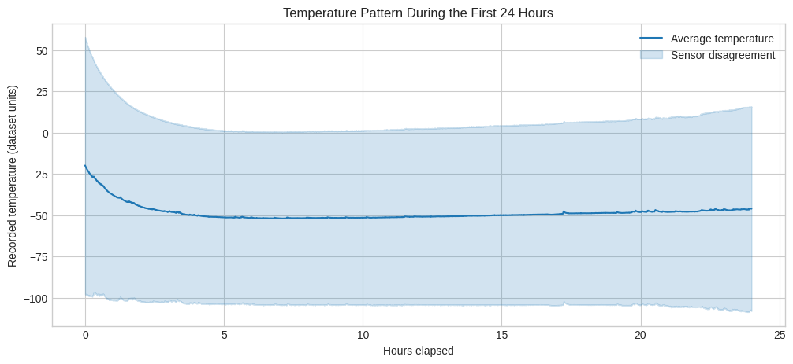
Figure 1. Temperature pattern during the first 24 hours. The line is mean temperature across usable channels and the shaded band shows sensor spread. Source: updated ML_questions_Ultralow_Vaccine_Distribution_Data Colab visualization.
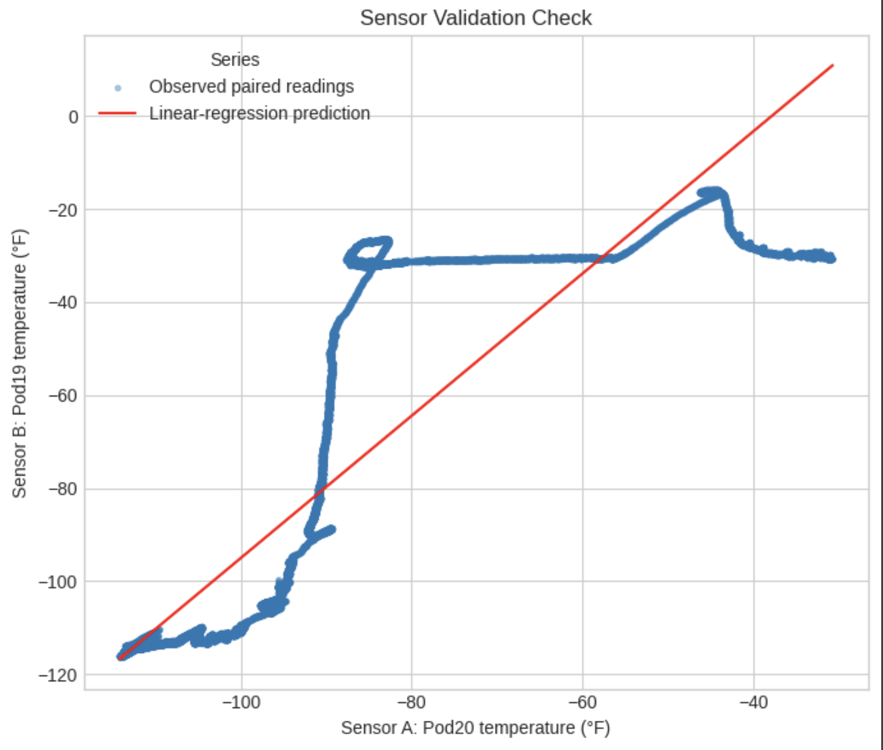
Figure 2. Sensor-validation check. One existing temperature channel is used to estimate another; deviations from the fitted relationship prompt review, not a calibration claim. Source: updated Colab visualization.
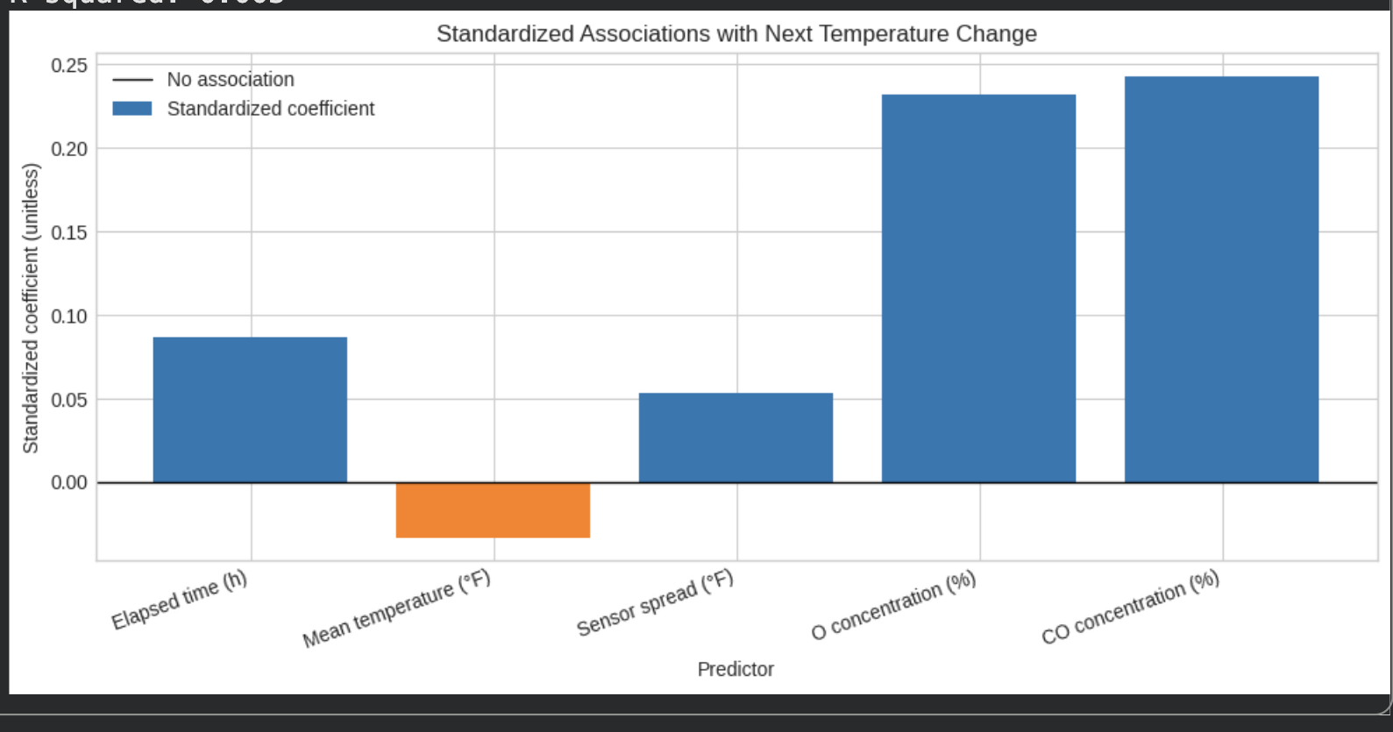
Figure 3. Standardized associations with next temperature change. The predictors are elapsed time, mean temperature, sensor spread, O₂, and CO₂; bars show fitted association, not causation. Source: updated Colab visualization.
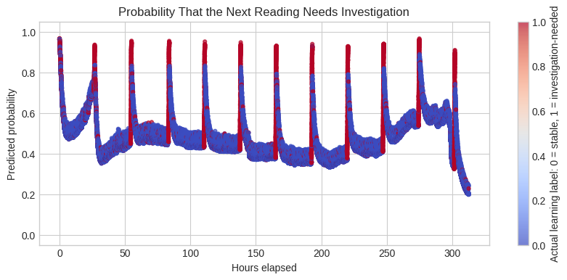
Figure 4. Predicted probability that the next reading needs investigation. The label is based on the 10% largest absolute next-reading changes in this dataset, so it indicates review rather than a confirmed failure. Source: updated Colab visualization.
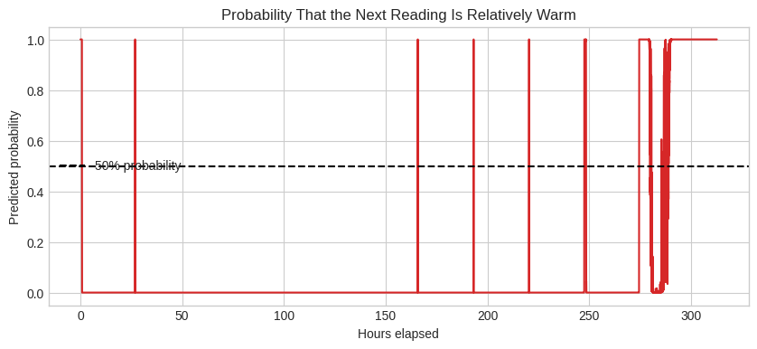
Figure 5. Predicted probability that the next reading is relatively warm. “Relatively warm” means at or above the 90th percentile of observed next temperatures; it is not a vaccine-storage limit. Source: updated Colab visualization.
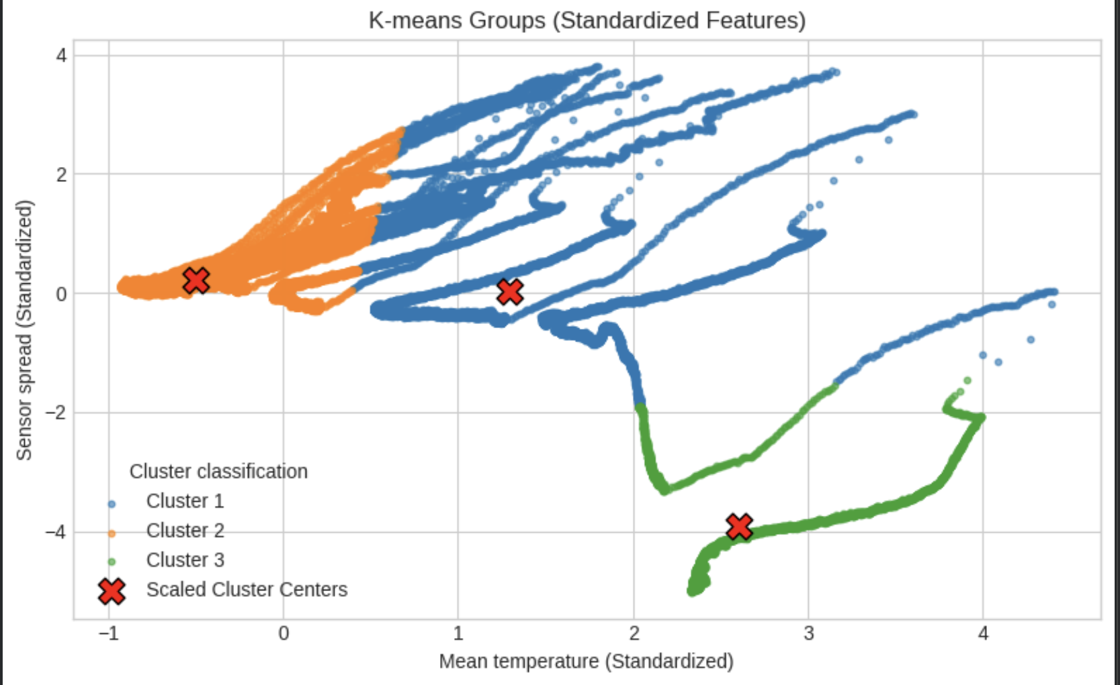
Figure 6. K-means groups of similar temperature behavior based on mean temperature and sensor spread. Cluster labels are descriptive and do not identify confirmed operating states or causes. Source: updated Colab visualization.

11. Physical Sensor Plan and Software Prototype Status
Project status: the Arduino Uno R4 Minima has been set up in the Arduino IDE, the correct board and USB connection were configured, and basic programs such as Blink were run successfully. Separately, the local software prototype now generates synthetic Temperature events, streams them through MQTT, persists them in PostgreSQL, and displays them in a read-only dashboard with Analytics, Raw Events, and Inference surfaces. The DHT22/BMP280 monitoring assembly, long-duration physical logging, and refrigerator or facility data collection are still planned; no physical sensor measurements are represented as completed results in this report.

11.1 Minimum Functional Requirements and Implemented Software Boundary
- Implemented: generate deterministic events for selected Pods, vaccine profiles, and monitoring scenarios.
- Implemented: validate event structure, derive status, and attach temperature-uncertainty context.
- Implemented: persist generic raw events and vaccine-specific temperature events with verification queries.
- Implemented: display operational analytics and read-only raw-event evidence in the local dashboard.
- Implemented: submit one event for advisory inference using saved model artifacts without retraining.
- Planned: connect the DHT22/BMP280 assembly and compare physical readings with a documented reference instrument.
- Boundary: never output a potency, safety, use, release, quarantine, or discard decision.

12. Safe Experimental Plan
All future controlled experiments will use an insulated cooler, reusable cold packs, empty containers representing vaccine packages, or a supervised small refrigerator. No real vaccine, patient information, or clinical workflow will be used. Cold packs will be conditioned and separated from sensors and dummy packages to avoid uncontrolled freezing contact. Electrical components will be protected from condensation. The public ultralow-temperature dataset analysis is already complete; these physical experiments are planned work.
Experiment | Hypothesis | Control | Independent variable | Dependent variables | Interval | Duration | Trials | Expected pattern | Limitation
Stable cooling baseline | A stable enclosure will remain mostly within the configured range | Same enclosure, placement, load | No disturbance | Temperature, RH, pressure, variability | 10–30 s | 45–90 min | 3 | Small oscillations around equilibrium | No real-vaccine conclusions
Short door opening | A brief opening produces a fast air spike but short recovery | Baseline run | Door open 30 s | Peak temp, RH pulse, recovery | 10 s | 30–60 min | 3 | Transient rise and RH change | Exact pattern depends on room
Repeated openings | Repeated access prevents full recovery | Single-opening run | Five 30 s openings | Cumulative rise, sawtooth pattern | 10 s | 45–75 min | 3 | Increasing peaks or delayed recovery | Manual timing error
Extended opening | Long opening creates a clear warm excursion | Closed-door baseline | Door open 5 min | Detection delay, duration, recovery | 10 s | 60–90 min | 3 | Sustained warming | Do not overheat electronics
Cooling interruption | Loss of cooling causes a gradual persistent rise | Cooling active baseline | Unplug supervised model or remove packs | Slope, warning lead time, duration | 15–30 s | 1–3 h | 3 | Slower sustained rise | Only with supervision
Sensor placement | Placement changes measured extremes | Center placement | Door/vent/wall placement | Bias, peak difference, disagreement | 10 s | 45 min each | 3 | Door/vent sensors show larger extremes | Not all positions simultaneous
Warm object insertion | Added heat load delays recovery | Dummy load at equilibrium | Insert sealed warm-water container | Peak, recovery, spatial response | 10 s | 60–90 min | 3 | Localized rise then recovery | Use safe sealed container

11.4 Arduino Setup Completed and Planned Wiring
The completed setup is an Arduino Uno R4 Minima configured in the Arduino IDE with the correct board and USB port. Basic sketches, including Blink, were uploaded successfully. The Uno R4 Minima uses a 32-bit Renesas RA4M1 Arm Cortex-M4 microcontroller at 48 MHz and provides a practical education board for serial logging. This establishes the programming environment; it is not evidence that the sensing system has already collected refrigerator data.
The planned wiring uses the DHT22 as a digital temperature/humidity channel and the BMP280 through I²C or SPI as a secondary temperature/pressure channel. The Arduino will print one CSV row at a documented sampling interval to a connected computer. Before a long run, each sensor will be checked for missing values, impossible values, and disagreement with a reference thermometer if one is available. Wiring and library versions will be documented with the data file.

11.5 Sensors Used and Specifications
DHT22 (AM2302): planned primary educational air sensor. The manufacturer’s commonly cited operating range is −40°C to 80°C for temperature and 0–100% relative humidity; typical temperature accuracy is ±0.5°C and typical humidity accuracy is ±2% RH, subject to the specific device, operating conditions, and datasheet revision. It is suitable for learning and prototyping but is not a certified vaccine data logger or buffered probe.
BMP280: planned secondary channel. Bosch specifies a pressure operating range of 300–1100 hPa and temperature operating range of −40°C to 85°C; its stated typical absolute pressure accuracy is about ±1 hPa under the stated reference conditions. It communicates by I²C or SPI. Its reported pressure is barometric pressure, not a direct measure of refrigerator airflow, compressor health, or vaccine condition.
Reference instrument: future work should add a documented, calibrated thermometer or suitable buffered probe for comparison. Neither low-cost sensor will be treated as a compliance instrument. The report will distinguish air temperature, simulated product temperature, and any reference reading rather than treating them as interchangeable.

11.6 Planned Data-Collection Procedure
Each planned run will receive a unique trial identifier. Before sampling, the operator will record the date, approximate location type, sensor placement, enclosure type, the intended operating condition, and whether the run is a controlled educational test or a permitted facility observation. The logger will record timestamp, DHT22 temperature and relative humidity, BMP280 temperature and pressure, status flags, and field notes. Sampling interval, time zone, sensor library version, and any missing-data handling will be recorded in a run log.
For controlled tests, the prototype will be placed in safe locations such as the center, door-adjacent area, top, bottom, or vent-adjacent area of an empty cooler or approved test enclosure. Any planned disturbance, such as a brief opening, simulated warming, or placement comparison, will be labeled in advance. The study will not intentionally expose real vaccines to a noncompliant condition. Data will be exported in raw form first; cleaning will occur in a separate, reproducible notebook so the original log remains traceable.

12.1 Real-World Facility Outreach and Collection Process
The next field phase is outreach to local pharmacies and similar facilities that voluntarily agree to discuss storage practices. The initial purpose is to learn which locations store vaccines, what type of storage equipment and monitoring they use, where monitoring devices are placed, and whether a facility is willing to permit a educational observation. The project will begin with a one-page request, identify at least three nearby facilities, and seek permission before collecting any information.
No data will be collected in a restricted area or from a refrigerator without explicit site permission. The project will not photograph labels, inventory, patient records, staff schedules, or any personally identifiable or protected health information. If a facility declines, no data are collected. If a facility allows an observation, the dataset will use a coded facility identifier and general facility type rather than a public name or street address unless the facility expressly authorizes identification.
A permitted observation form will include: facility code; general location category; equipment type; whether the unit is intended for vaccines; existing monitoring type; approximate sensor/probe placement; staff-described alert or documentation practice; observation date; permission scope; and a note stating whether measurements were collected by the facility’s existing system or by the educational prototype. Facility information will be descriptive context, not a performance ranking or compliance assessment.

12.2 Safe Facility Observation and Data-Collection Plan
Purpose and scope. This is a permission-based, educational observation plan for learning how a participating facility monitors vaccine-storage conditions. It is not an inspection, a compliance audit, a product-quality assessment, or a test involving real vaccine inventory. The initial 20-minute meeting is only an overview: it gives the student time to introduce the project, explain its purpose and reasoning, describe the Arduino prototype, and answer questions. It is not the data-collection session.
Before the visit. The student will request permission in advance, explain the educational purpose, and agree on the areas, equipment, and data categories that may be observed. The facility may decline any question, limit access, request a change in sensor location, or end the visit at any time. The student will bring only a clean, battery-powered Arduino prototype and a blank observation form; no device will be connected to facility power, Wi-Fi, or internal systems.
Initial overview and facility-approved data collection. During the first 20-minute overview, confirm staff permission and explain the project boundary, the data fields, the privacy safeguards, the Arduino prototype, and why the study is being conducted. If the facility chooses to participate, schedule or agree on a separate data-collection period. That collection period will last for an amount of time that is appropriate for the research question, sampling interval, facility approval, and normal operations; it is not limited to 20 minutes. With a staff escort when required, place the prototype only in an approved non-contact location and collect time-stamped ambient readings for the approved duration. The student will not open refrigerator doors, move products, alter controls, block airflow, unplug equipment, or ask staff to change normal work practices. At the end of collection, remove the prototype and confirm what information was recorded.
Information that may be collected. The planned dataset may include facility code, general location category, date and time, storage-unit category, sensor identifier, approved sensor position, temperature, relative humidity, pressure, sampling interval, existing monitoring type, data-quality flags, and brief non-identifying notes about the session. Measurements from the educational prototype will be labeled separately from information voluntarily described by facility staff or visible on an approved existing display.
Information that will not be collected. The project will not collect patient, customer, or staff names; medical information; vaccine lot numbers; inventory counts; schedules; passwords; internal network information; security details; proprietary procedures; photographs; audio recordings; or any information from labels or records. A facility name or street address will not be published unless the facility explicitly gives written permission.
Safety and stop rules. The prototype will remain outside restricted, sterile, hazardous, and medication-handling areas unless the facility gives explicit approval and staff supervision. The student will stop immediately if a staff member requests it, if access or safety conditions change, if sensitive information could be exposed, or if the device could interfere with operations. Any unusual reading will be described only as a condition for review. The student will not state that a vaccine is safe, unsafe, usable, unusable, compliant, or noncompliant; facility staff will follow their own SOPs and approved escalation procedures.
Data handling and follow-up. Raw logs will be saved with a coded facility identifier, preserved as a read-only original, and stored in access-restricted project storage. Notes will be de-identified before analysis, and results will be reported in aggregate unless the facility authorizes identification. The facility may ask to review the recorded non-sensitive session summary or request deletion of its coded observation before it is used. Any project requirements for school, program, or facility approval will be completed before a visit.
Interpretation boundary. This plan can generate an educational dataset about monitoring context and short, approved environmental observations. It cannot validate a refrigerator, replace a calibrated digital data logger, determine vaccine potency, or make a storage-disposition decision. All findings will be framed as descriptive evidence that may guide future engineering experiments, not as a judgment about a participating facility.

12.3 Clinical-Environment Safety, Data Boundary, and Study Protocol
Clinical boundary. A clinic’s certified digital data logger (DDL), its calibration record, its vaccine manufacturer instructions, and its written procedures remain the only operational controls for live vaccine storage. CDC recommends—and the Vaccines for Children program requires—a continuous DDL with a current calibration certificate for units holding public vaccine; the logger is typically configured to record at least every 30 minutes and uses a buffered probe to better approximate product temperature. The Arduino prototype is educational only. It will not be placed in a live vaccine-storage unit, connected to a facility system, used to compare against or replace the DDL, or used to trigger an alert, inventory action, or storage decision (CDC, 2024; CDC, 2025).
Authorization before any visit. Before entering a clinical area or collecting any information, the student will obtain written approval from the designated facility contact and agree on the precise areas, dates, collection mode, allowed data fields, supervision requirements, device location, duration, and data-retention plan. The facility may revise the scope, stop the visit, or require staff escort at any time. If the work is intended to contribute to generalizable research rather than only an educational project, the student will first obtain a determination from the school’s or sponsoring institution’s IRB or other designated review process; the student will not self-classify the work as exempt.
Three permitted collection modes. Mode A is a visual-only observation: under staff supervision, record only approved high-level facts such as the storage-unit category, the presence and general placement of the official probe, and the monitoring workflow. Mode B is an isolated-environment test: place the Arduino in a non-live backup refrigerator, empty training unit, approved transport cooler, or other facility-approved nonclinical enclosure. Any door opening or other test condition must be initiated and supervised by facility staff, never by the student, and must not involve live vaccines. Mode C is a structured staff interview: collect staff-approved descriptions of monitoring, alarm response, placement rationale, and recurring non-sensitive operational concerns. A refusal to allow hardware does not prevent useful Mode A or Mode C data collection.
On-site safety controls. The prototype must be clean, battery powered, visibly labeled as an educational device, and physically secured so it cannot obstruct airflow, doors, shelves, medication handling, cleaning, or emergency access. It will not use facility power, Wi-Fi, Bluetooth pairing, USB ports, networks, or cloud accounts. The student will follow the site’s visitor, infection-control, escort, hand-hygiene, PPE, and restricted-area rules. The student will not touch inventory, controls, outlets, probes, screens, or equipment; open a storage unit; simulate a failure in a live unit; or ask staff to depart from normal operations. The session stops immediately if patient care, privacy, safety, workflow, or equipment access could be affected.
Privacy and information boundary. The study will not collect, view intentionally, photograph, record, or transcribe patient information, appointment schedules, names, staff identifiers, medical records, prescription labels, vaccine recipient data, lot numbers, expiration dates, inventory counts, shipment records, screen contents, passwords, network information, or security layouts. HIPAA protects individually identifiable health information held by covered entities; therefore, the protocol is designed to avoid PHI entirely rather than rely on later de-identification. No photographs, audio, or video will be taken unless the facility separately authorizes a narrowly defined, PHI-safe image process in writing (HHS, n.d.).
Usable data that may be collected. With explicit approval, the project may record a coded facility ID; general facility type; non-identifying storage-unit category; general probe placement category; whether the official system uses a buffered probe; staff-approved sampling interval or alert-persistence category; general room context; session start and end time; Arduino sensor ID and approved location; temperature, relative humidity, pressure, sampling interval, and data-quality flags from a non-live test; and non-identifying staff event labels such as delivery period, scheduled cleaning, or door-access period. Exact device serial numbers, active alarm settings, and raw official DDL downloads are excluded unless the facility’s privacy and compliance contact expressly authorizes a separate written data-sharing arrangement.
Data duration and quality plan. The initial 20-minute meeting is only for explaining the project and agreeing on scope. For an approved non-live test, collect a baseline long enough to observe normal cooling cycles and operating variation—preferably seven consecutive days at a one-minute educational sampling interval, with a shorter pilot permitted if the facility requires it. Preserve the original CSV as read-only, log all placement changes and interruptions, synchronize the device clock before deployment, and label missing readings rather than filling them silently. The project will report the number of usable observations, the collection duration, and any deviations from the approved protocol.
How the data can make an impact. The non-live telemetry can quantify temperature stability, peak-to-peak variation, rate of change, time to recover after an approved staff-led event, sensor-location differences, missing-data frequency, and recurring patterns by time of day. The interview and observation data can explain why professional systems use buffered probes, continuous logging, alarms, backup devices, and defined response procedures. Results will be shared as an aggregate educational summary or a facility-approved unit-specific summary that identifies patterns for staff review—not compliance findings, potency estimates, or recommendations to use, move, quarantine, discard, or release vaccine inventory. Any actual excursion or alarm remains under the facility’s existing SOP and manufacturer/immunization-program guidance.

13. Limitations, Future Improvements, and Conclusion

13.1 Major Limitations
- The DHT22 and BMP280 are not certified or calibrated vaccine-monitoring instruments.
- Air temperature is not identical to vaccine temperature; buffered probes intentionally respond differently.
- One or two sensors cannot describe every hot or cold zone in a storage unit.
- Absolute atmospheric pressure is not a dependable indicator of refrigerator airflow or mechanical condition.
- Cooler experiments do not reproduce the compressor, fan, insulation, load, controller, or defrost behavior of a pharmaceutical refrigerator.
- Manufacturer excursion allowances do not authorize the prototype to release the product for use.
- Public ultra-cold datasets support analytical methods but do not validate GARDASIL 9 performance.
Additional software limitation: the saved-model inference service and dashboard are educational decision support, not validated clinical or calibrated risk systems. The notebook has no held-out test split, and the logistic labels are constructed from the same data rather than confirmed events. Its probabilities therefore cannot be treated as calibrated risk probabilities. The K-means groups are descriptive only. The public data are from an ultralow-temperature laboratory test, while the implemented scenarios are synthetic and profile-driven; neither directly validates GARDASIL 9 performance in a routine storage unit.
Additional field limitation: facility outreach has not yet occurred, so this report contains a collection plan rather than pharmacy results. Facilities may differ in willingness to participate, equipment, monitoring policies, and access restrictions. A small convenience sample would not support claims about all pharmacies or the quality of vaccine storage in a region.

13.2 Future Improvements
- Add a calibrated reference thermometer and documented calibration checks.
- Use a glycol-buffered probe to compare air and simulated product temperature.
- Add a magnetic door switch and an independent power-status input.
- Use multiple temperature sensors to map spatial gradients.
- Add an SD card, real-time clock, and battery-backed logging.
- Extend the implemented local dashboard with calibrated physical-sensor input, stronger audit history, and deployment controls while preserving its read-only operational and inference boundaries.
- Publish the labeled experimental dataset and analysis notebook with versioned vaccine-source metadata.
- Investigate anomaly detection only after a strong labeled baseline exists.
Immediate future work is to assemble the DHT22/BMP280 logger, run safe labeled baseline and placement tests, finalize the one-page facility request, contact at least three nearby facilities, and document permission decisions. The analytical next step is to add a time-aware held-out evaluation, preserve metrics from the training/testing notebooks, and compare models only after labels and evaluation rules are fixed. The software prototype should continue to be tested against these physical and analytical extensions without converting advisory output into an automatic disposition decision.

13.3 Conclusion
The most defensible version of this internship project is now a staged, evidence-labeled study: a completed exploration of an ultralow-temperature public dataset; a completed local software prototype for simulated cold-chain monitoring, persistence, dashboard review, and advisory ML inference; a planned Arduino-based physical extension; and planned permission-based pharmacy facility outreach. The software demonstrates how events can be generated, stored, inspected, and analyzed while preserving a clear boundary between raw operational status and ML-assisted context. It does not validate clinical or operational decision-making.
A successful prototype will not prove that a vaccine is safe. It will prove that a student team can define a medically relevant engineering boundary, detect and quantify controlled failures, recognize sensor limitations, and build an auditable workflow that explains when professional investigation is required. That is a stronger and more honest contribution than claiming that inexpensive hobby hardware can replace commercial cold-chain systems.

References
Centers for Disease Control and Prevention. (2024). Vaccine Storage and Handling Toolkit. U.S. Department of Health and Human Services.
Centers for Disease Control and Prevention. (2024). Chapter 5: Vaccine storage and handling. Epidemiology and Prevention of Vaccine-Preventable Diseases (Pink Book).
Centers for Disease Control and Prevention. (2024). Storage and handling of immunobiologics: General best practice guidelines for immunization.
Centers for Disease Control and Prevention. (n.d.). Handling a temperature excursion in your vaccine storage unit.
Chojnacky, M. J., Miller, W. W., Strouse, G. F., & Ripple, D. C. (2013). Methods for accurate cold-chain temperature monitoring using digital data-logger thermometers. National Institute of Standards and Technology.
Food and Drug Administration. (2025). GARDASIL 9 product information and package insert.
Merck Sharp & Dohme LLC. (2025). GARDASIL 9 (Human Papillomavirus 9-valent Vaccine, Recombinant): Prescribing information.
Merck Vaccines. (2025). Storage and handling of GARDASIL 9.
Sun, J., et al. (2022). Dataset of ultralow temperature refrigeration for COVID-19 vaccine distribution solution. Scientific Data, 9.
World Health Organization. (2022). Temperature sensitivity of vaccines and vaccine cold-chain guidance.
Bosch Sensortec. (n.d.). BMP280 digital pressure sensor datasheet.
Aosong Electronics. (n.d.). AM2302/DHT22 temperature and humidity sensor technical documentation.
Yakum, M. N., Ateudjieu, J., Walter, E. A., & Watcho, P. (2015). Vaccine storage and cold chain monitoring in the North West region of Cameroon. BMC Research Notes, 8.
Kaggle contributor Manan Khanna. (n.d.). Vaccine distribution with temperature logging [Dataset]. Kaggle.
Arduino. (2026). Arduino UNO R4 Minima datasheet and user manual. https://docs.arduino.cc/resources/datasheets/ABX00080-datasheet.pdf
Bosch Sensortec. (n.d.). BMP280 digital pressure sensor: technical data and datasheet. https://www.bosch-sensortec.com/products/environmental-sensors/pressure-sensors/bmp280/
Sun, J., Zhang, M., Gehl, A., et al. (2022). Dataset of ultralow temperature refrigeration for COVID-19 vaccine distribution solution. Scientific Data, 9, 67. https://doi.org/10.1038/s41597-022-01167-y
Centers for Disease Control and Prevention. (2025). Vaccines for Children Program: Operations Guide. U.S. Department of Health and Human Services.
U.S. Department of Health and Human Services. (n.d.). Research: HIPAA Privacy Rule guidance. Office for Civil Rights. https://www.hhs.gov/hipaa/for-professionals/privacy/guidance/research/

Source-Control Note
Product-specific storage limits in this report were taken from the current Merck prescribing information reviewed in June 2026. Before any implementation or presentation, the team should re-open the FDA or manufacturer source, confirm the exact presentation, and record the new verification date. This report is an educational proof of concept and does not supersede current labeling, CDC guidance, organizational SOPs, or professional judgment.

