* Open Android Studio

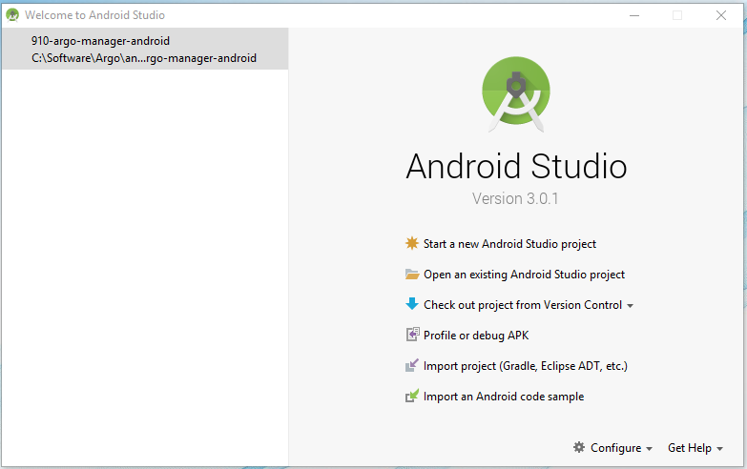

* Import Gradle project

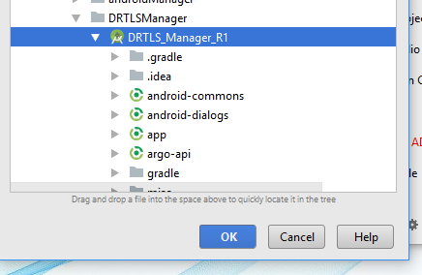

* Select Build->Build APKs …