Hydrothermally Grown In-doped ZnO Nanorods on p-GaN Films for Color-tunable Heterojunction Light-emitting-diodes

Geun Chul Park¹, Soo Min Hwang¹, Seung Muk Lee¹, Jun Hyuk Choi¹, Keun Man Song¹, Hyun You Kim², Hyun-Suk Kim³, Sung-Jin Eum⁴, Seung-Boo Jung¹, Jun Hyung Lim¹ & Jinho Joo¹
e-mail: jinho@skku.edu & lanosjh@gmail.com

¹School of Advanced Materials Science and Engineering, Sungkyunkwan University, Suwon, Gyeonggi 440-746, Korea.
²Department of Nanomaterials Engineering, Chungnam National University, Daejeon 305-764, Korea.
³Department of Materials Science and Engineering, Chungnam National University, Daejeon 305-764, Korea.
⁴HeeSung Material Ltd. 113-9, Yongin, Gyeonggi, 449-884, Korea.

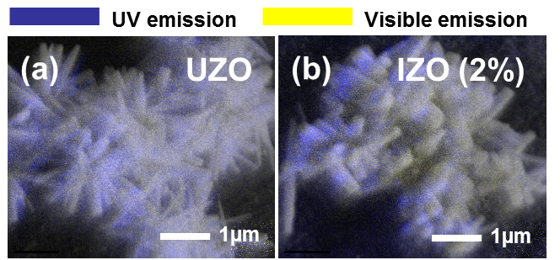

Figure S1. CL images of the (a) UZO and (b) IZO (2%) NRs.

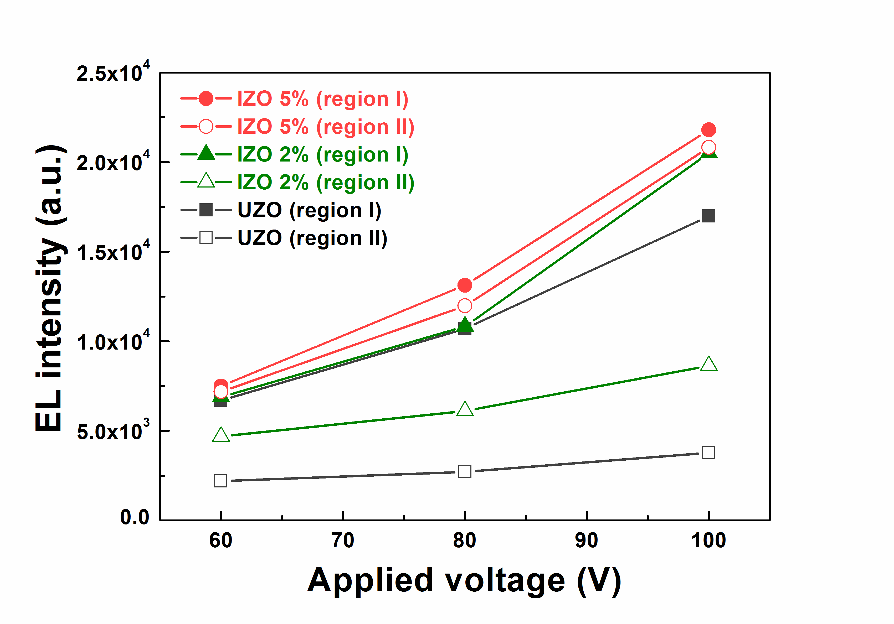
Figure S2. Integrated EL intensity of the UZO and IZO NRs/p-GaN heterojunction LEDs as a function of the applied voltages (60~100 V).
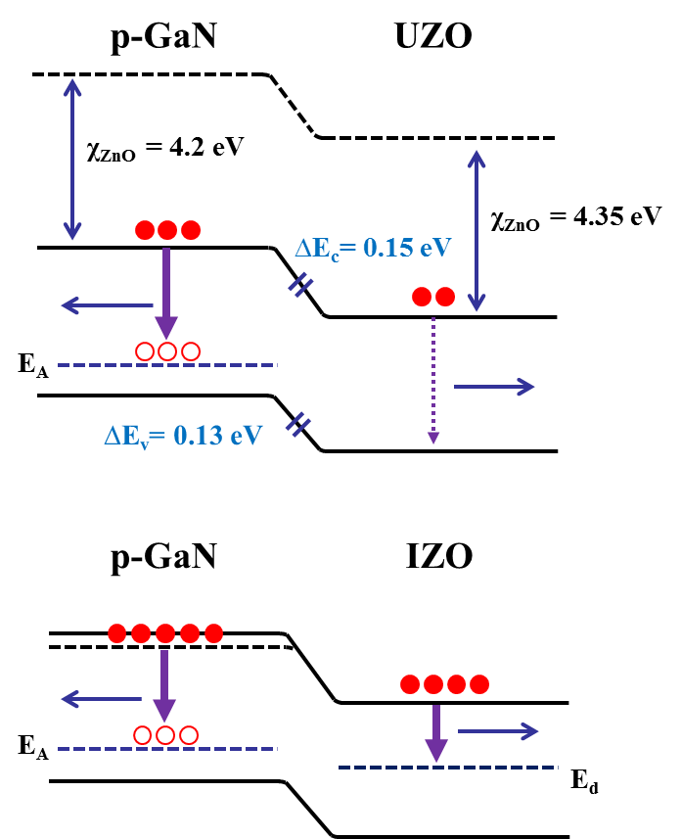

Figure S3. Energy band diagram of the ZnO NRs/p-GaN heterostructure.
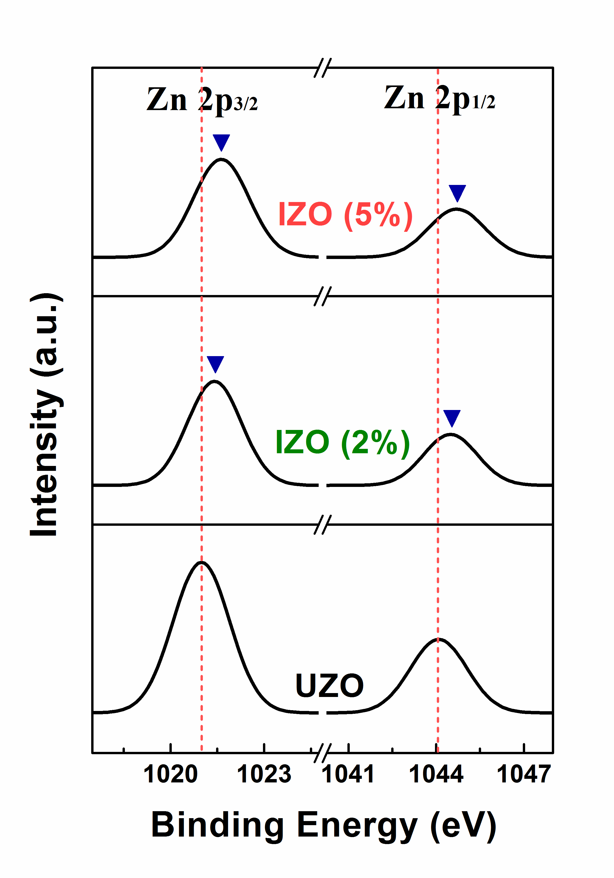
Figure S4. XPS spectra of the Zn 2p peaks of the IZO (0~5%) NRs.

