Team name: Team Nedrub

Members: Yeo Quan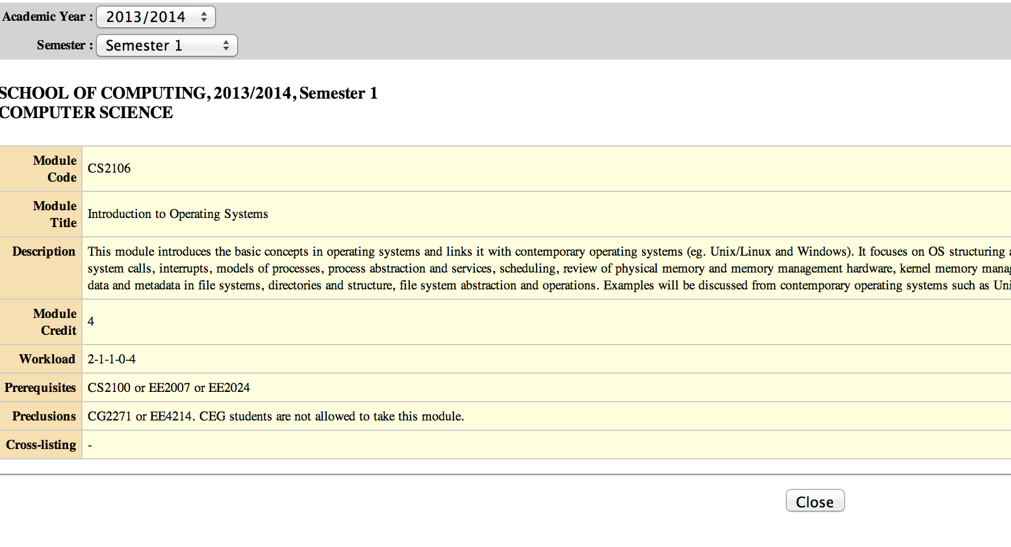 Yang, Davis Gay

Project Name: ModTree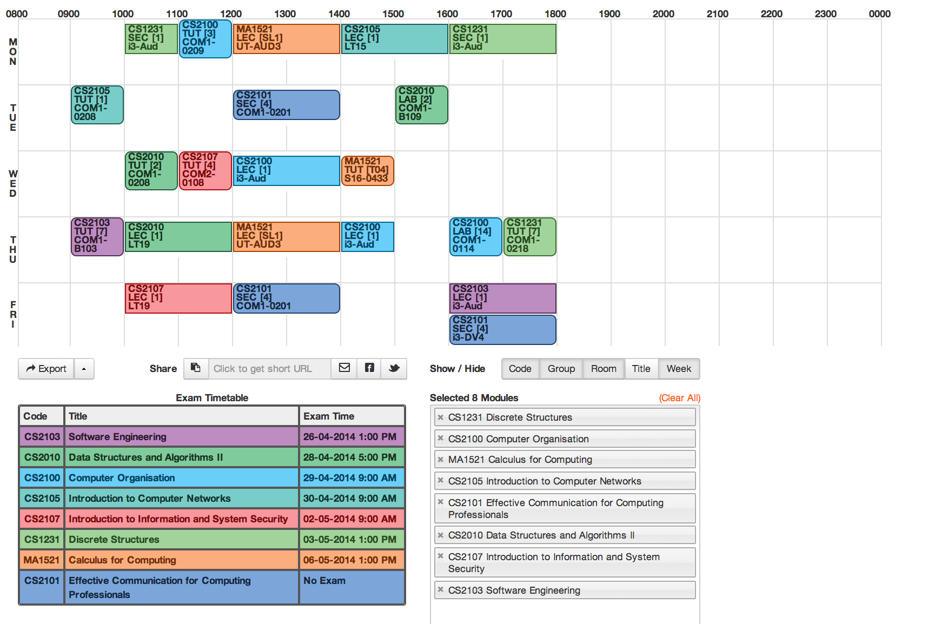

## T

## Solution:

**Y U NO EASY PLANNER**