TitleHere
Carlos Mendez
tba

Introduction
Write one sentence per line. Leave one blank line to separate paragraphs. Write one sentence per line. Leave one blank line to separate paragraphs. Write one sentence per line. Leave one blank line to separate paragraphs.
Regional inequality is a pervasive feature of the Indonesian economy (Esmara 1975; Mishra 2009; Bendesa et al. 2016). To a large extent, the insular geography and the unbalanced spatial distribution of natural resources suggest that regional inequality is an expected outcome. However, regional improvements in labor productivity may help reduce these regional imbalances and promote economic development. Moreover, since the early 2000s, major political reforms such as decentralization and democratization initiatives may have influenced the trajectories of labor productivity and its proximate determinants: physical capital, human capital, and aggregate efficiency.
The results of this paper contribute to the literature of regional development in Indonesia in three fronts. First, there is a large literature that studies provincial income disparities in Indonesia (Akita 1988; Mishra 2009; Akita, Kurniawan, and Miyata 2011). To this literature, this paper contributes an evaluation of provincial disparities in some of the main determinants of per-capita income: labor productivity, physical capital, human capital and efficiency. Second, there is a growing literature that studies provincial convergence with a focus on the dynamics of the “average” province that converges to a unique equilibrium (Garcia and Soelistianingsih 1998; Resosudarmo and Vidyattama 2006; Vidyattama 2013). To this literature, this paper provides an alternative perspective the goes beyond the dynamics of the average province. Specifically, this paper incorporates the role of provincial heterogeneity and the formation of multiple convergence clubs (multiple equilibria). Third, there is an emerging literature that studies provincial convergence in Indonesia from a convergence clubs perspective (Gunawan, Mendez, and Santos-Marquez 2019; Kurniawan, Groot, and Mulder 2019; Mendez 2020). To this literature, this paper contributes a more comprehensive evaluation of productivity-related indicators.
The rest of this paper is organized as follows. Section 2 provides an overview of the related literature. Section 3 describes the data and documents a set of stylized facts. Section 4 presents the methodological approach of the paper. Section 5 discusses the results. Finally, Section 6 offers some concluding remarks.

Related literature

Two established literatures: Productivity accounting and convergence
At least since the seminal contribution of Solow (1956), the study economic growth has emphasized the role of capital accumulation and aggregate efficiency (technological progress) for understanding labor productivity differences across countries and over time.

Other subsection

Data and stylized facts

Data construction and descriptive statistics
Data of 26 provinces over the 1990-2010 period are used to measure labor productivity and its proximate sources: capital accumulation and aggregate efficiency Based on publicly available information from the Central Bureau of Statistics of Indonesia, labor productivity is constructed by dividing real Gross Regional Domestic Product (GRDP) by the number of workers in the labor force. Based on the same data source, human capital per worker is constructed as a weighted average of the years of education of the labor force. Based on the physical capital stock estimates of Kataoka (2013), physical capital per worker is constructed by dividing provincial capital stock by the number of workers in the labor force.

Other subsection

Methodology

Convergence framework
Phillips and Sul (2007) proposed a convergence test based on the decomposition of panel data. Consider a variable, $y_{it}$, that can be decomposed as follows:
$$y_{it}=g_{it}+a_{it},$$
where $g_{it}$ is a systematic component and $a_{it}$ is a transitory component. To further separate common from idiosyncratic components, Equation is restated as follows:
$$y_{it}=\left(\frac{g_{it}+a_{it}}{μ_{t}}\right)μ_{t}=δ_{it}μ_{t},$$
where $δ_{it}$ is an idiosyncratic component and $μ_{t}$ is a common component.
Intuitively, $δ_{it}$ describes the transition path of each economy towards its own equilibrium growth path and $μ_{t}$ describes a hypothesized equilibrium growth path that is common to all economies. More formally, Equation is a dynamic factor model where the idiosyncratic component, $δ_{it}$, is a factor-loading coefficient that represents the individual distance between a common trending behavior, $μ_{t}$, and the observed variable, $y_{it}$.
Next, the following semi-parametric specification is suggested by Phillips and Sul (2007) and Phillips and Sul (2009) to characterize the dynamics of the idiosyncratic component, $δ_{it}$:
$$δ_{it}=δ_{i}+\frac{σ_{i}ξ_{it}}{log\left(t\right)t^{α}},$$
where $δ_{i}$ is constant over time but varies across economies, $ξ_{it}$ is a weakly time dependent process with mean 0 and variance 1 across economies.
Specifically, a one-sided t test with heteroskedasticity-autocorrelation consistent (HAC) standard errors is used. In this setting, the null hypothesis of convergence is rejected when $t_{b}<−1.65$.

Other subsection

Results
The log t test of convergence suggested by Phillips and Sul (2007) rejects the convergence hypothesis for labor productivity.
This is a figure that is nativaly created in this document using R
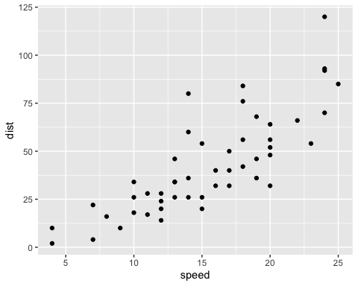
Figure 1: Title of the figure
Write one sentence per line. Leave one blank line to separate paragraphs. Write one sentence per line. Leave one blank line to separate paragraphs. Write one sentence per line. Leave one blank line to separate paragraphs.
This is a table that is nativaly created in this document using R
Table 1: A knitr kable table
speed | dist
4 | 2
4 | 10
7 | 4
7 | 22
8 | 16
Here I add a PNG figure from the results folder
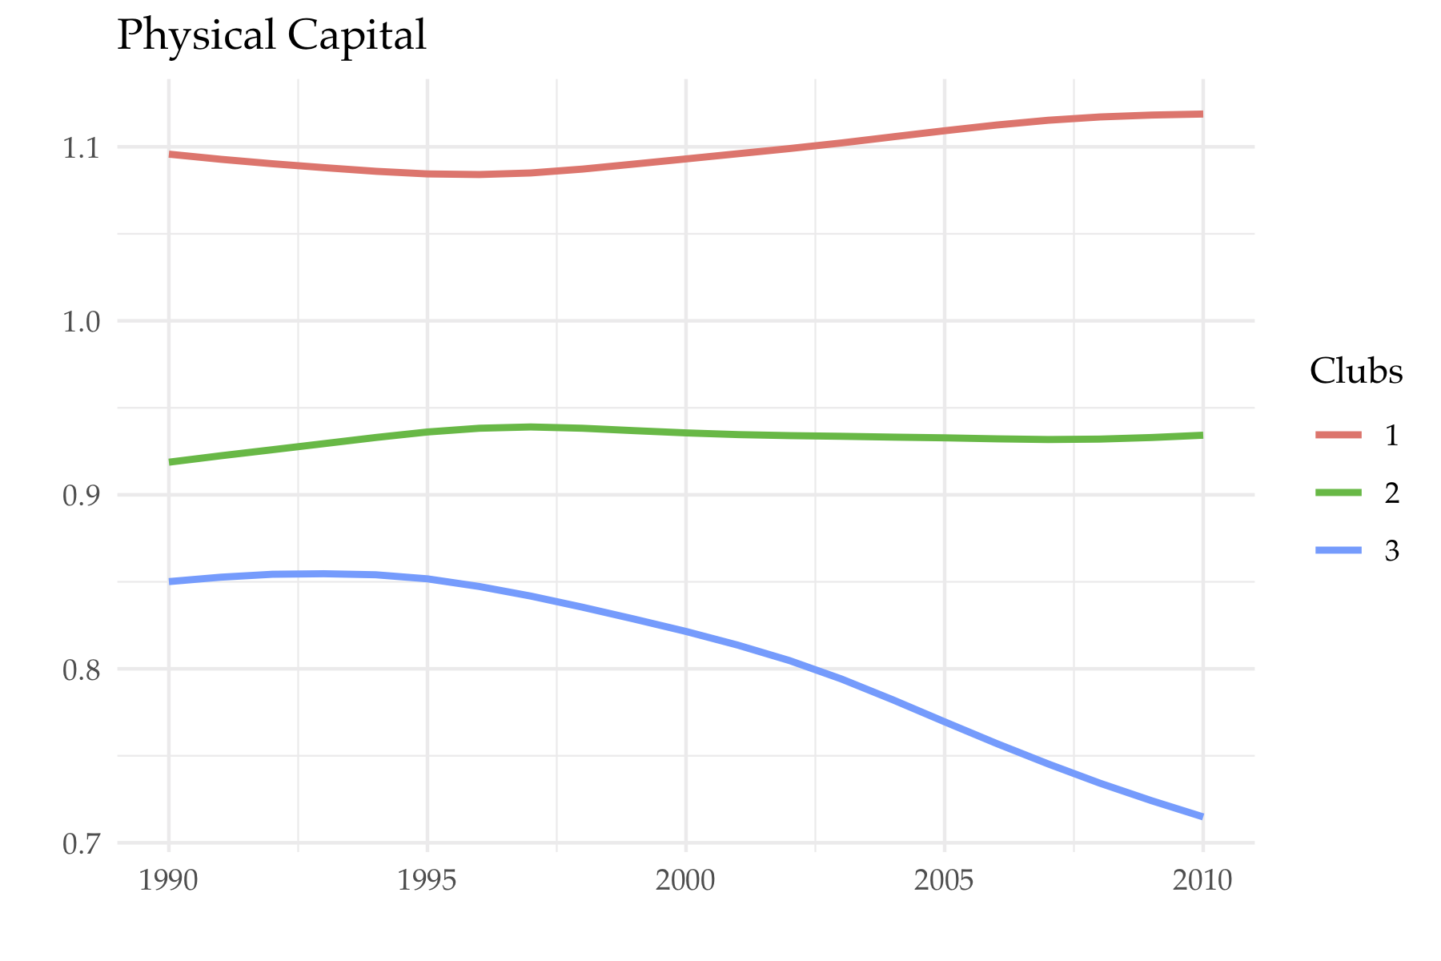
Figure 2: Figure from png

Concluding remarks
This paper studies the evolution of provincial disparities in labor productivity, physical and human capital accumulation per worker, and aggregate efficiency in Indonesia over the 1990-2010 period. In particular, the convergence test proposed by Phillips and Sul (2007) is applied to evaluate whether all provinces are converging to a common steady-state path. The results are three fold. First, there is a lack of overall convergence in labor productivity and two convergence clubs characterize its provincial dynamics. Second, the hypothesis of overall convergence is also rejected for both capital inputs. Physical and human capital per worker are characterized by three and two convergence clubs, respectively. Third, aggregate efficiency is the only production variable for which the convergence hypothesis is not rejected.

Appendix

A) Convergence clubs using a common Y axis

Labor productivity

Physical capital per worker

B) Initial (before merge) convergence clubs of physical capital per worker

References
Akita, Takahiro. 1988. “Regional Development and Income Disparities in Indonesia.” Asian Economic Journal 2 (2). Wiley Online Library: 165–91.
Akita, Takahiro, Puji Agus Kurniawan, and Sachiko Miyata. 2011. “Structural Changes and Regional Income Inequality in Indonesia: A Bidimensional Decomposition Analysis.” Asian Economic Journal 25 (1). Wiley Online Library: 55–77.
Akita, Takahiro, and Rizal Affandi Lukman. 1995. “Interregional Inequalities in Indonesia: A Sectoral Decomposition Analysis for 1975–92.” Bulletin of Indonesian Economic Studies 31 (2). Taylor & Francis: 61–81.
Bendesa, I Komang Gde, Luh Gede Meydianawathi, Hefrizal Handra, D.S. Priyarsono Djoni Hartono, Budy P. Resosudarmo, and Arief A. Yusuf. 2016. Tourism and Sustainable Regional Development. Bandung: Padjadjaran University Press.
Esmara, Hendra. 1975. “Regional Income Disparities.” Bulletin of Indonesian Economic Studies 11 (1). Taylor & Francis: 41–57.
Garcia, Jorge Garcia, and Lana Soelistianingsih. 1998. “Why Do Differences in Provincial Incomes Persist in Indonesia?” Bulletin of Indonesian Economic Studies 34 (1). Taylor & Francis: 95–120.
Gunawan, Anang, Carlos Mendez, and Felipe Santos-Marquez. 2019. “Regional Income Disparities, Distributional Convergence, and Spatial Effects: Evidence from Indonesia.” MPRA Working Paper 95972. University Library of Munich, Germany. https://ideas.repec.org/p/pra/mprapa/97090.html.
Kataoka, Mitsuhiko. 2010. “Factor Decomposition of Interregional Income Inequality Before and After Indonesia’s Economic Crisis.” Studies in Regional Science 40 (4). JAPAN SECTION OF THE REGIONAL SCIENCE ASSOCIATION INTERNATIONAL: 1061–72.
———. 2013. “Capital Stock Estimates by Province and Interprovincial Distribution in Indonesia.” Asian Economic Journal 27 (4). Wiley Online Library: 409–28.
———. 2018. “Inequality Convergence in Inefficiency and Interprovincial Income Inequality in Indonesia for 1990–2010.” Asia-Pacific Journal of Regional Science 2 (2). Springer: 297–313.
Kurniawan, Hengky, Henri LF de Groot, and Peter Mulder. 2019. “Are Poor Provinces Catching-up the Rich Provinces in Indonesia?” Regional Science Policy & Practice 11 (1). Wiley Online Library: 89–108.
Mendez, Carlos. 2019. “Regional Efficiency Dispersion, Convergence, and Efficiency Clusters: Evidence from the Provinces of Indonesia 1990-2010.” MPRA Working Paper 97090. University Library of Munich, Germany. https://ideas.repec.org/p/pra/mprapa/95972.html.
———. 2020. “Regional Efficiency Convergence and Efficiency Clusters: Evidence from the Provinces of Indonesia 1990–2010.” Asia-Pacific Journal of Regional Science https://doi.org/10.1007/s41685-020-00144-w. Springer.
Mishra, Satish Chandra. 2009. “Economic Inequality in Indonesia: Trends, Causes and Policy Response.” Colombo, UNDP Regional Office.
Phillips, Peter CB, and Donggyu Sul. 2007. “Transition Modeling and Econometric Convergence Tests.” Econometrica 75 (6). Wiley Online Library: 1771–1855.
———. 2009. “Economic Transition and Growth.” Journal of Applied Econometrics 24 (7). Wiley Online Library: 1153–85.
Resosudarmo, Budy P, and Yogi Vidyattama. 2006. “Regional Income Disparity in Indonesia: A Panel Data Analysis.” ASEAN Economic Bulletin. JSTOR, 31–44.
Sakamoto, Hiroshi. 2007. “The Dynamics of Inter-Provincial Income Distribution in Indonesia.” The International Centre for the Study of East Asian Development Working Paper 2007-25.
Solow, Robert M. 1956. “A Contribution to the Theory of Economic Growth.” The Quarterly Journal of Economics 70 (1). MIT Press: 65–94.
Vidyattama, Yogi. 2013. “Regional Convergence and the Role of the Neighbourhood Effect in Decentralised Indonesia.” Bulletin of Indonesian Economic Studies 49 (2). Taylor & Francis: 193–211.

By studying the determinants of income, this paper is also related to the literature that decomposes income differences into factors in Indonesia (Akita and Lukman 1995; Kataoka 2010, 2018).
The papers of Sakamoto (2007) and Gunawan, Mendez, and Santos-Marquez (2019), for instance, only focus on income, while the paper of Mendez (2019) only focuses on efficiency. Although Kurniawan, Groot, and Mulder (2019) evaluate four different socio-economic indicators, they do not include the dynamics of labor productivity, physical capital, and efficiency, which are the main indicators of the current paper.

