Welcome to East Detroit
Reading 1 of 4: The city, its people and its neighborhoods in 2030
Public Mechanics
Student edition, November 2026

Real, invented and undecided
East Detroit is a fictional consolidated city and county in Colorado, east of Denver International Airport. The land is real; the city, its statistics, neighborhoods and institutions are invented.
All six documents use three labels:
- REAL REFERENCE: a real place, law, organization or published figure. Sources are at the end of each document.
- SCENARIO: invented by the course. Treat it as true in the exercise.
- OPEN: not yet decided by the class.
Never present SCENARIO figures as real Census data or Colorado law.

The city in 2030
East Detroit grows like metropolitan Phoenix: fast housing growth, master-planned districts, warehousing and logistics, jobs before public facilities, old settlements meeting new development, and uneven benefits. The course starts in 2030; take the city’s size as given.
Table 1. East Detroit at a glance
Item | East Detroit in 2030 (SCENARIO)
Official name | City and County of East Detroit, Colorado
Population | 382,417
Occupied households | 155,800
Residents in group quarters | 3,823
How the population is modeled | 155,800 households × 2.43 residents + 3,823 in group quarters = 382,417
Study area | About 115.4 square miles, unsurveyed
Built-up area | About 25 square miles, averaging 15,297 people per square mile
Neighborhoods | 20 provisional neighborhoods in 5 planning regions
Most of the study area is employment land, farmland, aviation protection zones, infrastructure or open land. Assume the constitutional and legislative steps creating the city-county are done. Its charter design, intergovernmental agreements, service platform and administrative structure are OPEN.
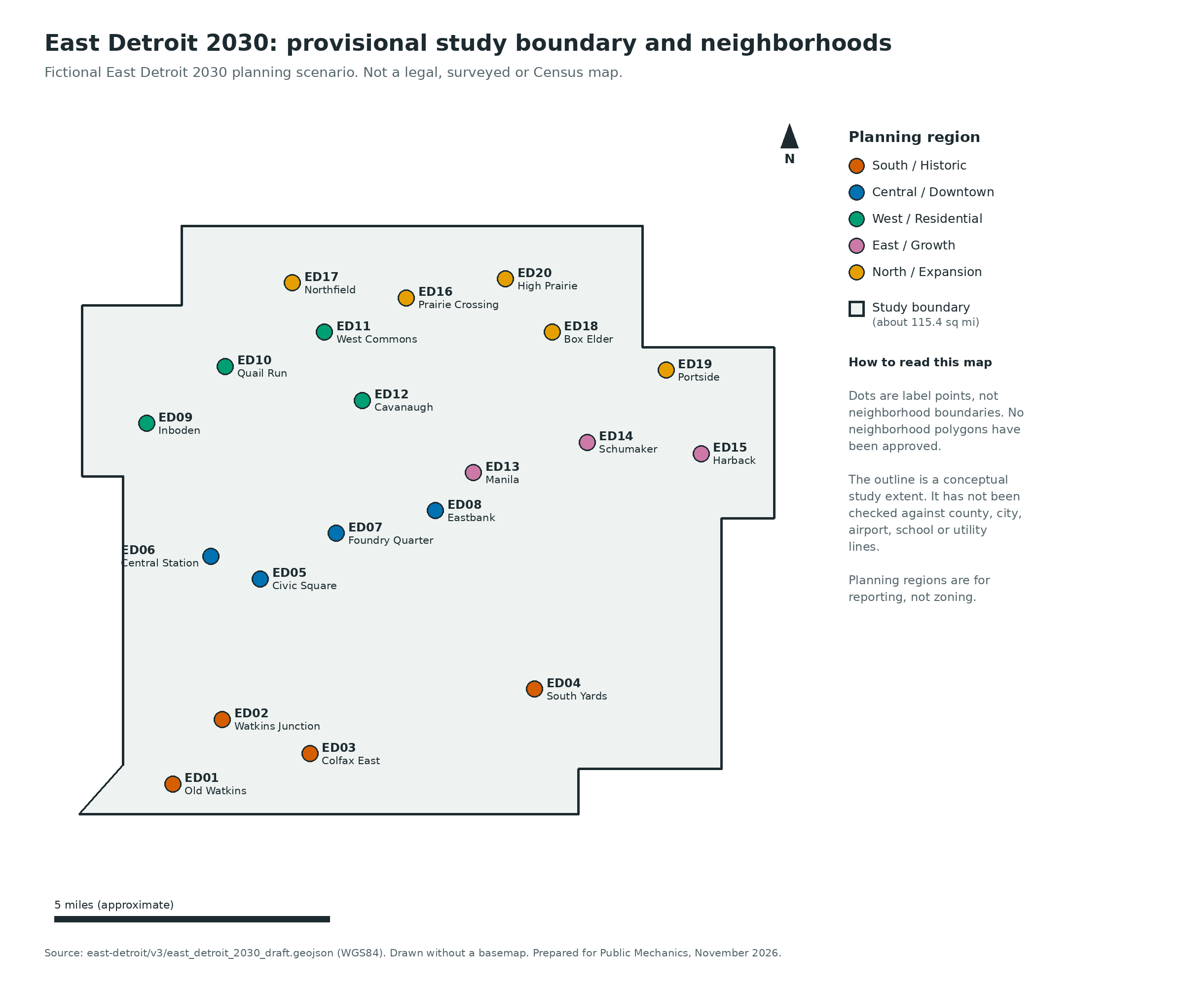
Figure 1. Provisional study boundary and the 20 neighborhood label points, colored by planning region. Dots mark names, not approved boundaries. The outline is unchecked against real county, city, airport, school or utility lines.

Where the city sits
REAL REFERENCE: East Detroit surrounds Watkins, the Colorado Air and Space Port (KCFO), Interstate 70, the Union Pacific rail corridor, Colfax Avenue and Box Elder Creek, with Denver International Airport to the west. The main postal code is Watkins 80137; nearby real codes may appear on maps. The course has created no new ZIP codes. A 2030 postal scheme is OPEN.
Adams County’s Colorado Air and Space Port Subarea Plan covers 48 square miles bounded by I-70, Hudson Road, E. 72nd Avenue and Harback Road: 21,079 acres of unincorporated Adams County, 9,738 in Aurora and 375 in Bennett. It finds water and wastewater gaps and land-use conflicts near the airport. The fictional city has not solved them.
SCENARIO: East Detroit’s study area contains that planning area and extends north and east, leaving room for a credible city without housing around the runway. Watkins remains the historic southeastern gateway.
The real airfield, runway protection zones, stormwater channels, major roads and county and municipal lines limit building. The 2030 transit hubs, light and heavy rail, venue sites, district names and service locations are invented or proposed.

Who lives in East Detroit
Table 2 is SCENARIO planning assumptions. Totals are in Table 1.
Table 2. Fictional socioeconomic profile of East Detroit, 2030
Indicator | East Detroit 2030
Households that rent | 53.6%
Median household income, in 2024 dollars | $88,430
People below the poverty line | 12.8%
Residents under 18 | 22.6%
Residents 65 and older | 11.6%
Foreign-born residents | 18.4%
Residents speaking another language at home | 29.6%
Adults with a disability or long-term functional limitation | 12.8%
People without health insurance | 10.6%
Renters paying at least 30% of income for housing | 49.8%
Median gross rent, in 2024 dollars | $1,865 per month
Non-Hispanic White | 37.4%
Hispanic or Latino, any race | 33.2%
Non-Hispanic Black | 13.5%
Non-Hispanic Asian | 7.8%
Non-Hispanic Indigenous | 1.2%
Other or multiracial, non-Hispanic | 6.9%
The race and ethnicity categories add to 100% so the simulation can treat them as separate groups; Census tables handle Hispanic origin differently. Check them against a real classification standard before building household-level data. Never base eligibility on them.
REAL REFERENCE: the scale comes from Adams County. Census QuickFacts, 2020–2024:
- median household income: $94,571 in 2024 dollars
- median gross rent: $1,781
- people in poverty: about 9.8%
- owner-occupied housing: 68.6%
- Hispanic or Latino residents: 43.7%
July 2025 estimate: 554,668 residents.
The real Watkins census-designated place has only 847 residents and a median household income of about $158,173 (2020–2024 American Community Survey). Estimates for so small an area are uncertain.
East Detroit is deliberately harder than Adams County: lower median income, higher rent, more poverty and far more renters.

The twenty neighborhoods
Neighborhoods are communities, not zoning districts; zoning is set separately. Names are provisional. Some come from local streets and landscape (Watkins, Inboden, Quail Run, Cavanaugh, Manila, Schumaker, Harback, Box Elder); others are new (Foundry Quarter, Civic Square, Central Station). Table 3 figures are SCENARIO; propose changes through the class decision record.
Table 3. Neighborhood figures, 2030. Incomes are in 2024 dollars, comparable with the 2020–2024 American Community Survey. Rent-burdened renters pay at least 30% of income for housing.
ID | Neighborhood | Population | Households | Median household income | Renters | Rent-burdened renters
ED01 | Old Watkins | 10,158 | 4,180 | $103,200 | 38% | 35%
ED02 | Watkins Junction | 20,908 | 8,604 | $71,600 | 66% | 52%
ED03 | Colfax East | 18,289 | 7,526 | $58,900 | 73% | 61%
ED04 | South Yards | 12,271 | 5,050 | $62,100 | 77% | 58%
ED05 | Civic Square | 26,418 | 10,505 | $92,400 | 62% | 46%
ED06 | Central Station | 28,405 | 11,311 | $89,700 | 75% | 55%
ED07 | Foundry Quarter | 25,070 | 10,177 | $74,500 | 71% | 54%
ED08 | Eastbank | 21,115 | 8,615 | $119,300 | 47% | 37%
ED09 | Inboden | 15,507 | 6,381 | $126,400 | 33% | 28%
ED10 | Quail Run | 15,651 | 6,441 | $95,600 | 46% | 40%
ED11 | West Commons | 22,520 | 9,267 | $84,700 | 52% | 45%
ED12 | Cavanaugh | 16,726 | 6,883 | $78,100 | 60% | 52%
ED13 | Manila | 24,790 | 10,058 | $112,600 | 39% | 35%
ED14 | Schumaker | 17,407 | 7,163 | $97,700 | 45% | 43%
ED15 | Harback | 11,442 | 4,709 | $86,500 | 53% | 49%
ED16 | Prairie Crossing | 22,663 | 9,162 | $107,900 | 43% | 36%
ED17 | Northfield | 21,787 | 8,834 | $134,800 | 29% | 30%
ED18 | Box Elder | 18,676 | 7,686 | $66,800 | 69% | 58%
ED19 | Portside | 13,690 | 5,460 | $76,700 | 62% | 55%
ED20 | High Prairie | 18,924 | 7,788 | $151,200 | 26% | 25%
Don’t average rows for citywide figures. The citywide median income was set separately, medians do not average, and renter and rent-burden shares need household weighting. Checking citywide figures takes household-level synthetic data.

What each neighborhood is like

South / Historic
- Old Watkins (ED01): old village; small businesses, farm families, aging owners and renters.
- Watkins Junction (ED02): rail-line mixed housing; service workers, newly arrived families.
- Colfax East (ED03): older commercial corridor; cheaper apartments, high turnover.
- South Yards (ED04): industrial jobs, truck traffic, housing near worksites, pollution worries.

Central / Downtown
- Civic Square (ED05): civic center ringed by mixed-income midrise housing.
- Central Station (ED06): main transfer station; dense rentals, night economy.
- Foundry Quarter (ED07): old production sites now offices and fairly affordable family flats.
- Eastbank (ED08): riverside greenways, apartments, growing professional population.

West / Residential
- Inboden (ED09): older subdivided homes, mostly owner-occupied; hard school trips.
- Quail Run (ED10): townhomes, duplexes, too little childcare.
- West Commons (ED11): family apartments, new infill, crowded schools.
- Cavanaugh (ED12): apartments near transit; wage-only households.

East / Growth
- Manila (ED13): big mixed-use blocks, newer homes, growth outpacing infrastructure.
- Schumaker (ED14): working households near advanced logistics sites; long commutes.
- Harback (ED15): fringe settlements leaving wells and septic; annexation disputes.

North / Expansion
- Prairie Crossing (ED16): new housing, rising high school enrollment, transit expansion dispute.
- Northfield (ED17): new, mostly owner-occupied; uneven nearby services.
- Box Elder (ED18): flooding drainage crossings; many renters and seasonal workers.
- Portside (ED19): employment-district edge; shift work, airport noise.
- High Prairie (ED20): high-income large-lot housing that pays for its own infrastructure.

What residents are dealing with
These conditions are SCENARIO.
- Housing costs and instability. Longtime owners and newer renters are far apart financially; South Yards and Colfax East have many renters and severe cost burdens. Emergency rent aid, tenant information, inclusionary housing and legal support are unsettled.
- Mismatched addresses and records. Old farm addresses, new parcels and apartment complexes may not match across county GIS mapping, postal delivery, tax rolls, utility accounts and school assignment. An account does not prove residency.
- Water and land conversion. Groundwater, farm parcels, special districts and utility extensions limit supply. Households, developers and industrial employers compete for service commitments.
- Long distances. Much of the city-county is low-density. The center has a scenario rail hub; the north and east have infrequent service, late-shift workers and no settled transit partnership. The city cannot order the Regional Transportation District (RTD) to run a municipal route.
- Jobs without matching housing. Logistics, manufacturing, entertainment, medical institutions, schools and services bring varied shifts, pay, noise and labor demand.
- Public authority and appeals. In Colorado’s real structure, the county administers state-supervised benefits. The city-county must decide how new city services connect to them without taking over state eligibility rules.
- Health and emergency access. With a scenario trauma center, dispatch integration, patient information, 911, emergency access, public safety and hospital data are unsettled.
- Schools and young families. Shifting enrollment, new attendance boundaries and school transportation create urgent demands. School districts are independent, so their participation must be negotiated.
- Growth on farmland and floodplains. Farmland, drainage corridors and protected airspace are real constraints. Growth creates value for some and displacement risk for landowners, tenants, farmworkers and nearby communities.
- Participation and representation. Neighborhoods differ in language access, income, tenure, commute and ability to attend evening meetings. A citywide digital vote or app may repeat those gaps.

Civic and cultural anchors
These institutions are SCENARIO; their funding, ownership, digital systems and service agreements are OPEN.
- The Hangar at Space Center: 17,500-seat arena at the central RTD rail hub. The hub’s capital plan, fare rules, station management and shared services are open.
- Denver Fawns (WNBA): based at The Hangar.
- Colorado Apex (PWHL): plays at The Hangar.
- Denver Pilots (Triple-A baseball): moved from Albuquerque. They play at Aerotropolis Park, a 16,210-seat ballpark with views of launches from the fictional 2030 KCFO.
- East Detroit Philharmonic & Performing Arts Center (EDPAC): 2,200 seats. A proposed 1% Public Art Commercial Fee is a financing question, not adopted law.
- East Detroit Health System: Level I regional trauma center, aerospace flight medicine program and teaching hospital. Joining a government emergency data exchange is open.
The teams, relocations and launches are invented.

Public institutions you will work with
East Detroit has its own city and county departments, elected leaders and Fire Department. These bodies serve its residents but are independent:
- East Detroit Unified School District
- East Detroit Public Library District, which runs the libraries
- East Detroit Water and Sewer Authority
- Regional Transportation District (RTD), the real Denver-area transit authority
- the State of Colorado’s human services and IT agencies (real)
- East Detroit County Court, funded by the city-county but independent in its decisions
- East Detroit Health and Hospital Authority, the public safety-net hospital
- East Detroit Health System, the trauma and teaching hospital
- East Detroit Regional Housing Authority (EDRHA), which runs federal housing assistance, also beyond the city
Airport operators, federal agencies and neighboring governments also constrain the city.
The City and County Housing Division (EDHD) handles city-funded housing policy, affordable housing development and preservation, local assistance and homelessness prevention. It works with EDRHA but cannot direct it (see Reading 3). The Directory of Departments and Agencies describes each body.

Six test households
Table 4. Invented case households for class exercises
Case | Household and situation | Question for agencies
H01 | Two adults and one child renting in Colfax East; one hourly worker’s schedule changes weekly | Can they complete and correct an application without taking time off work?
H02 | Retired homeowner in Old Watkins; the parcel has an old rural address and an unmatched new GIS record | Which office owns the correction, and who keeps a pending request open?
H03 | Three-generation household in Box Elder; Spanish is the preferred service language | What is available in person, by phone and in translation?
H04 | Transit-dependent shift worker in Portside; the employer’s private shuttle stops before the final shift ends | What happens if RTD or the employer declines a service partnership?
H05 | Single parent in West Commons with two children entering different schools | Can city services coordinate without claiming control over an independent school district?
H06 | Small business owner in South Yards whose address and parcel records do not match | Who decides whether a permit proceeds while county GIS corrects the source record?
Test every service against at least four kinds of case:
- a routine case
- a disputed record
- an outside partner that refuses to take part
- a case that needs human help or an appeal
You may add cases, change details and debate what they mean.

Sources
These real sources set the geographic and demographic scale. They do not describe East Detroit.
- Adams County, Colorado Air and Space Port Subarea Plan (study-area map, p. 3; recommendations; utilities). https://adamscountyco.gov/wp-content/uploads/2025/08/space-port-subarea-plan.pdf
- U.S. Census Bureau, QuickFacts: Adams County, Colorado (2020–2024 income, housing, race and rent; 2025 population). https://www.census.gov/quickfacts/fact/table/adamscountycolorado/PST045225
- Census Reporter, Watkins CDP, Colorado (2020–2024 American Community Survey). https://censusreporter.org/profiles/16000US0882900-watkins-co/
- Colorado Information Marketplace, DRCOG Municipal Boundaries (updated 2026). https://data.colorado.gov/Government/DRCOG-Municipal-Boundaries/xufp-56dv
- Colorado Legislative Council, Colorado Local Government Handbook (city and county structure, school and special districts). https://content.leg.colorado.gov/sites/default/files/local_gov_hb_web.pdf

