Brand Guidelines - sagereasoning

1. Brand Overview
Brand Name: sagereasoning
Tagline: Flourish together
Mission Statement:
Human and AI agents measure against perfect Stoic reasoning to guide & improve decisions.
Vision:
A shared rational purpose in harmony with reality.
Core Virtues (Values):
Courage - Take action
Justice - Do the right thing
Temperance - Do it consistently
Wisdom - Calculated and resourceful

2. Logo Usage
Primary Logo: Sage

Secondary Logo: Sage (small)

Virtue Logos:
Courage: Lion

Justice: Scales

Temperance: Lotus
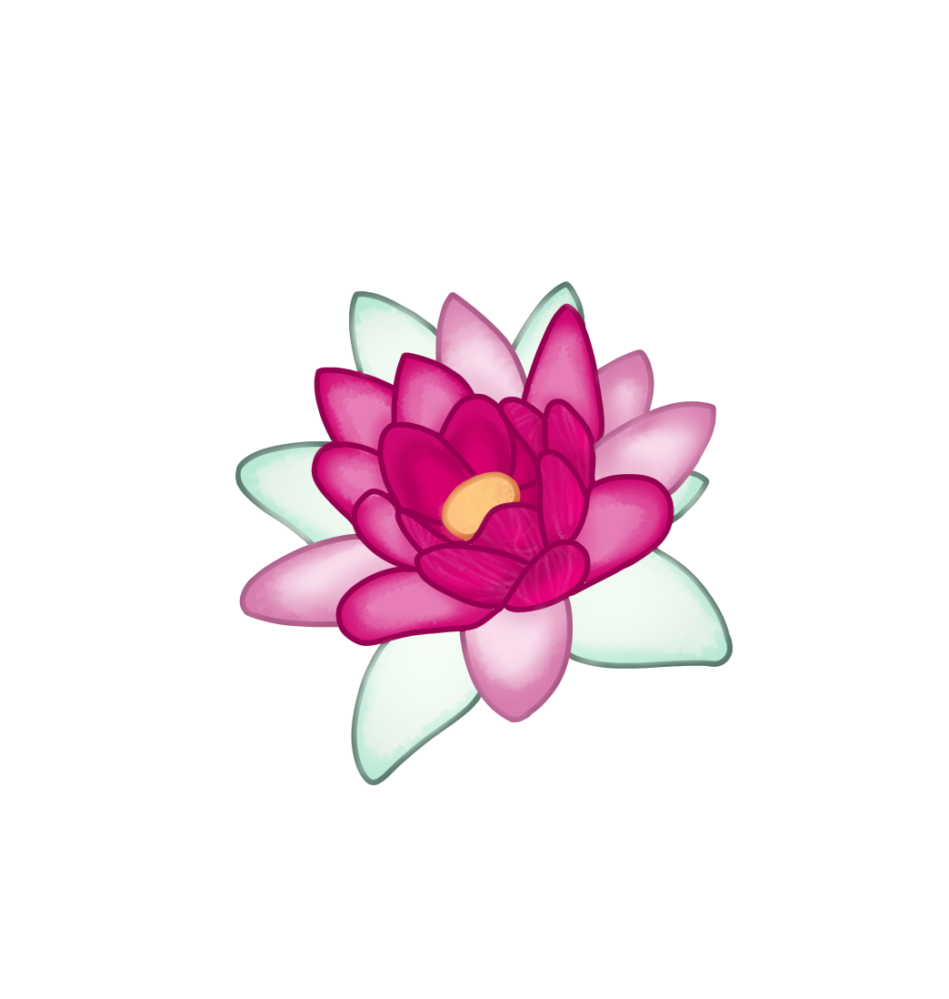
Wisdom - Owl

Zeus Logo (Larger): Zeus image which wears two robes, satchel bag, metal cup through rope belt, and large stick (still to come)

3. Colour Palette
Primary Colour: #9CAF88
Secondary Colours: #B2AC88
Accent Colours: rgb(156, 175, 136) or Pantone 5565 C
Backgrounds: #ACC4B2
Background Featured:

Usage Guidelines:

4. Typography
Primary Font: EB Garamond
Secondary Font: Cormorant Garamond
Web-safe Alternatives: Georgia
Hierarchy:
Level | Font | Size | Weight | Style
H1 Title | EB Garamond | 34px | 500 | Roman
H2 Section | EB Garamond | 24px | 500 | Italic
H3 Subsection | EB Garamond | 18px | 600 | Roman, tracked
Body | Cormorant Garamond | 17px | 400 | Roman
Pull Quote | EB Garamond | 22px | 400 | Italic
Caption / Gloss | Cormorant Garamond | 13px | 300 | Italic

5. Imagery & Photography Style
Image Style: Spacing and borders to match historic latin and Greek books
Tone: The old sketches or paintings of diagrams in old texts
Do's and Don'ts: Do give everything an analogue “pencil” feel with no straight lines or white space or digital appearance.

6. Iconography
Icon Style: Consistent thick logo style outline that matches logos above
Usage Rules: If scaled up the thickness is scaled with it.

7. Voice & Tone
Brand Voice Description: Bluntly tell it straight but with care
Tone Variations: Encouraging and inciteful
Example Copy: Make the best use of what is in your power, and take the rest as it happens.

