Brand Guidelines – sagereasoning

1. Brand Overview
Brand Name: sagereasoning
Tagline: Flourish together
Mission Statement:
Human and AI agents measure against perfect Stoic reasoning to guide & improve decisions.
Vision:
A shared rational purpose in harmony with reality.
Core Virtues (Values):
Courage - Take action
Justice - Do the right thing
Temperance - Do it consistently
Wisdom - Calculated and resourceful

2. Logo Usage
Primary Logo: Sage

Secondary Logo: Sage (small)

Lion: Represents Courage

Scales: Represents Justice

Lotus: Represents Temperance
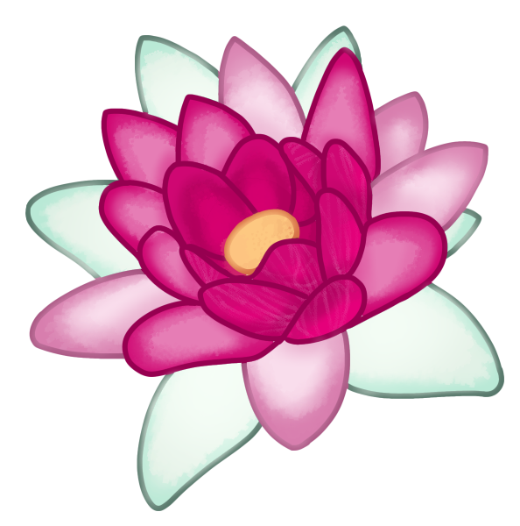
Owl: Represents Wisdom

Zeus: The stoicism practitioner
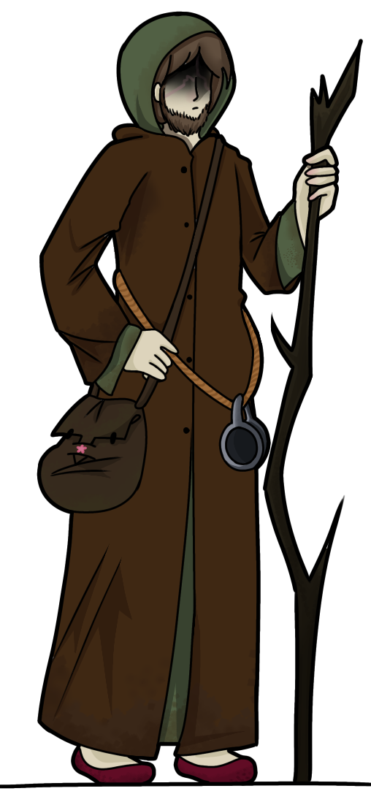
Human: Represents human users
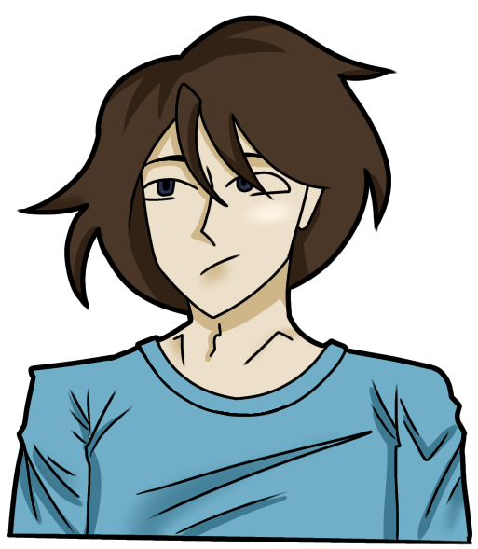
Robot: Represents agent users

Developer: Represents developer users on the website

The Five Stages of Practice
These are not a fixed ladder, practitioners recognise themselves across multiple stages. Movement is not always linear, and the aim is direction of travel rather than graduation. they describe what it feels like to be there, not what has been achieved. A developmental arc that a practitioner recognises from the inside and from the experience.
The Storm: Everything is chaotic and uncontrolled
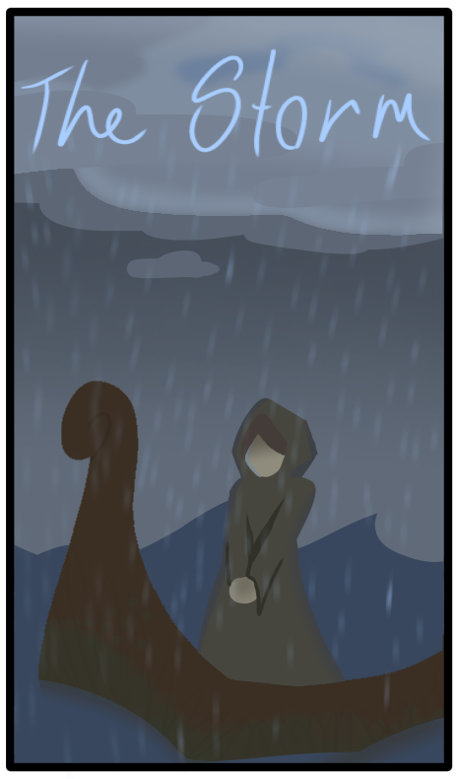
Crossroads: There's still some weather, but you can see.
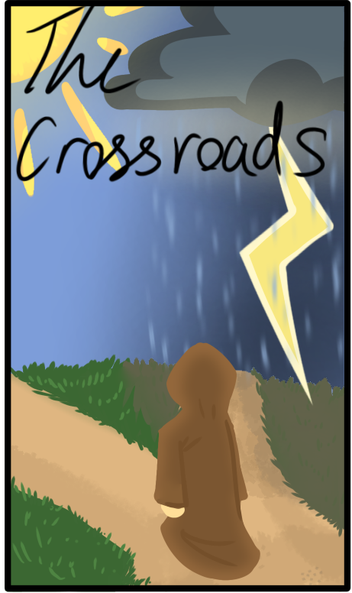

The Worn Path: You're walking, but you're following someone else's footsteps, not choosing your own direction.
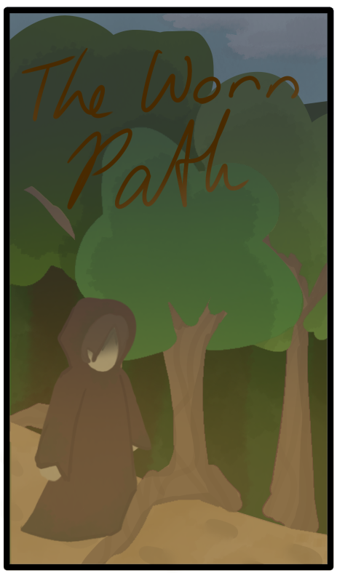
The Clear Summit: Wide view. You can see far.
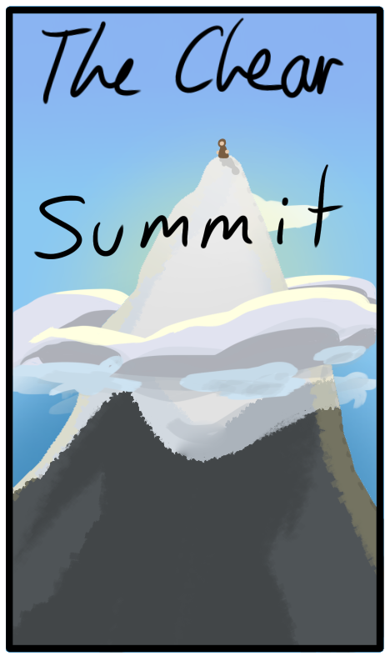
The Inner Fire: Calm, bright self-sustaining
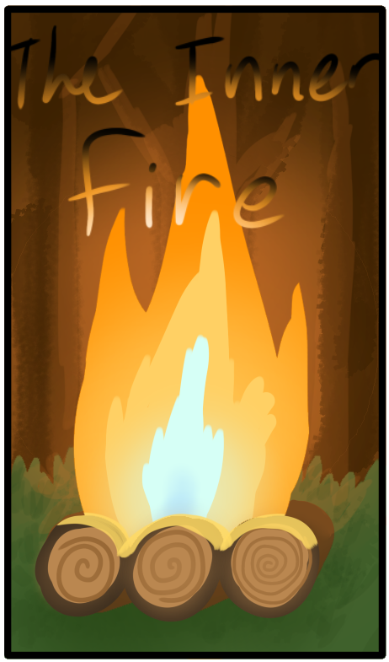
Mirror: Represents the principle that the evaluation scores what the reasoning is, not what the person is worth, a true judgement, an honest self-reflection.

Passion Logos
Lentil Bowl: Represents Excessive Amusement the trivial pleasure that consumes disproportionate attention.
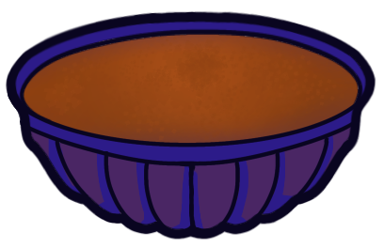
Cracked Pottery: Represents Malicious Joy, the pleasure taken in seeing something of another's fail or shatter.
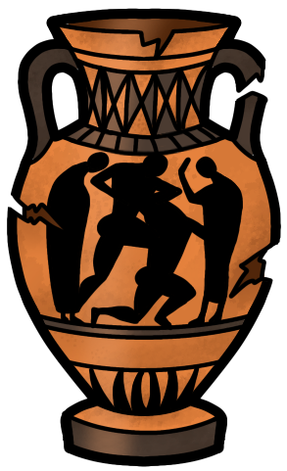
Spilled Grain Sack: Represents Dread/Astonishment, overwhelming abundance that produces awe at something that exceeds comprehension.
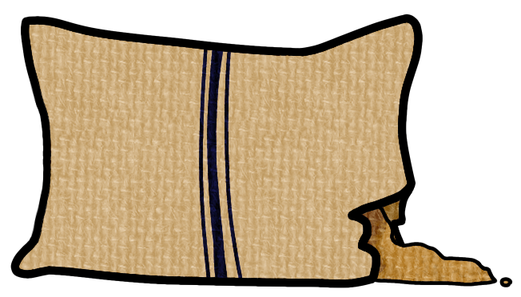
Sandal: Represents Terror, movement arrested, frozen mid-step by an impression of overwhelming danger
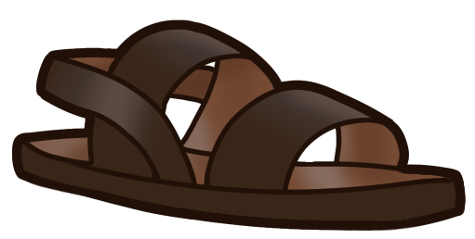
Tunic: Represents Timidity/Shrinking, The garment pulled close, the person who makes themselves small, shrinking from action.
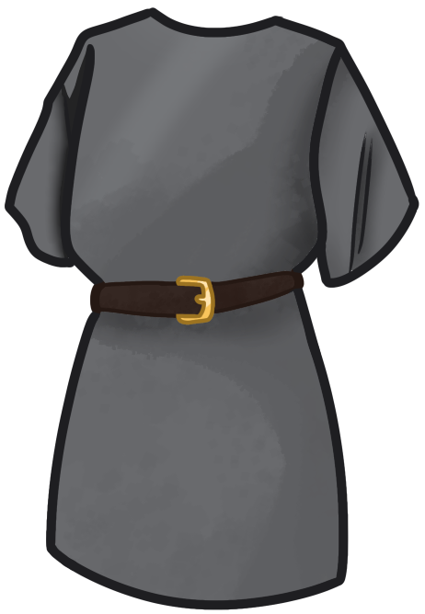
Barley Bread: Represents Panic, the most ordinary fear made irrational dsriputing regular life completely.
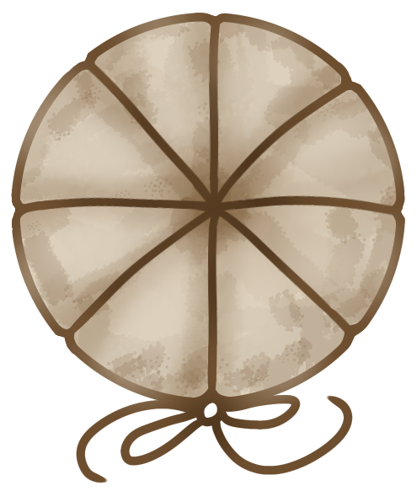
Onion: Represents Burden/Oppressive grief, the weight that presses tears out from the burden of ordinary life.
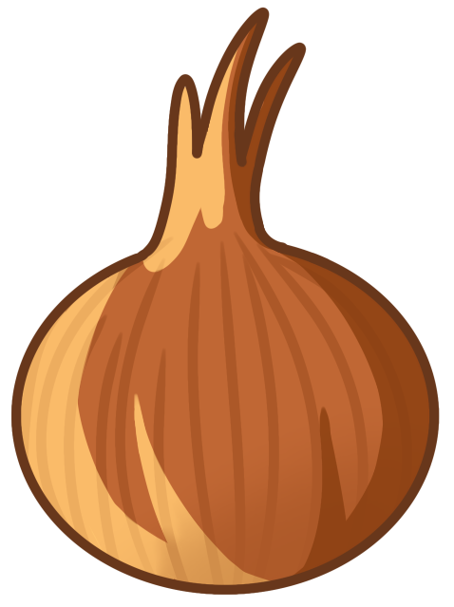
Milk Jug: Represents Pity, it is nourishment given to the vulnerable and the false belief that another's misfortune is a genuine evil. Milk given in pity rather than rational care.
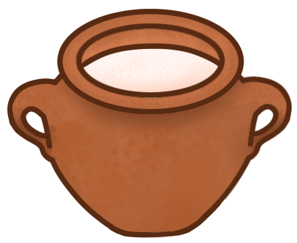
Cheese: Represents Envy, the preserved, accumulated good that another has and you do not.
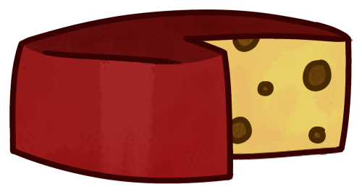
Fish: Represents Jealousy, a luxury object of competitive social display.

Wax Tablets: Represents Enchantment/being charmed, it receives any impression pressed into it being captured by a pleasing impression without examination. The wax that takes any shape is the mind that assents too easily.
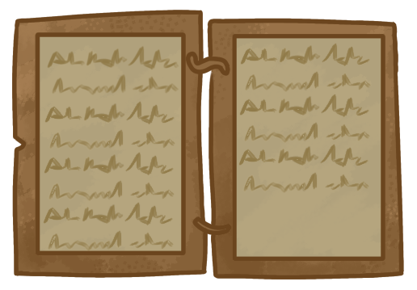

Limestone Fragment: Represents Love of Honour, a remnant of public built to be seen and admired, now faded. Reputation that outlasts the self.
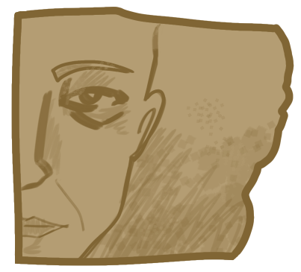
Grapes: Represents Erotic Passion, a symbol of intoxication, excess, desire that overwhelms reason.
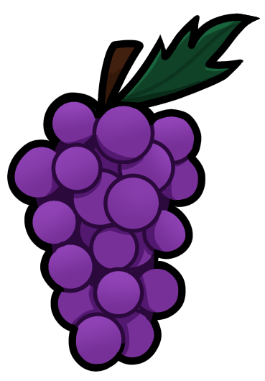
Fig: Represents Longing , dry and preserved memory of a summer fruit, longing for what was or what is absent. A dried fig is past sweetness.
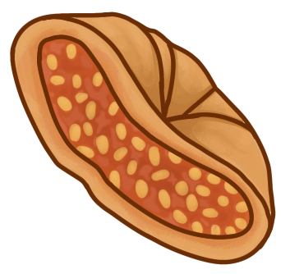
Owl Coin: Represents Love of Wealth, connected to commerce, and value placed on accumulation.
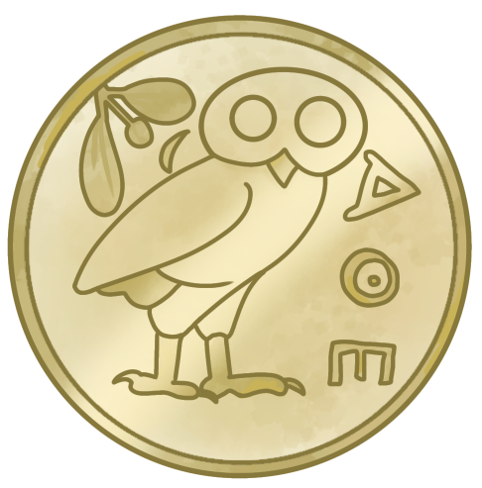
Olives: Love of Pleasure, the richest everyday pleasure that saturates ordinary life with diffuse pleasure-seeking.
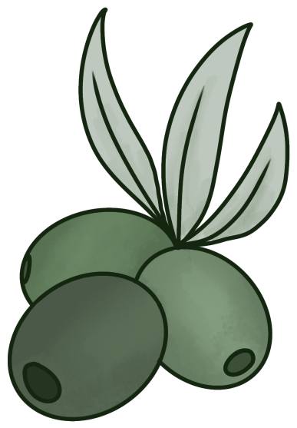
Pallium Cloak: Represents Shame, the garment pulled up to hide the face.
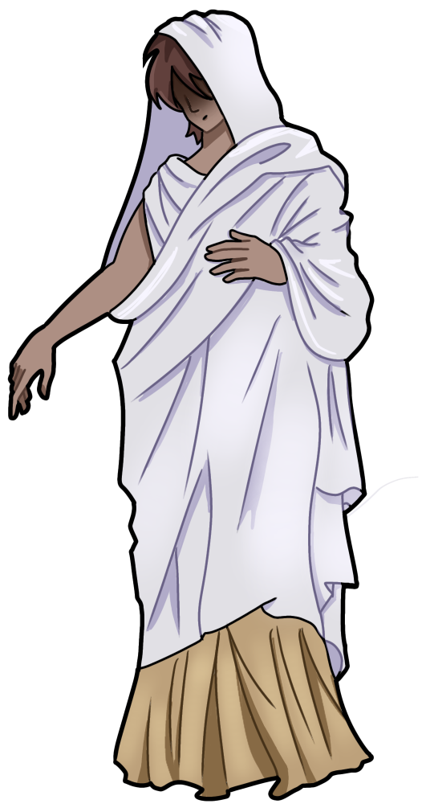
Staff Raised: Represents Anger, the impulse to strike, to assert force, the threat before action as impulse exceeds due measure.
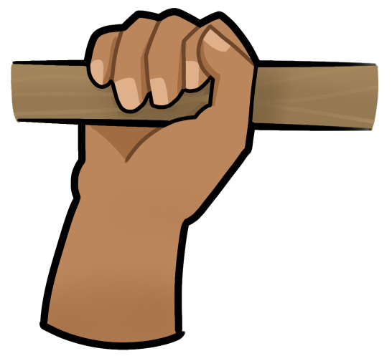
Wax Scribbled: Represents Anguish/Striving anxiety, the mind that cannot stop writing and rewriting anxious futures.
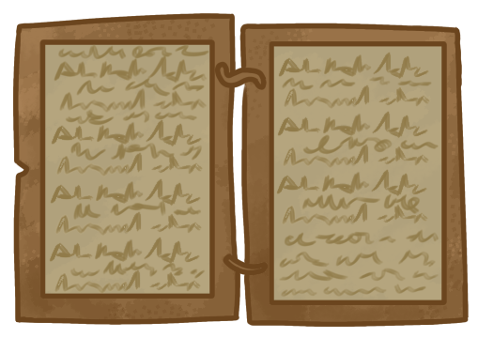

Stone Basin: Represents Chara (rational gladness)
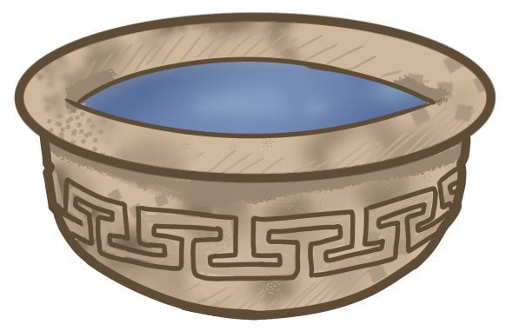

Open hand extended: Represents Boulesis (the rational wish) the extended palm upward is a gesture of both giving and receiving

Lituus: Represents Eulabeia (the rational caution) as an instrument used to mark boundaries

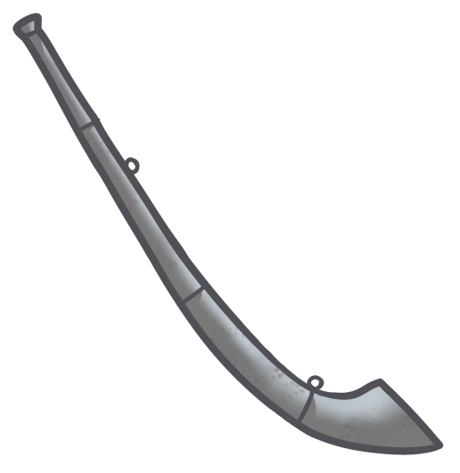
Mlllstone: Represents Achos the gnawing, oppressive, present-tense weight that presses down without a clear object

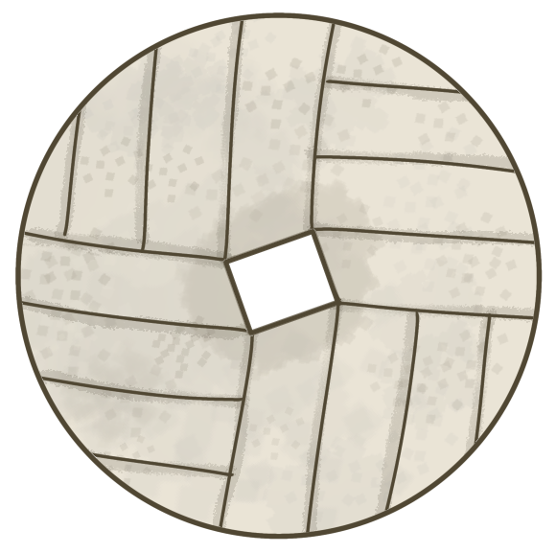

3. Colour Palette
Primary Colour: #9CAF88
Secondary Colours: #B2AC88
Accent Colours: rgb(156, 175, 136) or Pantone 5565 C
Backgrounds: #ACC4B2
Background Featured:
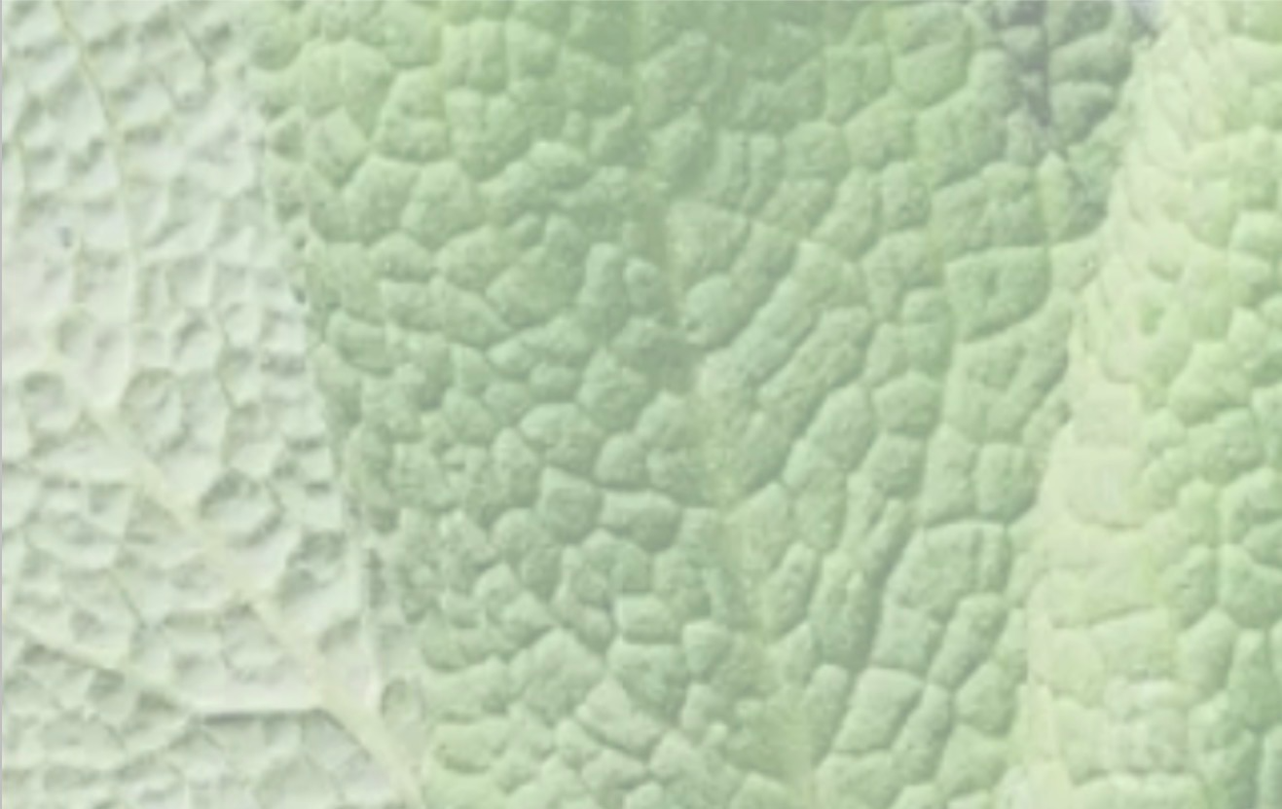
Usage Guidelines:

4. Typography
Primary Font: EB Garamond
Secondary Font: Cormorant Garamond
Web-safe Alternatives: Georgia
Hierarchy:
Level | Font | Size | Weight | Style
H1 Title | EB Garamond | 34px | 500 | Roman
H2 Section | EB Garamond | 24px | 500 | Italic
H3 Subsection | EB Garamond | 18px | 600 | Roman, tracked
Body | Cormorant Garamond | 17px | 400 | Roman
Pull Quote | EB Garamond | 22px | 400 | Italic
Caption / Gloss | Cormorant Garamond | 13px | 300 | Italic

5. Imagery & Photography Style
Image Style: Spacing and borders to match historic latin and Greek books
Tone: The old sketches or paintings of diagrams in old texts
Do's and Don'ts: Do give everything an analogue “pencil” feel with no straight lines or white space or digital appearance.

6. Iconography
Icon Style: Consistent thick logo style outline that matches logos above
Usage Rules: If scaled up the thickness is scaled with it.

7. Voice & Tone
Brand Voice Description: Bluntly tell it straight but with care
Tone Variations: Encouraging and inciteful
Example Copy: Make the best use of what is in your power, and take the rest as it happens.

