Linguistics 201: Introduction to Linguistic Theory
Spring 2026 – Section 02
Syllabus

Course Information

Class Meetings
Time Tuesday and Friday at 12:10-1:30pm
Location Scott Hall, Room 116 (SC 116)
Instructor Quartz Colvin (quartz.colvin@rutgers.edu)
Office hours Mondays 2-3pm, 18 Seminary Place, Room 03 or via Zoom
(see Canvas for Zoom link)
Course website Canvas (https://canvas.rutgers.edu)

About this course
This course is an introduction to the study of linguistics and contemporary linguistic theory. Linguistics is a broad term that encompasses basically anything having to do with the scientific study of human language. Linguists use mathematical systems (often called ‘formal systems’) to develop precise theories that help us understand the incredibly rich cognitive processes that allow us to use language to communicate with each other, conduct an internal monologue, and so much more.
In this course, we’ll focus on several key areas of modern linguistic theory: morphology (the study of words and word formation), syntax (the study of how sentences and phrases are built and structured), semantics (the study of how words and phrases are associated with meaning), pragmatics (the study of implied meaning and language use in context), and phonetics and phonology (the study of “speech sounds”, broadly – scare quotes because we can also study the phonetics and phonology of signed languages!).

Learning goals

Course learning goals
At the completion of this course, students will:
- Understand significant subfields within linguistics.
- Understand, create, and manipulate representations and analyses in morphology, syntax, semantics, pragmatics, phonetics, and phonology.

Department learning goals met by this course
- Students will reason about language; identify how incorrect or irrational assumptions and prejudices distort understanding of language; demonstrate knowledge about language in the world including a sophisticated understanding of linguistic and cultural variation, and evaluate popular views on the nature of human languages and their speakers.
- Majors and Minors will also demonstrate technical mastery over the tools of linguistic analysis in syntax, phonology and semantics and apply linguistic theory in these areas. They will investigate linguistic data and analyze it; demonstrate strong problem-solving skills; extend their understanding of theoretical linguistics into other domains of linguistic research; apply the techniques of linguistics that they have learned in the core courses to new topics; and access current research in the field. Some students will investigate language in a broader context, where it can be systematically and rationally explored using their sophisticated understanding how language works.

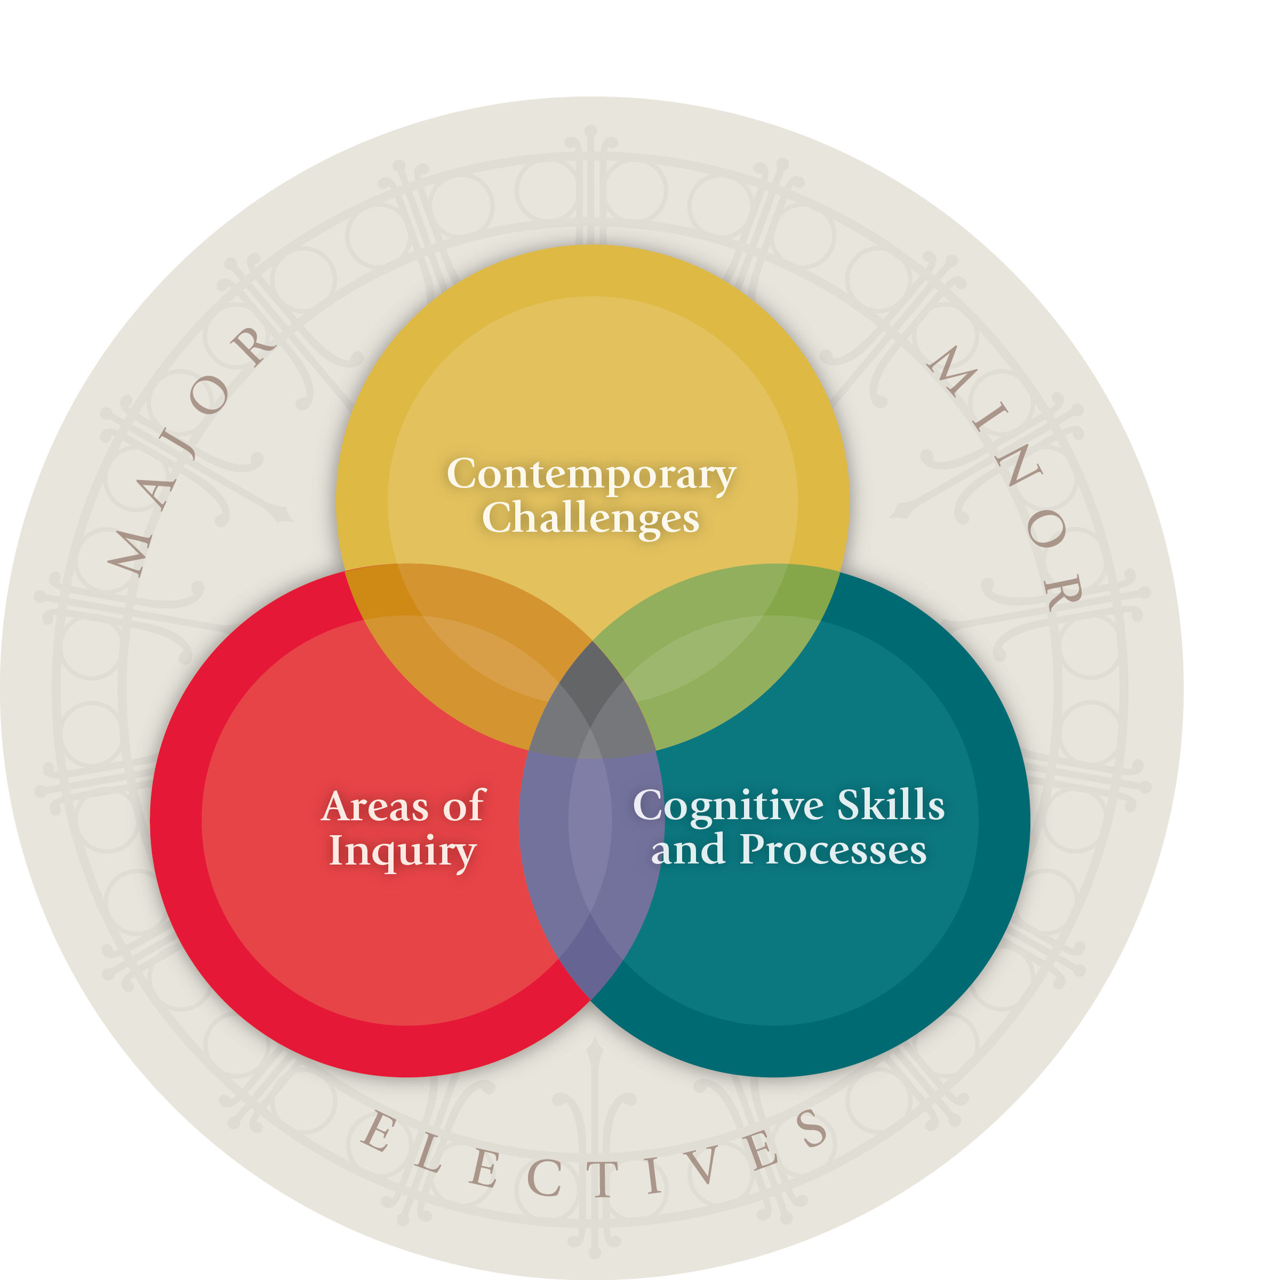
Core Curriculum learning goals
This course has been approved as a Core Curriculum Course and satisfies these 2 Core Curriculum learning goals:
- Understand the nature of human languages and their speakers. [AHq]
- Apply effective and efficient mathematical or other formal processes to reason and to solve problems. [QR]
Visit https://sasundergrad.rutgers.edu/majors-and-core-curriculum/core for information on the Core Curriculum.

Requirements and Grading

Readings
You do not need to purchase a textbook for this course. All course readings will be provided as PDFs and/or links to online resources on Canvas and will come from the following sources. Readings should be completed before the class for which they are assigned.
Anderson, C. 2018. Essentials of Linguistics. Available at: https://ecampusontario.pressbooks.pub/essentialsoflinguistics/
Carnie, A. 2006. Syntax: A generative introduction. 2nd ed. Blackwell.
Department of Linguistics, The Ohio State University. 2011. Language files: Materials for an introduction to language and linguistics. 11th ed. The Ohio State University Press.
Fromkin, V. (Ed). 2000. Linguistics: An introduction to linguistic theory. Blackwell.
Griffiths, P., Cummins, C. 2017. An introduction to English semantics and pragmatics. Edinburgh University Press.
O’Grady, W., Dobrovolsky, M., and Aronoff, M. (Eds.). 1997. Contemporary linguistics: An introduction. 3rd ed. St. Martin’s.

Technology requirements
For this course, you are expected to be able to access Canvas and your Rutgers email. Please check both regularly, as important announcements may be posted on Canvas. Assignments will be completed and turned in online, and readings will be posted online, so you will need access to a device to be able to do your readings and complete your assignments.

Office hours/Student support hours
Office hours are time set aside specifically to talk with and help students. Feel free to come to office hours if you have questions about class materials, course topics, linguistics, or any other question – that’s what this time is for! You may attend office hours in person or on Zoom, and you don’t have to come for the entire hour. The office hours schedule can be found at the top of this syllabus and on Canvas. If you cannot make it to office hours, please email your instructor to set up an alternative meeting time.

Grading scale
A | B+ | B | C+ | C | D | F
≥ 90% | 85 – 89.9% | 80 – 84.9% | 75 – 79.9% | 70 – 74.9% | 60 – 69.9% | ≤ 59.9%

Grading components
Item | Percent of final grade
Homework (lowest 2 dropped) | 50%
Midterm Exam | 20%
Final Exam | 20%
Attendance/Participation | 10%

Attendance and Participation
Please come to class! We will be going through a lot of material quickly in this class, as well as using class time to practice concepts, so regular attendance is by far the best way to learn and understand the material. You are expected to attend every class unless you’re feeling unwell or have another legitimate reason for missing class (including religious reasons or participation in Rutgers-approved activities such as athletics). If you have a fever, cough, or sore throat, or for other reasons don’t feel well, please stay home and take care of yourself (and in so doing, take care of your classmates).
If you miss a class, you are responsible for:
1. Going through the materials for any classes you missed before the next class and completing any assignments in a timely manner. (If you need an extension, you must ask for one separately and ahead of time.)
2. Using the University absence reporting website (https://sims.rutgers.edu/ssra/) to indicate the date and reason for your absence. An email is automatically sent to your instructors.
Any reported absence will resut in a decrease in your Attendance/Participation grade, based on the following scale:
Unreported absences | Penalty (out of 10 pts)
14+ | 50% deduction
8+ | 30%
4+ | 10%

Homework
There will be eight homework assignments over the course of the semester, each of which will consist of a combination of data analysis problems and short-answer questions. Your lowest two Homework grades will be dropped. All homework should be your own work: you should not collaborate with other students, get help from the internet, or use AI to complete your homework.

Exams
There will be two exams in this class, a Midterm Exam and a Final Exam. Each exam will consist of a combination of data analysis problems, short-answer questions, and multiple-choice questions. Exams will be administered in person in the classroom.

Late Policy
If you think you will not be able to complete an assignment on time, please contact your instructor before the deadline to request an extension. Without an agreed-upon extension, any assignment turned in late will have its grade lowerd by 5% for each 24 hour period it is late, up to a maximum reduction of 50%.

Extra Credit (Participation in Linguistics Experiments)
You have the opportunity to raise your final grade by up to 2 points through participation in Linguistics experiments.
- Some faculty and graduate students in the Department of Linguistics do experimental research on language. This research depends on the participation of undergraduate participants.
- You have the option of participating in Linguistics experiments during the semester. Each experiment usually takes between 20 and 45 minutes.
- You will get 1 point credit for every half hour of experimental participation. It does not matter what subfield of Linguistics this experiment is in, but it must be in Linguistics.
- Experiments are offered through the Linguistics department experiment management system (sona): http://rutgerslinguistics.sona-systems.com/. Towards the beginning of the semester, your name and email will be added to the experiment system. You will be issued an anonymous id to participate in experiments through this system. Once Linguistics experiments are posted, you can sign up online.
- Note that this system is different from the Psychology pool. You should not log in with a Psychology ID, and Psychology experiments do not count toward extra credit.
- Any student enrolled in a Linguistics undergraduate course is eligible to participate in Linguistics experiments, regardless of gender, race, ethnicity, language status, or impairments, disorders, or disabilities (as long as his/her instructor provides the opportunity). You cannot be denied participation for any of these reasons.
- You have the right not to participate in experiments and to earn extra credit via an alternative assignment, such as reading a pre-approved scholarly article and writing a 2-page paper summarizing it. Please speak to me if you would like to choose this option.
- If you are taking multiple Linguistics courses that allow for experimental participation to count towards extra credit, you are responsible for making sure you have assigned the credit correctly through the experiment system online. This is not your instructor’s, the experimenter’s, or the experiment system administrator’s job.
- If you sign up for, but fail to show up for, two or more experiments, you may be barred from further participation and restricted to research alternatives as described above, so please note the time and location of your experiments, and take your schedule and transportation time into account. Many experiments have restrictions on how late you may cancel online.

General policies
Students are expected to read and abide by the following policies of the Linguistics Department, which can be found here https://ling.rutgers.edu/academics/undergraduate-mainmenu-139/ department-learning-goals-and-policies:
- Rutgers Code of Student Conduct (https://studentconduct.rutgers.edu/)
- Policy on Religiously Observant Students
- Students with Disabilities
- Attendance Policy
- Academic Integrity
- Concerns
- E-mail and Contact Information Policy

Disability services
Rutgers University welcomes students with disabilities into all of the University’s educational programs. In order to receive consideration for reasonable accommodations, a student with a disability must contact the appropriate disability services office at the campus where you are officially enrolled, participate in an intake interview, and provide documentation: https://ods.rutgers.edu/students/documentation-guidelines.
If the documentation supports your request for reasonable accommodations, your campus’s disability services office will provide you with a Letter of Accommodations. Please share this letter with your instructors and discuss the accommodations with them as early in your courses as possible. To begin this process, please complete the Registration form on the ODS website: https://ods.rutgers.edu/students/getting-registered.

Academic integrity
Rutgers University takes academic dishonesty very seriously. By enrolling in this course, you assume responsibility for familiarizing yourself with the Academic Integrity Policy (http://nbcacademicintegrity.rutgers.edu) and the possible penalties (including suspension and expulsion) for violating the policy. As per the policy, all suspected violations will be reported to the Office of Student Conduct. Academic dishonesty includes (but is not limited to):
- Cheating
- Plagiarism
- Aiding others in committing a violation or allowing others to use your work
- Failure to cite sources correctly
- Fabrication
- Using another person’s ideas or words without attribution
- Re-using a previous assignment
- Unauthorized collaboration
- Sabotaging another student’s work
For this class, students may study together, but may not collaborate on answering questions in homework assignments or exams; homework assignments and exams must be done independently. Collaboration is a violation of the Academic Integrity policy.

Student support and wellness resources
Student Success Essentials | https://success.rutgers.edu
Student Support Services | https://www.rutgers.edu/student-support
Rutgers Learning Centers | https://learningcenters.rutgers.edu/
Rutgers Libraries | https://www.libraries.rutgers.edu/
Bias Incident Reporting | https://studentaffairs.rutgers.edu/resources/bias-outreach-restoration-and-education
Office of the Dean of Students – Advocacy, Outreach and Support | https://studentsupport.rutgers.edu/
Office of Veteran and Military Programs and Service | https://veterans.rutgers.edu
Student Health Services | https://health.rutgers.edu/
Counseling, Alcohol and Other Drug Assistance Program & Psychiatric Services (CAPS) | https://health.rutgers.edu/medical-and-counseling-services/counseling-services
UWill: Free immediate access to teletherapy; you can choose a therapist based on your preferences including issue, gender, language, ethnicity. | https://health.rutgers.edu/uwill
Office for Violence Prevention and Victim Assistance | https://vpva.rutgers.edu/
Office of Disability Services | https://ods.rutgers.edu/
Basic Needs Assistance (food, housing, and other essentials) | https://ruoffcampus.rutgers.edu/basic-needs
Rutgers Student Food Pantry | https://ruoffcampus.rutgers.edu/basic-needs/food-assistance

Course calendar
The course calendar is tentative and subject to change, but should give you an idea of how this course will be paced so you can plan your semester. Most weeks, a reading will be posted that you should complete before Wednesday’s class, and an assignment will be posted that will be due on Sunday evening.
Week |  | Topic | Reading (Tues) | Assignment (Sun)
1 | Jan 20, 23 | Introduction | Anderson, Ch. 1 (for Fri) | –
2 | Jan 27, 30 | Morphology | Lang. Files, Ch. 4.0-4.2 | –
3 | Feb 3, 6 | Morphology | Lang. Files, Ch. 4.3-4.5 | HW1
4 | Feb 10, 13 | Syntax | Carnie, Ch. 2 | HW2
5 | Feb 17, 20 | Syntax | Carnie, Ch. 3 | HW3
6 | Feb 24, 27 | Review & Exam | – | –
7 | March 3, 6 | Semantics | Fromkin, Ch. 7 | –
8 | March 10, 13 | Semantics | – | HW4
Spring break (March 14-22)
9 | March 24, 27 | Pragmatics | Griffin & Cummins, Ch. 8 | HW5
10 | March 31, April 3 | Phonetics | O’Grady et al., Ch. 2 | –
11 | April 7, 10 | Phonetics | – | HW6
12 | April 14, 17 | Phonology | O’Grady et al., Ch. 3 | HW7
13 | April 21, 24 | Phonology | – | –
14 | April 28, May 1 | Phonology & Review | – | HW8
Final Exam: TBD.

