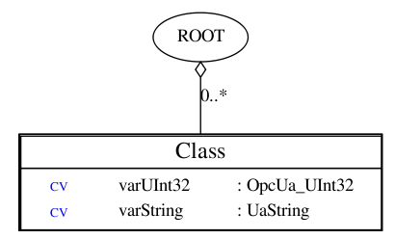
Initial comparison of various important measures between Quasar running on backends: UaToolkit vs open62541
By Piotr Nikiel, 04-Dec-2015

Note: Design has been kept very simple, it is just 1 class with 2 cachevariables. Variable “varUInt32” is updated every 1 second (on all objects) with a random value. Test done on SLC6.6 platform.

Measure | UA Toolkit backend |  | open62541
Measure | #objects = 1 | #objects = 1000 | #objects = 1 | #objects = 1000
Executable size after strip [kB] | 3882 |  | 1256
Resident size [kB]  (=RSS field of ps) | 12176 | 13864 | 7244 | 11208
Virtual size [kB]  (= VSZ field of ps) | 611604 | 613188 | 192356 | 196192
Dirty size [kB]  (= SZ field of ps) | 152901 | 153297 | 48089 | 49048
Estimated memory cost of 1 object as in design class [kB] | 1,69 |  | 3,96
CPU consumption [%] | 0,1 | 0,3 | 1,3 | 1,5
Valgrind-reported amount of allocated memory [kB] after 1 minute run | 25758 | 135804 | 696198 | 950574

This doesn't include UA Toolkit stack which in UaToolkit is linked dynamically. Therefore the number will be bigger in reality for UaToolkit.
Only 1 0bject is subscribed to in the UaExpert!

